2006年广东高考英语真题及答案

本试卷六大题，共16页，满分150分。考试用时120分钟。
注意事项：l.答卷前，考生务必用黑色字迹的钢笔或签字笔将自己的姓名和考生号填写在答 题卡上.用2B铅笔将答题卡试卷类型(B)涂黑。在答题右上角的“试室号”栏填写本科目试室号，在“座位号”列表内填写座位号，并用2B铅笔将相应的信息点涂黑。不按要求填涂的，答卷无效.
2.选择题每小题选出答案后，用2B铅笔把答题卡上对应题日的答案标号涂黑，如需改动，用橡皮擦干净后，再选涂其他答案，答案不能答在试卷上.
3．非选择题必须用黑色字迹钢笔或签字笔作答，答案必须写在答题卡各题目指定区域内相应位置上；如需改动，先划掉原来的答案，然后再写上新的答案；不准使用铅笔和涂改液.不按以上要求作答的答案无效。
4．考生必须保持答题卡的整洁，考试结束后，将试卷和答题卡一并交回.
Ⅰ. 听力(共两节，满分30分)
做题时，先将答案划在试卷亡。录音结束后．你将有两分钟的¨十问将试卷L的答案转
涂到答题卡上.

第一节：听独白或对话(共5小题；每小题1.5分，满分22.5分)
听下面5段对话或独白。每段对话或独白后有几个小题，从题中所给的A、B、C三个选项中选出最佳选项，并标在试卷的相应位置，听每段对话或独白前，你将有时间阅读各个小题，每小题5秒钟；听完后，各小题将给出5秒钟的作答时间。每段对话或独白读两遍。
听第1段对话，回答第1-3题。
1. Where does Jane ask Tom to meet her at first?
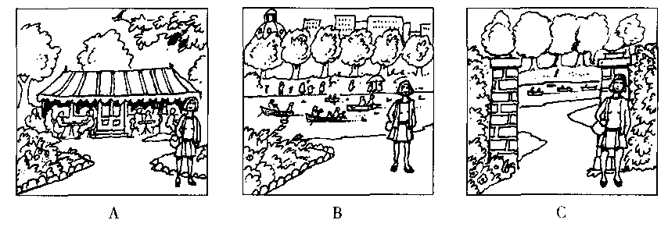
2. When and where do they agree to meet finally?
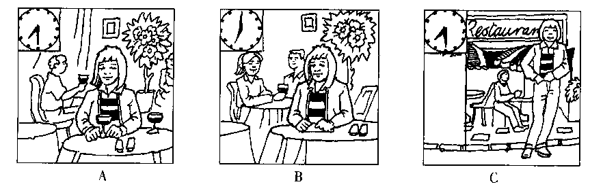
3. What does Jane have to do before going out to meet Tom?
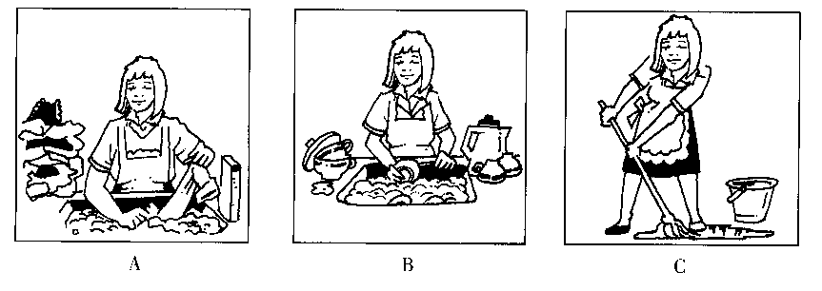
听第2段对话，回答第4-6题。
4. According to Peter, what is the problem with the building?
A. The air-conditioning is too strong.
B. The air-conditioning is out of order.
C. The air-conditioning stops working sometimes.
5. Why did Peter miss the breakfast yesterday morning?
A. He overslept.
B. He couldn't fall asleep the night before.
C. He talked with his roommates late into the night.
6. How many students will be staying in this room?
A. Two.
B. Three.
C. Four.
听第3段对话，回答第7-9题。
7. Which subject (s) does David find particularly difficult?
A. Math.
B. English.
C. The sciences.
8. What does David do to help his uncle with the cows?
A. He milks the cows on Sundays and cleans the cowshed sometimes.
B. He drives the tractor on Sundays and does the milking sometimes.
C. He cleans the cowshed on Sundays and drives the tractor sometimes.
9. What is David going to do now?
A. He is going to work on his own farm.
B. He is preparing to attend an agricultural college.
C. He is going to study hard to pass the exams.
听第4段对话，回答第10-12题。
10. What is the probable relation between the man and woman?
A. A research student and a stranger.
B. A social worker and a businessman.
C. A businessman and a research student.
11. What made the woman begin to smoke at the age of 17?
A. Her boyfriend offered her a cigarette.
B. She often went to parties with her friends.
C. She wanted to follow her friends’example.
12. What was the result of the woman's first attempt to stop smoking?
A. She stopped smoking for a while.
B. She managed to give up smoking completely.
C. She began to smoke fewer cigarettes than before.
听第5段对话，回答第13-15题。
13. What do the students come to the school for?
A. Visiting the school.
B. Attending summer courses.
C. A sightseeing tour of the area.
14. How long has the school been open?
A. Twenty years.
B. Five years.
C. Twenty-five years.
15. What could the students do in the study center if they were out late the night before?
A. Talk to the teachers.
B. Use the equipment.
C. Do the homework.
第二节：听取信息(共5小题；每小题1.5分，满分7.5分)
听下面1段对话。请根据题目要求，从所听到的内容中获取必要的信息，填入答题卡
标号为16—20的空格中。听录音前，你将有10秒钟的阅题时间，录音读两遍。你有80
秒钟的作答时间。
Caller information
Name of caller | John Smith
Where to go | London
When to go | (16)
What to do there | (17)
How long to stay | A week or so

Ticket information
Class | Airline | Price | When to leave | When to arrive
Economy | (18) | RMB5600 | 7:40 a.m. | In the morning
Economy | Pacific Airline | (19) | 11:40 a.m. | (20)

Ⅱ．单项填空(共15小题；每小题1分，满分15分)
从A、B、C、D四个选项中，选出可以填人空白处的最佳选项，并在答题卡上将该项涂黑。
21. -- Andrew won't like it, you know.
-- ? I don't care what Andrew thinks!
A. So what B. So where C. So why D. So how
22. -- Must he come to sign this paper himself?
-- Yes, he .
A. need B. must C. may D. will
23. I thought she was famous, but none of my friends have heard of her.
A. even B. ever C. just D. never
24. The traffic lights green and I pulled away.
A. came B. grew C. got D. went
25. I was still sleeping when the fire , and then it spread quickly.
A. broke out B. put out C. came out D. got out
26. Jenny was very sad over the loss of the photos she had shot at Canada, this was a memory she especially treasured.
A. as B. if C. when D. where
27. Sarah had her washing machine repaired the day before yesterday, she?
A. had B. did C. hadn't D. didn't
28. Much of the power of the trade unions has been lost , their political influence should be very great.
A. As a result B. As usual C. Even so D. So far
29. No matter how frequently , the works of Beethoven still attract people all over the world.
A. performed B. performing C. to be performed D. being performed
30. this cake, you'll need 2 eggs, 175 g sugar and 175 g flour.
A. Having made B. Make C. To make D. Making
31. "You can't have this football back you promise not to kick it at my cat again," the
old man said firmly.
A. because B. since C. when D. until
32. The young girl sitting next to me on the plane was very nervous. She before.
A. hasn't flown B. didn't fly C. hadn't flown D. wasn't flying
33. So difficult it to work out the problem that I decided to ask Tom for advice.
A. I did find B. did I find C. I have found D. have I found
34. You have been sitting on my hat and now it is badly out of .
A. date B. shape C. order D. balance
35. -- Excuse me, Sir, is the swimming pool open all day?
-- Only from 6:00 pal to 10:00 pm.
A. That's right. B. Yes, of course
C. Sorry, I am not sure D. Sorry, I'm afraid not
Ⅲ．完形填空(共20小题；每小题1.5分，满分30分)
阅读下面短文，掌握其大意，然后从36—55各题所给的四个选项(A、B、C和D)
中，选出最佳选项，并在答题卡上将该项涂黑。
The survey about childhood in the Third World shows that the struggle for survival is long and hard. But in the rich world, children can 36 from a different kind of poverty — of the spirit.
37 , one Western country alone now sees 14, 000 attempted suicides ( 自杀 ) every year by children under 15, and one child 38 five needs psychiatric (心理) advice.
There are many good things about 39 in the Third World. Take the close and constant relation between children and their parents, relatives and neighbours for example. In the West, the very nature of work puts distance between 40 and children. But in most Third World villages mother and father do not go miles away each day to work in offices. 41 , the child sees mother and father, relations and neighbours working 42 and often shares in that work.
A child 43 in this way learns his or her role through joining in the community's 44 ：helping to dig or build, look after animals or babies -- rather than 45 playing with water and sand in kindergarten, keeping pets 46 playing with dolls.
These children may grow up with a less oppressive sense of space and time than the 47 children. Their sense of days and time has a lot to do with the change of seasons and positions of the sun or the moon in the sky. Children in the rich world, 48 , are provided with a watch as one of the 49 signs of growing up, so that they can 50 along with their parents about being late for school times, meal times, bed times, the times of TV shows …
Third World children do not usually 51 to stay indoors, still less in highrise apartments(公寓) . Instead of dangerous roads, "keep off the grass" signs and "don't speak to strangers",there is often a sense of 52 to study and play. Parents can see their children outside rather than observe them 53 from ten floors up.
54 , twelve million children under five still die every year through hunger and disease.But childhood in the Third World is not all 55
36. A. come B. learn C. suffer D. survive
37. A. As usual B. For instance C. In fact D. In other words
38. A. by B. in C. to D. under
39. A. childhood B. poverty C. spirit D. survival
40. A. adults B. fathers C. neighbours D. relatives
41. A. Anyhow B. However C. Instead D. Still
42. A. away B. alone C. along D. nearby
43. A. growing up B. living through C. playing D. working
44. A. activity B. life C. study D. work
45. A. by B. from C. through D. with
46. A. and B. but C. or D. so
47. A. Eastern B. good C. poor D. Western
48. A. at any moment B. at the same time C. on the other hand D. on the whole
49. A. easiest B. earliest C. happiest D. quickest
50. A. care B. fear C. hurry D. worry
51. A. dare B. expect C. have D. require
52. A. control B. danger C. disappointment D. freedom
53. A. anxiously B. eagerly C. impatiently D. proudly
54. A. Above all B. In the end C. Of course D. What's more
55. A. bad B. good C. rich D. poor
Ⅳ．阅读理解(共20小题；每小题2分，满分40分)
阅读下列短文，从每题所给的四个选项(A、B、C和D)中，选出最佳选项，并在
答题卡上将该项涂黑。
A
Scientific experiments can sometimes go wrong and when they do the results may range from the disastrous to the troubling. One such experiment took place in South America about fifty years ago. Whether its final consequences will cause serious damage or nothing more than a small trouble still remains to be seen.
The story began in 1956 when an American scientist working in Brazil decided to solve the problem of increasing the productivity of that country's bees. He imported a very active type of Afri-can bee from Tanzania and mated (交配) it with the more easy-going native variety to produce a new kind of bees. The new bees worked harder and produced twice as much honey. It seemed that Professor Kerr, for that was the scientist's name, had a total success on his hands.
Then things began to go wrong. For some reason as yet unseen, but perhaps as a result of something in their environment, the new bees began to develop extremely attacking personali-ties. They became bad-tempered and easy to be angry, attacked the native bees and drove them from their living places.
But worse was to follow. Having taken over the countryside, the new bees, with their danger-ous stings (叮) , began to attack its neighbours -- cats, dogs, horses, chickens and finally man himself. A long period of terror began that has so far killed a great number of animals and about150 human beings.
This would have been bad enough if the bees had stayed in Brazil. But now they are on the move, heading northwards in countless millions towards Central and North America, and moving at the alarming speed of 200 miles a year. The countries that lie in their path are naturally worried because it looks as if nothing can be done to stop them.
56. The results of the South American experiment .
A. have caused a serious trouble
B. have proved to be wrong
C. are not yet certain
D. are not important
57. The experiment mentioned in this passage was designed to .
A. increase the amount of honey in Brazil
B. make Brazilian bees more easy-going
C. increase the number of bees in Brazil
D. make African bees less active
58. Which of the following may be the cause of the new bees' attacking personalities?
A. Their production of honey.
B. Their hard work.
C. Their living environment.
D. Their bad temper.
59. The last paragraph implies that .
A. the bees have been driven to Central and North America
B. the bees may bring about trouble in more countries
C. the bees must be stopped from moving north
D. the bees prefer to live in Brazil
B
He's an old cobbler (修鞋匠) with a shop in the Marais, a historic area in Paris. When I took him my shoes, he at first told me: “I haven't time. Take them to the other fellow on the main street ; he'll fix them for you right away.”
But I'd had my eye on his shop for a long time. Just looking at his bench loaded with tools and pieces of leather, I knew he was a skilled craftsman (手艺人). “No,”I replied,“the other fel-low can't do it well.”
“The other fellow” was one of those shopkeepers who fix shoes and make keys “while-U-wait” -- without knowing much about mending shoes or making keys. They work carelessly, and when they have finished sewing back a sandal strap (鞋带) you might as well just throw away the pair.
My man saw I wouldn't give in, and he smiled. He wiped his hands on his blue apron ( 围裙), looked at my shoes, had me write my name on one shoe with a piece of chalk and said,“Come back in a week.”
I was about to leave when he took a pair of soft leather boots off a shelf.
“See what I can do?” he said with pride. “Only three of us in Paris can do this kind of work.. ”
When I got back out into the street, the world seemed brand-new to me. He was something out of an ancient legend, this old craftsman with his way of speaking familiarly, his very strange,
dusty felt hat, his funny accent from who-knows-where and, above all, his pride in his craft.
These are times when nothing is important but the bottom line, when you can do things any old,way as long as it “pays”, when, in short, people look on work as a path to ever-increasing consumption (消费) rather than a way to realize their own abilities. In such a period it is a rare comfort to find a cobbler who gets his greatest satisfaction from pride in a job well done.
60. Which of the following is true about the old cobbler.'?
A. He was equipped with the best repairing tools.
B. He was the only cobbler in the Marais.
C. He was proud of his skills.
D. He was a native Parisian.
61. The sentence “He was something out of an ancient legend.” ( paragraph 7 ) implies that
A. nowadays you can hardly find anyone like him
B. it was difficult to communicate with this man
C. the man was very strange
D. the man was too old
62. According to the author, many people work just to .
A. realize their abilities
B. gain happiness
C. make money
D. gain respect
63. This story wants to tell us that .
A. craftsmen make a lot of money
B. whatever you do, do it well
C. craftsmen need self-respect
D. people are born equal
C
Members of the working class have blue-collar jobs. They are construction workers, truck drivers, mechanics, steel workers, electricians, and the like. What makes this class differ from the lower class is, first, longer periods of employment -- and therefore, more fixed incomes —and, second, employment in skilled or semiskilled (半熟练的 ) occupations, not unskilled ones. Although unemployment hits all levels of the American economy, including those of skilled and semi-skilled workers, it is most common at the bottom of the class structure and increasingly
less common at each level upward. They consider themselves to be respectable and hard working and they look down upon members of the "lower" class, whom they often consider to be lazy, dis-honest, and too ready to exploit public assistance.
Most people in the working class have at least high school education. Many have some experi-ence of college ( especially community college), though few are college graduates. Unionization has helped the working class, but a rapidly changing economy and frequent periods of high unem-ployment make it difficult for most of its members to be able to increase their savings great-ly. Purchasing a house for people in this class is extremely difficult, although a certain percentage
may receive houses from their parents. (Home-owning rises with social class. )
A greater number of the members of the working class take relatively little satisfaction in their jobs, because much of their work is ordinary and boring. As a result, many seek their main satis-faction in recreational ( 娱乐的) activities. Many members of this class would like to earn enough
money to leave their jobs and start their own businesses, though few make it. Many place their expectations on their children, hoping that they at least will rise in the ladder of success, Ameri-can style.
64. Which of the following is true about the working class.?
A. They are often employed as skilled and semi-skilled workers.
B. They are often offered jobs with high incomes.
C. They are often considered lazy and dishonest.
D. They are often exploited by the public.
65. The underlined word “hit” (paragraph 1 ) roughly means .
A. strike with a blow
B. have bad effects on
C. break up
66. Most people in the working class .
A. have difficulty increasing their savings greatly
B. have at least some experience of college
C. receive houses from their parents
D. buy houses by themselves
67. Many members from the working class are not satisfied with their jobs because .
A. they could not rise in the ladder of success
B. they are not interested in their jobs
C. they could not earn much money
D. they are not their own bosses
D
How many people have I met who have told me about the book they have been planning to write but have never yet found the time7 Far too many.
This is Life, all right, but we do treat it like a rehearsal (排演) and, unhappily, we do miss so many of its best moments.
We take jobs to stay alive and provide homes for our families always making ourselves believe that this style of life is merely a temporary state of affairs along the road to what we really want to do. Then, at 60 or 65, we are suddenly presented with a clock and several grandchildren and we look back and realize that all those years waiting for Real Life to come along were in fact real life.
In America they have a saying much laughed at by the English：“Have a nice day” they speak slowly and seriously in their shops, hotels and sandwich bars. I think it is a wonderful phrase, reminding us, in effect, to enjoy the moment: to value this very day.
How often do we say to ourselves, "I'll take up horse-riding (or golf, or sailing) as soon as I get a higher position," only to do none of those things when I do get the higher position.
When I first became a reporter I knew a man who gave up a very well paid respectable job at the Daily Telegraph to go and edit a small weekly newspaper. At the time I was astonished by what appeared to me to be his completely abnormal (反常的) mental state. How could anyone turn his back on Fleet Street in central London for a small local area？I wanted to know.
Now I am a little older and possibly wiser, I see the sense in it. In Fleet Street the man was under continual pressure. He lived in an unattractive London suburb and he spent much of his life sitting on Southern Region trains.
68. The first paragraph of the passage tells us that .
A. we always try to find some time to write a book
B. we always make plans but seldom fulfil them
C. we always enjoy many of life's best moments
D. we always do what we really want to do
69. The underlined phrase "turn his back on" (paragraph 6) most probably means .
A. leave for
B. return to
C. give up
D. rely on
70. The man ( paragraph 6) left his first job partly because he was .
A. in an abnormal mental state
B. under too much pressure
C. not well paid
D. not respected
71. What is probably the best title for the passage?
A. Provide Homes For Our Family
B. Take Up Horse-riding
C. Value This Very Day
D. Stay Alive
E

72. Who is (are) the editor (s) of William Faulkner: Novels 1926-1929?
A. Noel Polk & Joseph Blotner.
B. Phillip Lopate.
C. Tony Kushner.
D, Leo Bersani.
73. How much do you pay for American Movie Critics?
A. US $45.
B. US $40.
C. US $35.
D. US $25.
74. Which book do you buy if you want to read the play "Death of a Salesman" ?
A. Arthur Miller: Collected Plays 1944 -1961.
B. William Faulkner: Novels 1926-1929.
C. Henry James: Novels 1901 -1902.
D. American Movie Critics.
75. Henry James' only book written in the first person is
A. The Wings of the Dove.
B. The Sacred Fount.
C. Soldiers'Pay.
D. Mosquitoes.

V．短文改错(共10小题；每小题1分，满分10分)
此题要求改正所给短文中的错误。对标有题号的每一行作出判断：如无错误，在该行
右边横线上画一个勾(√)；如有错误(每行只有一个错误)，则按下列情况改正：
此行多一个词：把多余的词用斜线(＼)划掉，在该行右边横线上写出该词，并也用
斜线划掉。
此行缺一个词：在缺词处加一个漏字符号(八)，在该行右边横线上写出该加的词。
此行错一个词：在错的词下划一横线，在该行右边横线上写出改正后的词。
注意：原行没有错的不要改。
When a young man starts to earn his own living, he
can no longer expect others to pay his food, his clothes, 76.
or his room, but he has to work till he wants to live 77.
comfortable. If he spends most of his time playing 78.
about in the way that he used to as a child, they will go 79.
hungry. And if he breaks the laws of society that he used 80.
to break the laws of his parents, he may go to the prison. 81.
If, therefore, he works hard, keeps out of trouble and has 82.
better health, he can have the great happiness of seeing 83.
himself to make steady progress in his job and of 84.
building up for himself his own position in society. 85.

Ⅵ．书面表达(满分25分)
根据以下图画，写一篇英语短文，描述今昔通讯方式的变化，以及这些变化给人们生
活带来的影响。
注意：1．词数：100左右
2．生词：通讯：communicate(with sb．)vi.
communication n．
互联网：the Internet n.
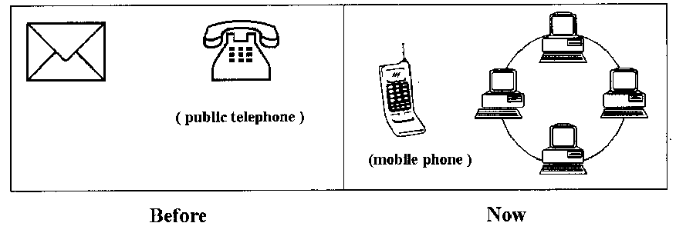

2006年广东高考英语真题参考答案

ⅰ. 听力 ( 略)
ⅱ．单项填空
21-25 abbda 26-30 adcac 31-35 dcbbd
ⅲ．完形填空
36- 40 cbbaa 41-45 cdadc 46-50 cdcba 51-55 cdaca
ⅳ．阅读理解
56-60 cacbc 61-65 acbab 66-70 abbcb 71-75 cabab
v．短文改错
76. pay后加 for 77. till → if 78. comfortable → comfortably 79. they → he 80.that → as /like 81. 去掉the 82. therefore→ however 83. better → good 84. 去掉to 85. √
ⅵ．书面表达
1
People used to communicate with each other through letters and public phones. but nowadays they use mobile phones and the internet instead. This change in communication has good effects on our life and work. Compared with letters and public phones, mobile phones and the internet are faster and much more convenient. if you miss your grandmother, you just take out your phone and say "hello" to her. if you want to place an order with a foreign company, you can e-mail the message, it’ll be a matter of minutes before you get their reply. Aren’t we living in a smaller world? (101words)
2
More and more people rely on email and mobile phones for communication rather than letters and public phones because the new tools seem faster and make work more efficient. however this change has bad as well as good effects, especially dependence on the internet. Firstly, as we lack enough practice, we are losing the beauty of hand-written Chinese words which express the writer better while machine words all have the same looks., secondly, our spelling becomes worse if we rely on the machine too much. last but not least, the pc screen does harm to our eyes. i prefer the old way of communication even though it is much too slow in the eyes of many.（116words）

