2006年湖南高考英语真题及答案

第一部分：听力（共三节，满分３０分）
做听力部分时，请先在试题卷上作答。听力部分结束前，你将有两分钟的时间将第１至第１７小题的答案转涂到答题卡上，将第１８至第２０小题的答案转写到答题卡上。
第一节（共５小题；每小题１．５分，满分７．５分）
听下面５段对话。每段对话后有一个小题，从题中所给的A、B、C三个选项中选出最佳选项，并标在试题卷的相应位置。听完每段对话后，你都有１０秒钟的时间来回答有关小题和阅读下一小题。每段对话仅读一遍。
例：How much is the shirt?
A.￡19.15. B.￡9.15. C.￡9.18.
答案是B。
1.Where will the man go for holiday?
A.France. B.Egypt. C.Austna.
2.Why did the man make the phone call?
A.His luggage was lost. B.His plane was late C.His office was looked
3.How much is a two-term course?
A.550 B.590 C.5120
4.What does the man mean?
A.He will not cook dinner. B.He isn’t good at cooking fish.
C.He prefers not to cook the fish.
5.When will the man probably nget to London?
A.At 8 o’clock. B.At 9 o’clock. C.At 10 o’clock.
第二节（共１２小题；每小题1.5分，满分18分）
听下面4段对话。每段对话后有几个小题，从题中所给的A、B、C三个选项中选出最佳选项。并标在试题卷的相应位置。听每段对话前，你将有时间阅读各个小题，每小题5秒钟；听完后，各小题将给出5秒钟的作答时间。每段对话读两遍。
听下面一段对话，回答第6和第7两个小题。
6.What can we learn from the dialogue?
A.The woman was badly hurt.
B.The car was tembly damaged.
C.The kids were seriously injured.
7.What was the woman thinking about?
A.Gotting the car repaired.
B.Selling the damaged car.
C.Buying a second-hand car.
听下面一段对话，回答第8至第10三个小题。
8.What do we know about the man?
A.He wrote three essays last week.
B.He went to the beach wath friends.
C.He drank late at a restaurant every night.
9.What did the woman do on Saturday?
A.She drove with a friend. B.She watched movies.
C.She played tennis.
10.Which word can best describe the woman last week?
A.Quet. B.Enioyable. C.Un table.
听下面一段对话，回答第11至第13三个小题。
11.On which day are the ticket ailable to the man?
A.October 3. B.October 4. C.October 5.
12.How much will the man pay if be book the ticket?
A.￡35. B.￡936. C.￡37.
13.What can be inferred about the man?
A.He was angry with the wman.
B.He thought the price was reasonable.
C.He gave up the idea of booking the ticket.
听下面一段对话，回答第14至第17四个小题。
14.What is the relationship between the two speakers?
A.Writer and reader. B.Teacher and student.
C.Intervicwer and interviewee.
15.How long did it take Tina to write the story?
A.A whole day. B.About two hours. C.Ninety minutes.
16.What do we know about the story?
A.It’s about Fred. B.It’s about a party. C.It’s about success.
17.What can we learn about Tina?
A.She has just been back from abroad..
B.She had a party for everyone in her street.
C.She won a writing competition unoapeetedly.
第三节（共３小题；每小题１．５分，满分4.5分）
听下面一段材料，将第18至第20三个小题的信息补充完整。每小题不超过三个单词。听材料前，你将有时间阅各个小题，每小题5秒钟，听完后，各小题将给出15秒钟的作答时间。本段材料读两遍。

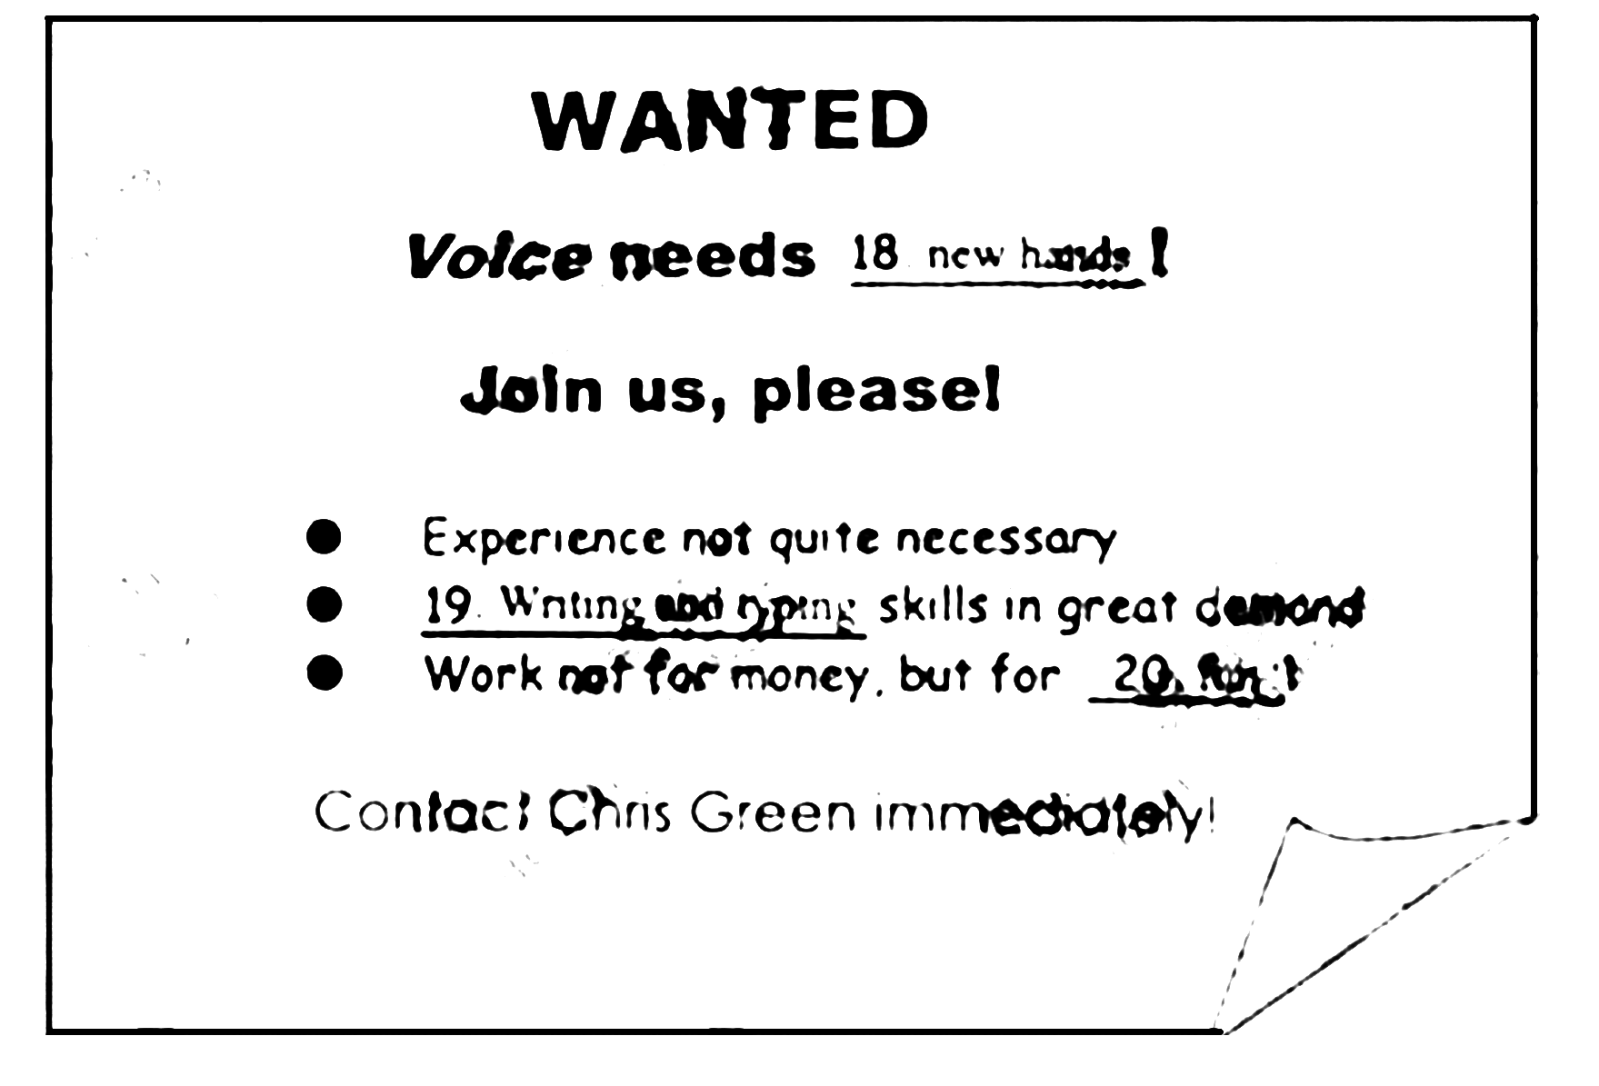
第二部分：英语知识运用（共两节，满分４５分）
第一节 单词填空（共１５小题；每小题１分，满分１５分）
从A、B、C、D四个选项中，选出可以填入空白处的最佳选项，并在答题卡上将该项涂黑。
例：It is generally considered unwise to give a child__________ he or she wants.
A.however B.whatever C.whichever D.whenever
答案是B

21.The wild flowers looked like a soft orange blanket__________ the desert.
A.covering B.coverod C.cover D.to cover
22.In___________ review off 44 studies,American researchers found that men and women who ate six key foods daily cut the risk of___________heart disease by 76%.
A.a; the B.the;a C.a;不填 D.不填;a
23.A man cannot smile like a child,_________a child smiles with is eyes,while a man smiles with his lips alone.
A.so B.but C.and D.for
24.I was giving a talk to a targe group of people,the same talk I __________to half a dozen other groups.
A.was giving B.am giving C.had given D.have given
25.Fred,who had expected how it would go with his daughter,had a great worry________his mind.
A.on B.in C.with D.at
26.As the busiest woman in Norton,she made_________her duty to look after all the other people’s affairs in that town.
A.this B.that C.one D.it
27.________achievement,last week’s ministerial meeting of the WTO here camed a low,though not failing ,grade.
A.In terms of B.In ease of B.As a result of D.In face of
28.If you think that treating a woman well means always_______her permission for things,think again.
A.gets B.got C.to get D.gutting
29.Although she did not know Boston well,she made her way________ to the Home Cirele Building.
A.easy enough B.enough easy C.easily enough D.enough easily
30.We saw several natives advancing towards our party,and one of them came up to us.________we gave ome bells and glasses.
A.to which B.to whom C.with whom D.with which
31.I had just stepred out of the bathroom and was busily drying myself with a towel_________I heard the steps.
A.while B.when C.since D.after
32.Some aspeets of a pilot’s job__________be boring,and prilots often____________work at inconvenient hours.
A.can;have to B.may;can C.have to;may D.ought to;must
33. As the twentieth century came to a close ,the raw matenals for a great nstional literature were at hand,waiting___________.
A.to use B.to be used C.to have used D.to be using
34.With his work completed,the businessman stepped back to his seat,feeling pleased________be was a man of action.
A.which B.that C.what D.whether
35.In a room above the store,where a party__________,some workers were busily seeting the table.
A.was to be held B.has been held C.will be held D.is being held
第二节 完型填空（共20小题;每小题1.5分，满分30分）
阅读下面短文，掌握其大意，然后从36~55各题所给的四个选项(A、B、C、D)中，选出最佳选项，并在答题卡上将该项涂黑。
I returned to Abujs,the capital of Nigerin,after college gradvation.I had been there before my mother became a minister.
Two weeks Inter.I told my mother I was bored.She said.“Here’re the car keys.Go and buy some fruit.” 36 ,I jurnped into the car and speeded off.
Seeing me or rather my 37 ,a boy sprang up(跳起来). 38 to sell his banan is and peanuts.“Banana 300 naira.Peanut 200 naira!”
Looking at his bbinck-striped bananas,I 39 to 200 total for the fruit and nuts.
He 40 .I handed him a 500 naira note.He didn’t have 41 .So I told him not to worry.He was 42 and smiled a row of petfect teeth.
When.two weeks later.I 43 this same boy.I was more aware of my position in Nigerian soeicty.I should 44 this country as the son of a 45 .But it was hard to find pleasure in a place where it was so 46 to see a little boy who should have been in school selling frust.
“What’s up?”I asked.He answered in 47 English,“I…I no get money to buy book.”I took out two 500 naira notes.He looked around 48 before sticking his hand into the car 49 the bills.One thousand naira means a lot to a farnily that 50 only 50,000 cach year.
The next morning,security officers told me,“In this place,when you give a little,people think you’re a fountain of opportunity(机会).”
51 it’s right,but this happens everywhere in the world.I wondered if my little friend had actually used the money for 52 .
After six months’work in northern Nigeria,I returned and saw him again standing on the road.
“Are you in school now?”
He nodded.
A silence fell as we looked at each other,then I 53 what he wanted.I held out a 500 naira note.“Take this.”
He shook his head fiercely and stepped back 54 hurt.
“It’s a gift.”I said.
Shaking his head again,he handed me a basket of bananas and peanuts,“I’ve been waiting to 55 these to you.”
36.A.Encouraged B.Disappointed C.Delighted D.Confused
37.A.car B.mother C.drivet D.keys
38.A.willing B.afraid C.cager D.ashamed
39.A.got down B.bargained down C.put down D.look down
40.A.explained B.promised C.agreed D.admitted
41.A.change B.notes C.checks D.bills
42.A.troubled B.regretful C.comfortable D.graleful
43.A.ran after B.ran into C.ran over D.ran to
44.A.proteet B.enjoy C.help D.support
45.A.minister B.headmaster C.manager D.president
46.A.lucky B.amazing C.funny D.common
47.A.old B.broken C.traditional D.modern
48.A.proudly B.madly C.cunously D.nervously
49.A.for B.with C.at D.upon
50.A.spends B.pays C.makes D.affords
51.A.Possibly B.Actually C.Certainly D.Fortunately
52.A.joys B.nuts C.books D.bananas
53.A.asked B.unagined C.reminded D.realized
54.A.when B.as if C.even if D.after
55.A.send B.provide C.sell D.give
第三部分：阅读理解（共20小题；每小题２分，满分40分）
阅读下列短文，从每题所给的四个选项(A、B、C、D)中，选出最佳选项，并在答题卡上将该项涂黑。
A
A NATIONWIDE BESTSELLER
It’s likely that everything you learned about.America’s ancient history is wrong.
The new book,1491,completely changes our understanding of the Amerieas before the arrival of Columbus in 1492.
DID YOU KNOW?
When Columbus landed there were probably more people in the Americas than there were in Europe.
The peoples of North America had such healthy life-styles that as late as the 19th century they continued to be the tallest people on earth.
Facts have shown that the Amenicas were populated as long as 33,000 years ago.
4,000 years ago Mesoamerican famers developed com in a feat (技艺) of genetie engineering that still isn’t completely understood.
COMMENTS ON 1491
“In the tradition of Jared Diamond & John MePhee,a totally new view of precolunhian America”.
－Richard Rhodes
“Attrnctively written and really absorbing Charles C.Mann has produced a book that’s part detective story,part cpie(史诗) and part tragedy(不幸).He has taken on a vast topic:thousands of years,two huge continents,and cultures.”
－Charles Matthews,San Jese Mercary News
“Powerful and challenging”
－Alan Taylor,Washingto post

“A pleasure to read as well as a wonderful education”
－Howard Zinn

56.On the whole,1491 is a book mainly about America’s________.
A.life-styles B.population C.history D.agrieulture
57.Which of the following as NOT TRUE about the comments on the book 1491?
A. It is interesting and instructive.
B. It is attractive and culturally related.
C. It is challenging and revolutionary.
D. It is hurnorous and persuasive.
58.From this passage,we can learn_________.
A.people settled in the Amencas a little carlier than 1942
B.North Americans were the tallest in the 18th cenntry in the world
C.Mesoamencan farmers knew genclic engineering 5,000 years ago
D.the population in the Americas was smaller than that in Europe in 1492
B
For the first time in modern history,less than half of the U.S.adult population now reads literature,according to a recent survey.Reading at Risk A Survey of Lilerary Reading in America presents a detailed review of the decline of reading’s role in the nation’s culture.
Reading at Risk is a survey of national fashion in adult literary reading.The data souree for Reading at Risk is as reliable and objective(客观的)as any such survey can be.The key results of the survey are presented in the “Surnmary”,but the report can be further exploined as:literary teading in America is not only declining rapidly among all groups,but the rate of decling has been speeded up,especially among the young.Rcading at Risk merely shows a great cultural change that most Americans have already noted－our society’s great turn to clectronic media for entertainment and information.
Reading a book requires a degree of active attention and devotion.Indced,reading itself is a progressive skillo that depends on years of cducation nand practice.On the contrary,most electronic media such as television,recordings,and radio make fewer demands on their audiences,and indced require no more than passive participation.While oral culture has a rich reality and electronic media offer the commdenbic atteation of variety.print culture affords irreplaceable forms of focused and thought than make varicen communications and views possible.The deline in reading.thenfore ,equals a larger retreat(减少)from participation in public and culutural life.
● What is to be done?There is surely no single solution to the pretent problem.just as there is no single cause .The important thing now is to underwand that America can no longer take active and devoted reading for granted.
● Reading is not a timeless,common ability.As more Americans love thus ability .out nation becomes less informed,active ,and independent minded .There are not speakeras that a free, inventive,or productive society can afford to love.
● 59.The main purpose of the survey is to _______.
● A.focus on the role of electronic media ang reading
● B.show that American young people read less and less
● C.give a report of the national of literary reading
● D.review that less that half of the population now reads litersture
● 60.According to the passage ,reading _______.
● A.requires less attention and devotion
● B.demsnds no more than passive participation
● C.limits various communications and views
● D.means active participation in pubnlic and cultural life
● 61.The underlined phrase “cultural chang”in Paragraph 2 refers to the change _______.
● A.from oral culture to electronic media
● B.from print culture to electronic to electronic media
● C.from electronic media to oral
● D.from electr onic media to print culture
● 62.The author of the passage ________.
● A.misunderstands oral culture
● B.doubts the Americans to read more
● C.encourages the Americans to read more
● D.agrees to the solution to present problem in reading
● C
● The coyote(丛林狼).that elever animal of wide-open space .has come to the nation’s captial.In fact ,coyotes have spread to every comer of the United States,changing their behaviors to fit new envioronments and causing researchers to deal with a troublesome new kind of creature:the city coyote.
The coyote originally lived in the middle of the continent.One of its most obvious characters is its smartness, which has made the animal a notorious（臭名昭著的） pest.Hunters trapped,shot and poisoned more than a million coyotes in the 1900s.It’s still one of America’s mosthunted animals. Yet the coyote has survived.How has the coyote shown this extraordinary ability?”I guess if you wanted to use one word,it’d be ‘plasticity’.”says Erie Gese,an expert at Utah State University. Coyotes can live alon, in pairs, or in large packs like wolves,hunt at night or during the day , occupy a small region or an area up to 40 square miles,and live on all sorts of food,from lizards（蜥蜴）and shoes, to ants and melons.
Unbelicvadly people helpcd coyotes increase when they kiltcd most of the wolves in the United States. The sprcdding of coyotes into city areas,though.is rccent.They travel at night,crossing sidcwalks and bridges.running atong roads and ducking into cuinerts (钻入 洞and underpasscs .No one knows why coyotes are maving into cities.but expertsexplaih that clevcter,more human-tolerant(不怕人的)coyotes are teaching urban survivalskills to new generations.
Occasionally.coyotes mighe attack human beings.There have been about 160 attacks on peoplc in reccnt years Therefore,people have bccn consistently told not feed coyotes or leave pct food unseeurcd.That ,plus a large trapping program in the neighborhood.has cur down on the coyote population.
63.The underlinged word “plasticity”in Paragraph 2refers to____________.
A.the ability to fit the environment B.notonous smartness
C.hunting ability D.being human-tolerant ［A］
64.The aim of the passage is to_____________.
A.tell pcople how to fight against coyotes
B.tell us why the coyote is the most hunted animal
C.supply the reason why the coyote is a kind of motorious pest
D.explain how the coyote has spread to and survived in cities ［D］
65.According to the passage,coyote__________.
A.originally lived in the west of the continent
B.sleep dung the day but look for food at night
C.are teaching survival skills to therr younger generations
D.suffered a population deerease because pcople killed wolves ［C］
66.According to the passage,to cut dowa on the coyolc population.people are advised to_______.
A.leave pct food secured B.keep coyotes in small regions
C.foree coyotes to live alone D.avond using trapping programs ［A］

D
The discovery of a dwarfed (矮个的)”human being” who lived in Flores .Indonesin .up to 18,000 years ago is changing the way we think about the human family .This “Flores Human”was three foot tall and her brain was smaller than that lf the average chimp (黑猩猩).yet she and her relatives apparently lived fully human lives .They seem to have made tools ,worked together to find food and cook it,and perhaps even hurried their dead with ceremony.
It was a major surprise to find tools associated with the new human family member .The tools are like those frmmerly seen only with European fossils (化石)from our own species;Homo sapiens (智人)；and the oldest of them were made 94,000years ago .Homo sapiens is thought to have amved in the island about 40,000 years ago ,much too late to be responsible for the tools .If this tiny human made the tools ,them the inside structure (结构)of its brain must have been more like our own than a chimp’s ,despite being just a third the size of ours.
This “new human” was suspected to be a dwarfed ranch of Homo erectus (直立人)。When creatures are separated in regions with rare resources but few enemies,being big is a disadvantage, and evolution tends to shrink them, aprocess known as island dwarfing.Could natural selection make a human smaller while keeping----even improving----mental ability ?Quite possibly, believes Christopher Wills of the University of California.
Has the “Flores Human” even shown the ability of language? “I find it difficult to imagine that people could make tools.use fire ,and kill large animals without fairly advanced communication.” Wills says .Did “Flores Human” possess the basic components of human culture ---such as the burying of the dead with ceremony ? Emiliano Bruner of the Italian Institute points out that Indonesia’s hot,wet environment is bad for fossilization.It is reasonable to assume ,he says ,that the 18,000-year-old bones of the most complete Flores woman were well-preserved because she was buried with special care.
67.According to the passage , “Flores Human”______.
A. lived a partly human life
B. was a branch of Homo sapiens
C. used tools before Homo sapiens arrived
D. had a brain as a common chimp’s [C]
68.The underlined part “this tiny human”in Paragraph 2 refers to _______.
A.a chimp . B.Flores Human
C.C.Homo sapiens D.Homo sapiens [B]

69.This passage mainly talks about______.
A. the tools made by “Flores Human”
B. the language used by “Flores Human”
C. the evolution of “Flores Human”
D.the major surprising findings about “Flores Human” [D]
70.According to the passage ,it is believed that “Flores Human”_______.
A. was dwarfed by its enemies
B.could use language
C.left a lot of fossils in hot and wet enviroment
D.reached Flores 40,000 years ago [B]

E
Susan Sontag (1933----2004)was one of the most noticeable figures in the world of literature.For more than 40 years she made it morally necessary to know everything---to read every book worth reading ,to see every movie worth seeing .When she was still in her early 30s,publishing essays in such important magazines as Partisan Review, she appeared as the symbol of American culture life ,trying hard to follow every new development in literature, film and art .With great effort and serious judgement. Sontag walked at the latest edges of world culture.
Seriousness was one of Sontage’s lifelong watchwords(格言).but at a time when the barriers between the well-educated and the poor-educated were obvious,she argued for a true openness to the pleasure of pop culture.In “Notes Camp”,the 1964 essay that first made her name ,she explained what was then a little-known set of difficult understandings,
through which she could not have been more famous .“Notes on Camp”,she wrote,represents“a victory of ‘form’over‘content’,‘beauty’over‘morals’”.
By conviction（信念）she was a sensualist（感觉论者）, but by nature she was a moralist （伦理学者）,and in the works she published in the 1970s and 1980s , it was the latter side of her that came forward. In illness as Metaphor —published in 1978, after she suffered cancer—she argued against the idea that cancer was somehow a special problem of repressed personalities（被压抑的性格）, a concept that effectively blamed the victim for the disease. In fact , re-examining old positions was her lifelong lifelong habit.
In America,her story of a 19th century Polish actress who set up a perfect society in California, won the National Book Award in 2000.But it was as a tirelessm all-purposer cultural view that she made her lasting fame.“Sometimes,”she once said ,“I feel that, in the end, all I am really defending …is the idea of seriousness, of true seriousness.”And in the end ,she made us take it seriously too.
71.The underlined sentence in paragraph 1 means Sontag_________.
A. was a symbol of American cultural life
B. developed world literature,film and art
C. published many essays about world culture
D. kept pace with the newst development of world culture
72.She first won her name through ___________.
A. her story of a Polish actress
B. her book illness as Metaphor
C. publishing essays in magazines like partisan Review
D. her explanation of a set of difficult understankings
73.According to the passage,Susan Sontag__________.
A. was a sensualist as well as a moralist
B. looked down upon the pop culture
C. thought content was more important than form
D. blamed the victim of cancer for being repressed
74.As for Susan Sontag’s lifelong habit , she __________.
A. misunderstood the idea of seriousness
B. re-examined old positions
C. argued for an openess to pop culture
D. preferred morals to beauty
75.Susan Sontag’s lasting fame was made upon___________-.
A.a tireless, all-purpose cultural view
B.her lifelong watchword ：seriousness
C.publishing books on morals
D.enjoying books worth reading and movies worth seeing
第四部分：书面表达（共两节，满分10分）
第一节 填空（共10小题：每小题1分，满分10分）
阅读短文，根据所读内容在文后76~85的空格里填上适当的单词或短语，并将答案转席写到答题卡上。
注意：每空不超过3个单词。
Puality after-school programs are designed to improve academic performance,decrease youth crimes and other high-risk be4haviors,and help young people grow into healthy,successful adulis.
The effect of quality after-school programs on academic performance is clear.Studies show that students who take part in such programs show better woek habits,higher rates of homework completion ,improved grades , and higher scores on achievement tests.They also have fewer absences and are liss likely to blame.After-school progrome also influemce high-risk teen behavior.Various studies show decreased rates of crime ,drug use ,and teen sex among youth who join in well-run after-school proframs when compared to similar youth who do not .Finally ,after-school p0rograms play sn important role in supporting the following fields of development,mental development and social development.Thus , one can safely say that after-school programming is an effective method to help young people become contributing members of society.
Although there is enough proof from both smsll and large assessments that after-school programs can make a positive difference,it is important to note that not all programs are equal .First ,dosage（时量）matters —young people who attend the most hours over the most years benefit more than members who attend less often or over a shorter period of time.Next ,after-school programs make a bigger difference for those students who need help most and have the fewest choices.Finally,program qualities mattir .After-school programs work best when they create uneqque opportunities for youth.They should provide opportunities ,skill building meanignful involvement（参与）,expression suggestion,service,and work.Staff characteristics make an important difference in the quality of a program.The adults should treat youth as partners ,create safe and fair environment,encourage personalized（个性化的）involvement,and actively create learning opportunities.In short, although after-school programs have promising future,how they are designed and tun matters.

Title 76.QualityAfter-school Program
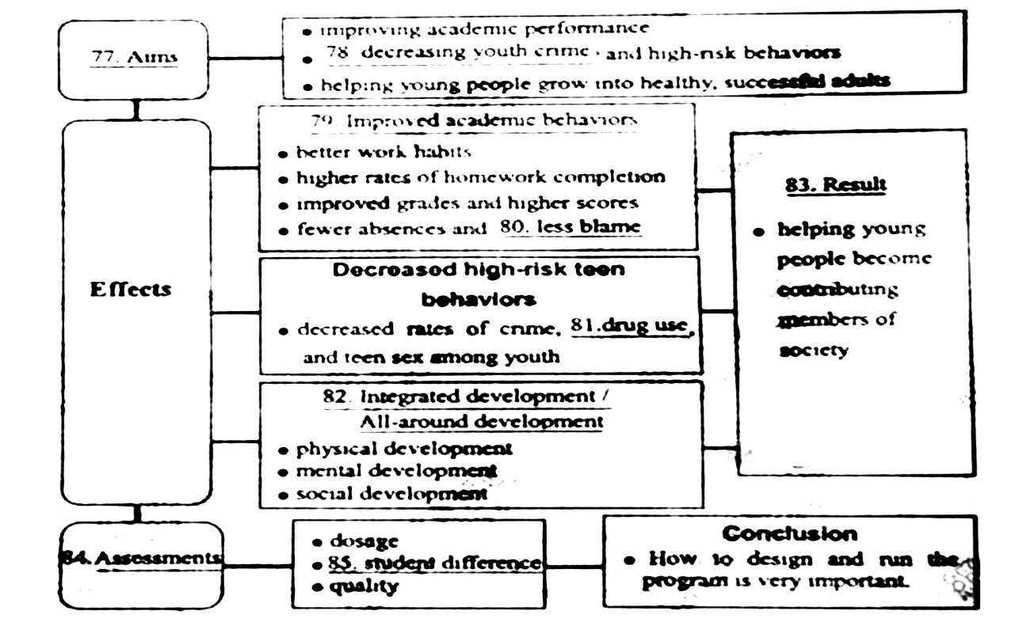
第二节 写作（满分25分）
请根据下面的英文短诗，展开适当的想象，写一篇短文。
标题为：My Teacher Mr Moore
There’s a teacher Mr .Moore.
Who is lovely and therty-four.
Always dncouraging us to try.
He leads us to a world of“why”.
We all admire him more and more.
注意：
1． 不得照抄短诗原文。
2． 必须结合短诗的内容，发挥想象，适当展开。
3． 必须突出短诗的主题，结构完整，语意连贯。
4． 短文不能写成诗歌形式。
5． 词数：120左右。

2006年湖南高考英语真题参考答案

1—5：AABCB 6—10：BCAAB 11—15：ABCCB
16—17：CC 18：new hands 19:Writing and typing 20:fun
21—25：ACDCA 26—30：DADCB 31—35：BABBA
36—40：CACBC 41—45：ADBBA 46—50：DBDAC
51—55：ACDBD
56—58：CDB 59—62：CDBC
63—66：ADCA 67—70：CBDB
71—75：DDABA

One possible version：
Of all my teachers,Mr. Moore is the one who impresses me most.,Though he is 34,he looks very young for hes age.And he’s one of the most popular teachers in our school.
Compared with other teachers ,Mr.Moore pays more attention to his way of tenching .He tries various ways to make his classes lively and interesting .In his opinion,we should not only know “what”, but also understand “why”.So ,instead of giving us answers immediately ,he encourage us to thenk by ourselves whenever he puts forward questions.With his help.we’ve learned how to analyze and settle problem.What a wonderful world of “why”he leads us to!
He is such a learned person that we all admire him very much.

