第Ⅰ卷（选择题 共50分）
第一部分 听力 （共两节，满分30分）
回答听力部分时，请先将答案标在试卷上。听力部分结束前，你将有两分钟的时间将您的答案转涂到客观答题卡上。
第一节（共5小题：每小题1.5分，满分7.5分）
听下面5段对话，每段对话后有一个小题，从题中所给的A、B、C三个选项选出最佳选项，并标在试卷的相应位置，听完每段对话后，你都有10秒钟的时间来回答有关小题和阅读下小题，每段对话仅读一遍。
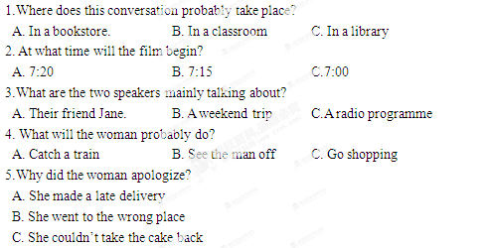
第二节（共15小题：每小题1.5分，满分22.5分）
听下面5段对话。每段对话有几个小题，从题中所给的A、B、C三个选项中选出的最佳选项，并标在试卷的相应位置。听每段对话前，你将有时间阅读各个小题，每小题5秒钟；听完后，各小题给出5秒钟的做答时间。每段对话读两遍。
听第6段材料，回答第6、7题。
6.Whose CD is broken?
A.Kathy’s B. Mum’s C. Jack’s
7.What dose the boy promise to do for the girl?
A. Buy her new CD. B. Do some cleaning. C. Give her 10 dollars.
听第7段材料，回答第8、9题。
8.What did the man think of the meal?
A. Just so-so. B. Quite satisfactory C.A bit disappointing.
9. What was the 15% on the bill paid for ?
A. The food B. The drinks C. The service.
听第8段材料，回答第10至12题。
10. Why is the man at the shop?
A. To order a camera for his wife.
B. To have a camera repaired.
C. To get camera changed.
11.What colour does the man want?
A. Pink. B.Black C.Orange.
12.What will the man do afterwards?
A. Make a phone call.
B. Wait until further notice.
C. Come again the next day.
听第9段材料，回答第13至16题。
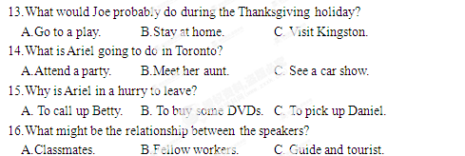
听第10段材料，回答每17至20题。
17.Where does Thomas Manning work?
A. In the Guinness Company.
B. At a radio station.
C. In a museum.
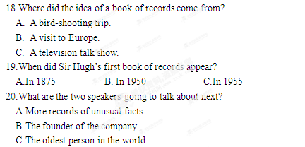
第二部分 英语知识运用（共两节，满分45分）
- 单项填空（共15小题；每小题1分，满分15分）
21.Carl is studying food science at college and hopes to open up meat processing factory of his own one day.
A. / ; a B. / ；the C. the; a D. the; the
22.—May I help you? You seem to be having some problems.
— , thanks. I think I can manage.
A. All right B. No problem C. It’s all right D. There’s no way
23.Interest is as to learning as the ability to understand, even more so.
A. vital B. available C. specific D. similar
24.I remembered the door before I left the office, but forgot to turn off the lights.
A. locking B. to lock C. having locked D. to have locked
25.You can change your job, you can move house, but friendship is meant to be life.
A. of B. on C. to D. for
26.In order to find the missing child, villagers all they can over the past five hours.
A. did B. do C. had done D. have been doing
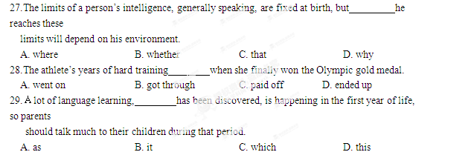30.When for his views about his teaching job, Philip said he found it very interesting and rewarding.
A. asking B. asked C. having asked D. to be asked
31.Grace doesn’t want to move to New York because she thinks if she there, she wouldn’t be able to see her parents very often.
A. lives B. would live C. has lived D. were to live
32.—I love the Internet. I’ve come to know many friends on the Net.
— . Few of them would become your real friends.
A. That’s for sure B. It’s not the case
C. I couldn’t agree more D. I’m pleased to know that
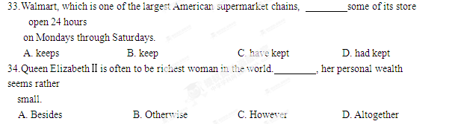35. After school we went to the reading-room to do some reading, only to be told that it .
A. was decorated B. had decorated C. had been decorating D. was being decorated [来源:学§科§网]
第二节 完形填空（共20小题；每小题1.5分，满分30分）
阅读下面短文，从短文后各题所给的四个选项（A、B、C、D）中，选出可以填入空白处的最佳选项，并在答题卡上将该项涂黑。
When I settled in Chicago, my new city seemed so big and unfriendly. Then I had a 36 problem and had to go to hospital for a 37 examination.
It seemed a small 38 compared to the one I was about to face ,but things started to go 39 right from the beginning.Not having a car or 40 the city, I was depending on a couple of buses to get me from A to B. 41 I’d left myself plenty of time, soon it was 42 I was going to be late, as I had mistakenly boarded a bus that was taking me in the 43 direction.
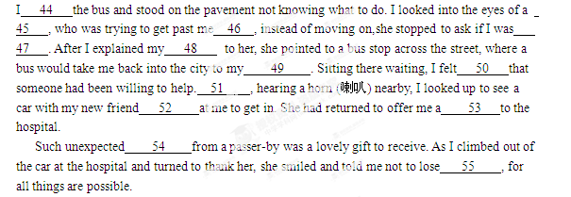36. A. physical B. traveling C. social D. housing
37. A. scientific B. final C. previous D. thorough
38. A. chance B. challenge C. success D. error
39. A. wrong B. easy C. fast D. ahead
40. A. leaving B. visiting C. knowing D. appreciating
41. A. Although B. Since C. Unless D. Once
42. A. strange B. necessary C. obvious D. important
43. A. same B. right C. general D. opposite
44. A. looked at B. waited for C. got off D. ran into
45. A. driver B. friend C. stranger D. gentleman
46. A. Especially B. Surprisingly C. Probably D. Normally
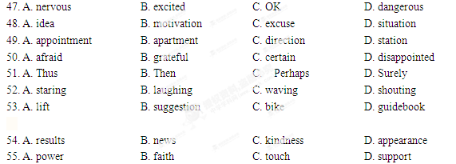第三部分 阅读理解（共20小题；每小题2分，满分40分）
阅读下列短文，从每题所给的四个选项（A、B、C、D）中，选出最佳选项，并在答r题卡上将该项涂黑。
A
Welcome to one of the largest collections of footwear（鞋类）in the world that will make you green with envy. Here at the Footwear Museum you can see exhibits（展品）from all over the world. You can find out about shoes worn by everyone from the Ancient Egyptians to pop stars.
Room 1  The celebrity（名人）footwear section is probably the most popular in the entire museum. Stared in the 1950s there is a wide variety of shoes and boots belonging to everyone from queens and presidents to pop stars and actors! Most visitors find the celebrities’ choice of footwear extremely interesting. | Room 2  Most of our visitors are amazed  —and shocked— by the collection of “special purpose”shoes on exhibition here at the Museum of Footwear. For example, there are Chinese shoes made of silk, that were worn by women to tie their feet firmly to prevent them from growing too much!
Room 3  As well as shoes and boots the museum also exhibits shoe-shaped objects. The variety is unbelievable. For example, there is a metal lamp that resembles a pair of shoes, and Greek wine bottles that like legs! | The footwear Library  People come from all over the world to study in our excellent footwear library. Designers and researchers come here to look up information on anything and everything related to the subject of footwear.
56. Where would you find a famous singer’s shoes?
A. Room1. B. Room 2.
C. Room3. D. The Footwear Library
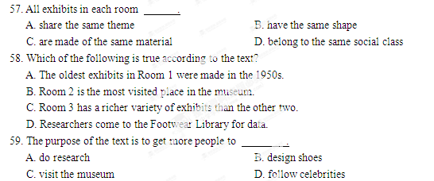B
Why is pink or purple a color for girls and blue or brown for boys?
The answer depends largely on cultural values as well as personal experiences. To the Egyptians, green was a color that represented the hope and joy of spring, while for Muslims, it means heaven. Red is a symbol of good luck in many cultures. In China, children are given money in a red envelope to bring good fortune in the New Year. For many nations, blue is a symbol of protection and religious beliefs. Greek people often wear a blue necklace hoping to protect themselves against evils（灾祸）.
People’s choice of colors is also influenced by their bodies’ reactions （反应）toward them. Green is said to be the most restful color. It has the ability to reduce pain and relax people both mentally and physically. People who work in green environment have been found to have fewer stomach aches.
Red can cause a person’s blood pressure to rise and increase people’s appetites（食欲）. Many decorators will include different shades of red in the restaurant. Similarly, many commercial websites will have a red “Buy Now” button because red is a color that easily catches a person’s eye.
Blue is another calming color. Unlike red, blue can cause people to lose appetite. So if you want to eat less, some suggest that eating from blue plates can help.
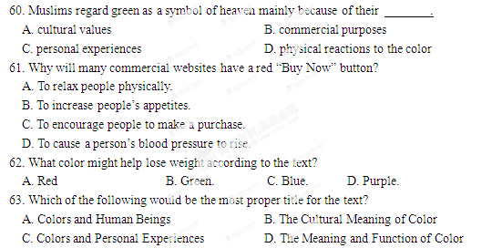
The next time you are deciding on what to wear or what color to decorate your room, think about the color carefully.
C
When Frida Kahlo’s paintings were on show in London, a poet described her paintings as “ a ribbon （丝带）around a bomb”. Such comments seem to suggest Kahlo had a big influence on the art world of her time. Sadly, she is actually a much bigger name today than she was during her time.
Born in 1907 in a village near Mexico City , Kahlo suffered from polio（小儿麻痹症）at the age of seven. Her spine（脊柱）become bent as she grew older. Then, in 1925, her back was broken in several places in a school-bus accident. Throughout the rest of her life, the artist had many operations, but noting was able to cure the terrible pain in her back. However, the accident had an unexpected side effect. While lying in her bed recovering, Kahlo taught herself to paint.
In 1929, she got married to Diego Rivera, another famous Mexican artist. Rivera’s strong influences on Kahlo’s style can be seen in her early works, but her later works from the 1940s, known today as her best works, show less influence from her husband.
Unfortunately, her works did not attract much attention in the 1930s and1940s, even in her home country. Her first one-woman show in Mexico was not held until 1953.For more than a decade after her death in 1954, Kahlo’s works remained largely unnoticed by the world, but in the 1970s her works began to gain international fame at last.
64. What does the phrase “a much bigger name” in paragraph 1 most nearly mean?[来源:学.科.网]
A. a far better artist B. a for more gifted artist
C. a much stronger person D. a much more famous person
65. The terrible pain Kahlo suffered was caused by .
A. polio B. her bent spine
C. back injuries D. the operations she had
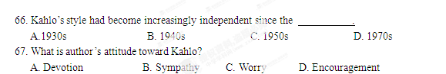
D
In Asia, there are special competitions where kites have complex designs and are fitted with instruments that make musical sounds as the wind blows through them. Although all kites have a similar structure （结构）, they are widely different in size and shape. Kite-fighting competitions are also held, in which competitions us their kites to attack and bring down their opponents’（对手）kites or cut their strings（线）.
For more than 15 years, the Big Wind Kite Factory has been giving kite-making and kite flying classes for the children on an island in Hawaii. In its kite-making lessons, students can make kites in as little as 20 minutes! Children as young as four years old can learn how to fly a kite. Jonathan Socher and his wife Daphne started the kite factory in 1980. Their kites are made of nylon（尼龙）.Their designs are Hawaiian themes created by Daphne. The designs are cut out of the nylon with a hot knife that seals the edges and then fastened directly onto the kite.
The kite that is used to give lessons is a regular diamond kite with a rainbow pattern. The difference between this kite and the ones they make during the lessons is that it is a two-string controllable kite. Big Wind employees fly the kite and for a few minutes show students how pulling on one line and then on the other controls the direction the kite goes in. Then the controls are given to the students.
Jonathan insists that it is not necessary to make a huge impressive kite to have fun making and flying kites. Even the simplest structure can work, and can give hours of fun. Go on, give it a try!
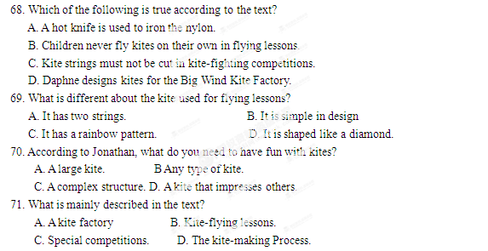
E
Welcome to your future life!
You get up in the morning and look into the mirror. Your face is firm and young-looking. In 2035, medical technology is better than ever. Many people your age could live to be 150, so at 40, you’re not old at all. And your parents just had an anti-aging(抗衰老的) treatment. Now, all three of look the same age!
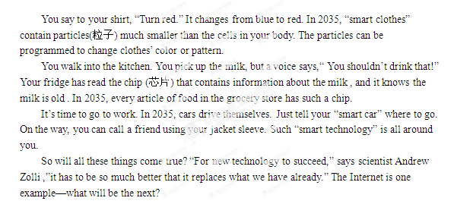
72. We can learn from the text that in the future__________.[来源:学科网ZXXK]
A .people will never get old B. everyone will look the same
C. red will be the most popular color D. clothes will be able to change their pattern
73. What can be inferred from Paragraph 4?
A. Milk will be harmful to health.
B. More drinks will be available for sale.
C. Food in the grocery store will carry electronic information.
D. Milk in the grocery store will stay fresh much longer.
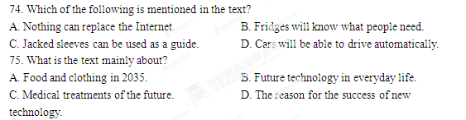2012年普通高等学校招生全国统一考试（安徽卷）
英语
第II 卷
考生注意事项：
请用0.5毫米黑色墨水签字笔在答题卡上作答，在 试题卷上答题无效。
第四部分 写作（共两节，满分35分）
- 任务型读写（共10小题；每小题1分，满分10分）
阅读下面短文，根据所读内容在表格中的空白处填入恰当的单词。
注意：每个空格只填一个单词。
Traveling to all corners of the world gets easier and easier. We live in a global village, but this doesn’t mean that we all behave in the same way.
How should we behave when you meet someone for the first time? An American shakes your hand firmly while looking you straight in the eye. In many part of Asia, there is no physical contact (接触)at all. In Japan, you should bow, and the more respect you want to show, the deeper you should bow. In Thailand, people greet each other by pressing both hands together at the chest. In both countries, eye contact is avoided as a sign of respect.
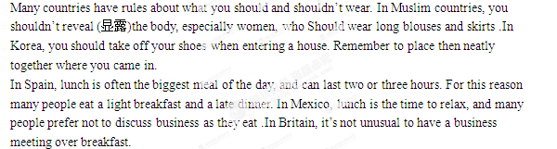In most countries, an exchange of business cards is necessary for all introductions. You should include your company name and your position. If you are going to a country where your language is not widely spoken, you can get the back side of your card printed in the local language. In China, you may present your card with the writing facing the person you are giving it to.
Title :good(76)
Aspect | Country | Custom
(77) | - America  - Japan  - Thailand | - Shaking hands firmly  - (78)_____to show respect  - Pressing both hands together at the chest
Dressing | - (79)________Countries  - Korea | - Wearing long blouses and skirts  - Taking off your shoes at the (80)___________
Eating | - Spain  - Mexico  - (82)___________ | - Having a light breakfast and a late dinner  - Relaxing while having (81)__________  - Holding a business meeting over breakfast
Doing  business | - Most countries  [来源:学科网]  - China | - Exchanging business cards when(83)_______yourself  - Presenting a card to a person (84)________it’s front facing him
Conclusion: When traveling (85) ________, we should follow local customs.
第二节 书面表达(满分25分)
假设美国某中学的学生明天来你校访问交流，主题是高中生对文，理科的选择。请你用英语写一篇发言稿，向他们介绍你所做的选择，并说明选择的理由。
注意： 1.开头和结尾已为你写好，不计入总词数；
2.词数120左右；
3.短文中不能出现与本人相关的信息。
参考词汇：文科 arts; 理科:science
Good afternoon, everyone.
Welcometo our school! ______________________________________________
_________________________________________________________________

Thanks！
[来源:学科网ZXXK]

