绝密★启用并使用完毕前
2012年普通高等学校招生全国统一考试（山东卷）
英 语（学生版）
本试卷分第I卷和第II卷两部分，共12页，满分150分。考试用时120分钟。考试结束后，将本试卷和答题卡一并交回。
注意事项:
- 答题前，考生务必用0.5毫米黑色签字笔将自己的姓名、座号、考生号、县区和科类填写在答题卡和试卷规定的位置上。
- 第I卷每小题选出答案后，用2B铅笔在答题卡上对应题目的答案标号涂黑，如需要改动，用橡皮擦干净后， 再选涂其他答案标号。
- 第II卷必须用0.5毫米黑色签字笔作答，答案必须写在答题卡各题目指定区域内相应的位置，不能写在试卷上；如需改动，先划掉原来的答案然后再写上新的答案；不能使用涂改液、脐带纸、修正带。不按以上要求作答的答案无效。
第I卷（共105分）
第一部分：听力（共两节，满分30分）
第一节（共5小题；每小题1.5分，满分7.5分）
听下面5段对话。每段对话后有一个小题，从题中所给的A、B、C三个选项中选出最佳选项，并标在试卷的相应位置。听完每段对话后，你都有10秒钟的时间来回答有关小题和阅读下一小题。每段对话仅读一遍。
例：How much is the shirt?
A. ￡19.5 B. ￡9.15 C. ￡9.18
答案是B。
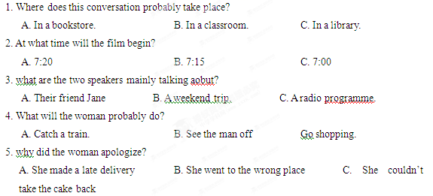

第二节（共15小题；每小题1.5分，满分22.5分）
听下面5段对话或独白。每段对话或独白后有几个小题，从题中所给的A、B、C三个选项中选出最佳选项，并标在试卷的相应位置。听每段对话或独白前，你将有时间阅读各个小题，每小题5秒钟；听完后，各小题将给出5秒钟的作答时间。每段对话读两遍。[来源:学。科。网]
听下面一段材料，回答第6和第7两个小题。
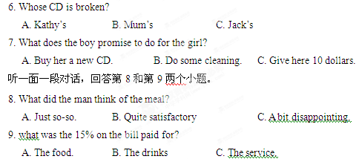
听一面一段对话，回答第10和第12三个小题。
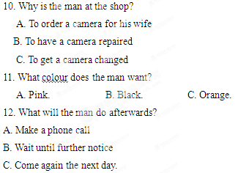
听一面一段对话，回答第13和第16两个小题。
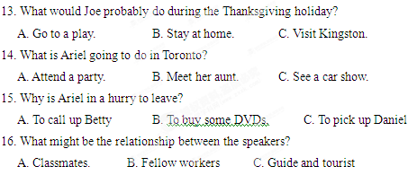
听一面一段对话，回答第17至第20四个小题。[来源:Z|xx|k.Com]
17. Where does Thomas Manning Work?
A. In the Guinness Company
B. At a radio station.
C. In a museum.
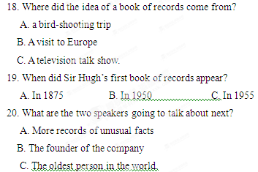
第二部分：英语知识运用（共两节,满分35分）
第一节 语法和词汇知识运用（共15小题；每小题1分，满分15分）
从A、B、C、D四个选项中，选出可以填入空白处的最佳选项，并在答题卡上将该项涂黑。
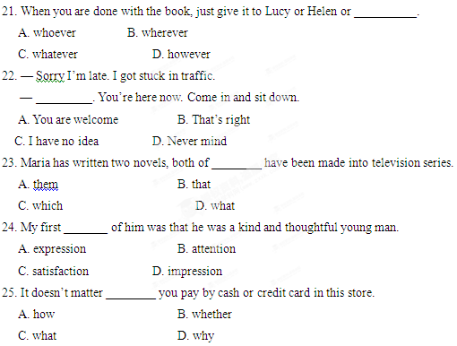
26. George returned after the war, only _______ that his wife had left him.
A. to be told B. telling
C. being told D. told
27. He smiled politely ______ Mary apologized for her drunken friends.
A. as B. if
C. unless D. though
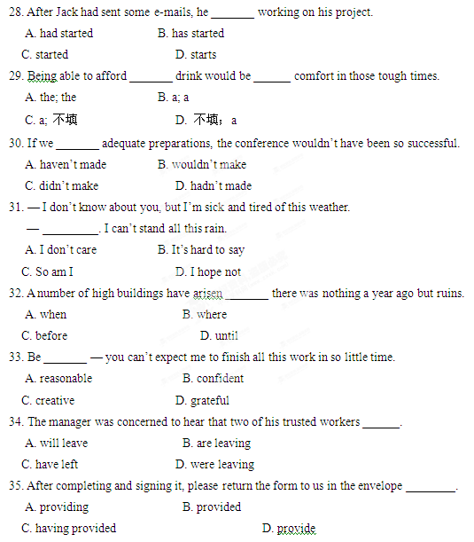
第二节：完形填空（共20小题；每小题1分，满分20分）
阅读下面短文，从短文后所给各题的四个选项（A、B、C和D）中，选出可以填入空白处的最佳选项，并在答题卡将该项涂黑。
Whenever we hear about “the homeless,”, most of us think of the Developing world. But the 36 is that homelessness is everywhere. For example, how many of us would expect to see people living on the streets of a 37 country like Germany?
Kurt Muller and his wife Rita have spent eleven years making 38 for the homeless of Berlin, Germany’s capital. They first 39 one long hot summer when most Germans were 40 on holiday. Kurt and his wife stayed at home, made sandwiches, 41 a table in the street and gave food to the homeless.
The Mullers soon realized that food and clothing weren’t 42 . “What these people also need is warmth and 43 ,” says Rita. The Mullers didn’t 44 to give their phone number to the street people and told them to phone anytime. Rita 45 there was somebody at home to answer the phone and their home was always 46 to anyone who couldn’t face another night on the street.
The couple were soon 47 all their time and money, so Kurt visited food and clothing companies to 48 donations. Today, over thirty companies 49 donate food and other goods to the cause and volunteers help to 50 them to the homeless. The public also give clothes and money and a shoe producer 51 new shoes.
Kurt and Rita receive no 52 for their hard work. “ We feel like parents,” says Rita, “and parents shouldn’t 53 money for helping their children. The love we get on the streets is our salary.” Though Rita admits she often gets 54 . She says she will continue with her work because she likes the feeling of having made a 55 in the world.
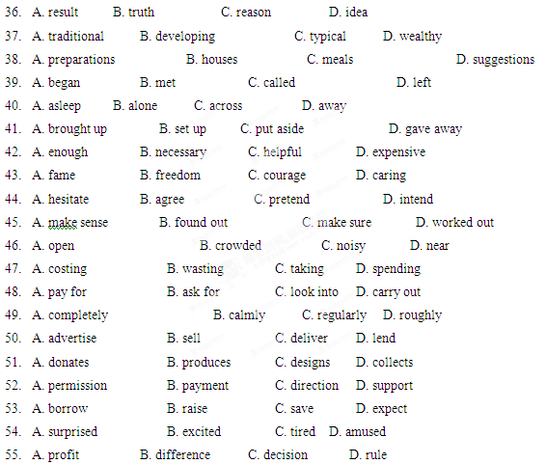第三部分：阅读理解（共20小题；每小题2分，满分 40分）[来源:Z*xx*k.Com]
阅读下列短文，从每题所给的四个选项（A、B、C和D）中，选出最佳选项，并在答题卡上将该项涂黑。
A
The Pacific island nation of Nauru used to be a beautiful place. Now it is an ecological disaster area. Nauru’s heartbreaking story could have one good consequence — other countries might learn from its mistakes.
For thousands of years, Polynesian people lived the remote island of Nauru, far from western civilization. The first European to arrive was John Fearn in 1798. He was the British captain of the Hunter, a whaling ship. He called the island Pleasant Island.
However, because it was very remote, Nauru had little communication with Europeans at first. The whaling ships and other traders began to visit, bringing guns and alcohol. These elements destroyed the social balance of the twelve family groups on the island. A ten-year civil war started, which reduced the population from 1,400 to 900. [来源:Zxxk.Com]
Nauru’s real troubles began in 1899 when a British mining company discovered phosphate (磷酸盐)on the island. In fact, it found that the island of Nauru was nearly all phosphate, which a very important fertilizer for farming. The company began mining the phosphate.
A phosphate mine is not a hole in the ground; it is a strip mine. When a company strip-mines, it removes the top layer of soil. Then it takes away the material it wants. Strip mining totally destroys the land. Gradually, the lovely island of Nauru started to look like the moon.
In 1968, Nauru became one of the richest countries in the world. Every year the government received millions and millions of dollars for its phosphate.
Unfortunately, the leaders invested the money unwisely and lost millions of dollars. In addition, they used millions more dollars for personal expenses. Soon people realized that they had a terrible problem — their phosphate was running out. Ninety percent of their island was destroyed and they had nothing. By 2000, Nauru was financially ruined. Experts say that it would take approximately $433,600,000 and more than 20 years to repair the island. This will probably never happen.
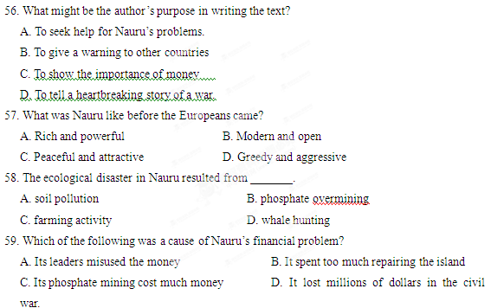60. What can we learn about Nauru from the last paragraph?
A. The ecological damage is difficult to repair.
B. The leaders will take the experts’ words seriously.
C. The island was abandoned by the Nauruans
D. The phosphate mines were destroyed
B
One of the greatest contributions to the first Oxford English Dictionary was also one of its most unusual. In 1879, Oxford University in England asked Prof. James Murray to serve as editor for what was to be the most ambitious dictionary in the history of the English language. It would include every English word possible and would give not only the definition but also the history of the word and quotations (引文)showing how it was used.
This was a huge task. So Murrary had to find volunteers from Britain, the United States, and the British colonies to search every newspaper, magazine, and book ever written in English. Hundreds of volunteers responded, including William Chester Minor. Dr. Minor was an American Surgeon who had served in the Civil War and was now living in England. He gave his address as “Broadmoor, Crowthorne, Berkshire,”” 50 miles from Oxford.
Minor joined the army of volunteers sending words and quotations to Murray. Over the next years, he became one of the staff’s most valued contributors.
But he was also a mystery. In spite of many invitations, he would always decline to visit Oxford. So in 1897， Murray finally decided to travel to Crowthorne himself. When he arrived, he found Minor locked in a book-lined cell at the Broadmoor Asylum for the Criminally insane.
Murray and Minor became friends, sharing their love of words. Minor continued contributing to the dictionary, sending in more than 10,000 submissions in 20 years. Murray continued to visit Minor regularly, sometimes taking walks with him around the asylum grounds.
In 1910, Minor left Broadmoor for an asylum in his native America. Murray was at the port to wave goodbye to his remarkable friend.
Minor died in 1920, seven years before the first edition of the Oxford English Dictionary was completed. The 12 volumes defined 414,825 words, and thousands of them were contributions from a very scholarly and devoted asylum patient.
61. According to the text, the first Oxford English Dictionary _________.
A. came out before minor died
B. was edited by an American volunteer
C. included the English words invented by Murray
D. was intended to be the most ambitious English dictionary
62. How did Dr. Minor contributed to the dictionary?
A. He helped Murray to find hundreds of volunteers.
B. He sent newspapers, magazines and books to Murray.
C. He provided a great number of words and quotations
D. he went to England to work with Murray.
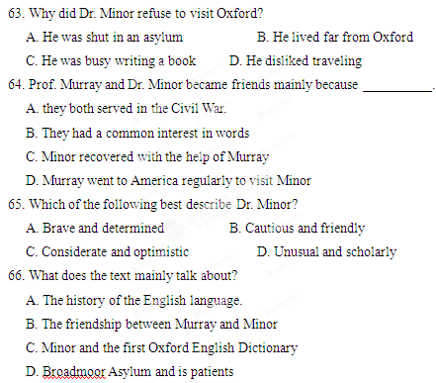
C
San Francisco has its cable cars. Seattle has its Space Needle. And, Longview has its squirrel bridge. The bridge, which has attracted international attention, is now a local landmark.
The Nutty Narrows Bridge was built in 1963 by a local builder, Amos Peters, to give squirrels a way to cross the busy road without getting flattened by passing cars.
The original bridge was built over Olympia Way on the west edge of the library grounds. Before the bridge was built, squirrels had to avoid traffic to and from the Park Plaza office building where office staff put out a nutty feast for the squirrels. Many times, Peters and others who worked in and near Park Plaza witnessed squirrels being run over.
One day Peters found a dead squirrel with a nut still in its mouth, and that day’s coffee break discussion turned into squirrel safety. The group of businessmen cooked up the squirrel bridge idea and formed a committee to ask the blessing of the City Council(市政会).The Council approved, and Councilwoman Bess LaRiviere named the bridge “Nutty Narrows.”
After architects designed the bridge, Amos Peters and Bill Hutch started Construction, They built the 60-foot bridge from aluminum and lengths of fire hose(消防水带). It cost 1,000.
It didn’t take long before reports of squirrels using the bridge started. Squirrels were even seen guiding their young and teaching them the ropes. The story was picked up by the media, and Nutty Narrows became know in newspapers all over the world.
In 1983, after 20 years of use, Peters took down the worn-out bridge. Repairs were made and crosspieces were replaced. The faded sign was repainted and in July 1983, hundreds of animal lovers attended the completion ceremony of the new bridge.
Peters died in 1984, and a ten-foot wooden squirrel sculpture was placed near the bridge in memory of its builder and his devotion to the project.
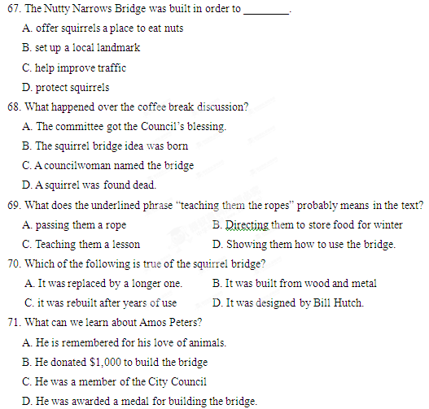
D
For those who are tired doing the laundry, Samsung has found an answer: a washing machine that can tell you when your laundry is done via a smartphone app(application).
Strange though it may seem — “my wife already does that” was a common response among attendees viewing the device when it was introduced at the Consumer Electronics Show (CES) this week — Samsung is just one of many appliance makers racing to install (安装) a large number of internet-connected features in machines in an effort to make them “smart”.
Last year, it was a refrigerator that tweeted. This year, it’s Wi-Fi-enabled laundry machines and fridges that can tell you when your groceries are going bad.
The washers and dryers, available starting in the spring, connect to any smartphone through a downloadable application. The phone can then be used as a remote control, so the machines can be turned on and off while their owners is at work or on the bus.
Samsung says it’s not just something new — the app connection actually has some practical uses.
“If you started to dry clothes in the morning and forgot to take them out, you can go to your phone and restart your dryer for the time when come home, so your clothes are refreshed and ready to go,” said spokesperson Amy Schmidt.
The company also says that with electricity rate(电价)varying depending on the time of day, more control over when the machines are used can help save money. [来源:学&科&网]
Perhaps, but what they will probably really accomplish is what all good technologies do —enable laziness. Rather than getting up to check on whether the laundry is done, users will instead monitor it on their phones while watching TV.
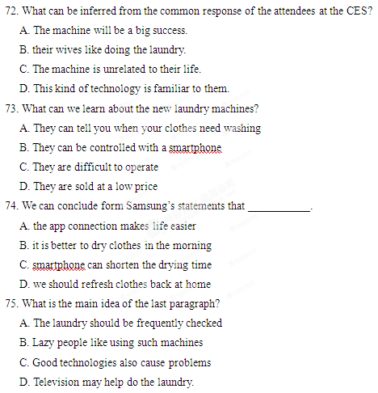
第II卷（共45分）
第四部分 书面表达（共两节，满分45分）
- 阅读表达（共5小题，每小题3分，满分15分）
阅读下面短文并回答问题，然后将答案写到答案卡相应的位置上（请注意76至79四个小题后面的词数要求）。
[1] Ashley Power’s mother bought a computer for her when she was eight. When she was thirteen, she was surfing the Internet regularly, but she couldn’t find anywhere for teenagers to meet and talk. And one day she thought, “If I had my own website, I’d make it a really interesting site for teenagers.”
[2]So, when Ashley was sixteen, she launched her own website, called Goosehead. She had no idea how big a success it would be, but three years later, the site was the most successful teen site in the USA! It was getting 100,000 hits every day, and Ashley had about 30 employees.
[3] After a few years, the website closed down. Then Ashley, who lives in Los Angeles, was asked to write a book called The Goosehead Guide to Life. The book is about how to design a website and start a business. It begins with a section called “All About Ashley,” where Ashley tells readers what it is like to be the boss of a company when you are only sixteen. “ I was so happy. But it was crazy in a lot of ways. I got very stressed. I mean, I was only sixteen — I didn’t even have a car! If you were sixteen and you had your own company, you’d be stressed, too！“
[4] In an interview Ashley gave advice to teenagers who wanted to start their own business, “Just be strong and have your dreams and work hard at them. And don’t listen when _______, because I heard ‘no’ a lot. Just keep going until you hear ‘yes’!”
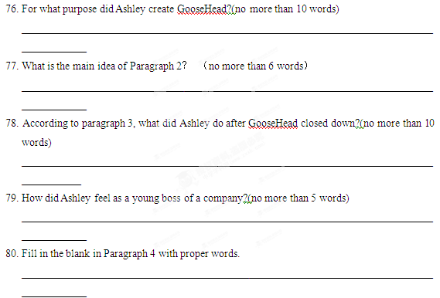第二节 写作（满分30分）
