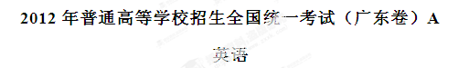
本试卷共12页，三大题，满分135分。考试用时120分钟。
注意事项：
1.答卷前，考生务必用黑色字迹的钢笔或签字笔将自己的姓名和考生号、试室号、座位号填写在答题卡上。用2B铅笔将试卷类型（A）填涂在答题卡相应位置上。将条形码横贴在答题卡右上角“条形码粘贴处”。
2.选择题每小题选出答案后，用2B铅笔把答题卡上对应题目选项的答案信息点涂黑，如需改动，用橡皮擦干净后，再选涂其他答案，答案不能答在试卷上。
3.非选择题必须用黑色字迹钢笔或签字笔作答，答案必须写在答题卡各题目指定区域相应位置上；如需改动，先划掉原来的答案，然后再写上新的答案；不准使用铅笔和涂改液。不按以上要求作答的答案无效。
4.考生必须保持答题卡的整洁。考试结束后，将试卷和答题卡一并交回。
I 语言知识及应用（共两节，满分45分）
第一节 完形填空（共15小题；每小题2分，满分30分）[来源:Z.xx.k.Com]
阅读下面短文，掌握其大意，然后从1~15各题所给的A、B、C和D项中，选出最佳选项，并在答题卡上将该项涂黑。
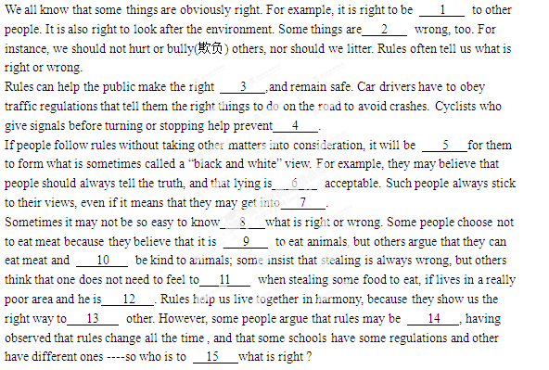
1. A. kind B. sensitive C. fair D. generous
2. A. equally B. slightly C. clearly D. increasingly
3. A. suggestion B. conclusions C. turns D. choices
4. A. accidents B. mistakes C. falls D. deaths
5. A. interesting B. vital C. easy D. valuable
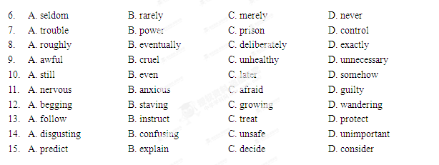

第二节 语法填空 （共10小题 ，每小题1.5分 ，满分15分）
阅读下面短文，按照句子结构的语法性和上下文连贯的要求，在空格处填入一个适当的词或使用括号中词语的正确形式填空 ，并将答案填写在答题卡标号为16~25的相应位置上。
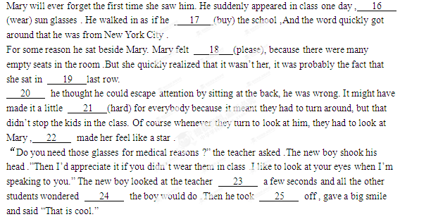
Ⅱ阅读理解（共两节，满分50分）[来源:学科网]
第一节 阅读理解（共20小题；每小题2分，满分40分）
阅读下列短文，从每题所给的A、B、C、D和D项中，选出最佳选项，并在答题卡上将该项涂黑。
A
“Have a nice day!” may be a pleasant gesture or a meaningless. When my friend Maxie says “Have a nice day” with a smile, I know she sincerely cares about what happens to me. I feel loved and secure since another person cares about me and wishes me well.
“Have a nice day. Next!”This version of the expression is spoken by a salesgirl at the supermarket who is rushing me and my groceries out the door. The words come out in the same tone（腔调）with a fixed procedure. They are spoken at me, not to me. Obviously, the concern for my day and everyone else’s is the management’s attempt to increase business.
The expression is one of those behaviors that help people get along with each other. Sometimes it indicates the end of a meeting. As soon as you hear it, you know the meeting is at an end. Sometimes the expression saves us when we don’t know what to say “oh, you may have a tooth out? I’m terribly sorry, but have a nice day.”
The expression can be pleasant. If a stranger says “Have a nice day” to you, you may find it heart-warming because someone you don’t know has tried to be nice to you.
Although the use of the expression is an insincere, meaningless social custom at times, there is nothing wrong with the sentence except that it is a little uninteresting. The salesgirl, the waitress, the teacher, and all the countless others who speak it without thinking may not really care about my day. But in a strange and comfortable way, it’s nice to know they care enough to pretend they care when they really don’t care all that much. While the expression may not often be sincere, it is always spoken. The point is that people say it all the time when they like.

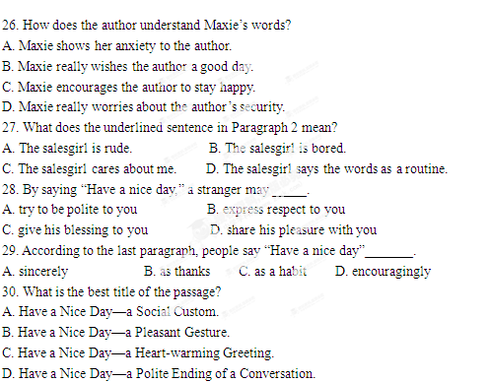
B
I have been consistently opposed to feeding a baby regularly. As a doctor, mother and scientist in child development I believe there is nothing to recommend it, from the baby’s point of view.
Mothers, doctors and nurse alike have no idea of where a baby’s blood sugar level lies. All we know is that a low level is harmful to brain development and makes a baby easily annoyed. In this state, the baby is difficult to calm down and sleep is impossible. The baby asks for attention by crying and searching for food with its mouth.
It is not just unkind but also dangerous to say a four-hourly feeding schedule will make a baby satisfied. The first of the experts to advocate a strict clock-watching schedule was Dr Frederic Truby King who was against feeding in the night. I’ve never heard anything so ridiculous. Baby feeding shouldn’t follow a timetable set by the mum. What is important is feeding a baby in the best way, though it may cause some inconvenience in the first few weeks.
Well, at last we have copper-bottomed research that supports demand feeding and points out the weaknesses of strictly timed feeding. The research finds out that babies who are fed on demand do better at school at age 5, 7, 11 and 14, than babies fed according to the clock. By the age of 8, their IQ （智商）scores are four to five percent higher than babies fed by a rigid timetable. This research comes from Oxford and Essex University using a sample （样本）of 10,419 children born in the early 1990s,taking account of parental education, family income, a child’s sex and age, the mother’s health and feeling style. These results don’t surprise me. Feeling according to schedule runs the risk of harming the rapidly growing brain by taking no account of sinking blood sugar levels.
I hope this research will put an end to advocating strictly timed baby feeling practices.

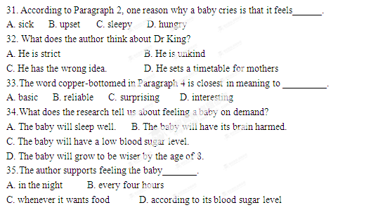
C
I was blind, but I was ashamed of it if it was known. I refused to use a white stick and hated asking for help. After all, I was a teenager girl, and I couldn’t bear people to look at me and think I was not like them. I must have been a terrible danger on the roads, coming across me wandering through the traffic, motorists probably would have to step rapidly on their brakes. Apart from that, there were all sorts of disasters that used to occur on the way to and from work.
One evening, I got off the bus about halfway home where I had to change buses, and as usual I ran into something,“I’m awfully sorry,”I said and stepped forward only to run into it again. When it happened a third time, I realized I had been apologizing to a lamppost. This was just one of the stupid things that constantly happened to me. So I carried on and found the bus stop, which was a request stop, where the bus wouldn’t stop unless passengers wanted to get on or off. No one else was there and I had to try to guess if the bus had arrived.
Generally in this situation, because I hated showing I was blind by asking for help, I tried to guess at the sound. Sometimes I would stop a big lorry and stand there feeling stupid as it drew away. In the end, I usually managed to swallow my pride and ask someone at the stop for help.
But on this particular evening no one joined me at the stop; It seemed that everyone had suddenly decided not to travel by bus. Of course I heard plenty of buses pass, or I thought I did. But because I had given up stopping them for fear of making a fool of myself, I let them all go by. I stood there alone for half an hour without stopping one. Then I gave up. I decided to walk on to the next stop.
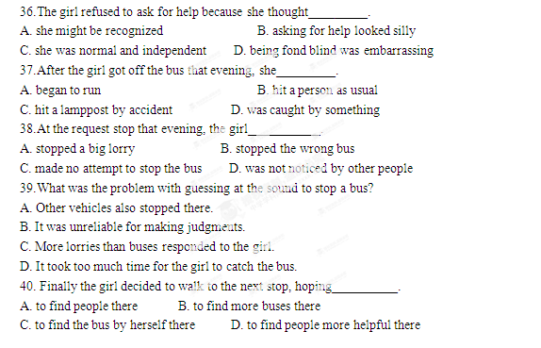
D
Sports account for a growing amount of income made on the sales of commercial time by television companies. Many television companies have used sports to attract viewers from particular sections of the general public, and then they have sold audiences to advertisers.
An attraction of sport programs for the major U. S. media companies is that events are often held on Saturday and Sunday afternoons—the slowest time periods of the week for general television viewing. Sport events are the most popular weekend programs, especially among male viewers who may not watch much television at other times during the week. This means the television networks are able to sell advertising time at relatively high prices during what normally would be dead time for programming.
Media corporations also use sports to attract commercial sponsors that might take their advertising dollars elsewhere if television stations did not report certain sports. The people in the advertising departments of major corporations realize that sports attract made viewers. They also realize that most business travelers are men and that many men make family decisions on the purchases of computers, cars and life insurance.
Golf and tennis are special cases for television programming. These sports attract few viewers, and the ratings(收视率)are unusually low. However, the audience for these sports is attractive to certain advertisers. It is made up of people from the highest income groups in the United States, to certain advertisers. It is made up of people from the highest income groups in the United States, including many lawyers and business managers. This is why television reporting of golf and tennis is sponsored by companies selling high-priced cars, business and personal computer, and holiday trips. This is also why the networks continue to carry these programs regardless of low ratings. Advertisers are willing to pay high fees to reach high-income consumers and those managers who make decisions to buy thousands of “company cars” and computer, with such viewers, these programs don’t need high ratings to stay on the air.
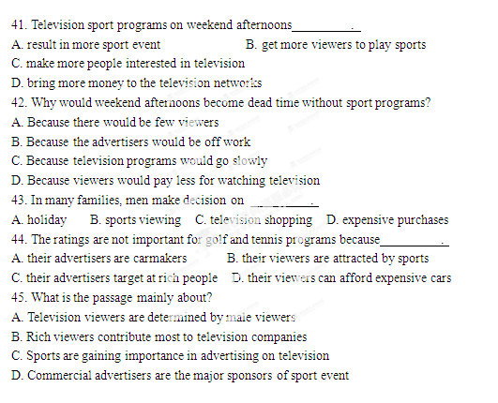

第二节 信息匹配（共5小题；每小题2分，满分10分）
阅读下列应用文及相关信息，并按照要求匹配信息。请在答题卡上将对应题号的相应选项字母涂黑。
首先阅读下列某实习编辑从一组读者来信中整理出来的关键备忘信息：
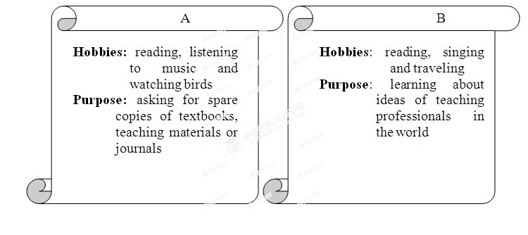

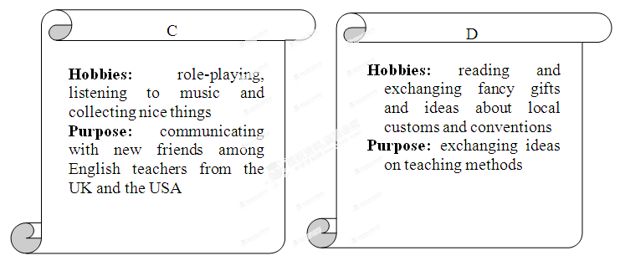

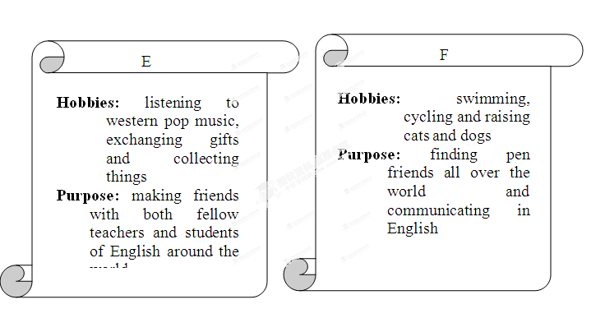
[来源:Z_xx_k.Com]

以下信函为上面关键备忘信息的来源。为有效管理资料，请将关键备忘信息与信函原件匹配起来。
Dear Editor,
I am a secondary school teacher of English. I would like to have pen friends all over the world for my students. They are aged 15-19 and good at swimming, cycling and raising cats and dogs. If students in your country are interested in corresponding with Turkish students in English, please tell them to write to my address, so that I can distribute their letters to my students who are willing to have friends and are in need of practice.
Ms. Imbat
81030, Istanbul
Turkey
46.

Dear Editor,
I am interested in corresponding with other TEFL teachers and researchers about issues of professional development. I would like to share ideas with fellow teachers from English-speaking countries throughout the world. My hobbies are reading, listening to music and watching birds. Since I live in a rather isolated area, I would appreciate any spare copies if text books, teaching materials or journals that other teachers would be able to send me.
Ms. Juliana Sirait
21214,Kisaran
Indonesia
47.

Dear Editor
I am a 33-year-old secondary school teacher of English in Hungary. I would like to make new friends among English teachers mainly from English, the USA, Switzerland, and Scandinavia. I am interested in role-playing and team work, I would also like to correspond with colleagues all over the world with the same hobbies as mine: collecting nice things, listening to music, reading and traveling
Mariann Nyari
6724, Szeged , Tavasz1/B
Hungary
21214,Kisaran
Indonesia

48.

Dear Editor,
I am a 23-year-old Peace Corps Volunteer teaching secondary English in Equatorial Guinea. This is my first experience teaching formally, so I would like to know some of the ideas of all you professionals out there in the world. Letters do not have to be all business. When the school day ends, I would enjoy hearing from you. I enjoy reading. Singing, traveling and so on.
Kury W. Cobham
AP Box 456
Equatorial Guinea
49.

Dear Editor,
I’m a 30-year-old teacher of English at a middle school. I’d be happy to make friends with both fellow teachers and students of English around the world. I also wish to find penfriends for my students between 13 and 20 years old. My interests are letter writing,listening to western pop music,exchanging gifts,and collecting stamps,maps,picture postcards and coins.
Mr. S. Thevachandra
47/1,Kalm Unai
Sri Lanka
50.

Ⅲ 写作 （共两节，满分40分）
第一节 基础写作 （共1小题；满分15分）
你接受了一项写作任务，要为英语校报写一篇人物介绍。

学习态度: 挑战自我，永远为时不晚。国 籍：澳大利亚
第二节 读写任务（共1小题；满分25分）
阅读下面短文，然后按要求写一篇150词左右的英语短文。[来源:Zxxk.Com]
My husband received a letter a month ago a young woman who had been his student when she was in middle school. She was writing because she wanted to thank for having a great influence in her life.
In the letter she wrote,“You were the teacher who helped me discover my talent for math. Before you came to teach us, I had been terribly poor at math, and had never thought that I would be interested in it. To my surprise, you magically showed me the beauty of math. I guess that was the turning point of my attitude towards it. Gradually my interest in it began to grow. Thanks to your encouragement, I made continuous progress in math, and finally made up my mind to study it in the university. Today I am working as an accountant at Valley Medical Center in California. You played an important part. Thank you!”[来源:学,科,网]
What a wonderful gift to a retired teacher! My husband has received many letters from students over the years. This one was special, for it arrived at this time in his life when he is in very poor health.
