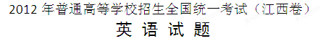
本试卷分第Ⅰ卷（选择题）和第Ⅱ卷（非选择题）两部分，全卷满分150分。
考生注意：
1．答题前，务必在试题卷、答题卡规定的地方填写自己的姓名、座位号，并认真核对答题卡上所粘贴的条形码中姓名、座位号与本人姓名、座位号是否一致。务必在答题卡背面规定的地方填写姓名和座位号后两位。
2．答第Ⅰ卷时，每小题选出答案后，用2B铅笔把答题卡上对应题目的答案标号涂黑。如需改动，用橡皮擦干净后，再选涂其他答案标号。第二卷用黑色墨水签字笔在答题卡上书写作答。如在试题卷上作答，答案无效。
3．考试结束，务必将试题卷和答题卡一并上交。
第一卷（选择题，满分115分）
第一部分：听力（满分30分）
做题时，先将答案标在试卷上。录音内容结束后，你将有两分钟的时间将试卷上的答案转涂到答题卡上。
第一节 （共5小题；每小题1.5分，满分7.5分）
听下面5段对话。每段对话后有一个小题，从题中所给的A、B、C三个选项中选出最佳选项，并标在试卷的相应位置。听完每段对话后，你都有10秒钟的时间来回答有关小题和阅读下一小题。每段对话仅读一遍。
例：How much is the shirt?
A．￡19.15. B．￡9.15. C．￡9.18.
答案是B。
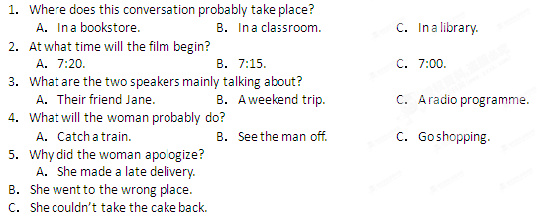第二节 （共15小题；每题1.5分，满分22.5分）
听下面5段对话。每段对话后有几个小题，从题中所给的A，B，C三个选项中选出最佳选项，并标在试卷的相应位置。听每段对话前，你将有时间阅读各个小题，每小题5秒钟；听完后，每小题将给出5秒钟的作答时间。每段对话读两遍。
听第6段材料，回答第6、7题。
6．Whose CD is broken?
A．Kathy’s. B．Mum’s. C．Jack’s.
7．What does the boy promise to do for the girl?
A．Buy her a new CD. B．Do some cleaning. C．Give her 10 dollars.
听第7段材料，回答第8、9题。
8．What did the man think of the meal?
A．Just so-so. B．Quite satisfactory. C．A bit disappointing.
9．What was the 15% on the bill paid for?
A．The food. B．The drinks. C．The service.
听第8段材料，回答第10至12题。
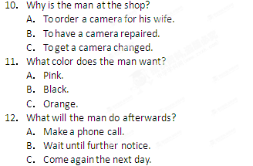
听第9段材料，回答第13至16题。
13．What would Joe probably do during the Thanksgiving holiday?
A．Go to a play. B．Stay at home. C．Visit Kingston.
14．What is Ariel going to do in Toronto?
A．Attend a party. B．Meet her aunt. C．See a car show.
15．Why is Ariel in a hurry to leave?
A．To call up Betty. B．To buy some DVDs. C．To pick up Daniel.
16．What might be the relationship between the speakers?
A．Classmates. B．Fellow workers. C．Guide and tourist.
听第10段材料，回答第17至20题。
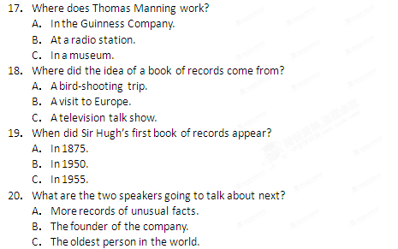
第二部分：英语知识运用（共两节, 满分45分）
第一节：单项填空（共15小题，每小题1分，满分15分）[来源:学科网ZXXK]
从A、B、C、D四个选项中，选出可以填入空白处的最佳选项，并在答题卡上将该项涂黑。
21．The Smiths don’t usually like staying at hotels, but last summer they spent a few days at a very nice hotel by ________ sea.
A．/; a B．the; the C．/; the D．the; a
22．We have bought so much food now that Suzie won’t be with us for dinner.
A．may not B．needn’t C．can’t D．mustn’t
23．My brother would like to buy a good watch but was available from that shop. A．nothing B．none C．no one D．neither
24．I’ve the habit of calling in on my grandparents on my way home from school.
A．come into B．gone into C．got into D．run into
25．It suddenly occurred to him he had left his keys in the office.
A．whether B．where C．which D．that
26．--Look! Somebody the sofa.
--Well, it wasn’t me. I didn’t do it.
A．is cleaning B．was cleaning C．has cleaned D．had cleaned
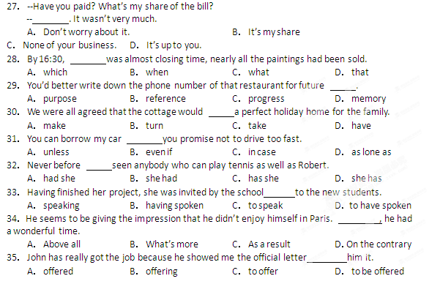
第二节 完型填空（共20小题；每小题1.5分，满分30分）
阅读下面短文，掌握其大意，然后从36—55各题所给的四个选项（A、B、C和D）中，选出最佳选项，并在答题卡上将该项涂黑。
That holiday morning I didn’t have to attend school. Usually, on holidays, Mother 36 me to sleep in. And I would certainly take full advantage of it. On this particular morning, ___37___,I felt like getting up early.
I stood by my window overlooking the ___38___, having nothing better to do. But as it turned out, I was soon to learn about something ___39___ in life.
As I watched several people go by, get into their cars and drive off, I ___40___ an old man on a bicycle with a bucket on its ___41___ and a basket rags and bottles on its back-carriage. He ___42___ from one car to another, washing and cleaning them. From the water on the ground, it seemed that he had already ___43___ washing and cleaning about a dozen or more cars. He must have begun to work quite early in the morning.
Several thoughts ___44___my mind as I watched him work. He wasn’t well-dressed. He had on a pair of shorts and a(n) ___45___ T-shirt. The bicycle he rode was not by any means the kind modern ___46___would want to be seen riding on. But he seemed___47___ with life. There he was, working hard at his small business, ___48___ at passers-by and stopping to chat now and then ___49___ elderly men and women on their way to the market nearby.
There was a noticeable touch of___50___ in the way he seemed to be doing things— ___51___the windscreen (挡风玻璃), then standing back to admire it; scrubbing (擦净) the wheels and ___52___, standing back to see what they look like after the scrub.[来源:学,科,网Z,X,X,K]
It was a ___53___ to learn, I felt. At no age need one have to beg for a ___54___if one has good health and is willing to work hard. For a while I felt ___55__ of myself. Young as I am—just sixteen, and there was this old man who must have been usefully engaged perhaps before the sun appeared above the horizon.
36．A．forces B．allows C．causes D．forbids
37．A．otherwise B．therefore C．however D．besides
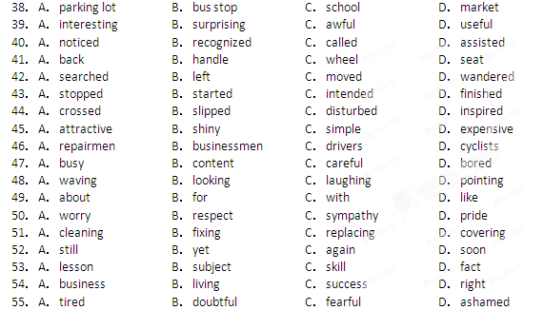
第三部分：阅读理解（共20小题，每题2分，满分40分）
阅读下列短文，从每题所给的四个选项（A、B、C和D）中，选出最佳选项，并在答题卡上将该项涂黑。
A
Mark and his brother Jason both were looking at the shining new computer enviously. Jason was determined not to go against their father’s wishes but Mark was more adventurous than his brother. He loved experimenting and his aim was to become a scientist like his father.
“Dad will be really mad if he finds out you’ve been playing with his new computer.” Jason said, “He told us not to touch it.”
“He won’t find out.” Mark said, “I’ll just have a quick look and shut it down.”
Mark had been scolded before for touching his father’s equipment. But his curiosity was difficult to control and this new computer really puzzled him.
It was a strange-looking machine –one his dad had brought home from the laboratory where he worked. “It’s an experimental model,” his father had explained, “so don’t touch it under any circumstances.” But his father's warning only served to make Mark more curious. Without any further thought, Mark turned on the power switch. The computer burst into life and seconds later, the screen turned into colors, shifting and changing and then two big white words appeared in the center of the screen: “SPACE TRANSPORTER.”
“Yes!” Mark cried excitedly, “It’s a computer game. I knew it! Dad’s only been pretending to work. He’s really been playing games instead.” A new message appeared on the screen:
“ENTER NAMES
VOYAGER 1: …
VOYAGER 2: …”
Mark’s fingers flew across the keyboard as he typed in both of their names.[来源:学科网]
“INPUT ACCEPTED. START TRANSPORT PROGRAM. AUTO-RETRIEVE INITIATED（自动回收程序已启动）.”
The screen turned even brighter and a noise suddenly rose in volume.
“I think we’d better shut it off, Mark,” Jason yelled, reaching for the power switch. He was really frightened.
But his hand never reached the switch. A single beam of dazzling white light burst out of the computer screen, wrapping the boys in its glow (光芒), until they themselves seemed to be glowing. Then it died down just as suddenly as it had burst into life. And the boys were no longer there. On the screen, the letters changed.
“TRANSPORT SUCCESSFUL. DESTINATION（目的地）: MARS. RETRIEVE DATE: 2025.”
56．Why did Mark touch the computer against his father’s warning?
A．He wanted to take a voyage. B．He wanted to practice his skill
C．He was so much attracted by it. D．He was eager to do an experiment.
57．Where did the boy’s father most likely work?
A．In an electronic factory. B．In a computer company.
C．In a scientific research center. D．In an information processing center.
58．Mark thought “SPACE TRANSPORTER” on the screen was the name of .
A．a computer game B．a company website
C．a software producer D．an astronomy program
59．Why did Jason want to shut off the computer?
A．He was afraid of being scolded.
B．He didn’t like the loud noise and light.
C．He didn’t want to play games any more. [来源:学科网ZXXK]
D．He was afraid something dangerous might happen.
60．What happened to the boys at the end of the story?
A．They were blown into the air. B．They were sent to another planet.
C．They were hidden in the strong light. D．They were carried away to another country
B
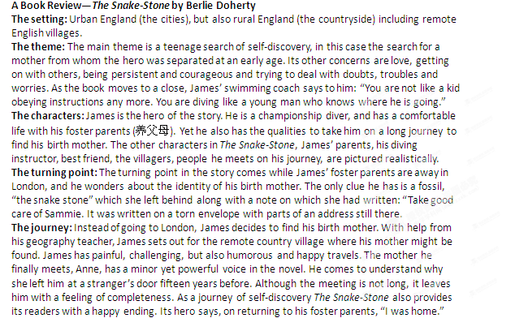61．What is the main theme of the novel?
A．Life with foster parents. B．Life in the world of diving.
C．A journey of self-discovery. D．A travel around the country.
62．What do the coach’s words in Paragraph 2 suggest?
A．James is a successful diver. B．James is a hopeful swimmer.
C．James is an outgoing young man. D．James is an independent young man.
63．The snake stone in the novel is .
A．a stone with an address on it B．a clue left by the birth mother
C．a gift from the swimming coach D．a fossil left by the foster parents
64．Which of the following is true about the novel?
A．The story has a sad ending.
B．The story takes place in the city of London.
C．The characters are vividly described.
D．The turning point comes after the hero meets his birth mother.
65．It can be concluded that James’ journey is _________.
A．worthwhile B．boring
C．comfortable D．disappointing
C
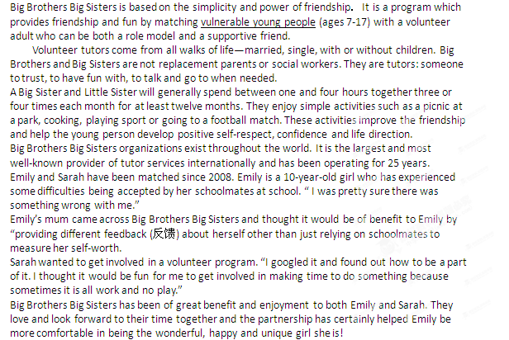66．What is the aim of Big Brothers Big Sisters?
A．To offer students public services．
B．To help students improve their grades．
C．To organize sport activities for young people．
D．To provide partnership and fun for young people．
67．A volunteer is usually expected to work within a year for at least______．
A．24 hours B．36 hours C．48 hours D．72 hours
68．According to Emily’s mother, this program may provide Emily with______．
A．advice from her teachers B．a new way to assess herself
C．a new way to judge her schoolmates D．more comments from her schoolmates
69．Why did Sarah want to get involved in the program?
A．She used to be a volunteer. B．She needed a part-time job.
C．She felt a bit bored with her life. D．She wanted to get a challenging job.
70．According to the passage, “vulnerable young people” are probably those who are _________.
A．popular at school B．rather weak physically
C．easily hurt emotionally D．confident in themselves
D
For those who make journeys across the world, the speed of travel today has turned the countries into a series of villages．Distances between them appear no greater to a modern traveler than those which once faced men as they walked from village to village. Jet planes fly people from one end of the earth to the other, allowing them a freedom of movement undreamt of a hundred years ago.
Yet some people wonder if the revolution in travel has gone too far. A price has been paid, they say, for the conquest (征服) of time and distance. Travel is something to be enjoyed, not endured (忍受). The boat offers leisure and time enough to appreciate the ever-changing sights and sounds of a journey. A journey by train also has a special charm about it. Lakes and forests and wild, open plains sweeping past your carriage window create a grand view in which time and distance mean nothing. On board a plane, however, there is just the blank blue of the sky filling the narrow window of the airplane. The soft lighting, in-flight films and gentle music make up the only world you know, and the hours progress slowly.
Then there is the time spent being “processed” at a modern airport. People are conveyed like robots along walkways; baggage is weighed, tickets produced, examined and produced yet again before the passengers move to another waiting area. Journeys by rail and sea take longer, yes, but the hours devoted to being “processed” at departure and arrival in airports are luckily absent. No wonder, then, that the modern high-speed trains are winning back passengers from the airlines.
Man, however, is now a world traveler and cannot turn his back on the airplane. The working lives of too many people depend upon it; whole new industries have been built around its design and operation. The holiday maker, too, with limited time to spend, patiently endures the busy airports and limited space of the flight to gain those extra hours and even days, relaxing in the sun. speed controls people’s lives; time saved, in work or play, is the important thing—or so we are told. Perhaps those first horsemen, riding free across the wild, open plains, were enjoying a better world than the one we know today. They could travel at will, and the clock was not their master.
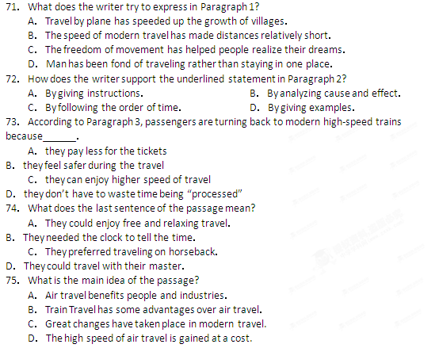
第二卷（非选择题 满分35分）
第四部分 写作（共两节，满分35分）
第一节 阅读表达（共5小题；每小题2分，满分10分）
阅读下面短文并回答问题，然后将答案写到答题卡相应的位置上（请注意问题后的词数要求）。
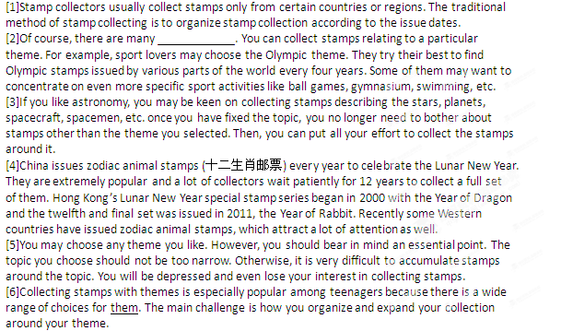76．What is the main idea of the passage? （no more than 5 words）
___________________________________________________________________________
77．Fill in the blanks in Paragraph 2 with proper words． （no more than 5 words）
Of course, there are many ____________________________________________.
78．What should you do if you want to collect a full set of zodiac animal stamps? （no more than 7 words）
_______________________________________________________________________________
79．List the three general themes in collecting stamps mentioned in the passage． （3 words）
_______________________________________________________________________________
80．What does the word "them" （Line2, Paragraph6） probably refer to? （1 word）
_______________________________________________________________________________
第二节 写作（满分25分）
某英文报社举办以 “I Like Reading”为主题的征文活动， 你打算投稿。 请根据以下要点些一篇短文：
1．你为什么喜欢读书；
2．你喜欢读哪一类的书（例如：历史、科学、文学等）？请给出至少两个理由。
注意：词数120左右；

[来源:Z.xx.k.Com]

