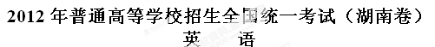
PartⅠ Listening Comprehension(30 marks)
Section A （22.5 marks）
Directions: In this section, you will hear six conversations between two speakers. For each conversation, there are several questions and each question is followed by three choices marked A, B and C. Listen carefully and then choose the best answer for each question.
You will hear each conversation TWICE.
Example:
When will the magazine probably arrive?
A. Wednesday B. Thursday C. Friday
The answer is B.
Conversation 1
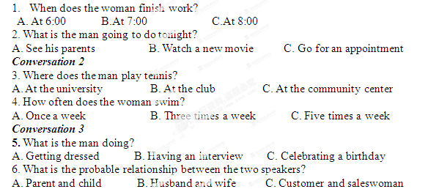Conversation 4
7. Why did the man come back late ?
A. He went to the bar. 
B. He met his teacher.
C. He played basketball.
8. What did the woman do this morning?
A. She took a physics test. B. She had a meeting C. She held a party
9. What will the woman probably do after the conversation?
A. See her friends B. Go to the school C. Prepare dinner
Conversation 5
10. Where did the woman grow up?
A. In Switzerland. B.In the UK. C. In France.
11. Which of the following does the woman like best about Weybridge?
A. Its scenery B. Its people C.Its facilities
12. What does the man do?
A.A teacher B.A host C.A tour guide
Conversation 6
13. Why is the woman upset?
A. The man didn’t apologize [来源:Z#xx#k.Com]
B. The man didn’t turn up. [来源:学科网ZXXK]
C. The man didn’t call.
14. Who is the man speaking to?
A. A waitress. B.A professor C.A doctor
15. When will the two speakers see each other?
A. On Tuesday B. On Thursday C. On Friday
Section B（7.5 marks）
Directions: In this section, you will hear a short passage. listen carefully and then fill in the numbered blanks with the information you have heard. Fill in each blank with NO MORE THAN THREE WORDS.
You will hear the short passage TWICE
School Library
Locations  And resources | ·1stfloor : 80,000 books  ·2nd floor: 16 ___ kinds of newspapers and magazines
Rules | ·Books for lending can be kept for a 17 _____by full-time students.  · 18 _ books, newspapers and magazines can never be taken out.
Opening time | ·All day long  ·All year round except Christmas Day and 19 _______
Access | ·By 20 ______

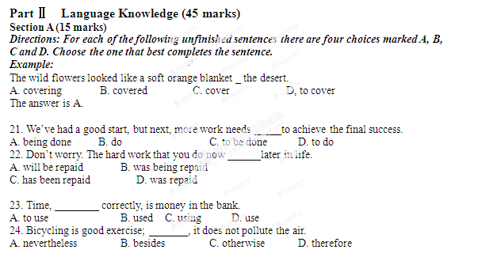

25. Close the door of fear behind you, and you _____ the door of faith open before you.
A. saw B. have seen C. will see D. are seeing

26. Everyone in the village is very friendly. It doesn’t matter ____you have lived there for a short or a long time.
A. why B. how C. whether D. when

27. "The moment _____soon," he thought to himself, waiting nervously.
A. came B. has tome C. was coming D. is coming

28. _____I always felt I would pass the exam, I never thought I would get an A.
A. While B. Once C. If D. Until
29. Sorry, I am too busy now. If I _____ time, I would certainly go for an outing with you.
A. have had B. had had C. have D. had
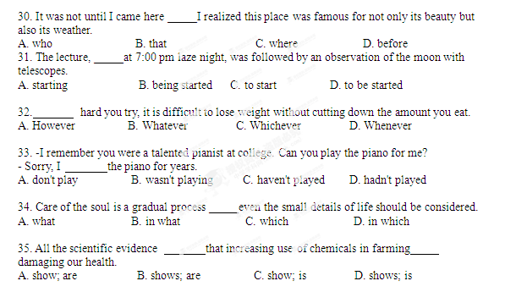
Part Ⅱ
Section B (18 marks)
Directions: For each blank in the following passage there are four words or phrases marked A， B， C and D. Fill in each blank with the word or phrase that best fits the context.
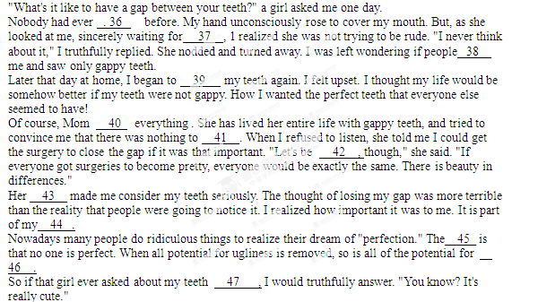36. A. faced B. guessed C. asked D. imagined
37. A. an offer B. an answer C. a suggestion D. a result[来源:学,科,网]
38. A heard of B. thought of C. talked about D. looked at
39. A. consider B. brush C. cover D. appreciate
40. A. admitted B. noticed C. controlled D. changed
41. A. worry about B. put off C. give up D. wipe out
42. A. friendly B. lovely C. honest D. helpful
43. A. words B. jokes C. dreams D. acts
44. A. ability B. decision C. goal D. identity
45. A. possibility B. purpose C. truth D. choice
46. A. courage B. wisdom C. kindness D. beauty
47. A. once B. again C. too D. instead
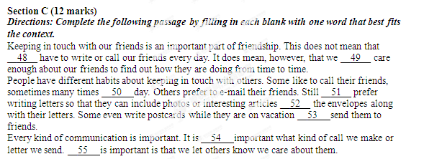
Part Ⅲ Reading Comprehension (30 marks)
Directions: Read the following three passages. Each passage is followed by several questions or unfinished .statements For each of them there are four chokes marked A. B. C and D. Choose the one that fits best according to the information given in the passage.

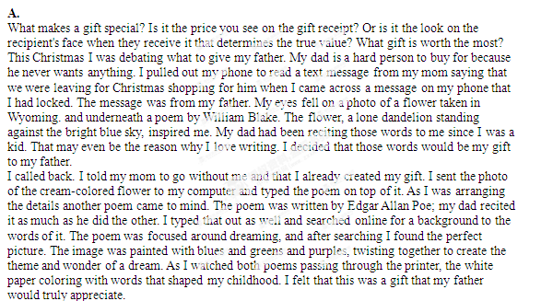Christmas soon arrived. The minute I saw the look on my dad's face as he unwrapped those swirling black letters carefully placed in a cheap frame, I knew I had given the perfect gift.
56. The idea for a special gift began to form when the author was______.
A. doing shopping B. having a debate
C. reading a message D. leaving for Wyoming
57. The author's inspiration for the gift came from_____.
A. a photo of a flower B. a story about a kid
C. a call from the mother D. a text about Christmas
58. The underlined word "it" in Paragraph 3 refers to a poem by_____.
A. the father B. the author
C. William Blake D. Edgar Allan Poe
59. The author made the gift by_____.
A. searching for the poems online B. drawing the background by hand
C. painting the letters in three colors D. matching the words with pictures
60. What is the main purpose of the passage?
A. To show how to design images for gifts.
B. To suggest making gifts from one's heart.[来源:学_科_网]
C. To explain how computers help create gifts.
D. To describe the gifts the author has received
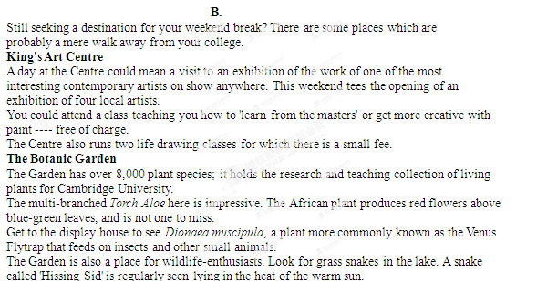Byron's Pool
Many stories surround Lord Byron's time as a student of Cambridge University, Arriving in 1805, he wrote a letter complaining that it was a place of "mess and drunkenness". However, it seems as though Byron did manage to pass the time pleasantly enough. I'm not just talking about the pet bear he kept in his roans. He spent a great deal of time walking in the village.
It is also said that on occasion Byron swam naked by moonlight in the lake, which is now known as Byron's Pool. A couple of miles past Grantchester in the south Cambridgeshire countryside, the pool is surrounded by beautiful circular paths around the fields. The cries of invisible birds make the trip a lovely experience and on the way home you can drop into the village for afternoon tea. If you don't trust me, then perhaps you’ll take it from Virginia Woolf- ----over a century after Byron, she reportedly took a trip to swim in the same pool.
61. As mentioned in the passage, there is a small charge for_____.
A. attending the masters' class B. working with local artists
C. learning life drawing D. seeing an exhibition
62. "Torch Aloe" and "Venus Flytrap" are_____.
A. common insects B. impressive plants
C. rarely-seen snakes D. wildlife-enthusiasts
63. We can infer from the passage that Byron seemed_____.
A. to fear pet bears B. to like walking
C. to be a heavy drinker D. to finish university in 1805
64. In the passage Byron's Pool is described as a lake_____.
.A. surrounded by fields B. owned by Lord Byron
C. located in Grantchester D. discovered by Virginia Woolf
65. What is the passage mainly about?
A. Some places for weekend break B. A way to become creative in art.
C. The colourful life in the countryside. D. Unknown stories of Cambridge University.

C.
Harvard researchers have created a tough, low-cost, biodegradable (可生物降解的) material inspired by insects' hard outer shells. The material's inventors say it has a number of possible uses and someday could provide a more environmentally friendly alternative to plastic. The material, made from shrimp ('虾) shells and proteins produced from silk, is called "shrilk." It is thin, clear, flexible and strong.
A major benefit of the material is its biodegradability. Plastic's toughness and flexibility represented a revolution in materials science during the 1950s and '60s. Decades later, however, 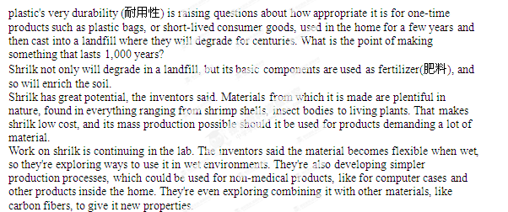66. Paragraph I of the passage is mainly about shritk's_____.
A. remarkable design B. interesting name
C. major features D. basic elements
67. What has become a concern about plastic?
A. Using it properly. B. Producing it cheaply.
C. Developing its properties quickly. , D. Evaluating its contributions fairly.
68. According to the inventors, shrilk has great potential partly because_____.
A. it can help plastic degrade B. it can be found in living things
C. its mass production has been realized D. its raw materials are abundant in mature
69. What are the inventors doing in the lab?
A. Replacing carbon fibers with shrilk.
B. Testing ahrilk's use in wet conditions.
C. Making shrilk out of used household goods.
D. Improving shrilk's flexibility for medical purposes.
70. Which of the following can be the best title for the passage?
A. Recent Progress in Environmental Protection
B. Benefits of Insects in Scientific Research
C. The Harm of One-time Products
D. A Possible Alternative to Plastic

Part IV Writing (45 marks)
Section A (10 marks)
Directions: Read the following passage. Fill in the numbered blanks by using the information from the passage
Write NO MORE THAN THREE WORDS for each answer.
Since the earliest civilizations, people have controlled rivers to meet society's demands. Today, rivers are controlled for many reasons, primarily to maintain reliable water supplies for daily, agricultural and industrial needs, for power generation, for navigation (航行), and to prevent flooding.
River control is achieved by channelization, a term that covers a range of river engineering works, including widening, deepening, straightening and stabilization of banks, and by the construction of dams.
An important period of channelization took place in Europe during the l9'th century, when many large rivers were straightened and their beds deepened. One of the most dramatically changed was the Tisza River, a branch of the Danube that flows through Hungary. The controlling of the Tisza, designed to reduce flooding and make land for agriculture, included cutting off more than 100 meanders (河曲), shortening the river's length by nearly 400 kilometers.
One of the most common ways in which people control rivers is by damming them. The past 50 years or so has seen an increase in dam construction worldwide, and at the beginning of the 21st century, there were about 800,000 dams globally, some towering more than 200 meters in height.
Despite their successes, many dams also cause significant environmental changes that prove harmful. Some particularly deep reservoirs (水库) can bring about earthquakes due to the stress on their bottom rocks caused by huge volumes of water. Downstream of a reservoir, the river is certainly influenced in many ways: water volume, speed and quality are all affected, leading to changes in the landscape and among plants and animals.
to _73_ adequate water for:
- daily life, __74__ and industry
- power generation
- navigation

Title:
__71_
Ways
_72
__79__:
·achievements:800,00 dams built
·problems: causing harmful changes to__80__
to stop rivers from __75__
channelization:
·engineering works:
·widening,__76__and straightening rivers
·__77__river banks
·an example: the _78_of the Tisza by nearly 400 km

[来源:学_科_网]

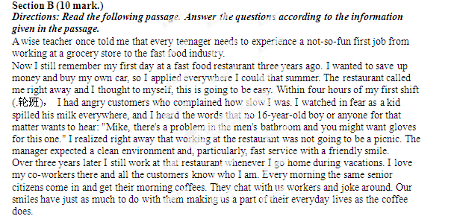From my first job at the restaurant, I learned teamwork and devotion. I also learned staying positive no matter how rough things seem to get. I will forever carry the experience that I gained at the restaurant with me as I go forward in my life.
81. Why did the author apply everywhere that summer?
(No more than 12 words) (2 marks)
82．What did the manager particularly expect the workers to do?
(No more than 14 words) (3 marks)
83．Why does the author still work at the restaurant during vacations?
(No more than 13 words) (2 marks)
84. What did the author learn from his first job?
(No mom dm II words) (3 marks)

Section C (25 marks)
Directions: Write an English composition according to the instructions given below in Chinese.
生活中.你白己或他人曾有过物品不慎丢失而又找回的经历，其间有烦恼、有惊喜、有感慨……请就此写一篇英语短文。
主要内容包括, 1)丢失的物品: 2)物品失而复得的经过; 3) 你的感想。
注意：
1.词数不少于120个;
2.不能使用真实姓名和学校名称.

