
第I卷（选择题共15分）
第一部分听力（共两节,满分30分）
做题时,先将答案标在试卷上。录音内容结束后，你将有两分钟的时间将试卷上的答案转涂到答题卡上。
第一节（共5小题;每小题1.5分，满分7.5分）
听下面5段对话。每段对话后有一个小题，从题中所给的A、B、C三个选项中选出最佳选项,并标在试卷的相应位罝。听完每段对话后,你都有10秒钟的时间来回答有关小题和阅读下一小题。每段对话仅读一遍。
例：How much is the shirt?
A. £19.15. B. £9.15. C. £9.18.[来源:Z,xx,k.Com]
答案:B[来源:学科网]
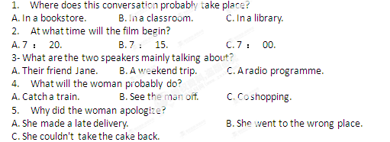
第二节（共15小题;每小题1.5分,满分22.5分）
听下面5段对话。毎段对话后有几个小题,从题中所给的A、B、C三个选项中选出最佳选项,并标在试卷的相应位置。听每段对话前，你将有时间阅读各个小题，每小题5秒钟;听完后,各小题给出5秒钟的做答时间。每段对话读两遍。
听第6段材料,回答第6、7题。
6. Whose CD is broken?
A. Kathy's. B. Mum's. C. Jack's.
7. What does the boy promise to do for the girl?
A. Buy her a new CD. B. Do some cleaning. C. Give her 10 dollars.
听第7段材料，回答第8、9题。
8. What did the man think of the meal?
A. Just so-so. B. Quite satisfactory. C. A bit disappointing.
9. What was the 15% on the bill paid for?
A. The food. B. The drinks. C. The service.
听第8段材料,回答第10至12题。
10. Why is the man at the shop?
A. To order a camera for his wife. B. To have a camera repaired. C. To get a camera changed.
11. What colour does the man want?
A. Pink. B. Black. C. Orange
12. What will the man do afterwards?
A. Make a phone call. B. wait until further notice. C. Come again the next day.
听第9段材料，回答第13至16题。
13. What would Jce probably do during the Thanksgiving holiday?
A. Go to a play. B. Stay at home. C. Visit Kingston.
14. What is Ariel going to do in Toronto?
A. Attend a party. B. Meet her aunt. C. See a car show.
15. Why is Ariel in a hurry to leave?
A. To call up Betty. B. To buy some DVDs. C. To pick up Daniel.
16. What might be the relationship betwee
A. Classmates. B. Fellow workers. C. Guide and tourist.
听第10段材料，回答第17至20题。
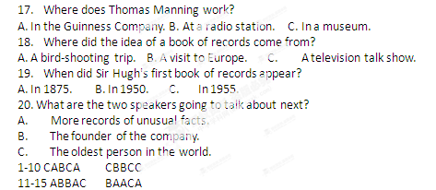
第二部分：英语知识运用
第一节：单项填空
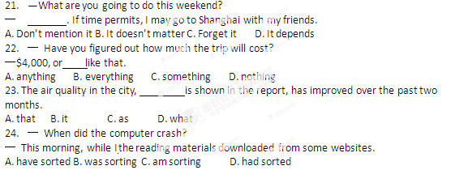25. 一 Why do you choose to work in an international travel agency?
一 Well, you know, English is my . So it is my best choice.
A. strength B. talent C. ability D.' skill
27. Anyone, whether he is an official or a bus driver, should be respected.
A. especially B. equally C. naturally . D. normally
28. China recently tightened its waters controls near the Huangyan Island to prevent Chinese fishing boats from in the South China Sea.
A. attacking B. having attacked C. being attacked D. having been attacked
29. You had better________ some time every day for sports so that you can keep yourself energetic.
A. set aside B. take up C. put away D. give out
30. It is hard for the Greek government to get over the present difficulties_________ gets more financial support from the European Union.
A. if B. unless C. because D. since
31. We lost our way in that small village, otherwise we________ more places of interest yesterday.
A. visited B. had visited C. would visit D. would have visited
32. — Can you lend me the book Gone with the Wind? zxxk
— Sorry. I returned it to the library just now. Maybe it is still ____.
33. Nothing is so easy as parents raise their expectations of their children too high.
A. of B. to C. by D. for
34. Pressed from his parents, and ______that he has wasted too much time , the boy is determined to stop playing video games.
A. realizing B. realized C. to realize D. being realized

35. We promise attends the party a chance to have a photo taken with the movie star.A. who B. whom C. whoever D. whomever
第二节：完形填空
第二节完形填空(共20小题;每小题1.5分,满分30分）
阅读下面短文,从短文后各题所给的四个选项（A、B、C和D)中，选出可以填入空白处的最佳选项,并在答题卡上将该项涂黑。
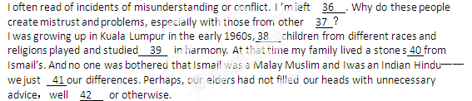We were nine when we became friends. During the school holidays, we'd 43 the countryside on our bicycles, hoping to 44 the unexpected. At times Ismail would accompany my family as we made a rare shopping trip to town. We would be glad of his 45 .
When I was twelve, my family moved to Johor. Ismail s family later returned to their village, and I 46 touch with him.
One spring afternoon in 1983, I stopped a taxi in Kuala Lumpur. I 47 my destination. The driver acknowledged my 48 but did not move off. Instead, he looked 49 at me. “Raddar?" he said, using my childhood nickname(绰号). I was astonished at being so 50 addressed (称呼). Unexpectedly! It was Ismail! Even after two 51 we still recognized each other. Grasping his shoulder, I felt a true affection, something 52 to describe.
If we can allow our children to be 53 without prejudice, they'll build friendships with people, regardless of race or religion, who will be 54 their side through' thick and thin. On such friendships are societies built and 55 we can truly be, as William Shakespeare once wrote, 44we happy few, we band of brothers".
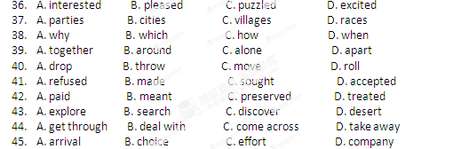
46.A. lost B. gained C. developed D. missed
47.A. stated B. ordered C. decided D. chose
48.A. attempts B. instructions C. opinions D. arrangements[来源:学+科+网]
49.A. anxiously B. carelessly C. disappointedly D. fixedly
50.A.familiarly B. strangely C. fully D. coldly
51.A.departures B. months C. years D. decades
52.A.possible B. funny C. hard D. clear
53.A.them B. themselves C. us D. ourselves
54.A. from B. by C. with D. against
55.A. still B. otherwise C. then D. instead
第三部分阅读理解（共20小题;每小题2分,满分40分）
阅读下列短文，从每题所给的四个选项（A、B、C和D)中,选出最佳选项,并在答题卡上将该项涂黑
A篇
Some people believe that a Robin Hood is at work, others that a wealthy person simply wants to distribute his or her fortune before dying. But the donator who started sending envelopes with cash to deserving causes，accompanied by an article from the local paper, has made a northern German city believe in fairytales (童话）•
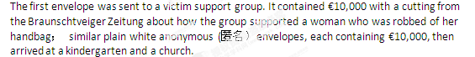The envelopes keep coming, and so far at least €190,000 has been distributed. Last month, one of them was sent to the newspaper ’s own office. It came after a story it published about Tom, a 14-year-old boy who was severely disabled in a swimming accident. The receptionist at the Braunschweiger Zeitung opened an anonymous white envelope to find 20 notes of €500 inside , with a copy of the article. The name of the family was underlined.
"I was driving when I heard the news,” Claudia Neumann, the boy s mother, told DerSpiegel magazine. “I had to park on the side of the road； I was speechless. ”
The money will be used to make the entrance to their house wheelchair-accessible .and for a course of treatment that their insurance company refused to pay for.
“For someone to act so selflessly, for this to happen in such a society in which everyone thinks of himself, was astonishing," Mrs. Neumann said. Her family wonder whether the donator is a Robin Hood character, taking from banks to give to the needy.
Henning Noske, the editor of the Braunschweiger Zeitung, said： “Maybe it is an old person who is about to die. We just do not know. ” However, he has told his reporters not to look for the city’s hero, for fear that discovery may stop the donations.
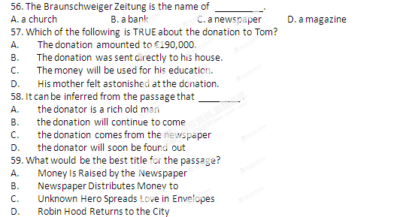
B篇
At exactly eleven Sir Percival knocked and entered, with anxiety and worry in every line of his face. This meeting would decide his future life，and he obviously knew it.
"You may wonder, Sir Percival,’’ said Laura calmly, “if I am going to ask to be released (免除）from my promise to many you. I am not going to ask this. I respect my father's wishes too much.“
His face relaxed a little, but one of his feet kept beating the carpet.
"No, if we are going to withdraw.(退出）from our planned marriage, it will be because of your wish, not mine.
“Mine?” he said in great surprise. “What reason could I have for withdrawing?’
"A reason that is very hard to tell you," she answered. "There is a change in me. ”
His face went so pale that even his lips lost their color. He turned his head to one side.
"What change?" he asked, trying to appear calm.
“ When the promise was made two years ago, ” she said, ⁴⁴ my love did not belong to anyone. Will you forgive me, Sir Percival, if I tell you that it now belongs to another person?”
“I wish you to understand, “ Laura continued, “that I will never see this person again, and that if 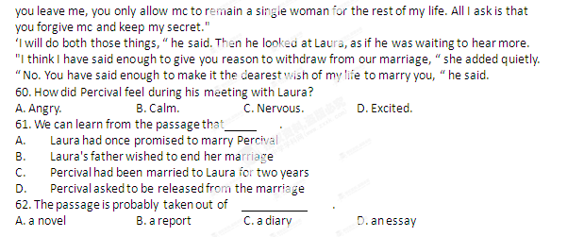
C篇
Finally, a cell phone
That's… a phone
With rates as low as $3.75 per week ！
“Well, I finally did it. I finally decided to enter the digital age and get a cell phone. My kids have been annoying me and the last straw was when my car broke down, and I was stuck by the highway for an hour before someone stopped to help. But when I went to the cell phone store, I almost changed my mind. The phones all have cameras, computers and a "global-positioning" something or other that's supposed to spot me from space. Goodness, all I want to do is to be able to talk to my grandkids ！ The people at the store weren't much help. They couldn't understand why someone wouldn't want a phone the size of a postage stamp. And the rate plans! They were confusing, and expensive… and the'contract (合同）lasted for two years! I'd almost given up until a friend told me about her new Jitterbug phone. Now,I have the convenience and safety of being about to stay in touch with a phone I can actually use. ”
Affordable plans that I can understand一and no contract to sign (签订）！ Unlike other cell phones，Jitterbug has plans that make sense. Why should I pay for minutes I m never going to use? And if I do talk more than I plan，I won ’t find myself with no minutes like my friend who has a prepaid phone. Best of all, there is no contract to sign_so I m not locked in for years at a time. The US-based customer service is second to none. And the phone gets service anywhere in the country.
Monthly Minutes | 50 | 100
Monthly Rate | $14.99 | S19.99
911 Access | FREE | .FREE
Long Distance Calls | No additional charge | No additional charge
Friendly Return Policy | 30 days | 30 days
Call now and receive a FREE gift when you order. Try Jitterbug for 30 days and if you don ’t love it, just return it! Why wait, the Jitterbug comes ready to -use right out of the box. If you aren't as happy with it as I am, you can return it and get your money back. Call now, the Jitterbug product experts are ready to answer your questions.
Call 1-888-809-8794 or visit www. jitlerbugdirect. com.
63. What made “I” finally think of getting a cell phone?
A. Being stuck by the highway.
B. Being urged by his grandkids.
C. Being persuaded by cell phone salespersons.
D. Being attracted by the friendly return policy.
64. On the monthly basis of 100 minutes, the Jitterbug weekly rate is about .
A. $3.75 B. $4.99 C. $14.99 D. $19.99
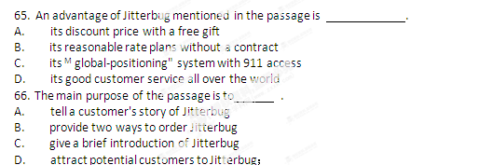
D篇
Do you know how it is when you see someone yawn and you start yawning too? Or how hard it is to be among people laughing and not laugh yourself? Well, apparently it's because we have mirror neurons (神经元）in our brains.
Put simply, the existence of mirror neurons suggests that every time we see someone else do something, our brains imitate (模仿)it，whether or not we actually perform the same action. This explains a great deal about how we learn to smile, talk, walk, dance or play sports. But the idea goes further： mirror neurons not only appear to explain physical actions _{y} they also tell us that there is a biological basis for the way we understand other people.
Mirror neurons can undoubtedly be found all over our brains, but especially in the areas which relate to our ability to use languages, and to understand how other people feel. Researchers have found that mirror neurons relate strongly to language. A group of researchers discovered that if they gave people sentences to listen to ( for example ："The hand took hold of the ball" ) , the same mirror neurons were triggered as when the action was actually performed (in this example, actually taking hold of a ball).
Any problems with mirror neurons may well result in problems with behavior. Much researeh suggests that people with social and behavioral problems have mirror neurons which are not fully functioning. However, it is not yet known exactly how these discoveries might help find treatments for social disorders.
Research into mirror neurons seems to provide us with ever more information concerning how humans behave and interact(互动）.Indeed, it may turn out to be the equivalent (相等物）for ncurosciencc of what Einstein's theory of relativity was for physics. And the next time you feel the urge to cough in the cinema when someone else does--well，perhaps you'll understand why.
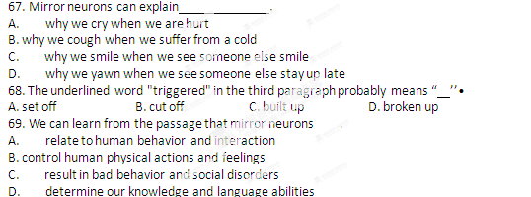
70. What is the passage mainly about?[来源:Z|xx|k.Com]
A. Ways to find mirror neurons.
B. Problems of mirror neurons.
C. Existence of mirror neurons.
D. Functions of mirror neurons.
E篇
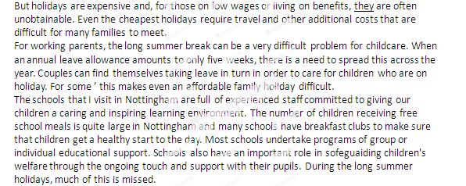
Holidays are really important. Many of us will have childhood memories of summer holidays where we were taken away from home to experience new environments and learn in different ways.
While teachers are holidaying in the UK, many of their pupils spend the whole six weeks on the street where they live. The lack of free school meals for six weeks can result in pressure on a family budget and an inability to afford the inspiring experiences that help children to continue their learning.[来源:学科网]
In setting out its plans for a five-term year, Nottingham City Council (委员会)is seeking to reduce the summer holiday down lo four and a half weeks, with a more balanced five terms of roughly eight weeks, each followed by a two-week break. We believe this will give real “down time" for school staff and pupils alike but will be short enough not to cause a real break in learning.
We acknowledge that this change may be difficult for some school staff, particularly whose own children are educated in other authorities. However, this must be weighed against the benefits for city children for whom we all have the greatest duty of care.
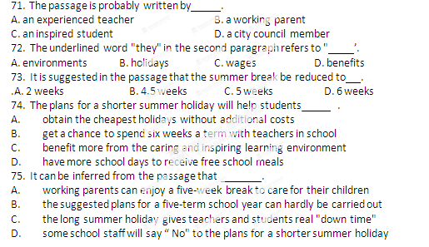
第II卷（非选择题共35分）
第四部分写作（共两节,满分35分）
第一节短文填词（共10小题;每小题1分,满分10分）
People often don’ t do what they really want to for fear
of failure. You don't apply for a job case you don't 76.____________
get it. You don't perform at the school concert b others 77.____________
might laugh at you. A lack of confidence can 1 to a lot 78.____________
of suffering. The key to o this problem is to believe in 79.____________
yourself. This might be (容易)said than done, but there 80.____________
are many w___ to help you do this. Talk about your problem 81.____________
with a friend or look advice on the Internet. Imagine 82.____________
yourself being (成功）and practice breathing techniques 83.____________
to keep you calm when you get nervous. And the _ important 84.____________
thing is ： believe you can do it. When you’ve____ (学会）to do 85.____________
that, you are well on your way.
答案：
第二节书面表达(满分25分）
假定你是某中学生英语报的小记者，以下漫画内容是你的所见所闻,谙根据要求写一篇英语短文投稿。
内容要求：
1.描述漫画内容；2.发表个人感想。
