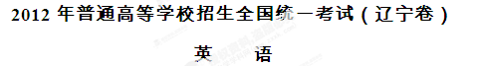
本试卷分第一卷（选择题）和第二卷（非选择题）两部分。考试结束后，将本试卷和答题卡一并交回。
第一卷
注意事项：
- 答题前，考生务必将自己的姓名、准考证号填写在答题卡上。
- 选出每小题答案后，用铅笔把答题卡上对应题目的答案标号涂黑。如需改动，用橡皮擦干净后，再选其他答案标号，不能答在试卷上，否则无效。
第一部分 听力（共两节，满分30分）
做题时，先将答案标在试卷上。录音内容结束后，你将有两分钟的时间将试卷上的答案转涂到答题卡上。
- （共5小题：每小题1. 5分，满分7. 5分）
听下面5段对话。每段对话后有一个小题，从题中所给的A、B、C三个选项中选出最佳选项，并标在试卷的相应位置。听完每段对话后，你都有10秒钟的时间来回答有关小题和阅读下一小题。每段对话仅读一遍。
例；How much is the shirt?
A. ￡19. 15 B. ￡ 9. 15 C. ￡9. 18
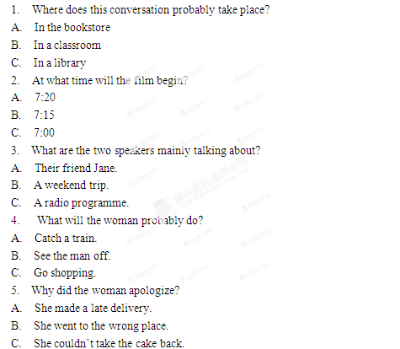
答案是B。
- （共15小题；每小题1. 5分，满分22. 5分）
听下面5段对话。每段对话后有几个小题，从题中所给的A、B、C 三个选项中选出最佳选项，并标在试卷的相应位置。听每段对话前，你将有时间阅读各个小题，每小题5秒钟，听完后，各个小题给出5秒钟的做答时间。每段对话读两遍。
听第6段材料，回答第6、7题。
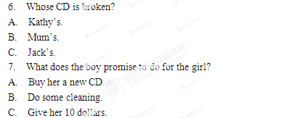
听第7段材料，回答第7、8题。
8. What did the man think of the meal?
A. Just so-so.
B. Quite satisfactory.
C. A bit disappointing.
9. What was the 15% on the bill paid for？
A. The food.
B. The drinks.
C. The service.
听第8段材料，回答第10至12题。
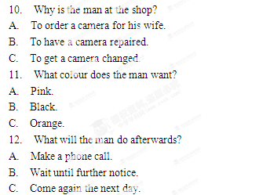
听第9段材料，回答第13至16题。
13. What would Joe probably do during the Thanksgiving holiday?
A. Go to a play.
B. Stay at home.
C. Visit Kingston.
14. What is Ariel going to do in Toronto?
A. Attend a party.
B. Meet her aunt.
C. See a car show.
15. Why is Ariel in a hurry to leave?
A. To call up Betty.
B. To buy some DVDs.
C. To pick up Daniel.
16. What might be the relationship between the speakers?
A. Classmates.
B. Fellow workers.
C. Guide and tourist.
听第10段材料，回答第17至20题。
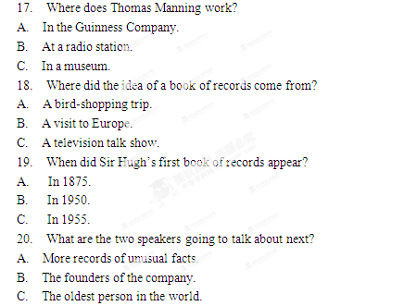
第二部分 英语知识运用（共两节，满分45分）
第一节 单项填空（共15小题；每小题1分，满分15分）
从A、B、C、D四个选项中，选出可以填入空白处的最佳选项，并在答题卡上将该项涂黑。
例：We last night, but we went to the concert instead.
A. must have studied B. might study
C. should have studied D. would study
答案是 C 。
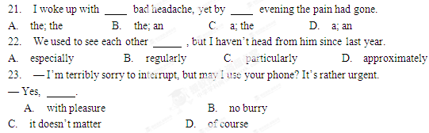
24. One of our rules is that every student wear school uniform while at school.
A. might B. could C. shall D. will
25. The old couple often take a walk after supper in the park with their pet dog them.
A. to follow B. following C. followed D. follows
26. Rod loves clocks. However, he never manages to put them together again.
A. taking apart B. giving away [来源:学科网]
C. making up D. turning off
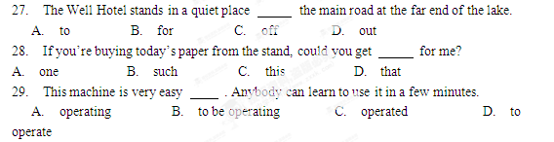30. Leave your key with your neighbor you lock yourself out one day.
A. as long as B. even though C. in case D. as if
31. I feel so excited! At this time tomorrow morning I to Shanghai.
A. will be flying B. will fly
C. have been flying D. have flown
32. Not until he retired from teaching three years ago having a holiday abroad.
A. he had considered B. had he considered
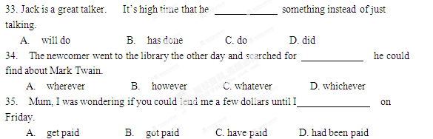
C. he considered D. did he consider
- 完形填空（共20小题；每小题1. 5分，满分30分）
阅读下面短文，从短文后各题所给的四个选项（A、B、C、D）中，选出可以填入空白处的最佳选项，并在答题卡上将该项涂黑。[来源:Z#xx#k.Com][来源:Zxxk.Com]
When Glen Kruger picked a small cat from an animal shelter, he did not expect much. Yet right from the start, eight years ago, there was an uncommon connection between him and the small black cat. He 36 her Inky.
“ I grew up on a hundred-acre farm and had only cats 37 playmates ,” Kruger,
The seventy-year-old man , says. “My hearing was damaged by the 38 of farm equipment , so I learned to connect with 39 . They react to what they see and what you do. ”
Inky was a gentle cat, 40 the house with five other cats. But on a January night in 2009, Inky did 41 that would set her apart from 42 cats forever.
Kruger had gone down to the basement to 43 the wood stove for the night. When he was finished, he 44 to the top of the stairs and reached to turn off the lights. In doing so , he slipped and 45 his back against an old shelf. The heavy shelf came crashing down and sent Kruger down the stairs.
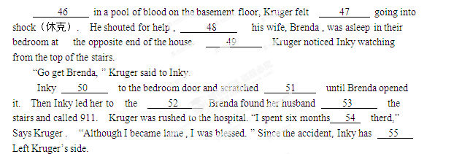
36. A. gave B. chose C. named D. remembered
37. A. like B. as C. except D. among
38. A. sound B. alarm C. noise D. voice
39. A. animals B. friends C. farmers D. neghbors
40. A. sharing B. visiting C. dividing D. discovering
41. A. anything B. nothing C. something D. everything
42. A. familiar B. lovely C. ordinary D. outstanding
43. A. shut out B. shut off C. shut down D. shut up
44. A. marched B. flew C. struggled D. climbed
45. A. bent B. hit C. shook D. pulled
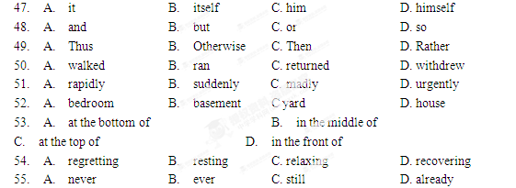
46. A. Falling B. Lying C. Appearing D. Thinking
第三部分 阅读理解（共两节，满分40分）
- （共15小题；每小题2分，满分30分）
阅读下列短文，从每题所给的四个选项（A、B、C、D）中，选出最佳选项，并在答题卡上将该项涂黑。
A
Mini Book Excerpts（节选）
Biography
When Salinger learned that a car park was to be built on the land , the middle-aged writer was shocked and quickly bought the neighboring area to protect it… The townspeople never forgot the rescue and came to help their most famous neighbor.
J. D. Salinger：A Life by Kenneth Slawenski（Random House,$27）
Mystery（疑案小说）
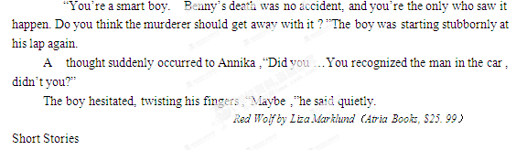 She wants to say to him what she has learned , none of it in class. Some women are borm stupid,and some women are too smart for their own good. Some women are born to give ,and some women only know how to take. Some women learn who they want to be from their mothers,some who they don’t want to be. Some mothers suffer so their daughters won’t. Some mothers love so their daughters won’t.
You Are Free by Danzy Senna （Riverhead Books,$15）
Humor
Do your kids like to have fun? Come to Fun Times! Do you like to watch your kids having fun? Bring them to Fun Times! Fun Times! ’s “amusement cycling ”is the most fun you can have , legally , in the United States right now. Why spend thousands of dollars flying to Disney World when you can spend less than half to that within a day’s drive lf most cities?
Happy And Other Bad Thoughts by Larry Doyle（Ecco,$14. 99）
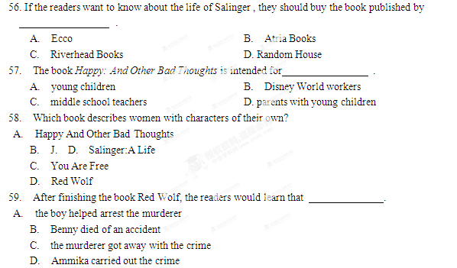B
Astronauts on shorter shuttle missions（使命）often work very long days. Tasks are scheduled so tightly that break times are often used to finish the day’s work. This type of schedule is far too demanding for long missions on the International Space Station（ISS）. ISS crewmembers usually live in space for at least a quarter of a year. They work five days on and two days off to mimic the normal way they do things on Earth as much as possible . Weekends give the crew valuable. Weekends give the crew valuable time to rest and do a few hours of housework. They can communicate with family and friends by email , internet phone and through Private video conferences.
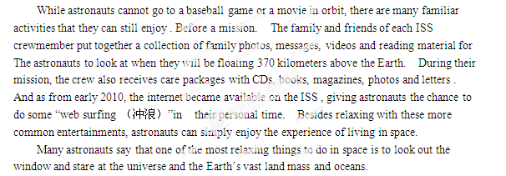60. What does the word “mimic ”in Paragraph 1 probably mean?
A. Find B. Copy
C. Change D. Lose
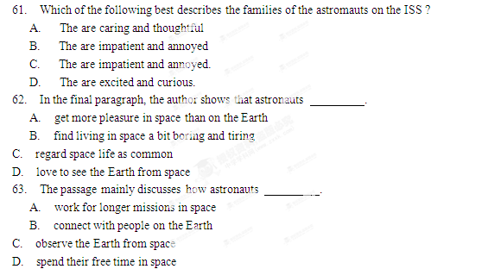C
If Confucius（孔子）were still alive today and could celebrate his September 28 birthday with a big cake, there would be a lot of candles. He’d need a fan or a strong wind to help him put them out.
While many people in China will remember Confucius on his special day, few people in the United States will give him a passing thought. It’s nothing personal. Most Americans don’t even remember the birthdays of their own national heroes.
But this doesn’t mean that Americans don’t care about Confucius. In many ways he has become a bridge that foreigners must cross if they want to reach a deeper understanding of China.
In the past two decades, the Chinese studies programs have gained huge popularity in Western universities. More recently, the Chinese government has set up Confucius Institutes in more than 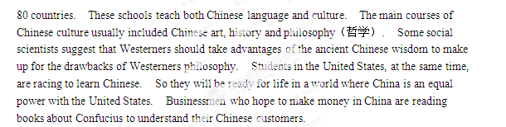
So the old thinker’s ideas are still alive and well.
Today China attracts the West more than ever, and it will need more teachers to introduce Confucius and Chinese culture to the West.
As for the old thinker, he will not soon be forgotten by people in the West, even if his birthday is.
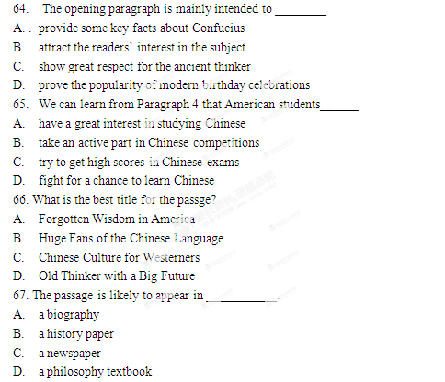
D
Inside the pleasingly fragrant cafe, So All May Eat(SAME) in downtown Denver ,the spirit of generosityis instantly noticeable :A donation box stands in place of a cash register. Customers here pay only what they can afford, no questions asked. A risky business plan, perhaps, but SAME Café has done one unchangeable thing in the Mile High City for six years: Open only at midday, the restaurant provides poor local can instead volunteer as waiters and waitresses, and dishwashers, or took after the buildings and equipment for the cafe.
“It’s based on trust, and it’s working all right” , says co-owner Brad Birky , who started the café in 2006. With his wife Libby. Previously volunteering at soup kitchens, the Birkys were dissatisfied with the often unhealthy meals they served there. “We wanted to offer quality food in a restaurant where everyone felt comfortable ,regardless of their circumstances,” Birky says. SAME’s special lunch menu changes daily and most food materials are natural and grown by local farmers. The café now averages 65 to 70 customers (and eight volunteers) a day. And the spirit of generosity behind the project appears to be spreading. In early 2007,one volunteer who had cleared snow for his meals during the long winter said goodbye to the Birkys,” He said he was going to New Orleans to help with the hurricane clear up,” says Birky. 68.What can we learn about the soup kitchens the Birkys previously worked for?
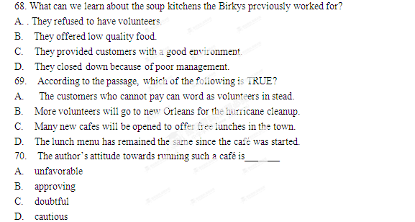第二节（共5小题；每小题2分，满分10分）
根据短文内容，从短文后的选项中选出能填入空白处的最佳选项，并在答题卡上将该项涂黑。选项中有两项为多余选项。[来源:学&科&网Z&X&X&K]
How to Make Friends
Friendship is a very important human relationship and everyone needs good friends. Good friendship has many benefits. It offers companionship, improves self-worth and promotes good health. There are times in our lives such as when we have recently moved into a new town, or changed our jobs or schools. Such changes often leaves us without a friend 71 . But for many of us the process is difficult and requires courage. Below are some helpful suggestions on how to make and keep friends.
1. Associate with others.
The first step to making friends is associating with other people. You can go to public places to meet new people. Besides, you will need to make yourself known by becoming an active member of such places.
- Start a conversation
Starting a conversation is the second most important step in making new friends. 72 You can always start the conversation. Being able to make small talk is a very useful skill in relating with other people.
- 73
Choosing friends with common interests is important in building friendship as these interests would always bring you and your friend together, Hanging out will always be a pleasant experience.
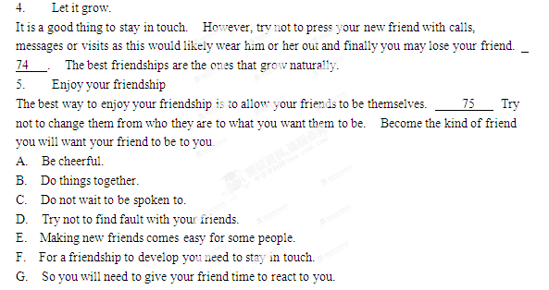第二卷
第四部分——写作（共两节，满分35分）
- 短文改错（共10小题；每小题1分，满分10分）
假定英语课上老师要求同桌之间交换修改作文，请您修改你同桌写的以下作文。文中共有10处语文错误，每句中最多有两处。每处错误仅涉及一个单词的增加、删除或修改。
增加：在缺词处加一个漏字符号（），并在其下面写出该加的词。[来源:学科网]
删除：把多余的词用斜钱（\）划掉。
修改：在错的词下划一横线，并在该词下面写出修改后的词。
注意：
1. 每处错误及其修改均仅限一词；
2．只充许修改10处，多者（从第11处起）不计分。
Dear Diana,

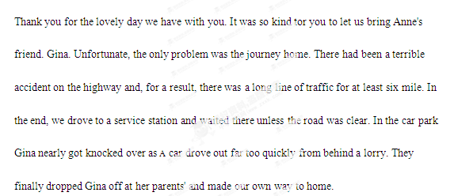
- 书面表达（满分25分）
假定你是某中学的学生李华。请用英语给出版社会的编辑写封信，表达你对现在使用的英语材料的看法，内容主要包括：
优点：1. 话题广泛；
2图片丰富；
3有助于提高 学习兴趣。
建议“适当降低词汇难度。

注意：
- 词数100左右；
- 可以适当增加细节，以使用文连贯；
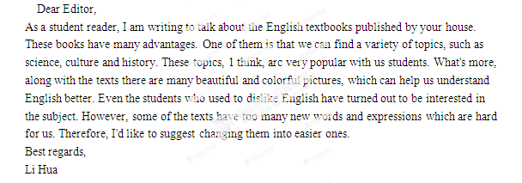
- 开头语已您写好，不讲总词数。

