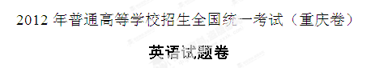
2012年英语高考试题秉承了以往的难度适中，不偏不怪，展现了交际原则与生活感。在选材上，有一些创新，其中作文题尤为时髦，学生需要用英语发布网上物品交换信息。为2013新高考做出了平稳铺垫。
听力题，还是采用传统的美式英语，语速适中，比较简单，语音语调比较清晰，和平时学生练习的内容差不多。单选题，覆盖了大纲要求的大部分语法知识点，在语言考试中，对交际语言的考察向来重视。在单选设置上有了创新，其中一题情景题虽然简单，但所考交际用语从未在其它省市高考题中出现，内容涉及朋友之间的邀请用语，学生读来很有兴趣。完形题，采用了一篇记叙文，材料地道，体现了人文教育的理念。读懂大意容易，但也有一定的梯度和区分度，符合高考选拔性考试的要求。各种题型分布合理，难度适中。个别空需要学生跨越句子和段落去寻找线索，重点考查学生对语境的理解和英语词汇的应用能力。
完型与阅读一向是拉开差距的题型，今年这两道题材料选择地道，强调上下文对照，重点考察学生对语境的理解，以及交际性用语。对于考生来说，阅读题相对亲切，与去年相比甚至更简单。从文章体裁来看，A篇记叙文，B篇应用文，C、D两篇说明文，E篇议论文。五篇文章中前三篇难度较小，但后两篇生词、难度都增多，选项难度较大，尤其最后一篇阅读，易丢分。今年短文改错覆盖的考点也较为传统，文章选择是一篇类似学生习作的给爷爷的一封书信。
“英语作文题让人眼前一亮，不仅时髦还很环保！”英语作文是一篇半开放式作文，形式采用学生熟悉的汉语提示，要求写一篇“发布网上物品交换信息”的作文，和学生生活贴得很近。基础差的考生容易上手，基础好的学生则有足够发挥空间。这类作文学生都能动手写作，但是如果要得高分，以下几个因素缺一不可：好的开头结尾、行文逻辑清晰、高级词汇及句型的使用、漂亮的书写和卷面。
一、听力（共两节，满分35分）
做题时，请先将答案划在试题卷上。录音内容结束后，你将有两分钟的时间将试题卷上的答案转涂或转填到答题卡上。
第一节（共5小题；每小题1. 5分，满分7. 5分）
请听下面5段对话。每段对话后有一个小题，从题中所给的A、B、C三个选项中选出最佳选项，并标在试题卷的相应位置。听完每段对话后，你都有10秒钟的时间来回答有关小题和阅读下一小题。每段对话仅读一遍。
例：How much is the shirt？
A. ￡19. 15. | B ￡9. 15. | C. ￡9. 18.
答案是B。
1.How old is the girl?
A. 7 | B. 8 | C. 10
2. Where does the conversation most probably take place?
A. In a bank. | B. In a store. | C. In a library.
3. How will the two spekers travel?
A. By bus. | B. By car. | C. By train.
4. What are the two speakers talking about?
A. Their work. | B. Their manager. | C. Their meeting.
5. What is the woman’s problem?
A. She is thirsy. | B. She is sick. | C. She is tired.
第二节（共12小题；每小题1. 5分，满分18分）
请听下面4段对话或独白。每段对话或独白后有几个小题，从题中所给的A、B、C三个选项中选出最佳选项，并标在试题卷的相应位置。听每段对话或独白前，你将有时间阅读各小题，每小题5秒钟；听完后，各小题将给出5秒钟的作答时间。每段对话或独白读两遍。
请听第6段材料，回答第6至8题。
6. Which TV program does the women like best ?
A. Sports program. | B. Morning news. | C. Talk show.
7. How much time does the woman spend watching TV every day ?
A. About half an hour. | B. About two hours. | C. About four hours.
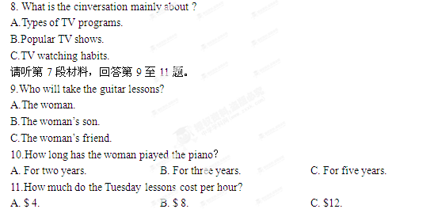请听第8段材料回答12至14题。
12. What was the umbrella first used for?
A. Keeping the water off on rainy days.
B. Protecting people against the sun.
C. Showing the power of the rich.
13. Who were the first to use the umbrella in Europe?
A. The English. | B. The French. | C. The Creeks.
14. What is the passage mainly about?
A. The invention of the umbrella.
B. The history of the umbrella.
C. The style of the umbrella.
请听第9段材料，回答第15至17题。
15.When does the conversation most probably take place?
A. On Monday. | B. On Wednesday. | C. On Saturday.
16.What kind of food might the woman have tonight?
A. Italian food. | B. French food. | C. Janpanese food.
17.How many people will go for dinner?
A. Three. | B. Six. | C. Eight.
第三节（共3小题；每小题1.5分，满分4.5）
请听下面一段独白，用所听到的独白中的词或数填空，每空限填一个词或一个数。填入的内容写在答题卡相应位置上，在听本段独白前，你将有时间阅读各小题，每小题5秒钟；听完后，各小题将给出5秒钟的作答时间，本段独白读两遍。
请听第10段材料，回答第18至20题。
Timetable of a Radio Station
 | Time | Program
Radio Four | 7:30 | 18
Radio Three | 7:30 | Concert
Radio Two | 8:00 | 19 Match
Radio One | 10:00 | News
Radio One | 20 | Travel
二、英语知识运用（共两节，满分45分）
第一节 单项填空（共15小题；每小题1分，满分15分）
请从A、B、C、D四个选项中，选出可以填入空白处的最佳选项，并在答题卡上将该选项标号涂黑。
例：A computer can only do __________you have instructed it to do.
A. how | B. after | C. what | D. when
答案是C.
21.—John,when shall we meeet again,Thursday or Friday?
—__________.I’ll be off to London then.
A.Either | B.Neither | C.Both | D.None
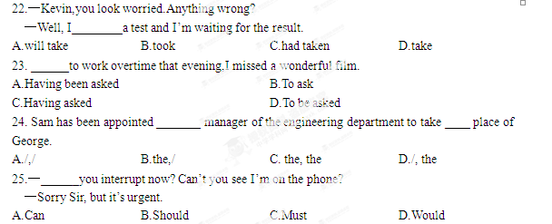26. —The Modern Art Exhibition in the City Museum has been cancelled.
—Oh, no!______.
A.It’s a pity | B.It doesn’t matter
C.I knew it already | D.It’s not interesting at all
27.Food supplies in the flood-stricken area______. We must act immediately before there’s left.
A.have run out | B.are running out
C.have been run out | D.are being run out
28. We’re having a meeting in half an hour.The decision______at the meeting will influence the future of our company.
A.to be made | B.being made | C.made | D.having been made[来源:学.科.网Z.X.X.K]
29. Sales director is a position______communication ability is just as importane as sales.
A.which | B.that | C.when | D.where
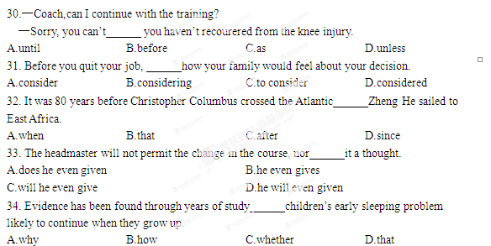35.—Look, here comes your dream girl. Invite her to dance.
—______ What if she refuses me?
A.I don’t know. | B.Why me? | C.With pleasure. | D.So what?
第二节 完形填空（共20小题；每小题1. 5分，满分30分）
请阅读下面短文，掌握其大意，然后从36-55各题所给的四个选项（A、B、C、D）中，选出最佳选项，并在答题卡上将该选项的标号涂黑。
I became a gardener when I was twelve. My early 36 of gardening may not have originated from my love for nature. It was to 37 my parents.
At that time, we had a big yard in which a beautiful maple tree stood. But my mother often looked with 38 at this work of natural art. Those golden leaves seemed like tons of rubbish to her, “something else to 39 !” Seeing the neighbors busy with gardening, my father even thought it a waste of time.
At that age, I always did something 40 to whatever my parents did! If gardening were something they found 41 , I would plant a garden!
I planted some lily(百合花) seeds in the yard. But they failed to 42 . I continued to plant sunflower seeds and roses. Wild 43 joy, I found the first rose bloom(开花). One by one, the flowers bloomed their heads off. 44 , I was touched by this land of wonder.
45 , my parents showed no interest in my garden. My father even 46 at me because he found it was 47 to move around my garden to the driveway. To my mother’s 48 , I put in her vase my real roses which, in her eyes, were simply weeds 49 flowers.
Regardless of their 50 , I kept on planting my garden and 51 to enjoy the pleasure of gardening. Plants make such good companions: they breathe, they bloom, they 52 to care and love.
It has been many years since I made my first garden out of my desire to 53 my parents. Today I become known as Mrs. Greenthumbs, teaching gardening and hosting a gardening show, which makes my parents feel very 54 . And now I could say it is my affection for 55 that makes me a real gardener.
36. A. memory | B. dream | C. intention [来源:学_科_网] | D. design
37. A. please | B. change | C. help | D. annoy
38. A. doubt | B. appreciation | C. surprise | D. excitement
39. A. collect up | B. care about | C. clean up | D. come in
40. A. equal | B. similar | C. superior | D. opposite
41. A. painful | B. valuable | C. upsetting | D. interesting
42. A. come up | B. break out | C. hold on | D. get through
43. A. to | B. with | C. in | D. by
44. A. Luckily | B. Cheerfully | C. Regularly | D. Eventually
45. A. Instead | B. However | C. Therefore | D. Besides
46. A. shouted | B. lagghed | C. glanced | D. jumped
47. A. convenient | B. troublesome | C. enjoyable | D. dangerous
48. A. sadness | B. displeasure | C. delight | D. relief
49. A. other than | B. more than | C. rather than | D. less than
50. A. dislike | B. encouragement | C. threat[来源:Z*xx*k.Com] | D. suggestion
51. A. decided | B. stopped | C. continued[来源:学+科+网Z+X+X+K] | D. struggled
52. A. devote | B. turn | C. respond | D. lead
53. A. defeat | B. satisfy | C. respect | D. challenge
54. A. proud | B. comfortable | C. srange | D. disappointed
55. A. freedom | B. life | C. growth | D. nature
三、阅读理解（共20小题；每小题2分，满分40分）
请阅读下列短文，从每题所给的四个选项（A、B、C和D）中，选出最佳选项，并在答题卡上将该选项的标号涂黑。
A
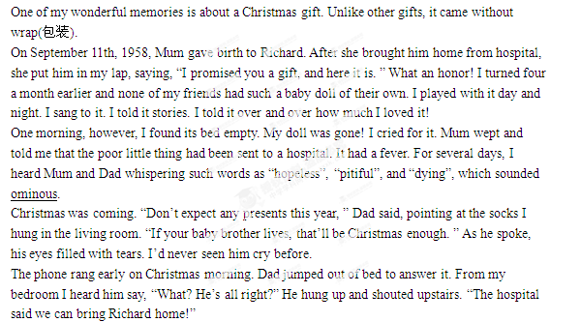 “Thank God!” I heard Mum cry.
From the upstairs window, I watched my parents rush out to the car. I had never seen them so happy. And I was also full of joy. What a wonderful day! My baby doll would be home. I ran downstairs. My socks still hung there flat. But I knew they were not empty; they were filled with love!

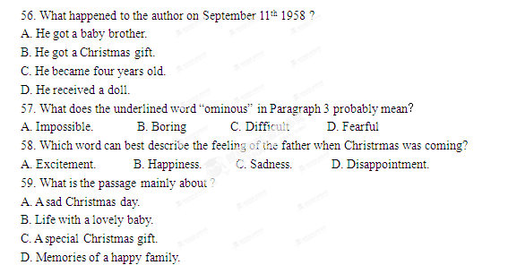B
Top lists are lecturing people on everything from “100 books to visit” to “100 books to read”. Aren't you just tired of being told what to do with your time?
Now you have a list to end all lists!
Take a look at the following two examples from the list of "101 things not to do":
Swim with Dolphins(海豚)？
Swimming with dolphins is one of the world’s most profitable tourist activities. However, not every dolphin will welcome having their busy, tiring day interrupted by tourists screaming and pushing around them in the water. Worse yet, when dolphins get too near to the boats loaded with tourists, they could get caught up in ropes and killed by propellers(螺旋桨).
Here’s a little secret. Dolphins look like smiling at you, but actually they’re just opening their mouths.
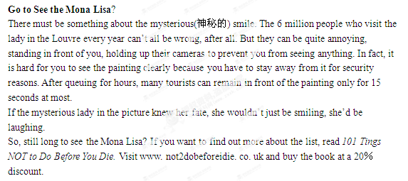
60. According to the passage, swimming with dolphins________.
A. is the world’s most popular tourist activity
B. gives fun to both tourists and dolphins
C. will make tourists busy and tired
D. can cause danger to dolphins
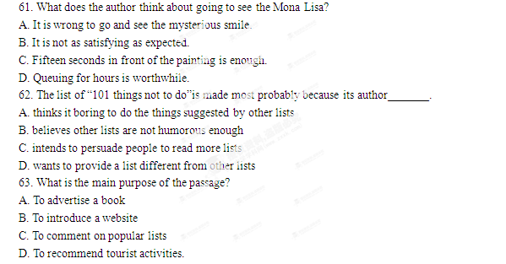
C
There is no better way to enjoy Scottish traditions than going fishing and tasting a little bit of whisky(威士忌) at a quiet place like the Inverlochy Castle. When Queen Victoria visited the castle in 1873 she wrote in her diary, “I never saw a lovelier spot , ” And she didn’t even go fishing.
Scotland is not easily defined. In certain moments, this quiet land of lakes and grass and mountains changes before your very eyes. When evening gently sweeps the hillside into orange light, the rivers, teeming with fish, can turn into streams of gold. As you settle down with just a fishing pole and a basket on the bank of River Orchy, near the Inverlochy castle, any frustration(烦恼) will float away as gently as the circling water. It’s just you and purple, pink, white flowers, seeking a perfect harmony. If you are a new comer to fishing, learning the basics from a fishing guide may leave you with a lifetime’s fun. For many, fishing is more than a sport; it is an art.
Scotland offers interesting places where you can rest after a long day’s fishing. Set against a wild mountain and hidden behind woodland, the beautiful Inverlochy Castle Hotel below the Nevis is a perfect place to see the beauty of Scotland’s mountains. Ben Nevis is the highest of all British mountains, and reaching its 1342-metre top is a challenge. But it’s not just what goes up what matters; what comes down is unique. More than 900 metres high, on the mountain’s north face, lies an all-important source of pure water. Its name comes form the Gaelic language “usquebaugh” or “water of life”; and it is the single most important ingredient(原料) in scotland’s best known drink: whisky.

64. The story of Queen Victoria is to show that _____.
A. the queen is rich in tour experience
B. the Castle is a good place to go in Scotland
C. tasting whisky is better than going fishing
D. 1873 is a special year for the queen
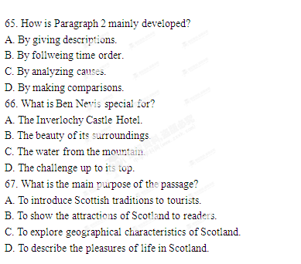
D
To take the apple as a forbidden fruit is the most unlikely strory the Christians(基督教徒) have ever cooked up. For them, the forbidden fruit from Eden is evil(邪恶的). So when Columbus brought the tomato back from South America, a land mistakenly considered to be Eden, everyone jumped to be the obvious conclusion. Wrongly taken as the apple of Eden, the tomato was shut out of the door of Europeans.
What made it particularly terrifying was its similarity to the mandrake, a plant that was thought to have come from Hell(地狱). What earned the plant its awful reputation was its roots which looked like a dried-up human body occupied by evil spirits. Though the tomato and the mandrake were quite different except that both had bright red or yellow fruit, the general population considered them one and the same, too terrible to touch.
Cautious Europeans long ignored the tomato, and until the early 1700s most of the West people continued to drag their feet. In the 1880s, the daughter of a well-known plant expert wrote that the most interestinig part of an afternoon tea at her father’s house had been the “introduction of this wonderful new fruit—or is it a vegetable?” As late as the twentieth century some writers still classed tomatoes with mandrakes as an “evil fruit”.
But in the end tomatoes carried the day. The hero of the tomato was an American named Robert Johnson, and when he was publicly going to eat the tomato in 1820, people journeyed for hundreds of miles to watch him drop dead. “What are you afraid of?” he shouted. “I’ll show you fools that these things are good to eat!” Then he bit into the tomato. Some people fainted. But he survived and, according to a local story, set up a tomato-canning factory.

68. The tomato was shut out of the door of early Europeans mainly because ______.
A. it made Christive evil
B. it was the apple of Eden
C. it came from a forbidden land
D. it was religiously unacceptable
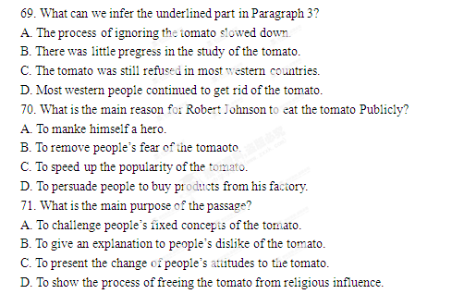
E
In his 1930 essay “Economic Possibilities for Our Grandchildren”, John Keynes, a famous ecconmist, wrote that human needs fall into two classes: absolute needs, which are independent of what other have, and relative needs, which make us feel superior to our fellows. He thought that although relative needs may indeed be insatiable(无止境的), this is not true of absolute needs.
Keynes was surely correct that only a small part of total spending is decided by the desire for superiority. He was greatly mistaken, however, in seeing this desire as the only source of insatiable demands.
Decisions to spend are also driven by ideas of quality which can influnce the demand for almost all goods, including even basic goods like food. When a couple goes out for an anniversary dinner, for example, the thought of feeling superior to others probably never comes to them. Their goal is to share a special meal that stands out from other meals.
There are no obvious limits to the escalation of demands for quality. For example, Porsche, a famous car producer, has a model which was considered perhaps the best sport car on the market. Priced at over $120, 000, it handles perfectly well and has great speed acceleration. But in 2004, the producer introduced some changes which made the model slightly better in handling and acceleration. People who really care about cars find these small improvements exciting. To get them, however, they must pay almost four times the price.
By placing the desire to be superior to others at the heart of his description of insatiable demands, Keynes actually reduced such demands. However, the desire for higher quality has no natural limits.

72. According to the passage, John Keynes Believed that_______.
A. desire is the root of both absolute and relative needs
B. absolute needs come from our sense of superiority
C. relative needs alone lead to insatiable demands
D. absolute needs are stronger than relative needs
73. What do we know about the couple in Paragraph 3?
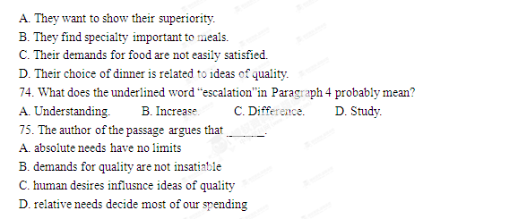
四、写作（共两节，满分35分）
第一节 短文改错（共10小题；每小题1份，满分10分）
以下标有题号的每一行均有一个错误，请找出，并按下列情况改正：
此行多一个词：把多余的词用斜线（\）划掉，在该行右边横线上写出该词，并也用斜线划掉。
此行缺一个词：在缺词处加一个漏字符号（∧），在该行右边横线上写出该加的词。
此行错一个词：在错的词下划一横线，在该行右边横线上写出改正后的词。
注意：请在答题卡上作答。
Dear Grandpa,
How are you those days? I have been missing you very | 76. ________
much after I went to college a year ago. Whenever I think of | 77. ________
the old days, I feel very happily. I still remember when I | 78. ________
was child, you always held me in your arms and told me stories | 79. ________
till I fall asleep. We often went to the fields to enjoy the pleasant | 80. ________
view there. You told me the name of different plants and their | 81. ________
characteristies. Gradually, I became interesting in biology | 82. ________
and chose to learn biology when I entered into the college. Now | 83. ________
my friend Ann, together with me, are going to do field study | 84. ________
and the findings will be use as materials for our research. Since | 85. ________
we’ll do the study in our homewown, I hope to see you by then.
Yours,
Daisy
第二节 书面表达（满分25分）
某国际网站提供个人闲置物品交换服务。现在，你打算通过该网站将自己的一件闲置物品与他人交换（exchange）。请你用英文在该网站上发帖，发布物品交换信息。内容应包括：
·你将拿出什么物品进行交换
·具体介绍该物品
·你希望换回什么物品
·请愿意交换的朋友给你留言
注意：
（1）词数100左右；
（2）格式不限；
（3）文中不得使用考生真实姓名和学校名称。

