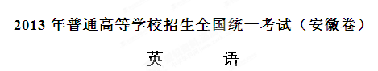
本试卷分为第I卷（选择题）和第II卷（非选择题），第I卷第1页至第14页，第II卷第15页至第16页。全卷满分150分，考试时间120分钟。
考生注意事项：
1．答题前，务必在试题卷、答题卡规定的地方填写自己的姓名、座位号，并认真核对答题卡上所粘贴的条形码中的姓名、座位号与本人姓名、座位号是否一致。务必在答题卡背面规定的地方填写姓名和座位号后两位。
2．答第I卷时，每小题选出答案后，用2B铅笔把答题卡上所对应题目的答案标号涂黑。如需改动，用橡皮擦干净后，再选涂其他答案标号。
3．答第II卷时，必须使用0.5毫米的黑色墨水签字笔在答题卡上书写，要求字体工整、笔迹清晰。作图题可先用铅笔在答题卡的规定的位置绘出，确认后再用0.5毫米的黑色墨水签字笔描清楚。必须在题号所指示的答题区域作答，超出答题区域书写的答案无效，在试题卷、草稿纸上答题无效。
4．考试结束后，务必将试题卷和答题卡一并上交。
第I卷
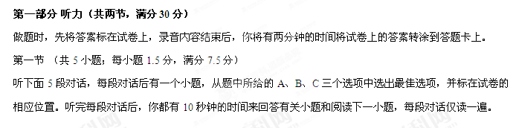
例：How much is the shirt?
A. £19.15 B. £9.18 C. £9.15
答案是C
- What does the man want to do?
- Take photos
- Boy a camera
- Help the woman
- What are the speakers talking about?
- A noisy night
- Their life in town
- A place of living
- Where is the man now?
- On his way
- In a restaurant
- At home
- What will Celia do?
- Find a player
- Watch a game
- Play basketball
- What day is it when the conversation takes place?
- Saturday
- Sunday
- Monday

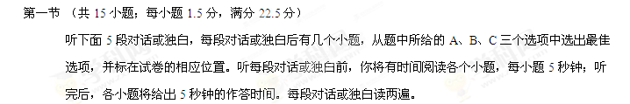听第6段材料，回答第6、7题。
- What is Sara going to do?
- Buy John a gift
- Give John a surprise
- Invite Johe to France
- What does the man think of Sara,s plan?
- Funny
- Exciting
- Strange
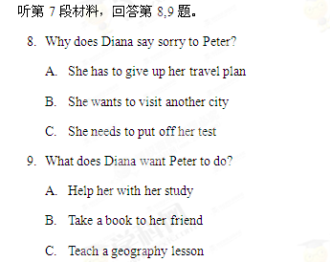
听第8段材料，回答第10至12题
10.Why does the man call the woman?
- To tell her about her new job
- To ask about her job program
- To plan a meeting with her
11.Who needs a new flat?
- Alex
- Andrea
- Miranda
12.Where is the woman now?
- In Baltimore
- In New York
- In Avon
听第9段材料，回答第13至16题
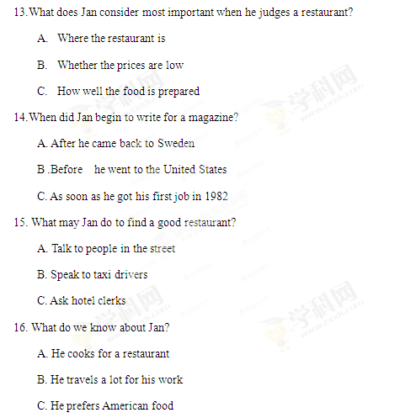
听第10段材料，回答第17至20题
17.What do we know about the Plaza Leon?
A. It’s a new building
B. It’s a small town
C. It’s a public place
18. When do parents and children like going to the Plaza Leon?
A. Saturday nights
B. Sunday afternoons
C. Fridays and Saturdays
19. Which street is known for its food shops and markets?
A. Via del Mar Street
B. Femando Street
C. Hemandes Street
20.Why does the speaker like Horatio Street best?
A. It has an old stone surface
B. It is named after a writer
C. It has a famous university
第二部分 英语知识运用（共两节，满分45分）
- 单项填空（共15小题，每小题1分，满分15分）
从A、B、C、D四个选项中，选出可以填入空白处的最佳选项，兵在答题卡将该项涂黑。
例：It is generally considered unwise to give a child he or she wants.
- However B. whatever C. whichever D. whenever
答案是B

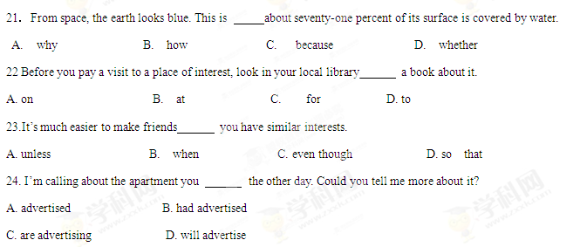
25.----This is your order, a hamburger and an apple pie ?
A. Anything else B. Is that OK
C. For here or to go D. Something to drink
26. Traditionally, college students hold a graduation ceremony to encourage themselves before they on their life joumey.
A. give up B. settle down C. get through D. set off
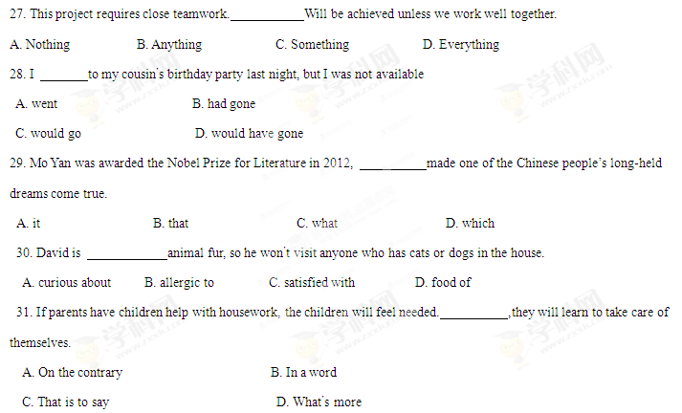32. in the early 20th century, the school keeps on inspiring children’s love of art.
A. To found B. Founding
C. Founded D. Having founded
33. It,s said that the power plant is now large as what it was.
A. twice as B. as twice
C. twice much D. much twice
34. It be the vocabulary that caused you the problem in the exercise because you know a lot of words.
A. may B. couldn’t C. should D. needn’t
35,----How did your interview with the manager go?
---- He seemed interested in my experience, but he didn’t ask for references.
A. Perfect! B. I’m not sure.
C. That’s right. D. Couldn’t be better.

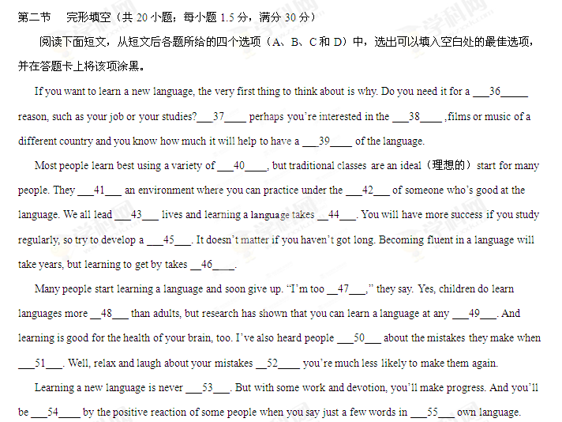Good luck!
36.A. technical B. political C. practical D. physical
37. A. After B. So C. Though D. Or
38.A literature B. transport C.agriculture D. medicine
39.A view B. knowledge C. form D. database
40.A paintings B. regulations C. methods D. computers
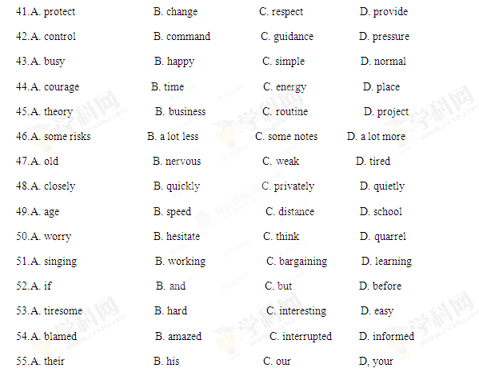
第三部分 阅读理解（共20小题；每小题2份，满分40分）
阅读下列短文，从每题所给的四个选项（A、B、C和D）中，选出最佳选项，并在答题卡上将该项涂黑。
A
Tht Healthy Habits Survey（调查）shows that only about one third of American seniors have correct habits. Here are some findings and expert advice.
1.How many times did you brush your teeth yesterday?
·Finding：A full 33% of seniors brush their teeth only once a day.
·Step：Remove the 300 types of bacteria in your mouth each morning with a battery-operated toothbrush. Brush gently for 2 minutes, at least twice a day.
2.How many times did you wash your hands or bathe yesterday?
·Finding：Seniors, on average, bathe fewer than 3 days a week. And nearly 30%wash their hands only 4 times a day-half of the number doctors recommend.
·Step：We touch our faces around 3,000 times a day-often inviting germs（病菌）to enter our mouth, nose, and eyes.Use toilet paper to avoid touching the door handle. And, most important, wash your hands often with hot running water and soap for 20 seconds.
3. How often do you thind about fighting germs?
·Finding：Seniors are not fighting germs as well as they should.
·Step：Be aware of germs. Do you know it is not your toilet but your kitchen sponge（海绵）that can carry more germs than anything else? To kill these germs, keep your sponge in the microwave for 10 seconds.

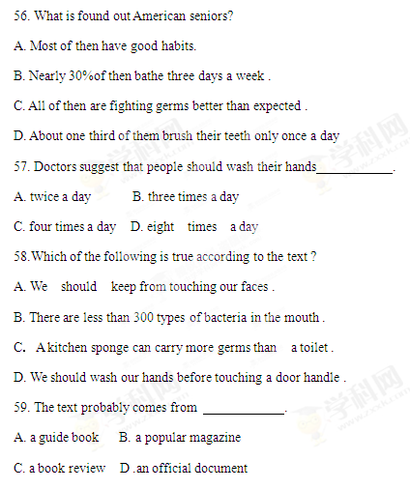

B
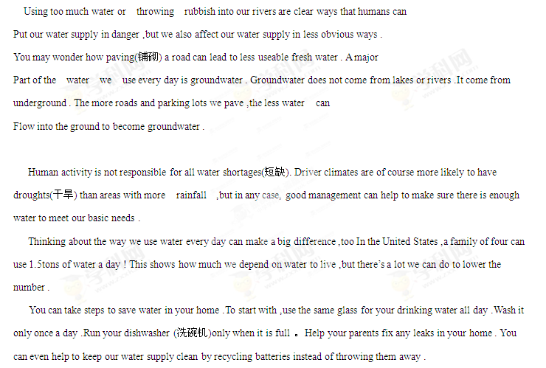60. Which of the following is most likely to lead to less groundwater ?
A. Using river water . B .Throwing batteries away .
C. paving parking lots . D. Throwing rubbish into lakes .
61. What can be inferred from the text ?
A. All water shortages are due to human behavior .
B. It takes a lot of effort to meet our water needs .
C. There is much we can do to reduce family size .
D. The average family in America makes proper use of water .
62. The last paragraph is intended to .
A. show us how to fix leaks at home
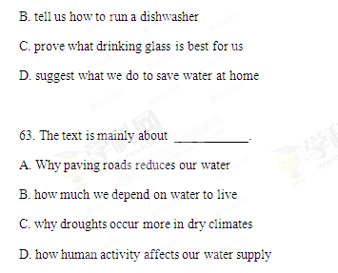

C
When 19-year-old Sophia Giorgi said she was thinking of volunteering to help the Make-A-Wish Foundation (基金会)，nobody understood what she was talking about .But Sophia knew just how important Make – A –Wish could be because this special organization had helped to make a dream come true for one her best friends .We were interested in finding out more ,so we went along to meet Sophia listen to what she had to say .
Sophia told us that Make – A –Wish is a worldwide organization that started in the United States in 1980.”It’s a charity(慈善机构)that helps children who have got very serious illnesses. Make – A –Wish help children feel happy even though they are sick, by making their wishes and dreams come true ,” Sophia explained .
We asked Sophia how Make – A –Wish had first started .She said it had all begun with a very sick young boy called Chris ,who had been dreaming for a long time of becoming a policeman .Sophia said lots of people had wanted to find a way to make Chris’s dream come true ----so, with everybody’s help , Chris, only seven years old at the time ,had been a “policeman” for a day .” when people saw how delighted Chris was when his dream came true, they decided to try and help other sick children too ,and that was the beginning of Make – A –Wish,” explained Sophia
Sophia also told us the Foundation tries to give children and their families a special, happy time. A Make-A-Wish volunteer visits the families and asks the children what they would wish for if they could have anything in the world. Sophia said the volunteers were important because they were the ones who helped to make the wishes come true. They do this either by providing things that are necessary, or by raising money or helping out in whatever way they can.
64. Sophia found out about Make-A-Wish because her best friend had .
A. benefited from it B. volunteered to help it
C. dreamed about it D. told the author about it
65. According to Sophia, Make-A-Wish .
A. is an international charity
B. was understood by nobody at first
C. raises money for very poor families
D. started by drawing the interest of the public

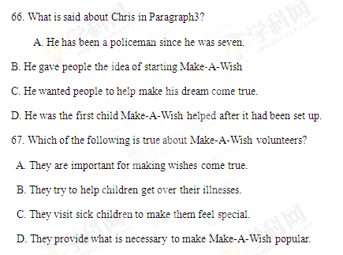

D
“People are ruder today because they are rushed and more ‘time poor’ than ever before,” says Patsy Rowe, “ Manners have fallen off the radar(雷达).” Due to our strong attraction to electronic equipment it is a wonder more people don’t wake up each morning and greet the singing birds with a complaint（抱怨）about the noise. Here are some examples of rudeness.
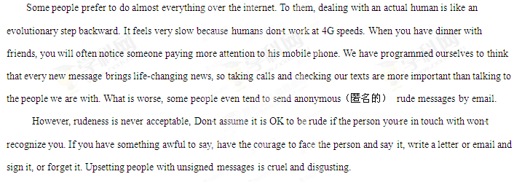
We shouldn′t blame technology for our shortcomings.Technology is here to help us,but we should not allow it to take over our lives. An important step ia acknowledging our shortcomings.People spend a lot of time pointing out bad manners but it would be even more help if we′d publicly acknowledge good manners when we see them.
68.What can be infend from the underlined sentence in Paragraph I?
A.People can tell good from bad behavior.
B.Radar is able tu obserbe human behabior.
C. People care little about their behabior.
D. Radar can be used to predict human behabior.
69.Some people are less willing to deal with humans because
A.they are becoming less patient
B.they are growing too independent
C.they have to handle many important messages
D.they have to follow an evolutionary step backward.
70.The author thinks sending unsigned awful messages is
A.Ridiculous B.disgusting C.acceptable D.reasonable
71.What can we learn from the last paragraph?
A.We should applaud good behabior.
B.Technology can neber be blamed
C.We should keep pointing out mistakes.
D.Technology will take over lives one day.
E
Argentina in the late nineteenth century was an exciting place.Around 1870,it was experiencing an economic(经济的)boom,and the captital,Buenos Aires,attracted many people.Farmers,as well as a flood of foreifners from Spain and Italy,came to Buenos Aires seeking jobs.These jobs didn′t pay well,and the people felt lonely and disappointed with their new lefe in the city.As the unhappy newcomers mixed together in the poor parts of the city,the dance known an the tango(探戈舞)came into being
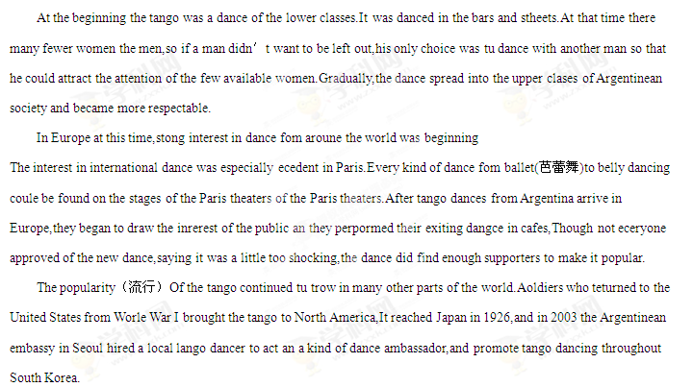72.The origin of the tango is associated with
A Belly dances B.American soldiers
C.Spanish city D.the captital of Argentina
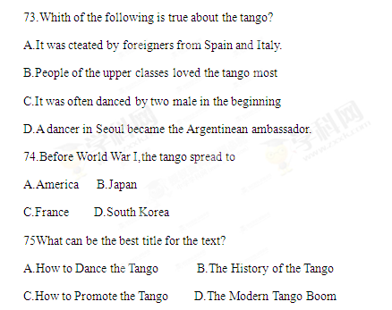
第四部分 写作（共两节，满分35分）
- 任务型读写（共10小题；每小题1分，满分10分）
阅读下面短文，根据所读内容在表格中的空白处填入恰当的单词。注意：每个空格只填一个单词。
Aristotle once wrote that “happiness is a state of activity”. In other words, whether you,re
Seeking life-long satisfaction or a few moments of good cheer, you,ve got to move forward. We,ve interviewed the experts and found five steps to take toward a sunny mood（心情）：
Over a 30-year period, University of Illinois researchers asked nearly 120,000 people how income, education, political participation, volunteer activities and close relationships affexted their happiness. Reported Newsweek,s Sharon Begley on the findings, “The highest levels of happiness are found with the most stable and satisfying relationships.”
Singing aloud, talking to a stranger, raising your hand: all may increase a feeling of happiness, according to a study from Wake Forest University. Participants（参与者）followed the development of their moods for two weeks and reported feeling happier when they were more outgoing and less happy when reserved or withdrawn.
The editors of forbes. Com gave $5 or $20 to 46 strangers by chance. Half the group was told to spend the money on themselves, while the other half was told to spend it on others. Those who,d whaed the wealth felt much happier at the end of the day than those who,d spent it on themselves. There was no difference in happiness between those who spent $5 or $20, suggesting that it,s not how much money you spend, but how you spend it, that inspires the spirit.
Studies from the Positive Psychology Center showed that discouraged people who wrote down three good things that happened to them each day for six months reported an improved attitude.
Drinking water really can help keep you cheerful. A small 2012 study from the University of Connecticut suggested that even slight dehydration（脱水） affected the moods of its female participants.

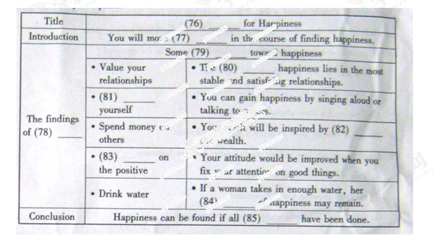
第二节 书面表达（满分25分）
假设你校英语社团举办以“讲求文明，从我做起”为主题的征文活动，请你以“On the Way to School”为题，写一篇英语短文。
内容主要包括：
1.遵守交通法规；
2.注意举止文明。
注意：1.词数120左右；
2.可以适当增加细节，以使行文连贯；
3.短文中不能出现与本人相关的信息；
4.短文的题目已为你拟好，不计入总词数

