
第I卷（共105分）
第一部分：听力（共两节，满分30分）
该部分分为第一、第二两节。注意：回答听力部分时，请先将答案标在试卷上。听力部分结束时，你将有两分钟的时间将你的答案转涂到客观题答题卡上。
第一节（共5小题；每小题1.5分，满分7.5分）
听下面5段对话。每段对话后有一个小题，从题中所给的A、B、C三个选项中选出最佳选项，并标在试卷的相应位置。听完每段对话后，你都有10秒钟的时间来回答有关小题和阅读下一小题。每段对话仅读一遍。
例：How much is the shirt?
A. ￡19.15 B. ￡ 9.18 C. ￡9.15
答案是C。
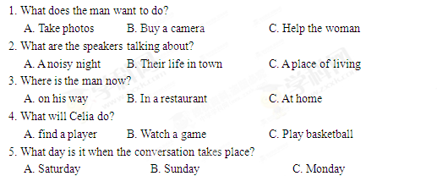
第二节（共15小题；每小题1.5分，满分22.5分）
听下面5段对话或独白。每段对话或独白后有几个小题，从题中所给的A、B、C三个选项中选出最佳选项，并标在试卷的相应位置。听每段对话或独白前，你将有时间阅读各个小题，每小题5秒钟；听完后，各小题将给出5秒钟的作答时间。每段对话或独白读两遍。
听下面一段对话，回答第6至7两个小题。
6. What is Sara going to do?
A. Buy John a gift B. Invite John to France C. Give John a surprise
7. What does the man think of Sara’s plan?
A. Funny B. Exciting C. Strange
听下面一段圣诞，回答第8和第9两个小题
8. Why does Diana say sorry to Peter?
A. She has to give up her travel plan.
B. She wants to visit another city
C. She needs to put off her test.
9. What does Diana want Peter to do?
A. Help her with her study.
B. Take a book to her friend
C. Teach a geography lesson.
听下面一段对话，回答第10至第12三个小题。
10. Why does the man call the woman?
A. To tell her about her new job.
B. To ask about her job program
C. To plan a meeting with her.
11. Who needs a new flat?
A. Alex B. Andrea C. Miranda
12. Where is the woman now?
A. In Baltimore B. In New York C. In Avon
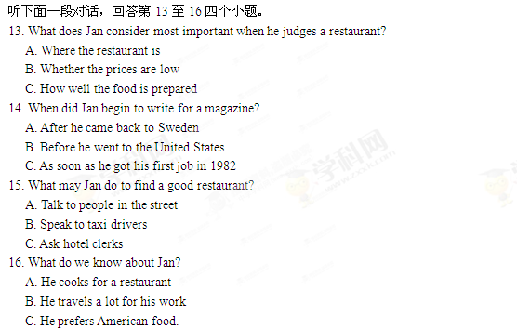
听下面一段独白，回答第17至20四个小题。
17. What do we know about the Plaza Leon?
A. It’s a new building B. It’s a small town C. It’s a public place
18. When do parents and children like going to the Plaza Leon?
A. Saturday nights B. Sunday afternoon C. Fridays and Saturdays
19. Which street is known for its food shops and markets?
A. Via Del Mar Street
B. Fernando Street
C. Hernandes Street
20. Why does the speaker like Horatio Street best?
A. It has an old stone surface
B. It is named after a writer
C. It has a famous university
第二部分：英语知识运用（共两节,满分35分）
第一节 单项填空（共15小题；每小题1分，满分15分）
从A、B、C、D四个选项中，选出可以填入空白处的最佳选项，并在答题卡上将该项涂黑。
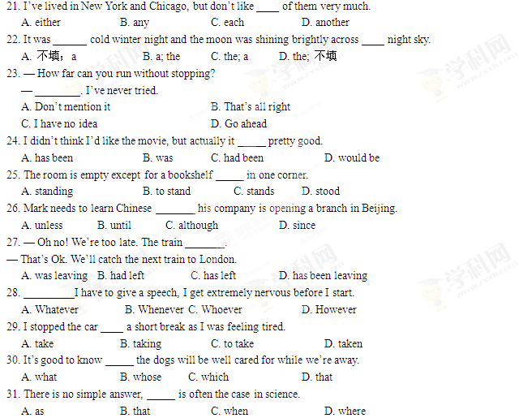
32. — This is a really lively party. There’s a great atmosphere, isn’t there?
— ________ The hosts know how to host a party.
A. Don't worry B. Yes, indeed C. No, there’s isn’t D. It all depends
33. ________ at the cafeteria before, Tina didn’t want to eat there again.
A. Having eaten B. To eat C. Eat D. Eating
34. The Smiths are praised _______ the way they bring up their children.
A. from B. by C. at D. for
35. Finally he reached a lonely island _________ was completely cut off from the outside world.
A. when B. where C. which D. whom
第二节：完形填空（共20小题；每小题1分，满分20分）
阅读下面短文，从短文后所给各题的四个选项（A、B、C和D）中，选出可以填入空白处的最佳选项，并在答题卡将该项涂黑。
I used to be a very self-centered person, but in the past two years I have really changed. I have started to think about other people 36 I think about myself. I am happy that I am becoming a 37 person.
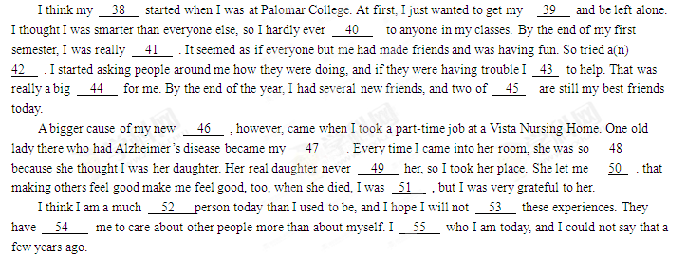36. A. since B. before C. or D. unless
37. A. famous B. simple C. different D. skilled
38. A. education B. career C. tour D. change
39. A. balance C. homework C. degree D. interest
40. A. talked B. wrote C. lied D. reported
41. A. careful B. lonely C. curious D. guilty
42. A. argument B. game C. experiment D. defence
43. A. dared B. offered C. hesitated D. happened
44. A. dream B. problem C. duty D. step
45. A. us B. which C. them D. whom
46. A. attitude B. hobby C. hope D. luck
47. A. friend B. partner C. guide D. guest
48. A. polite B. happy C. strange D. confident
49. A. bothered B. answered C. visited D. trusted
50. A. explain B. guess C. declare D. see
51. A. homeless B. heartbroken C. bad-tempered D. hopeless
52. A. quieter B. busier C. better D. richer
53. A. forget B. face C. improve D. analyze
54. A. forced B. preferred C. ordered D. taught
55. A. miss B. like C. wonder D. expect
第三部分：阅读理解（共20小题；每小题2分，满分 40分）
阅读下列短文，从每题所给的四个选项（A、B、C和D）中，选出最佳选项，并在答题卡上将该项涂黑。
A
Jimmy is an automotive mechanic, but he lost his job a few months ago. He has good heart, but always feared applying for a new job.
One day, he gathered up all his strength and decided to attend a job interview. His appointment was at 10 am and it was already 8:30. While waiting for a bus to the office where he was supposed ot be interviewed, he saw an elderly man wildly kicking the tyre of his car. Obviously there was something wrong with the car. Jimmy immediately went up to lend him a hand. When Jimmy finished working on the car, the old man asked him how much he should pay for the service. Jimmy said there was no need to pay him; he just helped someone in need, and he had to rush for an interview. Then the old man said, “Well, I could take you to the office for your interview. It’s the least I could do. Please. I insist.” Jimmy agreed.
Upon arrival, Jimmy found a long line of applications waiting to be interviewed. Jimmy still had some grease on him after the car repair, but he did not have much time to wash it off or have a change of shirt. One by one, the applicants left the interviewer’s office with disappointed look on their faces. Finally his name was called. The interviewer was sitting on a large chair facing the office window. Rocking the chair back and forth, he asked, “Do you really need to be interviewed?” Jimmy’s heart sank. “With the way I look now, how could I possibly pass this interview?” he thought to himself.
Then the interviewer turned the chair and to Jimmy’s surprise, it was the old man he helped earlier in the morning. It turned out he was the General Manager of the company.
“Sorry I had to keep you waiting, but I was pretty sure I made the right decision to have you as part of our workforce before you even stepped into the office. I just know you’d be a trustworthy worker. Congratulations!” Jimmy sat down and they shared a cup of well-deserved coffee as he landed himself a new job.
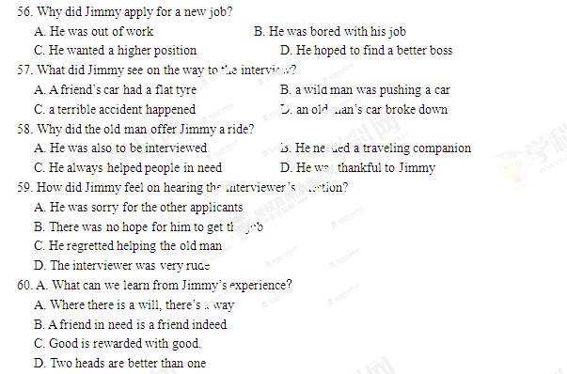
B
George Gershwin, born in 1998, was one of America’s greatest composers. He published his first song when the was eighteen years old. During the next twenty years he wrote more than five hundred songs.
Many of Gershwin’s songs were first written for musical plays performed in theatres in New York City. These palys were a popular form of entertainment in the 1920s and 1930s. Many of his songs have remained popular as ever. Over the years they have been sung and played in every possible way — from jazz to country.
In the 1920s there was a debate in the United States about jazz music. Could jazz, some people asked, be considered serious music? In 1924 jazz musician and orchestra leader Paul Whiteman decided to organize a special concert to show that jazz was serious music. Gershwin agreed to compose something for the concert before he realized he had just a few weeks to do it. And in that short time, he composed a piece for piano and orchestra which he called Rhapsody in Blue. 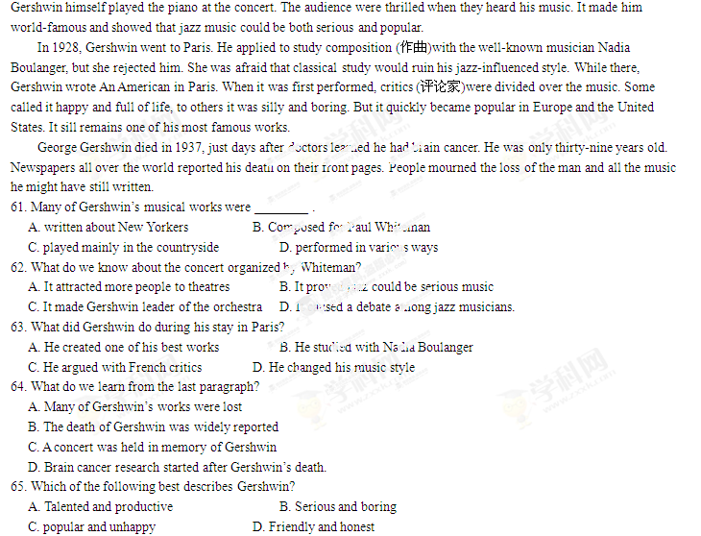
C
You can’t always predict a heavy rain or remember your umbrella. But designer Mikhail Belvacv doesn’t think that forgetting to check the weather forecast before heading out should result in you getting wet. That’s why he created lampbrella, a lamp post with its own rain sensing umbrella.
The designer says he come up with the idea after watching people get wet on streets in Russia. “once, I was driving on a central Saint Petersburg street ad saw the street lamps lighting up people trying to hide from the rain. I thought it would be appropriate to have a canopy(伞蓬)built into a street lamp.” he said.
The lampbrella is a standard-looking street lamp fitted with an umbrella canopy. It has a built-in electric motor which can open or close the umbrella on demand. Sensors(传感器)then ensure that the umbrella offers pedestrians shelter whenever it starts raining.
In addition to the rain sensor, there’s also a 360°motion sensor on the biberglass street lamp which detects whether anyone’s using the lampbrella. After three minutes of not being used the canopy is closed.
According to the designer, the lampbrella would move at a relatively low speed, so as not to cause harm to the pedestrians. Besides, it would be grounded to protect from possible lighting strike. Each lampbrella would offer enough shelter for several people. Being installed at 2 meters off the ground, it would only be a danger for the tallest of pedestrians.
While there are no plans to take lampbrella into production, Belyacv says he recently introduced his creation one Moscow Department, and insists this creation could be installed on my street where a lot of people walk but there are no canopies to provide shelter.
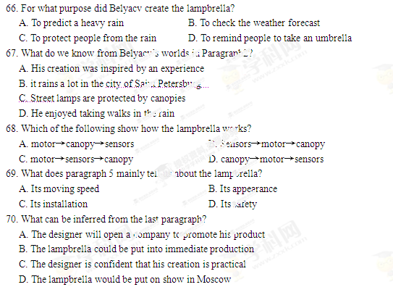
D
Sparrow is a fast-food chain with 200 restaurants. Some years ago, the group to which Sparrow belonged was taken over by another company. Although Sparrow showed no sign of declining, the chain was generally in an unhealthy state. With more and more fast-food concepts reaching the market, the Sparrow menu had to struggle for attention. And to make matters worse, its new owner had no plans to give it the funds it required.
Sparrow failed to grow for another two years. Until a new CEO, Carl Pearson, decided to build up its market share. He did a survey, which showed that consumers who already used Sparrow restaurants were extremely positive about the chain, while customers of other fast-food chains were unwilling to turn away from them. Sparrow had to develop a new promotional campaign.
Pearson faced a battle over the future of the Sparrow brand. The chain’s owner now favored rebranding Sparrow as Marcy’s restaurants. Pearson resisted, arguing for an advertising campaign designed to convince customers that visits to Sparrow restaurants were fun. Such an attempt to establish a positive relationship between a company and the general public was unusual for that time. Pearson strongly believed that numbers were the key to success, rather than customers’ speeding power. Finally, the owner accepted his idea.
The campaign itself changed the traditional advertising style of the fast-food industry. The TV ads of Sparrow focused on entertainment and featured original sons performed by a variety of stars. Instead of showing the superiority of a specific product, the intension was to put Sparrow in the hearts of potential customers.
Pearson also made other decisions which he believed would contribute to the new Sparrow image. For example, he offered to lower the rent of any restaurants which achieved a certain increase in their turnover. (营业额)
These efforts paid off, and Sparrow soon became one of the most successful fast-food chains in the regions where it operated.
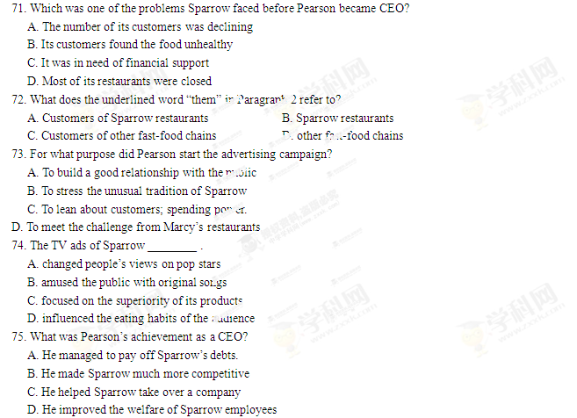
第II卷
第四部分：书面表达（共两节，满分45分）
- 阅读表达 （第76、77、80题每题3分，第78题4分，79题2分，满分15分）
阅读下面短文并用英语回答问题，交答案与在答题卡相应的位置上（请注意76、77、79和80四个小题后面的词数要求）。
[1] Jean Paul Getty was born in 1892 in Minneapolis, Minnesota. He became a millionaire when he was only 24. His father was wealthy, but he did not help his son. Getty made his millions alone. He made his money from oil. He owned Getty Oil and over 100 other companies. The Fortune magazine once called Getty “the richest man in the world.”
[2]But money _________. He married five times and divorced five times. He had five children but spent little time with them. None of Getty’s children had very happy lives.
[3]Getty loved to make money and loved to save it. In spite of his great wealth, Getty was miser. Every evening, he wrote down every cent he spent that day. He even put pay telephone in the guest’s bedrooms in his house so he could save money on phone bills.
[4] In 1973, kidnappers took his 16-year-old grandson, and demanded a large amount of money for his safe return. Getty’s son asked his father for money to save his child. But Getty refused. The kidnappers were merciless and Getty’s son made repeated requests for help from his father. Finally, Getty agreed to lend the money, but at 4 percent interest.
[5] Getty started a museum at his home Malibu, California. He bought many important and beautiful pieces of art for the 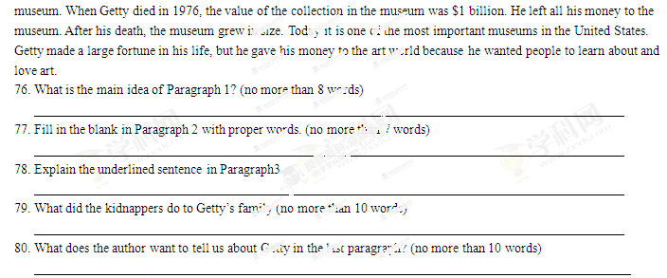第二节 写作（满分30分）
假如你是新华中学的学生李华，你的美国朋友Tom一周前给你发电子邮件，询问你暑假里的打算，但你因准备期末考试未能及时回复。请根据双下要点给他回封邮件：
- 未及时回信的原因；
- 你假期的打算（如做兼职、旅行、做志愿者等）
注意：1. 词数：120-150；
2 可适当增加细节，以使行文连贯。

