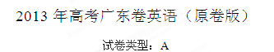
2013年普通高等学校招生全国统一考试（广东卷）
英语
本试卷共12页,三大题,满分135分.考试用时120分钟
注意事项：
1.答卷前，考生务必用黑色笔迹的钢笔或签字笔将自己的姓名和考生号、考场号、座位号填写在答题卡上。用2B铅笔将试卷类型（A）填涂在答题卡相应的位置上。将条形码横贴在答题卡右上角“条形码粘贴处”。
2.选择题每小题选出答案后，用2B铅笔把答题卡上对应题目选项的答案信息点涂黑；如需改动，用橡皮擦干净后，再选涂其他答案，答案不能答在试卷上。
3.非选择题必须用黑色字迹的钢笔或签字笔作答，答案必须写在答题卡各题目指定区域内相应位置上；如需改动，先划掉原来的答案，然后再写上新的答案；不准使用铅笔和涂改液。不按以上要求作答的答案无效。
4.考生必须保持答题卡的整洁，考试结束后，将试题与答题卡一并交回。
I 语言知识及应用（共两节，满分45分）
- 完形填空（共15小题；每小题2分，满分30分）
阅读下面短文，掌握其大意，然后从1~15各题所给的A、B、C和D项中，选出最佳选项，并在答题卡上将该项涂黑。
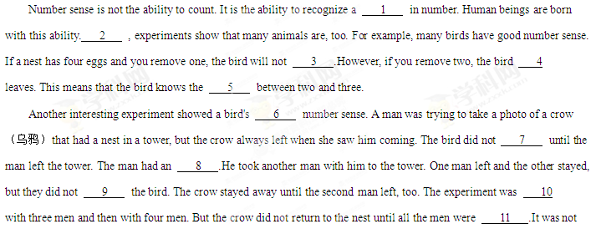until five men went into the tower and only four left that they were 12 able to fool the crow.
How good is a human's number sense? It's not very good. For example, babies about fourteen months old almost always notice if something is taken away from a 13 group. But when the number goes beyond three or four, the children are 14 fooled.
It seems that number sense is something we have in common with many animals in this world, and that our human 15 is not much better than a crow's.
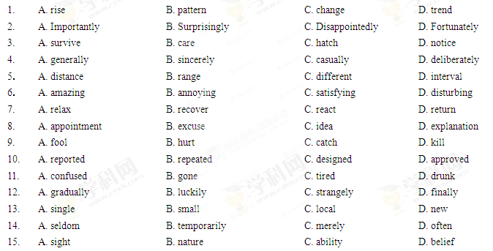
- 语法填空（共10小题；每小题1.5分，满分15分）
阅读下面短文，按照句子结构的语法性和上下文连贯的要求，在空格处填入一个适当的词或者括号中词语的正确形式填空，并将答案填写在答题卡标号为16~25的相应位置上。
One day, Nick invited his friends to supper. He was cooking some delicious food in the kitchen .Suddenly, he 16 （find）that he had run out of salt. So Nick called to his son,” Go to the Village and buy some salt, but pay a fair price for it: neither too much 17 too little.”
His son looked surprised. ”I can understand why I shouldn’t pay too much, Father, but if I can pay less, 18 not save a bit of money?”
“That would be a very 19 （reason）thing to do in a big city, but it could destroy a small village like ours,” Nick said.
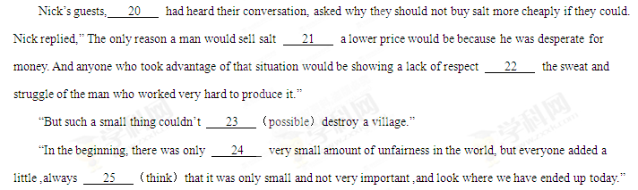Ⅱ 阅读（共两节，满分50分）
- 阅读理解（共20小题；每小题2分，满分40分）
阅读下列短文，从每题所给的A、B、C和D项中，选出最佳选项，并在答题卡上将该项涂黑。
A
Imagination and fantasy can play an important role in achieving the things we fear. Children know this very well. Fred Epstein ,in his book If I Make It to Five, tells a story he heard from one of friends about Tom, a four-year-old boy with a cancer in his back bone. He came through several operations and a lot of pain by mastering his imagination.
Tom loved to pretend, and he particularly loved to play superheroes ,Dr. Epstein explained that it was actually a brilliant way for his young mind to handle the terrifying and painful life he led.
The day before his third trip to the operating room, Tom was terribly afraid. ”Maybe I could go as Superman ,”he whispered to his mom. Hearing this, the mother hesitated for a while. She had avoided buying the expensive costume（戏装），finally she agreed.
The next day Tom appeared as the powerful Superman, showing off through the hospital halls and coolly waving his hand to the people greeting him along the way. And Tom, with the strength of his fantasy, successfully made it through the operation.
The power of imagination need not be reserved for children only. We all have the power to use our fantasies to attempt things we never thought possible, to go through those things that seem impossible, and to achieve what we never believed we could. Just as Dr. Epstein puts it ,”If you can dream it, you can do it”
It doesn‘t mean that you should dress as a superhero for your next job interview. But, next time you are texted in a way that seems impossible, imagine what it would take to overcome it .Become the person you need to become to win over your challenge and do it in your mind first. So, let your imagination run wild, and dare to dream.
26.What do we know about Tom?
A. He was seriously ill B.He was a dishonest boy.
C.He was crazy about magic D.He was Dr.Epstein’s patient
27.What can be inferred about Tom’s mother?
A.She was a rich lady B.She refused Tom’s request
C.She wanted Tom to be a superhero D.She wanted to get Tom through the pain
28.When Tom went for the third operation,he .
A.pretended to be painful B.acted like a superhero
C.appeared in poor spirit s D.argued with his mother
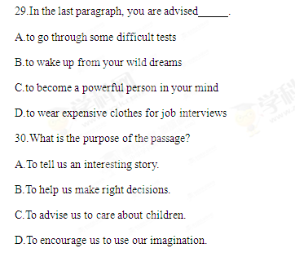
B
Some people think that success is only for those with talent or those who grow up in the right family, and others believe that success mostly comes down to luck. I’m not going to say luck,talent,and circumstances don’t come into play because they do. Some people are born into the right family while others are born with great intelligence, and that’s just the reality of how life is.
However,to succeed in life,one first needs to set a goal and then gradually make it more practical.And,in addition to that,in order to get really good at something,one needs to spend at least 10,000 hours studying and practicing.To become great at certain things,it’ll require even more time,time that most people won’t put in.
This is a big reason why many successful people advise you to do something you love. If you don’t enjoy what you do ,it is going to feel like unbearable pain and will likely make you quit well before you ever become good at it.
When you see people exhibiting some great skills or having achieved great success,you know that they have put in a huge part of their life to get there at a huge cost.It’s sometimes easy to think they got lucky or they were born with some rare talent,but thinking that way does you no good,and there’s a huge chance that you’re wrong anyway.
Whatever you do,if you want to become great at it, you need to work day in and day out,almost to the point of addiction,and over a long period of time.If you’re not willing to put in the time and work,don’t expect to receive any rewards.Consistent, hard work won’t guarantee you the level of success you may want, but it will guarantee that you will become really good at whatever it is you put all that work into.
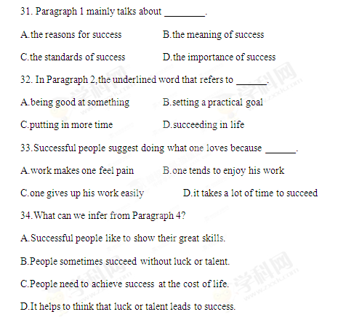
35.What is the main theme of the passage?
A.Having a goal is vital to success. B. Being good is different from being great.
C.One cannot succeed without time and practice.
D.Luck,talent and family help to achieve success.

C
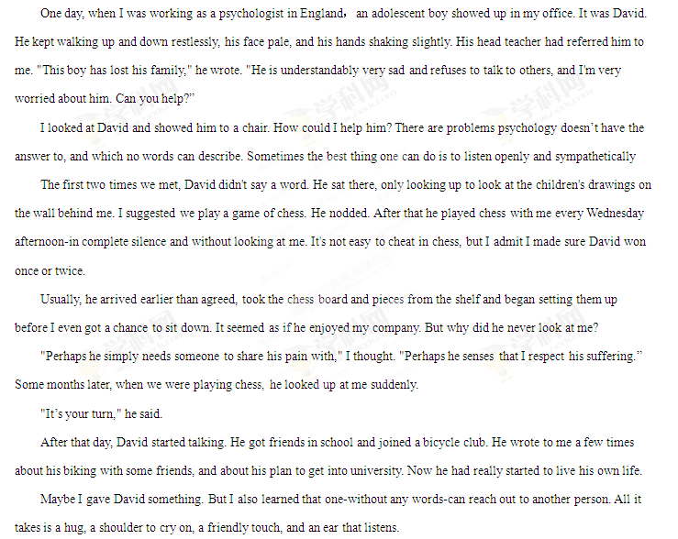36. When he first met the author, David .
A. felt a little excited B. walked energetically
C. looked a little nervous D. showed up with his teacher
37. As a psychologist, the author .
A. was ready to listen to David B. was skeptical about psychology
C. was able to describe David's problem D. was sure of handling David's problem
38．David enjoyed being with the author because he________.
A．wanted to ask the author for advice B. need to share sorrow with the author
C．liked the children’s drawings in the office
D．bear the author many times in the chess game
39．What can be inferred about David?
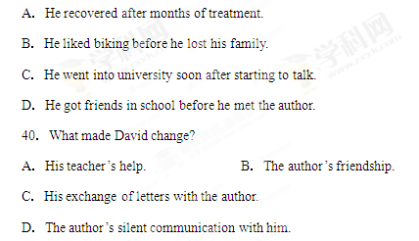
D
While Jennifer was at home taking an online exam for her business law class, a monitor（监控器）a few hundred miles away was watching her every move.
Using a web camera equipped in Jennifer’s Los Angeles apartment, the monitor in Phoenix tracked how frequently her eyes moved from the computer screen and listened for the secret sounds of a possible helper in the room. Her Internet access was locked - remotely - to prevent Internet searches , and her typing style was analyzed to make sure she was who she said she was: Did she enter her student number at the same speed as she had in the past? Or was she slowing down?
In the battle against cheating, this is the cutting edge and a key to encourage honesty in the booming field of online education. The technology gives trust to the entire system, to the institution and to online education in general. Only with solid measures against cheating, experts say, can Internet universities show that their exams and diplomas are valid - that students haven’t just searched the Internet to get the right answers.
Although online classes have existed for more than a decade, the concern over cheating has become sharper in the last year with the growth of "open online courses." Private colleges, public universities and corporations are jumping into the online education field, spending millions of dollars to attract potential students, while also taking steps to help guarantee honesty at a distance.
Aside from the web cameras, a number of other high-tech methods are becoming increasingly popular. Among them are programs that check students’ identities using personal information, such as the telephone number they once used.
Other programs can produce unique exam by drawing on a large list of questions and can recognize possible cheaters by analyzing whether difficult test question are answered at the same speed as easy ones. As in many university classes, term papers are scanned against some large Internet data banks for cheating.
41. Why was Jennifer watched in an online exam?
A. To correct her typing mistakes.
B. To find her secrets in the room.
C. To prevent her from slowing down.
D. To keep her from dishonest behaviors.
42. The underlined expression cutting edge in Paragraph 3 is closest in meaning to______.
A. advanced technique B. sharpening tool
C. effective rule D. dividing line
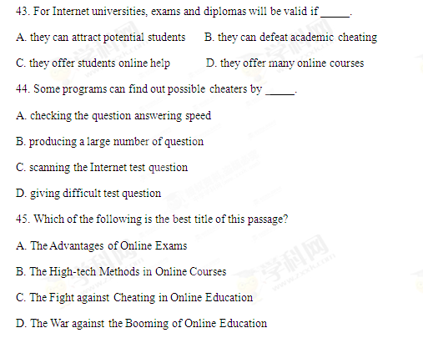

第二节 信息匹配（共5小题；每小题2分，满分10分）
阅读下列应用文及相关信息，并按照要求匹配信息，请在答题卡上将对应题号的相应选项字母涂黑。
首先请阅读下列杂志上的广告内容：
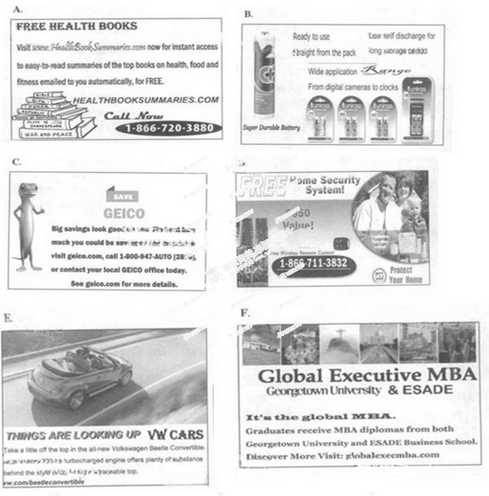

以下是读者为了获取相关广告详细信息的电子邮件，请匹配内容与邮件。

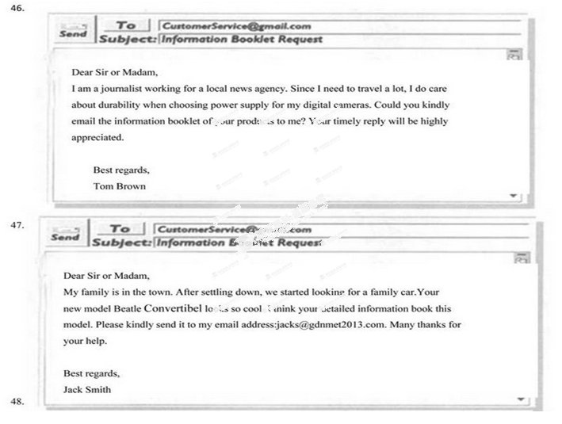
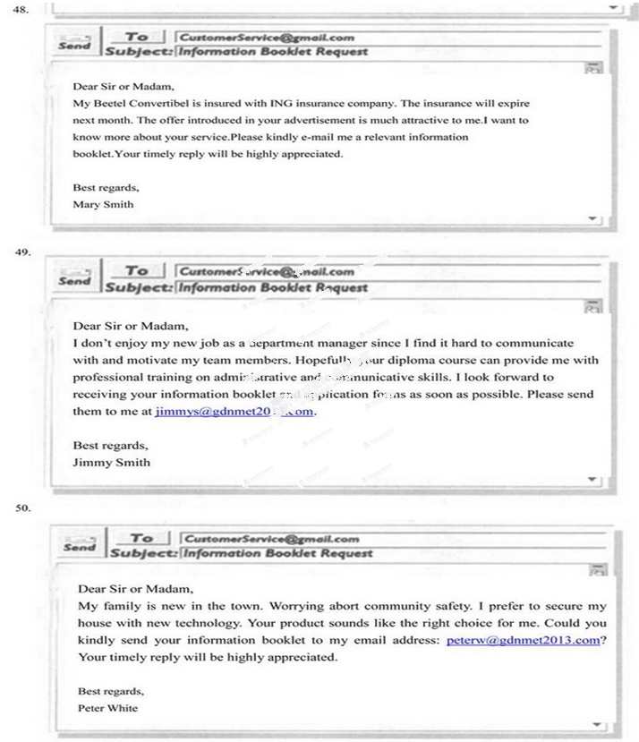

Ⅲ 写作（共两节，满分40分）
- 基础写作（共1小题；满分15分）
你接受了一项写作任务，要为英语校报写一篇时事快讯。
[写作内容]
请根据以下信息，写一篇关于移民火星的快讯
志愿者的选拔
到2015年，在全球选出约30名去火星*的志愿者
志愿者的条件
至少18岁；做好不回地球的准备；愿与他人保持良好的关系。
专家观点
火星生活条件太艰苦；面临严寒气候、孤独和恐惧。
志愿者观点
厌倦地球生活，想体验火星生活；
如果成功，就是人类英雄。
*火星： the Mars
[写作要求]
只能用5个句子表达全部内容
[评分标准]
句子结构准确，信息内容完整，篇章连贯。
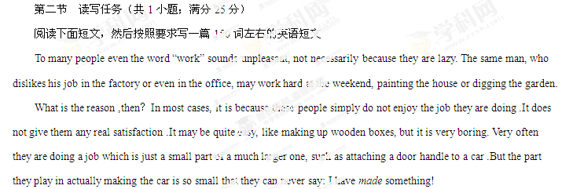
Yet in modern society somebody has to do ordinary jobs such as cleaning streets because this is the way society is organized. No matter how ordinary a job is, it plays a part in society and therefore deserves our due respect. Society cannot function a single day without the “dull and boring” jobs.

[写作要求]
1.作文中可以使用亲身经历或虚构的故事，也可以参照阅读材料的内容，但不得直接引用原文中的句子。
2.作文中不能出现真实姓名和学校名称。
[评分标准]
概括准确，语言规范，内容合适，语篇连贯。

