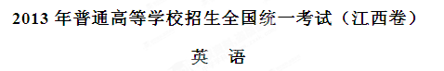
第Ⅰ卷（选择题 共115分）
第一部分 听力 （共两节，满分30分）
回答听力部分时，请先将答案标在试卷上。听力部分结束前，你将有两分钟的时间将您的答案转涂到客观答题卡上。
第一节（共5小题：每小题1.5分，满分7.5分）
听下面5段对话，每段对话后有一个小题，从题中所给的A、B、C三个选项选出最佳选项，并标在试卷的相应位置，听完每段对话后，你都有10秒钟的时间来回答有关小题和阅读下小题，每段对话仅读一遍。
例：How much is the shirt?
A. ￡19.15. B. ￡ 9.18 C.￡9.15.
答案是C。
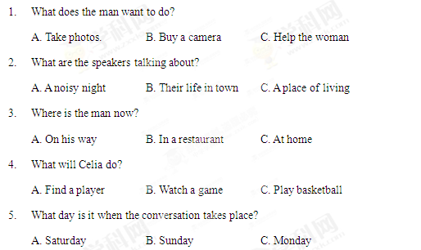
第二节（共15小题：每小题1.5分，满分22.5分）
听下面5段对话。每段对话有几个小题，从题中所给的A、B、C三个选项中选出的最佳选项，并标在试卷的相应位置。听每段对话前，你将有时间阅读各个小题，每小题5秒钟；听完后，各小题给出5秒钟的做答时间。每段对话读两遍。
听第6段材料，回答第6、7题。
6. What is Sara going to do?
A. Buy John a gift. B. Give John a surprise C. Invite John to France
7. What does the man think of Sara’s plan?
A. Funny B. Exciting C. Strange.
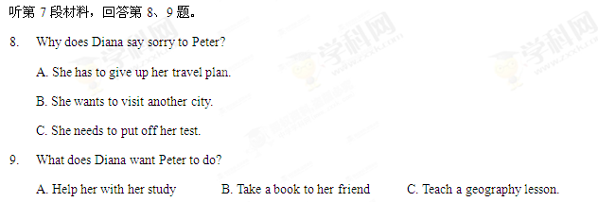
听第8段材料，回答第10至12题。
10. Why does the man call the woman?
A. To tell her about her new job B. To ask about her job program C. To plan a meeting with her.
11. Who needs a new flat?
A. Alex B. Andrea. C. Miranda.
12. Where is the woman now?
A. In Baltimore. B. In New York. C. In Avon
听第9段材料，回答第13至16题。
13. What does Jan consider most important when he judges a restaurant?
A. Where the restaurant is.
B. Whether the prices are low
C. How well the food is prepared.
14. When did Jan begin to write for a magazine?
A. After he came back to Sweden
B. Before he went to the United States.
C. As soon as he got his first job in 1982.
15. What may Jan do to find a good restaurant?
A. Talk to people in the street. B. Speak to taxi drivers C. Ask hotel clerks.
16. What do we know about Jan?
A. He cooks for a restaurant. B. He travels a lot for his work. C. He prefers American food.
听第10段材料，回答每17至20题。
17. What do we know about the Plaza Leon?
A. It’s a new building B. It’s a small town. C. It’s a public place.
18. When do parents and children like going to the Plaza Leon?
A. Saturday nights. B. Sunday afternoons. C. Fridays and Saturdays.
19. Which street is known for its food shops and markets?
A. Via del Mar Street. B. Fernando Street C. Hernandes Street.
20. Why does the speaker like Horatio Street best?
A. It has an old stone surface. B. It is named after a writer. C. It has a famous university.
第二部分英语知识运用（共两节.满分45分）
笫一节 单项填空（共15小题，每小题1分，共15分）
从A、B、C、D四个选项中.选出可以填入空白的最佳选项，并在答题卡上将该项涂黑。
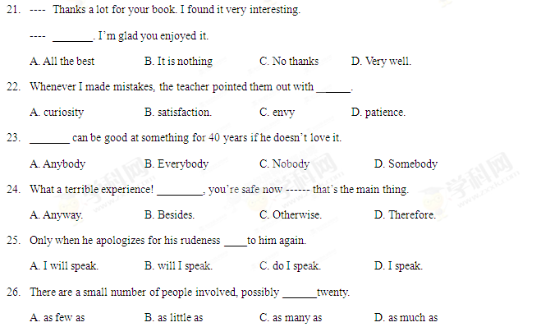
27. Mother always complains that children _______ their shoes very quickly.
A. find out B. wash out C. wear out D. set out
28. She says that she’ll have to close the shop ________ business improves.
A. if B. unless C. after D. when
29. When I was a child, I ______ watch TV whenever I wanted to.
A. should B. could C. must D. need
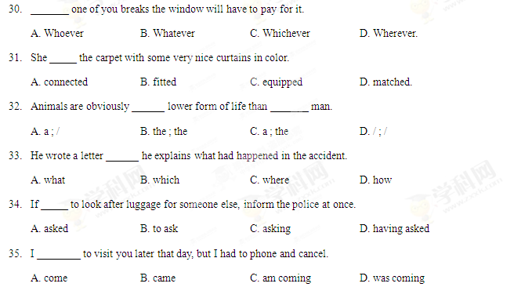
第二节完形填空(共20小题，每小题1.5分，满分30分)
阅读下面短文，掌握其段落大意，然后从36至55各题所给的四个选项A.B.C和D，选出最佳选项，并在答题卡上将该项涂黑。
Diane Ray was completely self-centered and very spoilt. Her parents gave her 36 she wanted, knowing that she would throw a temper tantrum(耍小孩脾气)if they did not. She would scream and kick and 37 on the floor drumming her heels. Her parents always 38 .
That was why she was alone on the 39 , wearing an expensive swimsuit. It has taken a massive tantrum to 40 her parents to buy it. They were back at the beach-house, 41 from the tantrum she had thrown when they told her that it was too dangerous to go diving 42 . “Dangerous?” she had said. “You just don’t want me to have 43 . I’m going and if you try to stop me, I’ll scream.”
“What are you doing ?” a voice asked. Diane jumped. She did not know that the man was there 44 he spoke .
“I’m going diving, ” she answered.
“You shouldn’t swim that day, ” the man 45 . “There is a storm coming up.”
“You should mind your own 46 !” Diane replied and walked into the gentle waves.
“If you go out there you’ll be 47 ,” the man called after her. She did not bother to reply.
Diane slipped into the water and dived 48 until white caps began rolling in and it became harder to 49 against the current (水流). Saltwater hit against her face, making it 50 to breathe. Oh, why had she not listened to advice.
Panicking, she began to 51 . Then, just as it seemed as if she would slip beneath the surface, she heard a 52 voice. “Hold on ! I’m coming.” With 53 , she saw the old man rowing an ancient-looking boat towards her. “I hope you’ve learned a lesson. You put us both in 54 , ” he shouted angrily, as he dragged her over the side of the 55 . Gratefully, Diane thanked him and ran towards the beach-house.
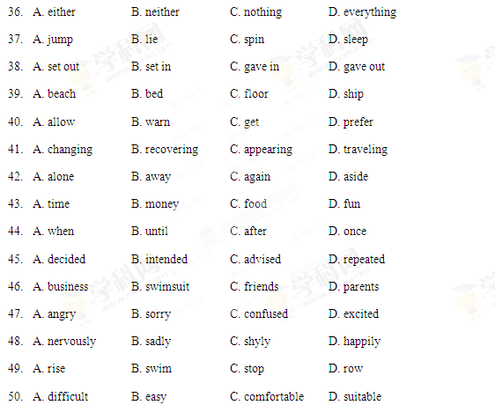
51. A. speak B. sing C. sniff D. scream
52. A. calm B. frightening C. beautiful D. disgusting
53. A. regret B. relief C. interest D. ease
54. A. power B. safety C.. danger D. thought
55. A. house B. wave C. beach D. boat
第三部分 阅读理解（共20小题；每小题2份，满分40分）
阅读下列短文，从每题所给的四个选项（A、B、C和D）中，选出最佳选项，并在答题卡上将该项涂黑。
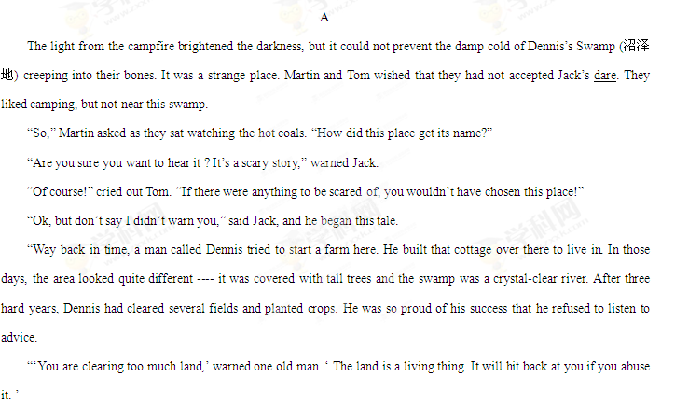 “‘Silly fool,’ said Dennis to himself. ‘If I clear more land, I can grow more crops. I’ll become wealthier. He’s just jealous!’”
“Dennis continued to chop down trees. Small animals that relied on them for food and shelter were destroyed. He was so eager to expand his farm that he did not notice the river flowing slowly towards his door. He did not notice salt seeping to the surface of the land. He did not notice swamp plants choking all the native plants.”
“What happened?” Martin asked. It was growing colder. He trembled, twisting his body closer to the fire.
“The land hit back ---- just as the old man warned,” Jack shrugged. “Dennis disappeared. Old folks around here believe that swamp plants moved up from the river and dragged him underwater. His body was never found.”
“What a stupid story,” laughed Tom. “Plants can’t …” Before he had finished speaking, he screamed and fainted (晕倒). The other two boys jumped up with fright, staring at Tom. Suddenly, they burst out laughing. Some green swamp ivy (常春藤) had covered Tom’s face. It was a while before Tom could appreciate the joke.
56. The underlined word “dare” in Paragraph 1 is closed in meaning to ________.
A. courage B. assistance C. instruction D. challenge
57. Why did Jack tell Tom and Martin the story?
A. To frighten them.
B. To satisfy their curiosity.
C. To warn them of the danger of the place.
D. To persuade them to camp in the swamp.
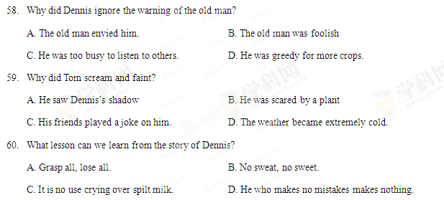
B
When international aid is given, steps must be taken to ensure (确保)that the aid reaches the people for whom it is intended. The way to achieve this may not be simple. It is very difficult for a nation to give help directly to people in another nation. The United Nations Organization (UNO) could undertake to direct the distribution of aid. Here however rises the problem of costs. Also tied with this is time. Perhaps the UNO could set up a body of devoted men and women in every country who can speedily distribute aid to victims of floods and earthquakes.
More than the help that one nation can give to another during a disaster; it would be more effective to give other forms of help during normal times. A common proverb says, “Give me a fish and I eat for day, teach me to fish and I eat for a lifetime.” If we follow this wise saying, it would be right to teach people from less developed nations to take care of themselves. For example, a country could share its technology with another. This could be in simple areas like agriculture or in more complex areas like medical and health care or even in building satellites. Even small country is able to help less developed nations. Sometimes what is take for granted, like the setting up of a water purification plant or the administration of a school, could be useful for countries which are looking about to solve common problems. It does not cost much to share such simple things. Exchange students could be attached for a number of months or years and learn the required craft while on the site. They can then take their knowledge back to their homelands and if necessary come back form time to time to clear doubts or to update themselves. Such aid will be truly helpful and there is no chance of it being temporary or of it falling into the wrong hands.
Many countries run extensive courses in all sorts of skills. It will not cost much to include deserving foreigners in these courses. Besides giving effective help to the countries concerned, there is also the build-up of friendships to consider. Giving direct help by giving materials may be effective in the short run and must continue to be given in the event of emergencies. However, in the long run what is really effective would be the sharing of knowledge.
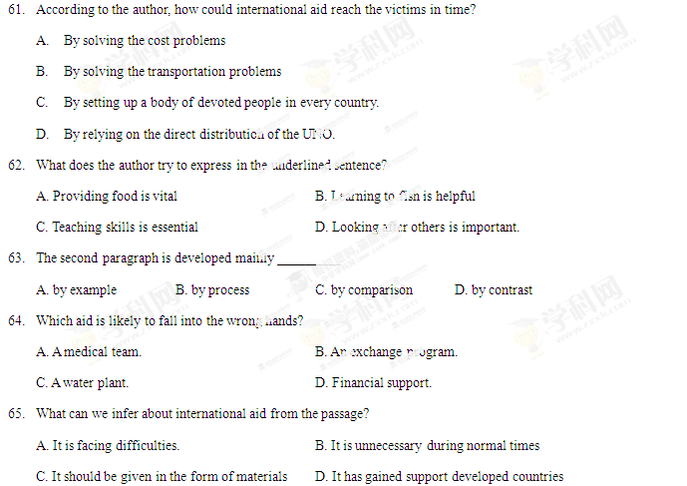C
Many people think that listening is a passive business. It is just the opposite. Listening well is an active exercise of our attention and hard work. It is because they do not realize this, or because they are not willing to do the work, that most people do not listen well.
Listening well also requires total concentration upon someone else. An essential part of listening well is the rule known as ‘bracketing’. Bracketing includes the temporary giving up or setting aside of your own prejudices and desires, to experience as far as possible someone else’s world from the inside, stepping into his or her shoes. Moreover, since listening well involves bracketing, it also involves a temporary acceptance of the other person. Sensing this acceptance, the speaker will seem quite willing to open up the inner part of his or her mind to the listener. True communication is under way and the energy required for listening well is so great that it can be accomplished only by the will to extend oneself for mutual growth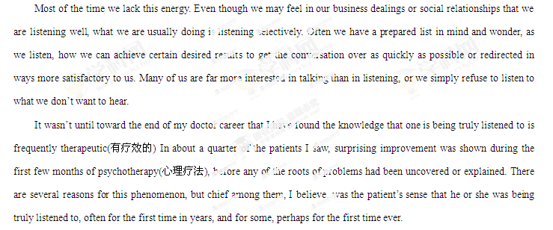66. The phrase “stepping into his or her shoes” in paragraph 2 probably means _______.
A. preparing a topic list first B. focusing on one’s own mind
C. directing the talk to the desired results D. experiencing the speaker’s inside world
67. What is mainly discussed in Paragraph 2?
A. How to listen well. B. What to listen to.
C. Benefits of listening. D. Problems in listening
68. According to the author, in communication people tend to ________.
A. listen actively B. listen purposefully
C. set aside their prejudices D. open up their inner mind
69. According to the author, the patients improved mainly because _______.
A. they were taken good care of. B. they knew they were truly listened to.
C. they had partners to talk to. D. they knew the roots of problems.
70. What type of writing the article likely to be?
A. Science fiction B. A news report. C. A medical report. D. Popular science
D
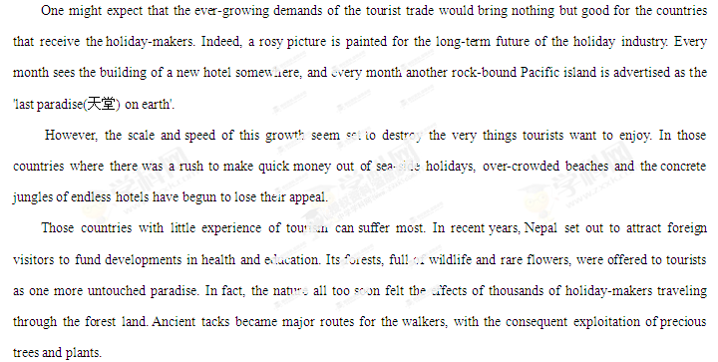 Not only can the environment of a country suffer from the sudden growth of tourism. The people as well rapidly feel its effects. Farmland makes way for hotels, roads and airports; the old way of life goes. The one-time farmer is now the servant of some multi-national organization; he is no longer his own master. Once it was his back that bore the pain; now it is his smile that is exploited. No doubt he wonders whether he wasn't happier in his village working his own land.
Thankfully, the tourist industry is waking up to the responsibilities it has towards those countries that receive its customers. The protection of wildlife and the creation of national parks go hand in hand with tourist development and in fact obtain financial support from tourist companies. At the same time, tourists are being encouraged to respect not only the countryside they visit but also its people.
The way tourism is handled in the next ten years will decide its fate and that of the countries we all want to visit. Their needs and problems are more important than those of the tourist companies. Increased understanding in planning world-wide tourism can preserve the market for these companies. If not, in a few years’ time the very things that attract tourists now may well have been destroyed.
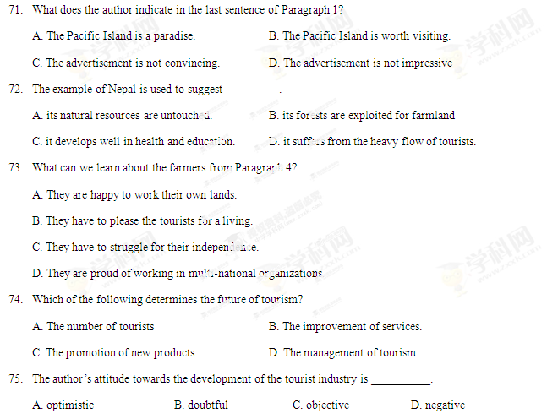
第二卷（非选择题 满分35分）
注意事项：
第二卷2页，须用黑色墨水签字笔在答题卡上书写作答。如在试题卷上作答，答案无效。
第四部分 写作（共两节，满分35分）
第一节 阅读表达（共5小题；每小题2分，满分10分）
阅读下面短文并回答问题，然后将答案写到答题卡相应的位置上（请注意问题后的词数要求）。
[1] Fishing is probably the world’s most popular sport. People spend many dollars each year on items like boats and four-wheel-drive vehicles. In addition, they spend money on fishing equipment, bait, fuel and boat repairs. And you can see that fishing can be an expensive pastime. Fishing lovers believe that their hobby is worth it. Others say that fishing is spoiling the environment and that it is a cruel hobby.
[2] Supporters of fishing say that it is a nice hobby. Firstly, of the millions of people who fish for fun, most only catch enough fish to feed their families. They catch fish that are found in large numbers, so there is little danger to the species (种类).
[3] Secondly, recreational fishermen contribute to the economy. They spend money on equipment and other items, and they also spend it indirectly by paying taxes on their equipment and fuel. Those who travel to fishing spots pay for accommodation (食宿) and airfares. This money keeps people in work and provides new jobs each year.
[4] Thirdly, fishing is relaxing and fun so it lessens stress. Instead of turning to drugs or alcohol, it is far better to go fishing. People who are relaxed are generally healthier and much nicer to be near ----- except for the smell of the bait!
[5] Those who _________________ say that there are too many fish thoughtlessly taken from rivers, lakes, streams and oceans. This could lead to the dying out of some species. Modern cars and boats mean that people can fish in remote areas of the world, so no place is safe from greedy fishermen who take both males and females, leaving few fish to produce young.
[6] Those against fishing also say that it is a blood sport, which means that an animal must die so that a human can have fun. Many of the fish caught for sport are not suitable for eating, so they are thrown away. Once hooked, fish have no chance of escape.
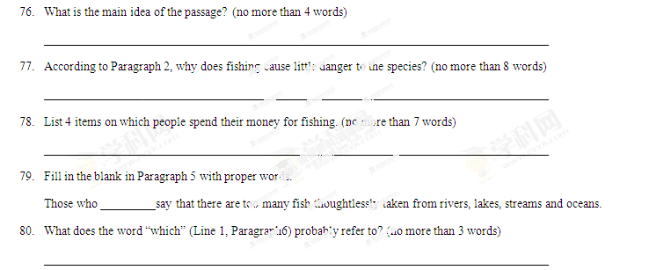第二节 书面表达（满分25分）
星光中学（Xingguang High School）近期举行了一次登山活动。假定你是学校英语报记者，请写一篇短文，报道此次活动。内容包括：
