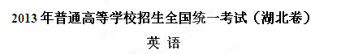
本试题卷共16页，81题。全卷满分150分。考试用时120分钟。
★祝考试顺利★

注意事项：
1. 答卷前，考生务必将自己的姓名、准考证号填写在试题卷和答题卡上，并将准考证号条形码粘贴在答题卡上的指定位置。用统一提供的2B铅笔将答题卡上试卷类型A后的方框涂黑。
2. 选择题的作答：每小题选出答案后，用统一提供的2B铅笔把答题卡上对应题目的答案标号涂黑。如需改动，用橡皮擦干净后，再选涂其它答案标号。答在试题卷、草稿纸上无效。
3. 完成句子和短文写作题的作答：用统一提供的签字笔直接答在答题卡上对应的答题区域内。答在试题卷、草稿纸上无效。
4. 考生必须保持答题卡的整洁。考试结束后，请将本试题卷和答题卡一并上交。
第一部分：听力（共两节，满分30分）
做题时，先将答案划在试卷上。录音内容结束后，你将有两分钟的时间将试卷上的答案转涂到答题卡上。
第一节（共5小题；每小题1.5分，满分7.5分)
听下面5段对话。每段对话后有一个小题，从题中所给的A、B、C三个选项中选出最佳选项，并标在试卷的相应位置。听完每段对话后，你都有10秒钟的时间来回答有关小题和阅读下一小题。每段对话仅读一遍。
例：How much is the shirt?
A. £ 19.15． B. £ 9.15． C. £ 9.18．
答案：B
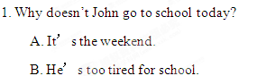
C. His school is closed down.
2. What will the man do tomorrow morning?
A. Give Frank a bath.
B. Cook Frank a meal.
C. Take Frank to a vet.
3. What is the male speaker?
A. A student.
B. A president.
C. A professor.
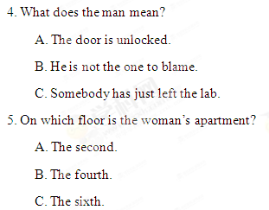
第二节（共15小题；每小题1.5分，满分22.5分)
听下面5段对话或独白。每段对话或独白后有几个小题，从题中所给的A、B、C三个选项中选出最佳选项，并标在试卷的相应位置。听每段对话或独白前，你将有时间阅读各个小题，每小题5秒钟；听完后，各小题将给出5秒钟的作答时间。每段对话或独白读两遍。
听第6段材料，回答第6、7题。
6. What is the man’s problem?
A. He is too busy to wait.
B. He cannot find his pills.
C. He has a pain in his back.
7. Why does Doctor Green break the rule for the man?
A. He is very polite.
B. He is going on a vacation.
C. He is unable to afford a full checkup.
听第7段材料，回答第8、9题。
8. Why does the woman call?
A. To offer a job.
B. To raise money.
C. To make an appointment.
9. Where is the man expected to go tomorrow?
A. The agency.
B. Grand Hotel.
C. The City Hall.
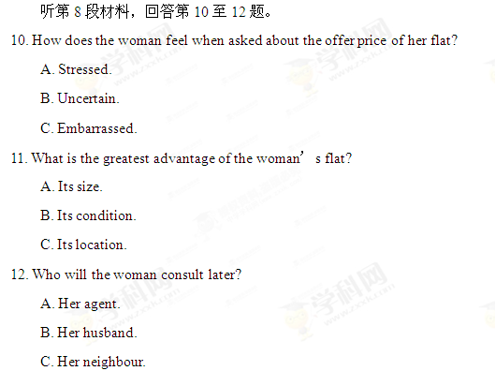
听第9段材料，回答第13至16题。
13. Who is Alexander?
A. The woman’s boss.
B. The woman’s host.
C. The woman’s cook.
14. What extra dish is to be prepared?
A. Fish. B. Steak. C. Shrimps.
15. What happened in the woman’s department last year?
A. It faced a risk of being shut down.
B. It introduced a new system.
C. It fired a sales manager.
16. What is the man’s attitude towards the preparation for the dinner?
A. He is critical.
B. He is practical.
C. He is enthusiastic.
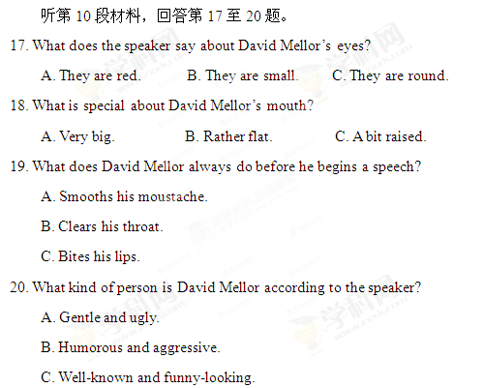

第二部分：词汇知识运用(共两节，满分30分)
第一节：多项选择（共10小题；每小题1分，满分10分)
从A、B、C、D四个选项中，选出可以填入空白处的最佳选项，并在答题卡上将该项涂黑。
例：To make members of a team perform better, the trainer first of all has to know
their _____ and weaknesses．
A. strengths B. benefits C. techniques D. values
答案：A
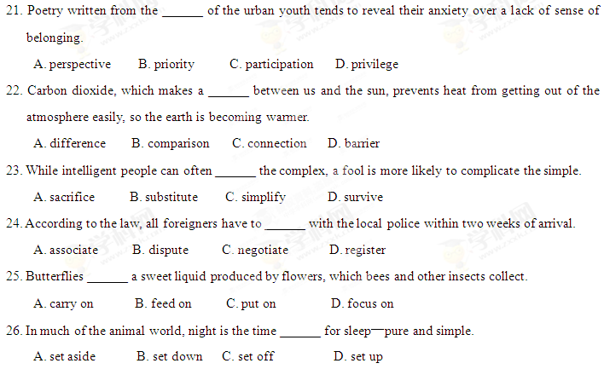27. People complain that decisions to approve or deny a permit are often ______ rather than based on fixed criteria.
A. appropriate B. conscious C. arbitrary D. controversial
28. He didn’t selfishly keep for himself the money inherited from his uncle. Instead, he made a ______ contribution to help the community.
A. commercial B. generous C. comparable D. profitable
29. Don’t defend him any more. It’s obvious that he ______ destroyed the fence of the garden even without apology.
A. accidentally B. carelessly C. deliberately D. clumsily
30. An artist who was recently traveling on a ferry to the southern island discovered ______ a long lost antique Greek vase.
A. at random B. by chance C. in turn D. on occasion

第二节：完形填空（共20小题；每小题1分，满分20分）
阅读下面短文，从短文后所给各题的四个选项（A、B、C和D）中，选出可以填入空白处的最佳选项，并在答题卡上将该项涂黑。
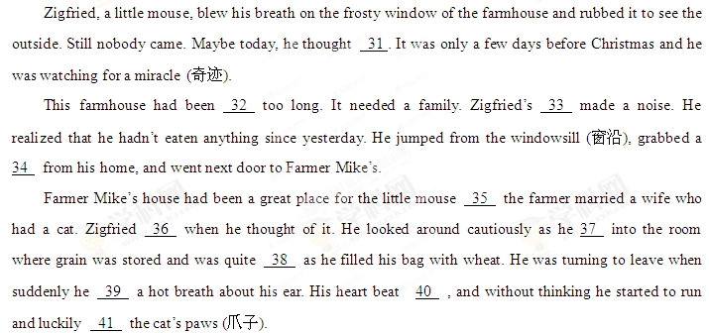The next afternoon Zigfried heard some good news: a 42 family would be moving into the farmhouse soon. Zigfried’s granny would arrive on Christmas Eve to 43 with him. He hoped that the family would come before his granny came. Before long, a car came 44 the road leading to the house, with butter sandwiches, cheese and chocolate.
Zigfried’s Christmas miracle did arrive!
The house came 45 the next few days. Zigfried 46 every single hour of them. 47 , the day before Christmas when he was drinking hot chocolate with a 48 smile at the door of his home, he heard the 49 of the children of the family about what they might get for Christmas. What? A cat? The 50 froze on his face; his mouth fell wide open. After a long while, he at last found his voice: “Hey! Whose Christmas miracle is this?”
31. A. carefully B. excitedly C. hopefully D. proudly
32. A. shabby B. noisy C. messy D. empty
33. A. mouth B. nose C. stomach D. throat
34. A. bag B. stick C. bowl D. coat
35. A. although B. until C. whereas D. unless
36. A. leapt B. sniffed C. trembled D. withdrew
37. A. broke B. marched C. paced D. stole
38. A. curious B. nervous C. pitiful D. sensible
39. A. took B. released C. felt D. drew
40. A. strongly B. irregularly C. slowly D. wildly
41. A. escaped B. seized C. rubbed D. scratched
42. A. close B. happy C. new D. young
43. A. celebrate B. communicate C. compete D. compromise
44. A. across B. from C. off D. up
45. A. alive B. loose C. open D. still
46. A. counted B. enjoyed C. missed D. wasted
47. A. However B. Instead C. Moreover D. Therefore
48. A. bitter B. forced C. polite D. satisfied
49. A. introduction B. discussion C. comment D. debate
50. A. blood B. smile C. tear D. sweat

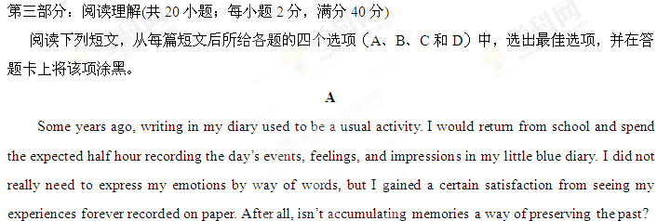When I was thirteen years old, I went on a long journey on foot in a great valley, well-equipped with pens, a diary, and a camera. During the trip, I was busy recording every incident, name and place I came across. I felt proud to be spending my time productively, dutifully preserving for future generations a detailed description of my travels. On my last night there, I wandered out of my tent, diary in hand. The sky was clear and lit by the glare of the moon, and the walls of the valley looked threatening behind their screen of shadows. I automatically took out my pen…
At that point, I understood that nothing I wrote could ever match or replace the few seconds I allowed myself to experience the dramatic beauty of the valley. All I remembered of the previous few days were the dull characterizations I had set down in my diary.
Now, I only write in my diary when I need to write down a special thought or feeling. I still love to record ideas and quotations that strike me in books, or observations that are particularly meaningful. I take pictures, but not very often—only of objects I find really beautiful. I’m no longer blindly satisfied with having something to remember when I grow old. I realize that life will simply pass me by if I stay behind the camera, busy preserving the present so as to live it in the future.
I don’t want to wake up one day and have nothing but a pile of pictures and notes. Maybe I won’t have as many exact representations of people and places; maybe I’ll forget certain facts, but at least the experiences will always remain inside me. I don’t live to make memories—I just live, and the memories form themselves.
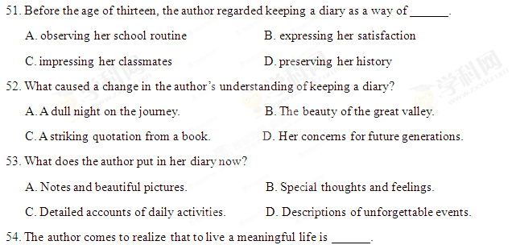
A. to experience it B. to live the present in the future
C. to make memories D. to give accurate representations of it
B
Mothers and daughters go through so much—yet when was the last time a mother and daughter sat down to write a book together about it all? Perri Klass and her mother, Sheila Solomon Klass, both gifted professional writers, prove to be ideal co-writers as they examine their decades of motherhood, daughterhood, and the wonderful ways their lives have overlapped (重叠).
Perri notes with amazement how closely her own life has mirrored her mother’s: both have full-time careers; both have published books, articles, and stories; each has three children; they both love to read. They also love to travel—in fact, they often take trips together. But in truth, the harder they look at their lives, the more they acknowledge their big differences in circumstance and basic nature.
Looking deep into the lives they have lived separately and together, Perri and Sheila tell their mother-daughter story with honesty, humor, enthusiasm, and admiration for each other. A written account in two voices, Every Mother Is a Daughter is a duet (二重奏) that produces a deep, strong sound with the experiences that all mothers and daughters will recognize.
55. Why does Perri think that her own life has mirrored her mother’s?
A. They both have gone through difficult times.
B. They have strong emotional ties with each other.
C. They have the same joys and pains, and love and bitterness.
D. They both have experiences as daughter, mother and writer.
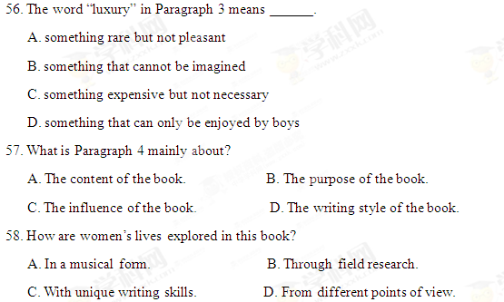
C
We’ve reached a strange—some would say unusual—point. While fighting world hunger continues to be the matter of vital importance according to a recent report from the World Health Organization (WHO), more people now die from being overweight, or say, from being extremely fat, than from being underweight. It’s the good life that’s more likely to kill us these days.
Worse, nearly l8 million children under the age of five around the world are estimated to be overweight. What’s going on?
We really don’t have many excuses for our weight problems. The dangers of the problem have been drilled into us by public-health campaigns since 2001 and the message is getting through—up to a point.
In the 1970s, Finland, for example, had the highest rate of heart disease in the world and being overweight was its main cause. Not any more. A public-health campaign has greatly reduced the number of heart disease deaths by 80 per cent over the past three decades.
Maybe that explains why the percentage of people in Finland taking diet pills doubled between 2001 and 2005, and doctors even offer surgery of removing fat inside and change the shape of the body. That has become a sort of fashion. No wonder it ranks as the world’s most body-conscious country.
We know what we should be doing to lose weight—but actually doing it is another matter. By far the most popular excuse is not taking enough exercise. More than half of us admit we lack willpower.
Others blame good food. They say: it’s just too inviting and it makes them overeat. Still others lay the blame on the Americans, complaining that pounds have piled on thanks to eating too much American-style fast food.
Some also blame their parents—their genes. But unfortunately, the parents are wronged because they’re normal in shape, or rather slim.
It’s a similar story around the world, although people are relatively unlikely to have tried to lose weight. Parents are eager to see their kids shape up. Do as I say—not as I do.
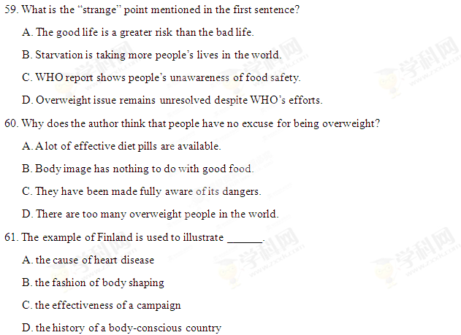
62. Which would be the best title for the passage?
A. Actions or Excuses? B. Overweight or Underweight?
C. WHO in a Dilemma D. No Longer Dying of Hunger
D
The technology is great. Without it we wouldn’t have been able to put a man on the moon, explore the ocean’s depths or eat microwave sausages. Computers have revolutionized our lives and they have the power to educate and pass on knowledge. But sometimes this power can create more problems than it solves.
Every doctor has had to try their best to calm down patients who’ve come into their surgery waving an Internet print-out, convinced that they have some rare incurable disease, say, throat cancer. The truth is usually far more ordinary, though: they don’t have throat cancer, and it’s just that their throats are swollen. Being a graduate of the Internet “school” of medicine does not guarantee accurate self-health-checks.
One day Mrs. Almond came to my hospital after feeling faint at work. While I took her blood sample and tried to find out what was wrong, she said calmly, “I know what’s wrong; I’ve got throat cancer. I know there’s nothing you doctors can do about it and I’ve just got to wait until the day comes.”
As a matter of routine I ordered a chest X-ray. I looked at it and the blood results an hour later. Something wasn’t right. “Did your local doctor do an X-ray?” I asked. “Oh, I haven’t been to the doctor for years,” she replied. “I read about it on a website and the symptoms fitted, so I knew that’s what I had.”
However, some of her symptoms, like the severe cough and weight loss, didn’t fit with it—but she’d just ignored this.
I looked at the X-ray again, and more tests confirmed it wasn’t the cancer but tuberculosis (肺结核)—something that most certainly did need treating, and could be deadly. She was lucky we caught it when we did.
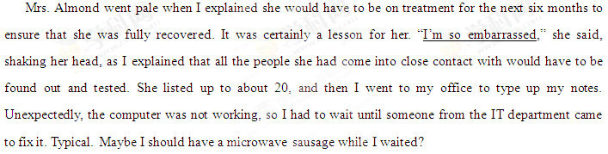63. Mrs. Almond talked about her illness calmly because ______.
A. she thought she knew it well
B. she had purchased medicine online
C. she graduated from a medical school
D. she had been treated by local doctors
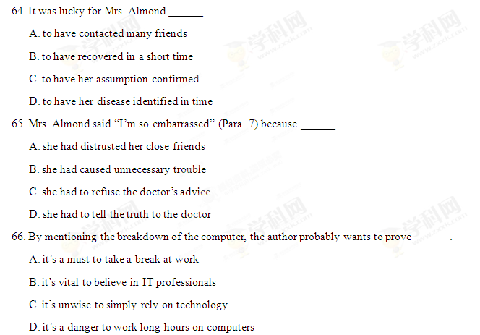
E
A German study suggests that people who were too optimistic about their future actually faced greater risk of disability or death within 10 years than those pessimists who expected their future to be worse.
The paper, published this March in Psychology and Aging, examined health and welfare surveys from roughly 40,000 Germans between ages 18 and 96. The surveys were conducted every year from 1993 to 2003.
Survey respondents (受访者) were asked to estimate their present and future life satisfaction on a scale of 0 to 10, among other questions.
The researchers found that young adults (age 18 to 39) routinely overestimated their future life satisfaction, while middle-aged adults (age 40 to 64) more accurately predicted how they would feel in the future. Adults of 65 and older, however, were far more likely to underestimate their future life satisfaction. Not only did they feel more satisfied than they thought they would, the older pessimists seemed to suffer a lower ratio (比率) of disability and death for the study period.
“We observed that being too optimistic in predicting a better future than actually observed was associated with a greater risk of disability and a greater risk of death within the following decade,” wrote Frieder R. Lang, a professor at the University of Erlangen-Nuremberg.
Lang and his colleagues believed that people who were pessimistic about their future may be more careful about their actions than people who expected a rosy future.
“Seeing a dark future may encourage positive evaluations of the actual self and may contribute to taking improved precautions (预防措施),” the authors wrote.
Surprisingly, compared with those in poor health or who had low incomes, respondents who enjoyed good health or income were associated with expecting a greater decline. Also, the researchers said that higher income was related to a greater risk of disability.
The authors of the study noted that there were limitations to their conclusions. Illness, medical treatment and personal loss could also have driven health outcomes.
However, the researchers said a pattern was clear. “We found that from early to late adulthood, individuals adapt their expectations of future life satisfaction from optimistic, to accurate, to pessimistic,” the authors concluded.
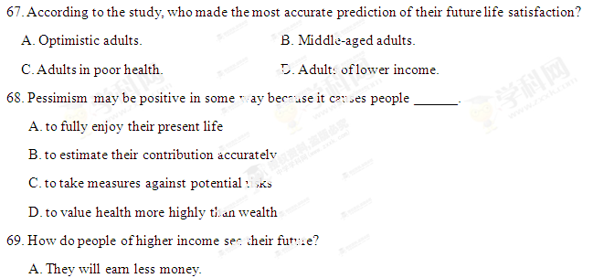
B. They will become pessimistic.
C. They will suffer mental illness.
D. They will have less time to enjoy life.
70. What is the clear conclusion of the study?
A. Pessimism guarantees chances of survival.
B. Good financial condition leads to good health.
C. Medical treatment determines health outcomes.
D. Expectations of future life satisfaction decline with age.

第四部分：书面表达(共两节，满分50分)
第一节：完成句子（共10小题；每小题2分，满分20分)
阅读下列各小题，根据汉语提示，用句末括号内的英语单词完成句子，并将答案写在答题卡上的相应题号后。
例：______ was that the young player performed extremely well in the table tennis tournament. (delight)
令球迷欣喜的是那位年轻的球员在乒乓球锦标赛中表现得极为出色。
答案：What delighted the fans/made the fans delighted
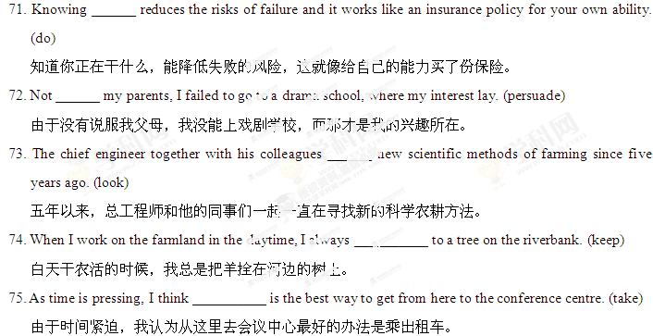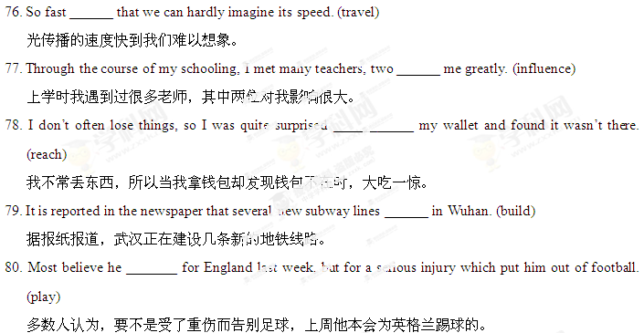
第二节：短文写作（共1题；满分30分)
请根据以下提示，并结合事例，用英语写一篇短文。
We all know that “sticks and stones may break our bones”, but we should also be aware that words can hurt people, too.
注意：①无须写标题，不得照抄英语提示语；
②除诗歌外，文体不限；
③文中不得透露个人姓名和学校名称；
④词数为120左右。

