第一部分 听力（共两节，满分30分）
做题时，先将答案标在试卷上，录音结束后，你将有两分钟的时间将试卷上的答案转涂到答题卡上。
第一节 （共5小题，每小题1.5分，满分7.5分）
听下面5段对话。每段对话后有一个小题，从题中所给的A、B、C三个选项中选出最佳答案。听完每段对话后，你都有10秒钟的时间来回答有关小题和阅读下一小题。每段对话仅读一遍。
例: How much is the shirt?
A. £ 19.15. B. £9.18. C. £9.15.
答案是C.
1. What does the man want to do?
A. Take photos. B. Buy a camera. C. Help the woman.
2. What are the speakers talking about?
A. A noisy night. B. Their life in town. C. A place of living.
3. Where is the man now?
A. On his way. B. In a restaurant. C. At home
4. What will Celia do?
A. Find a player. B. Watch a game. C. Play basketball.
5. What day is it when the conversation takes place?
A. Saturday. B. Sunday. C. Monday.

第二节 （共15小题：每小题1.5分，满分22.5分）
听下面5段对话或独白。每段对话或独白后有几个小题，从题中所给的A、B、C三个选项中选出最佳选项，并标在试卷的相应位置。听每段对话或独白前，你将有时间阅读各个小题，每小题5秒钟；听完后，个小题将给出5秒钟的作答时间。每段对话或独白读两遍。

听第6段材料，回答6、7题。
6. What is Sara going to do?
A. Buy John a gift. B. Give John a surprise. C. Invite John to France.
7. What does the man think of Sara’s plan?
A. Funny. B. Exciting. C. Strange.

听第7段材料，回答第8、9题。
8. Why does Diana say sorry to peter?
A. She has to give up her travel pan.
B. She wants to visit another city.
C. She needs to put off her test.
9. What does Diana want Peter to do?
A. Help her with her study.
B. Take a book to her friend.
C. Teach a geography lesson.

听第8段材料，回答第10至12题。
10. Why does the man call the woman?
A. To tell her about her new job.
B. To ask about her job program.
C. To plan a meeting with her.
11. Who needs a new flat?
A. Alex. B. Andrea. C. Miranda.
12. Where is the woman now?
A. In Baltimore. B. In New York. C. In Avon.

听第9段材料，回答第13至16题。
13. What does Jan consider most important when he judges a restaurant?
A. Where the restaurant is.
B. Whether the prices are low.
C. How well the food is prepared.
14. When did Jan begin to write for a magazine?
A. After he came back to Sweden.
B. Before he went to the United States.
C. As soon as he got his first job in 1982.
15. What may Jan do to find a good restaurant?
A. Talk to people in the street.
B. Speak to taxi drivers.
C. Ask hotel clerks.
16. What do we know about Jan?
A. He cooks for a restaurant.
B. He travels a lot of his work.
C. He prefers American food.

听第10段材料，回答第17至20题。
17. What do we know about the piaza Leen?
A. It’s new building. B. It’s a small town. C It’s public place.
18. When do parents and children like going to the Piaza Leen?
A. Saturday nights. B. Sunday afternoons. C. Fridays and Saturdays.
19. Which street is known for its food shops and markets?
A. Via dei Mar Street. B. Femando Street. C. Hemandes Street.
20. Why does the speaker like Horation Street best ?
A. It has an old stone surface.
B. It is named after a writer.
C. It is a famous university.

第二部分 英语知识运用
第一节 单项填空
21. The "Chinese Dream" is ____ dream to improve people's well-being and ____ dream of harmony, peace and development.
A. the; a B. a; a C. a; the D. the; the
22. _____ basic first-aid techniques will help you respond quickly to emergencies.
A. Known B. Having known C. Knowing D. Being known
23. The famous musician, as well as his students, ____ to perform at the opening ceremony of the 2012 Taipei Flower Expo.
A. were invited B. was invited C. have been invited D. has been invited
24. Michelle found a job as a high school teacher which _____ spending quite a lot of time with students.
A. enjoys B. involves C. practices D. suggests
25. The Forbidden City attracts a _____ stream of visitors every day, especially during national holidays.
A. constant B. main C. powerful D. shallow
26. The girl has a great interest in sport and ____ badminton classes twice a week over the last three years.
A. took B. is taking C. takes D. has been taking
27. The book tells stories of the earthquake through the eyes of those ____ lives were affected.
A. whose B. that C. who D. which
28. Old-fashioned phones matter when wireless networks _____in disasters.
A. turn down B. turn out C. break down D. break out
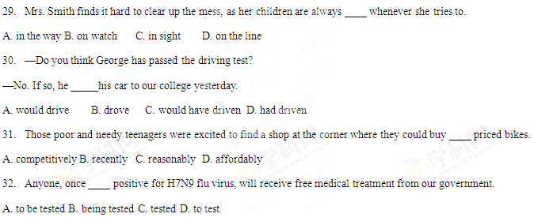
33. —Would you mind answering some questions on shopping habits?
— ________.
A. Yes, with great pleasure B. No, I am afraid I can't make it
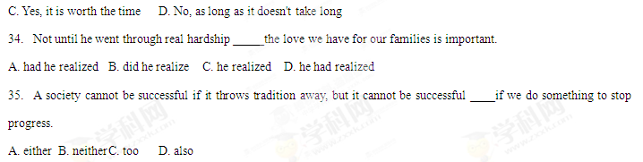第二节 完形填空
We have been driving in fog all morning, but the fog is lifting now. The little seaside villages are 36 , one by one. "There is my grandmother's house," I say, 37 across the bay to a shabby old house.
I am in Nova Scotia on a pilgrimage (朝圣) with Lise, my granddaughter, seeking roots for her, retracing (追溯) 38 memory for me. Lise was one of the mobile children, 39 from house to house in childhood. She longs for a sense of 40 , and so we have come to Nova Scotia where my husband and I were born and where our ancestors 41 for 200 years.
We soon 42 by the house and I tell her what it was like here, the memories 43 back, swift as the tide (潮水).
Suddenly, I long to walk again in the 44 where I was once so gloriously a child. It still 45 a member of the family, but has not been lived in for a while. We cannot go into the house, but I can still walk 46 the rooms in memory. Here, my mother 47 in her bedroom window and wrote in her diary. I can still see the enthusiastic family 48 into and out of the house. I could never have enough of being 49 them. However, that was long after those childhood days. Lise 50 attentively as I talk and then says, " So this is where I 51 ; where I belong. "
She has 52 her roots. To know where I come from is one of the great longings of the human 53 To be rooted is "to have an origin". We need 54 origin. Looking backward, we discover what is unique in us; learn the 55 of "I". We must all go home again—in reality or memory.
36.A. appearing B. moving C. exposing D. expanding
37.A. referring B. travelling C. pointing D. coming
38. A. shared B. short C. fresh D. treasured
- A. passed B. raised C. moved D. sent
- A. home B. duty C. reality D. relief
41.A. built B. lived C. remained D. explored
42.A. catch up B. pull up C. step down D. come down
43.A. falling B. turning C. rushing D. bringing
44.A. yard B. village C. room D. house
45.A. adapts to B. appeals to C. belongs to D. occurs to
46.A. across B. through C. along D. past
47.A. lay B. played C. stood D. sat
48.A. marching B. looking C. breaking D. pouring
49.A. between B. with C. near D. behind
50.A. wonders B. listens C. reacts D. agrees
51.A. began B. grew C. studied D. stayed
52.A. deepened B. recognized C. accepted D. found
53.A. heart B. rights C. interest D. behaviors
54.A. one B. its C. that D. every
55.A. meaning B. expression C. connection D. background
Then she handed me a small ring box. I took it from her and opened it to find my beautiful signet ring inside. The family who had bought our house 13 years earlier had recently decided to do some redecorations, which included replacing the carpets. When they pulled the carpet up in my old bedroom, they found the ring. As it had my initials carved into it, they realized who owned the ring. They'd had it professionally cleaned up by a jeweler before sending it to my mother. And it still fits me.
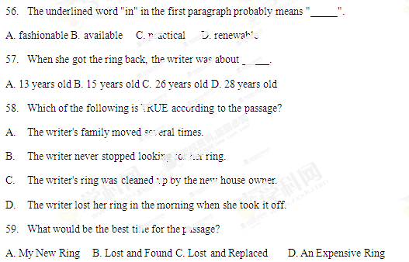
B
Your glasses may someday replace your smartphone, and some New Yorkers are ready for the switch. Some in the city can't wait to try them on and use the maps and GPS that the futuristic eyewear is likely to include.
" I'd use it if I were hanging out with friends at 3 a. m. and going to the bar and wanted to see what was open," said Walter Choo, 40, of Fort Greene.
The smartphone-like glasses will likely come out this year and cost between $250 and $600, the Times said, possibly including a variation of augmented(增强的) reality, a technology already available on smartphones and tablets (平板电脑) that overlays information onto the screen about one's surroundings. So, for example, if you were walking down a street, indicators would pop up showing you the nearest coffee shop or directions could be plotted out and come into view right on the sidewalk in front of you.
" As far as a mainstream consumer product, this just isn't something anybody needs," said Sam Biddle, who writes for Gizmodo.com. " We're accustomed to having one thing in our pocket to do all these things," he added, "and the average consumer isn't gonna be able to afford another device (装置) that's hundreds and hundreds of dollars. "
9to5Google publisher Seth Weintraub, who has been reporting on the smartphone-like glasses since late last year, said he is confident that this type of wearable device will eventually be as common as smartphones.
"It's just like smartphones 10 years ago," Weintraub said. "A few people started getting emails on their phones, and people thought that was crazy. Same kind of thing. We see people bending their heads to look at their smartphones, and it's unnatural," he said. " There's gonna be improvements to that, and this a step there. "
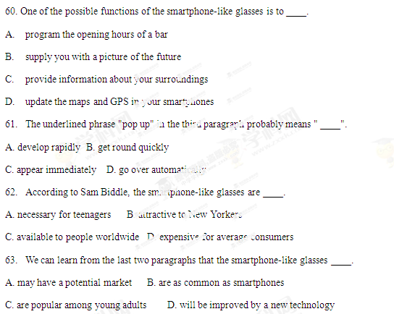
C
This is What a REAL Silver Dollar Looks Like
If you trust in the yen, the euro, and the dollar... stop reading.
Because this is a story about the silver coin EVERYBODY wants.
You read the headlines. You know that troubled economic times have put global currency on a rollercoaster ( ride. But millions have found a smarter way to build long-term value with high-grade collectable silver. And right now, those people are lining up to secure some of the last 2012 U. S. Mint Silver Eagles, America's Newest Silver Eagle Dollars. Today, you can graduate to the front of that line. Buy now and you can own these brilliant uncirculated Silver Dollars for only $38.95!
You Can't Afford to Lose
Why are we releasing (发行) this silver dollar for such a remarkable price? Because we want to introduce you to what hundreds of thousands of smart collectors and satisfied customers have known since 1984—New York Mint is the place to find the world's finest high-grade coins. That's why we're offering you this Brilliant Uncirculated 2012 U. S. Silver Eagle for as little as $37.45 (plus s/h).

Note: $10 s/h (shipping and handling) for each purchase
For fastest service, call toll-free 24 hours a day
1-888-201-7143
Offer Code (代码) ASE177-04
Please mention this code when you call.
New York Mint 14101
Southcross Drive W.,Dept. ASE177-04
Burnsville, Minnesota 55337
www. NewYorkMint. com
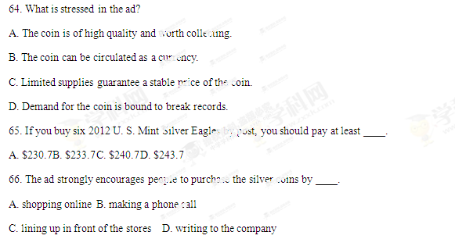
D
Pride and Prejudice for the Modern Woman
Let us imagine how Pride and Prejudice, Jane Austen's most famous work, might be updated, 200 years on.
Austen's popularity is rooted in her intelligence. But today she would certainly have had a very different life, as would her characters. Here's my own suggestion. . .
It is a truth finally and universally acknowledged that a single woman with brains deserves to have equal opportunities to men, however disadvantaged she may feel by sexism.
" My dear husband," said his hopeful wife one day, " have you heard that the local store, standing empty for so long, is taken over by a bright young businesswoman?"
Her dull and indifferent (漠不关心的) husband replied that he had not. "But it is, it is," she replied excitedly. Mr Dull-Husband made no reply.
"Don't you want to know her plans?" she cried with some impatience.
"Well, clearly you think it matters to your silly little head. .. so I'd better listen. "
"Well, my dear, the rumour (传言) is that she has already set up a string of successful businesses in northern England, though how a woman can know anything about that is beyond me. She will move in herself next month. " "What is her name?" "Bingley. "
"Is she married or single?"
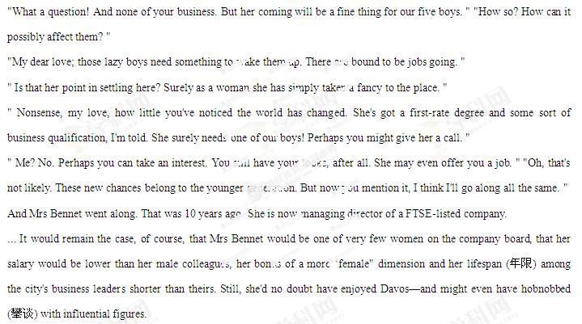67. Which of the following is TRUE according to the passage?
A. Austen was born 200 years ago.
B. Austen rewrote Pride and Prejudice.
C. Austen's success lies in her wisdom.
D. Austen's updated work gains popularity.
68. The underlined part in the passage suggests that Mrs Bennet ____.
A. had mixed feelings of admiration and surprise about Bingley
B. felt kind of worried and doubtful about Bingley
C. was extremely anxious to meet Bingley
D. had a great curiosity about Bingley
69. In the eyes of Mrs Bennet, Bingley surely needed one of their boys to ____.
A. get married to B. work for her
C. help her move in D. take over her store
70. What does the writer intend to tell us?
A. Women with brains can also be as successful as men.
B. Women have to pay a high price for success.
C. A judgment must be made free from prejudice.
D. Sex discrimination still exists nowadays.
E
A MENTORING (导师制) program is giving life changing opportunities to Banbury youth.
Young Inspirations was founded two years ago to provide mentoring sessions for students and unemployed young adults aged 11 to 21.
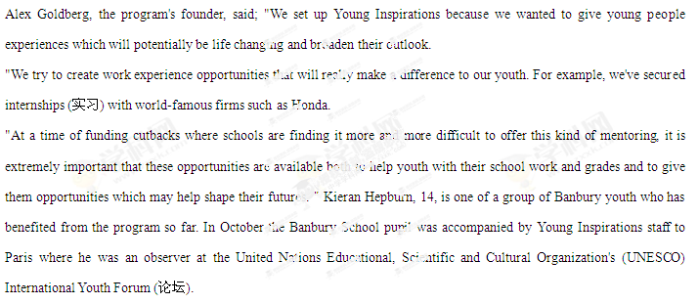The event was held for young people from around the world, to seek their views on how the future of youth and education should look. Kieran joined several hundred observers mostly in their 20s and was the only UK school pupil to attend the event. Kieran thinks the trip was a life changing experience. " Before we left I didn't quite know what to make of it but when we got there we didn't stop, it was amazing," he said, " We went to three or four hours of debates each day and then did something cultural each afternoon. "
The main theme of the forum was how youth can drive change in political and public life. It dealt with issues (问题) such as drug abuse, violence and unemployment.
Kieran said: " It has really helped me to improve my confidence and social skills as well as my school grades and I was voted most improved pupil at school in August. "
The Young Inspirations mentoring sessions take place each Friday in Banbury. For details visit www.younginspirations.com.
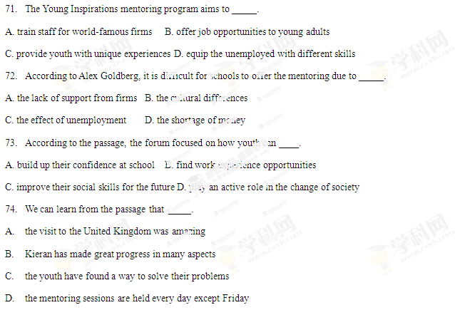
75. What would be the best tide for the passage?
A. Alex Goldberg, Founder of Young Inspirations
B. Young People Find a World of Opportunity
C. Kieran, Banbury School Pupil to Paris
D. Debates Help Youth with Their Grades
第II卷（非选zxxk择题共35分）
第四部分写作（共两节, 满分35分）
第一节短文填词（共10小题;每小题1分,满分10分）
Every individual is a member of a group called the community, and it
is the duty of every citizen _____ ask what he can do for his community.
76. _____
A good citizen _____(相信) that he should serve the community
77. _____
and not the community serve h_____. As students, there are many ways
78. _____
in _____ you can serve the community. Above all, however, you have to
79. _____
acquire a certain amount of skill and experience b_____ you can be of
80. _____
service to others. Your school has lots of_____(活动) which prepare
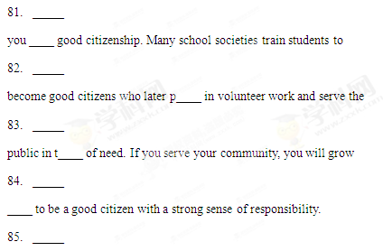
第二节 书面表达
第二节书面表达(满分25分）
孩子的成长和教育是社会热议的话题，现今父母包揽一切、孩子过度依赖等现象十分严重。请阅读下面 的漫画，按要求用英文写一篇短文。
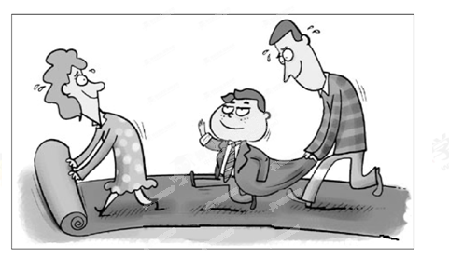
内容要求： 1.描述漫画内容；
2. 分析漫画所揭示的问题； 3. 提出你的看法。
注意：
1.短文开头已给出，不计入总词数；
2.考生可适当发挥，使文章内容充实、连贯；
3.词数120左右;
4. 文中不能出现考生的具体信息。
参考词汇:pave the way

From the picture, we can see a family of three walking on a long red carpet.
_________________________________________________________________________________________________________________________________________________________________________________________________________________________________________________________________________________________________________________________________________________

