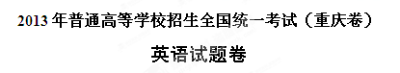
一、听力（共两节，满分30分）
做题时，请先将答案划在试题卷上。录音内容结束后，你将有两分钟的时间将试题卷上的答案转涂或转填到答题卡上。本解析为重庆名师何为原创，授权学科网独家使用，如有盗用，依法追责！
第一节（共5小题；每小题1. 5分，满分7. 5分）
请听下面5段对话。每段对话后有一个小题，从题中所给的A、B、C三个选项中选出最佳选项，并标在试题卷的相应位置。听完每段对话后，你都有10秒钟的时间来回答有关小题和阅读下一小题。每段对话仅读一遍。
例：How much is the shirt？
A. ￡19. 15. | B. ￡9. 15. | C. ￡9. 18.
答案是B。本解析为学科网名师解析团队原创，授权学科网独家使用，如有盗用，依法追责！
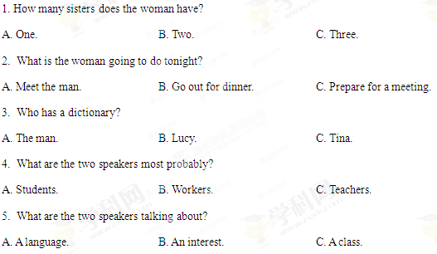
第二节（共12小题；每小题1. 5分，满分18分）
请听下面4段对话或独白。每段对话或独白后有几个小题，从题中所给的A、B、C三个选项中选出最佳选项，并标在试题卷的相应位置。听每段对话或独白前，你将有时间阅读各小题，每小题5秒钟；听完后，各小题将给出5秒钟的作答时间。每段对话或独白读两遍。
请听第6段材料，回答第6至8题。
6. Which city is the woman going to?
A. Chicago. | B. Boston. | C. New York.
7. How much will the woman pay for her ticket?
A. $30. | B. $50. | C. $60.
8. Where does the conversation most probably take place?
A. At an airport. | B. At a bus stop. | C. At a railway station.
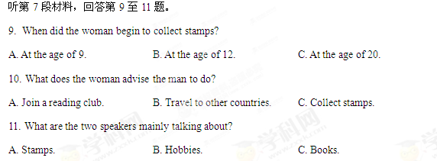
听第8段材料，回答第12至14题。
12. What is the woman going to do on Friday?
A. Attend a meeting. | B. Go on vacation. | C. Make a phone call.
13. Who is most probably going to meet the man at the airport?
A. The woman. | B. The man’s brother. | C. The woman’s sister.
14. What is the possible relationship between the two speakers?
A. Parent and teacher. | B. Brother and sister. | C. Husband and wife
听第9段材料，回答第15至17题。
15. At what time are they leaving for the Natural Museum?
A. 7:30 a.m. | B. 8:30 a.m. | C. 3:30 p.m.
16. What will they possibly do right before supper?
A. Swim at the beach. | B. Do some shopping. | C. See an exhibition.
17. What is the speaker mainly talking about?
A. An arrangement for a day.
B. An introduction to a place.
C. An experience of culture.
第三节（共3小题；每小题1. 5分，满分4. 5）
请听下面一段独白，用所听到的独白中的词或数填空，每空限填一个词或一个数。填入的内容写在答题卡相应位置上，在听本段独白前，你将有时间阅读各小题，每小题5秒钟；听完后，各小题将给出5秒钟的作答时间，本段独白读两遍。
请听第10段材料，回答第18至20题。
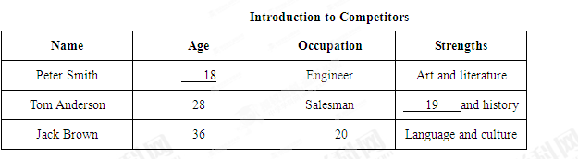
二、英语知识运用（共两节，满分45分）
第一节 单项填空（共15小题；每小题1分，满分15分）
请从A、B、C、D四个选项中，选出可以填入空白处的最佳选项，并在答题卡上将该选项标号涂黑。本解析为学科网名师解析团队原创，授权学科网独家使用，如有盗用，依法追责！
例：A computer can only do _______ you have instructed it to do.
A. how | B. after | C. what | D. when
答案是C.
21. I felt very tired when I got home, and I ______ straight to bed.
A. go | B. went | C. had gone | D. have gone
22. — Would you like a glass of wine?
—______. I don’t drink.
A. No, thanks | B. Yes, please
C. I don’t like it | D. It’s my favorite
23. It’s not easy to change habits, ______ with awareness and self-control, it is possible.
A. for | B. or | C. but | D. so
24. John invited about 40 people to his wedding, most of ______ are family members.
A. them | B. that | C. which | D. whom
25. ______we have enough evidence, we can’t win the case.
A. Once | B. As long as | C. Unless | D. Since
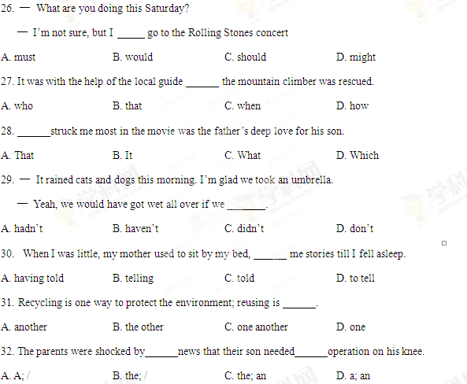
33. A Midsummer Night’s Dream ______at the Theatre Royal on 19th June, and then tours throughout Scotland.
A. opens | B. is opened | C. will open | D. will be opened
34. The engine just won’t start. Something seems ______ wrong with it.
A. to go | B. to have gone | C. going | D. having gone
35. — Forgotten something? I can keep an eye on your kids if you want to go and get it.
—______
A. It’s very kind of you. | B. Oh. how careless of me!
C. I might as well go and got it. | D. Well, I can do without it.
三、完形填空（共20小题；每小题1. 5分，满分30分）
请阅读下面短文，掌握其大意，然后从36-55各题所给的四个选项（A、B、C、D）中，选出最佳选项，并在答题卡上将该选项的标号涂黑。
A
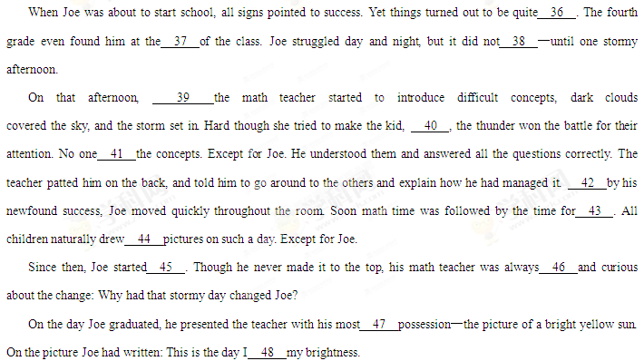本解析为学科网名师解析团队原创，授权学科网独家使用，如有盗用，依法追责！
36. A. unfair | B. boring | C. disappointing | D. dangerous
37. A. center | B. top | C. beginning | D. bottom
38. A. happen | B. work | C. finish | D. last
39. A. until | B. since | C. because | D. as
40. A. concentrate | B. change | C. hide | D. sit
41. A. challenged | B. grasped | C. doubted | D. admitted
42. A. Relieved | B. Surprised | C. Encouraged | D. Puzzled
43. A. class | B. sports | C. art | D. tea
44. A. great | B. dark | C. different | D. strange
45. A. improving | B. painting | C. recovering | D. studying
46. A. worried | B. amazed | C. friendly | D. cautious
47. A. familiar | B. expensive | C. admirable | D. precious
48. A. woke up to | B. put up with | C. got on with | D. looked down upon
B
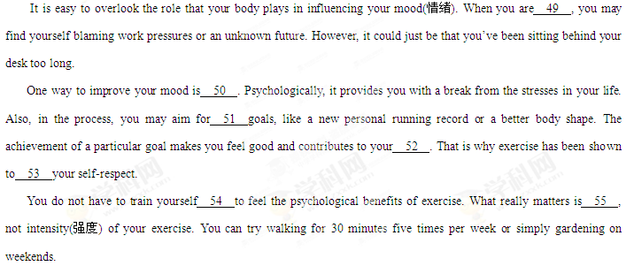本解析为学科网名师解析团队原创，授权学科网独家使用，如有盗用，依法追责！
49. A. ill | B. poor | C. unhappy | D. unsuccessful
50. A. play | B. communication | C. sleep | D. exercise
51. A. clear | B. present | C. common | D. early
52. A. ability | B. relationship | C. confidence | D. business
53. A. tear down | B. build up | C. set aside | D. give out
54. A. hard | B. everywhere | C. carefully | D. late
55. A. time | B. length | C. form | D. frequency
四、阅读理解（共20小题；每小题2分，满分40分）
请阅读下列短文，从每题所给的四个选项（A、B、C和D）中，选出最佳选项，并在答题卡上将该选项的标号涂黑。
A
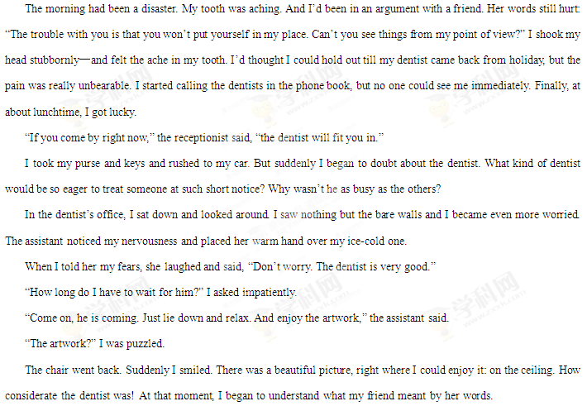名师解析团队原创，授权学科网独家使用，如有盗用，依法追责！
What a relief! 本解析为学科网名师解析团队原创，授权学科网独家使用，如有盗用，依法追责！
56. Which of the following best describes the author’s feeling that morning?
A. Cheerful. B. Nervous. C. Satisfied. D. Upset.
57. What made the author begin to doubt about the dentist?
A. The dentist’s agreeing to treat her at very short notice.
B. The dentist’s being as busy as the other dentists.
C. The surroundings of the dentist’s office.
D. The laughing assistant of the dentist.
58. Why did the author suddenly smile?
A. Because the dentist came at last.
B. Because she saw a picture on the ceiling.
C. Because she could relax in the chair.
D. Because the assistant kept comforting her.
59. What did the author learn from her experience most probably?
A. Strike while the iron is hot.
B. Have a good word for one’s friend.
C. Put oneself in other’s shoes.
D. A friend in need is a friend indeed.
B
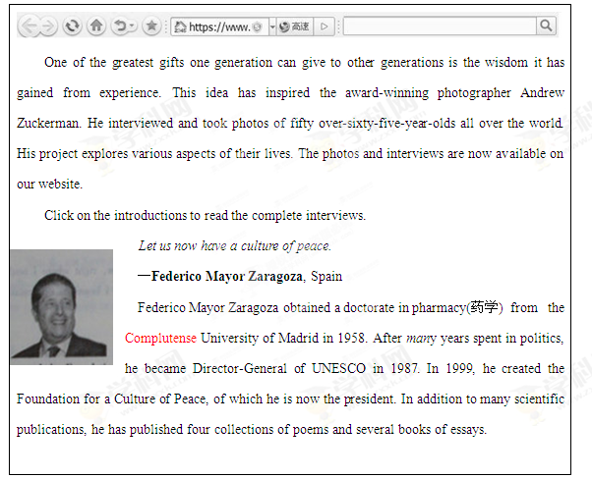
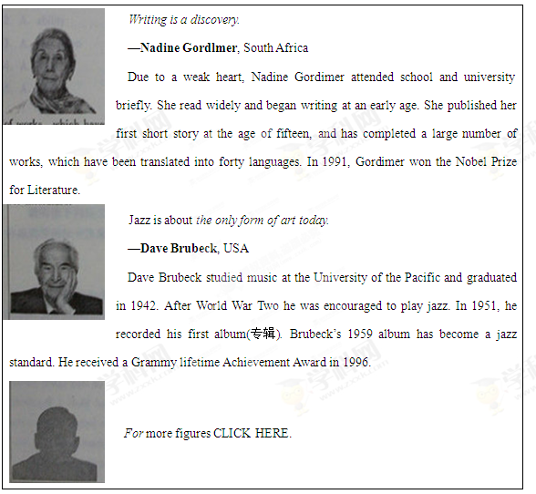
60. Why did Andrew Zuckerman choose the fifty elders for his project?
A. Because their wisdom deserves to be passed on.
B. Because they are physically impressive.
C. Because their accomplishments inspired him.
D. Because they have similar experiences.
61. According to the web page, Federico Mayor Zaragoza_____.
A. has won many awards for his work in politics
B. has served as the president of a university
C. has devoted all his life to the field of science
D. has made achievements in different areas
62. Who most probably said “My education has been the library and books” in the interview when reflecting on his/her experience?
A. Andrew Zuckerman.
B. Federico Mayor Zaragoza.
C. Nadine Gordimer.
D. Dave Brubeck.
63. What is the main purpose of this web page?
A. To show Zuckerman’s awards.
B. To publicize Zuckerman’s project.
C. To spread the wisdom of the three people.
D. To celebrate the achievements of the three people.
C
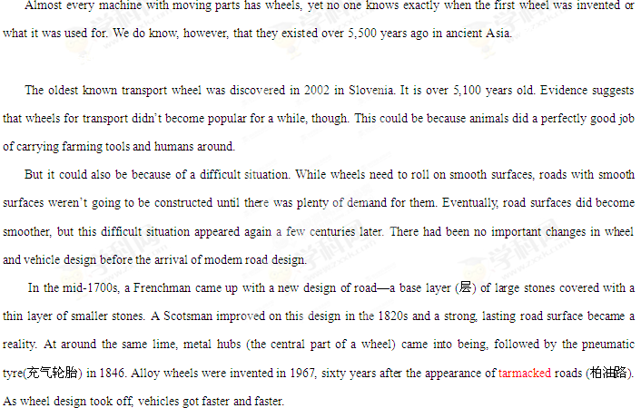有盗用，依法追责！
64. What might explain why transport wheels didn’t become popular for some time?
A. Few knew how to use transport wheels.
B. Humans carried farming tools just as well.
C. Animals were a good means of transport.
D. The existence of transport wheels was not known.
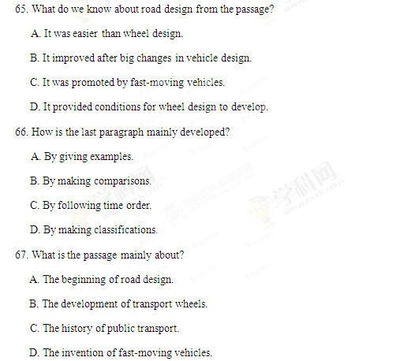
D
Not all bodies of water are so evidently alive as the Atlantic Ocean, an S-shaped body of water covering 33 million square miles. The Atlantic has, in a sense, replaced the Mediterranean as the inland sea of Western civilization. Unlike real inland seas, which seem strangely still, the Atlantic is rich in oceanic liveliness. It is perhaps not surprising that its vitality has been much written about by ancient poets.
“Storm at Sea”, a short poem written around 700, is generally regarded as one of mankind’s earliest artistic representations of the Atlantic.
When the wind is from the west
All the waves that cannot rest
To the east must thunder on
Where the bright tree of the sun
Is rooted in the ocean’s breast.
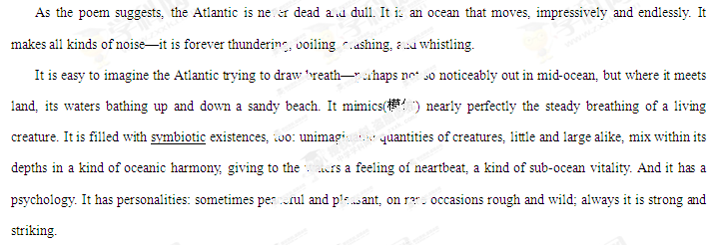68. Unlike real inland seas, the Atlantic Ocean is______.
A. always energetic解析为重庆名师何为原创，授权学科网独家使用，如有盗用，依法追责！
B. lacking in liveliness
C. shaped like a square
D. favored by ancient poets
69. What is the purpose of using the poem “Storm at Sea” in the passage?
A. To describe the movement of the waves.
B. To show the strength of the storm.
C. To represent the power of the ocean.
D. To prove the vastness of the sea.
70. What does the underlined word “symbiotic” mean?
A. Living together.
B. Growing fast. 解析为重庆名师何为原创，授权学科网独家使用，如有盗用，依法追责！
C. Moving harmoniously.
D. Breathing peacefully.
71. In the last paragraph, the Atlantic is compared to______.
A. a beautiful and poetic place
B. a flesh and blood person
C. a wonderful world
D. a lovely animal解析为重庆名师何为原创，授权学科网独家使用，如有盗用，依法追责！
E
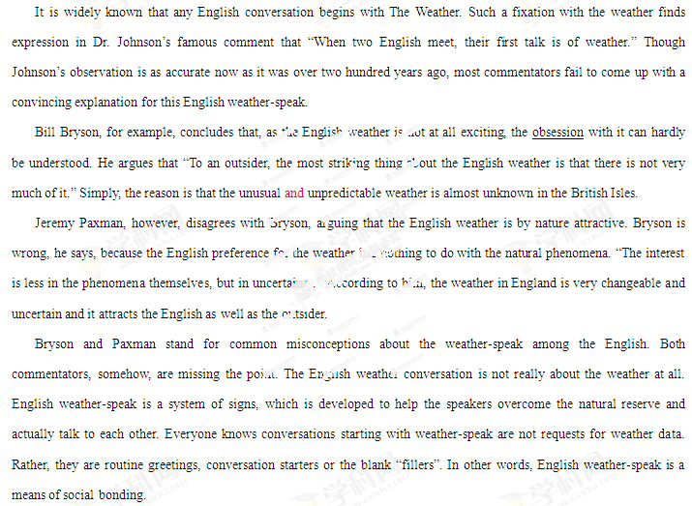72. The author mentions Dr. Johnson’s comment to show that______.
A. most commentators agree with Dr. Johnson
B. Dr. Johnson is famous for his weather observation
C. the comment was accurate two hundred years ago
D. English conversations usually start with the weather
73. What does the underlined word “obsession” most probably refer to?
A. A social trend. 本解析为学科网名师解析团队原创，授权学科网独家使用，如有盗用，依法追责！B. An emotional state.
C. A historical concept.
D. An unknown phenomenon.
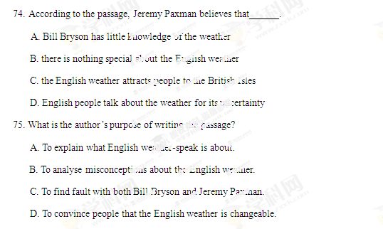本解析为学科网名师解析团队原创，授权学科网独家使用，如有盗用，依法追责！
五、写作 (共两节，满分35分)
写作一（满分15分)
A mother said, “My son is always on the phone, sleeping, out with his friends, or in his room. He never has time to talk to me.”
要求：1) 就此材料发表你的看法；
2) 紧扣材料，有明确的观点；
3) 词数不少于60；
4）在答题卡上作答。
写作二（满分30分)
调查显示，中国长江江豚(finless porpoise)受人类活动影响而濒临灭绝，目前总数不足1000只。假设你是李华，现请用英文给WWF(世界自然保护基金组织)写一封信，请他们关注这一情况并提供帮助。内容应包括：
● 说明写信目的
