英 语
第一部分 英语知识运用（共两节，满分55分）
第一节 单项选择（共10小题；每小题1.5分，满分15分）
1. Writing out all the invitations by hand was more time-consuming than we______.
A. will expect B. are expecting C. expect D. had expected 学科网
2. I don’t really like the author,_______ I have to admit his books are very exciting.
A. although B. unless C. until D. once
3.—This apple pie is too sweet, don’t you think so?
—_____. I think it’s just right, actually. [来源:Zxxk.Com]
A. Not really B. I hope so C. Sounds good D .No wonder [来源:学科网ZXXK]
4. Susan made______ clear to me that she wished to make a new life for herself. [来源:学#科#网Z#X#X#K]
A. that B. this C. it D. her
5. They made up their mind that they______ a new house once Larry changed jobs.
A. bought B. would buy C. have bought D. had bought
6. There is a note pinned to the door______ when the shop will open again.
A. saying B. says C. said D. having said
7. It is difficult for us to imagine_____ life was like for slaves in the ancient world.
A. where B. what C. which D. why
8.—Is Anne coming tomorrow?
—_____.If she were to come, she would have called me.
A. Go ahead B. Certainly C. That’s right D. I don’t think so
9. It’s standard practice for a company like this one______ a security officer.
A. employed B. being employed C. to employ D. employs
10. A company ______profits from home markets are declining may seek opportunities abroad.
A. which B. whose C. who D. why
第二节 完型填空（共两篇；第一篇短文10小题，每小题1分；第二篇短文20小题，每小题1.5分；满分40分）
A
There was a pet store and the owner had a parrot. One day a 11 walked in and the parrot said to the man ,“Hey you!” The man said, “What!?” The parrot said, “Your 12 is really ugly.” The man got very 13 and went to the store owner and said, “Your bird just 14 my wife. It said she was ugly.”
The owner stormed over, 15 the bird, took it into the “black room,”shook it a bit, 16 out a few feathers, and said,“Don’t ever, ever say anything to 17 my customers again. You got that！！！”
With that 18 he took the bird and put it back into its cage. The old bird shook out its 19 and relaxed in its cage. A couple of weeks 20 and in walked this guy and his wife again. The parrot said, “Hey you!” The guy said, “What!?” The parrot answered, “You know that.” 学科网
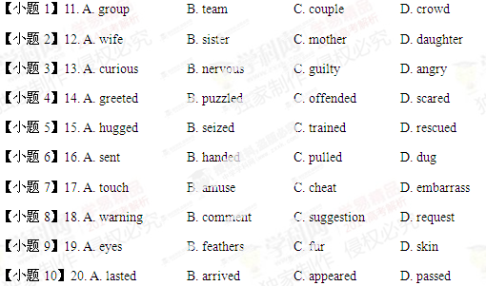
B
Charlotte Whitehead was born in England in 1843, and moved to Montreal, Canada at the age five with her family. While 21 her ill elder sister throughout the years, Charlotte discovered she had a(an) 22 in medicine. At 18 she married and 23 a family. Several years later, Charlotte said she wanted to be a 24 . Her husband supported her decision. 学科网
25 , Canadian medical schools did not 26 women students at the time. Therefore, Charlotte went to the United States to study 27 at the Women’s Medical College in Philadelphia. It took her five years to 28 her medical degree.
Upon graduation, Charlotte 29 to Montreal and set up a private 30 . Three years later, she moved to Winnipeg, Manitoba, and there she was once again a 31 doctor. Many of her patients were from the nearby timber and railway camps. Charlotte 32 herself operating on damaged limbs and setting 33 bones, in addition to delivering all the babies in the area.
But Charlotte had been practicing without a license. She had 34 a doctor’s license in both Montreal and Winnipeg, but was 35 . The Manitoba College of Physicians and Surgeons, an all-male board, wanted her to 36 her studies at a Canadian medical college! Charlotte refused to 37 her patients to spend time studying what she already knew. So in 1887, she appeared to the Manitoba Legislature to 38 a license to her but they, too, refused. Charlotte 39 to practice without a license until 1912. She died four years later at the age of 73.
In 1993, 77 years after her 40 , a medical license was issued to Charlotte. This decision was made by the Manitoba Legislature to honor “this courageous and pioneering woman.”
【小题1】21. A. raising B. teaching C. nursing D. missing
【小题2】22. A. habit B. interest C. opinion D. voice
【小题3】23. A. invented B. selected C. offered D. started
【小题4】24. A. doctor B. musician C. lawyer D. physicist
【小题5】25. A. Besides B. Unfortunately C. Otherwise D. Eventually
【小题6】26. A. hire B. entertain C. trust D. accept
【小题7】27. A. history B. physics C. medicine D. law
【小题8】28. A. improve B. save C. design D. earn
【小题9】29. A. returned B. escaped C. spread D. wandered
【小题10】30. A. school B. museum C. clinic D. lab
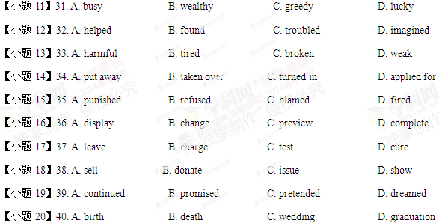
第二部分：阅读理解（共25题，每小题2分，满分50分）
阅读下列短文，从每题所给的四个选项中，选出最佳选项，并在答题卡上将该项涂黑。
A
One morning, Ann’s neighbor Tracy found a lost dog wandering around the local elementary school. She asked Ann if she could keep an eye on the dog. Ann said that she could watch it only for the day.
Tracy took photos of the dog and printed off 400 FOUND fliers（传单）, and put them in mailboxes. Meanwhile, Ann went to the dollar store and bought some pet supplies, warning her two sons not to fall in love with the dog. At the time, Ann’s son Thomas was 10 years old, and Jack, who was recovering from a heart operation, was 21 years old. 学科网
Four days later Ann was still looking after the dog, whom they had started to call Riley. When she arrived home from work, the dog threw itself against the screen door and barked madly at her. As soon as she opened the door, Riley dashed into the boys’ room where Ann found Jack suffering from a heart attack. Riley ran over to Jack, but as soon as Ann bent over to help him the dog went silent.
“If it hadn’t come to get me, the doctor said Jack would have died,” Ann reported to a local newspaper. At this point, no one had called to claim the dog, so Ann decided to keep it.
The next morning Tracy got a call. A man named Peter recognized his lost dog and called the number on the flier. Tracy started crying, and told him, “That dog saved my friend’s son.”
Peter drove to Ann’s house to pick up his dog, and saw Thomas and Jack crying in the window. After a few moments Peter said, “Maybe Odie was supposed to find you, maybe you should keep it.”
【小题1】41. What did Tracy do after finding the dog?
A. She looked for its owner B. She gave it to Ann as a gift.
C. She sold it to the dollar store. D. She bought some food for it.
【小题2】42. How did the dog help save Jack?
A. By breaking the door for Ann. B. By leading Ann to Jack’s room.
C. By dragging Jack out of the room. D. By attending Jack when Ann was out.
【小题3】43. What was Ann’s attitude to the dog according to Paragraph 4?
A. Sympathetic B. Doubtful C. Tolerant D. Grateful
【小题4】44. For what purpose did Peter call Tracy?
A. To help her friend’s son. B. To interview Tracy
C. To take back his dog. D. To return the flier to her.
【小题5】45. What can we infer about the dog from the last paragraph?
A. It would be given to Odie. B. It would be kept by Ann’ family.
C. It would be returned to Peter. D. It would be taken away by Tracy.
B
It was one of those terribly hot days in Baltimore. Needless to say, it was too hot to do anything outside. But it was also scorching in our apartment. This was 1962, and I would not live in a place with an air conditioner for another ten years. So my brother and I decided to leave the apartment to find someplace indoors. He suggested we could see a movie. It was a brilliant plan. 学科网[来源:Zxxk.Com]
Movie theaters were one of the few places you could sit all day and—most important —sit in air conditioning. In those days, you could buy one ticket and sit through two movies. Then, the theater would show the same two movies again. If you wanted to, you could sit through them twice. Most people did not do that, but the manager at our theater. Mr. Bellow did not mind if you did.
That particular day, my brother and I sat through both movies twice, trying to escape the heat. We bought three bags of popcorn and three sodas each. Then, we sat and watched The Music Man followed by The Man Who Shot Liberty Valance. We’d already seen the second movie once before. It had been at the theater since January, because Mr. Bellow loved anything with John Wayne in it.
We left the theater around 8, just before the evening shows began. But we returned the next day and saw the same two movies again, twice more. And we did it the next day too. Finally, on the fourth day, the heat wave broke.
Still, to this day I can sing half the songs in The Music Man and recite half of John Wayne and Jimmy Stewart’s dialogue from The Man Who Shot Liberty Valance! Those memories are some of the few I have of the heat wave of 1962. They’re really memories of the screen, not memories of my life.
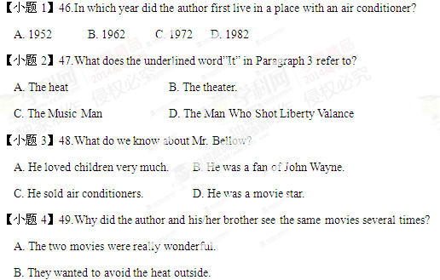
C. The manager of the theater was friendly.
D. They liked the popcorn and the soda at the theater.
【小题5】50.What can we learn from the last paragraph?
A. The author turned out to be a great singer.
B. The author enjoyed the heat wave of 1962.
C. The author’s life has been changed by the two movies.
D. The author considers the experience at the theater unforgettable.
C
Elizabeth Freeman was born about 1742 to African American parents who were slaves. At the age of six months she was acquired, along with her sister, by John Ashley, a wealthy Massachusetts slaveholders. She became known as “Mumbet” or “Mum Bett.” 学科网
For nearly 30 years Mumbet served the Ashley family. One day, Ashley’s wife tried to strike Mumbet’s sister with a spade. Mumbet protected her sister and took the blow instead. Furious, she left the house and refused to come back. When the Ashleys tried to make her return, Mumbet consulted a lawyer, Theodore Sedgewick. With his help, Mumbet sued(起诉) for her freedom.
While serving the Ashleys, Mumbet had listened to many discussions of the new Massachusetts constitution. If the constitution said that all people were free and equal, then she thought it should apply to her. Eventually, Mumbet won her freedom---- the first slave in Massachusetts to do so under the new constitution.
Strangely enough, after the trial, the Ashleys asked Mumbet to come back and work for them as a paid employee. She declined and instead went to work for Segdewick. Mumbet died in 1829, but her legacy lived on in her many descendants(后裔). One of her great-grandchildren was W.E.B. Du Bois, one of the founder of the NAACP, and an important writer and spokesperson for African American civil rights.
Mumbet’s tombstone still stands in the Massachusetts cemetery where she was buried. It reads, in part: “She was born a slave and remained a slave and remained a slave for nearly thirty years. She could neither read nor write, yet in her own sphere she had no superior or equal.” 学科网
【小题1】51. What do we know about Mumbet according to Paragraph 1?
A. She was born a slave B. She was a slaveholder
C. She had a famous sister D. She was born into a rich family
【小题2】52. Why did Mumbet run away from the Ashleys?
A. She found an employer B. She wanted to be a lawyer
C. She was hit and got angry D. She had to take care of her sister
【小题3】53. What did Mumbet learn from discussions about the new consititution?
A. She should always obey her owners’ orders B. She should be as free and equal as whites
C. How to be a good servant D. How to apply for a job
【小题4】54. What did Mumbet do after the trial?
A. She chose to work for a lawyer B. She found the NAACP
C. She continued to serve the Ashleys D. She went to live with her grandchildren
【小题5】55. What is the test mainly about?
A. A story of a famous writer and spokesperson B. The friendship between a lawyer and a slave
C. The life of a brave African American woman D. A trial that shocked the whole world
D
How fit are your teeth? Are you lazy about brushing them? Never fear: An inventor is on the case. An electric toothbrush senses how long and how well you brush, and it lets you track your performance on your phone.
The Kolibree toothbrush was exhibited at the International Consumer Electronics Show in Las Vegas this week. It senses how it is moved and can send the information to an Android phone or iPhone via a Bluetooth wireless connection.
The toothbrush will be able to teach you to brush right (don’t forget the insides of the teeth!) and make sure you’re brushing long enough. “It’s kind of like having a dentist actually watch your brushing on a day-to-day basis,” says Thomas Serval, the French inventor.
The toothbrush will also be able to talk to other applications on your phone, so developers could, for instance, create a game controlled by your toothbrush. You could score points for beating monsters among your teeth. “We try to make it smart but also fun,” Several says.
Serval says he was inspired by his experience as a father. He would come home from work and ask his kids if they had brushed their teeth. They said “yes,” but Serval would find their toothbrush heads dry. He decided he needed a brush that really told him how well his children brushed.
The company says the Kolibree will go on sale this summer, for $99 to $199, developing on features. The U.S. is the first target market. 学科网
Serval says that one day, it’ll be possible to replace the brush on the handle with a brushing unit that also has a camera. The camera can even examine holes in your teeth while you brush.
【小题1】56. Which is one of the feature of the Kolibree toothbrush?
A. It can sense how users brush their teeth. B. It can track users’ school performance.
C. It can detect users’ fear of seeing a dentist. D. It can help users find their phones.
【小题2】57. What can we learn from Serval’s words in Paragraph 3?
A. You will find it enjoyable to see a dentist.
B. You should see your dentist on a day-to –day basis.
C. You can brush with the Kolibree as if guided by a dentist.
D. You’d like a dentist to watch you brush your teeth every day.
【小题3】58. Which of the following might make the Kolibree toothbrush fun?
A. It can be used to update mobile phones. B. It can be used to play mobile phone games
C. It can send messages to other users D. It can talk to its developers.
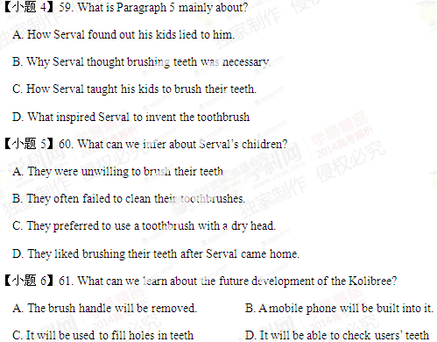
E
The kids in this village wear dirty, ragged clothes. They sleep beside cows and sheep in huts made of sticks and mud. They have no school. Yet they all can chant the English alphabet, and some can make words.
The key to their success: 20 tablet computers(平板电脑) dropped off in their Ethiopian village in February by a U.S. group called One Laptop Per Child.
The goal is to find out whether kids using today’s new technology can teach themselves to read in places where no schools or teachers exist. The Massachusetts Institute of Technology researchers analyzing the project data say they’re already amazed. “What I think has already happened is that the kids have already learned more than they would have in one year of kindergarten,” said Matt Keller, who runs the Ethiopia program.
The fastest learner—and the first to turn on one of the tablets—is 8-year-old Kelbesa Negusse. The device’s camera was disabled to save memory, yet within weeks Kelbesa had figured out its workings and made the camera work. He called himself a lion, a marker of accomplishment in Ethiopia. [来源:学科网ZXXK]
With his tablet, Kelbasa rearranged the letters HSROE into one of the many English animal names he knows. Then he spelled words on his own. “Seven months ago he didn’t know any English. That’s unbelievable,” said Keller.
The project aims to get kids to a stage called “deep reading,” where they can read to learn. It won’t be in Amharic, Ethiopia’s first language, but in English, which is widely seen as the ticket to higher paying jobs.
【小题1】62. How does the Ethiopia program benefit the kids in the village?
A. It trains teachers for them. B. It contributes to their self-study.
C. It helps raise their living standards. D. It provides funds for building schools.
【小题2】63. What can we infer from Keller’s words in Paragraph 3? [来源:学科网ZXXK]
A. They need more time to analyze data.
B. More children are needed for the research.
C. He is confident about the future of the project.
D. The research should be carried out in kindergartens.
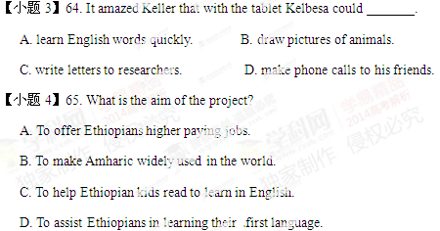
第II卷（共45分）
第三部分 书面表达（共两节，满分45分）
第一节：阅读表达（共5小题；每小题3分，满分15分）
阅读下面的短文并用英语回答问题，然后将答案写到答题卡相应的位置上（请注意问题后的字数要求）。
[1] Nowadays the cost of a new car has fallen in real terms so that it is cheaper than ever to own one, and better road conditions have also attracted more drivers. The result is overcrowding on the road system, which is one of the problems the local governments are faced with.
[2] When people travel to other towns, the problem might be relieved by getting them to park outside the town. Buses could be provided to take them into the centre. These Park and Ride projects are increasingly popular in the UK. At Southerton, for example, a council-funded project led to a 15% drop in city centre traffic over five months.
[3] What the council found, though, was that the project proved somewhat unpopular with shop owners in the area outside the centre. Many of their shops relied on passing car drivers for some of their trade. As the number of people driving past dropped, so did their incomes.
[4] Making car driving expensive is another way of ____________. Road taxes tend to mean that people use their cars less. Fining drivers who are in areas where cars have been banned can also tend to encourage them to leave their cars behind. 学科网
[5] However, one thing has to be got right for any solution to succeed. If we expect people to give up the habit of driving, we must give them an alternative they can rely on. Constant delays, unannounced changes to the timetable and sudden cancellations all discourage people from using public transport. People will only see it as a real choice if the buses and trains are on time. [来源:Zxxk.Com]
【小题1】66. What causes overcrowding on the road system according to Paragraph 1? (no more than 12 words)
_______________________________________________________________________________
【小题2】67. What should people do when traveling to other towns according to the Park and Ride projects? (no more than 10 words)
_______________________________________________________________________________
【小题3】68. Why were some shop owners unhappy about the project? (no more than 10 words)
_______________________________________________________________________________
【小题4】69. Fill in the blank in Paragraph 4. ( no more than 8 words)
_______________________________________________________________________________
【小题5】70. Why are people unwilling to use public transport according to Paragraph 5? (no more than 8 words) [来源:学科网ZXXK]
_______________________________________________________________________________
第二节：写作（满分30分）
某英文报社组织题为“我喜欢的英语谚语”征文活动，你有意参加。请从下面两句谚语中任选一句作为标题写一篇英语作文，内容须包括：1.该谚语的含义；2.体现该谚语含义的个人经历。
- A friend in need is a friend indeed.
②Where there’s a will, there’s a way. 学科网
注意：1.词数：120-150；
2.文中不得透露个人姓名和学校名称。
参考词汇：谚语 proverb

