绝密★启用前 试卷类型：A
本试卷共12页,三大题,满分135分.考试用时120分钟
注意事项：
1. 答卷前，考生务必用黑色笔迹的钢笔或签字笔将自己的姓名和考生号、考场号、座位号填写在答题卡上。用2B铅笔讲试卷类型（A）填涂在答题卡相应的位置上。将条形码横贴在答题卡右上角“条形码粘贴处”。
2.选择题每小题选出答案后，用2B铅笔把答题卡上对应题目选项的答案信息点涂黑；如需改动，用橡皮擦干净后，再选涂其他答案，答案不能答在试卷上。
3.非选择题必须用黑色字迹的钢笔或签字笔作答，答案必须写在答题卡各题目指定区域内相应位置上；如需改动，先划掉原来的答案，然后再写上新的答案；不准使用铅笔和涂改液。不按以上要求作答的答案无效。学科网[来源:学科网ZXXK]
4.考生必须保持答题卡的整洁，考试结束后，将试题与答题卡一并交回。

I 语言知识及应用（共两节，满分45分）[来源:Zxxk.Com]
第一节 完形填空
Parents feel that it is difficult to live with teenagers. Then again, teenagers have 1 feelings about their parents, saying that it is not easy living with them. According to a recent research, the most common 2 between parents and teenagers is that regarding untidiness and daily routine tasks. On the one hand, parents go mad over 3 rooms, clothes thrown on the floor and their children’s refusal to help with the 4 . On the other hand, teenagers lose their patience continually when parents blame them for 5 the towel in the bathroom, not cleaning up their room or refusing to do the shopping at the supermarket.
The research, conducted by St. George University, shows that different parents have different 6 to these problems. However, some approaches are more 7 than others. For example, those parents who yell at their children for their untidiness, but 8 clean the room for them, have fewer chances of changing their children’s 9 . On the contrary, those who let teenagers experience the 10 of their actions can do better. For example, when teenagers who don’t help their parents with the shopping don’t find their favorite drink in the refrigerator, they are forced to 11 their actions.
Psychologists say that 12 is the most important thing in parent-child relationships. Parents should 13 to their children but at the same time they should lend an ear to what they have to say. Parents may 14 their children when they are untidy but they should also understand that their room is their own private space. Communication is a two-way process. It is only by listening to and 15 each other that problems between parents and children can be settled.
【小题1】 A. natural B. strong C. guilty D. similar
【小题2】A. interest B. argument C. link D.knowledge
【小题3】A. noisy B. crowded C. messy D. locked
【小题4】A. homework B. housework C. problem D. research
【小题5】A. washing B. using C. dropping D. replacing
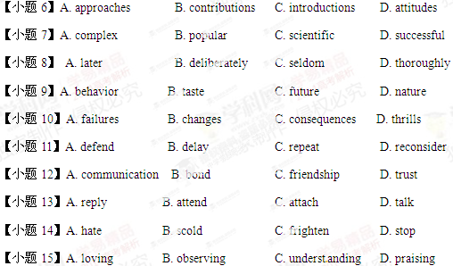
第二节 语法填空（共10题；每小题1.5分，满分15分）[来源:学*科*网]
阅读下面短文，学科网按照句子结构的语法性和上下文连贯的要求，在空格处填入一个适当的词或使用括号中词语的正确形式填空，并将答案填写在答题卡标号为16-25的相应位置上。
Last year, my brother and I went to Miami for a vacation. Some of my friends who had been there before said_16_____ was a wonderful holiday destination. Before we went, we had planned for months. When the day came, we were ready.
After our plane landed, we went to the hotel. We had made our reservation six months__17____ （early）, but the man at the front desk said there had been a mistake. We 18_____（tell）that our rooms hadn’t been reserved for that week, 19_____ for the week after. I didn’t understand 20____ this would happen and my credit card had already been charged______ the reservation. What’s worse, the hotel had been fully booked. When we were wondering what to do, the manager came out. She was 22_____（surprise）helpful. She apologized for the mistake and gave us a spare VIP room on 23_____ top floor. We had never stayed in such an amazing room, and we weren’t charged extra.
The next day, my brother and I went to the beach 24____ we watched some people play volleyball. We got a little_____（sunburn），but the day had been so relaxing that we didn’t mind.
阅读（共两节）
- 阅读理解（共20小题；每小题2分，满分40分）
阅读下列短文，从每题所给的A、B、C和D项中，选出最佳选项，并在答题卡上将该项涂黑。
A
Samuel Osmond is a 19-year-old law student from Cornwall, England. He never studied the piano. However, he can play very difficult musical pieces by musicians such as Chopin and Beethoven just a few minutes after he hears them. He learns a piece of music by listening to it in parts. Then he thinks about the notes in his head. Two years ago, he played his first piece Moonlight Sonata（奏鸣曲）by Beethoven. He surprised everyone around him.
Amazed that he remembered this long and difficult piece of music and played it perfectly, his teachers say Samuel is unbelievable .They say his ability is very rare, but Samuel doesn’t even realize that what he can do is special. Samuel wanted to become a lawyer as it was the wish of his parents, but music teachers told him he should study music instead. Now, he studies law and music.
Samuel can’t understand why everyone is so surprised. “I grew up with music. My mother played the piano and my father played the guitar. About two years ago, I suddenly decided to start playing the piano, without being able to read music and without having any lessons. It comes easily to me ---I hear the notes and can bear them in mind---each and every note,” says Samuel.
Recently, Samuel performed a piece during a special event at his college. The piece had more than a thousand notes. The audience was impressed by his amazing performance. He is now learning a piece that is so difficult that many professional pianists can’t play it. Samuel says confidently,” It’s all about super memory---I guess I have that gift.”
However, Samuel’s ability to remember things doesn’t stop with music. His family says that even when he was a young boy, Samuel heard someone read a story, and then he could retell the story word for word.
Samuel is still only a teenager. He doesn’t know what he wants to do in the future. For now, he is just happy to play beautiful music and continue his studies.
【小题1】What is special about Samuel Osmond?
A. He has a gift for writing music.
B. He can write down the note he hears.
C. He is a top student at the law school.
D. He can play the musical piece he hears.
【小题2】What can we learn from Paragraph 2?
- Samuel chose law against the wish of his parents.[来源:Zxxk.Com]
B. Samuel planned to be a lawyer rather than a musician.
C. Samuel thinks of himself as a man of great musical ability.
D. Samuel studies law and music on the advice of his teachers.
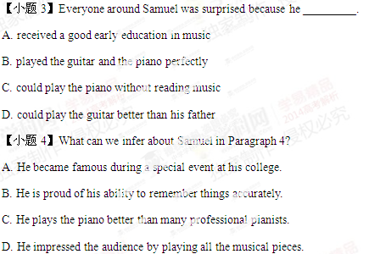
【小题5】Which of the following is the best title of the passage?[来源:学科网]
- The Qualities of a Musician
- The Story of a Musical Talent
- The Importance of Early Education
- The Relationship between Memory and Music.
B
It was a cold winter day. A woman drove up to the Rainbow Bridge tollbooth (收费站). “I’m paying for myself, and for the six cars behind me,” she said with a smile, handing over seven tickets. One after another, the next six drivers arriving at the tollbooth were informed, “Some lady up ahead already paid your fare.”
It turned out that the woman, Natalie Smith, had read something on a friend’s refrigerator: “Practice random kindness and senseless acts of beauty.” The phrase impressed her so much that she copied it down.
Judy Foreman spotted the same phrase on a warehouse wall far away from home. When it stayed on her mind for days, she gave up and drove all the way back to copy it down. “I thought it was beautiful,” she said, explaining why she’d taken to writing it at the bottom of all her letters, “like a message from above.” Her husband, Frank, liked the phrase so much that he put it up on the classroom wall for his students, one of whom was the daughter of Alice Johnson, a local news reporter. Alice put it in the newspaper, admitting that though she liked it, she didn’t know where it came from or what it really meant.
Two days later, Alice got a call from Anne Herbert, a woman living in Marin. It was in a restaurant that Anne wrote the phrase down on a piece of paper, after turning it around in her mind for days.
“Here’s the idea,” Anne says. “Anything you think there should be more of, do it randomly.” Her fantasies include painting the classrooms of shabby schools, leaving hot meals on kitchen tables in the poor part of town, and giving money secretly to a proud old lady. Anne says, “Kindness can build on itself as much as violence can.”
The acts of random kindness spread. If you were one of those drivers who found your fare paid, who knows what you might have been inspired to do for someone else later. Like all great events, kindness begins slowly, with every single act. Let it be yours!
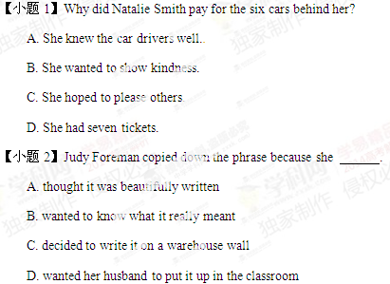
【小题3】Who came up with the phrase according to the passage?
A. Judy Foreman.
B. Natalie Smith.
C. Alice Johnson.
D. Anne Herbert. 学科网
【小题4】Which of the following statements is closest in the meaning to the underlined sentence above?
A. Kindness and violence can change the world.
B. Kindness and violence can affect one’s behavior.
C. Kindness and violence can reproduce themselves.
D. Kindness and violence can shape one’s character.
【小题5】What can we infer from the last paragraph?
A. People should practice random kindness to those in need.
B. People who receive kindness are likely to offer it to others.
C. People should practice random kindness to strangers they meet.
D. People who receive kindness are likely to pay it back to the giver.
C
Like many new graduates, I left university full of hope for the future but with no real idea of what I wanted to do. My degree, with honors, in English literature had not really prepared me for anything practical. I knew I wanted to make a difference in the world somehow, but I had no idea how to do that. That’s when I learned about the Lighthouse Project.
I started my journey as a Lighthouse Project volunteer by reading as much as I could about the experiences of previous volunteers. I knew it would be a lot of hard work, and that I would be away from my family and friends for a very long time. In short, I did not take my decision to apply for the Lighthouse Project lightly. Neither did my family.
Eventually, however, I won the support of my family, and I sent in all the paperwork needed for the application. After countless interviews and presentations, I managed to stand out among the candidates and survive the test alone. Several months later, I finally received a call asking me to report for the duty. I would be going to a small village near Abuja, Nigeria. Where? What? Nigeria? I had no idea. But I was about to find out.
After completing my training, I was sent to the village that was small and desperately in need of proper accommodation. Though the local villagers were poor, they offered their homes, hearts, and food as if I were their own family. I was asked to lead a small team of local people in building a new schoolhouse. For the next year or so, I taught in that same schoolhouse. But I sometimes think I learned more from my students than they did from me.
Sometime during that period, I realized that all those things that had seemed so strange or unusual to me no longer did, though I did not get anywhere with the local language, and returned to the United States a different man. The Lighthouse Project had changed my life forever.
【小题1】What do we know about the author?
A. His university education focused on the theoretical knowledge.
B. His dream at university was to become a volunteer.
C. He took pride in having contributed to the world.
D. He felt honored to study English literature.
【小题2】According to the Paragraph 2, it is most likely that the author [来源:学|科|网Z|X|X|K]
A. discussed his decision with his family.
B. asked previous volunteers about voluntary work
C. attended special training to perform difficult tasks[来源:Zxxk.Com]
D. felt sad about having to leave his family and friends
【小题3】In his application for the volunteer job, the author
A. participated in many discussions
B. went through challenging survival tests
C. wrote quite a few paper on voluntary work
D. faced strong competition from other candidates
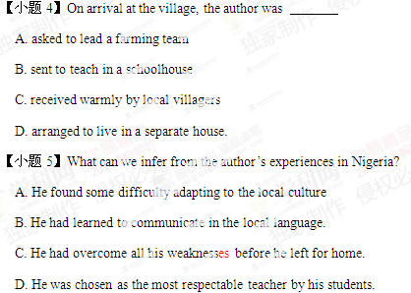
D
Scientists today are making greater effort to study ocean currents (洋流) . Most do it using satellites and other high-tech equipment. However, ocean expert Curtis Ebbesmeyer does it in a special way -- by studying movements of random floating garbage. A scientist with many years’ experience, he started this type of research in the early 1990s when he heard about hundreds of athletic shoes washing up on the shores of the northwest coast of the United States. There were so many shoes that people were setting up swap meets to try and match left and right shoes to sell or wear.
Ebbesmeyer found out in his researches that the shoes — about 60,000 in total — fell into the ocean in a shipping accident. He phoned the shoe company and asked if they wanted the shoes back. As expected, the company told him that they didn't. Ebbesmeyer realized this could be a great experiment. If he learned when and where the shoes went into the water and tracked where they landed, he could learn a lot about the patterns of ocean currents.
The Pacific Northwest is one of the world's best areas for beachcombing(海滩搜寻) because winds and currents join here, and as a result, there is a group of serious beachcombers in the area. Ebbesmeyer got to know a lot of them and asked for their help in collecting information about where the shoes landed. In a year he collected reliable information on 1, 600 shoes. With this data, he and a colleague were able to test and improve a computer program designed to model ocean currents, and publish the findings of their study. 学科网
As the result of his work, Ebbesmeyer has become known as the scientist to call with questions about any unusual objects found floating in the ocean. He has even started an association of beachcombers and ocean experts, with 500 subscribers from West Africa to New Zealand. They have recorded all lost objects ranging from potatoes to golf gloves.
【小题1】 The underlined phrase swap meets in Paragraph 1 is closest in meaning to ______________.
A. fitting rooms
B. trading fairs
C. business talks
D. group meetings
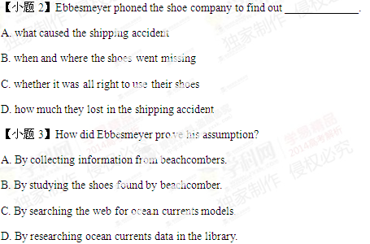
【小题4】Ebbesmeyer is most famous for ___________________.
A. traveling widely the coastal cities of the world
B. making records for any lost objects on the sea学科网
C. running a global currents research association
D. phoning about any doubtful objects on the sea
【小题5】What is the purpose of the author in writing this passage?
A. To call people's attention to ocean pollution.
B. To warn people of shipping safety in the ocean.
C. To explain a unique way of studying ocean currents.
D. To give tips on how to search for lost objects on the beach.
第二节 信息匹配（共5小题；每小题2分，满分10分）
阅读下列应用文及相关信息，并按照要求匹配信息，请在答题卡上将对应题号的相应选项字母涂黑。
首先请阅读某大学提供给学生的项目信息：
A． |  | B.
In-Company Experience  Challenging posts in industry for gap year students. Use your academic and interpersonal skills to improve a product or service provided by a top name company-and get paid for it! [来源:学科网] | 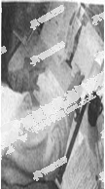 | Camp World[来源:学科网]  Work in camps for young people in one or more of the five continents. You help organize sports activities and other outdoor pursuits and you could end up with a qualification as an instructor.
 |  | 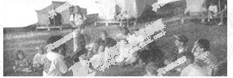
C. |  | D.
Community Care  Volunteer work at home and abroad with the physically and mentally handicapped, the homeless, the elderly and orphans. You’ll need to be committed, patient and sensitive to others. | 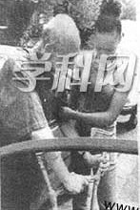 | Academic Study Year  Spend a whole year studying at a foreign university in Europe, the USA or even further afield, without the pressure of exams. Accommodation with local families. Grants available. | 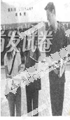
E. |  | F.
Conservation International  Conservation and research work with teams of volunteers on nature reserves in South America and Africa. Projects include monitoring wildlife, path building and water and soil conservation. | 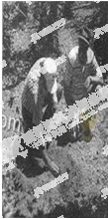 | Language Teachers Abroad  Teach your own language or English in almost any country in the world. Class sizes vary from one to one hundred and resources can be basic, but your students will welcome you with open arms. | 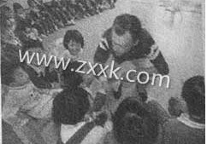

【小题1】 I grow up in a very big family. My parents have raised twelve kids and I am their first-born. It has been my duty to help my mom take care of my brothers and sisters. To handle them, often I have to organize an outdoor activity, like a softball game. I must say that I have the potential to work as an instructor.
【小题2】 Last year, my dog got crippled after losing the fight to my neighbor’s bulldog. I rinsed its wound with some lotion and tied its leg with a stick. I had him take medicine every day for a full month. Finally he recovered. I think I can help the elderly and the disabled as well. I feel so good when I can offer help.
【小题3】 I am a film buff. A big fan of Antonio Banderas. He is so wild and charming. Because of him, I fell in love with Spain. The Latin dance and the bullfight are really exciting. Oh, if only I could stay in Spain as an exchange student! I would be learning Spanish so well that I can watch a Spanish film with the dubbing.
【小题4】 I had the experience of working as a social worker in Switzerland last summer. I love the country and its people. There are great mountains for climbers and the local people are so nice to strangers. I helped the kids with their English. My teaching skills improved greatly during my stay. Now I’m well prepared to work as a language instructor. 学科网
【小题5】 I spent my gap year traveling all over Africa last year. It was definitely an eye- opening experience. The exotic clothes and tribal dances of the people really fascinated me. But I was most amazed by the wildlife there. I really took great pleasure in watching those animals hunting their prey. You know, I specialize in zoology, and I’m a good observer.
III 写作（共两节，满分40分）
第一节 基础习作
你接受一项写作任务，要为当地英语晚报写一篇报道。
［写作内容］
请根据以下信息写一篇英文报道，内容包括：
人物：英国人查理德·阿维斯（Richard Avis）
出生日期：1974年12月1日
时间：2011年开始在世界各地寻找同年同月同日生的人
目的：理解不同文化中成功人生的含义学科网
相关信息：
- 借助当地媒体寻找
- 迄今找到32名，其中男性17名，女性15名，来自13个国家
- 职业包括政府官员、运动员、司机、教师、艺术家等
- 计划40岁生日前找到40位同年同月同日生的人
- 打算根据此经历写一本书
- 同年同月同日生的人：time twin
［写作要求］
只能用5个句子表达全部内容
［评分标准］
句子结构准确，信息内容完整，篇章结构连贯。
第二节 读写任务（共1小题；满分25分）
阅读下面短文，然后按照要求写一篇150词左右的英语短文。
Oseola McCarty spent more than 75 years washing and ironing other people’s clothes. As a laundrywoman, she was paid only a few dollars each time. Certainly nobody would consider her rich, so they were all amazed when Miss McCarty decided to donate $ 150,000 to the University of Southern Mississippi.
The money was all my savings. She could save such a large amount of money because she lived a very simple life. She never learned to drive, and when she wanted to go somewhere, she just walked. She never flew to anywhere till the donation（捐助），and in 50 years she had been out of the South only once. The house in which she lived was also a rather modest one her last uncle left her. Only after she became known in America did she begin to travel all over the country. Since then, she had been the subject of many interviews and articles and was even invited to the White House.
Her donation was for students who clearly needed financial help. She herself left school in the sixth grade and had never married or had children. She said to the reporters that the idea of helping somebody’s child go to college gave her much pleasure.
[写作内容]
- 用约30个词概括上文的主要内容。
- 用约120个词就Miss McCarty的捐助谈谈你的想法，内容包括：
- 你如何看待她的捐助行为；
- 你认为她的捐助对受惠学生有哪些影响；
- 如果你自己要捐助，你会选择哪个群体并陈述理由。
[写作要求] 学科网
- 作文中可以使用亲身经历或虚构的故事，也可以参照阅读材料的内容，但不得直接引用原文的句子。
- 作文中不得出现真实姓名和学校名称。
[评分标准]
概括准确，语言规范，内容合适，篇章连贯。

