“- “: actions
“*”: thoughts or notes

AI Robot
Logbook by Timoteo Volante
07/04Apr/25-
-Used the FreeNove Arduino Kit Tutorial to learn about Arduino dc motors and servos.
*Challenge: Even though the design is not mine, the code will be created by me and the robot itself would also be built by me.
Robot ideas:
https://www.instructables.com/Building-a-Simple-Arduino-Robot/
chooses this: https://www.youtube.com/shorts/hWn8QDk0wE4
-Ordered 4 servos, 4 aa battery holders and an Arduino usb cable.
08/04Apr/25-
-Tested the servo code on 180deg servo from FreeNove Arduino Kit Tutorial and found the speed for the legs: delay of 3 ms.
09/04Apr/25-
-Tested the servo code on 360deg servo but did not work.
-Looked at codes for 360deg servo from the internet:
https://www.youtube.com/watch?app=desktop&v=OtOcuJwtPdQ
pos = 89-95 means stop, pos>95 means ccw, and pos<89 means cw.
24/05May/25-
-Thought using a Raspberry Pi 4 and adding AI to it is more interesting than Arduino.
-Researched about power supplies for RPi 4 (battery holders and converters) and ordered heat sink and the supply.
Battery holder and converter: https://www.amazon.co.uk/dp/B0CJ2LBY94?ref=ppx_yo2ov_dt_b_fed_asin_title
Heat sink and fan:
https://www.amazon.co.uk/dp/B07JGNF5F8?ref=ppx_yo2ov_dt_b_fed_asin_title
11/06June/25-
Inspiration for robot design:
https://tutorials-raspberrypi.com/programming-raspberry-pi-robots-making-it-follow-the-lines/
-Ordered components from Amazon:
Microphone: https://www.amazon.co.uk/dp/B0BHYC2MYV?ref=ppx_yo2ov_dt_b_fed_asin_title
5x battery holder:
https://www.amazon.co.uk/dp/B07MC7XC15?ref=ppx_yo2ov_dt_b_fed_asin_title
Camera module:
https://www.amazon.co.uk/dp/B076FB1KCW?ref=ppx_yo2ov_dt_b_fed_asin_title&th=1
Short USB C to A Cable:
https://www.amazon.co.uk/dp/B0D9RGCNLN?ref=ppx_yo2ov_dt_b_fed_asin_title&th=1
L293D Stepper Motor Drivers:
https://www.amazon.co.uk/dp/B09TK1RPSX?ref=ppx_yo2ov_dt_b_fed_asin_title
Chassis:
https://www.amazon.co.uk/dp/B07F73HY34?ref=ppx_yo2ov_dt_b_fed_asin_title
12/06June/25-
-Used Google AI search to get an idea of how to add Open AI to RPi 4.
-Watched https://www.youtube.com/watch?v=Cj7NhuLkvdQ to update Python 3 in RPi4.
-Watched https://www.youtube.com/watch?v=lHxFFn04L10&t=271s to implement the speaking chatbot.
-Had problems with pip install “error: externally-managed-environment” so went to https://forums.raspberrypi.com/viewtopic.php?t=367098 and typed and entered
mkdir my_project
cd my_project
python -m venv --system-site-packages env
source env/bin/activate
and used pip install afterwards.
-Stopped at
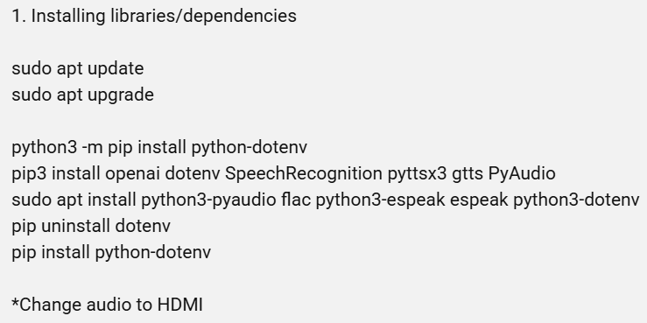
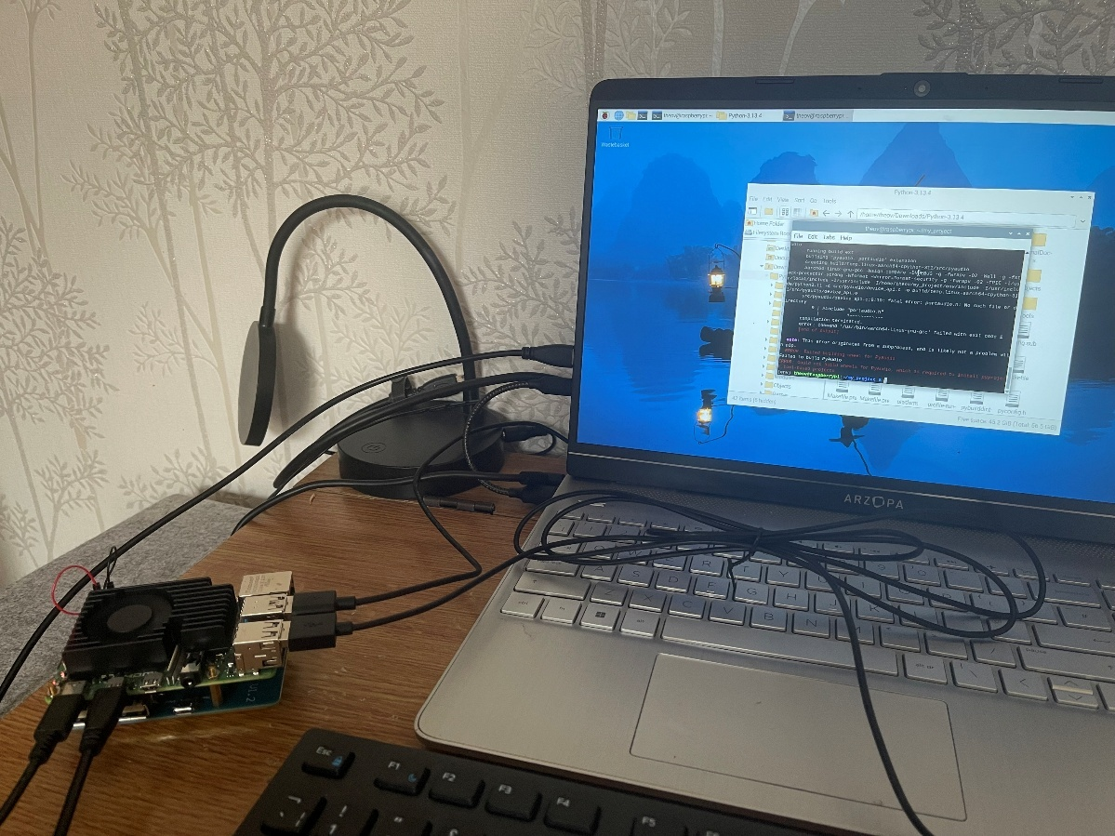

14/06June/25-
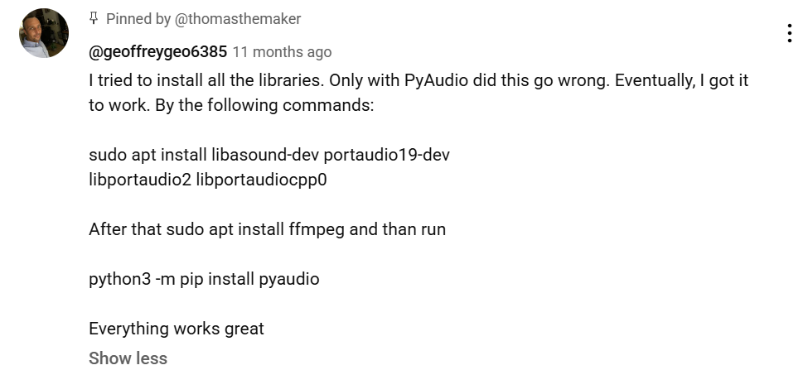
-Deleted my_project directory and redid the installations.
-Followed the comment by Geoffrey by typing the first typing and entering the first line and then following the step 1 of the youtube description.
-Continued debugging the chatbot code.
-Ran the github version but had errors.
-Fixed the first error by removing os.getenv in
api_key = os.getenv("OPENAI_API_KEY").
-Fixed another error my installing an additional library.
https://stackoverflow.com/questions/40246437/problems-with-gst-in-python-program
16/June/25-
-Ran the script.
-Had rate limit error.
-Added some money to my OpenAI account.
-Reran the script and it worked.
-Terminated the script using Ctrl + Z.
-Tried automatically running script when RPi boots up.
Followed these sites:
https://www.instructables.com/Raspberry-Pi-Launch-Python-script-on-startup/
https://raspberrytips.com/autostart-a-program-on-boot/
https://forums.raspberrypi.com/viewtopic.php?t=267113
https://linuxconfig.org/how-to-autostart-python-script-on-raspberry-pi
To find my ip address: 192.168.0.21
-Had audio source error and fixed it by changing audio input to Pro Audio.
-Automatic script when booting worked.
Problem: Sound output for the script is stuck at hdmi when booting.
-Added this exit plan code:
while not done:
for event in pygame.event.get():
if event.type == KEYDOWN:
done = True
Where KEYDOWN = ALT
But didn’t work
17/06June/25-
-Made my own script from scratch by reading the library documentations from Thomas Vu Nguyen’s script and taking inspirations from the script itself.
https://pypi.org/project/openai/
20/June/25-
-Continued making my own script.
-Decided to keep most of Thomas Vu Nguyen’s script but added threads, modified the listen_for_wake_word() into wake_word(), listen_and_respond() into converse(), and overall flow of code.
-Added sleep function so the ai would not input its own response, and “wait” message so the user would wait for the ai to respond.
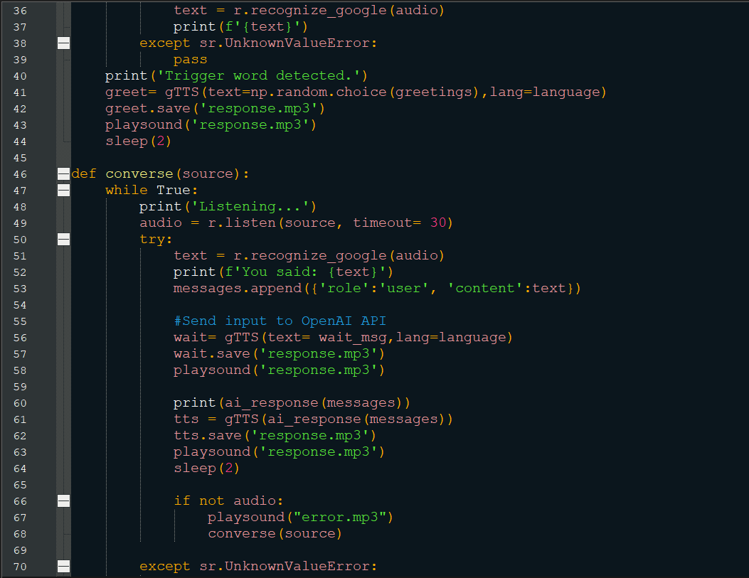
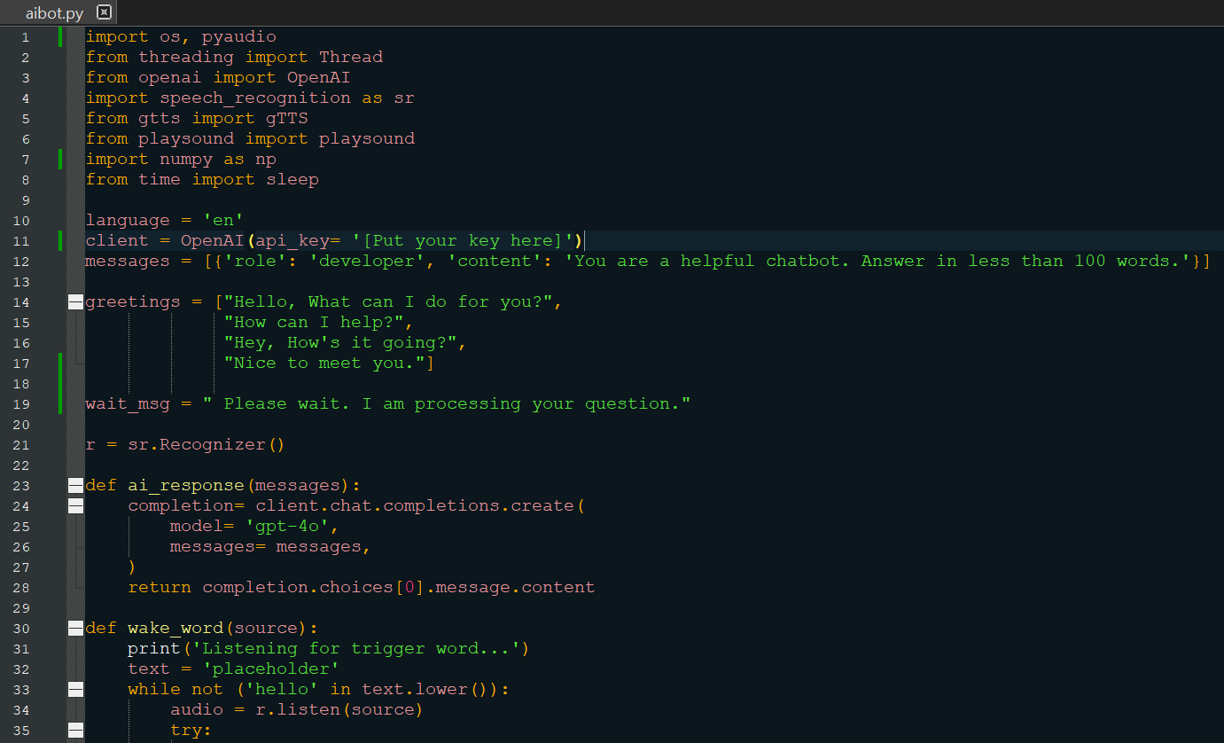

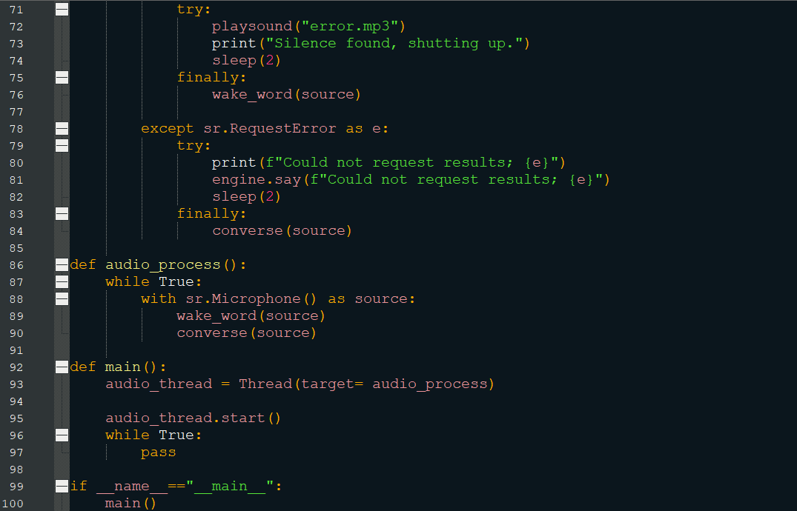

25/06June/2025-
-Added memory allocation and de-allocation for the list messages.
-Added wake_for_silence() function to “sleep” until silence is found to minimise
AI responding to its own voice and forming a loop.
-Removed the break inside sr.UnknownValueError: to simply let it pass to avoid unnecessary return to wake_word() everytime he hears silence quickly.
-Added timing to return the converse() back into wake_word() when a time has elapsed enough.
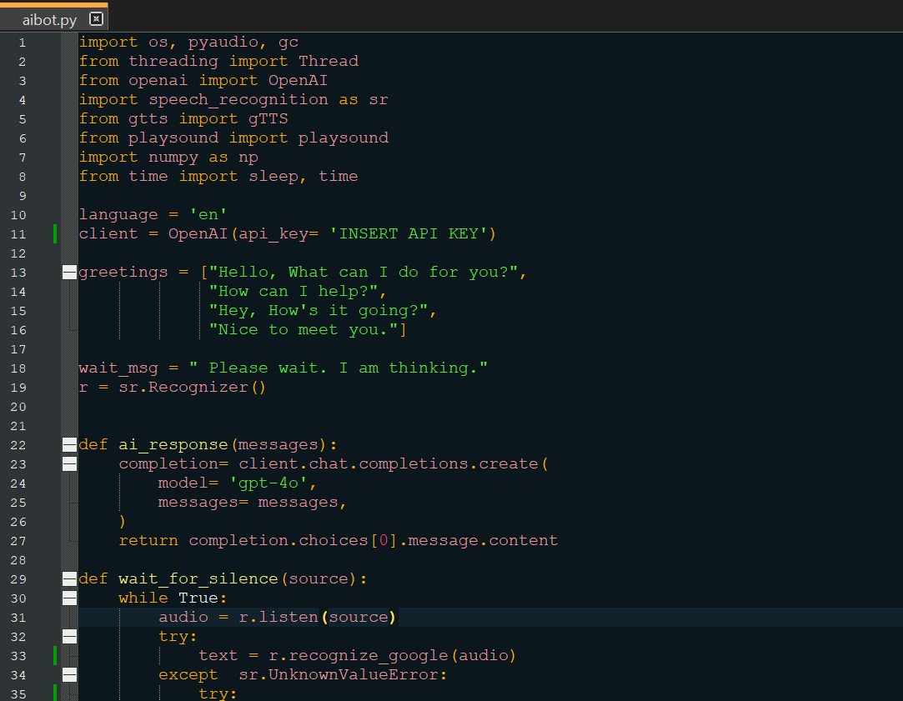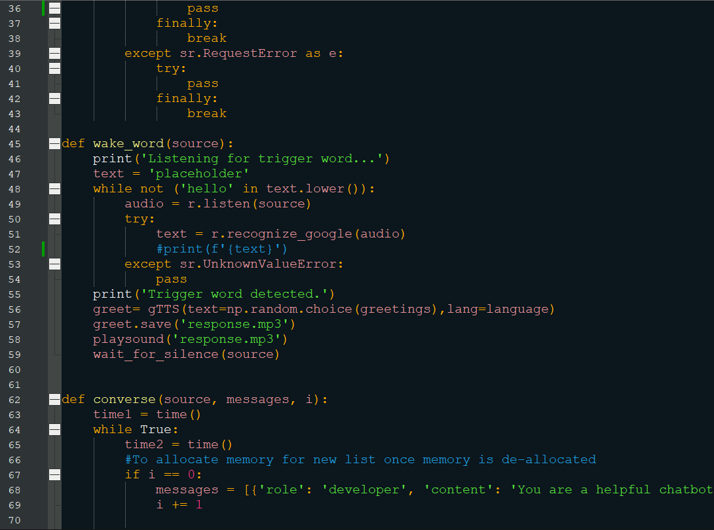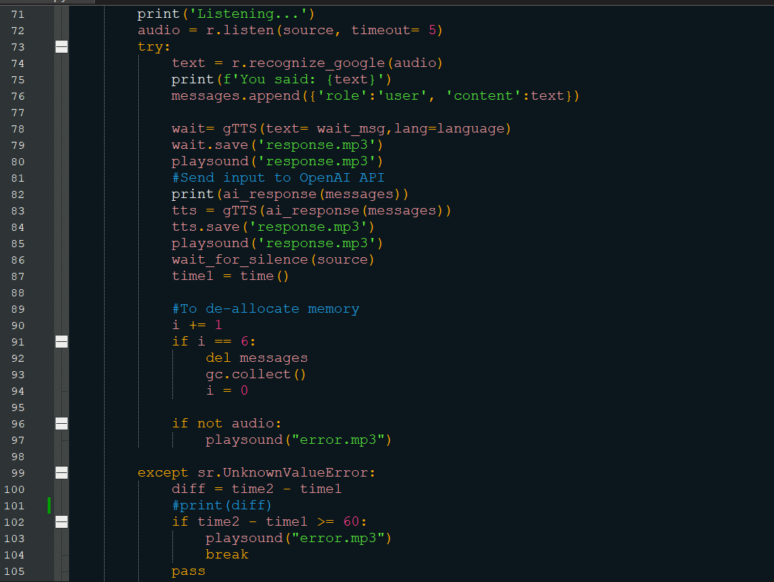
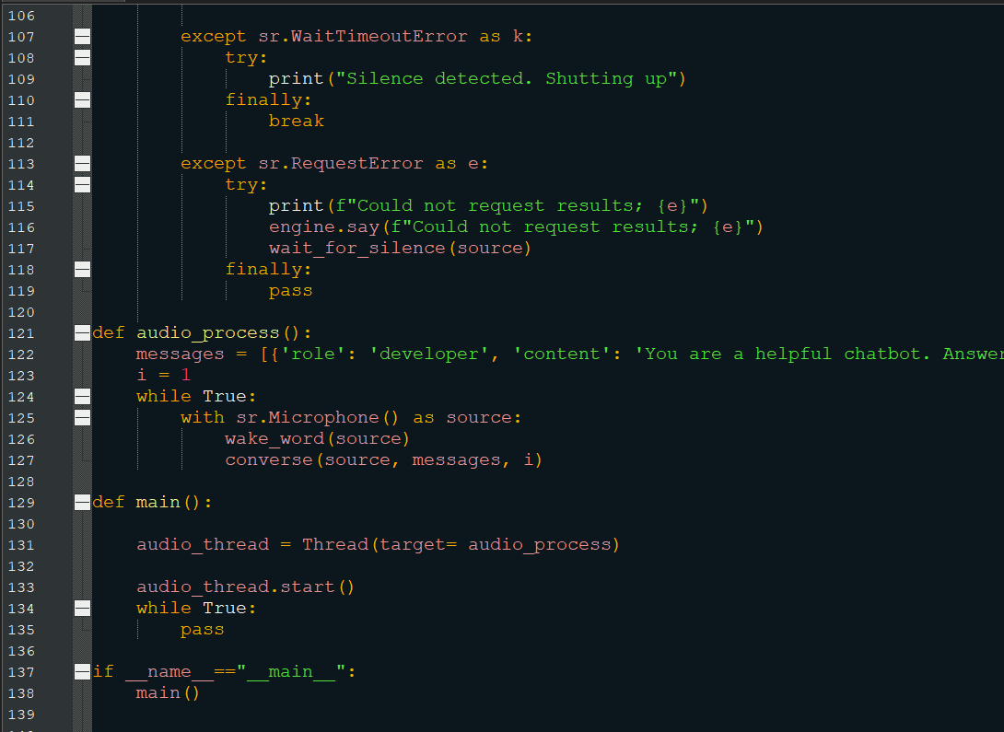
26/06June/25-
*AI API for vision inspiration:
https://cookbook.openai.com/examples/gpt_with_vision_for_video_understanding
*Getting stream video from camera:
https://stackoverflow.com/questions/70805012/cv2-videocapture-html-live-stream
-Typed and entered:
Python3 –m pip install opencv-python
after setting up virtual environment.
And it install opencv-python
30/06June/25-
-Completed the vision thread.
-Followed a few websites to fix some small errors.
https://stackoverflow.com/questions/77284901 to fix a request error about chat completions api inputting a the jpg file.
*Note: Need to reboot or (maybe cam.close()) again camera is used to fix the error about cannot access camera resources to rerun the script.
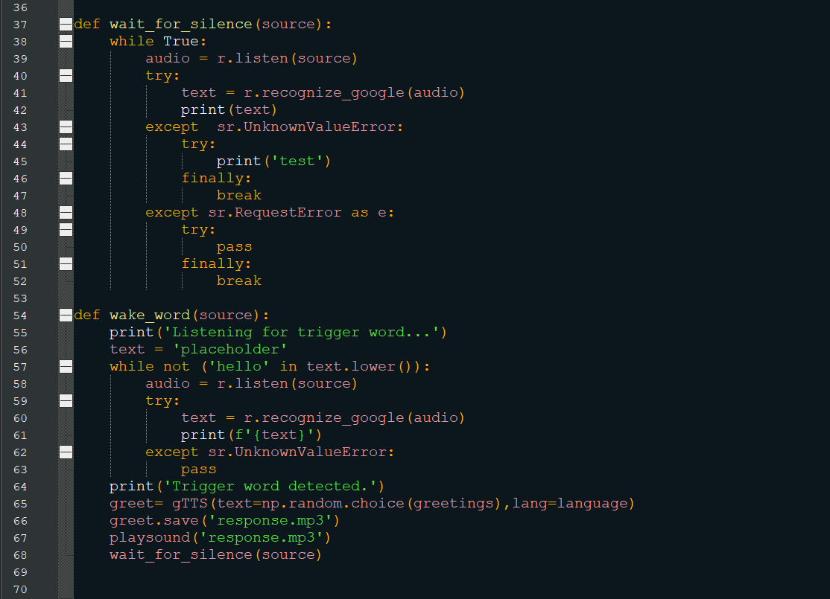
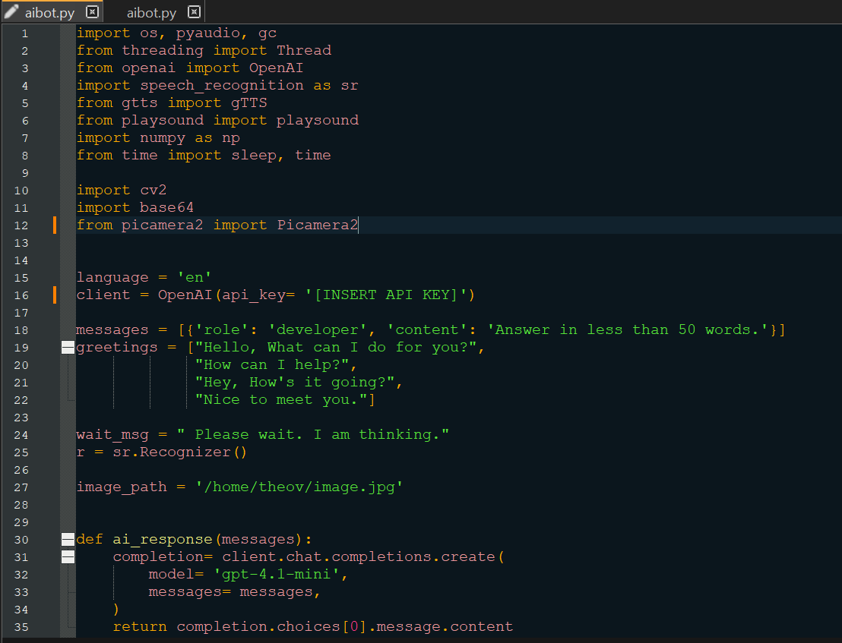

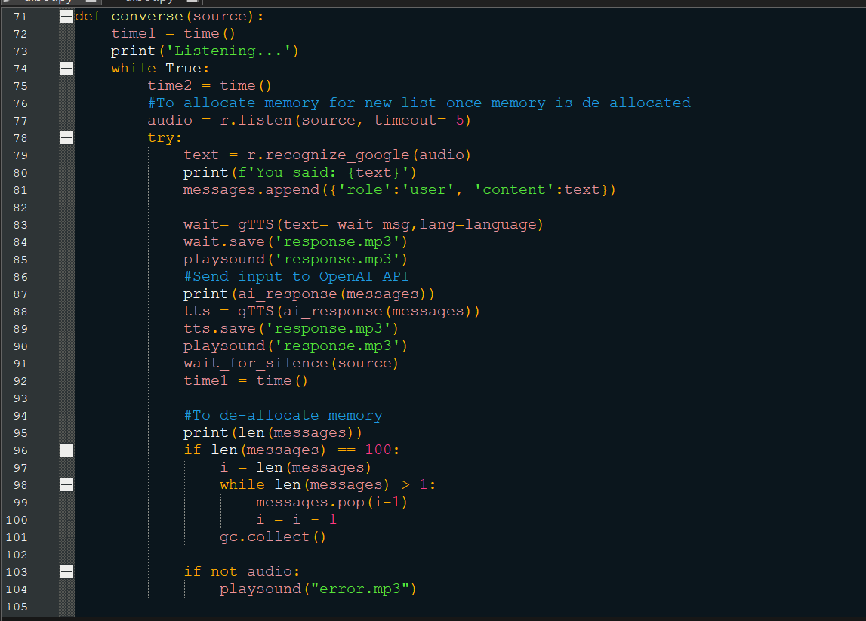

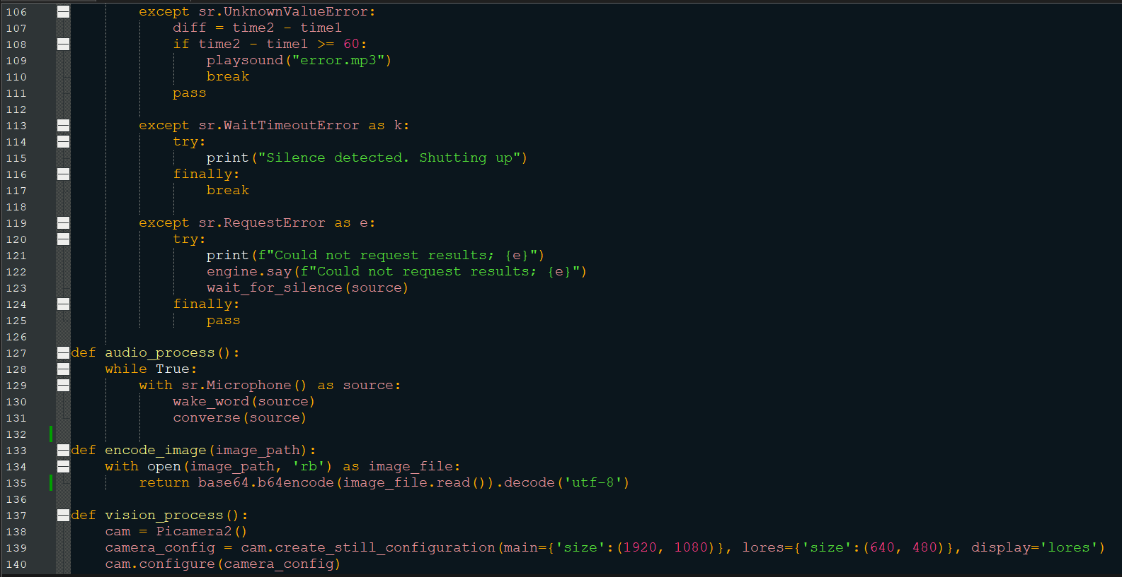

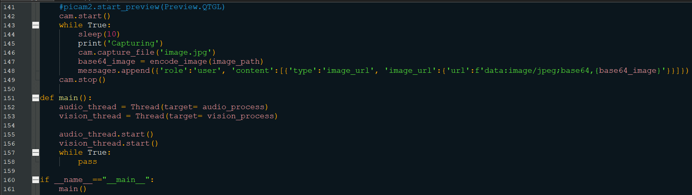

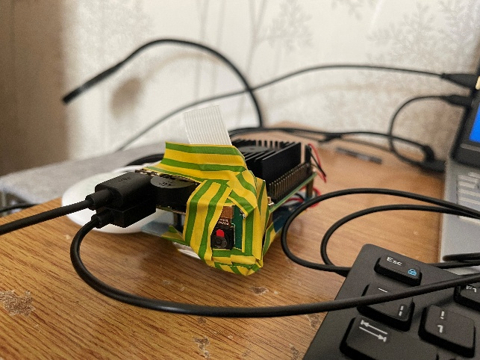
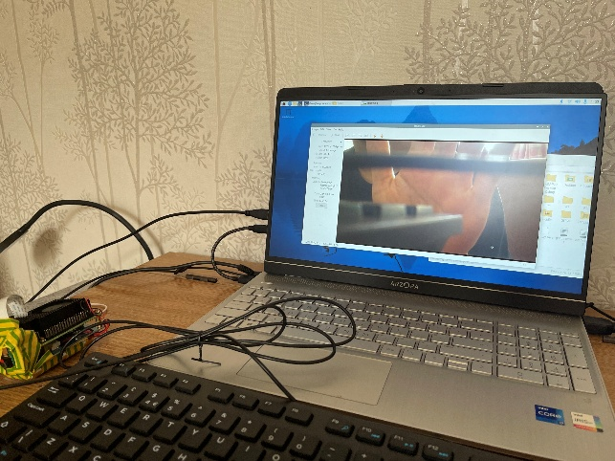
01/07July/25-
-Replaced the de-allocation code block with the function deallocate(memory, max_len)
-Split the list into two global lists: message[] for audio and images[] for vision.
-Vision takes maximum 10 images while audio takes maximum 3 messages(1 dev msg, 1 usr msg, 1 latest image input).
*This should prevent wasteful spending of tokens (unnecessary inputs to AI).
-Tried asking the AI how far away my phone is. It replied and said 1-2 feet (will use this to judge distance for driving)
-Constructed the chassis.
-Read https://lastminuteengineers.com/l293d-dc-motor-arduino-tutorial/
for the half-h drivers.
-Adjusted the regulator to output 5V from 7 – 5.5 V input.
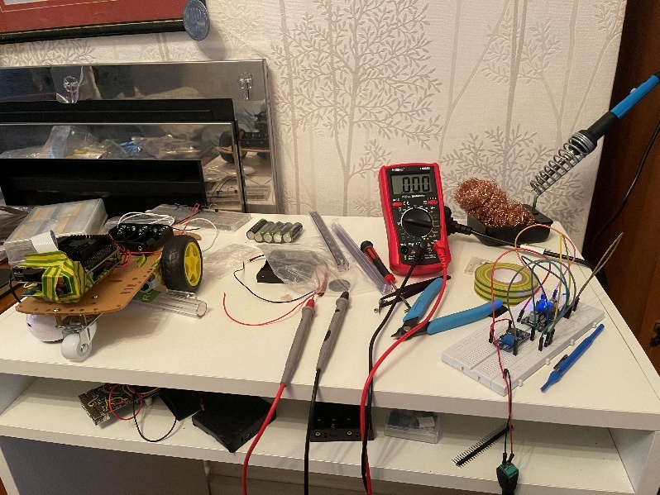
The picture above shows the built chassis on the left and the regulator on the right.
03/07July/25-
-Tested the new speaker and its volume is better than the previous one.
-Added the wheel control thread and its functions.
-Constructed the breadboard circuit of the motor driver and tested a 3 V dc motor.
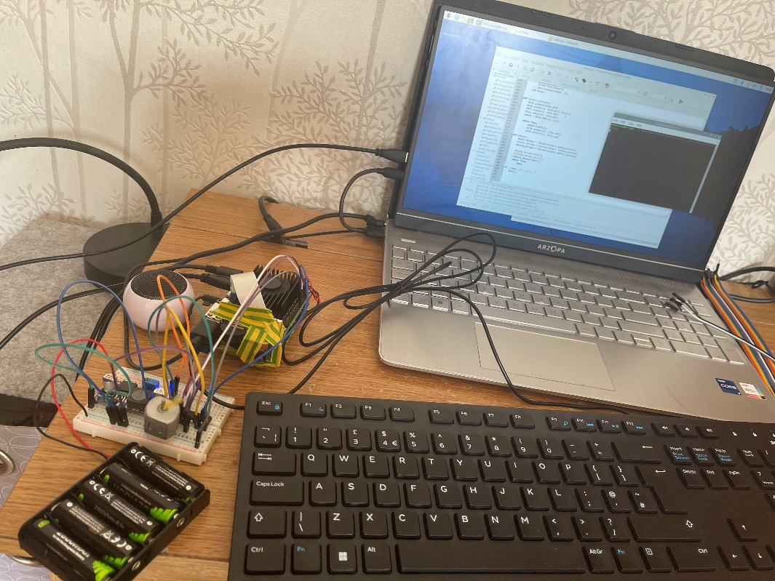

04/07July/25-
-Finished constructing the robot.
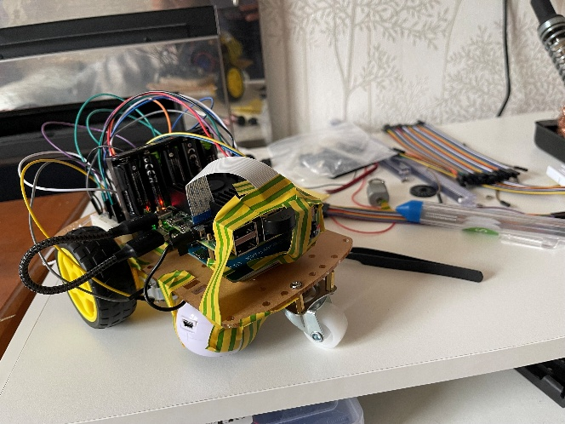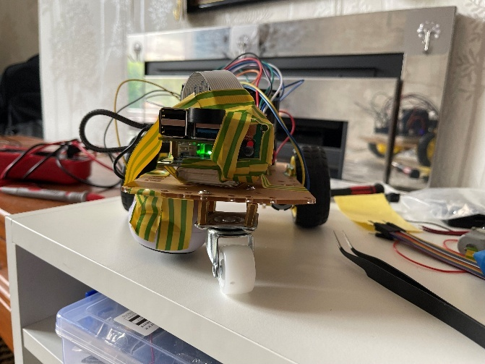

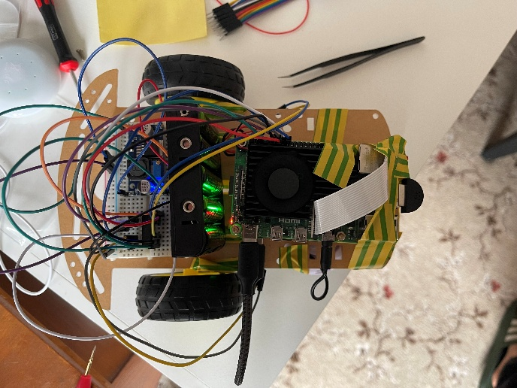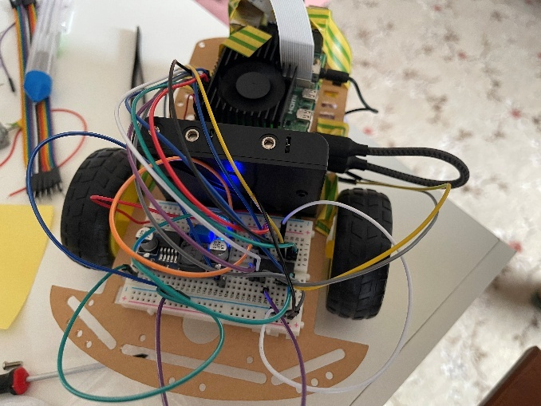
-Combined vision and wheel control thread.
-Added control_wheels() inside converse().
-Set the developer instructions such that the robot strictly only say the commands to avoid collision.
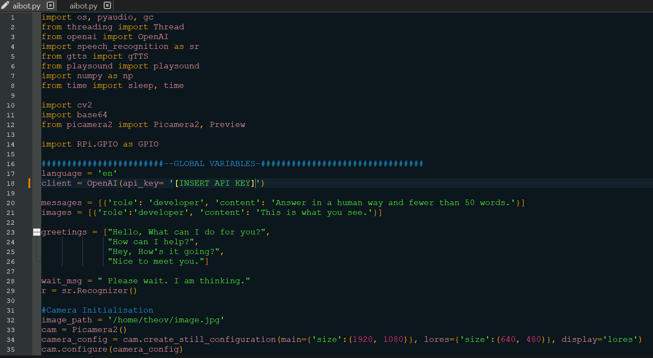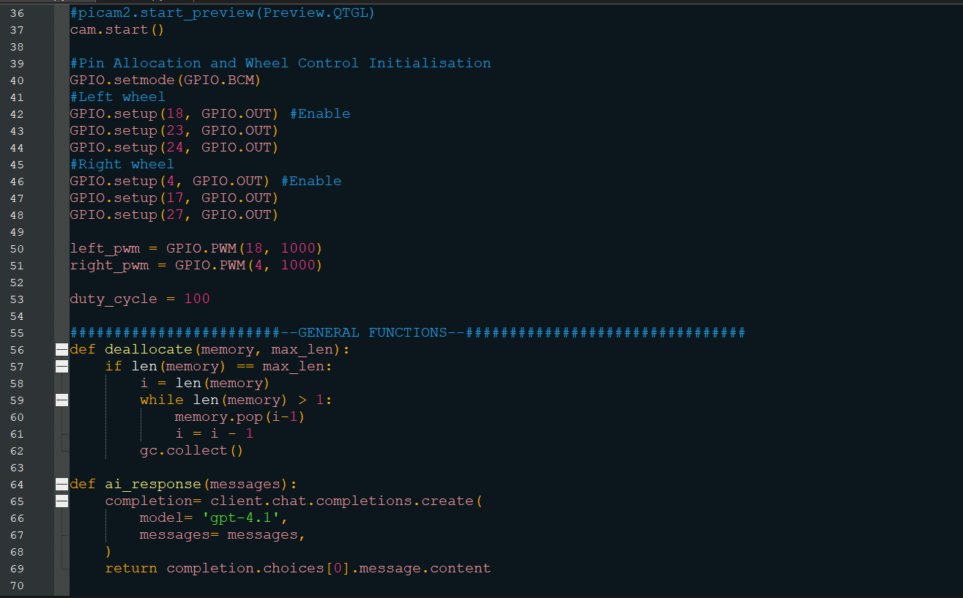
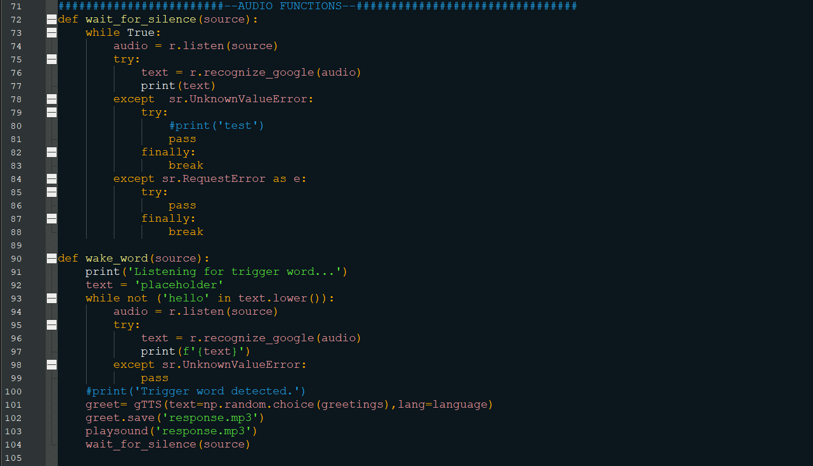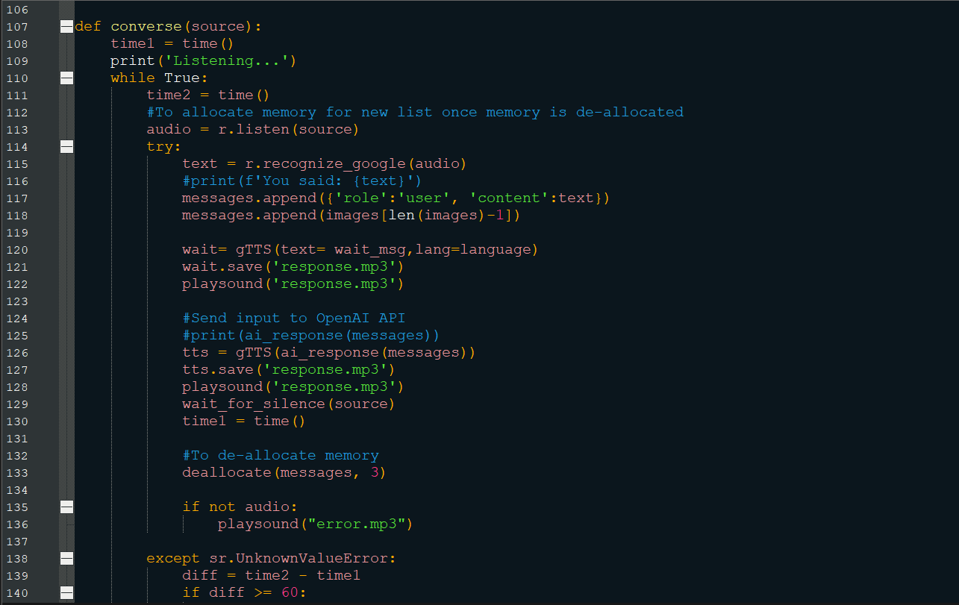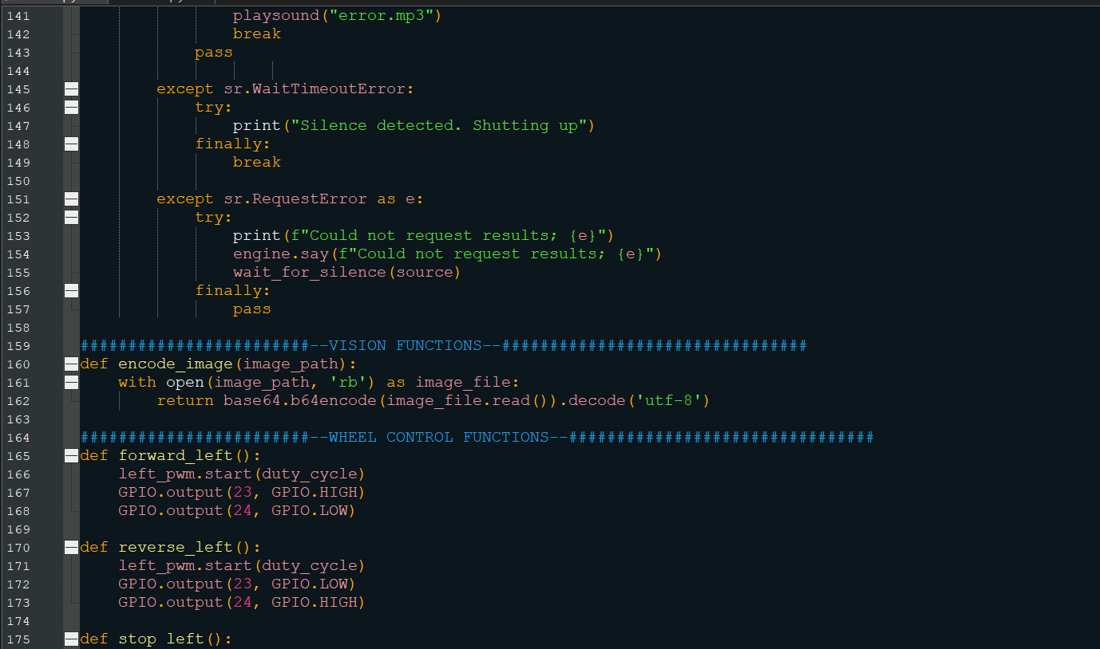

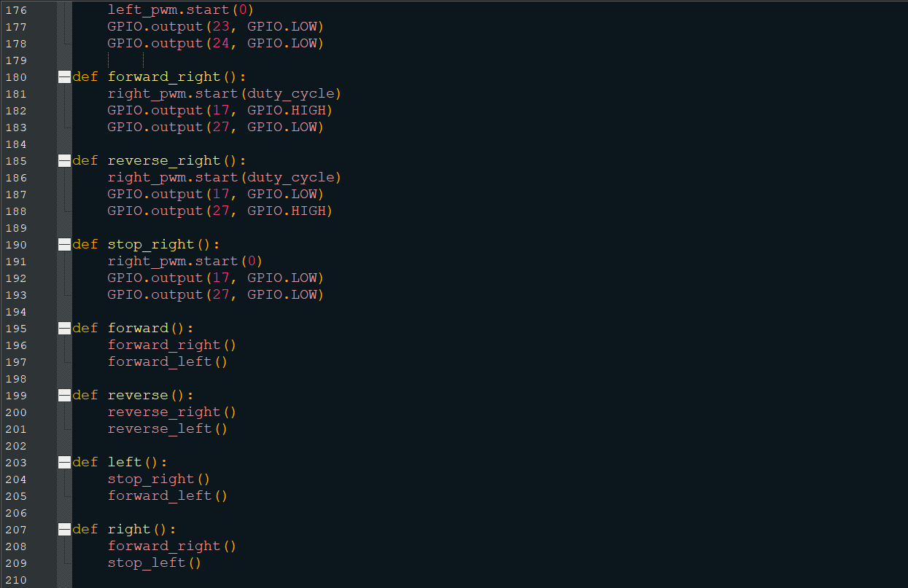.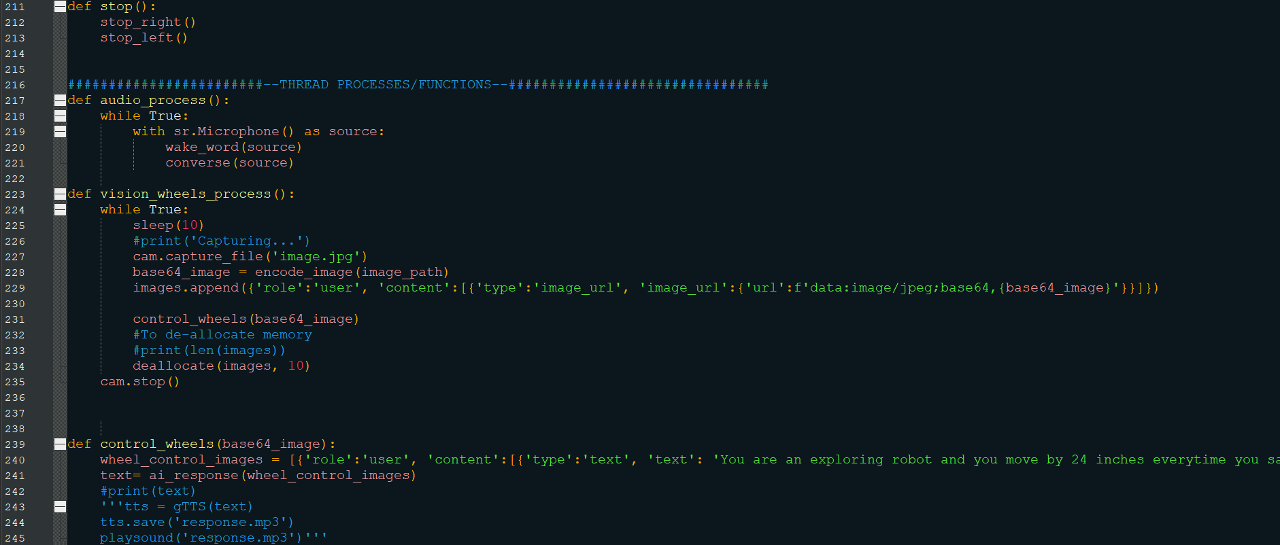
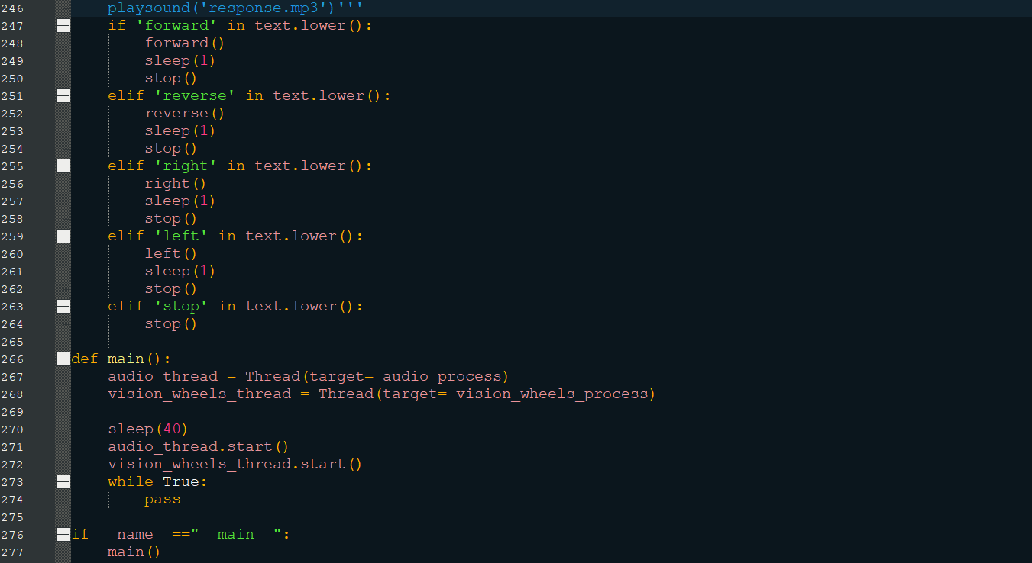
07/07July/25-
-Modified the code such that it only adds one image at a time in the messages list to prevent rate limit errors and save tokens.
-Implemented the solution to mute the microphone when the AI is speaking to prevent self-responding.
-Recorded the 2nd demonstration.
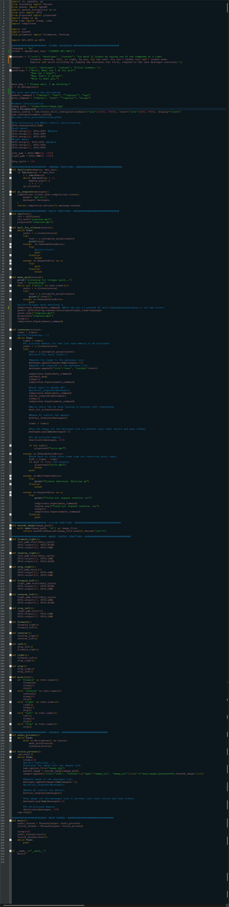
09/07July/25-
-Removed the sleep() to reduce latency.
-Recorded the 3rd demonstration.
