Robust Traffic Sign Recognition Under Visual Corruptions
Course: INDENG 1/242B Final Project
Team: [Insert names]
Interactive demo: https://huggingface.co/spaces/Theo9598/gtsrb-reliability-workbench
GitHub appendix: [Insert GitHub repository URL]/blob/main/APPENDIX.md
Presentation recording: [Insert recording link before Gradescope submission]
Abstract
We study traffic sign recognition as a 43-class image classification task using the German Traffic Sign Recognition Benchmark (GTSRB). To match the course emphasis on building a model, we first train our own convolutional neural network from scratch, then compare it with a stronger ImageNet-pretrained ResNet18 trained with RandAugment and MixUp. The custom CNN reaches 58.99% clean test accuracy, while the final ResNet18 reaches 98.76% accuracy and 98.33% macro F1. We also run a CNN ablation study: removing BatchNorm drops clean test accuracy to 19.21%, and removing Dropout drops it to 39.05%, showing why these course concepts matter. Because traffic sign recognition is safety-relevant, we evaluate visual corruptions, apply temperature scaling to reduce expected calibration error from 6.36% to 3.04%, and deploy a Streamlit demo with upload, corruption, top-5 prediction, and Grad-CAM features.
1. Motivation and Learning Problem
Traffic sign recognition is a core perception task for driver-assistance and autonomous vehicle research. A useful classifier should perform well not only on clean benchmark images, but also under realistic image degradation caused by motion, compression, lighting, camera quality, or weather. A wrong prediction on a stop sign, no-entry sign, or speed-limit sign could be dangerous if a downstream system over-trusts the classifier.
We formulate the task as supervised multiclass classification. Each input X_i is a cropped RGB traffic sign image, and each label Y_i is one of 43 GTSRB classes. The model f_theta(X_i) outputs 43 logits, which are converted to class probabilities using softmax. The prediction is the class with maximum probability. We train using multiclass cross-entropy with regularization:
min_theta (1/N) sum_i L(f_theta(X_i), Y_i) + R(theta),
where R(theta) includes weight decay, data augmentation, MixUp, and validation-based checkpoint selection. This directly uses course material on CNNs, softmax classification, cross-entropy, minibatch optimization, regularization, and loss-curve diagnostics.
2. Data
We use the Hugging Face GTSRB dataset tanganke/gtsrb, with 26,640 training images and 12,630 test images over 43 classes. We create a stratified train/validation split from the original training set and reserve the official clean test set for final evaluation. Images are resized to 96 by 96 pixels and normalized using ImageNet mean and standard deviation to match the pretrained ResNet18 backbone.
The dataset contains cropped signs, so this project studies classification rather than object detection in full road scenes. To measure reliability, we evaluate on both locally generated corruptions and the dataset's corrupted splits. Local corruptions include Gaussian noise, blur, JPEG compression, pixelation, and low contrast. The provided corrupted splits include contrast, Gaussian noise, impulse noise, JPEG compression, motion blur, pixelate, and spatter. This lets us compare clean benchmark performance to performance under degraded visual conditions.
3. Methodology
The project uses two model levels so that the report includes both a course-aligned model and an advanced comparison model. The course-aligned model is a custom CNN trained from scratch, meaning all convolutional, BatchNorm, and classifier weights are randomly initialized and learned only from the GTSRB training set. The advanced model is an ImageNet-pretrained ResNet18, used to test how much transfer learning and robust augmentation improve performance beyond the self-built CNN baseline.
Custom CNN architecture.
The custom CNN follows the standard lecture pipeline for image classification: convolutional filters produce feature maps, ReLU adds nonlinearity, pooling reduces spatial resolution, BatchNorm stabilizes intermediate activations, Dropout regularizes the classifier, and a final linear layer outputs 43 logits. The logits are trained with multiclass cross-entropy, which combines the softmax probability model with the negative log-likelihood of the true traffic sign class.
Table 1. Custom CNN architecture implemented from scratch.
Stage | Layer(s) | Output Channels / Size | Course Concept
Input | RGB image resized to 96 x 96 | 3 channels | Image tensor representation
Block 1 | Conv2d 3->32, BatchNorm, ReLU, MaxPool | 32 feature maps | Local filters, activation, pooling
Block 2 | Conv2d 32->64, BatchNorm, ReLU, MaxPool | 64 feature maps | Hierarchical feature learning
Block 3 | Conv2d 64->128, BatchNorm, ReLU, MaxPool | 128 feature maps | Deeper visual patterns
Block 4 | Conv2d 128->256, BatchNorm, ReLU, AdaptiveAvgPool | 256 pooled features | Global feature aggregation
Classifier | Flatten, Dropout p=0.35, Linear 256->43 | 43 logits | Regularization and multiclass classification
Both models are trained with minibatches and multiclass cross-entropy. For the custom CNN, the goal is to demonstrate the mechanics learned in class: convolutional filters learn local visual patterns, pooling reduces spatial size, ReLU introduces nonlinearity, BatchNorm stabilizes activation distributions, Dropout regularizes the classifier, and softmax converts logits into class probabilities. For the ResNet18 model, we use AdamW, weight decay, a cosine learning-rate schedule, an initially frozen backbone, and later end-to-end fine-tuning.
Our advanced methodology beyond the standard CNN pipeline is robust training with RandAugment and MixUp. RandAugment randomly applies image transformations so the model learns useful invariances. MixUp forms convex combinations of images and labels, encouraging smoother decision boundaries and reducing overconfident memorization. We also add two deployment-aware components: temperature scaling calibrates confidence by rescaling logits before softmax, and Grad-CAM visualizes which image regions influence the prediction.
4. Results
The custom CNN and ablation models were trained for 12 epochs from scratch. The full custom CNN reached 78.03% validation accuracy and 58.99% clean test accuracy. Removing BatchNorm caused the model to learn poorly, reaching only 20.85% validation accuracy and 19.21% clean test accuracy. Removing Dropout was less damaging but still reduced clean test accuracy to 39.05%. The final ResNet18 model trained for 25 epochs on an NVIDIA GeForce RTX 2080 Ti and reached 99.97% validation accuracy, 98.76% clean test accuracy, and 98.33% macro F1.
Table 2. Model comparison and ablation results.
Model | Pretrained? | Metrics (%) | Delta vs Full CNN
Full custom CNN | No | Val 78.03; Test 58.99; F1 39.26 | Baseline
No BatchNorm | No | Val 20.85; Test 19.21; F1 6.02 | -39.78 pp
No Dropout | No | Val 50.03; Test 39.05; F1 21.06 | -19.94 pp
ResNet18 robust | Yes | Val 99.97; Test 98.76; F1 98.33 | +39.77 pp
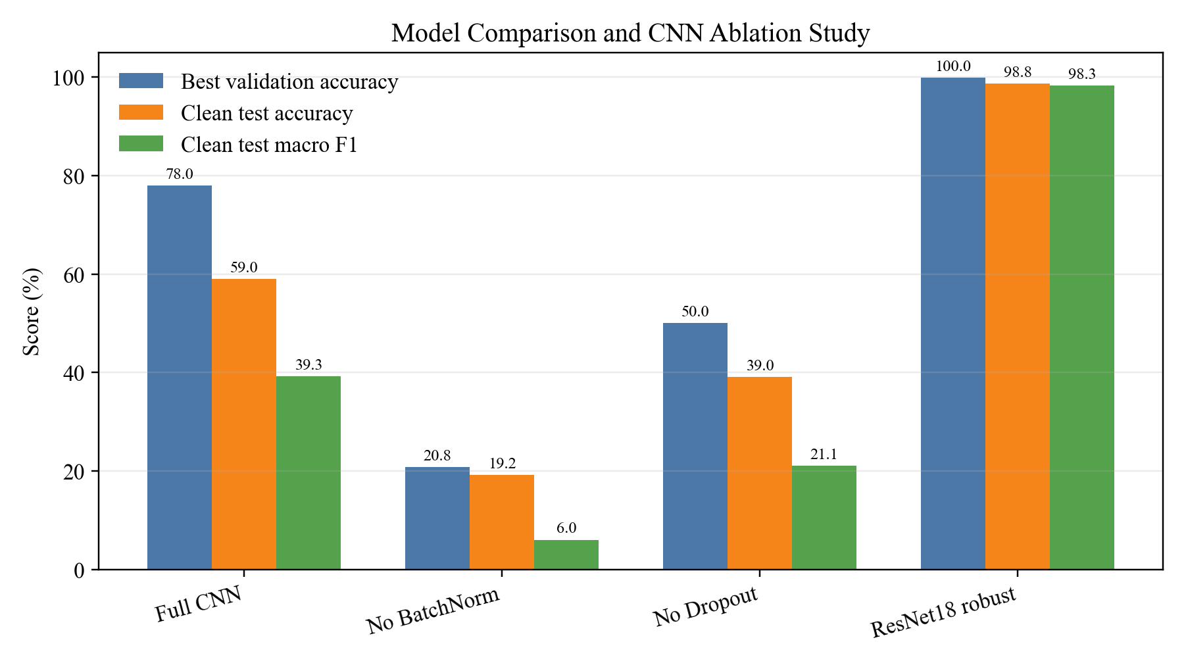
Figure 1. Model comparison and CNN ablation study.
Table 2 reports the numerical comparison directly. The full custom CNN is the from-scratch course model, so the ablation rows measure how much performance changes when one component is removed. Removing BatchNorm drops clean-test accuracy by 39.78 percentage points, and removing Dropout drops it by 19.94 percentage points. The ResNet18 model is included as the advanced pretrained comparison and improves clean-test accuracy by 39.77 percentage points over the full custom CNN.
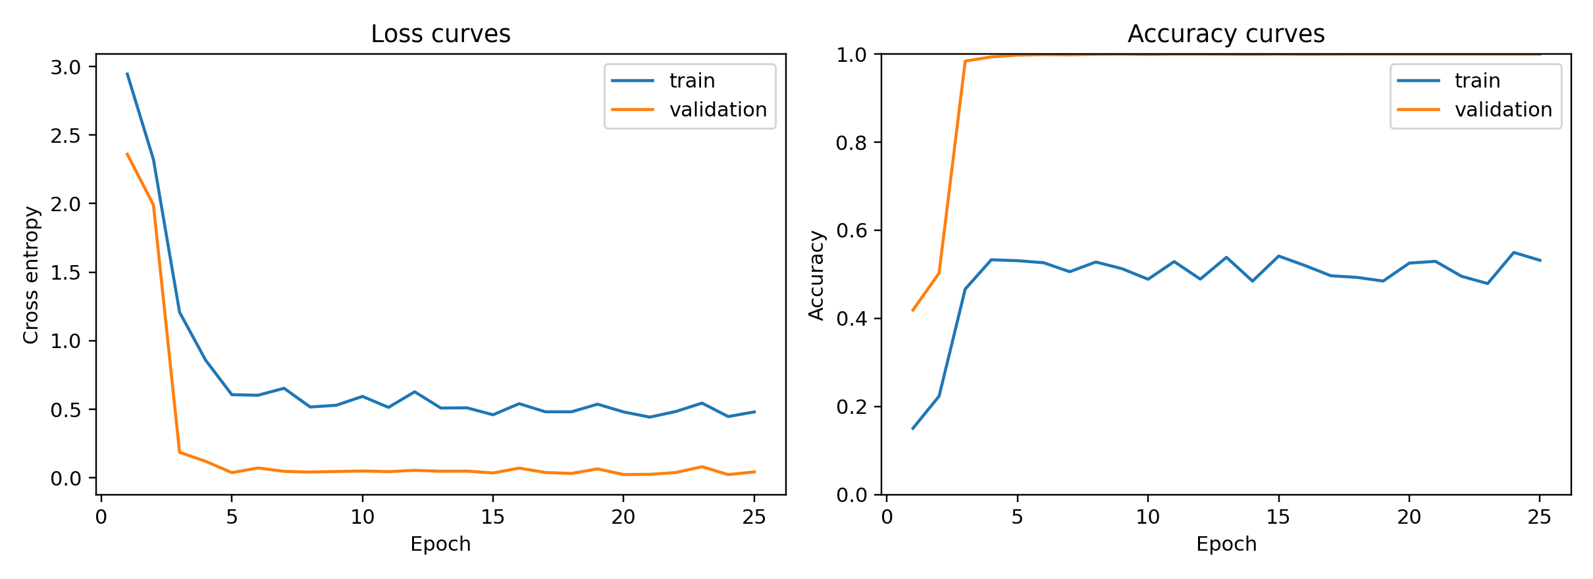
Figure 2. Training and validation loss/accuracy curves.
On the clean official GTSRB test set, the model performs strongly:
Metric | Value
Accuracy | 98.76%
95% bootstrap CI for accuracy | 98.56%-98.95%
Macro F1 | 98.33%
ECE before calibration | 6.36%
ECE after temperature scaling | 3.04%
Learned temperature | 0.8592

Robustness testing gives a more complete picture:
Evaluation split | Source | Accuracy | Macro F1
Clean test | Clean | 98.76% | 98.33%
Gaussian noise | Local corruption | 84.57% | 84.44%
Blur | Local corruption | 62.61% | 62.21%
JPEG compression | Local corruption | 85.91% | 84.99%
Pixelate | Local corruption | 36.30% | 32.89%
Low contrast | Local corruption | 98.42% | 98.00%
Contrast | HF corrupted split | 98.42% | 97.86%
Gaussian noise | HF corrupted split | 88.25% | 87.53%
Impulse noise | HF corrupted split | 84.24% | 83.44%
JPEG compression | HF corrupted split | 96.05% | 95.14%
Motion blur | HF corrupted split | 97.93% | 97.14%
Pixelate | HF corrupted split | 96.79% | 95.83%
Spatter | HF corrupted split | 91.91% | 90.20%

The model is robust to several benchmark corruptions, especially contrast, motion blur, JPEG compression, and low contrast. However, severe local pixelation is a major weakness: accuracy drops to 36.30%. This likely removes fine details such as digits, arrows, and sign boundaries that distinguish similar classes. Thus, the project produces a scientifically useful result: the model is strong on clean and many corrupted images, but not reliable under every degradation.
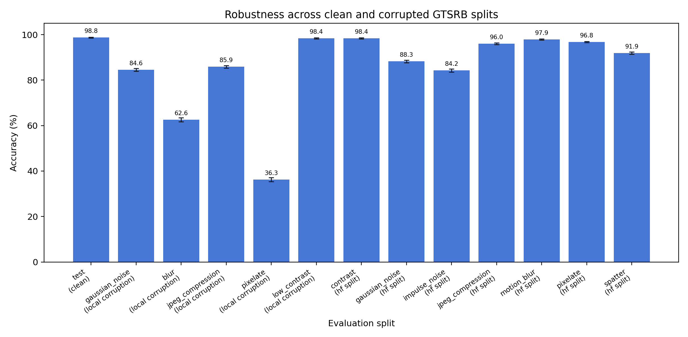
Figure 3. Accuracy under clean and corrupted evaluation splits.
Calibration also improves meaningfully. Expected calibration error decreases from 6.36% to 3.04% after temperature scaling, which makes predicted confidence more aligned with empirical correctness. This matters because high confidence should not be interpreted as a guarantee of safety.
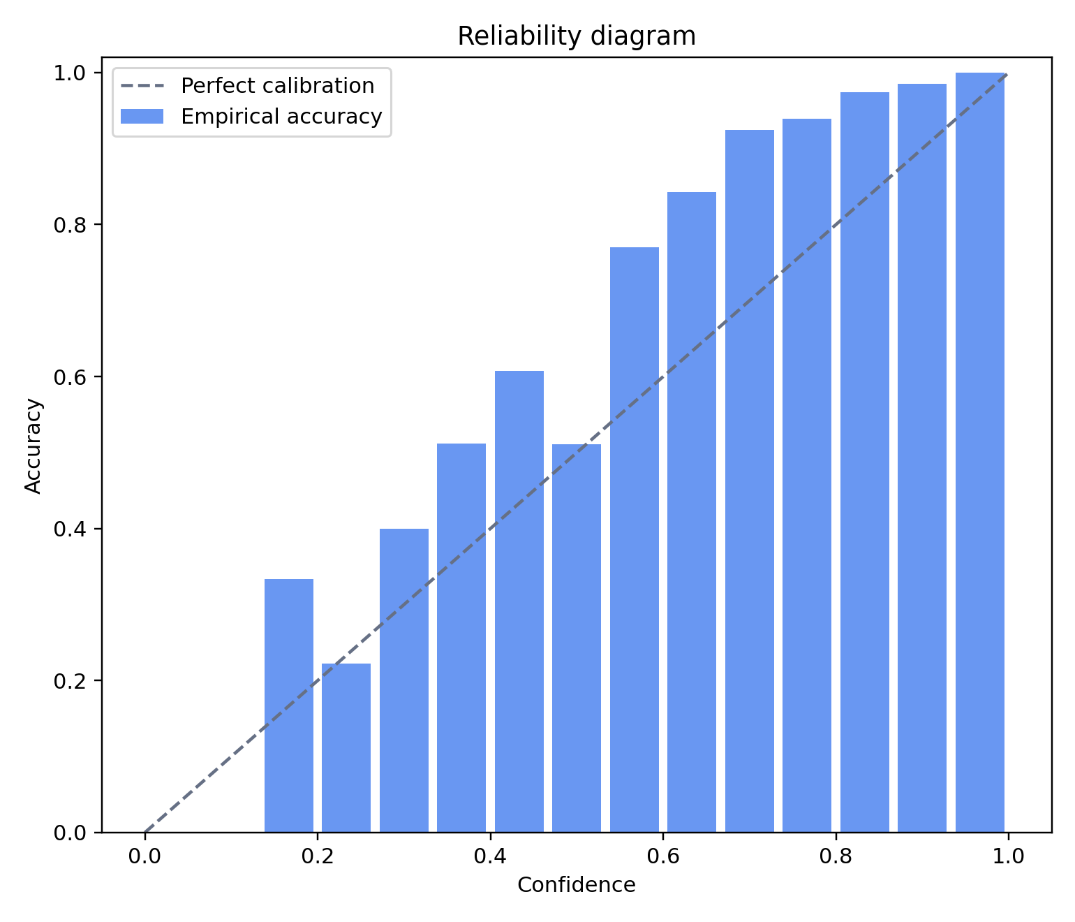
Figure 4. Reliability diagram after temperature scaling.
5. Interactive Tool and Bonus Component
We deploy a Streamlit workbench on Hugging Face Spaces: https://huggingface.co/spaces/Theo9598/gtsrb-reliability-workbench. The tool lets users upload a traffic sign image, view top-5 predictions, apply realistic corruptions, adjust calibration temperature, and inspect Grad-CAM heatmaps. This interaction directly supports the project thesis: users can test whether a prediction remains stable when the image is degraded, rather than only seeing one clean-image classification result. The complete appendix, commands, source-code map, and additional diagnostic figures are maintained in the GitHub repository appendix: [Insert GitHub repository URL]/blob/main/APPENDIX.md.
6. Safety, Security, and Ethics
This project should be treated as an educational prototype, not a deployable autonomous driving component. It classifies cropped signs but does not detect signs in full road scenes. It also does not handle occlusion, night driving, unusual weather, camera motion, vandalized signs, adversarial stickers, or map context.
False predictions can be safety-critical. Misclassifying a stop sign, no-entry sign, or speed limit could cause unsafe downstream behavior if used without safeguards. Domain shift is also important because GTSRB uses German signs; results may not transfer to other countries or rare sign variants. The corruption experiments show that high clean accuracy does not guarantee robustness, especially under severe resolution loss.
A real deployment would require uncertainty thresholds, out-of-distribution detection, redundant sensors, human oversight, extensive field testing, and regulatory review. For this reason, the demo includes an educational-use disclaimer.
7. Conclusion
This project applies deep learning methodology to a real image classification problem and extends it with robustness, calibration, interpretability, and deployment analysis. The custom CNN architecture demonstrates course concepts directly: convolution, ReLU, pooling, BatchNorm, Dropout, softmax-style multiclass classification, and cross-entropy training. The ablation study shows that BatchNorm and Dropout materially affect performance. The fine-tuned ResNet18 trained with RandAugment and MixUp achieves 98.76% clean test accuracy and 98.33% macro F1 on GTSRB. Calibration reduces ECE from 6.36% to 3.04%, and corruption testing reveals the model's strengths and limitations. The main conclusion is that strong clean performance is achievable, but reliability requires explicit model comparison, ablation, robustness testing, and safety analysis.

