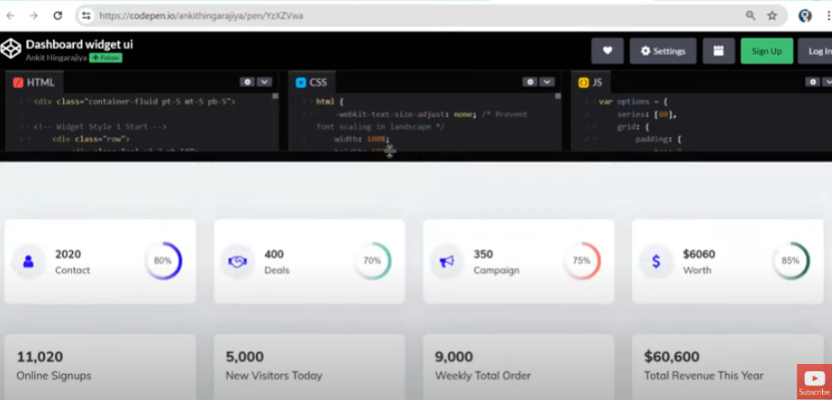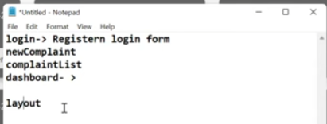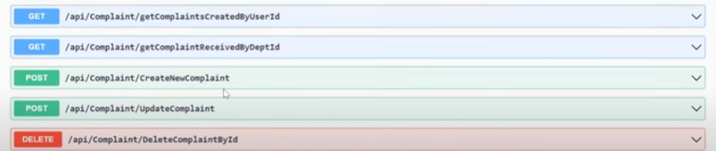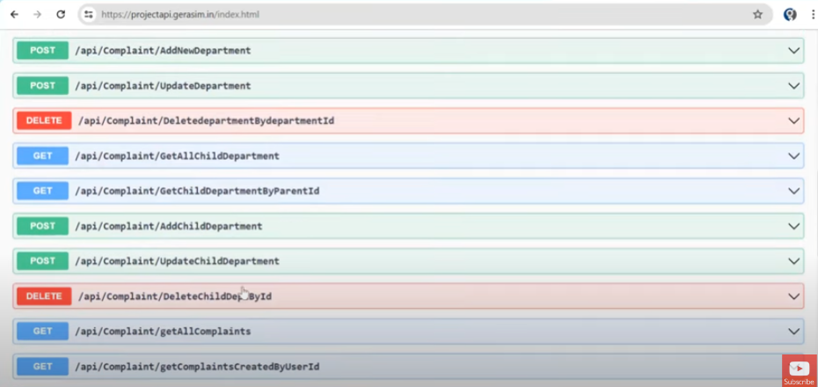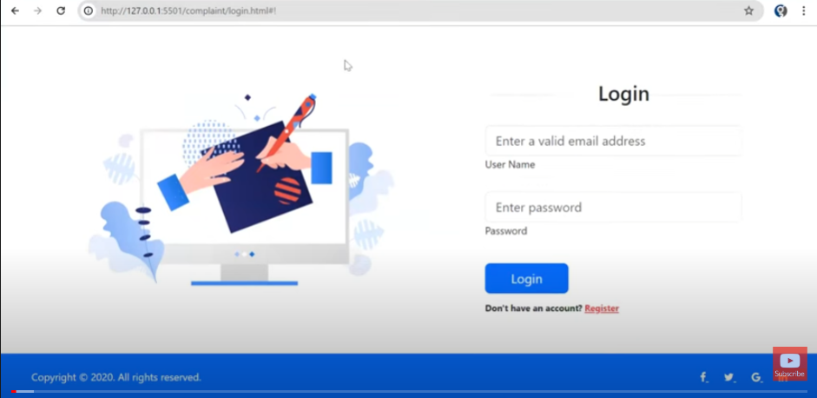Complaint Management System

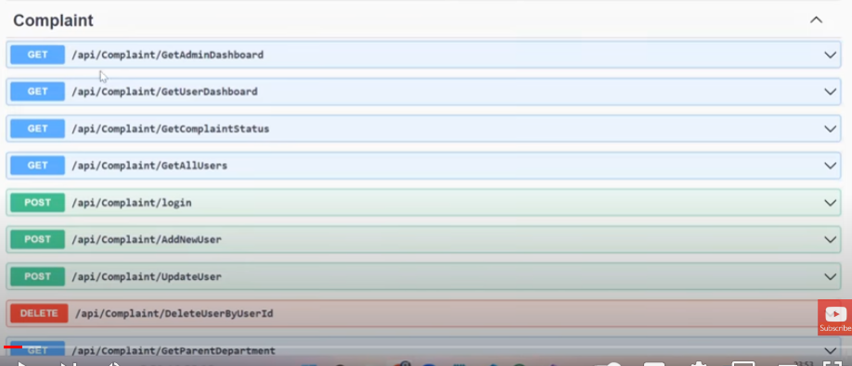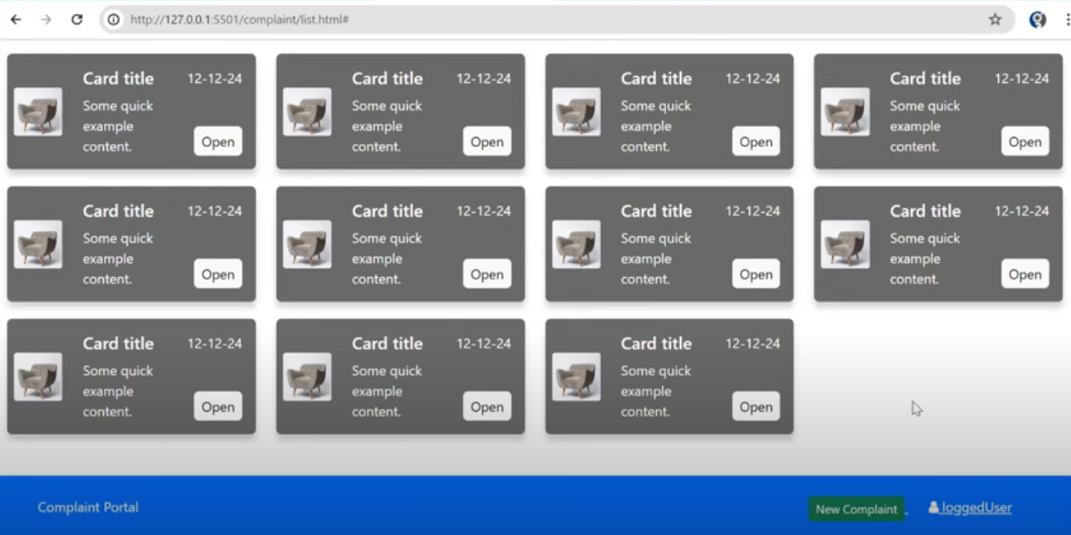so, we will be focusing on on authentication, list of complaints, a form for new complaints and then a dashboard to give some general overview of all complaints.

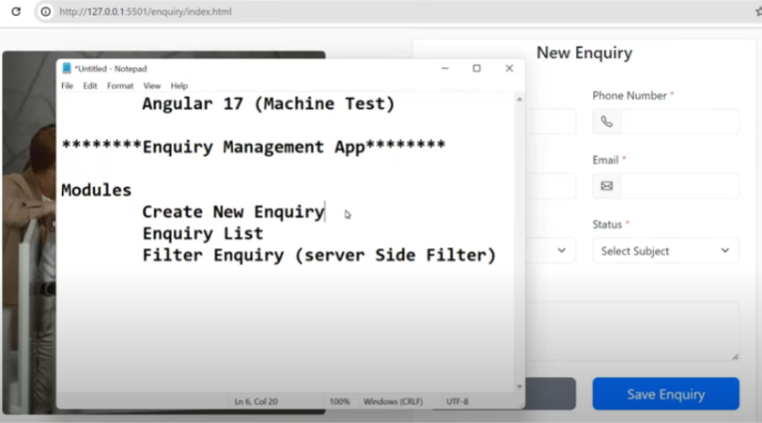

NB: list complaints and dashboard is going to look and feel different for both user and admin. Once we are done with this, we will be looking at an [enquiry management crud application](https://www.youtube.com/watch?v=KHiHa4kxD4g).

# Authentication Module

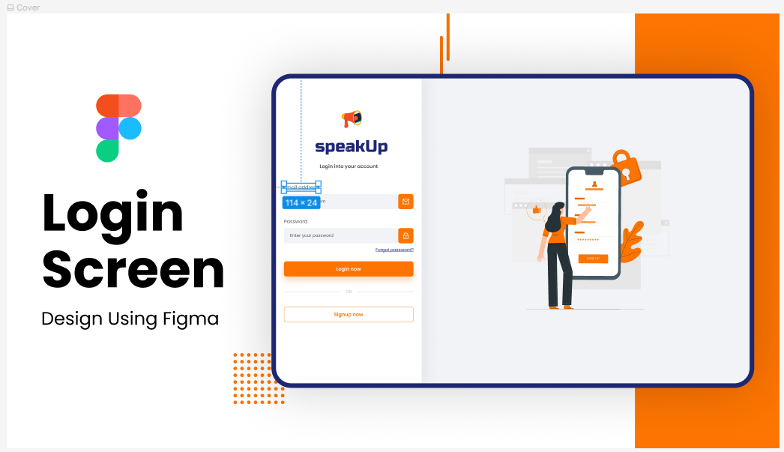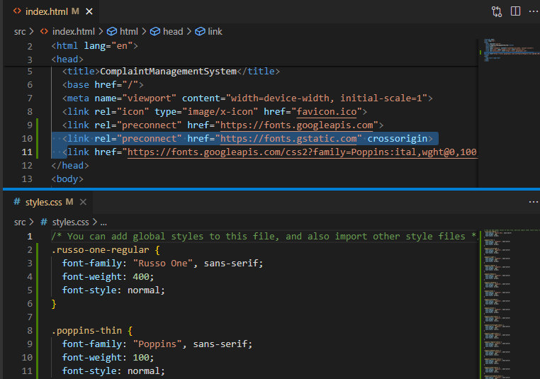got a login template from figma, tweaked it a bit to suit our taste and we will start building.

Got fonts from google fonts and did the basic setup.

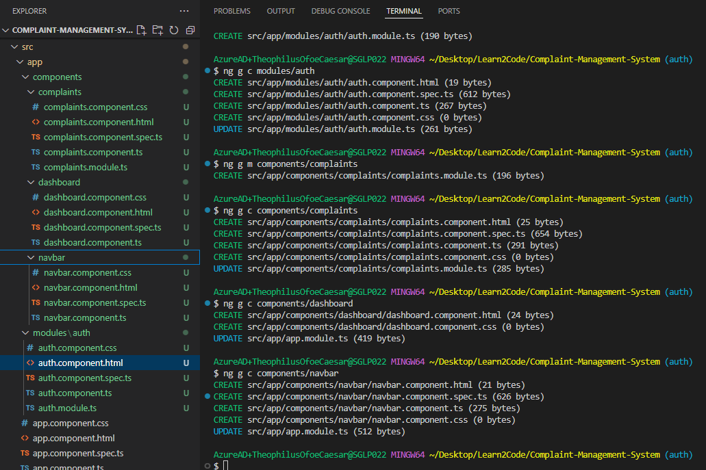

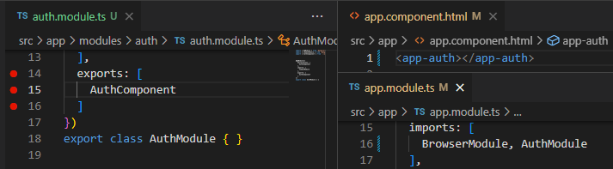We are going to have login and registration in our auth component, with toggle by Boolean and if statement.