UNIVERSITY OF GHANA
SECOND SEMESTER EXAMINATION 2025/26
CSCD 602: ADVANCED SOFTWARE ENGINEERING



NKWANTA: A ROAD INCIDENT REPORTING AND DISPATCH SYSTEM FOR URBAN GHANA — PROJECT DOCUMENTATION

BY
THEOPHILUS OFOE CAESAR
(ID. NO: 22424543)

ABSTRACT
Nkwanta is a road incident reporting and dispatch system for urban Ghana. Road users report what is blocking a road; the system works out which reports describe the same real event, scores how believable each event is from the reporters' track records, warns other commuters travelling that way, and places credible events in front of a traffic control officer who can send a warden. This document consolidates the full engineering record across all nineteen required sections: problem, stakeholders, requirements analysis, effort estimation, system analysis and design, implementation, testing, technical debt, deployment, maintenance, future evolution and limitations. The system is deployed and reachable, carries 508 automated tests including 35 property-based invariants, and records 23 technical debt items and 45 dated design decisions written as the work was done. Two gaps are declared rather than rounded away: one functional requirement is verified only by inspection, and one non-functional requirement is stated as a target rather than a measurement.

TABLE OF CONTENT

ABSTRACT 2
TABLE OF CONTENT 3
LIST OF FIGURES 4
LIST OF TABLES 5
LIST OF ABBREVIATIONS 6
CHAPTER 1 - INTRODUCTION 1
CHAPTER 5 – CONCLUSION AND FUTURE WORKS 2
5.1 Overview 2
REFERENCES 4

LIST OF FIGURES

LIST OF TABLES

LIST OF ABBREVIATIONS

University of Ghana · Examiner: Prof. Solomon Mensah · 14 August 2026 ## How to read this document This is the consolidating document. It covers all nineteen required sections in order. Where a section has a dedicated document, this one gives the substance and points to it rather than duplicating it — a duplicated section is a section that will disagree with its original after the next change. Nothing here depends on reading the others. | Referenced as | Full document | |—|—| | SRS | 10-srs.md | | Design | 09-system-design.md | | Testing | 11-testing-report.md | | Debt | 08-technical-debt.md | | Estimation | 06-effort-estimation.md | | Evolution | 12-maintenance-and-evolution.md | | Manual | 13-user-manual.md | | Decisions | 05-decision-log.md (D-nnn) |

1. Title
Nkwanta: A Road Incident Reporting and Dispatch System for Urban Ghana.
Nkwanta is Twi for junction — the place where roads meet, and where they block.

2. Problem statement
When a road in Accra is blocked, the information exists — dozens of people are sitting in it — and there is no path from those people to anyone who can act. A commuter three kilometres back learns about it by arriving. A traffic control officer learns about it from scattered phone calls, with no way to tell six calls about one accident from six separate accidents.
Two failures, and they are the same failure: the information is present and unusable.
Three things make it hard rather than merely tedious:
- Reports arrive in no controlled order, from phones with different signal, some twice.
- Not every report is true. The system lets people report other people to the police, which makes it a harassment vector unless something defends against it.
- A warning that arrives late is worth nothing, so the pipeline cannot be allowed to silently drop work.

3. Aim and objectives
Aim. Turn scattered reports from road users into a single, believable, actionable picture of what is blocking the roads — and put that picture in front of both the commuter about to set out and the officer who can send someone.
Objectives.
# | Objective | Where it is met
1 | Capture typed, located, timestamped reports from ordinary road users, safely and offline-tolerantly | SRS Section 3.2
2 | Group reports describing one real event, independent of arrival order | SRS FR-19, FR-20
3 | Score believability from reporter track record, decaying with age | SRS FR-21–FR-24
4 | Warn commuters on affected routes, exactly once each | SRS FR-35–FR-40
5 | Give officers a ranked queue whose scores can be interrogated, not just read | SRS FR-29
6 | Defend against false reporting without exposing either party | NFR-04, NFR-04a
7 | Guarantee that saving a report and queueing its warnings cannot come apart | SRS FR-12

4. Stakeholders
Stakeholder | Interest | Influence on the design
Commuters and motorists | Know before setting out | The public map needs no account; the driver-facing view is read-only (NFR-03)
Traffic control officers (MTTD) | A queue worth acting on | Primary actor. The dispatch queue is the core screen
Traffic wardens | Clear instructions, and to be believed | Resolution feeds reputation — the loop closes here
Reported parties | Not to be publicly accused | NFR-04: never identified. No field records them
Reporters | Not to be exposed for reporting | NFR-04a: voice private by default, withdrawable (D-029)
Road maintenance agencies | Structured defect reports | Report type 6, no separate workflow
Administrators | Oversight, abuse control | Roles assigned only by an admin; nobody self-registers as police
The primary actor is the officer, not the commuter. Commuters are the sensor network; the officer is the person whose job the system exists to do. That choice decides which screen is the core one, and it makes the system demonstrable without a large user base.

5. Requirements analysis
The original brief was a wish-list containing at least three separate products. The analysis that mattered was unification:
Five items — traffic impediments, accidents, maintenance reports, road-condition reviews, and signal outages needing a warden — collapsed into one report pipeline differentiated only by type. They differ in who acts on them, not in how they are captured, grouped or scored.
This is the single most important requirements decision in the project. It converted a sprawling brief into one well-engineered core, and it is what made the advanced concept affordable inside 48 hours.
Prioritisation used MoSCoW, and the cuts are recorded with reasoning (SRS Section 6). Four Won’t-haves — ride-sharing, subscription transport, real emergency dispatch, fare adjudication — were each cut for a stated reason, not for lack of time. Ride-sharing alone is a second product: matching, payments, identity, passenger safety, liability, sharing nothing with the report pipeline.
Two requirements arose from reviewing the brief rather than from the brief itself, and both are load-bearing: NFR-03 (the system must not create the hazard it exists to reduce) and NFR-04 (the reported party is never identified). A later review found NFR-04 conflated protecting the accused with protecting the accuser, and NFR-04a was added — see D-029.

6. Software Requirements Specification
Full document: 10-srs.md.
Fifty numbered functional requirements, each with a MoSCoW priority, a status, the module implementing it and the test verifying it. Seven non-functional requirements. Four use cases with alternative flows.
Group | Requirements
Accounts and roles | FR-01 – FR-08
Reporting | FR-09 – FR-18
Grouping, scoring, lifecycle | FR-19 – FR-28
Dispatch and reputation | FR-29 – FR-34
Warning commuters | FR-35 – FR-40
Public map and privacy | FR-41 – FR-46
Administration and resilience | FR-47 – FR-50
49 of 50 implemented; FR-40 (clearance) is declared Partial. Six of seven non-functional requirements are verified by test; NFR-07 is declared a target rather than a measurement. Both gaps are stated in the specification rather than rounded away.

7. Software effort estimation
Full document: 06-effort-estimation.md.
Two techniques, deliberately, because they disagree and the disagreement is informative.
Technique | Result
Use Case Points | 97.39 UCP → 1,948 person-hours
Bottom-up task breakdown | ~64 person-hours for the reduced scope
The 30× gap is the finding, not an error. UCP is calibrated on commercial projects with teams, handovers, meetings, environments and support. A single developer, working continuously, on a system with no stakeholders to consult and no integration to negotiate, operates in conditions UCP does not model.
What the estimate actually did. It made the cuts non-negotiable. 1,948 hours against 48 available says plainly that the brief cannot be built, so the only question is what to remove — and the removals in Section 5 followed from the arithmetic rather than from taste. That is what estimation is for, and it is why it is worth 5 marks.

8. System analysis
The problem’s two structural facts determine the architecture:
The fact | What it forces
Reports arrive in an uncontrolled order, sometimes twice | Grouping must be order-independent and provable; every write carries a key making retries harmless
A warning that is not sent is worse than no system | Saving and enqueueing must be one transaction
Evidence must be auditable | Reports written once, never edited
The score decides police involvement | It must be explainable, not merely displayed
The advanced concept, in one paragraph: reports are permanent, unchangeable records. A background process groups reports close in place and time into an Incident, and scores its believability from reporter track record, fading with age. Saving a report and queueing its notifications happen in one transaction, so a crash cannot lose one without the other. Notifications carry a unique key, so a retry cannot warn anyone twice.
The property that must always hold: the order reports arrive in must not change the result. Full treatment in 04-advanced-concept.md.
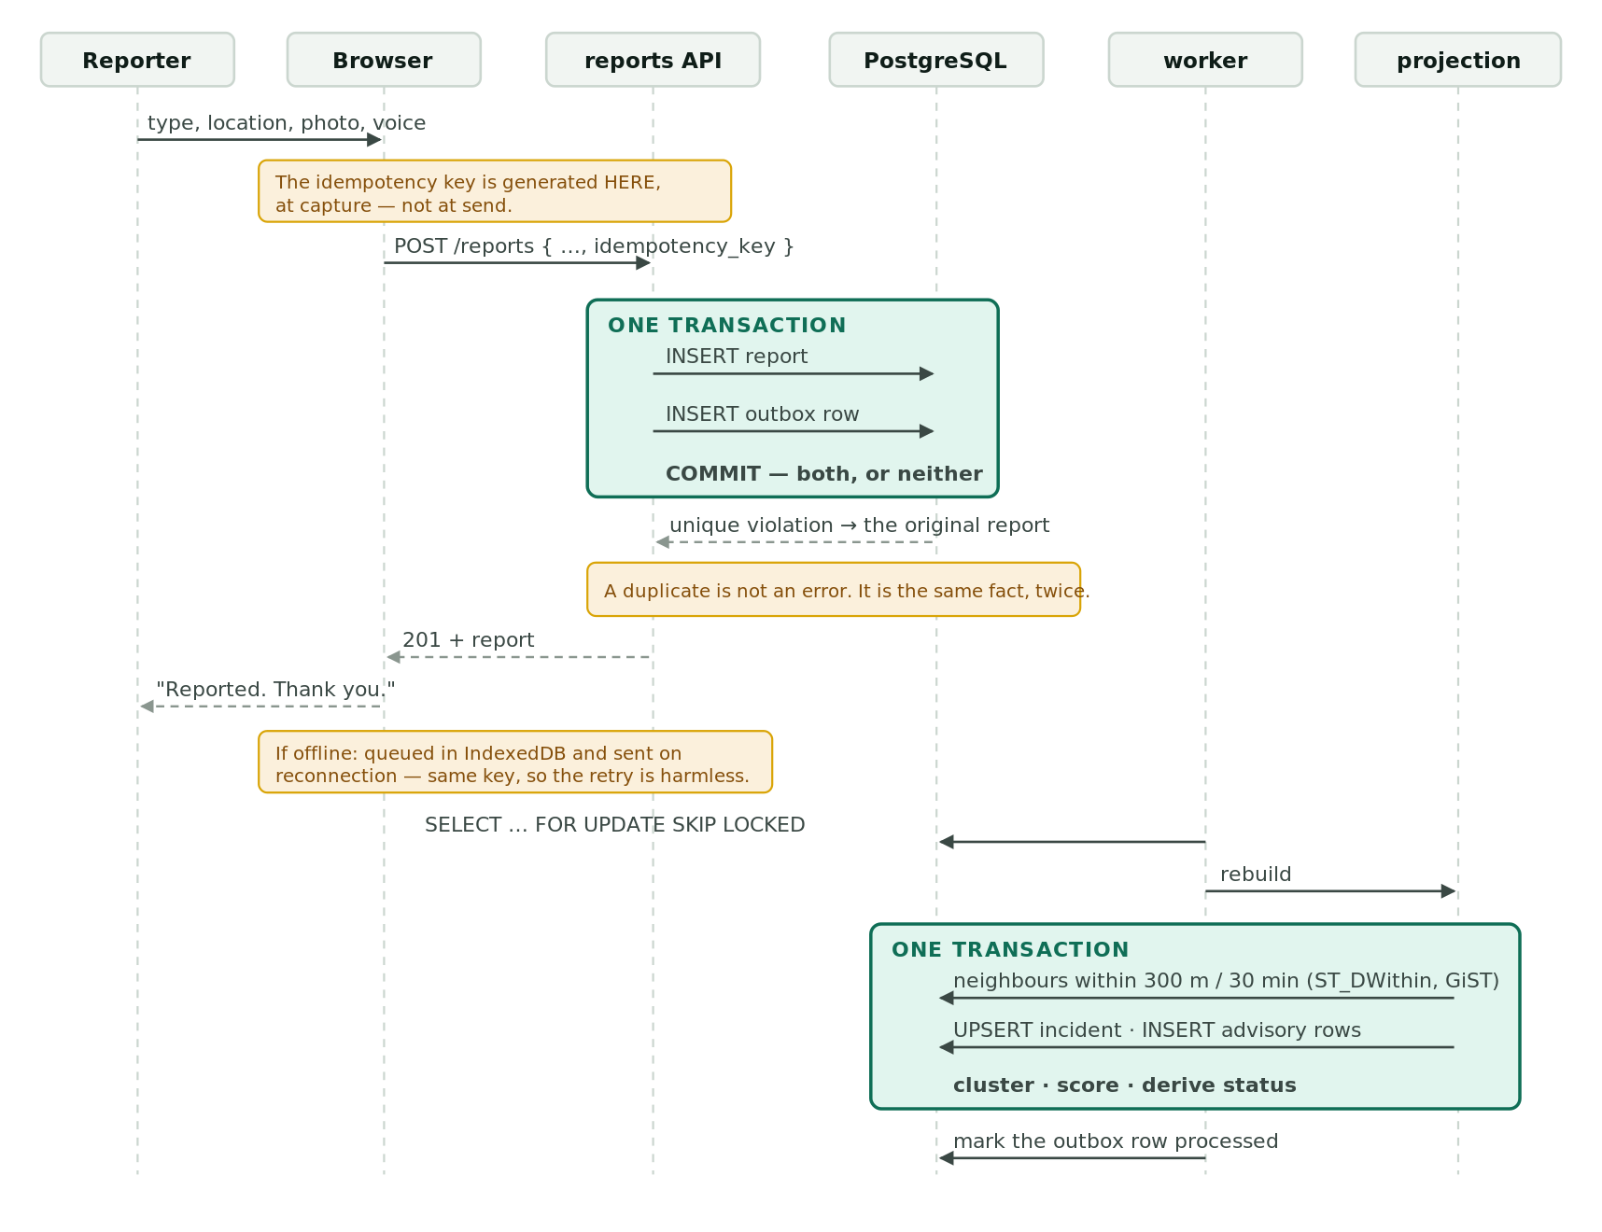
Figure 3 — Report intake: saving and enqueueing in one transaction
Figure 3 — Report intake: saving and enqueueing in one transaction.

9. System design
Full document: 09-system-design.md, with nine diagrams.
Diagram placement for the PDF build — see docs/diagrams/README.md. Four essential diagrams exist as standalone SVG; the remaining five are Mermaid, which renders on GitHub.
Architecture: layered, with a pure core. Four layers, and one rule — the domain layer imports nothing from above it and touches no database, clock or network.
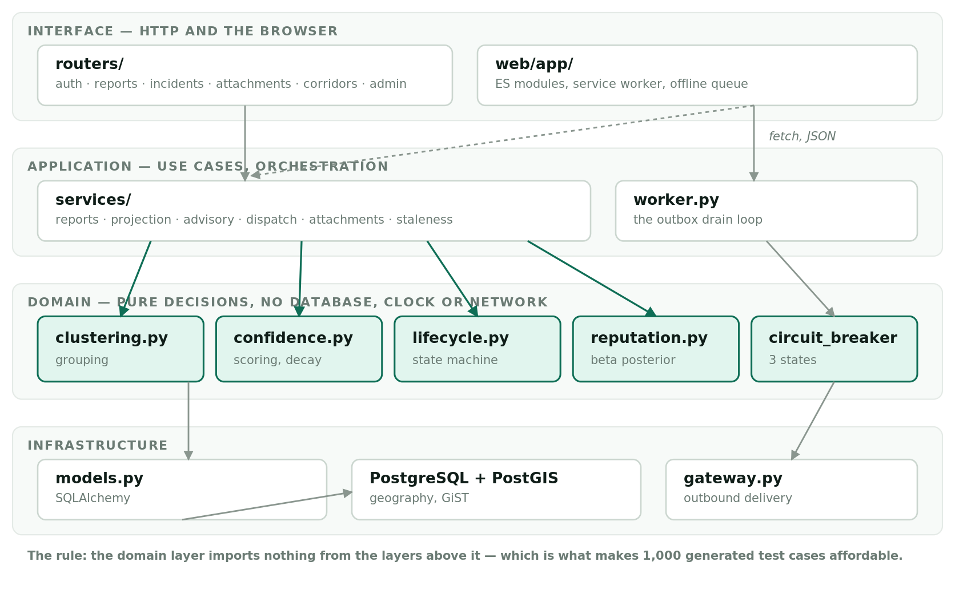
Figure 1 — Architecture: layered, with a pure core
Figure 1 — Architecture: layered, with a pure core.
That rule is not decoration. It is why property-based testing was affordable: Hypothesis can call clustering.group() a thousand times because calling it costs nothing. A clustering function that read from the database could not be tested that way, and the order-independence property could not have been proved.
Data model. Nine tables. Two are the design rather than incidental:
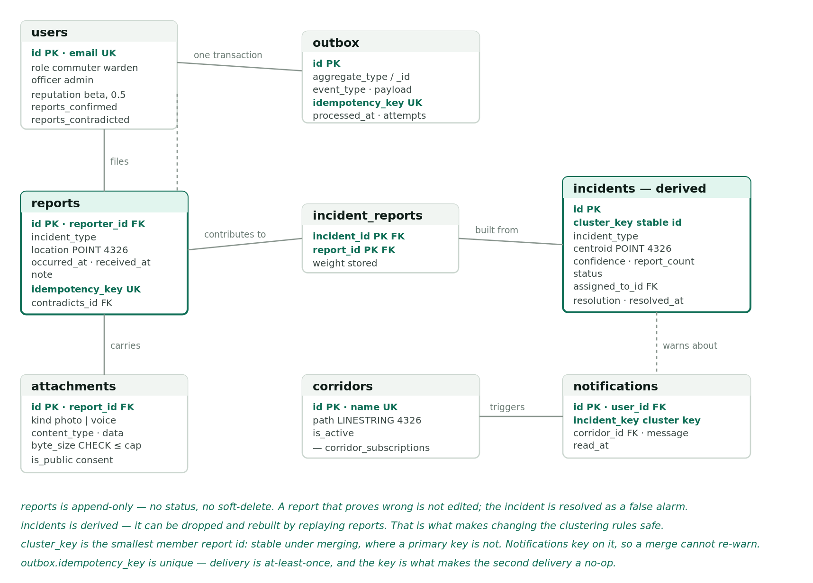
Figure 2 — Data model: reports are append-only, incidents derived
Figure 2 — Data model: reports are append-only, incidents derived.
- reports is append-only. No status, no soft-delete. A report that turns out to be wrong is not edited — the incident is resolved as a false alarm and reputation moves.
- incidents is derived. It could be dropped and rebuilt by replaying the reports. That is what makes it safe to change the clustering rules later: the history is the reports, not the map.
Three columns worth explaining: incidents.cluster_key (the smallest member report id — stable under merging, where a primary key is not), incident_reports.weight (stored so the score is explainable), outbox.idempotency_key (unique, so a retry is a no-op).
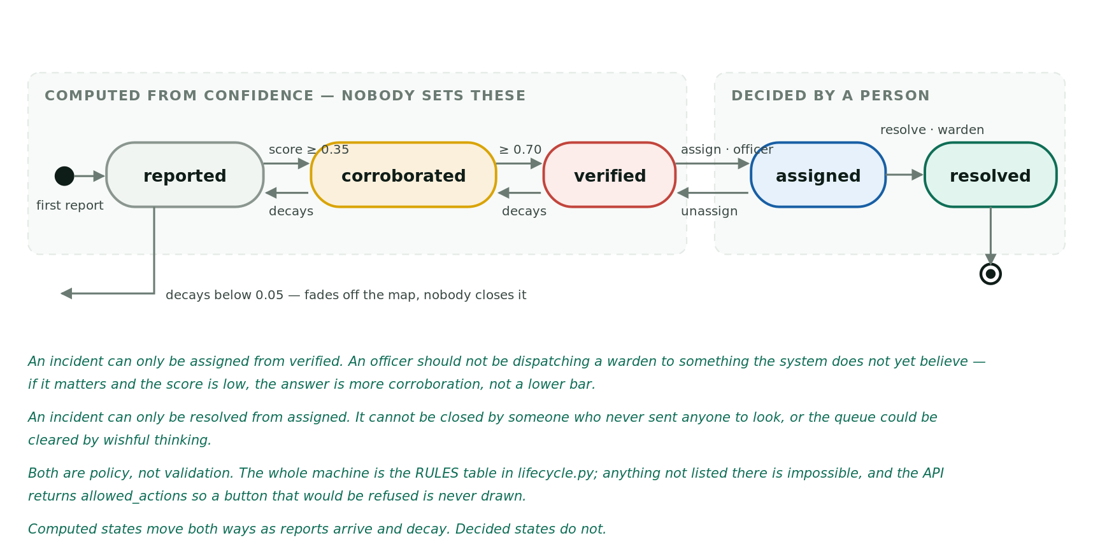
Figure 4 — The incident lifecycle: computed states versus decided states
Figure 4 — The incident lifecycle: computed states versus decided states.

10. Implementation
Layer | Choice | Why
Backend | Python, FastAPI | Async, typed, generates its own API documentation
Database | PostgreSQL + PostGIS | ST_DWithin on geography measures real metres; a GiST index makes it fast
ORM | SQLAlchemy 2.0 async + Alembic | Typed models, versioned migrations
Front end | Native ES modules, no build step (D-037) | A build pipeline is a thing that breaks at hour 44 for reasons unrelated to the product
Tests | pytest + Hypothesis | The order-independence property cannot be demonstrated by examples
Hosting | Neon (database) + Render (application) | Free tier; no Vercel (D-012)
Scale: ~2,000 statements of Python across 30 modules, 13 front-end ES modules, 508 tests, 7 migrations.
The front end is an installable progressive web application — offline report queueing in IndexedDB, a service worker caching the shell, role-differentiated views, voice notes, photographs, and a public map that needs no account.
Three implementation details worth defending in a viva:
- The idempotency key is generated in the browser at capture, not by the server at send. That is what makes the offline queue safe: the same physical report carries the same key however many times it is attempted.
- FOR UPDATE SKIP LOCKED lets multiple workers drain one queue without collision. There is one worker today; the query does not have to change when there are more.
- Attachment URLs are signed and short-lived (D-043), because <img> and <audio> cannot send an Authorization header — the same mechanism as an S3 presigned URL.

11. Testing and quality assurance
Full document: 11-testing-report.md.
508 tests. 499 without a database, 9 requiring PostGIS. 69% statement coverage overall, 99% on the pure domain core.
The gap between those two numbers is the honest summary: the parts that decide things are property-tested almost exhaustively; the parts that move data around rest on nine integration paths.
Thirty-five properties under Hypothesis, at 150 examples each by default and 1,000 before submission. Eight defects were found by tests rather than by use. The best of them: Hypothesis generated three identical longitudes and the computed mean came out one unit in the last place below its own minimum, because floating-point addition is not associative. No hand-written test picks that input — it looks degenerate and not worth writing.
Forty-nine tests check the documents against the code — every module named in the SRS exists, every table in the ER diagram is in the metadata and vice versa, quoted thresholds match the constants, every citation resolves. Documentation rot is a defect class, and it can be tested for.

12. Technical debt
Full document: 08-technical-debt.md. Repayment plan: 12-maintenance-and-evolution.md Section 4.
Twenty-three items, every one recorded at the moment the shortcut was taken. Each records Debt → Cause → Impact → Priority → Proposed Resolution, classified A (acceptable), S (scheduled) or C (critical).
Class | Count | Meaning
C — Critical | 2 | Must go before any real user: TD-17, TD-21
S — Scheduled | 10 | Named release, ordered by interest rate
A — Acceptable | 11 | Reasonable trade-offs, recorded with reasoning
Two items have demonstrated their cost with dates. TD-18 — one database serving development and production — produced two false test failures by two different mechanisms, both recorded. Debt whose cost has been observed twice is no longer theoretical.
The most important item is TD-03: the clustering constants, 300 metres and 30 minutes, are untuned guesses. They are the two most consequential numbers in the system — they decide whether six reports are one flood or six — and repaying this needs real data, which needs users. The architecture was built so that repaying it is cheap: reports are the history, incidents are derived, and a replay produces a new map under new parameters with no migration.

13. Deployment and accessibility
Live: https://nkwanta.onrender.com/ — Repository: https://github.com/TheoCaesar/nkwanta Credentials and a seven-step walkthrough: Deployment_and_Source_Links.txt.
Component | Host
API, worker and the web application | Render (free tier, one process)
PostgreSQL 16 + PostGIS 3.6 | Neon
The application is served from the root by FastAPI — there is no separate front-end host (D-012). The outbox worker runs in-process as an asyncio task, because the free tier permits one service; this is forced rather than chosen, and recorded as TD-01.
Known deployment characteristics, stated rather than hidden: the free instance sleeps after inactivity, so the first request can take up to a minute (TD-09). Demonstration seed and gateway-failure endpoints exist in production for the viva, and are the two Critical debt items.

14. User manual
Full document: 13-user-manual.md. Per role — commuter, officer, warden, administrator — with troubleshooting and demonstration credentials.
It opens with a safety note, before anything else: never use this while driving, and the system does not call the police or an ambulance. A manual that explains reporting before saying that has put the instruction where nobody reads it.

15. Maintenance strategy
Full document: 12-maintenance-and-evolution.md.
Built around Lehman’s laws, because they predict what happens here specifically:
- Continuing change. The two clustering constants will be wrong the moment a real commuter appears. Reports permanent + incidents derived is the property that makes fixing them cheap.
- Increasing complexity. The dependency rule is the resistance — a decision that stays pure stays testable, and a decision that stays testable stays cheap to change. It has already failed once, in the layer with the least structure (the CSS).
- Declining quality. 508 tests, 49 of which check documents against code.
Routine operations are listed with frequencies: outbox rows at MAX_ATTEMPTS (a poison message is skipped forever and is silent), breaker state, staleness sweep, dependency audit, and a quarterly restore test — a backup nobody has restored is a hypothesis.

16. Future evolution
Ordered by value against cost to the existing design (12- Section 6):
- Tune the clustering constants against real data. Not a feature — the difference between a system that works and one that appears to. Everything else assumes the grouping is right.
- Extract the worker. The outbox already decouples it; a deployment change.
- Real notification delivery. The breaker, the idempotency keys and the at-least-once semantics were all built for a real gateway. The work is an adapter, not a redesign.
- Reroute advisories. Needs a routing engine and full road-network data.
- Ride-sharing — should stay excluded. Not cut for lack of time. It is a second product wearing the same name, and building half of it inside this one would damage both. If ever built, it should be a separate system reading Nkwanta’s public incident feed.
- Never: direct emergency dispatch. NFR-05. A system that appears to summon an ambulance and does not is worse than no system.

17. Limitations
Stated plainly. Every one is recorded elsewhere with its reasoning; none is discovered by the reader.
Limitation | Consequence
The clustering constants are untuned | The system’s central judgement rests on two reasoned guesses (TD-03)
Reputation is unvalidated | The model is arithmetically sound and empirically unchecked — no real outcomes exist to check it against (TD-04)
Noisy-OR assumes independent reports | A crowd watching one accident is not independent, so confidence is overstated in exactly the situation the system is for. Accepted because the ordering stays correct, and ordering is what the queue uses (TD-15)
Clearance (FR-40) is untested | The code path exists and is wired; no test calls it and no seeded incident demonstrates it
NFR-07 is unmeasured | “Under 3 seconds on 3G” is a target, not a result
No end-to-end browser tests | Three real interface defects were invisible to the suite, including offline never having worked
No CI | 508 tests are worth nothing on the day nobody runs them (TD-11)
Single shared database | No environment in which to test a destructive change safely (TD-18)
Media stored in PostgreSQL | The first thing to break under adoption (TD-19)
Notification delivery is log-only | No SMS or push; the gateway is a sink (TD-08)

18. Conclusion
The examination rewards visible engineering process, not application size: implementation is 10 marks of 48, and requirements, estimation, design, testing, debt, documentation and evolution are the other 38. Nkwanta was built to that shape deliberately — a small system, documented and tested in depth, rather than a large one thrown together.
Three things are worth pointing at.
The scope decision. Five features became one pipeline. A 1,948-hour estimate against 48 available hours made the cuts arithmetic rather than opinion, and every cut is recorded with its reason.
The advanced concept is proved, not asserted. Order-independence is not demonstrated on three hand-picked inputs — it is a property checked against a thousand generated cases, holding because connected components and noisy-OR are commutative by construction. The method found a real floating-point defect that no example-based test would have chosen.
The record is honest. Twenty-three debt items written as the shortcuts were taken. Forty-five dated decisions, none rewritten — a reversed decision is superseded by a new entry so the reasoning at the time survives. One requirement declared Partial and one non-functional requirement declared unmeasured, in three documents each, rather than rounded up to a full mark.
That last point is the one to defend. A submission claiming fifty of fifty would be a less useful document and a less honest one, and the difference between the two is most of what this course is about.

19. References
Course material
- Mensah, S. (2026). CSCD602 Advanced Software Engineering, University of Ghana. Session 4: software evolution and Lehman’s laws.
- Lehman, M. M. (1980). Programs, life cycles, and laws of software evolution. Proceedings of the IEEE, 68(9), 1060–1076.
Methods
- Karner, G. (1993). Resource Estimation for Objectory Projects. Objective Systems. (Use Case Points — 06-effort-estimation.md.)
- Cunningham, W. (1992). The WyCash portfolio management system. OOPSLA ’92. (The technical debt metaphor.)
- Kruchten, P., Nord, R., Ozkaya, I. (2012). Technical debt: from metaphor to theory and practice. IEEE Software, 29(6). (The classification used in 08-technical-debt.md.)
- Fowler, M. (2011). CircuitBreaker. martinfowler.com. (circuit_breaker.py.)
- Richardson, C. Pattern: Transactional outbox. microservices.io. (The core pattern.)
- Claessen, K., Hughes, J. (2000). QuickCheck: a lightweight tool for random testing of Haskell programs. ICFP ’00. (The property-based testing method Hypothesis implements.)
- MacIver, D. R. et al. Hypothesis: property-based testing for Python.
Third-party components (acknowledged under Rule 6 of the examination paper)
Component | Licence | Use
FastAPI, Starlette, Pydantic | MIT | API framework, validation
SQLAlchemy, Alembic | MIT | ORM and migrations
GeoAlchemy2, Shapely | MIT / BSD | Spatial types
asyncpg | Apache 2.0 | PostgreSQL driver
PostGIS | GPL-2.0 | Spatial database extension
bcrypt, PyJWT | Apache 2.0 / MIT | Password hashing, tokens
pytest, pytest-asyncio, Hypothesis | MIT / MPL-2.0 | Testing
MapLibre GL JS | BSD-3-Clause | Map rendering
OpenStreetMap tiles | ODbL | Map imagery — attributed in the interface
Mermaid | MIT | Diagrams in 09-system-design.md
No third-party code was copied into this project. All application code is original.
Project documents
00-original-brief.txt · 01-exam-requirements.md · 02-problem-and-scope.md · 03-glossary.md · 04-advanced-concept.md · 05-decision-log.md · 06-effort-estimation.md · 07-build-schedule.md · 08-technical-debt.md · 09-system-design.md · 10-srs.md · 11-testing-report.md · 12-maintenance-and-evolution.md · 13-user-manual.md · design/ui-designs.html · explainers/01–09 · HANDOFF.md · RUNBOOK.md

List of Abbreviations
Abbreviation | Meaning
API | Application Programming Interface
CI | Continuous Integration
ERD | Entity Relationship Diagram
FK | Foreign key — a column holding another table’s primary key, linking the two
FR | Functional Requirement
GiST | Generalised Search Tree — the spatial index used by PostGIS
JWT | JSON Web Token
MoSCoW | Must have, Should have, Could have, Won’t have
MTTD | Motor Traffic and Transport Department
NFR | Non-Functional Requirement
PK | Primary key — the column that uniquely identifies a row
PK_FK | Both at once: part of a composite primary key, and a foreign key
PostGIS | The spatial extension to PostgreSQL
PWA | Progressive Web Application
SRS | Software Requirements Specification
TD | Technical Debt item
UCP | Use Case Points
UK | Unique key — no two rows may share this value, though it is not the identifier
UML | Unified Modelling Language

