**Sample1:**

Input: ssssssss

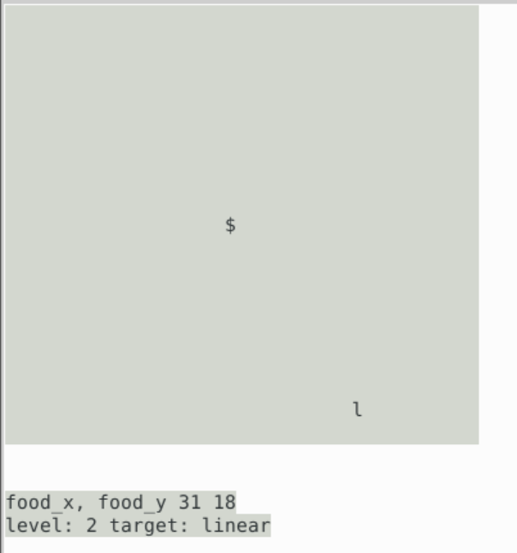

Output:

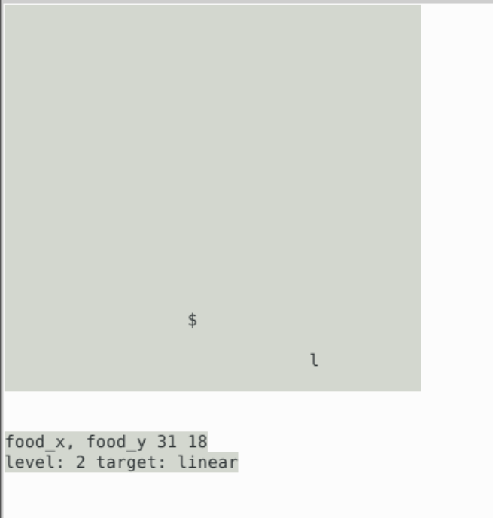

**Sample2**

Input: entering several ‘d’s and ‘s’s



Output:

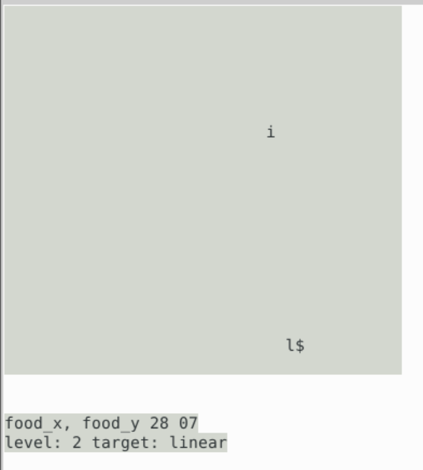

**Sample3**

Input: aaaaaaa

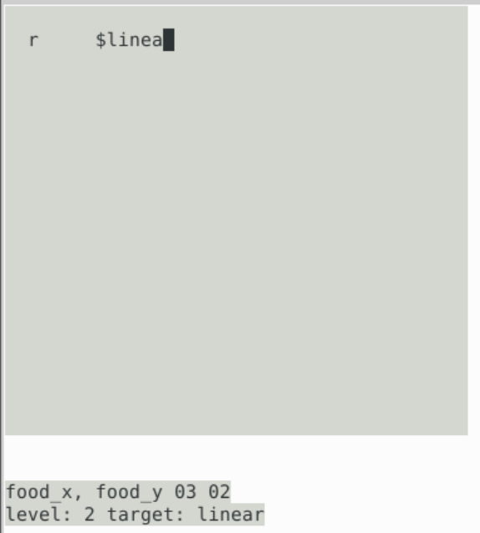

Output: (win the level and enter the next level)

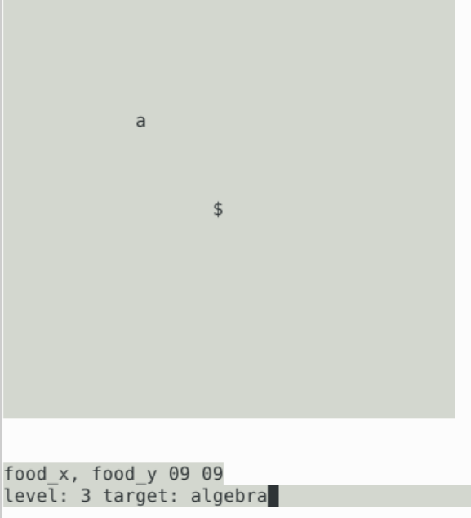

**Sample4**

Hit walls

Input: keep entering ‘w’ until hit the wall

Output:

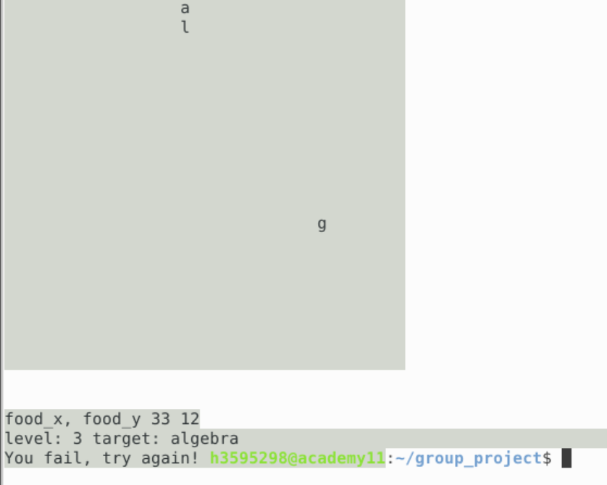

Hit itself

Input: using ‘w’,’d’,’s’,’a’ to hit itself

Output:

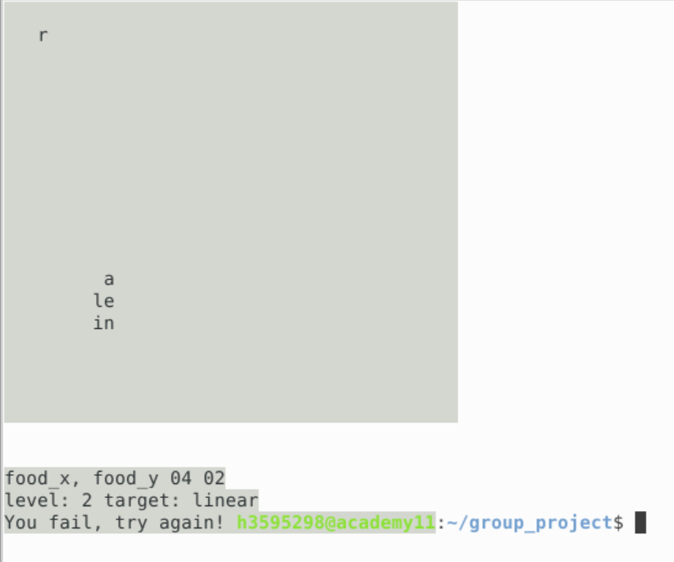

**Sample4**

Quit

Input: q

Output:

