NEMA 8



Nema 8(20x28mm) 1.8deg 0.2A Smallest stepper motor 8HS11-0204S
http://www.omc-stepperonline.com/nema-820x28mm-18deg-02a-smallest-stepper-motor-8hs110204s-p-81.html
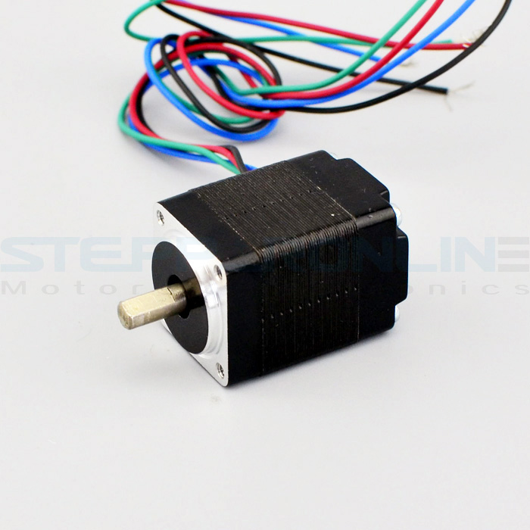
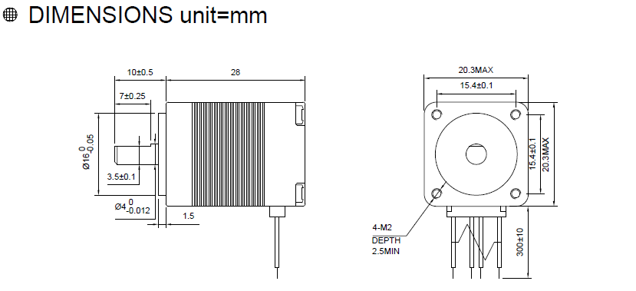

Body length: 28 mm
Shaft Length: 10 mm
Width: 20.3 mm
Step: 1.8 deg
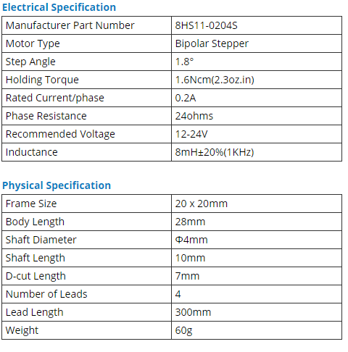

NEMA 11
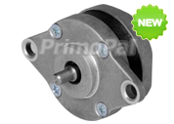


PHB26K- Ø26mm Round Step Motor
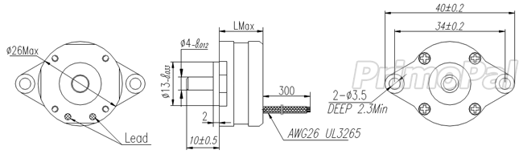
http://www.primopal.com/web/Product4_GoodsID_7.html

Body length (Lmax): 13.5 mm
Shaft Length: 10 mm
Diameter: 26 mm
Step: 1.8 deg

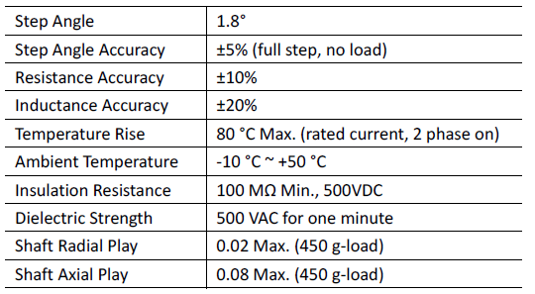

NEMA 14

.9deg Thin Stepper Motor 12.5mm 0.5A 7Ncm(10oz.in) 14HR05-0504S
http://www.omc-stepperonline.com/9deg-thin-stepper-motor-125mm-05a-7ncm10ozin-14hr050504s-p-88.html
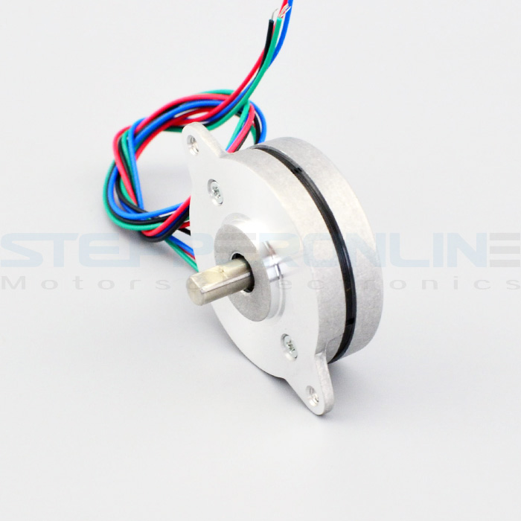
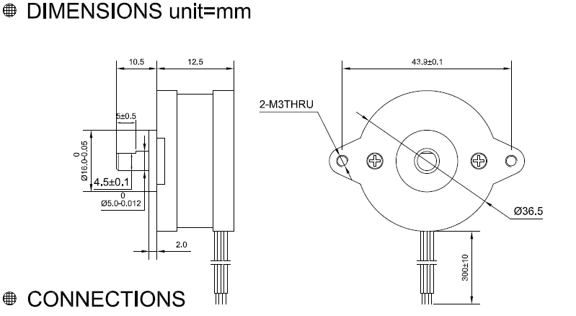

Body length: 12.5mm
Shaft Length: 10.5 mm
Diameter: 36.5mm
Step: 0.9 deg

Electrical Specification
Manufacturer Part Number | 14HR05-0504S
Motor Type | Bipolar Stepper
Step Angle | 0.9°
Holding Torque | 7Ncm(10oz.in)
Rated Current/phase | 0.5A
Phase Resistance | 17ohms
Recommended Voltage | 12-24V
Inductance | 7.5mH±20%(1KHz)

Physical Specification
Frame Size | Φ36mm
Body Length | 12.5mm
Shaft Diameter | Φ5mm
Shaft Length | 10.5mm
D-cut Length | 5mm
Number of Leads | 4
Lead Length | 300mm
Weight | 50g

PHB36D - Ø36mm Round Step Motor
http://www.primopal.com/web/Product4_GoodsID_17.html

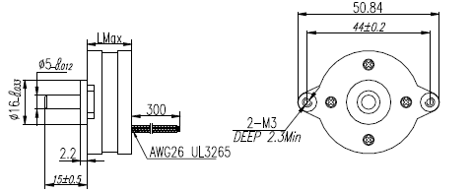

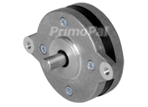

Body length (Lmax): 13.5mm
Shaft Length: 15 mm
Diameter: 36mm
Step: 0.9 deg

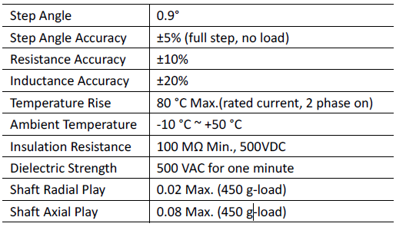



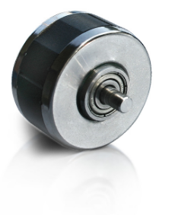
3809 Series

Xtreme Accuracy Stepper Motor
http://www.linengineering.com/products/stepper-motors/3809-series/

Body length: 12.7 / 14.0 / 14.7 / 19.8 mm
Step: 0.9 deg
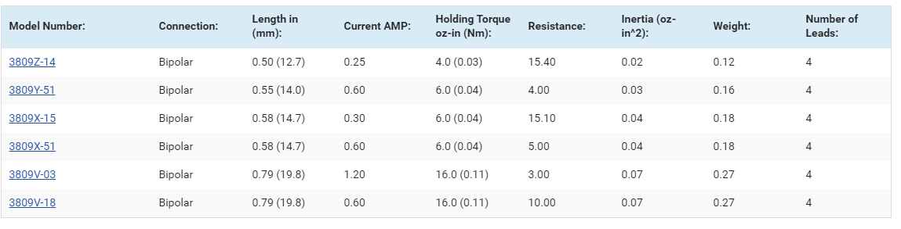
- Signature Series Technology for ultimate smooth motion and high accuracy

3809Z-14:
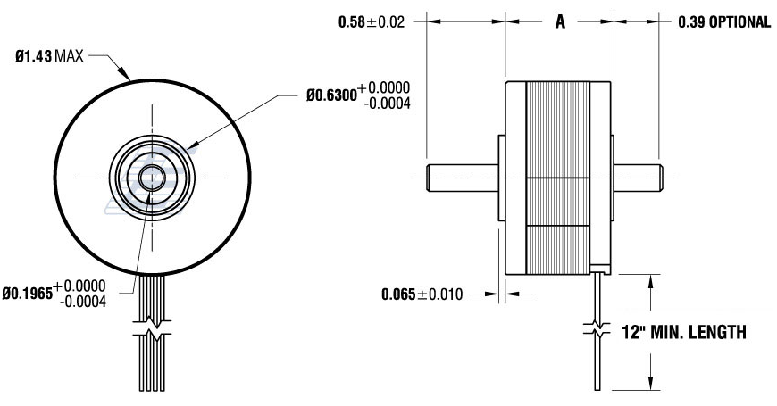
Shaft Length: 14.7 mm
Diameter: 36mm
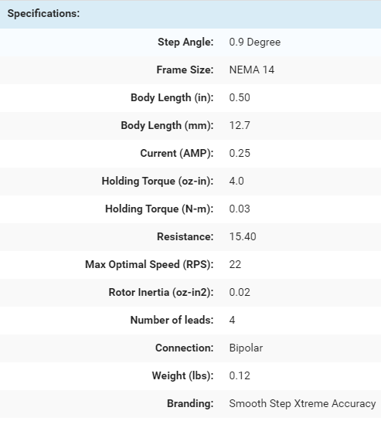

3709 Series

Xtreme Accuracy Stepper Motor
Mοντέλα: 3709Ζ-14 , 3709Ζ-12, 3709Υ-51, 3709Χ-15
http://www.linengineering.com/products/stepper-motors/3709-series/
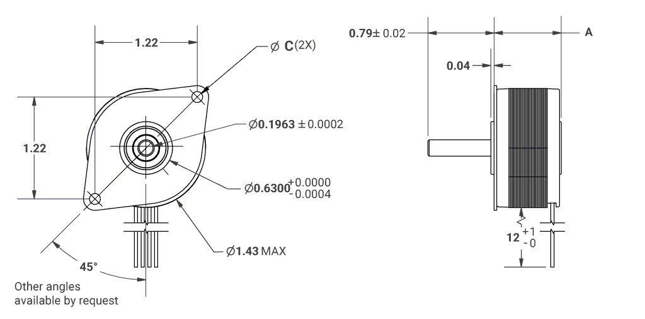

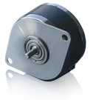

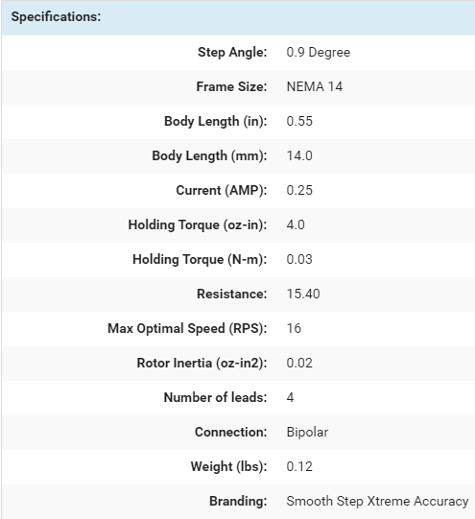
Body length: 14.0 / 15.0
Shaft Length: 20 mm
Diameter: 36mm
Step: 0.9 deg
- Signature Series Technology for ultimate smooth motion and high accuracy

