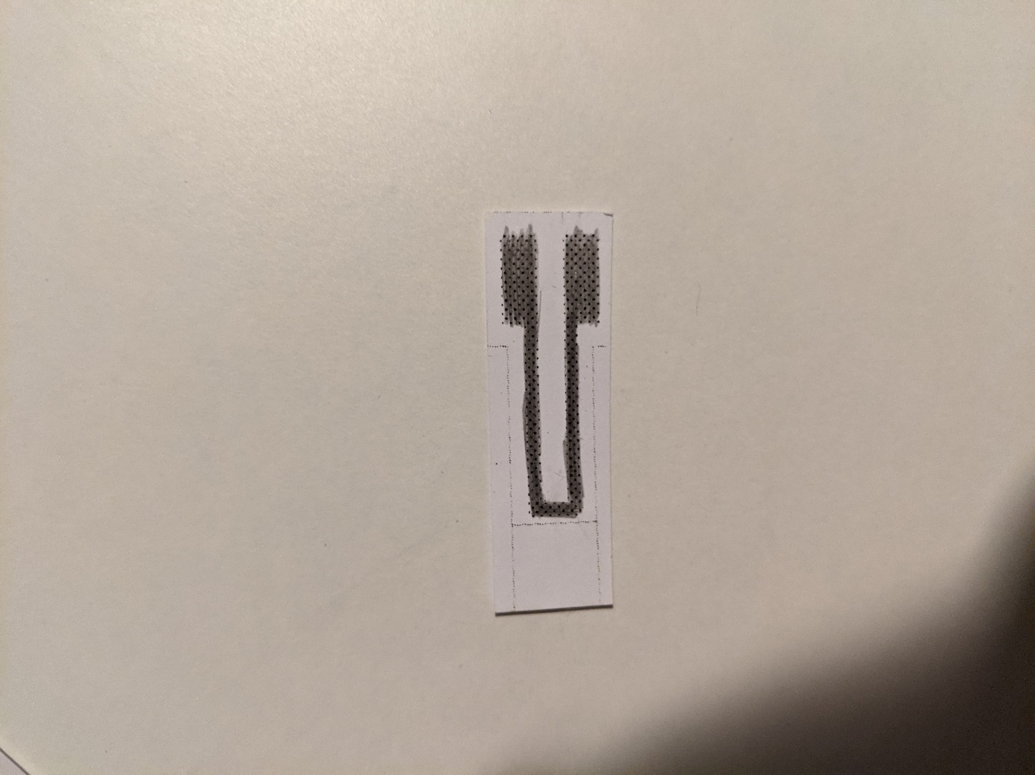**Low power flex sensor based on graphite granular system**

# General features

* Flex sensor
* Low power consumption
* Easy to use
* Thin
* Low-cost
* Portable
* Environment friendly

# Description

This flex sensor is made from basic paper and graphite dropped by a pencil. By drawing with a pencil on a sheet of paper we rub off graphite particles which then stick to the paper fibers. Those particles form granular system. When the sensor is compressed the grains of graphite get closer to each other and thus quantum tunneling allow more electrons to travel from a grain to another. The overall electrical resistance of the sensor lowers when compressed and heightens when expanded. This sensor can be used as a flex sensor compressing and expending according to the direction of the flexion. It is a passive sensor; we only need to measure its electrical resistance. The relative resistance is around a few MΩ with an HB pencil, it therefore does not consume much power. It is low-cost and easy to make. It is thin and with the good integration can be easy to transport. Like paper and pencil, it is environment friendly.

# Specifications

|  |  |
| --- | --- |
| Type | Flex sensor |
| Sensing principle | Granular system sensor |
| Materials | Paper and graphite from HB pencil |
| Power supply requirement | Passive (no power supply required) |
| Nature of output signal | Analog resistivity |
| Dimensions | 15mm x 37mm |
| Mounting | Glue or tape |

# Standard use condition

|  |  |  |
| --- | --- | --- |
|  | Unit | Typical value |
| Temperature | °C | 20±5 |
| Humidity | % | 60±5 |
| Air quality | %N2/O2 | 80/20 |

# Flex Characteristics

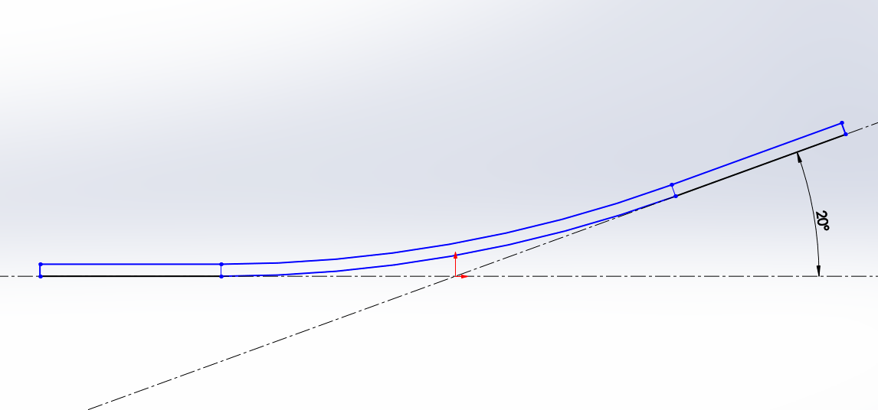The characteristics of the sensor were determined by measuring its resistance when bent by a servomotor. The measured values are according to the angle of bending as shown in the figure below.

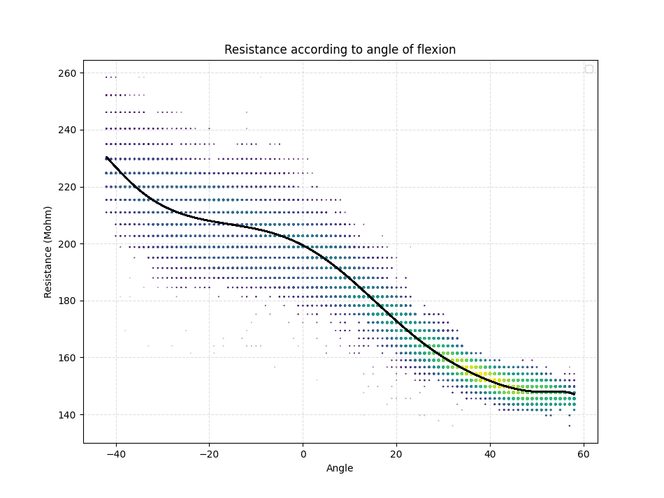By testing multiple times multiple angles at different moments, we get an overview of the analog response of the sensor to different flexion. Only a small part of the curve bellow is recommended for use as shown later.

We are only interested in the linear part with angles from 5° to 50°.

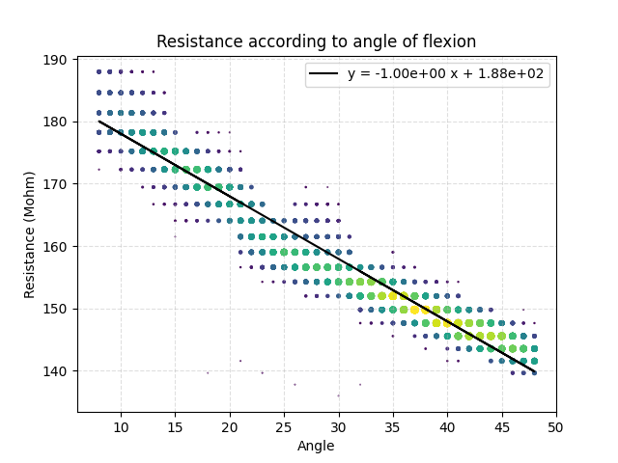Sensitivity in linear part: 1MΩ/degree

# Example of integration

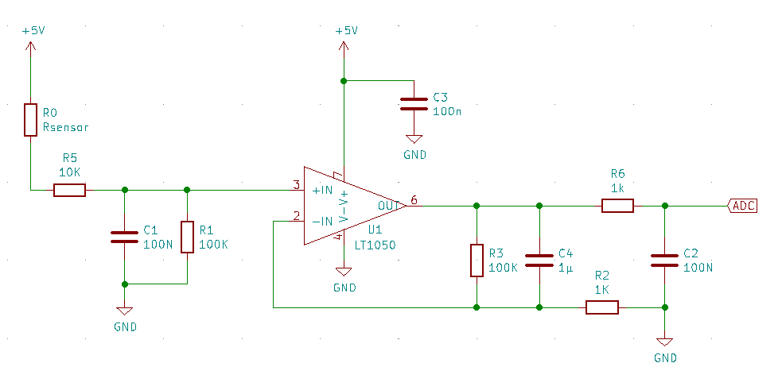Below is an example of an integration circuit used to interface the flex sensor with an Arduino analog input pin. The operational amplifier will convert and amplify a current proportionally to the resistance of the flex sensor.