**Deep Learning preparation**

1. Download Anaconda installer for Windows from [here](https://www.anaconda.com/products/individual) and install it.
2. Open Anaconda Navigator and go to Environments.
3. Create a new environment named “DeepLearning”. Choose Python package and 3.8.x version (if there is no Python 3.8.x package, please install it from [here](https://www.python.org/downloads/)).

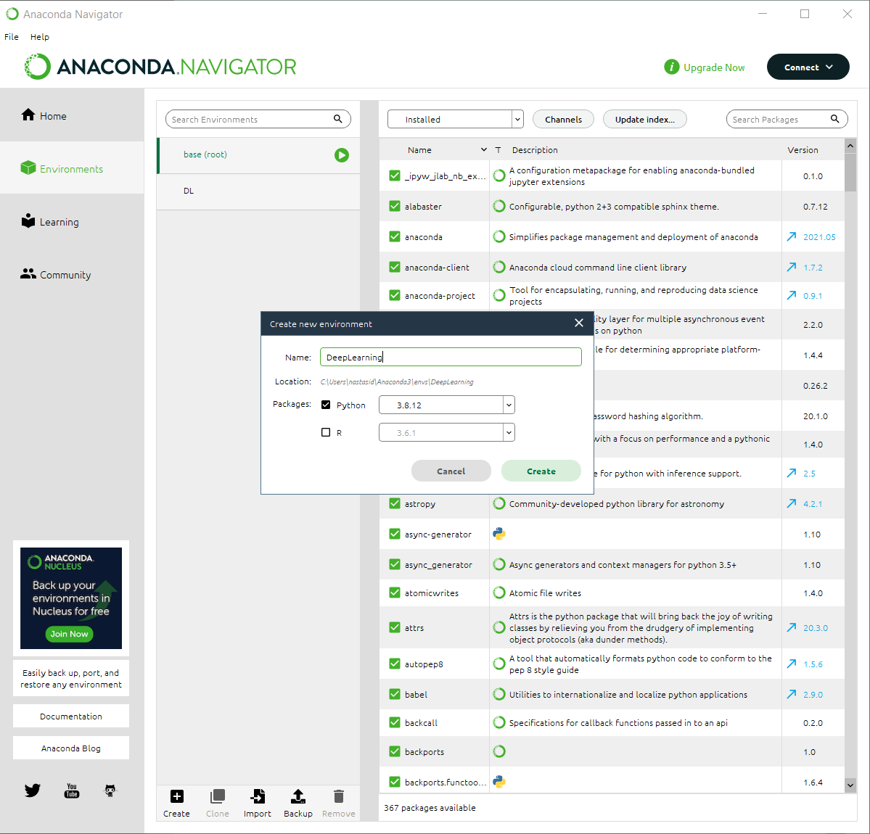

1. Go back to Home tab in Anaconda Navigator and install JupyterLab and (Jupyter)Notebook by clicking “Install” under their logo.

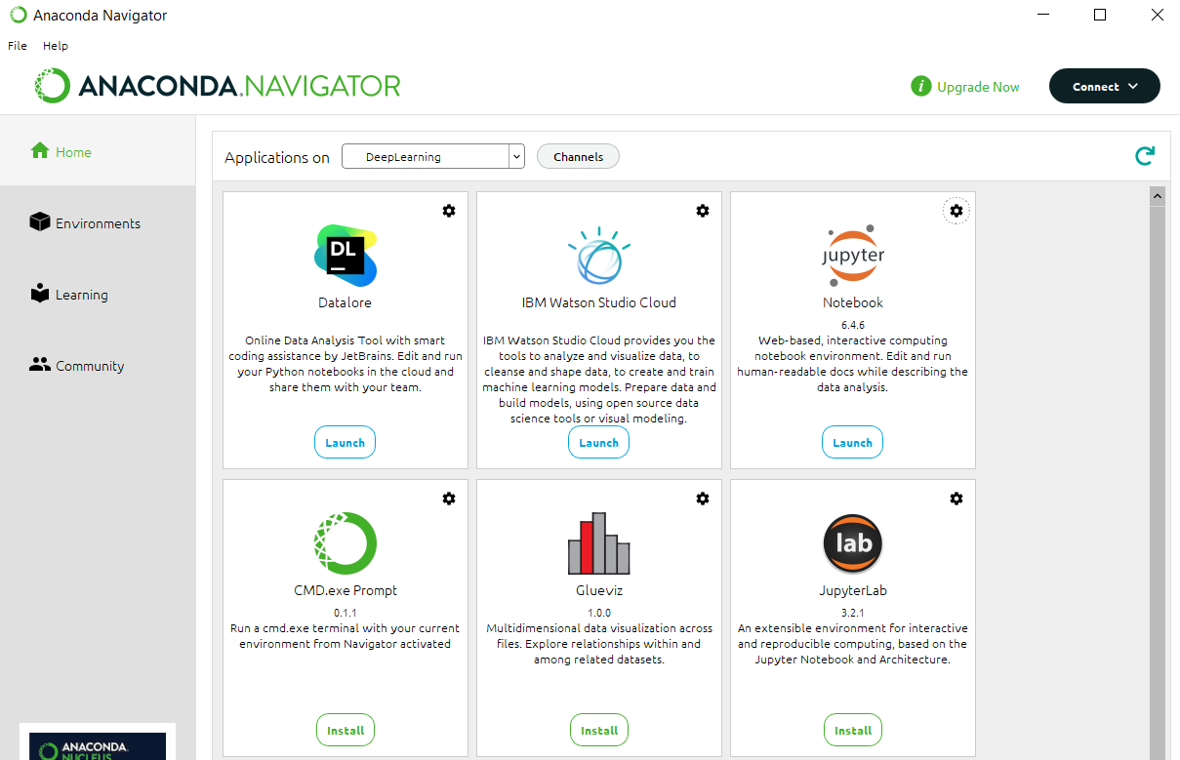

1. After installing JupyterNotebook and JupyterLab, go to Environments tab and select the newly created environment and open it in a terminal (command prompt).

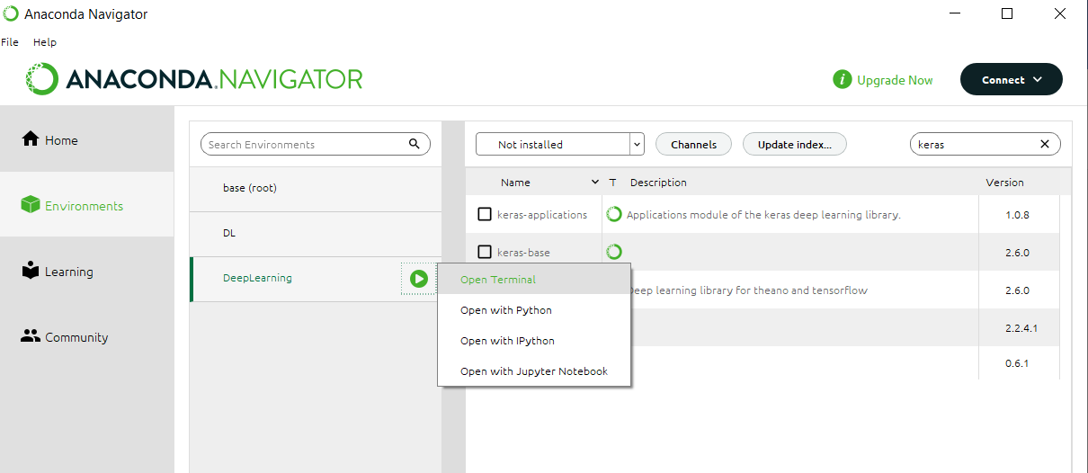

1. To install Keras use the following command: **conda install keras**
   1. Next, to install Tensorflow use the following command: **conda install tensorflow**
   2. Choose “yes” when asked
2. Go back to Home tab and launch JupyterNoteBook. Create a new Jupyter NoteBook and use the code below to get started with DeepLearning.

OBS: Jupyter Notebook offers the possibility to execute your code in a block-wise manner. For more information access the [link](https://jupyter-notebook.readthedocs.io/en/stable/examples/Notebook/examples_index.html).



Example of JupyterNoteBook

