**1 Introduction**

**1.1 Rationale and Structure**

This report outlines the development of the Weather Project, a cloud-based web application created by Team 30 as part of a group assignment for the Cloud Computing course at Auckland University of Technology. The project builds a weather information platform that combines user authentication, real-time weather data and cloud-hosted services with modern frontend and backend technologies.

This report covers the entire development process of the Weather project from early planning to final delivery. The report begins with an overview of the system requirements, including the key functions and performance expectations of our design. The following sections describe how the user interaction process and core business requirements affect the system design, and how the layers from the user interface to back-end services and data storage are developed to achieve the intended features. Finally, we provided a user manual to demonstrate the operation of core functions, reflect on our collaborative experience, emphasize lessons learned and suggestions for future improvement.

**1.2 Business Scenario**

The Weather Project is designed for users who want quick access to reliable and location-specific weather data.

The solution allows users to:  
• Search for weather conditions and forecasts for cities around the world  
• Provide detailed weather reports with temperature, humidity, and a 7-day forecast  
• Save viewed locations as favorites for quick access  
• Log in and access the custom weather dashboard

**1.3 Approach**

Figures 1 and 2 present the conceptual direction and intended outcomes identified during the team’s early planning discussions.

表格

AI 生成的内容可能不正确。

图形用户界面, 应用程序

AI 生成的内容可能不正确。

The team uses the GitHub project board to organize and monitor all development and documentation work. Tasks are grouped under columns such as "To Be Done", "In Progress" and "Completed", and the project board will be updated regularly to reflect the progress.

Figure 3 shows the process of the project board during the development process, demonstrating the ongoing tasks at that time.

图形用户界面, 文本, 应用程序, 电子邮件

AI 生成的内容可能不正确。

**2 Requirements and Analysis**

**2.1 Requirements**

The requirements for the Weather Project were documented as feature tasks and tracked using GitHub Project Boards as described in the earlier approach section.  
The main objectives included enabling users to search weather information for different cities, view detailed weather reports, manage a personalized list of favorite cities, and securely log in and maintain session persistence across devices.

**2.2 Use Case Model**

A Use Case Model, as shown in Figure 4 below, was created using draw.io to provide a visual overview of the functionality delivered in the Weather Project.

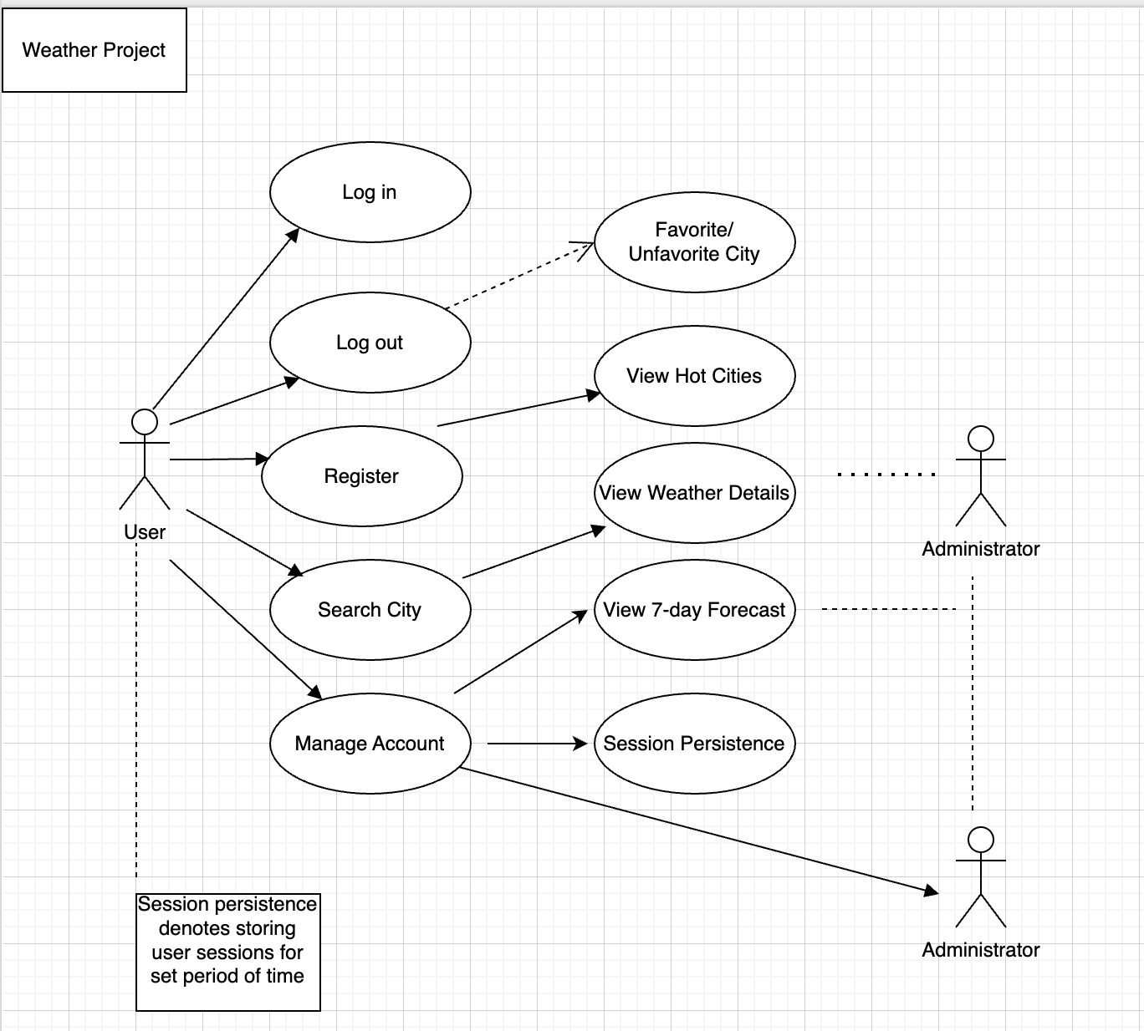

**3 Business Design**

**3.1 User Journeys**

The swimlane diagrams in Figures 5, 6, and 7 below show the user journeys associated with the action functions of visiting the homepage to search for a city, view city weather details, and view detailed weather, respectively. 图示

AI 生成的内容可能不正确。

图示

AI 生成的内容可能不正确。