Howard University
College of Engineering and Architecture
Department of Electrical Engineering & Computer Science

Large Scale Programming
Fall 2024

Midterm Exam – Part I
October 17, 2024

Part I: 50 pts. (essay questions)

Instructions:
- Submit completed exam to your github repository under package org.howard.edu.lsp.midterm

Verify that the commit(s) completed successfully

- OPEN BOOK, OPEN NOTES. THERE IS NO COLLABORATION ON THIS EXAM
- Site any and ALL references for anything obtained off the internet.

Question 1. (10 pts.)

You are reviewing the following class in a Fitness Tracking System. The class is intended to manage various aspects of a user’s fitness activities.

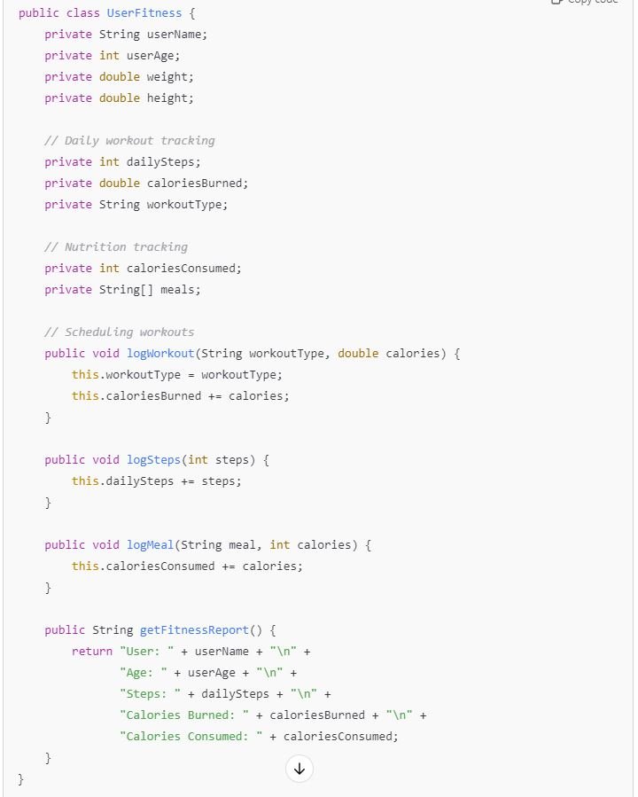

Tasks:
- Analyze the UserFitness class. Explain why this class has low cohesion. (5 pts.)
  - Answer: Think of cohesion as how well different parts of a class stick together toward a single purpose. Ideally, a class should handle one main thing. But here, the UserFitness class is trying to juggle too many tasks that don't seem very connected.
It’s doing the following:
    - Tracking personal details (username, age, weight, height).
    - Logging workouts (steps, calories burned, workout types).
    - Tracking nutrition (meals, calories consumed).

I believe these are all important aspects of fitness but they don’t quite belong in the same "box"/ “category” or class. When you have a class handling profile info, workout data, and meals all at once, it gets cluttered and confusing. Things will get messy fast!

Another issue is that the methods and fields are all mixed up. There is a method tracking meals (logMeal()), another one counting steps (logSteps()), and yet another for workouts (logWorkout()). These things aren't tightly connected—they're different aspects of fitness and would be clearer and easier to maintain if they were split up.

- Describe, in general, how you would split the UserFitness class into more cohesive classes. Your answer should not be a complete design. (5 pts.)
  - To fix this, splitting up your fitness tracking into clearer sections will improve cohesion.
  - This could look like :
    - UserProfile Class:
class would only handle the user’s personal details
Fields: username, age, weight, height.
Methods: getUsername(), updateWeight(), etc.
    - WorkoutTracker Class:
class focused just on workout-related data
Fields: dailySteps, caloriesBurned, workoutType.
Methods: logWorkout(), logSteps().
    - NutritionTracker Class:
This class would be responsible for tracking meals and the number of calories consumed each day.
Fields: meals, caloriesConsumed.
Methods: logMeal(), getCaloriesConsumed().
    - • FitnessReport Class:
    - a report class that pulls data from the other specialized classes (like pulling clothes, food, and gym gear from separate drawers to make an outfit). It could summarize everything in a report that gives the user a nice overview of their day.
    - Methods: generateDailyReport(), getSummary()
Question 2. (5 pts.)
Given the following, answer the below questions.

A university manages its students using a program that has a class Student with subclasses FirstYear, SecondYear, and ThirdYear for year-specific state and behaviors. The program has a List that contains all Students.

Should Student be a class, an abstract class or an interface? Explain your answer

- At the end of each year, the third-year students graduate and must be removed. This is done by passing the list to the following method:

void removeThirdYears(List<Students> students) {
for (Student student : students) {
try {
ThirdYear = (ThirdYear) student;
students.remove(thirdyear);
}
}
}

Why is the above method flawed? Hint: Another Arthur Riel heuristic (5 pts.)

Answer
- I believe Student should be an abstract class. A regular class would work if there weren’t any specialized versions of a student, but here we have FirstYear, SecondYear, and ThirdYear as subclasses, each with their own unique state or behavior. Furthermore, an interface defines a set of methods that any implementing class must have, but it doesn’t hold any actual code or common behavior that the Student subclasses could share. However, there are likely some shared attributes and methods that all students have like a name, ID, or the ability to view their course schedule. These shared behaviors are better implemented in an abstract class rather than an interface, which doesn’t allow you to have common functionality. An abstract class allows you to define common attributes and methods that all student types share making it the most appropriate choice.
- This method is flawed due to a common collection-modification error: I noticed that you’re modifying the list (students.remove()) while looping over it. As conferred from an Arthur Riel heuristic, which advises that you shouldn't modify a collection directly while iterating through it. In this case, the method is trying to remove third-year students from the list while looping over that same list, which is dangerous because the list's structure changes mid-iteration. Furthermore, iterating through a list using a for-each loop and modifying that list at the same time can cause the program to throw a ConcurrentModificationException because the loop doesn’t expect the collection to change while it’s iterating through it.

Question 3. (5 pts.)
Given the following, answer the below questions.

public class BankAccount {
public String accountHolderName;
public String accountNumber;
public double balance;
public double interestRate;

public BankAccount(
String accountHolderName,
String accountNumber,
double initialDeposit,
double interestRate) {
this.accountHolderName = accountHolderName;
this.accountNumber = accountNumber;
this.balance = initialDeposit;
this.interestRate = interestRate;
}

// Exposed implementation for adding interest
public void addInterest() {
double interest = balance * (interestRate / 100);
balance += interest;
}

// Exposed implementation for deposits
public void deposit(double amount) {
balance += amount;
}

// Exposed implementation for withdrawals
public void withdraw(double amount) {
balance -= amount;
}
}

- Is BankAccount well-encapsulated? Why or why not? If so, describe what changes you would make to the class. Otherwise, state nothing. (5 pts.)
Answer
No, the BankAccount class is not well-encapsulated. All its fields are declared as public, which allows external code to access and modify them directly. This violates the principle of encapsulation, where an object's internal state should be hidden from the outside world and only accessible through methods. Direct access to sensitive fields like balance or accountNumber poses security risks, allowing unintended or unauthorized modifications. Furthermore, there are no safeguards in place to protect against invalid operations. For instance, the withdraw() method should check whether the withdrawal amount is greater than the current balance to prevent overdrawing the account.
Changes include:

Make the attributes private: This prevents direct access and modification of the internal state from outside the class.
Example :
private String accountHolderName;
private String accountNumber;
private double balance;
private double interestRate;

Use getters and setters: Provide public methods for controlled access to the fields. For sensitive fields like balance or accountNumber, we can decide whether to make them readable or writable.
Example:
public String getAccountHolderName() {
return accountHolderName;
}

public String getAccountNumber() {
return accountNumber;
}

public double getBalance() {
return balance;
}

Question 4. (10 pts.)
Given the following, answer the below questions.

Given:
A car manufacturer uses Java software to track current vehicles being built. The UML diagram below shows an excerpt of the current software structure. You should assume the presence of other appropriate fields and methods

Car
getTrimLevel()
Engine
accelerate()
getFuelLevel()
Base
Sports
Luxury
Electric
Petrol

Each car can be built to one of three trim levels: Base, Luxury or Sport. They can also be configured with an electric or petrol engine. At various points in the manufacturing process the customer can choose to change the trim level.

Task:
- Explain in detail why the current structure does not support this. (5 pts.)

- Describe how to refactor the structure to allow trim-level change for a car to dynamically change. Hint: How would you modify Car to use composition to solve the problem? (5 pts.)

Answer:

a) Why the current structure doesn’t support trim-level changes:
The current design uses inheritance to represent the different trim levels (Base, Sports, Luxury). This means when you create a car as, say, a Base car, it's stuck being a Base car. You can’t just change its trim to Sports or Luxury because inheritance locks that in when the object is created. In other words, the trim level is hardcoded into the car's class.

b) How to fix it:
To make things more flexible, we need to switch to composition. Instead of having separate subclasses for each trim level, the Car class can hold a TrimLevel object (like Base, Sports, or Luxury). Now, if the customer wants to change the trim, you just swap out the TrimLevel object without messing with the car itself. Furthermore, To allow a car’s trim level to be changed dynamically, we need to move away from the inheritance-based structure. Instead, we can use composition, where the Car class will have a reference to a TrimLevel object. This way, the trim level can be changed by simply assigning a new TrimLevel object to the car, without needing to change the car's class itself.

Question 5. (5 pts.)
Suppose you are about to code a particular class and find that you have written another class with nearly the functionality that you now are developing. This means that the two classes in large parts contain the same code, but in smaller parts have different code. Explain in detail why this may be a problem and how to solve it. Give your answer in terms of Arthur Riel’s design heuristics.

Answer:
When you have two classes with similar code, you run into issues like code duplication, making maintenance harder. If you need to update that shared code, you’ll have to do it in multiple places, which increases the risk of mistakes.
To solve this, you can:
- Use inheritance or interfaces: Pull the shared code into a superclass or interface and let both classes use it, overriding where needed.
- Favor composition: Instead of inheritance, create a helper class for the shared functionality and inject it into both classes.
- Abstract differences: Use something like the Strategy Pattern to separate the varying behavior and keep the common parts clean.

This reduces duplication and makes your code easier to manage and extend

Question 6. (5 pts.)
Suppose we need to store instances of the classes Car and BankAccount in a database. To obtain low coupling it may seem as if the functionality to save an instance should be in precisely those classes, since they have the information that shall be saved. Why is it unwise to place the database calls there?

Answer:
It’s unwise to place database calls directly in the Car and BankAccount classes because it increases coupling between your core business logic and the database. Here’s why:
- Violation of the Single Responsibility Principle (SRP):
Each class should focus on its main job. For Car and BankAccount, their job is to manage car and account data, not to handle saving data to a database. Adding database functionality mixes responsibilities, making the class do more than it should.
- Increased Coupling:
If the Car and BankAccount classes handle database operations, they become tightly coupled to the database. If you change the database technology (like switching from SQL to NoSQL), you’ll need to update the core class logic, leading to maintenance headaches.
- Reduced Flexibility:
If you embed database logic inside these classes, testing becomes harder. You’d need a live database to test even simple class functionality. Separating database logic allows you to mock the database during testing.

Better Solution:
Use a Data Access Object (DAO) or a repository pattern. This separates database operations into their own layer, keeping your core classes clean and focused on their main task. You get lower coupling, more flexibility, and better maintainability.

Question 7. (5 pts.)
Given a set of requirements, what conditions must be met to make it appropriate to create a new class hierarchy using inheritance? Neither superclass nor subclass exist before, the question is about designing a new class hierarchy.

When designing a new class hierarchy with inheritance, the following conditions should be met:
- Shared Behavior: There must be a clear, logical set of behaviors or attributes that multiple subclasses share. This shared functionality should belong in a superclass to avoid duplicating code across the subclasses.
- Is-a Relationship: Inheritance should be used when there is a true "is-a" relationship between the superclass and its subclasses. For example, if Car is a superclass and Sedan is a subclass, a Sedan is a Car. If this relationship feels forced, inheritance is likely not the right choice.
- Extendable Behavior: Subclasses should have distinct behaviors that extend or specialize the superclass behavior. The subclass should either override or add new functionality, allowing polymorphism to make sense in the design.
- Low Coupling: The classes in the hierarchy should not have overly complex dependencies. Each class should be loosely coupled so that changes in the superclass do not force major changes in all subclasses.
- Avoiding Misuse of Inheritance: Don’t use inheritance just to "reuse code." If the main goal is to share functionality, consider composition instead. Inheritance should only be used when it makes sense in terms of the object model.

If these conditions are met, it’s appropriate to build a new class hierarchy using inheritance.

Question 8. (2.5 pts.)
Describe the difference between inheritance and composition why would you choose one over the other.

Inheritance and composition are two ways to reuse code, but they work differently:
- Inheritance is like a parent-child relationship. A class (child) inherits behaviors and attributes from another class (parent). It’s used when one class is a type of another. For example, a Dog class might inherit from an Animal class because a dog is an animal.
- Composition is more like a "has-a" relationship. A class contains an object of another class, meaning it has certain functionality. For example, a Car might have an Engine, so you’d use composition to include an Engine object inside the Car class.
Why Choose…
- Inheritance is great when you have a clear "is-a" relationship and need to share common behavior. It also enables polymorphism, where a subclass can be treated as its parent class.
- Composition is preferred when you need more flexibility. It avoids the rigid nature of inheritance and allows you to change parts of a class’s behavior by changing its components. It’s also great for decoupling—the inner objects can be swapped without affecting the main class.

Question 9. (2.5 pts.)
Explain the meaning of cohesion and describe whether low or high cohesion is better.
Cohesion refers to how closely related and focused the responsibilities of a class or module are. In other words, it measures how well the parts of a class work together toward a single goal or task.
- High cohesion means that a class or module has a clear, single purpose, and all its methods and attributes are directly related to that purpose. For example, a UserProfile class that only handles user details like name and email has high cohesion.
- Low cohesion happens when a class does many unrelated tasks, leading to confusion and making the class harder to maintain. Imagine a class that manages both user details and database operations—this would be an example of low cohesion.

High cohesion is always better because:
- It makes your code easier to understand, maintain, and extend.
- It helps keep your classes small and focused, which reduces bugs and complexity.
- Changes or updates to one part of the class are less likely to affect other parts.

