PRE FINAL PROJECT DOCUMENTATION



ONLINE CAR SALE MANAGEMENTSYSTEM

By

TEAM SKYWALKERS

Team Members

Theoda Hettiarachchi – leader

Samathri Abhayapala

Dilekha Dissanayaka

R.A.Kanishka Nadushan Ranasinghe

R.M.D. Arundethie Wijerathne

Neranju Chathumina

Sadeep Sachintha

Arshad Hameem

K. Rukshan C. Wijewickrama

**Table of Content**

Chapter 1 - INTRODUCTION

1.1 About the client

1.2 Motivation of the project

1.3 Objectives of the project

1.4 Scope of the project

Chapter 2 - ANALYSIS

2.1 Introduction

2.2 Overview of the Current system and the Workflow Diagram

2.3 Drawbacks of the current system

2.4 Current system use case diagram

2.5 Similar System Comparison

2.6 Requirement gathering

2.7 Functional requirements

2.8 Non-Functional requirements

Chapter 3 - DESIGN

3.1 Introduction

3.2 Methodologies

3.3 Proposed system Use Case diagram with Use Case Description

3.4 Proposed system class diagram

3.5 Proposed system ER diagram with Database Design

3.6 Proposed system Sequence diagram

3.7 User Interface design

**Chapter: 01**

**Introduction**

* 1. **Client**

Our client is Mr.Amaljith who is the owner of the Sky Motorhub Car Sale. This is situated in Kirulapana and has over 30 vehicles for sale. He sells Brand new, Re-condition and used vehicles in his sale. Generally for a month he sells 5 vehicles in average and sometimes gets 10 vehicles for sale from different customers. He wants a website which allows general public to view all the features.

* 1. **Motivation to the project** 
     1. This project encourage us to learn the process of building a website and to collect new techniques related to coding to develop our skills.
     2. This inspired us to work as a team, to collaborate with each other, to exchange our ideas, to help each other and to build our team spirit.
     3. This stimulate our team to put a lot of effort to make great accomplishments.
     4. Also by doing this it will help us to make our final year project a success.
     5. This will help each team member to learn how to take up a challenge to grow, participate and take ownership for project responsibilities as a team member.
  2. **Objectives of the project**
     1. To manage the details of inventory, sales, customers, car models and car owners.
     2. To reduce manual work to manage all the information and make our work easy.
     3. To increase the efficiency of the sales process.
     4. To maintain the accuracy of the information provided.
     5. To track the details about car models, sales and car owners.
  3. **Scope of the project**

This module will allow a person to look for a vehicle they desire to buy or to post an advertisement about a vehicle they desire to sell and provide the necessary details to proceed for the payment. The current system registers and hold all the data of the Sky Motor hub.

**Chapter: 02**

**Analysis**

**2.1 Introduction**

This chapter will cover the overview of the current system and determines the need of developing a new system for the client organization. To illustrate the suggested system strength a similar system comparison has been done.

Once the need of the new system has been justified the chapter will use appropriate fact-finding techniques in order to gather requirements and further these requirements will be classified as functional and non-functional requirements.

**2.2 Overview of the current system**

Sky MotorHub is one of the best car sales in Sri Lanka. Since its inauguration in 1975, by Mr. Amaljith Sky MotorHub continues to be the number one in the journey of supplying high quality motor vehicles and related services around the country. Our services are not limited to car dealerships, we offer the best payment method that matches with your plan. We are your one-stop solution for all your vehicle trading requirements.

Our Mission is to be an industry leader in providing unmatched quality automotive products and services.

Our Vision is to be so effective that we are able to be helpful to others.

Current system use by Sky MotorHub only consists of a car detail page as the front end. Anyone who visits the site can view a limited number of details of the car including Model, Year, Type, Transmission, Fuel type, Condition and the Estimated selling price. Then the admin panel consists of all the necessary details of the car and the previous owner of the car. And admin and edit the details and delete the records if needed. All the other record keeping is done manually.

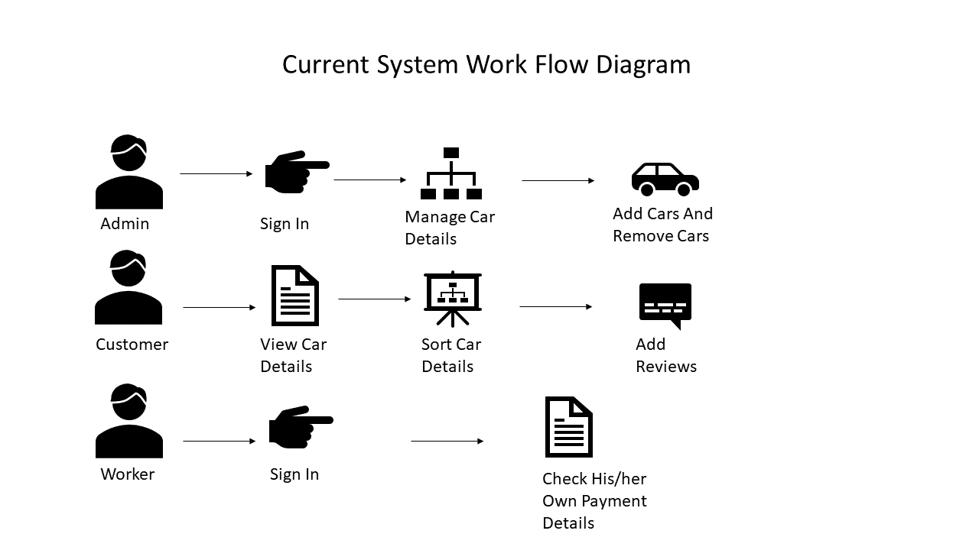

**2.3 Drawbacks of the existing system**

Selling a car of the 3rd party is done more physically: If a single car owner needed to sell his or her car through the car sale, he should bring the car to the place physically and discuss with the owner of the car sale. And all the car details must be added by the car sale owner. With his busy schedule, arranging time for entering such data will not be practical. It is better if the 3rd party can enter the data himself and the car sale owner only has to check it and give the approval, so the data will be entered to the system.

Delay in editing and deleting car details: Current system take such a long time with the editing and deleting process.

Maintenance record keeping is done manually: Since current system doesn’t have a part of maintenance record keeping, it is done manually by maintaining a record book. This takes much time and cannot edit the data even though it is necessary. And the calculations done manually which causes accuracy issues.

**2.4 Current system Use Case Diagram**

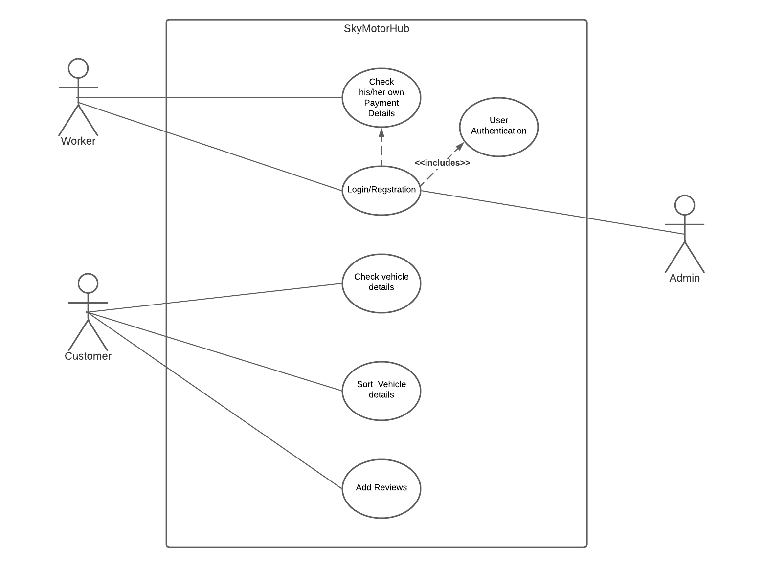

**2.5 Similar System Comparison**

**Feature Comparison**

|  |  |  |  |
| --- | --- | --- | --- |
| **Feature** | **Punchi Car Sale** | **Pat Pat.lk** | **Proposed System** |
| Customers can view vehicle details | yes | yes | yes |
| Admins Approve 3rd Party vehicle ads | No | Yes | Yes |
| Customers can add reviews | Yes | No | Yes |
| Customers can sort vehicles by their features | Yes | Yes | Yes |

**2.6 Introduction to Fact finding technique**

For this project we used interviews as the main fact-finding technique because we can directly ask what were the difficulties the users found when using the previous system. By this method we were able to takes notes of the features they were wishing to have in the system. We were able to take an idea of functionality the way they were wishing. Interviews were directed to the owner of the company and only two other workers since it takes a lot of time to interview them one by one. Other workers were given a questionnaire with static questions which was an easy way to find out the functionality of their desired software.

|  |  |
| --- | --- |
| Date of Interview | 2022/07/20 |
| Duration | 1 hour |
| Interviewee | Mr. Amaljith |
| Position | Owner |
| Purpose | Structure and the Process of the current system |

|  |  |
| --- | --- |
| Date of Interview | 2022/07/20 |
| Duration | 15 minutes |
| Interviewee | Mr. Kamal |
| Position | Record Keeper |
| Purpose | To find out the requirements of the workers |

We made a questionnaire asking whether they were happy with the previous system. Only 40% percentage of answers came out with the option yes. This led us to make a new system correcting the issues of the previous one.

**2.7 Function Requirements**

According to the feedback of the fact-finding technique, we noticed the need of a “Post New car” feature. So we added a button to the home page, which directs user to a registration tab, and then, after registering, it will lead the user to a form. After submitting the form, admin will accept or decline the add. If it was accepted the ad will be appeared on the page, or else the entered records via form, will be deleted.

**2.8 Non-Functional Requirements**

Admin always wanted a system which can do processing in a blink of an eye, and a user interface which gives all car details at a glance. Even the filtering process of car by their categories is convenient and speedy. Unlike the current system, adding new car details by the admin is also can be done quickly. Taking reports is speedy and accurate. In this system, viewing modules such as Vehicle exchange module, Maintenance module, Staff management modules takes no time. User registration and login process is, confirmation e-mail sending is done withing 1 minute. Entering username and password is secured, so is the users’ personal data such as contact number, address, e-mail etc. Submitting the ‘vehicle selling form’ is quick. Adding review option is user-friendly and the process is speedy too.

**Chapter: 03**

**Design**

**3.1 Introduction**

This chapter covers the methodology which will be used to develop the system. Further elaborates the proposed system use case diagram with its use case description followed by the proposed system.

The design of the system is rather cumbersome, and the report will provide the dynamic perspective of the system using sequence diagrams, while the static view will be illustrated using a class diagram.

The database design will also be done using an ER diagram.

**3.2 Methodology**

SSADM – Also known as Structured System Analysis and Design Method, is highly useful when developing such systems because it divides the development process into parts such as modules, stages, steps and lastly tasks. That way we can develop better quality systems and to improve project management.

SCRUM – This describes incremental development, with each iteration consists of two-three-week sprints. This is a bit rigid but it provides high-end collaboration and efficiency for project-based work.

UML with RUP – With four major phases and five main stages, this methodology executes in an ordered form, from small releases into complex once.

The selected UML with RUP since UML allows your team to communicate their requirements, architecture, and design of the project, RUP guides how to use UML. By using RUP we can develop high-quality software that meets the needs and requirements of its users. And also since it allows us to deal with changing requirements regardless of whether they are coming from the customer or from the project itself, this methodology suits best with our developing process.

**3.3 Proposed System Use Case Diagram**

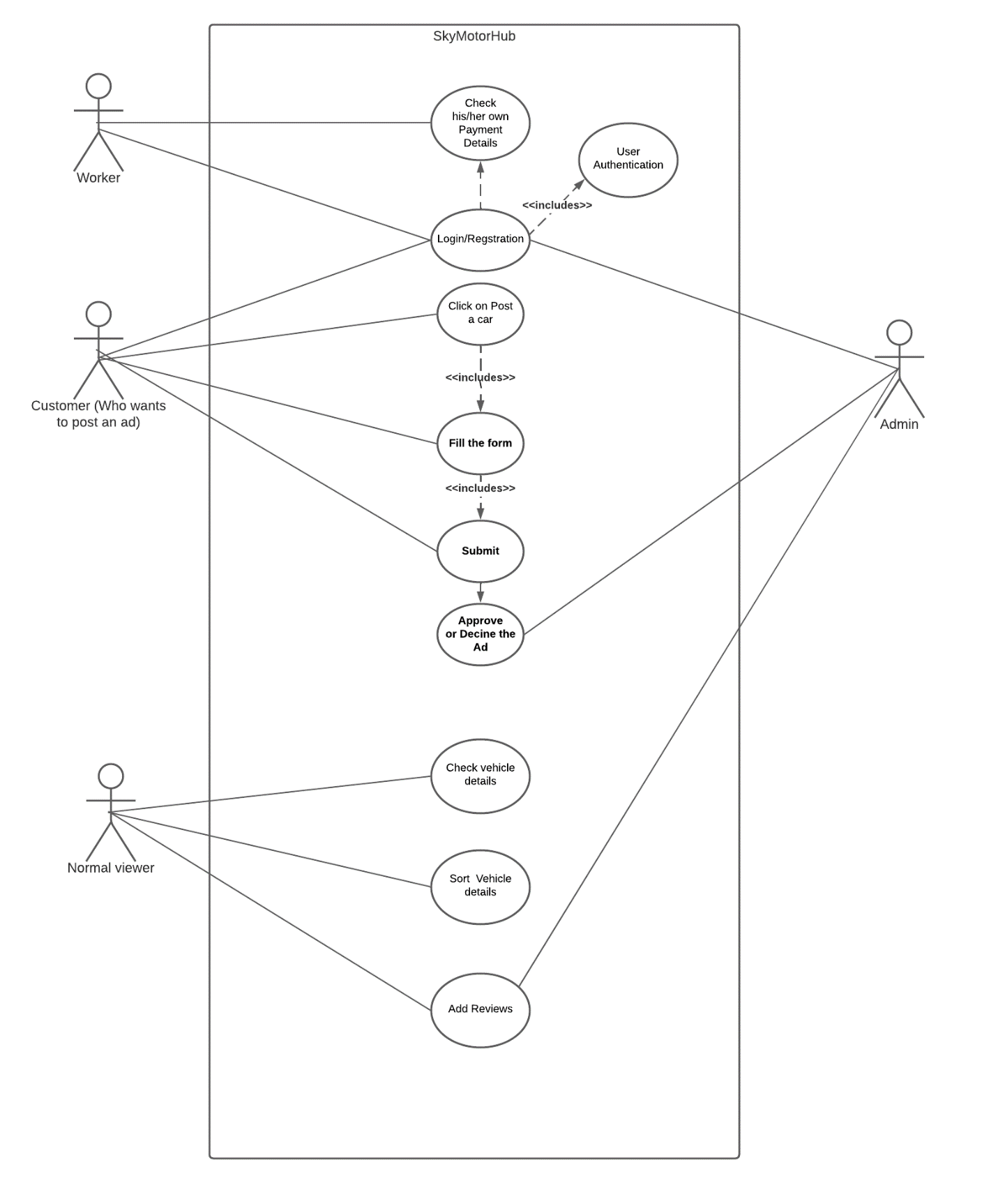

|  |  |
| --- | --- |
| Use case | Login Registration |
| Actor | Admin, Customer, Worker |
| Description | Actors can register by entering relative usernames and passwords |
| Normal course events | 1. Enter user name 2. Enter password 3. Press Login   Or   1. Enter username 2. Enter password 3. Confirm Password 4. Register |
| Preconditions | To login, user must have registered before |
| Post Condition | No post conditions |
| Assumptions | Actors will be distinguished by their usernames |

|  |  |
| --- | --- |
| Use case | Click On post New Car |
| Actor | Customer |
| Description | Customers can view the form of posting cars by clicking this button |
| Normal course events | 1. Click On Post New car |
| Preconditions | No Preconditions |
| Post Condition | Customer must be registered as a customer |
| Assumptions | Clicking the button will direct the customer to the form |

|  |  |
| --- | --- |
| Use case | Fill the form |
| Actor | Customer |
| Description | Customers can add their car details to the form |
| Normal course events | 1. View the form 2. Enter details 3. Click on existing features |
| Preconditions | User must have registered as a customer |
| Post Condition | No post conditions |
| Assumptions | Customer can only add about one car at a time. |

|  |  |
| --- | --- |
| Use case | Approve or Decline Ad |
| Actor | Admin |
| Description | Admin can approve the ad if he willing to post it on his page, or decline otherwise. |
| Normal course events | 1. Login as the admin 2. View car details from admin page 3. Click the button approve or Decline |
| Preconditions | Admin must have logged in as admin |
| Post Condition | No post conditions |
| Assumptions | Ads forms are already filled by this time. |

* 1. **Proposed System Class Diagram**

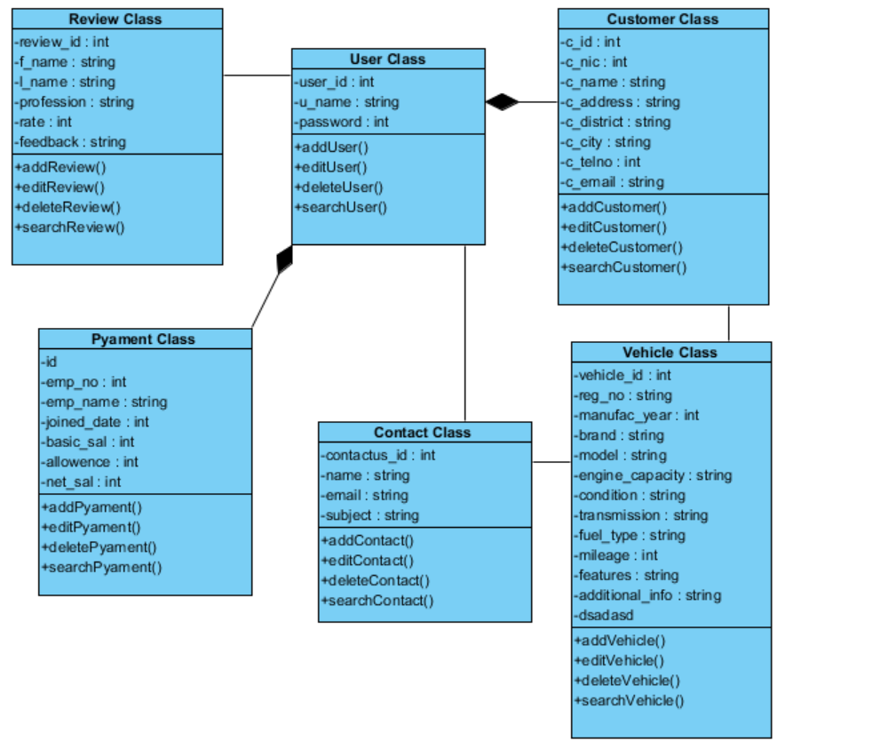

* 1. **Proposed System Database Design**

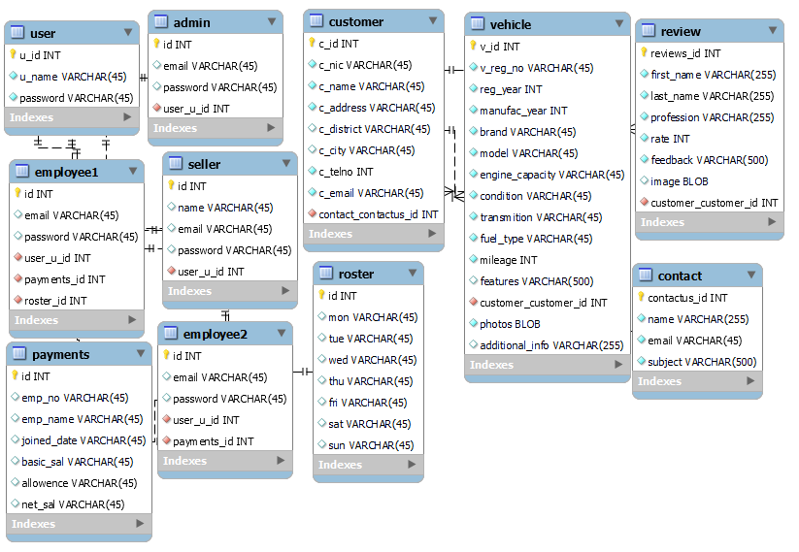

* 1. **Sequence Diagram**

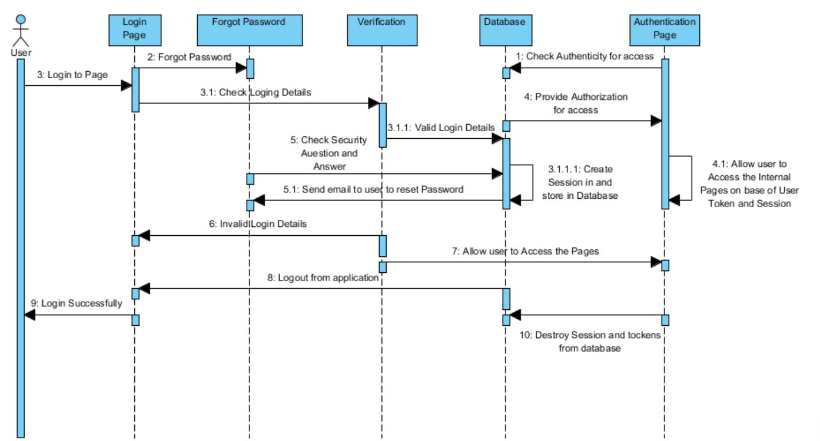

**3.7 Proposed System UI**

