IR Explorer
Educational Information Retrieval Learning Tool

1. Introduction
IR Explorer is a desktop application designed for learning Information Retrieval concepts through interactive exploration and guided lessons. It provides a hands-on environment where users can load document collections, build inverted indexes, run search queries, and visualize how text retrieval systems work — from tokenization through link analysis.
The application serves two audiences: students studying information retrieval who need to understand theory in action, and instructors who can use it for live demonstrations during lectures. It runs as a standalone Windows desktop application with no server or internet connection required.

2. Features Overview

2.1 Dual-Mode Interface
The application offers two complementary modes accessible via a toggle at the top of the window:
Learn Mode provides structured lessons that guide users through IR concepts step by step. Each lesson includes theory explanations, animated demonstrations, interactive experiments, and self-check questions. Lessons progress from basic text processing through advanced topics like link analysis, with automatic advancement between sections.
Explore Mode offers free-form interaction with all IR components through a tabbed interface. Users can load their own documents, build indexes, run queries, and examine results without following a prescribed order.

2.2 Learn Mode — 9 Interactive Lessons
Tokenization: How raw text is split into searchable tokens, including case folding and punctuation handling.
Stopword Removal: Why common words are filtered and the trade-offs involved, with vocabulary size comparisons.
Stemming: How suffix stripping collapses word variants, the difference between stemming and lemmatization.
Inverted Index: How documents become searchable through dictionary and postings list structures.
Boolean Retrieval: AND, OR, NOT operations on postings lists with merge algorithm visualization.
TF-IDF & Vector Space Model: Term weighting, document vectors, and cosine similarity for ranked retrieval.
Evaluation Metrics: Precision, recall, average precision, and the precision-recall trade-off.
Web Crawling: BFS and DFS traversal strategies, frontier management, and politeness.
Link Analysis: PageRank and HITS algorithms with convergence visualization.
Each lesson includes animated demonstrations that play directly within the application, showing step-by-step how each algorithm works. Animations have playback controls (play, pause, step forward/backward, speed adjustment) so users can examine each step at their own pace.

2.3 Explore Mode — 10 Interactive Tabs
Corpus: Import PDF or text files, load curated example corpora, or generate synthetic corpora with controllable properties. Documents can be edited in-place during the session.
Index: Build and browse the inverted index. Click any term to see its postings list and document frequency.
Search: Run Boolean queries (AND, OR, NOT) or TF-IDF ranked queries with cosine similarity scores.
Vocabulary: View term frequency distributions, top-N terms, and Zipf's law log-log plots. Toggle stopword removal to see the impact.
Postings: Examine postings list lengths, document frequency distribution, and identify rare vs. common terms.
Pipeline: Step-by-step preprocessing visualization showing raw tokens, after stopword removal, and after stemming side by side.
Compare: Pairwise Jaccard similarity between documents with a heatmap matrix and shared term lists.
Evaluation: Run queries, mark relevant documents, and compute precision, recall, and average precision with a PR curve plot.
Crawler: Simulate BFS and DFS web crawling on the document link graph with animated traversal.
Link Analysis: Run PageRank or HITS on the link graph and watch scores converge iteration by iteration.

2.4 Corpus Management
The application supports multiple ways to load document collections:
- Import PDF files with automatic section splitting (by title, subtitle, or as a single document).
- Import plain text files.
- Load curated example corpora designed to highlight specific IR concepts (synonym variations, link structures).
- Generate synthetic corpora with configurable number of documents, length, vocabulary overlap, and reproducible random seeds.
- Edit document text directly within the application during the session.

2.5 Configurable Stemmer
The suffix-stripping stemmer can be customized through the Settings menu. Users can add, remove, or reorder suffix rules to experiment with how different stemming strategies affect vocabulary size and retrieval quality. Changes are saved across sessions.

2.6 Contextual Hints
Explore Mode tabs include collapsible hint panels that provide context-aware explanations. For example, clicking a term in the Index tab shows its document frequency and explains what that means for retrieval. Hints can be collapsed per-tab when not needed.

3. Default Corpus — Source Documents
The application ships with a default corpus of 13 section-level documents extracted from three published research papers on multiverse physics and quantum mechanics. These provide rich, real-world academic text for demonstrating IR concepts:
Tegmark, M. (2005). "The Multiverse Hierarchy"
File: the_multiverse_hierarchy_max_tegmark.pdf
Documents d1–d5. Covers the four-level multiverse hierarchy from cosmological inflation through mathematical structures. Provides vocabulary around inflation, quantum mechanics, and cosmology.
Guth, A. H. (2007). "Eternal Inflation and its Implications"
File: eternal_inflation_and_its_implication_alan_h_guth.pdf
Documents d6–d9. Covers inflationary cosmology, the flatness problem, eternal inflation mechanisms, and the string landscape. Shares significant vocabulary overlap with the Tegmark paper, making it useful for similarity and retrieval demonstrations.
Blackshaw, N. & Franklin, A. (2026). "Everettian Interpretations of Quantum Mechanics"
File: Everett_Encyclopedia_Chapter.pdf
Documents d10–d13. Covers the Everett interpretation, decoherence, the preferred basis problem, and the probability problem in quantum mechanics. Introduces distinct vocabulary (decoherence, branching, wavefunction) while sharing quantum mechanics terms with the other papers.
The source PDF files are included in the project root directory for reference. The extracted text is stored in ir_explorer/assets/default_corpus.json and is used by the lesson animations.

4. Technical Details

4.1 Architecture
The application follows a clean separation between core logic and user interface. All information retrieval algorithms (tokenization, indexing, retrieval, evaluation, crawling, link analysis) are implemented in pure Python modules with no UI dependencies, making them independently testable. The UI layer uses tkinter for the graphical interface and draws charts and animations directly on Canvas widgets.

4.2 Dependencies
- Python 3.10 or later
- tkinter (included with Python)
- NumPy — vector operations for TF-IDF cosine similarity
- PyMuPDF — PDF text extraction with font size analysis
- PyYAML — lesson definition files

4.3 Lesson System
Lessons are defined as YAML files, making it straightforward to add new lessons or modify existing content without changing application code. Each lesson specifies theory content, demo actions (mapped to animation generators), experiment widgets, and checkpoint questions. The lesson engine tracks progress across sessions.

4.4 Animation System
Animations use a snapshot-based approach where each frame renders the complete visual state. This enables VCR-style controls including play, pause, step forward, step backward, go to start, and go to end. Playback speed is adjustable from 0.5x to 4x. Lesson animations use a private, isolated corpus that is independent of whatever the user has loaded in Explore mode.

5. Getting Started
Launch the application and it opens in Learn Mode with the first lesson (Tokenization) displayed. Navigate through the lessons using the Back and Next buttons, or click any lesson in the sidebar to jump directly to it.
To explore freely, switch to Explore Mode using the toggle at the top. Load a corpus using "Load Example Corpus" (recommended for first use — try the Link Structure corpus for crawling and link analysis, or the Synonyms corpus for stemming experiments). Then navigate through the tabs to build indexes, run searches, and visualize results.

6. Educational Applications
The application can be used in several educational contexts:
- Self-paced learning: Students work through the 9 lessons at their own speed, with animated demonstrations making abstract concepts concrete.
- Lecture demonstrations: Instructors can use Explore Mode to show live how changing parameters (stopwords, stemming, TF weighting, damping factors) affects retrieval results.
- Experimentation: Students can import their own PDF documents, generate synthetic corpora with specific properties, and observe how corpus characteristics influence index structure and retrieval quality.
- Reproducible exercises: The corpus generator accepts a random seed, allowing instructors to set up exercises where all students work with identical synthetic data.

7. Use Case Diagrams

7.1 Student Use Cases
The following diagram shows how a student interacts with IR Explorer. In Learn Mode, students follow structured lessons with theory, animated demos, and checkpoints. In Explore Mode, they freely investigate all aspects of the information retrieval pipeline.
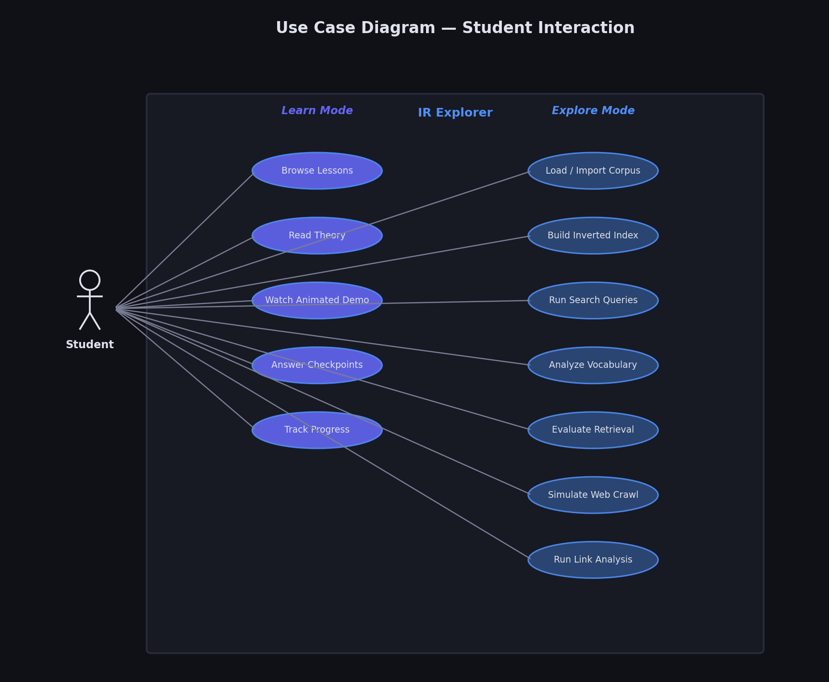

7.2 Instructor Use Cases
Instructors use Explore Mode for live lecture demonstrations. Key capabilities include generating reproducible corpora with specific seeds, comparing algorithms side by side, adjusting parameters in real-time to show their effect, and importing custom PDF documents relevant to the course material.
