VerifAI – Deliverable 5: Tests and Results
Eduvos Bedfordview | Faculty of IT (Software Engineering) | Module ITMDA3-34 | Group SE16 | Lecturer: Mpho Thobejane
Team: Mpho Mokoena, Lwandle Mvelase, Meshaque Kalonji, Vusani Mulaudzi, Theodore Nangara
Observed results are entered below. Cases not executed remain Pending; expected results were not copied into Actual. This run is incomplete and requires additional execution and evidence before final academic submission.

1. Introduction and Testing Objectives
VerifAI is a mobile and web application that measures a graduate's AI workplace readiness. Learners work through realistic scenarios containing flawed AI output or a judgement call, identify the problem, correct it, justify a decision, and build a readiness profile from assessed attempts. The app is built with Flutter on the client, a Node.js and Express API, PostgreSQL on Supabase, and Firebase Authentication.
This deliverable validates that the working application is functional, stable, user-friendly and free of critical bugs. The testing objectives are:
- Functionality: confirm that every implemented feature behaves according to its specification and user story, including navigation, data operations and login/logout logic.
- Reliability: confirm that the app runs without crashing during a full pass through all major features.
- Usability: confirm that the interface is easy to understand, that buttons and inputs respond correctly, and that every action gives visible feedback.
- Robustness: confirm that blank, invalid, oversized or unexpected input, and loss of connectivity, are either prevented or met with clear feedback.
- Security of access: confirm that protected data and the staff/admin portal are only reachable by authenticated and authorised users.
- Data integrity: confirm that task attempts, profile changes and progress are stored correctly in the database and returned correctly by the API.
- Defect resolution: record every significant defect, fix the critical ones, and retest the fix.

2. Scope

2.1 In scope
- Authentication: sign-in, registration, password reset, sign-out, session handling
- Onboarding: welcome tour and industry track selection
- The five main hubs: Home, Learn, Practice, Progress, Profile
- Scenario task runner, scored feedback and next action
- Decision-based assessments (AI Judgement, Risk and Governance)
- Progress and readiness view, attempt history and saved feedback
- Profile, preferences and track updates
- Role-gated staff/admin portal
- API and database behaviour behind these screens (health check, protected routes, persisted attempts)
- Input validation, error handling and UI feedback states

2.2 Out of scope or known limitations
- Prompt Design has no authored task content yet (the app's own README lists this limitation). It is recorded as not complete and not tested as a finished feature.
- Human-AI Collaboration is no longer on the challenge cards and is not tested as a scored dimension.
- The Workshop (community threads) is complete on the API but has no mobile screen, so it is not tested from the app.
- Offline mode is not implemented. Offline behaviour is tested only for graceful failure (clear message, retry, no crash), not cached reading.
- Learners cannot edit task definitions, so full CRUD is not claimed for tasks. CRUD is tested for the data learners can change (profile, track, attempts); admin content actions are tested separately.
- Load and performance testing at scale, and penetration testing, are outside this assessment.

3. Testing Plan

3.1 Approach
Testing is manual, scripted black-box testing against the running application, supported by the team's automated test suite. Each test case has an ID, a feature, a description of what is tested, an expected result, and a recorded actual result. A tester follows the steps, observes the behaviour, captures a screenshot or screen recording, and marks the case Pass or Fail. Failed cases are logged in the Bug Log (Section 6), fixed, and retested.
Fresh rerun: backend `npm test` completed with 186 passed and 0 failed. Flutter tests could not run because Flutter is not installed; the earlier combined 241-test result was not reproduced.
The backend suite mocks PostgreSQL, so database persistence and SQL behaviour are verified manually (API-05, API-06). The repository's backend/TEST_MATRIX.md lists further backend checks (missing token, invalid track, answer-key leakage, SQL-injection strings) that complement the cases below.

3.2 Test environment
Item | Detail
Client build | Flutter web deployment; deployed Flutter version/build type was not exposed.
Platform tested | Web build: https://verif-ai-5a435.web.app/ (signed-in learner session).
Device and OS | Windows host (Win32); embedded Chromium 130.0.6723.191. Exact Windows build unavailable.
Backend | Node.js 22 + Express per project specification; deployed API https://verifai-2wnm.onrender.com. Local suite ran under Node v26.7.0.
Database | PostgreSQL on Supabase. Live API health returned db=connected; direct table inspection was not performed.
Authentication | Firebase Authentication
Network conditions | Internet-connected browser session; Wi-Fi/mobile/airplane-mode scenarios not run.
Test period | 29 October 2026.
Testers | Buffy (assistant): live API checks and backend test suite. User provided the signed-in browser session. No other tester participation claimed.

3.3 Test data
- This run used the learner session made available in the shared browser. No accounts were created and no credentials or tokens are included. Synthetic learner and staff/admin accounts are still needed for pending tests.
- Invalid inputs prepared in advance: empty strings, a malformed email, a short password, a very long string, special characters and an injection-style string.
- Screenshots are captured with secrets, tokens and personal identifiers removed.

3.4 Entry and exit criteria
- Entry: the build installs and launches, the API is reachable, and test accounts exist.
- Exit: all test cases executed, no open Critical or High defects, and every major feature used at least once during the run.

3.5 Defect severity
Severity | Meaning
Critical | Crash, data loss, security breach, or a core flow (sign-in, task submission) is unusable
High | A major feature fails or gives wrong results, but a workaround exists
Medium | A feature works with a noticeable flaw (wrong message, layout break)
Low | Cosmetic or minor wording issue

4. Types of Testing
Type | What it covers | Test case prefix
Functional | Each feature works to specification: navigation, CRUD on user data, login/logout, data interactions | AUTH, ONB, NAV, LRN, PRC, PRG, PRO, ADM, API
Usability | Clear, intuitive interface; actions easy to complete; buttons and inputs respond correctly | USE
Edge-case | Blank forms, invalid characters, oversized input, offline use, interrupted flows | EDG
Bug testing and fixing | Hunting for crashes and defects, reproducing them, fixing and retesting | Bug Log

5. Test Cases and Results
Status key: Pass, Fail, or Pending (not yet run). Evidence references (e.g. S-AUTH-01) point to the screenshot index in Section 8.

5.1 Authentication (Functional)
ID | Feature | What was tested | Expected result | Actual result | Status | Notes / Evidence
AUTH-01 | Sign-in | Valid email and password | User is signed in and lands on onboarding or Home | User signed in successfully; after Firebase sign-in/account lookup, `/api/auth/sync` and `/api/users/me` returned HTTP 200 and the app opened `#/dashboard`. | Pass | Signed-in session and dashboard screenshot: [test-evidence/dashboard-signed-in.png](test-evidence/dashboard-signed-in.png). No credentials recorded.
AUTH-02 | Sign-in | Correct email, wrong password | Sign-in rejected with a clear error; no session created | Not run. | Pending | —
AUTH-03 | Sign-in | Unregistered email | Rejected with a clear error that does not expose internal details | Not run. | Pending | —
AUTH-04 | Sign-in | Both fields blank | Required-field validation shown; no request sent | Not run. | Pending | —
AUTH-05 | Sign-in | Malformed email (e.g. "user@") | Email format error shown | Not run. | Pending | —
AUTH-06 | Registration | New account with valid details | Account created, user continues to onboarding | Not run; registration flow was not operable in this session. | Pending | —
AUTH-07 | Registration | Existing email, password under 6 characters, or mismatched confirmation | Clear inline error (e.g. "Passwords do not match"); no duplicate account | Not run. | Pending | —
AUTH-08 | Password reset | Reset request for a valid email | Confirmation shown and reset email sent | Not run. | Pending | —
AUTH-09 | Sign-out | Sign out from Profile | Session ends and user returns to sign-in; back button does not reopen protected screens | Not run; requires an authenticated account. | Pending | —
AUTH-10 | Session persistence | Close and reopen the app while signed in | User remains signed in or is cleanly returned to sign-in | Not run; requires an authenticated account and app restart. | Pending | —

5.2 Onboarding and Navigation (Functional)
ID | Feature | What was tested | Expected result | Actual result | Status | Notes / Evidence
ONB-01 | Welcome tour | Step through every tour screen | Each screen shows in order; user can proceed or skip | Not run; app controls were not operable. | Pending | —
ONB-02 | Industry selection | Choose one industry track | Selection highlighted and saved; Home reflects the track | Not run; requires onboarding/account. | Pending | —
ONB-03 | Industry selection | Continue without choosing a track | User is prevented from continuing or told to choose | Not run. | Pending | —
NAV-01 | Main navigation | Tap Home, Learn, Practice, Progress, Profile in turn | Each hub opens the correct screen with no crash or blank state | Not run; no hub controls available through the browser snapshot. | Pending | —
NAV-02 | Back navigation | Use back from nested screens | User returns to the previous screen; hub state is kept | Not run. | Pending | —
NAV-03 | Deep route guard | Open a protected route while signed out | User is redirected to sign-in | Not run in the client. | Pending | API authorization checks are recorded under API-02/03.
NAV-04 | Home dashboard | Open Home with a lived-in account | Dashboard shows real data returned by the API | Signed-in dashboard displayed IT / Software, readiness 22 (Novice), a one-day streak, nine completed tasks, and “The Working Query That’s Insecure” as the next task. Dashboard requests returned HTTP 200. | Pass | [test-evidence/dashboard-signed-in.png](test-evidence/dashboard-signed-in.png).

5.3 Learning and Practice (Functional)
ID | Feature | What was tested | Expected result | Actual result | Status | Notes / Evidence
LRN-01 | Learn hub / AI Lab | Open the Learn hub and an available lesson | Content loads and activities respond | Not run. | Pending | —
LRN-02 | Learn hub | Open the Prompt Design area | Shows as not yet available; no crash | Not run in the UI. | Pending | The plan identifies authored Prompt Design content as a known limitation.
PRC-01 | Practice hub | Open Practice and view skill areas | Skill areas listed for the selected track | Not run. | Pending | —
PRC-02 | Task runner | Open a scenario | Scenario text and AI output display fully before submission | Not run. | Pending | —
PRC-03 | Task runner | Complete and submit a scenario | Loading indicator, then scored feedback from the real API | Not run. An attempted “Start task” click did not reach the Flutter canvas; the app remained on the dashboard and no submission was made. | Pending | No attempt or score was invented.
PRC-04 | Feedback | Review feedback after submission | Score, explanation and a next action are shown | Not run. | Pending | —
PRC-05 | AI Judgement | Complete a decision-based task | Decision recorded and assessed; feedback shown | Not run. | Pending | —
PRC-06 | Risk and Governance | Complete a decision-based task | Decision recorded and assessed; feedback shown | Not run. | Pending | —
PRC-07 | Task content | Open one task from each industry track | Each track returns its own tasks | Not run. | Pending | —

5.4 Progress, History and Profile (Functional)
ID | Feature | What was tested | Expected result | Actual result | Status | Notes / Evidence
PRG-01 | Progress view | Open Progress after several attempts | Readiness scores reflect the assessed attempts | Progress displayed level 6, 99 / 550 XP, one-day streak, nine completed tasks, seven-day practice activity, leaderboard rank 1, and readiness skill scores. Authenticated progress activity and leaderboard requests returned HTTP 200. | Pass | [test-evidence/progress-signed-in.png](test-evidence/progress-signed-in.png).
PRG-02 | Progress view | Open Progress with a brand-new account | Clear empty state, not an error | Not run. | Pending | —
PRG-03 | Attempt history | Open history and select an attempt | Saved feedback for that attempt is shown | Not run. | Pending | —
PRG-04 | Data update | Complete a new task and return to Progress | Progress updates to include the new attempt | Not run; no task was submitted. | Pending | —
PRO-01 | Profile | View profile and preferences | Correct user details shown | Not run. | Pending | —
PRO-02 | Profile update | Change preferences or display details and save | Success message; change persists after restart | Not run. | Pending | —
PRO-03 | Track change | Switch industry track | Track saved; Home and Practice reflect the new track | Not run. | Pending | —

5.5 Staff/Admin Portal and Access Control (Functional)
ID | Feature | What was tested | Expected result | Actual result | Status | Notes / Evidence
ADM-01 | Admin access | Sign in with the staff/admin account | Portal is accessible | Not run; no staff account supplied. | Pending | —
ADM-02 | Role gating | Try to reach the portal as a normal learner | Access denied, enforced by the server and not only hidden in the UI | Not run; requires role-specific authenticated accounts. | Pending | —
ADM-03 | Admin actions | Perform an admin content action | Action succeeds and is reflected for learners | Not run; no staff account supplied. | Pending | —

5.6 Backend and Database Integration (Functional)
ID | Feature | What was tested | Expected result | Actual result | Status | Notes / Evidence
API-01 | Health check | Call the deployed API health endpoint | Returns a healthy status | `GET /api/health` returned HTTP 200 JSON: `status: ok`, `db: connected`. | Pass | Live API request on 29 Oct 2026.
API-02 | Protected route | Request a protected endpoint without a token | Rejected with an authorisation error | `GET /api/users/me` returned HTTP 401 with a missing/malformed Authorization message. | Pass | Live API request; no account data returned.
API-03 | Protected route | Request a protected endpoint with an invalid or expired token | Rejected with an authorisation error | `GET /api/users/me` with `Bearer invalid.test.token` returned HTTP 401, `Invalid or expired token.` | Pass | Live API request.
API-04 | Data retrieval | Load tracks and dashboard data | Real data returned and displayed in the app | `GET /api/tracks` returned HTTP 200 with four tracks (Finance, Legal, IT / Software, Business Consulting). In the signed-in app, `/api/dashboard` returned HTTP 200 and its data appeared on the Home dashboard. A separate unauthenticated `GET /api/dashboard` returned HTTP 401. | Pass | Live API responses and [test-evidence/dashboard-signed-in.png](test-evidence/dashboard-signed-in.png).
API-05 | Persistence | Submit a task, then inspect the Supabase attempts table | A new attempt row exists with correct user, task and score | Not run; no authenticated submission or database console access. | Pending | Automated backend suite uses mocks and does not prove deployed persistence.
API-06 | Data isolation | Compare history of two test accounts | Each user sees only their own attempts | Not run; no test accounts/history supplied. | Pending | —

5.7 Usability and UI Feedback
ID | Feature | What was tested | Expected result | Actual result | Status | Notes / Evidence
USE-01 | Clarity | A tester who has not used the app completes a first task unaided | Task finished without help; hesitation points noted | Not run; no participant completed a task. | Pending | —
USE-02 | Controls | Tap every primary button on each hub | Each responds visibly and leads to the expected screen | Not run; controls were not available through the browser accessibility snapshot. | Pending | —
USE-03 | Feedback | Trigger a success, a validation error and a network error | A clear message appears for each | Not run. | Pending | —
USE-04 | Loading states | Submit a task on a slower connection | A loading indicator shows and the button cannot be pressed twice | Not run. | Pending | —
USE-05 | Responsiveness | Run on a small phone screen, a larger screen and the web build | Layout adapts with no overflow or clipped text | Web layouts were visually inspected at the captured 1600 × 1125 dashboard and progress viewport; small-phone and comparative large-screen checks were not run. | Pending | [Dashboard screenshot](test-evidence/dashboard-signed-in.png), [Progress screenshot](test-evidence/progress-signed-in.png). Multi-size requirement incomplete.
USE-06 | Orientation | Rotate the device mid-task | Layout adapts and entered answers are not lost | Not run; no device/emulator. | Pending | —
USE-07 | Readability | Check text size, contrast and wording on key screens | Text is legible and instructions are clear | No formal readability, contrast, or wording assessment performed. | Pending | Rendered screens captured: [dashboard](test-evidence/dashboard-signed-in.png), [progress](test-evidence/progress-signed-in.png).

5.8 Edge-case and Invalid-input Testing
ID | Feature | What was tested | Expected result | Actual result | Status | Notes / Evidence
EDG-01 | Blank submission | Submit a task with no answer | Prevented or clear message; nothing stored | Not run; no task submitted. | Pending | —
EDG-02 | Special characters | Enter symbols and emoji in text fields | Accepted or rejected cleanly; no crash | Not run. | Pending | —
EDG-03 | Injection-style input | Enter an SQL-style string in a text field | Handled as plain text; no error or data exposure | Not run against the running app. | Pending | Backend source suite is not a substitute for this manual case.
EDG-04 | Very long input | Paste several thousand characters into an answer field | Limited or handled gracefully; no crash | Not run. | Pending | —
EDG-05 | No internet | Use airplane mode, then open the app and submit a task | Inline "Check your connection and try again" message with a retry; no crash; no partial save (offline mode is not implemented) | Not run; airplane-mode/device network controls unavailable. | Pending | —
EDG-06 | Connection lost mid-submit | Disable the network while submitting | Error shown; user can retry; no duplicate attempt | Not run. | Pending | —
EDG-07 | Double submit | Tap Submit twice quickly | Only one attempt is recorded | Not run. | Pending | —
EDG-08 | Interrupted flow | Press back or background the app mid-task | No crash; sensible behaviour on return | Not run. | Pending | —
EDG-09 | Expired session | Leave the app idle until the token expires, then act | Token refreshed or user returned to sign-in cleanly | Not run; requires an authenticated session and expiry wait. | Pending | —
EDG-10 | Automated suite | Re-run backend and Flutter tests | Totals and failures recorded (reported earlier: 241 total) | Backend: `npm test` completed with 186 passed, 0 failed. Flutter: not run because Flutter is unavailable. | Pending | The requested combined result is incomplete. Backend run used Node v26.7.0; local `DATABASE_URL` was unset.

5.9 Additional Feature and Security Coverage
These cases cover features present in the repository that the sections above do not reach, plus further API-level checks.
ID | Feature | What was tested | Expected result | Actual result | Status | Notes / Evidence
EXT-01 | Registration validation | Submit a 1-character name, an invalid email, a password under 6 characters, then mismatched passwords | Each case shows its own inline message; no account is created | Not run. | Pending | —
EXT-02 | Google sign-in | Sign in with Google, then cancel the Google prompt once | Sign-in succeeds and the profile syncs; cancelling returns to sign-in without a crash | Not run; no Google account/session interaction. | Pending | —
EXT-03 | Account deletion | Delete a test account from Profile and confirm | A confirmation is asked first; the account and learner data are removed and the user returns to sign-in | Not run; no throwaway account supplied. | Pending | No account/data was deleted.
EXT-04 | Verification Studio | Paste an AI answer and request analysis | A structured report appears (status, items to review, sources confirmed, summary) | Not run through the app. | Pending | —
EXT-05 | Verification Studio upload | Upload a PDF/DOCX under 5 MB, then one over 5 MB | Small file is analysed; large file is rejected with a clear message | Not run. | Pending | —
EXT-06 | AI Lab capstone | Start a capstone, answer objective questions, submit; repeat until the attempt limit | Timer shown, objective questions auto-marked, result displayed; attempts beyond the limit are blocked | Not run. | Pending | —
EXT-07 | Interview practice | Mark the same question as practised twice | Marked once; coverage does not double-count | Not run. | Pending | —
EXT-08 | Industry cases | Open a case from Practice | Case content loads and the case shows as read afterwards | Not run. | Pending | —
EXT-09 | Rewards | Redeem a reward with too few tokens, then with enough | First is rejected with a clear message; second debits the balance once | Not run. | Pending | —
EXT-10 | Leaderboard | Open global and per-track views | Both load and show the learner's own rank | Not run in the app. | Pending | —
EXT-11 | Appearance and accessibility | Switch light, dark and system themes; set the OS text size to the maximum | Theme changes apply; no overflow or clipped text at large text sizes | Not run; no UI interaction/device accessibility settings. | Pending | —
EXT-12 | Ask Vera / assistant | Send a question | A reply streams in; if the AI service is unavailable a clear message appears | Not run in the app. | Pending | —
EXT-13 | Wellness centre | Log a mood or journal entry | Entry is saved and shown again after reopening | Not run. | Pending | —
EXT-14 | Cold start | First action after the free-tier API has been idle | Loading indicator shows, request completes or shows a retry; no crash | The live `/api/health` responded successfully; no timing baseline or first user action was measured. | Pending | No performance conclusion drawn.
EXT-15 | Answer-key protection | Inspect the response for a task before submitting | The correct answer is not present in the response | Not run with an authenticated task request. | Pending | —
EXT-16 | API negative cases | Call an unknown route, and set an invalid track via the profile endpoint | 404 for the unknown route; 400 for the invalid track | Unknown route check: `GET /api/this-route-does-not-exist` returned HTTP 404 JSON `Route not found`. Invalid profile-track update was not run. | Pending | Partial check only.
EXT-17 | Rate limiting | Send many rapid requests to a limited endpoint | Requests beyond the limit are refused; the app shows clear feedback and does not crash | Not run; no burst/load request was sent. | Pending | —

6. Bug Log and Resolution
Record every defect found. Fix Critical and High items first, then retest and record the retest result.
Bug ID | Found in test | Description | Severity | Steps to reproduce | Cause | Fix applied | Retest result
BUG-01 | None confirmed in completed checks | No reproducible application defect confirmed; most functional cases remain pending. | N/A | N/A | N/A | No fix required | N/A — no defect retested
BUG-02 | — | No additional confirmed defects recorded. | — | — | — | — | —
BUG-03 | — | No additional confirmed defects recorded. | — | — | — | — | —
Add rows as needed. If the team finds no defects in an area, say so in the summary rather than leaving the section empty.

7. Test Summary
Measure | Result
Total test cases | 76
Passed | 7
Failed (fixed and retested) | 0
Failed (open) | 0
Not implemented / not applicable | Not separately determined; documented plan limitations are not all independently retested.
Crashes observed during the full run | 0 observed during completed checks; full end-to-end crash-free run not completed.
Findings. The live API health endpoint returned HTTP 200 with status=ok and db=connected. Valid sign-in reached Home; authenticated dashboard/profile and Progress data loaded, while missing and invalid tokens were rejected with HTTP 401. The backend suite passed 186/186, but most manual cases remain pending and deployed attempt persistence was not inspected.
Known limitations and suggested improvements. 69 of 76 cases remain pending or partially covered, including task submission, profile changes, sign-out, admin authorization, offline/error handling and device checks. Flutter tests were unavailable, and browser automation could not reliably activate Flutter canvas controls. Complete these checks with an interactive client, test accounts and sanitized evidence. Prompt Design content and offline mode are known plan limitations, not independently retested here.

8. Evidence Index
Insert the matching screenshot or link to a screen recording for each reference below. Each should show the app under test conditions with real user actions.
Reference | Evidence to capture
S-AUTH-01 to S-AUTH-10 | Captured and embedded below: signed-in dashboard (display-name area blurred). Other auth cases pending.
S-NAV-01 to S-NAV-04 | Not captured; direct route inspection does not verify hub-button navigation.
S-PRC-01 to S-PRC-07 | Not captured; no scenario was submitted and no score generated.
S-PRG-01 to S-PRO-03 | Progress screen captured and embedded below. History/profile/track-update evidence not captured.
S-ADM-01 to S-ADM-03 | Not captured; no staff/admin session available.
S-API-01 to S-API-06 | Live API observations are recorded in the case table; no Supabase-row screenshot.
S-USE / S-EDG / S-EXT | Not captured; validation/offline/long-input cases remain pending.
S-TEST | Backend test output: 186 passed, 0 failed. No terminal screenshot captured.
Screen recording | No complete screen recording captured.
Captured application screenshots
S-AUTH-01 / S-NAV-04 — Signed-in Home dashboard (display-name area blurred).
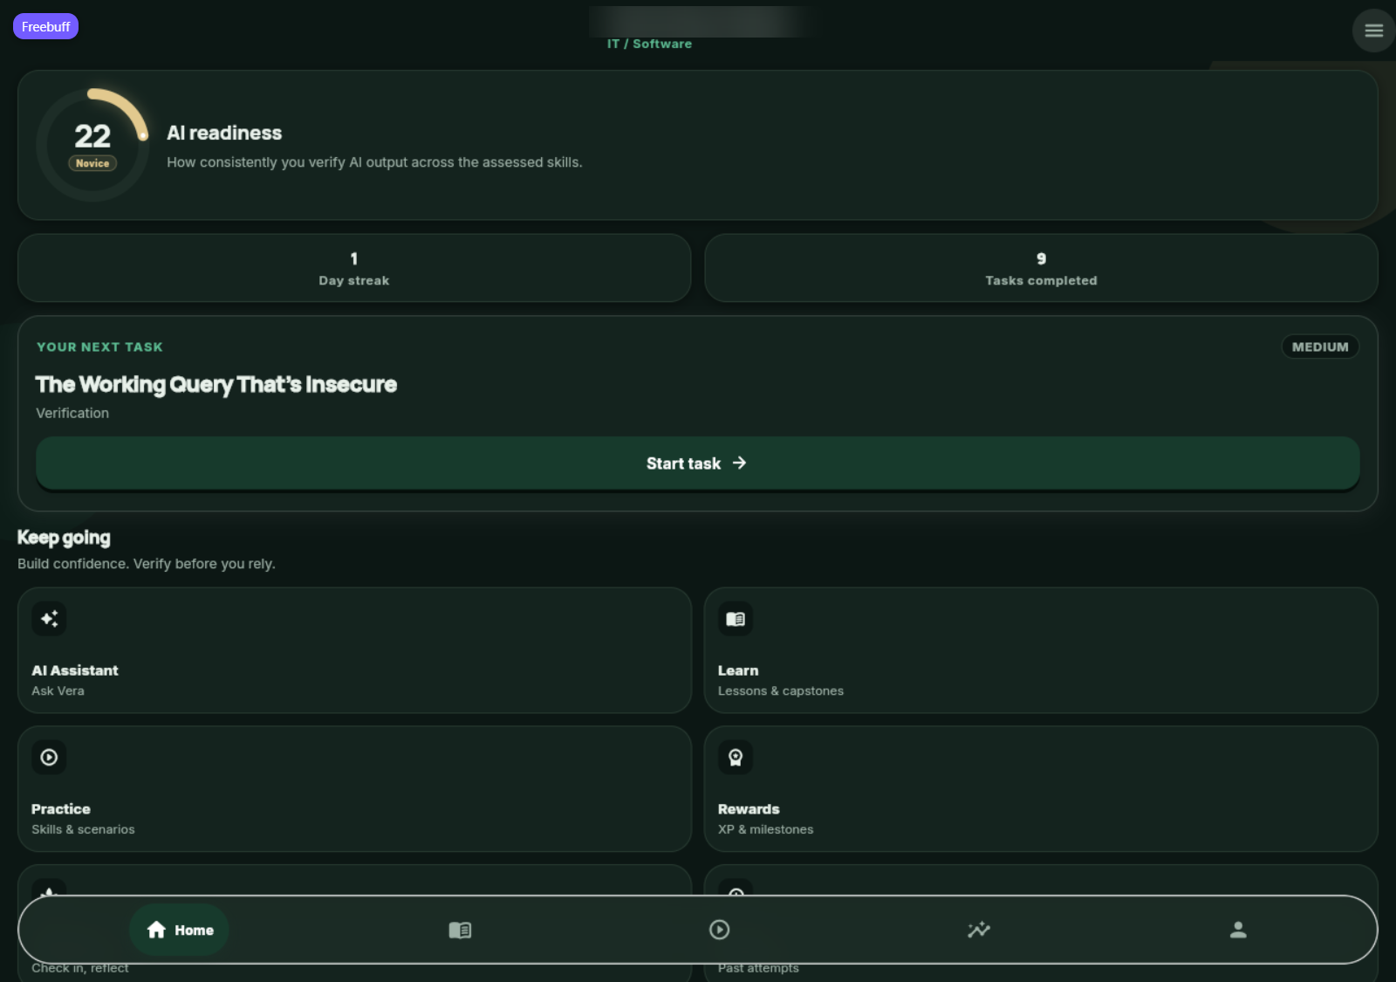
S-PRG-01 — Signed-in Progress screen.
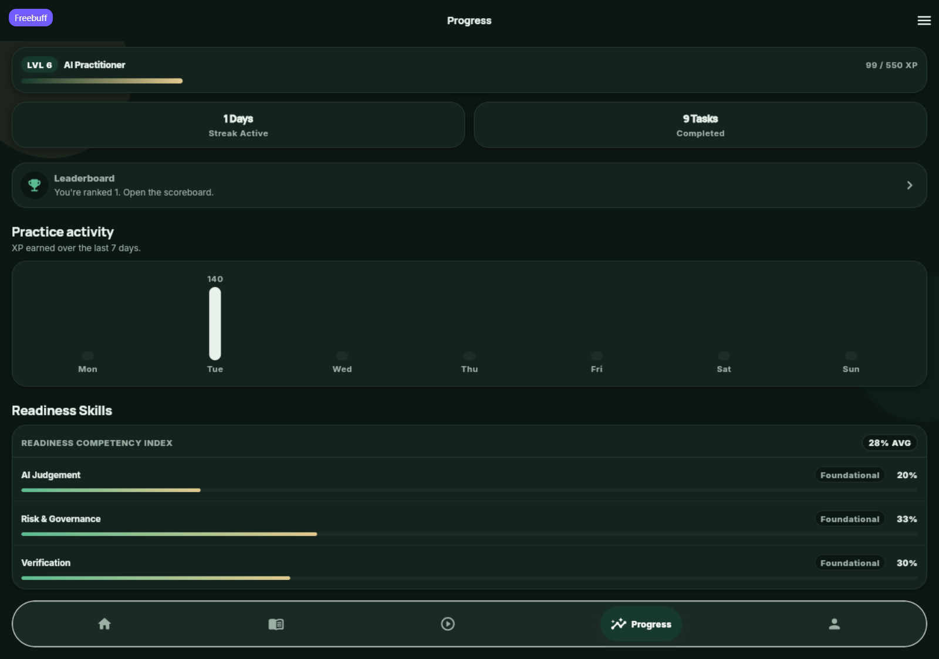

9. Conclusion
Conclusion. The limited objectives verifiable in this run were met: the signed-in web app loaded, live API health reported a connected database, authenticated dashboard/progress data loaded, and tested protected routes rejected unauthorized requests. A full stability or feature-completion conclusion cannot be made: 69 cases remain pending, Flutter tests were unavailable, and no task submission or database persistence inspection was performed. No confirmed application defect was recorded.

10. AI Disclosure Appendix
AI tool used | Purpose / how it was used | How I verified or adapted the output
Claude and Buffy (Freebuff coding assistant) | Claude drafted the test-plan structure and expected results. Buffy ran available live API checks and the backend test command after the user supplied a signed-in browser session, and compiled observed results and evidence. | Actual results are limited to observed browser/API behavior and command output. Unrun cases remain Pending. Screenshots show captured app screens with the display-name area blurred. Flutter tests and direct database persistence checks could not be completed.
Edit the row above so it describes what your group actually did. Complete the Eduvos coversheet and declaration, and paste the finished content into the Eduvos template if the module requires it.

