**Project 2:**

**Animate James Bond's Cessna!**

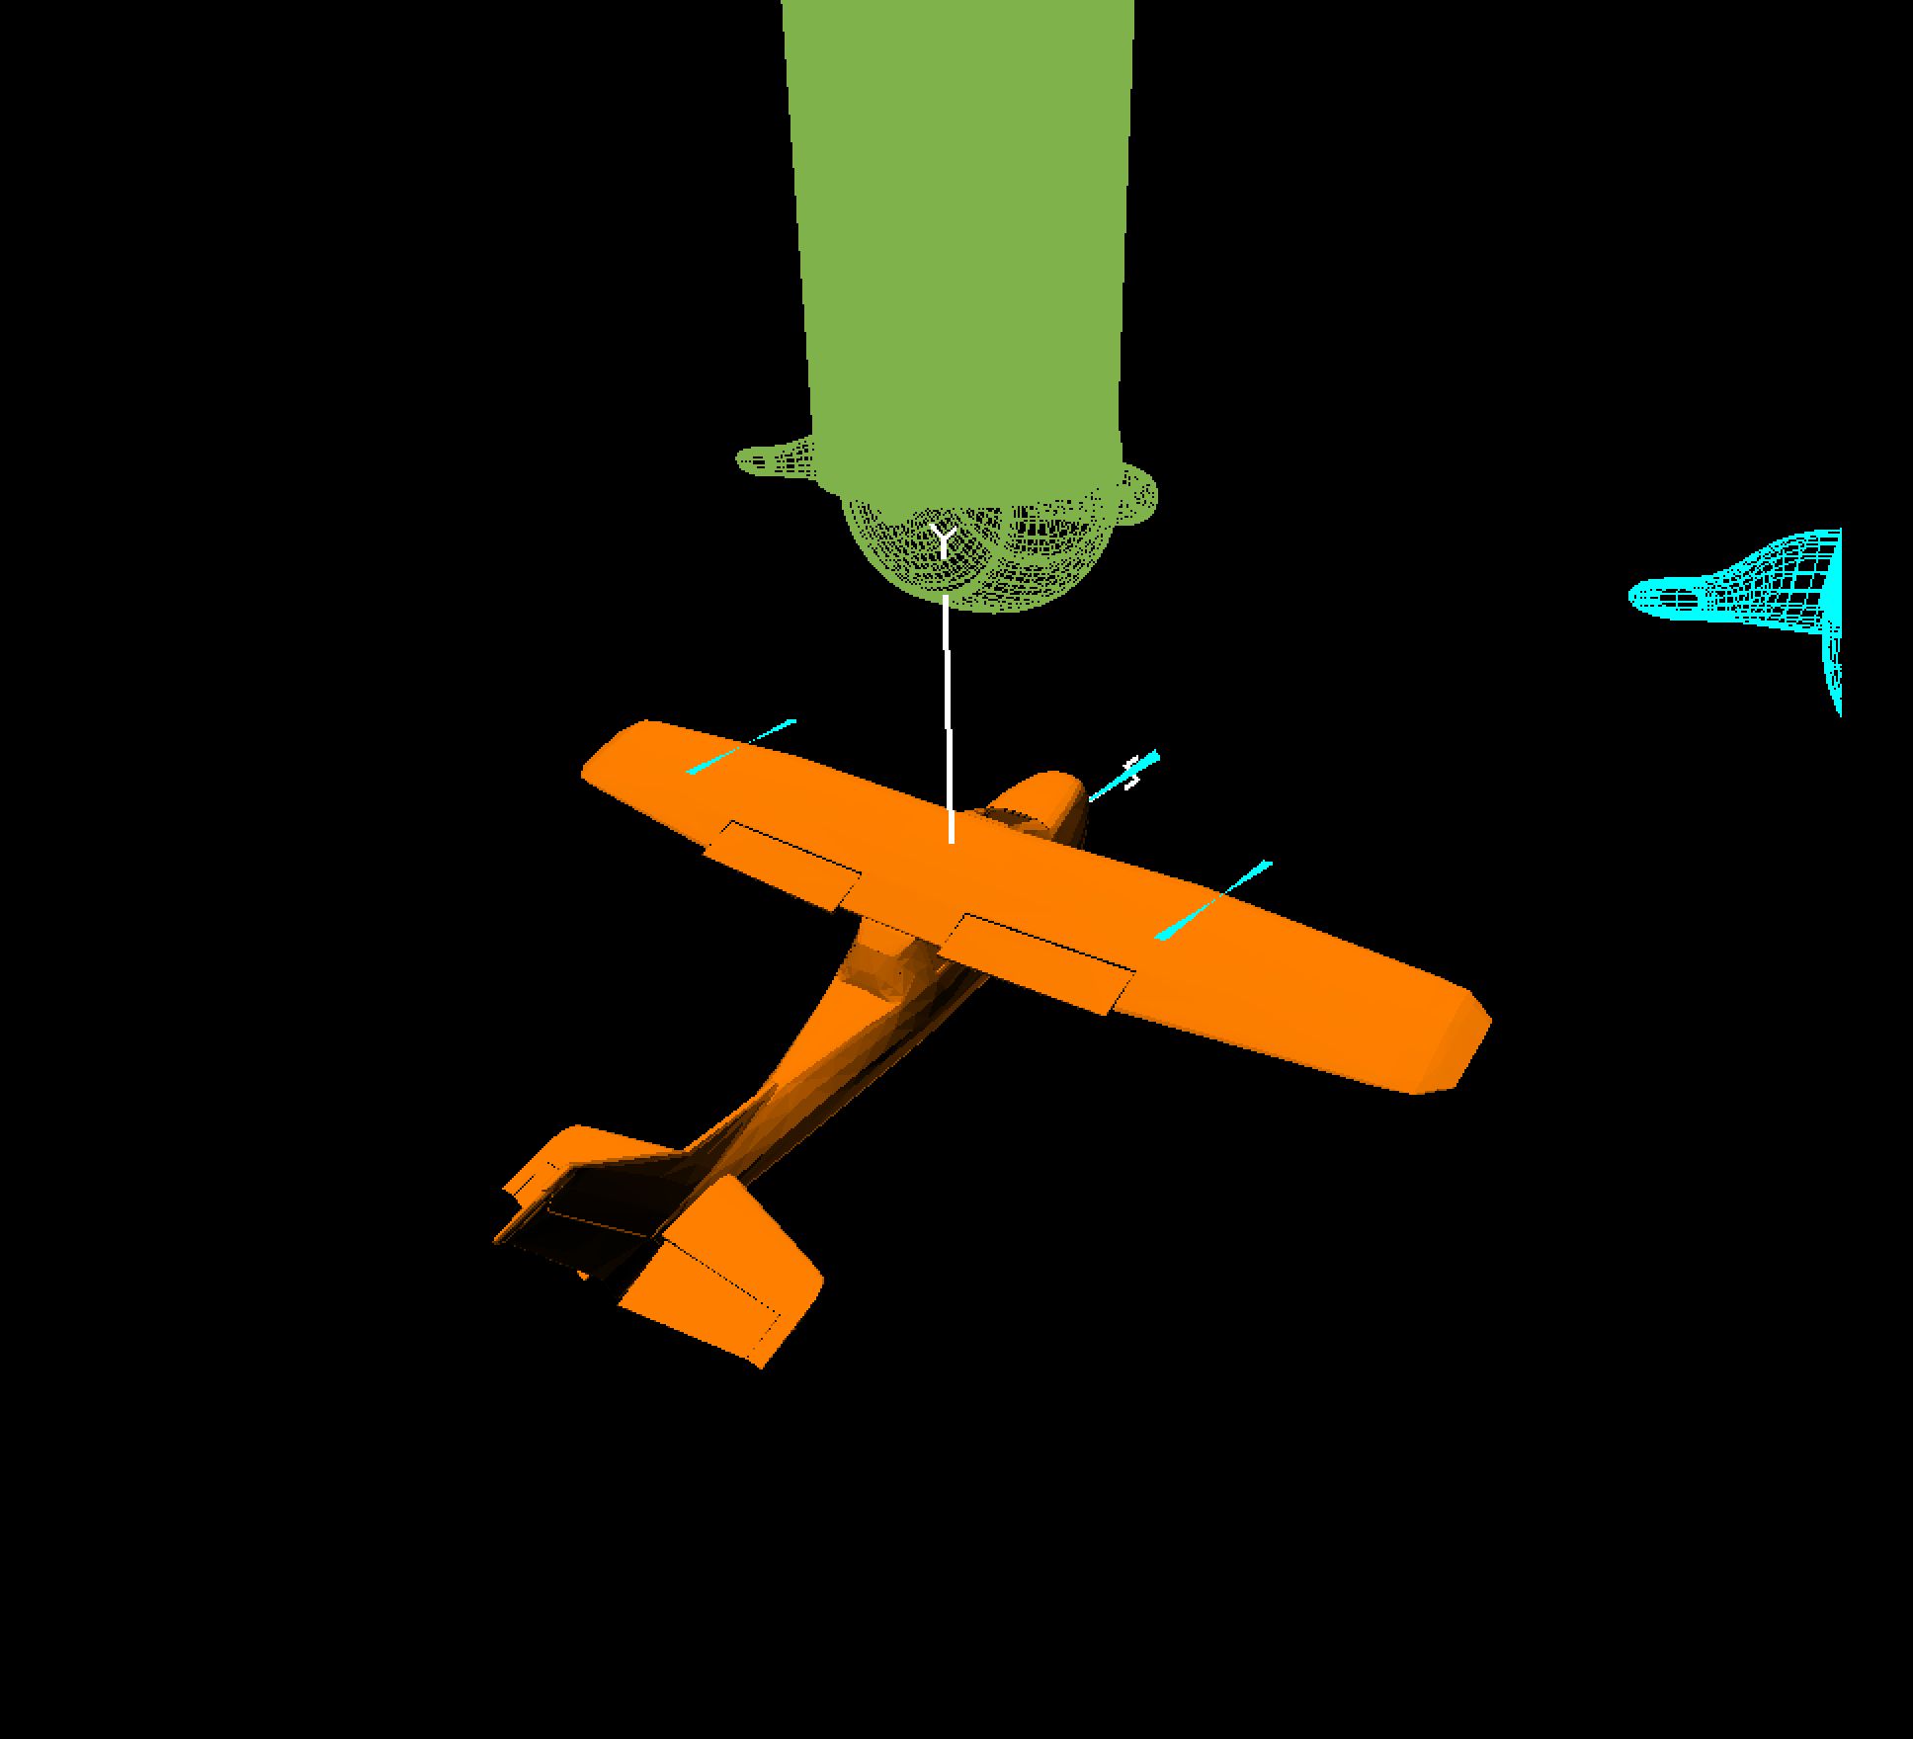

Mateo Estrada Jorge

Oct. 11, 2022

[mateo.estrada@oregonstate.edu](mailto:mateo.estrada@oregonstate.edu)

Kaltura Video Link: [Project 2](https://media.oregonstate.edu/media/t/1_4be911qk)

https://media.oregonstate.edu/media/t/1_4be911qk