11.2 Exercise

Theodore Koby-Hercsky

6/01/2021

## Set My working directory set to my week 11 assignment file

setwd(“~/Documents/Bellevue University Classes/DSC520/Week 11 Assignment”)

## Pulling the Data frame for the binary-classifier data as seen below.  
binary_classifier_data <- read_csv("data/binary-classifier-data.csv")  
head(binary_classifier_data)

## # A tibble: 6 x 3  
## label x y  
## <dbl> <dbl> <dbl>  
## 1 0 70.9 83.2  
## 2 0 75.0 87.9  
## 3 0 73.8 92.2  
## 4 0 66.4 81.1  
## 5 0 69.1 84.5  
## 6 0 72.2 86.4

## Next I will be pulling the Data frame for the trinary-classifier data as seen below.  
trinary_classifier_data <- read_csv("data/trinary-classifier-data.csv")  
head(trinary_classifier_data)

## # A tibble: 6 x 3  
## label x y  
## <dbl> <dbl> <dbl>  
## 1 0 30.1 39.6  
## 2 0 31.3 51.8  
## 3 0 34.1 49.3  
## 4 0 32.6 41.2  
## 5 0 34.7 45.5  
## 6 0 33.8 44.2

## Plot the data from each dataset using a scatter plot.

## Created a scatter plot for the binary_classifier_data frame  
ggplot(binary_classifier_data, aes(x=binary_classifier_data$x, y=binary_classifier_data$y, color=binary_classifier_data$label)) + geom_point() + scale_color_gradient2(low="white", mid="yellow", high="red")

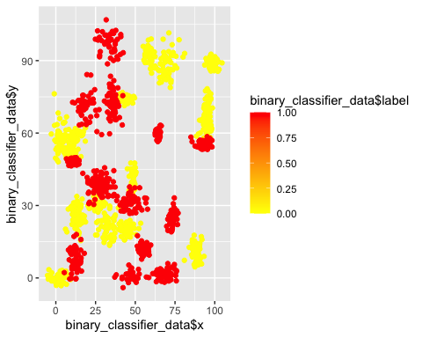

## Next I created a scatter plot for the trinary_classifier_data frame  
ggplot(trinary_classifier_data, aes(x=trinary_classifier_data$x, y=trinary_classifier_data$y, color=trinary_classifier_data$label)) + geom_point() + scale_color_gradient2(low="white", mid="yellow", high="red")

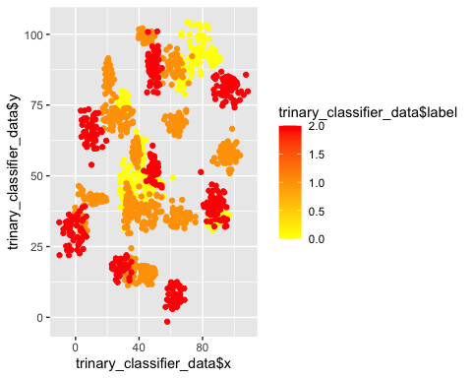

## The k nearest neighbors algorithm categorizes an input value by looking at the labels for the k nearest points and assigning a category based on the most common label. In this problem, you will determine which points are nearest by calculating the Euclidean distance between two points. As a refresher, the Euclidean distance between two points:

# First I will create data normalization for both bindary and trinary data frames.  
binary <- binary_classifier_data[, c("x", "y")]  
trinary <- trinary_classifier_data[, c("x", "y")]  
  
# Next I will create my train and test data sets for both binary and trinary data frames.  
# train and test data sets for binary data and pull the number of observations for the binary train and test data  
set.seed(150)  
binary_selection <- sample(1:nrow(binary), size=nrow(binary)*0.60, replace = FALSE)  
binary_train <- binary_classifier_data[binary_selection,]  
NROW(binary_train)

## [1] 898

binary_test <- binary_classifier_data[-binary_selection,]  
NROW(binary_test)

## [1] 600

# Next I will create dataframes for both train and test label data for the binary data and pull the number of observations for the binary train and test data  
train_label_binary <- binary_classifier_data[binary_selection,1,drop=TRUE]  
NROW(train_label_binary)

## [1] 898

test_label_binary <- binary_classifier_data[-binary_selection,1,drop=TRUE]  
NROW(test_label_binary)

## [1] 600

# train and test data sets for trinary data and pull the number of observations for the trinary train and test data  
set.seed(130)  
trinary_selection <- sample(1:nrow(trinary), size=nrow(trinary)*0.60, replace = FALSE)  
trinary_train <- trinary_classifier_data[trinary_selection,]  
NROW(trinary_train)

## [1] 940

trinary_test <- trinary_classifier_data[-trinary_selection,]  
NROW(trinary_test)

## [1] 628

# Next I will create dataframes for both train and test label data for the trinary data and pull the number of observations for the trinary train and test data  
train_label_trinary <- trinary_classifier_data[trinary_selection,1,drop=TRUE]  
NROW(train_label_trinary)

## [1] 940

test_label_trinary <- trinary_classifier_data[-trinary_selection,1,drop=TRUE]  
NROW(test_label_trinary)

## [1] 628

## Fit a k nearest neighbors’ model for each dataset for k=3, k=5, k=10, k=15, k=20, and k=25. Compute the accuracy of the resulting models for each value of k. Plot the results in a graph where the x-axis is the different values of k and the y-axis is the accuracy of the model.

## Fitting a model is when you use the input data to create a predictive model. There are various metrics you can use to determine how well your model fits the data. For this problem, you will focus on a single metric, accuracy. Accuracy is simply the percentage of how often the model predicts the correct result. If the model always predicts the correct result, it is 100% accurate. If the model always predicts the incorrect result, it is 0% accurate.

# Create a K nearest list the k nearest neighbors for binary data.  
k_nearest <- list(3,5,10,15,20,25)  
input=1  
binary_accuracy=1  
for (input in k_nearest) {  
 nearest_neighbor <- knn(train = binary_train, test = binary_test, cl=train_label_binary, k=input)  
 binary_accuracy[input] <- 100*sum(test_label_binary == nearest_neighbor)/NROW(test_label_binary)  
 k=input  
 cat(k,'=',binary_accuracy[input],'')  
}

## 3 = 98.16667 5 = 97.66667 10 = 97.5 15 = 97.16667 20 = 97.5 25 = 97.33333

# Next I will plot the accuracy of my k values for binary  
plot(binary_accuracy, type = "b", xlab = "k Nearest Neighbors Value", ylab = "Level of Accuracy")

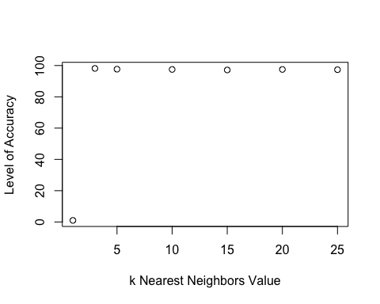

# Create a K nearest list the k nearest neighbors for trinary data.   
k_nearest_trinary <- list(3,5,10,15,20,25)  
input_trinary=1  
trinary_accuracy=1  
for (input_trinary in k_nearest_trinary) {  
 trinary_nearest <- knn(train = trinary_train, test = trinary_test, cl=train_label_trinary, k=input_trinary)  
 trinary_accuracy[input_trinary] <- 100*sum(test_label_trinary == trinary_nearest)/NROW(test_label_trinary)  
 k=input_trinary  
 cat(k,'=',trinary_accuracy[input_trinary])  
}

## 3 = 92.197455 = 91.082810 = 89.3312115 = 88.375820 = 86.7834425 = 87.73885

# Next I will plot the accuracy of my k values for binary  
plot(trinary_accuracy, type = "b", xlab = "k Nearest Neighbors Value", ylab = "Level of Accuracy")

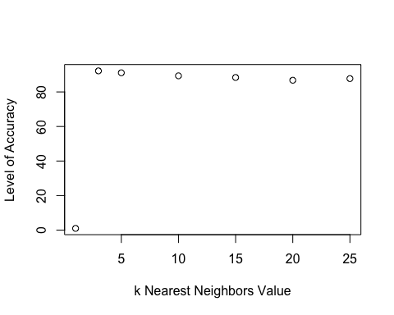

## Looking back at the plots of the data, do you think a linear classifier would work well on these datasets?

# yes I believe so as a linear classifier can classify data into labels based on a linear combination of input features

## How does the accuracy of your logistic regression classifier from last week compare? Why is the accuracy different between these two methods?

# The accuracy from this weeks method shows that for our trinary data that our accuracy went down as the k value went up as seen in our graph and outputs. While in our binary data we saw that as the k value increased the accuracy decreased as well but at a higher scale.

## Pulling the Data frame for the clustering_data as seen below.  
clustering_data <- read_csv("data/clustering-data.csv")  
View(clustering_data)

# Plot the dataset using a scatter plot.

## Created a scatter plot for the binary_classifier_data frame  
ggplot(clustering_data, aes(x=clustering_data$x, y=clustering_data$y)) + geom_point()

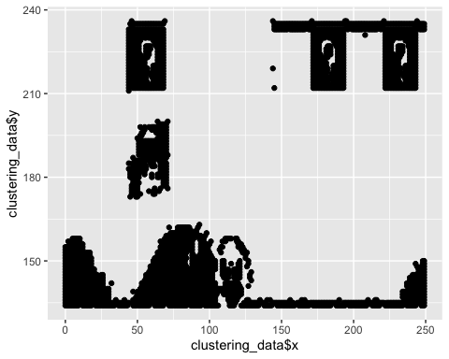

# Fit the dataset using the k-means algorithm from k=2 to k=12. Create a scatter plot of the resultant clusters for each value of k.

install.packages("rattle")

##   
## The downloaded binary packages are in  
## /var/folders/wm/_x82v16s45bgfptwshv23l3r0000gp/T//Rtmp7lmxje/downloaded_packages

library(rattle)  
head(clustering_data)

## # A tibble: 6 x 2  
## x y  
## <dbl> <dbl>  
## 1 46 236  
## 2 69 236  
## 3 144 236  
## 4 171 236  
## 5 194 236  
## 6 195 236

# standardize the variable  
clust_standard <- scale(clustering_data[-1])  
# k-means from k=2 to k=12  
clust_k_means_fit <- kmeans(clust_standard, 4)  
# collect attributes  
attributes(clust_k_means_fit)

## $names  
## [1] "cluster" "centers" "totss" "withinss" "tot.withinss"  
## [6] "betweenss" "size" "iter" "ifault"   
##   
## $class  
## [1] "kmeans"

# view the centroids   
clust_k_means_fit$centers

## y  
## 1 -0.8394230  
## 2 1.0720267  
## 3 1.4239069  
## 4 0.2920086

# view the clusters  
clust_k_means_fit$cluster

## [1] 3 3 3 3 3 3 3 3 3 3 3 3 3 3 3 3 3 3 3 3 3 3 3 3 3 3 3 3 3 3 3 3 3 3 3 3 3  
## [38] 3 3 3 3 3 3 3 3 3 3 3 3 3 3 3 3 3 3 3 3 3 3 3 3 3 3 3 3 3 3 3 3 3 3 3 3 3  
## [75] 3 3 3 3 3 3 3 3 3 3 3 3 3 3 3 3 3 3 3 3 3 3 3 3 3 3 3 3 3 3 3 3 3 3 3 3 3  
## [112] 3 3 3 3 3 3 3 3 3 3 3 3 3 3 3 3 3 3 3 3 3 3 3 3 3 3 3 3 3 3 3 3 3 3 3 3 3  
## [149] 3 3 3 3 3 3 3 3 3 3 3 3 3 3 3 3 3 3 3 3 3 3 3 3 3 3 3 3 3 3 3 3 3 3 3 3 3  
## [186] 3 3 3 3 3 3 3 3 3 3 3 3 3 3 3 3 3 3 3 3 3 3 3 3 3 3 3 3 3 3 3 3 3 3 3 3 3  
## [223] 3 3 3 3 3 3 3 3 3 3 3 3 3 3 3 3 3 3 3 3 3 3 3 3 3 3 3 3 3 3 3 3 3 3 3 3 3  
## [260] 3 3 3 3 3 3 3 3 3 3 3 3 3 3 3 3 3 3 3 3 3 3 3 3 3 3 3 3 3 3 3 3 3 3 3 3 3  
## [297] 3 3 3 3 3 3 3 3 3 3 3 3 3 3 3 3 3 3 3 3 3 3 3 3 3 3 3 3 3 3 3 3 3 3 3 3 3  
## [334] 3 3 3 3 3 3 3 3 3 3 3 3 3 3 3 3 3 3 3 3 3 3 3 3 3 3 3 3 3 3 3 3 3 3 3 3 3  
## [371] 3 3 3 3 3 3 3 3 3 3 3 3 3 3 3 3 3 3 3 3 3 3 3 3 3 3 3 3 3 3 3 3 3 3 3 3 3  
## [408] 3 3 3 3 3 3 3 3 3 3 3 3 3 3 3 3 3 3 3 3 3 3 3 3 3 3 3 3 3 3 3 3 3 3 3 3 3  
## [445] 3 3 3 3 3 3 3 3 3 3 3 3 3 3 3 3 3 3 3 3 3 3 3 3 3 3 3 3 3 3 3 3 3 3 3 3 3  
## [482] 3 3 3 3 3 3 3 3 3 3 3 3 3 3 3 3 3 3 3 3 3 3 3 3 3 3 3 3 3 3 3 3 3 3 3 3 3  
## [519] 3 3 3 3 3 3 3 3 3 3 3 3 3 3 3 3 3 3 3 3 3 3 3 3 3 3 3 3 3 3 3 3 3 3 3 3 3  
## [556] 3 3 3 3 3 3 3 3 3 3 3 3 3 3 3 3 3 3 3 3 3 3 3 3 3 3 3 3 3 3 3 3 3 3 3 3 3  
## [593] 3 3 3 3 3 3 3 3 3 3 3 3 3 3 3 3 3 3 3 3 3 3 3 3 3 3 3 3 3 3 3 3 3 3 3 3 3  
## [630] 3 3 3 3 3 3 3 3 3 3 3 3 3 3 3 3 3 3 3 3 3 3 3 3 3 3 3 3 3 3 3 3 3 3 3 3 3  
## [667] 3 3 3 3 3 3 3 3 3 3 3 3 3 3 3 3 3 3 3 3 3 3 3 3 3 3 3 3 3 3 3 3 3 3 3 3 3  
## [704] 3 3 3 3 3 3 3 3 3 3 3 3 3 3 3 3 3 3 3 3 3 3 3 3 3 3 3 3 3 3 3 3 3 3 3 3 3  
## [741] 3 3 3 3 3 3 3 3 3 3 3 3 2 2 2 2 2 2 2 2 2 2 2 2 2 2 2 2 2 2 2 2 2 2 2 2 2  
## [778] 2 2 2 2 2 2 2 2 2 2 2 2 2 2 2 2 2 2 2 2 2 2 2 2 2 2 2 2 2 2 2 2 2 2 2 2 2  
## [815] 2 2 2 2 2 2 2 2 2 2 2 2 2 2 2 2 2 2 2 2 2 2 2 2 2 2 2 2 2 2 2 2 2 2 2 2 2  
## [852] 2 2 2 2 2 2 2 2 2 2 2 2 2 2 2 2 2 2 2 2 2 2 2 2 2 2 2 2 2 2 2 2 2 2 2 2 2  
## [889] 2 2 2 2 2 2 2 2 2 2 2 2 2 2 2 2 2 2 2 2 2 2 2 2 2 2 2 2 2 2 2 2 2 2 2 2 2  
## [926] 2 2 2 2 2 2 2 2 2 2 2 2 2 2 2 2 2 2 2 2 2 2 2 2 2 2 2 2 2 2 2 2 2 2 2 2 2  
## [963] 2 2 2 2 2 2 2 2 2 2 2 2 2 2 2 2 2 2 2 2 2 2 2 2 2 2 2 2 2 2 2 2 2 2 2 2 2  
## [1000] 2 2 2 2 2 2 2 2 2 2 2 2 2 2 2 2 2 2 2 2 2 2 2 2 2 2 2 2 2 2 2 2 2 2 2 2 2  
## [1037] 2 2 2 2 2 2 2 2 2 2 2 2 2 2 2 2 2 2 2 2 2 2 2 2 2 2 2 2 2 2 2 2 2 2 2 2 2  
## [1074] 2 2 2 2 2 2 2 2 2 2 2 2 2 2 2 2 2 2 2 2 2 2 2 2 2 2 2 2 2 2 2 2 2 2 2 2 2  
## [1111] 2 2 2 2 2 2 2 2 2 2 2 2 2 2 2 2 2 2 2 2 2 2 2 2 2 2 2 2 2 2 2 2 2 2 2 2 2  
## [1148] 2 2 2 2 2 2 2 2 2 2 2 2 2 2 2 2 2 2 2 2 2 2 2 2 2 2 2 2 2 2 2 2 2 2 2 2 2  
## [1185] 2 2 2 2 2 2 2 2 2 2 2 2 2 2 2 2 2 2 2 2 2 2 2 2 2 2 2 2 2 2 2 2 2 2 2 2 2  
## [1222] 2 2 2 2 2 2 2 2 2 2 2 2 2 2 2 2 2 2 2 2 2 2 2 2 2 2 2 2 2 2 2 2 2 2 2 2 2  
## [1259] 2 2 2 2 2 2 2 2 2 2 2 2 2 2 2 2 2 2 2 2 2 2 2 2 2 2 2 2 2 2 2 2 2 2 2 2 2  
## [1296] 2 2 2 2 2 2 2 2 2 2 2 2 2 2 2 2 2 2 2 2 2 2 2 2 2 2 2 2 2 2 2 2 2 2 2 2 2  
## [1333] 2 2 2 2 2 2 2 2 2 2 2 2 2 2 2 2 2 2 2 2 2 2 2 2 2 2 2 2 2 2 2 2 2 2 2 2 2  
## [1370] 2 2 2 2 2 2 2 2 2 2 2 2 2 2 2 2 2 2 2 2 2 2 2 2 2 2 2 2 2 2 2 2 2 2 2 2 2  
## [1407] 2 2 2 2 2 2 2 2 2 2 2 2 2 2 2 2 2 2 2 2 4 4 4 4 4 4 4 4 4 4 4 4 4 4 4 4 4  
## [1444] 4 4 4 4 4 4 4 4 4 4 4 4 4 4 4 4 4 4 4 4 4 4 4 4 4 4 4 4 4 4 4 4 4 4 4 4 4  
## [1481] 4 4 4 4 4 4 4 4 4 4 4 4 4 4 4 4 4 4 4 4 4 4 4 4 4 4 4 4 4 4 4 4 4 4 4 4 4  
## [1518] 4 4 4 4 4 4 4 4 4 4 4 4 4 4 4 4 4 4 4 4 4 4 4 4 4 4 4 4 4 4 4 4 4 4 4 4 4  
## [1555] 4 4 4 4 4 4 4 4 4 4 4 4 4 4 4 4 4 4 4 4 4 4 4 4 4 4 4 4 4 4 4 4 4 4 4 4 4  
## [1592] 4 4 4 4 4 4 4 4 4 4 4 4 4 4 4 4 4 4 4 4 4 4 4 4 4 4 4 4 4 4 4 4 4 4 4 4 4  
## [1629] 4 4 4 4 4 4 4 4 4 4 4 4 4 4 4 4 4 4 4 4 4 4 4 4 4 4 4 4 4 4 4 4 4 4 4 4 4  
## [1666] 4 4 4 4 4 4 4 4 4 4 4 4 4 4 4 4 4 4 4 4 4 4 4 4 4 4 4 4 4 4 4 4 4 4 4 4 4  
## [1703] 4 4 4 4 4 4 4 4 4 4 4 4 4 4 4 4 4 4 4 4 4 4 4 4 4 4 4 4 4 4 4 4 4 4 4 4 4  
## [1740] 4 4 4 4 4 4 4 4 4 4 4 4 4 4 4 4 4 4 4 4 4 4 4 4 4 4 4 4 1 1 1 1 1 1 1 1 1  
## [1777] 1 1 1 1 1 1 1 1 1 1 1 1 1 1 1 1 1 1 1 1 1 1 1 1 1 1 1 1 1 1 1 1 1 1 1 1 1  
## [1814] 1 1 1 1 1 1 1 1 1 1 1 1 1 1 1 1 1 1 1 1 1 1 1 1 1 1 1 1 1 1 1 1 1 1 1 1 1  
## [1851] 1 1 1 1 1 1 1 1 1 1 1 1 1 1 1 1 1 1 1 1 1 1 1 1 1 1 1 1 1 1 1 1 1 1 1 1 1  
## [1888] 1 1 1 1 1 1 1 1 1 1 1 1 1 1 1 1 1 1 1 1 1 1 1 1 1 1 1 1 1 1 1 1 1 1 1 1 1  
## [1925] 1 1 1 1 1 1 1 1 1 1 1 1 1 1 1 1 1 1 1 1 1 1 1 1 1 1 1 1 1 1 1 1 1 1 1 1 1  
## [1962] 1 1 1 1 1 1 1 1 1 1 1 1 1 1 1 1 1 1 1 1 1 1 1 1 1 1 1 1 1 1 1 1 1 1 1 1 1  
## [1999] 1 1 1 1 1 1 1 1 1 1 1 1 1 1 1 1 1 1 1 1 1 1 1 1 1 1 1 1 1 1 1 1 1 1 1 1 1  
## [2036] 1 1 1 1 1 1 1 1 1 1 1 1 1 1 1 1 1 1 1 1 1 1 1 1 1 1 1 1 1 1 1 1 1 1 1 1 1  
## [2073] 1 1 1 1 1 1 1 1 1 1 1 1 1 1 1 1 1 1 1 1 1 1 1 1 1 1 1 1 1 1 1 1 1 1 1 1 1  
## [2110] 1 1 1 1 1 1 1 1 1 1 1 1 1 1 1 1 1 1 1 1 1 1 1 1 1 1 1 1 1 1 1 1 1 1 1 1 1  
## [2147] 1 1 1 1 1 1 1 1 1 1 1 1 1 1 1 1 1 1 1 1 1 1 1 1 1 1 1 1 1 1 1 1 1 1 1 1 1  
## [2184] 1 1 1 1 1 1 1 1 1 1 1 1 1 1 1 1 1 1 1 1 1 1 1 1 1 1 1 1 1 1 1 1 1 1 1 1 1  
## [2221] 1 1 1 1 1 1 1 1 1 1 1 1 1 1 1 1 1 1 1 1 1 1 1 1 1 1 1 1 1 1 1 1 1 1 1 1 1  
## [2258] 1 1 1 1 1 1 1 1 1 1 1 1 1 1 1 1 1 1 1 1 1 1 1 1 1 1 1 1 1 1 1 1 1 1 1 1 1  
## [2295] 1 1 1 1 1 1 1 1 1 1 1 1 1 1 1 1 1 1 1 1 1 1 1 1 1 1 1 1 1 1 1 1 1 1 1 1 1  
## [2332] 1 1 1 1 1 1 1 1 1 1 1 1 1 1 1 1 1 1 1 1 1 1 1 1 1 1 1 1 1 1 1 1 1 1 1 1 1  
## [2369] 1 1 1 1 1 1 1 1 1 1 1 1 1 1 1 1 1 1 1 1 1 1 1 1 1 1 1 1 1 1 1 1 1 1 1 1 1  
## [2406] 1 1 1 1 1 1 1 1 1 1 1 1 1 1 1 1 1 1 1 1 1 1 1 1 1 1 1 1 1 1 1 1 1 1 1 1 1  
## [2443] 1 1 1 1 1 1 1 1 1 1 1 1 1 1 1 1 1 1 1 1 1 1 1 1 1 1 1 1 1 1 1 1 1 1 1 1 1  
## [2480] 1 1 1 1 1 1 1 1 1 1 1 1 1 1 1 1 1 1 1 1 1 1 1 1 1 1 1 1 1 1 1 1 1 1 1 1 1  
## [2517] 1 1 1 1 1 1 1 1 1 1 1 1 1 1 1 1 1 1 1 1 1 1 1 1 1 1 1 1 1 1 1 1 1 1 1 1 1  
## [2554] 1 1 1 1 1 1 1 1 1 1 1 1 1 1 1 1 1 1 1 1 1 1 1 1 1 1 1 1 1 1 1 1 1 1 1 1 1  
## [2591] 1 1 1 1 1 1 1 1 1 1 1 1 1 1 1 1 1 1 1 1 1 1 1 1 1 1 1 1 1 1 1 1 1 1 1 1 1  
## [2628] 1 1 1 1 1 1 1 1 1 1 1 1 1 1 1 1 1 1 1 1 1 1 1 1 1 1 1 1 1 1 1 1 1 1 1 1 1  
## [2665] 1 1 1 1 1 1 1 1 1 1 1 1 1 1 1 1 1 1 1 1 1 1 1 1 1 1 1 1 1 1 1 1 1 1 1 1 1  
## [2702] 1 1 1 1 1 1 1 1 1 1 1 1 1 1 1 1 1 1 1 1 1 1 1 1 1 1 1 1 1 1 1 1 1 1 1 1 1  
## [2739] 1 1 1 1 1 1 1 1 1 1 1 1 1 1 1 1 1 1 1 1 1 1 1 1 1 1 1 1 1 1 1 1 1 1 1 1 1  
## [2776] 1 1 1 1 1 1 1 1 1 1 1 1 1 1 1 1 1 1 1 1 1 1 1 1 1 1 1 1 1 1 1 1 1 1 1 1 1  
## [2813] 1 1 1 1 1 1 1 1 1 1 1 1 1 1 1 1 1 1 1 1 1 1 1 1 1 1 1 1 1 1 1 1 1 1 1 1 1  
## [2850] 1 1 1 1 1 1 1 1 1 1 1 1 1 1 1 1 1 1 1 1 1 1 1 1 1 1 1 1 1 1 1 1 1 1 1 1 1  
## [2887] 1 1 1 1 1 1 1 1 1 1 1 1 1 1 1 1 1 1 1 1 1 1 1 1 1 1 1 1 1 1 1 1 1 1 1 1 1  
## [2924] 1 1 1 1 1 1 1 1 1 1 1 1 1 1 1 1 1 1 1 1 1 1 1 1 1 1 1 1 1 1 1 1 1 1 1 1 1  
## [2961] 1 1 1 1 1 1 1 1 1 1 1 1 1 1 1 1 1 1 1 1 1 1 1 1 1 1 1 1 1 1 1 1 1 1 1 1 1  
## [2998] 1 1 1 1 1 1 1 1 1 1 1 1 1 1 1 1 1 1 1 1 1 1 1 1 1 1 1 1 1 1 1 1 1 1 1 1 1  
## [3035] 1 1 1 1 1 1 1 1 1 1 1 1 1 1 1 1 1 1 1 1 1 1 1 1 1 1 1 1 1 1 1 1 1 1 1 1 1  
## [3072] 1 1 1 1 1 1 1 1 1 1 1 1 1 1 1 1 1 1 1 1 1 1 1 1 1 1 1 1 1 1 1 1 1 1 1 1 1  
## [3109] 1 1 1 1 1 1 1 1 1 1 1 1 1 1 1 1 1 1 1 1 1 1 1 1 1 1 1 1 1 1 1 1 1 1 1 1 1  
## [3146] 1 1 1 1 1 1 1 1 1 1 1 1 1 1 1 1 1 1 1 1 1 1 1 1 1 1 1 1 1 1 1 1 1 1 1 1 1  
## [3183] 1 1 1 1 1 1 1 1 1 1 1 1 1 1 1 1 1 1 1 1 1 1 1 1 1 1 1 1 1 1 1 1 1 1 1 1 1  
## [3220] 1 1 1 1 1 1 1 1 1 1 1 1 1 1 1 1 1 1 1 1 1 1 1 1 1 1 1 1 1 1 1 1 1 1 1 1 1  
## [3257] 1 1 1 1 1 1 1 1 1 1 1 1 1 1 1 1 1 1 1 1 1 1 1 1 1 1 1 1 1 1 1 1 1 1 1 1 1  
## [3294] 1 1 1 1 1 1 1 1 1 1 1 1 1 1 1 1 1 1 1 1 1 1 1 1 1 1 1 1 1 1 1 1 1 1 1 1 1  
## [3331] 1 1 1 1 1 1 1 1 1 1 1 1 1 1 1 1 1 1 1 1 1 1 1 1 1 1 1 1 1 1 1 1 1 1 1 1 1  
## [3368] 1 1 1 1 1 1 1 1 1 1 1 1 1 1 1 1 1 1 1 1 1 1 1 1 1 1 1 1 1 1 1 1 1 1 1 1 1  
## [3405] 1 1 1 1 1 1 1 1 1 1 1 1 1 1 1 1 1 1 1 1 1 1 1 1 1 1 1 1 1 1 1 1 1 1 1 1 1  
## [3442] 1 1 1 1 1 1 1 1 1 1 1 1 1 1 1 1 1 1 1 1 1 1 1 1 1 1 1 1 1 1 1 1 1 1 1 1 1  
## [3479] 1 1 1 1 1 1 1 1 1 1 1 1 1 1 1 1 1 1 1 1 1 1 1 1 1 1 1 1 1 1 1 1 1 1 1 1 1  
## [3516] 1 1 1 1 1 1 1 1 1 1 1 1 1 1 1 1 1 1 1 1 1 1 1 1 1 1 1 1 1 1 1 1 1 1 1 1 1  
## [3553] 1 1 1 1 1 1 1 1 1 1 1 1 1 1 1 1 1 1 1 1 1 1 1 1 1 1 1 1 1 1 1 1 1 1 1 1 1  
## [3590] 1 1 1 1 1 1 1 1 1 1 1 1 1 1 1 1 1 1 1 1 1 1 1 1 1 1 1 1 1 1 1 1 1 1 1 1 1  
## [3627] 1 1 1 1 1 1 1 1 1 1 1 1 1 1 1 1 1 1 1 1 1 1 1 1 1 1 1 1 1 1 1 1 1 1 1 1 1  
## [3664] 1 1 1 1 1 1 1 1 1 1 1 1 1 1 1 1 1 1 1 1 1 1 1 1 1 1 1 1 1 1 1 1 1 1 1 1 1  
## [3701] 1 1 1 1 1 1 1 1 1 1 1 1 1 1 1 1 1 1 1 1 1 1 1 1 1 1 1 1 1 1 1 1 1 1 1 1 1  
## [3738] 1 1 1 1 1 1 1 1 1 1 1 1 1 1 1 1 1 1 1 1 1 1 1 1 1 1 1 1 1 1 1 1 1 1 1 1 1  
## [3775] 1 1 1 1 1 1 1 1 1 1 1 1 1 1 1 1 1 1 1 1 1 1 1 1 1 1 1 1 1 1 1 1 1 1 1 1 1  
## [3812] 1 1 1 1 1 1 1 1 1 1 1 1 1 1 1 1 1 1 1 1 1 1 1 1 1 1 1 1 1 1 1 1 1 1 1 1 1  
## [3849] 1 1 1 1 1 1 1 1 1 1 1 1 1 1 1 1 1 1 1 1 1 1 1 1 1 1 1 1 1 1 1 1 1 1 1 1 1  
## [3886] 1 1 1 1 1 1 1 1 1 1 1 1 1 1 1 1 1 1 1 1 1 1 1 1 1 1 1 1 1 1 1 1 1 1 1 1 1  
## [3923] 1 1 1 1 1 1 1 1 1 1 1 1 1 1 1 1 1 1 1 1 1 1 1 1 1 1 1 1 1 1 1 1 1 1 1 1 1  
## [3960] 1 1 1 1 1 1 1 1 1 1 1 1 1 1 1 1 1 1 1 1 1 1 1 1 1 1 1 1 1 1 1 1 1 1 1 1 1  
## [3997] 1 1 1 1 1 1 1 1 1 1 1 1 1 1 1 1 1 1 1 1 1 1 1 1 1 1

# view the cluster size  
clust_k_means_fit$size

## [1] 2255 674 752 341

# create the cluster  
clust_nearest <- list(2, 3, 4, 5, 6, 7, 8, 9, 10, 11, 12)  
clust_input = 1  
seed = 1234  
nc = 12  
clustplot <- function(clustering_data, nc=12, seed)+clustss <- (nrow(clustering_data)-1)*sum(apply(clustering_data,2,var))  
clustss <- (nrow(clustering_data)-1)*sum(apply(clustering_data,2,var))  
for (clust_input in 2:nc) {  
 set.seed(seed)  
 clustss[clust_input] <-sum(kmeans(clustering_data, centers = clust_input)$withinss)}  
# Plot my cluster using the plot function  
plot(1:nc, clustss, type="b", xlab="number of clusters", ylab="Within groups sum of squares")

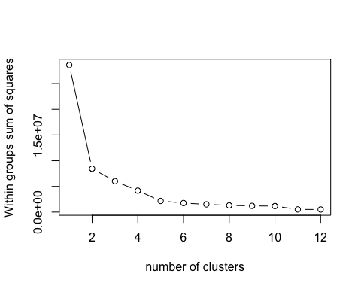

# As seen in our graph that was generated in the previous example we see that our elbow point was at 4  
clustplot(clust_standard, nc =4)

## Error in +clustss <- (nrow(clustering_data) - 1) * sum(apply(clustering_data, : could not find function "+<-"

## Next I will create a cluster plot to see the best value

library(cluster)  
# use the function clustplot to plot our findings  
clusplot(clust_standard, clust_k_means_fit$cluster, main = 'cluster solutions', color = TRUE, shade = TRUE, labels = 2, lines = 0)

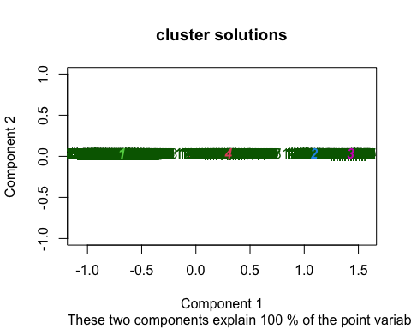

# As k-means is an unsupervised algorithm, you cannot compute the accuracy as there are no correct values to compare the output to. Instead, you will use the average distance from the center of each cluster as a measure of how well the model fits the data. To calculate this metric, simply compute the distance of each data point to the center of the cluster it is assigned to and take the average value of all of those distances.

# I will calculate the distance between and plot   
clust_dist <- dist(clust_standard)  
# create hclust for different methods  
clust_complete <- hclust(clust_dist, method = "complete")  
clust_single <- hclust(clust_dist, method = "single")  
clust_average <- hclust(clust_dist, method = "average")  
# plot data  
par(mfrow= c(1,3))  
plot(clust_complete, main = 'Complete link')  
plot(clust_single, main = 'Single link')  
plot(clust_average, main = 'Average link')

