ASSIGNMENT 4

Theodore Koby-Hercsky

2021-04-20

# Markdown Basics

## Favorite Foods

1. pasta
2. pizza
3. chicken

## Images

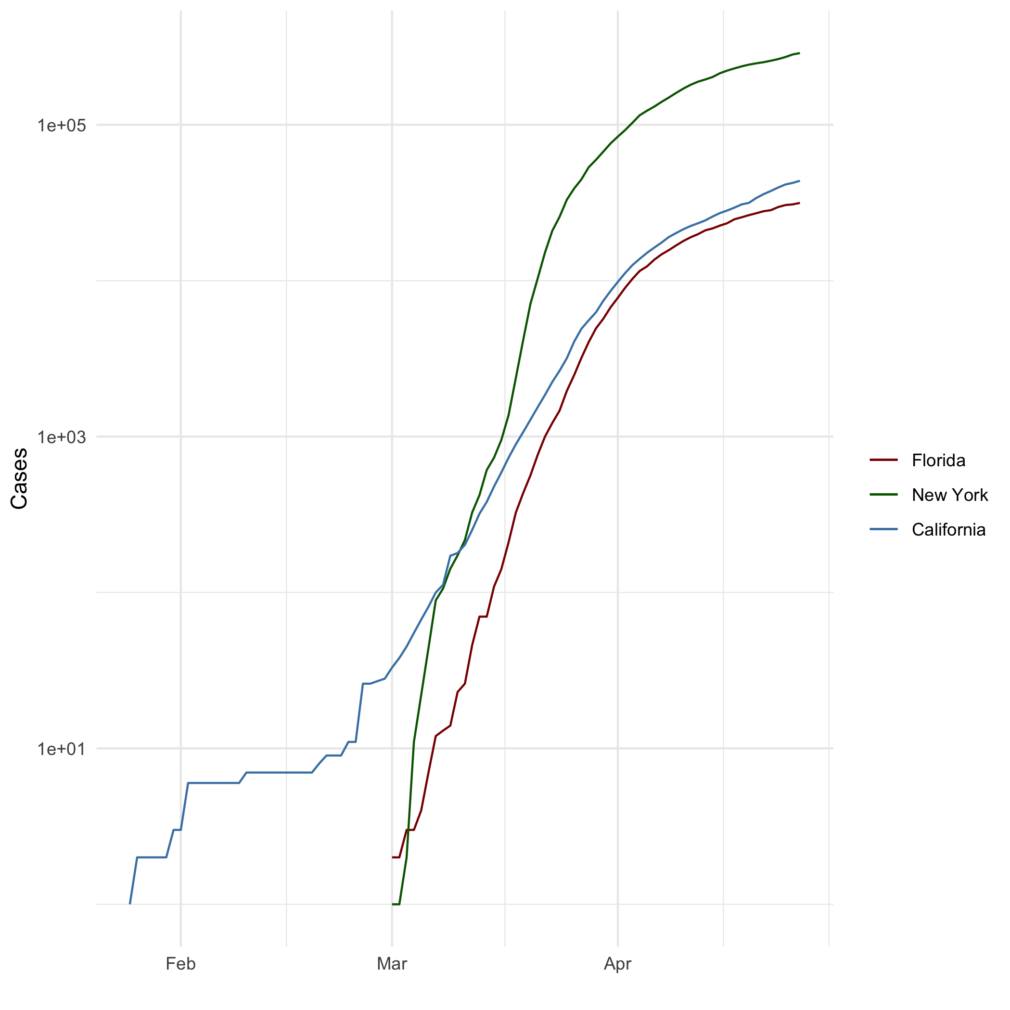

All Cases (Log Plot)

## Add a Quote

“Effort and courage are not enough without purpose and direction.”

— JFK

## Add an Equation

$$\frac{4z^{3}}{16}$$

## Add a Footnote

[1]

## Add Citations

* R for Everyone

Ordered lists start each line with a number (any number or letter) and a period. Lists can be nested by indenting certain item in the list Lander (2014)

* Discovering Statistics Using R

The ggplot2 function has some built-in functions called ‘stats’ that can be used a geom to get the necessary values to plot, or used directly to create visual elements on a layer of a plot (**field2012r?**)

# Inline Code

## NY Times COVID-19 Data

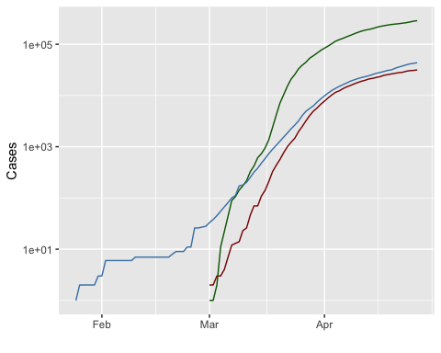

## R4DS Height vs Earnings

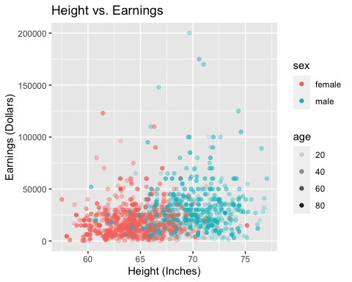

# Tables

## Knitr Table with Kable

One Ring to Rule Them All

|  |  |  |  |  |
| --- | --- | --- | --- | --- |
| name | race | in_fellowship | ring_bearer | age |
| Aragon | Men | TRUE | FALSE | 88 |
| Bilbo | Hobbit | FALSE | TRUE | 129 |
| Frodo | Hobbit | TRUE | TRUE | 51 |
| Galadriel | Elf | FALSE | FALSE | 7000 |
| Sam | Hobbit | TRUE | TRUE | 36 |
| Gandalf | Maia | TRUE | TRUE | 2019 |

## Pandoc Table

##   
##   
## | name | race | in_fellowship | ring_bearer | age |  
## |:---------:|:------:|:-------------:|:-----------:|:----:|  
## | Aragon | Men | TRUE | FALSE | 88 |  
## | Bilbo | Hobbit | FALSE | TRUE | 129 |  
## | Frodo | Hobbit | TRUE | TRUE | 51 |  
## | Galadriel | Elf | FALSE | FALSE | 7000 |  
## | Sam | Hobbit | TRUE | TRUE | 36 |  
## | Gandalf | Maia | TRUE | TRUE | 2019 |  
## | Legolas | Elf | TRUE | FALSE | 2931 |  
## | Sauron | Maia | FALSE | TRUE | 7052 |  
## | Gollum | Hobbit | FALSE | TRUE | 589 |

## # References

(**book?**){lander2014r, title={R for Everyone: Advanced Analytics and Graphics}, author={Lander, J.P.}, isbn={9780321888037}, lccn={2013027407}, series={Addison-Wesley data and analytics series}, url={<https://books.google.com/books?id=3eBVAgAAQBAJ>}, year={2014}, publisher={Addison-Wesley}}

(**book?**){field2012r, title={Discovering Statistics Using R}, author={Field, A.; Miles, J.; Field, Z.}, isbn={9781446258460}, lccn={1446258467}, series={}, url={<https://books.google.com/books?id=wd2K2zC3swIC>.}, year={2012}, publisher={SAGE Publications}} —

Lander, J. P. 2014. *R for Everyone: Advanced Analytics and Graphics*. Addison-Wesley Data and Analytics Series. Addison-Wesley. <https://books.google.com/books?id=3eBVAgAAQBAJ>.

1. This is my footnote.