Tudorache Alexandru-Theodor

Grupa 242

**Proiect SGBD**

-Cinema Database-

1. Baza de date este a unui cinema cu o singură locație (nu un lanț de cinematografe precum Cinema City), dar cu săli multiple. Cu ajutorul acestei baze de date clienții își pot cumpăra bilete la anumite ecranizări ale filmelor pe care vor să le vizioneze, biletele având diferite tipuri pentru a putea determina prețul acestora. De asemenea, în baza de date se află și actorii care joacă în filmele care sunt ecranizate pentru a putea fi afișați alături de filmul/filmele în care joacă.

2.

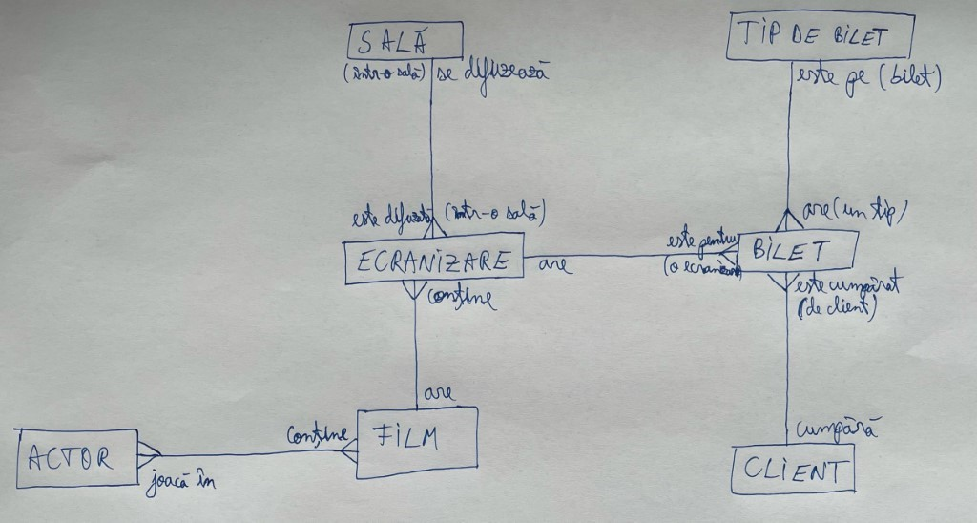

3.

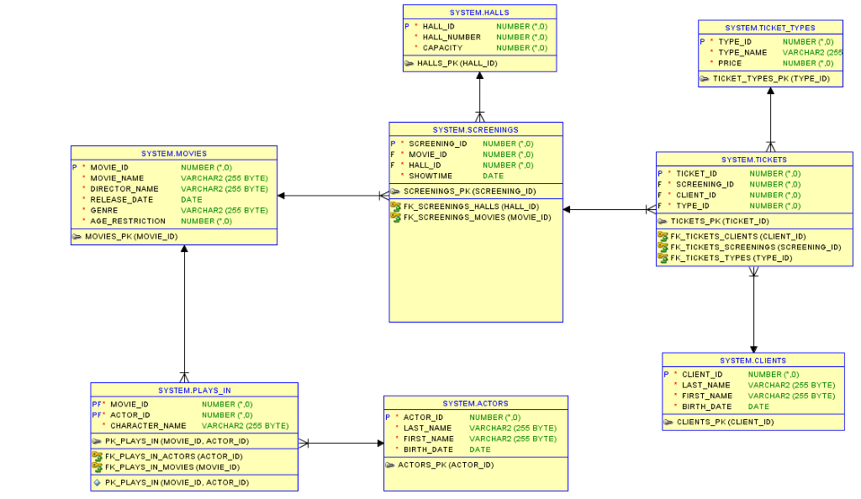

4.

|  |
| --- |
| **CREATE** **TABLE** ACTORS (   actor_id INT PRIMARY **KEY**,   last_name varchar(255) **NOT** NULL,   first_name varchar(255) **NOT** NULL,   birth_date DATE **NOT** NULL  );    **CREATE** **TABLE** MOVIES (   movie_id INT PRIMARY **KEY**,   movie_name varchar(255) **NOT** NULL,   director_name varchar(255) **NOT** NULL,   release_date DATE **NOT** NULL,   genre varchar(255) **NOT** NULL,   age_restriction int **NOT** NULL  );    **CREATE** **TABLE** PLAYS_IN (   movie_id INT **NOT** NULL,   actor_id INT **NOT** NULL,   character_name varchar(255) **NOT** NULL,   **CONSTRAINT** FK_PLAYS_IN_MOVIES FOREIGN **KEY** (movie_id) **REFERENCES** MOVIES(movie_id),   **CONSTRAINT** FK_PLAYS_IN_ACTORS FOREIGN **KEY** (actor_id) **REFERENCES** ACTORS(actor_id),   **CONSTRAINT** PK_PLAYS_IN PRIMARY **KEY** (movie_id, actor_id)  );    **CREATE** **TABLE** CLIENTS (   client_id INT PRIMARY **KEY**,   last_name varchar(255) **NOT** NULL,   first_name varchar(255) **NOT** NULL,   birth_date DATE **NOT** NULL  );    **CREATE** **TABLE** HALLS (   hall_id INT PRIMARY **KEY**,   hall_number INT **NOT** NULL,   **capacity** INT **NOT** NULL  );    **CREATE** **TABLE** SCREENINGS (   screening_id INT PRIMARY **KEY**,   movie_id INT **NOT** NULL,   hall_id INT **NOT** NULL,   showtime DATE **NOT** NULL,   **CONSTRAINT** FK_SCREENINGS_MOVIES FOREIGN **KEY** (movie_id) **REFERENCES** MOVIES(movie_id),   **CONSTRAINT** FK_SCREENINGS_HALLS FOREIGN **KEY** (hall_id) **REFERENCES** HALLS(hall_id)  );    **CREATE** **TABLE** TICKET_TYPES (   type_id INT PRIMARY **KEY**,   type_name VARCHAR(255) **NOT** NULL,   price INT **NOT** NULL  );    **CREATE** **TABLE** TICKETS (   ticket_id INT PRIMARY **KEY**,   screening_id INT **NOT** NULL,   client_id INT **NOT** NULL,   type_id INT **NOT** NULL,   **CONSTRAINT** FK_TICKETS_SCREENINGS FOREIGN **KEY** (screening_id) **REFERENCES** SCREENINGS(screening_id),   **CONSTRAINT** FK_TICKETS_CLIENTS FOREIGN **KEY** (client_id) **REFERENCES** CLIENTS(client_id),   **CONSTRAINT** FK_TICKETS_TYPES FOREIGN **KEY** (type_id) **REFERENCES** TICKET_TYPES(type_id)  ); |

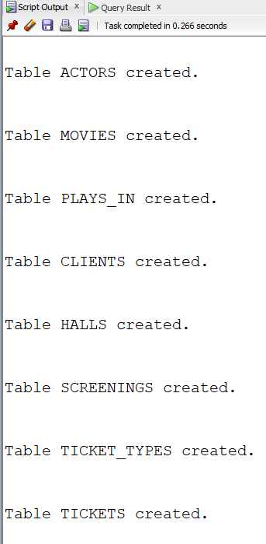

5.

|  |
| --- |
| -----ACTORS INSERTS-----    **INSERT** **INTO** ACTORS  **VALUES** (1, 'Leonardo', 'DiCaprio', **TO_DATE**('1974/11/11', 'yyyy/mm/dd'));    **INSERT** **INTO** ACTORS  **VALUES** (2, 'Jamie', 'Foxx', **TO_DATE**('1967/12/13', 'yyyy/mm/dd'));    **INSERT** **INTO** ACTORS  **VALUES** (3, 'Gary', 'Oldman', **TO_DATE**('1958/03/21', 'yyyy/mm/dd'));    **INSERT** **INTO** ACTORS  **VALUES** (4, 'Robert', 'Pattinson', **TO_DATE**('1986/05/13', 'yyyy/mm/dd'));    **INSERT** **INTO** ACTORS  **VALUES** (5, 'Matthew', 'McConaughey', **TO_DATE**('1969/11/04', 'yyyy/mm/dd'));    **INSERT** **INTO** ACTORS  **VALUES** (6, 'Joseph', 'Gordon-Levitt', **TO_DATE**('1981/02/17', 'yyyy/mm/dd'));    **select** * **from** actors; |

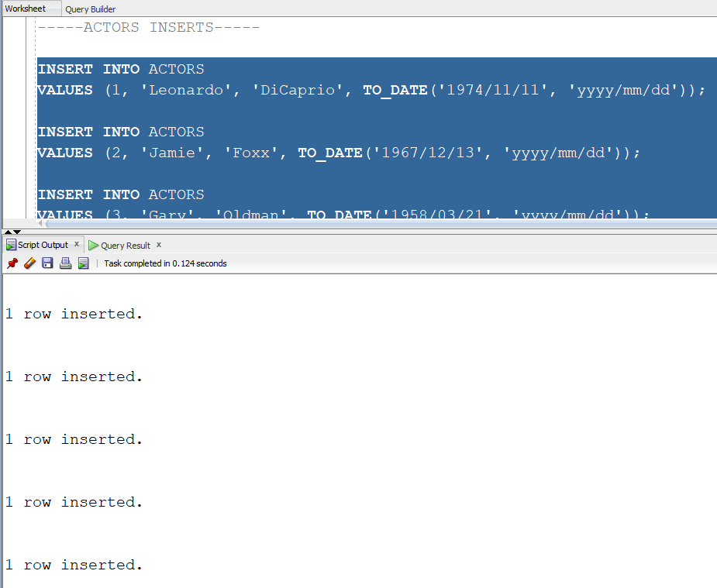

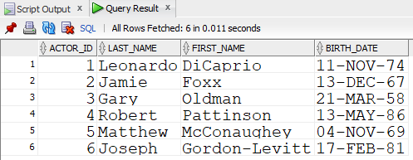

|  |
| --- |
| -----MOVIES INSERTS-----    **INSERT** **INTO** MOVIES  **VALUES** (1, 'Soul', 'Docter', **TO_DATE**('2020/12/25', 'yyyy/mm/dd'), 'Drama', 10);    **INSERT** **INTO** MOVIES  **VALUES** (2, 'Mank', 'Fincher', **TO_DATE**('2020/11/13', 'yyyy/mm/dd'), 'Drama', 13);    **INSERT** **INTO** MOVIES  **VALUES** (3, 'Borat 2', 'Woliner', **TO_DATE**('2020/10/23', 'yyyy/mm/dd'), 'Comedy', 15);    **INSERT** **INTO** MOVIES  **VALUES** (4, 'Tenet', 'Nolan', **TO_DATE**('2020/09/18', 'yyyy/mm/dd'), 'Action', 13);    **INSERT** **INTO** MOVIES  **VALUES** (5, 'Interstellar', 'Nolan', **TO_DATE**('2014/11/07', 'yyyy/mm/dd'), 'Sci-Fi', 13);    **INSERT** **INTO** MOVIES  **VALUES** (6, 'Dunkirk', 'Nolan', **TO_DATE**('2017/07/13', 'yyyy/mm/dd'), 'Action', 15);    **INSERT** **INTO** MOVIES  **VALUES** (7, 'Inglorious Basterds', 'Tarantino', **TO_DATE**('2020/09/04', 'yyyy/mm/dd'), 'Action', 13);    **INSERT** **INTO** MOVIES  **VALUES** (8, '30 Years and 15 Minutes', 'Mandachi', **TO_DATE**('2020/08/08', 'yyyy/mm/dd'), 'Action', 15);    **INSERT** **INTO** MOVIES  **VALUES** (9, 'The Social Dilemma', 'Orlowski', **TO_DATE**('2020/09/09', 'yyyy/mm/dd'), 'Documentary', 10);    **INSERT** **INTO** MOVIES  **VALUES** (10, 'Inception', 'Nolan', **TO_DATE**('2020/07/30', 'yyyy/mm/dd'), 'Action', 13);    **select** * **from** movies; |

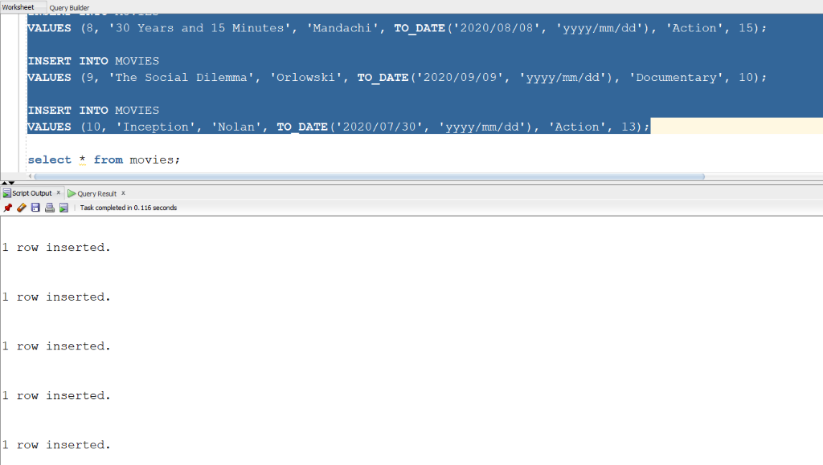

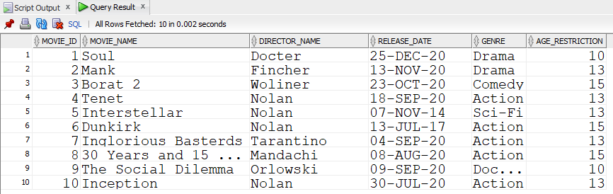

|  |
| --- |
| -----PLAYS IN INSERTS-----    **INSERT** **INTO** PLAYS_IN  **VALUES** (1, 2, 'Joe');    **INSERT** **INTO** PLAYS_IN  **VALUES** (4, 4, 'Neil');    **INSERT** **INTO** PLAYS_IN  **VALUES** (4, 2, 'Protagonist');    **INSERT** **INTO** PLAYS_IN  **VALUES** (5, 5, 'Cooper');    **INSERT** **INTO** PLAYS_IN  **VALUES** (10, 1, 'Cobb');    **INSERT** **INTO** PLAYS_IN  **VALUES** (10, 6, 'Arthur');    **INSERT** **INTO** PLAYS_IN  **VALUES** (10, 5, 'Eames');    **INSERT** **INTO** PLAYS_IN  **VALUES** (7, 1, 'Aldo Raine');    **INSERT** **INTO** PLAYS_IN  **VALUES** (7, 6, 'Hans Landa');    **INSERT** **INTO** PLAYS_IN  **VALUES** (2, 5, 'Kane');    **INSERT** **INTO** PLAYS_IN  **VALUES** (2, 3, 'Mank');    **INSERT** **INTO** PLAYS_IN  **VALUES** (2, 4, 'Joe');    **select** * **from** plays_in; |

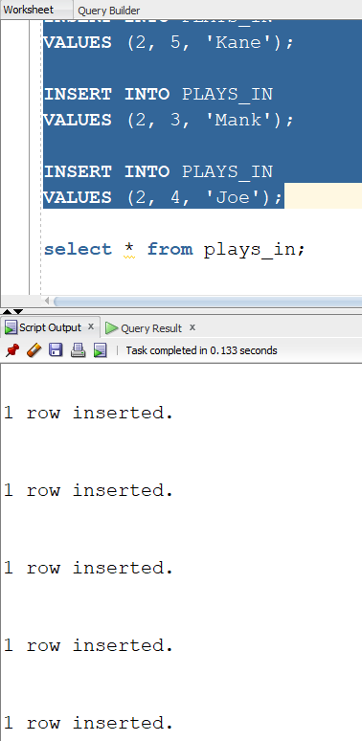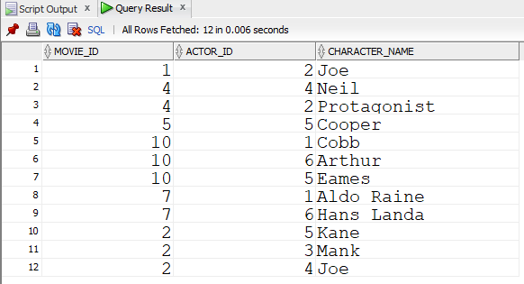

|  |
| --- |
| -----CLIENTS INSERTS-----    **INSERT** **INTO** CLIENTS  **VALUES** (1, 'Tudorache', 'Theodor', **TO_DATE**('2000/05/20', 'yyyy/mm/dd'));    **INSERT** **INTO** CLIENTS  **VALUES** (2, 'Bugheciu', 'Eduard', **TO_DATE**('2000/02/27', 'yyyy/mm/dd'));    **INSERT** **INTO** CLIENTS  **VALUES** (3, 'Constantin', 'Sorin', **TO_DATE**('1987/07/17', 'yyyy/mm/dd'));    **INSERT** **INTO** CLIENTS  **VALUES** (4, 'Craciun', 'Andrei', **TO_DATE**('2008/09/07', 'yyyy/mm/dd'));    **INSERT** **INTO** CLIENTS  **VALUES** (5, 'Curtamet', 'Ixan', **TO_DATE**('2006/08/02', 'yyyy/mm/dd'));    **INSERT** **INTO** CLIENTS  **VALUES** (6, 'Raduna', 'Daniel', **TO_DATE**('2005/10/08', 'yyyy/mm/dd')); |

select * from clients;

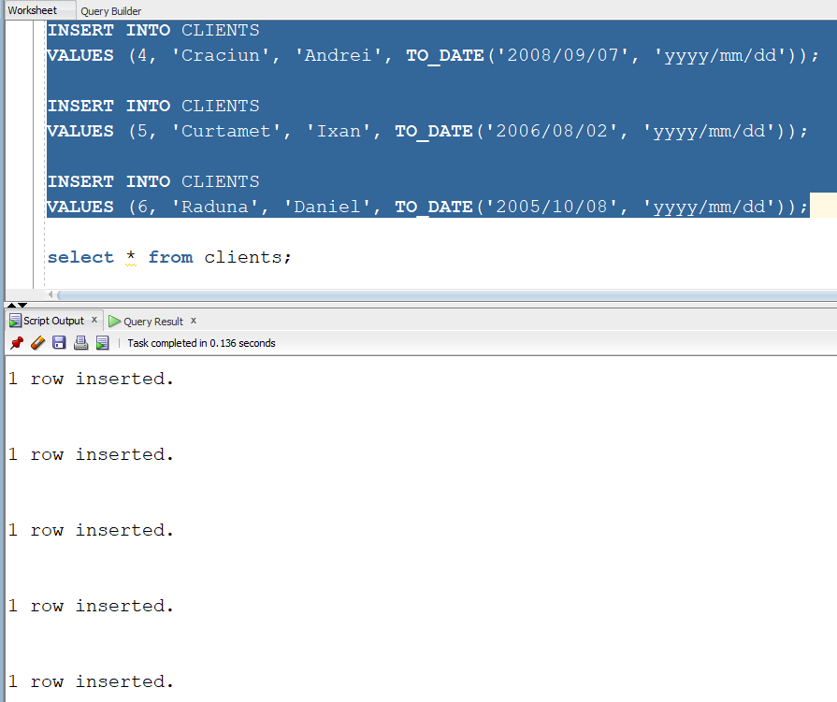

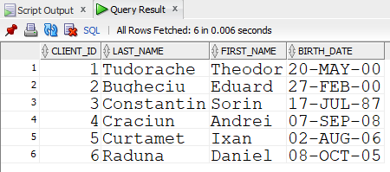

|  |
| --- |
| -----HALLS INSERTS-----    **INSERT** **INTO** HALLS  **VALUES** (1, 1, 100);    **INSERT** **INTO** HALLS  **VALUES** (2, 2, 50);    **INSERT** **INTO** HALLS  **VALUES** (3, 3, 250);    **INSERT** **INTO** HALLS  **VALUES** (4, 4, 100);    **INSERT** **INTO** HALLS  **VALUES** (5, 5, 150);    **INSERT** **INTO** HALLS  **VALUES** (6, 6, 5);    **select** * **from** halls; |

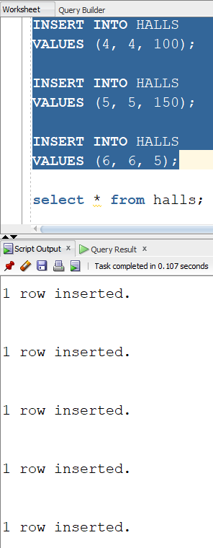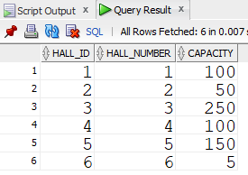

|  |
| --- |
| -----SCREENINGS INSERTS-----    **INSERT** **INTO** SCREENINGS  **VALUES** (1, 1, 6, **TO_DATE**('2020-12-25 13:00', 'YYYY-MM-DD HH24:MI'));    **INSERT** **INTO** SCREENINGS  **VALUES** (2, 3, 6, **TO_DATE**('2020-12-25 17:00', 'YYYY-MM-DD HH24:MI'));    **INSERT** **INTO** SCREENINGS  **VALUES** (3, 1, 1, **TO_DATE**('2020-12-30 21:00', 'YYYY-MM-DD HH24:MI'));    **INSERT** **INTO** SCREENINGS  **VALUES** (4, 2, 2, **TO_DATE**('2021-01-02 20:00', 'YYYY-MM-DD HH24:MI'));    **INSERT** **INTO** SCREENINGS  **VALUES** (5, 4, 3, **TO_DATE**('2020-01-03 17:00', 'YYYY-MM-DD HH24:MI'));    **INSERT** **INTO** SCREENINGS  **VALUES** (6, 4, 3, **TO_DATE**('2021-01-03 17:00', 'YYYY-MM-DD HH24:MI'));    **INSERT** **INTO** SCREENINGS  **VALUES** (7, 5, 4, **TO_DATE**('2021-01-03 13:00', 'YYYY-MM-DD HH24:MI'));    **INSERT** **INTO** SCREENINGS  **VALUES** (8, 6, 5, **TO_DATE**('2021-01-05 11:00', 'YYYY-MM-DD HH24:MI'));    **INSERT** **INTO** SCREENINGS  **VALUES** (9, 7, 6, **TO_DATE**('2021-01-05 20:00', 'YYYY-MM-DD HH24:MI'));    **INSERT** **INTO** SCREENINGS  **VALUES** (10, 8, 6, **TO_DATE**('2021-01-01 21:00', 'YYYY-MM-DD HH24:MI'));    **INSERT** **INTO** SCREENINGS  **VALUES** (11, 9, 5, **TO_DATE**('2020-12-29 17:00', 'YYYY-MM-DD HH24:MI'));    **INSERT** **INTO** SCREENINGS  **VALUES** (12, 10, 4, **TO_DATE**('2020-12-31 10:00', 'YYYY-MM-DD HH24:MI'));    **select** * **from** screenings; |

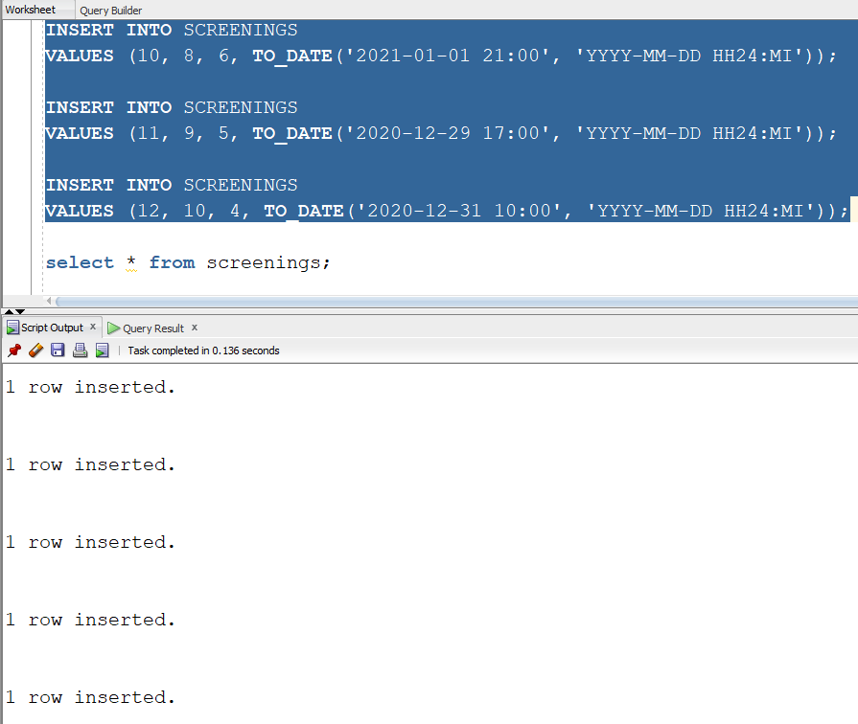

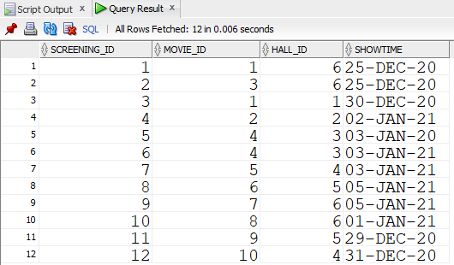

|  |
| --- |
| -----TICKET TYPES INSERTS-----    **INSERT** **INTO** TICKET_TYPES  **VALUES** (1, 'Adult', 21);    **INSERT** **INTO** TICKET_TYPES  **VALUES** (2, 'Student', 14);    **INSERT** **INTO** TICKET_TYPES  **VALUES** (3, 'Retired', 16);    **select** * **from** ticket_types; |

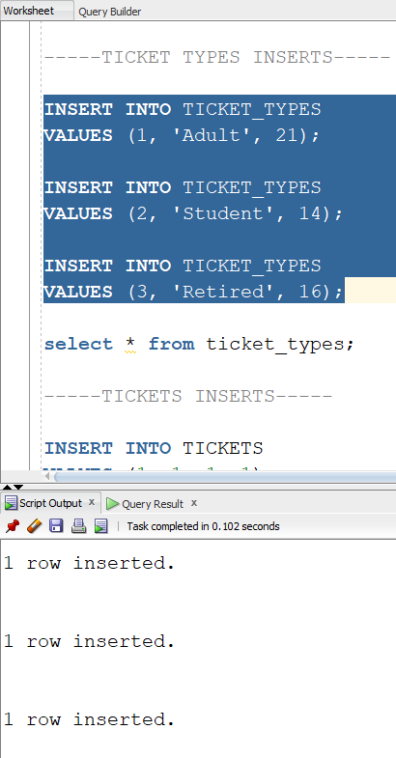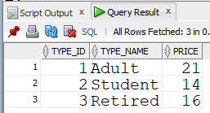

|  |
| --- |
| -----TICKETS INSERTS-----    **INSERT** **INTO** TICKETS  **VALUES** (1, 1, 1, 1);    **INSERT** **INTO** TICKETS  **VALUES** (2, 1, 2, 2);    **INSERT** **INTO** TICKETS  **VALUES** (3, 1, 3, 2);    **INSERT** **INTO** TICKETS  **VALUES** (4, 1, 4, 1);    **INSERT** **INTO** TICKETS  **VALUES** (5, 1, 5, 3);    **INSERT** **INTO** TICKETS  **VALUES** (6, 2, 1, 2);    **INSERT** **INTO** TICKETS  **VALUES** (7, 2, 2, 3);    **INSERT** **INTO** TICKETS  **VALUES** (8, 2, 3, 2);    **INSERT** **INTO** TICKETS  **VALUES** (9, 2, 4, 1);    **INSERT** **INTO** TICKETS  **VALUES** (10, 2, 5, 3);    **INSERT** **INTO** TICKETS  **VALUES** (11, 3, 1, 1);    **INSERT** **INTO** TICKETS  **VALUES** (12, 4, 2, 2);    **INSERT** **INTO** TICKETS  **VALUES** (13, 5, 3, 3);    **INSERT** **INTO** TICKETS  **VALUES** (14, 10, 1, 1);    **INSERT** **INTO** TICKETS  **VALUES** (15, 10, 2, 2);    **INSERT** **INTO** TICKETS  **VALUES** (16, 10, 3, 2);    **INSERT** **INTO** TICKETS  **VALUES** (17, 10, 4, 1);    **INSERT** **INTO** TICKETS  **VALUES** (18, 10, 5, 3);    **INSERT** **INTO** TICKETS  **VALUES** (19, 9, 1, 2);    **INSERT** **INTO** TICKETS  **VALUES** (20, 9, 2, 3);    **INSERT** **INTO** TICKETS  **VALUES** (21, 9, 3, 2);    **INSERT** **INTO** TICKETS  **VALUES** (22, 9, 4, 1);    **INSERT** **INTO** TICKETS  **VALUES** (23, 9, 5, 3);    **select** * **from** tickets; |

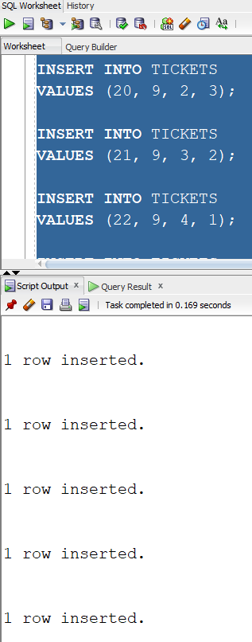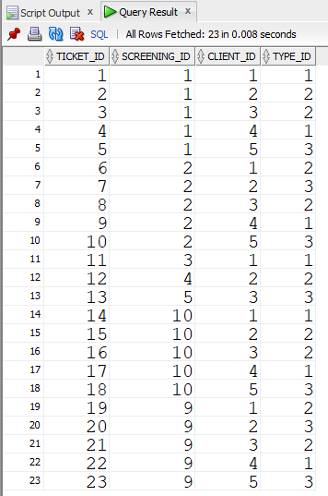

6. Să se definească o funcție care să afișeze numele actorilor, dar și personajul lor, care au jucat în filmele regizate de un regizor cu nume dat că parametru(Parametrul default va fi 'Nolan'). Acest subprogram trebuie să returneze numărul acestor actori.

|  |
| --- |
| **CREATE** **OR** REPLACE **FUNCTION** **fct_ex6**   (director movies.director_name%**TYPE** **DEFAULT** 'Nolan')   **RETURN** **NUMBER**   **IS**   **TYPE** **type_actors** **IS** **TABLE** **OF** **varchar**(255);   **TYPE** type_roles **IS** TABLE **OF** varchar(255);   **TYPE** type_movies **IS** TABLE **OF** varchar(255);   t_actors type_actors;   t_roles type_roles;   t_movies type_movies;  **BEGIN**   **SELECT** (last_name|| ' ' || first_name) actor, (pi.character_name) personaj, (m.movie_name) BULK COLLECT **INTO** t_actors, t_roles, t_movies   **FROM** actors a **JOIN** plays_in pi **on** (pi.actor_id = a.actor_id)   **JOIN** movies m **on** (pi.movie_id = m.movie_id)   **WHERE** m.director_name = director   **ORDER** **BY** m.movie_name;     DBMS_OUTPUT.PUT_LINE('---In filmele lui ' || director || ' au jucat:');     **FOR** I **in** t_actors.first..t_actors.last **LOOP**   DBMS_OUTPUT.PUT_LINE('Actorul ' || t_actors(i) || ' a jucat rolul ' || t_roles(i) || ' in filmul ' || t_movies(i) || '.');   **END** **LOOP**;   DBMS_OUTPUT.NEW_LINE;   RETURN t_actors.count;  **END** fct_ex6;  /    --APELARE:    **BEGIN**   DBMS_OUTPUT.PUT_LINE('Total: ' || fct_ex6() || ' actori');   DBMS_OUTPUT.NEW_LINE;   DBMS_OUTPUT.PUT_LINE('Total: ' || fct_ex6('Tarantino') || ' actori');   DBMS_OUTPUT.NEW_LINE;   DBMS_OUTPUT.PUT_LINE('Total: ' || fct_ex6('Fincher') || ' actori');  **END**;  / |

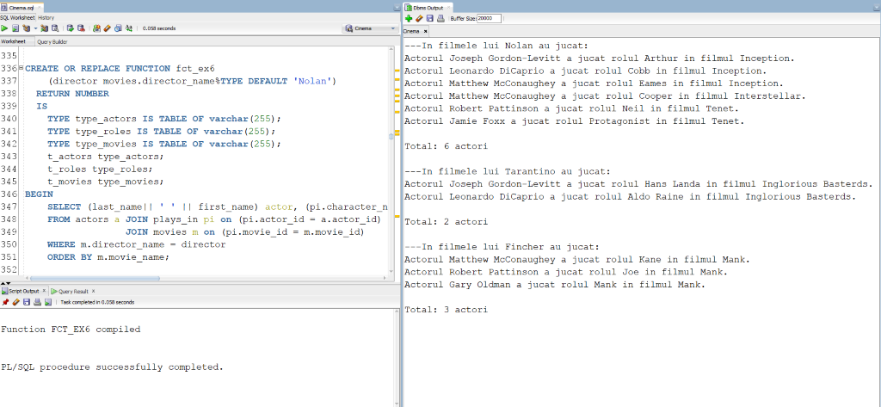

7. Să se definească o procedură care să afișeze(o singură dată) numele și vârstă tuturor clienților care au cumpărat bilete de tipul dat ca parametru(Parametrul default va fi 'Adult').

|  |
| --- |
| **CREATE** **OR** REPLACE **PROCEDURE** **proc_ex7**   (tip ticket_types.type_name%**TYPE** **DEFAULT** 'Adult')   **IS**   **CURSOR** **crs** **IS**   **SELECT** **unique**(last_name), **first_name**, **birth_date**   **FROM** **clients** **c** **join** **tickets** **t** **on** (t.client_id = c.client_id)   **join** **ticket_types** **tt** **on** (tt.type_id = t.type_id)   **WHERE** **tt**.**type_name** = **tip**;   **TYPE** ticket_typess **IS** TABLE **OF** ticket_types.type_name%**TYPE**;   all_types ticket_typess;   varsta NUMBER;   este_tip BOOLEAN := **FALSE**;  **BEGIN**   **SELECT** type_name bulk collect **into** all_types   **FROM** ticket_types;     **FOR** i **IN** all_types.first..all_types.last **LOOP**   **IF** (all_types(i) = tip) **THEN**   este_tip := **TRUE**;   **END** **IF**;   **END** **LOOP**;   **IF** (este_tip = **TRUE**) **THEN**   DBMS_OUTPUT.PUT_LINE('---Bilete de tipul ' || tip || ' au fost cumparate de urmatorii clienti: ');   **ELSE**   DBMS_OUTPUT.PUT_LINE ('Nu exista bilete de tipul ' || tip || '.');   **END** **IF**;   **FOR** i **in** crs **LOOP**   varsta := TRUNC(MONTHS_BETWEEN(sysdate, i.birth_date) / 12);   **IF** (varsta >= 20) **THEN**   DBMS_OUTPUT.PUT_LINE('Clientul ' || i.last_name || ' ' || i.first_name || ' cu varsta de ' || TRUNC(MONTHS_BETWEEN(sysdate, i.birth_date) / 12) || ' de ani.');   **ELSE**   DBMS_OUTPUT.PUT_LINE('Clientul ' || i.last_name || ' ' || i.first_name || ' cu varsta de ' || TRUNC(MONTHS_BETWEEN(sysdate, i.birth_date) / 12) || ' ani.');   **END** **IF**;   **END** **LOOP**;   DBMS_OUTPUT.NEW_LINE;  **END** proc_ex7;  /    --APELARE:    **BEGIN**   proc_ex7();   proc_ex7('Student');   proc_ex7('Retired');   proc_ex7('Dummy'); -- nu se va afisa nimic  **END**;  / |

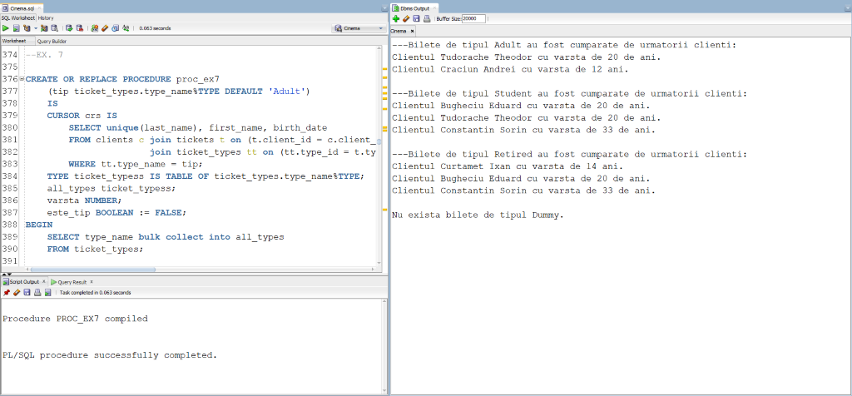

8. Să se definească o funcție care să afișeze următoarele detalii: (numele filmului; dată și ora la care a fost ecranizat) despre filmul care a rulat la o capacitate de peste 90% din sala în care au fost ecranizate, având genul dat ca parametru. Subprogramul trebuie să returneze id-ul ecranizării respective.

|  |
| --- |
| **CREATE** **OR** REPLACE **FUNCTION** **fct_ex8**   (gen movies.genre%**TYPE** **DEFAULT** 'Comedy')   **RETURN** **NUMBER**   **IS**   **aux** **NUMBER** := 0;   screening screenings.screening_id%**TYPE**;   show_time screenings.showtime%**TYPE**;   movie movies.movie_name%**TYPE**;   sold_tickets NUMBER;   cap halls.capacity%**TYPE**;  **BEGIN**   **SELECT** s.screening_id, m.movie_name, s.showtime, count(t.ticket_id) , h.capacity **INTO** screening, movie, show_time,sold_tickets, cap   **FROM** screenings s **join** halls h **on** (h.hall_id = s.hall_id)   **join** tickets t **on** (t.screening_id = s.screening_id)   **join** movies m **on** (m.movie_id = s.movie_id)   **WHERE** genre = gen   **GROUP** **BY** s.screening_id, m.movie_name, s.showtime ,h.capacity   HAVING COUNT(t.ticket_id) >= h.capacity * (9/10);   DBMS_OUTPUT.PUT_LINE('Filmul ' || movie || ' a rulat la ' || TO_CHAR(show_time, 'dd/mm/yyyy HH24:MI') || ' cu capacitatea ' || sold_tickets || '/' || cap || '.');   DBMS_OUTPUT.NEW_LINE;   RETURN screening;   EXCEPTION   WHEN NO_DATA_FOUND **THEN**   DBMS_OUTPUT.PUT_LINE('Nu exista filme care au rulat la capacitate de peste 90% avand genul ' || gen || '.');   DBMS_OUTPUT.NEW_LINE;   return -1;   WHEN TOO_MANY_ROWS **THEN**   DBMS_OUTPUT.PUT_LINE('Exista mai multe filme care au rulat la capacitate de peste 90% avand genul ' || gen || '.');   DBMS_OUTPUT.NEW_LINE;   return -2;   WHEN OTHERS **THEN**   DBMS_OUTPUT.PUT_LINE('Alta eroare!');   return -3;  **END** fct_ex8;  /    --APELARE:    **BEGIN**   DBMS_OUTPUT.PUT_LINE('Id-ul ecranizarii: ' || fct_ex8('Drama'));   DBMS_OUTPUT.NEW_LINE;   DBMS_OUTPUT.PUT_LINE('Id-ul ecranizarii: ' || fct_ex8('Comedy'));   DBMS_OUTPUT.NEW_LINE;   DBMS_OUTPUT.PUT_LINE('Eroare: ' || fct_ex8('Action')); -- mai mult de 1 film   DBMS_OUTPUT.NEW_LINE;   DBMS_OUTPUT.PUT_LINE('Eroare: ' || fct_ex8('Documentary')); -- niciun film   DBMS_OUTPUT.NEW_LINE;  **END**;  / |

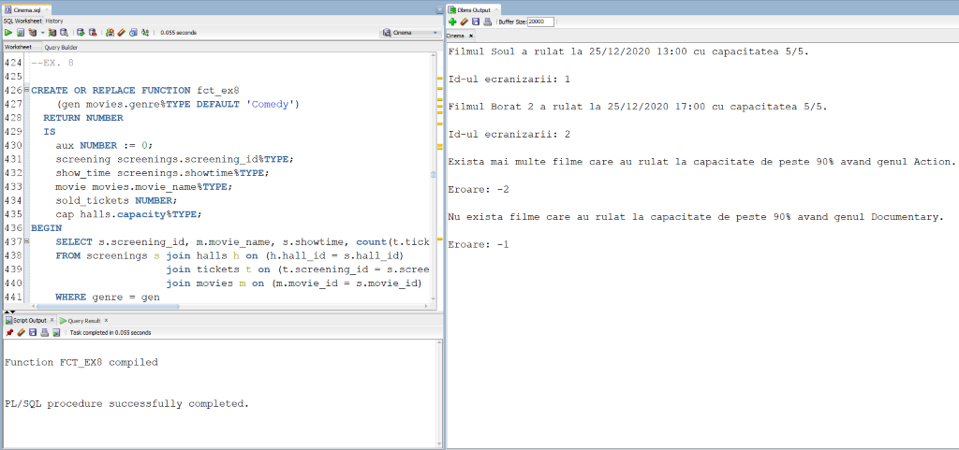

9. Să se definească o procedură care să afișeze numele filmelor(o singură dată) și numele actorilor care au jucat în ele, care au rulat în sala cu capacitate dată ca parametru.

|  |
| --- |
| **CREATE** **OR** REPLACE **PROCEDURE** **proc_ex9**   (cap halls.capacity%**TYPE**)   **IS**   **hall** **halls**.**hall_id**%**TYPE**;   last_movie movies.movie_name%**TYPE** := '0'; -- nu exista niciun film **in** baza de date cu numele '0'   aux NUMBER := 0;   CURSOR c **IS**   **SELECT** unique(m.movie_name), (a.last_name || ' ' || a.first_name) nume   **FROM** screenings s **join** movies m **on** (m.movie_id = s.movie_id)   **join** plays_in pi **on** (pi.movie_id = m.movie_id)   **join** actors a **on** (a.actor_id = pi.actor_id)   **WHERE** hall_id = hall   **ORDER** **BY** m.movie_name;  **BEGIN**   **SELECT** hall_id **into** hall   **FROM** halls   **WHERE** capacity = cap;     **FOR** i **in** c **LOOP**   **IF** (i.movie_name != last_movie) **THEN**   DBMS_OUTPUT.PUT_LINE ('---Filmul ' || i.movie_name || ' avand actorii: ');   **END** **IF**;   DBMS_OUTPUT.PUT_LINE (i.nume);   last_movie := i.movie_name;   aux := aux + 1;   **END** **LOOP**;   **IF** (aux = 0) **THEN**   DBMS_OUTPUT.PUT_LINE('Nu exista filme care sa fi rulat in sala cu capacitatea ' || cap);   **END** **IF**;   EXCEPTION   WHEN TOO_MANY_ROWS **THEN**   DBMS_OUTPUT.PUT_LINE('Exista mai multe sali cu capacitatea ' || cap);   WHEN NO_DATA_FOUND **THEN**   DBMS_OUTPUT.PUT_LINE('Nu exista nicio sala care sa aiba capacitatea ' || cap);   WHEN OTHERS **THEN**   DBMS_OUTPUT.PUT_LINE('Alta eroare');  **END** proc_ex9;  /    --APELARE:    **BEGIN**   DBMS_OUTPUT.PUT_LINE('===Capacitate 5===');   proc_ex9(5); -- mai multe filme   DBMS_OUTPUT.NEW_LINE;   DBMS_OUTPUT.PUT_LINE('===Capacitate 250===');   proc_ex9(250); -- un singur film   DBMS_OUTPUT.NEW_LINE;   DBMS_OUTPUT.PUT_LINE('===Capacitate 150===');   proc_ex9(150); -- niciun film   DBMS_OUTPUT.NEW_LINE;   DBMS_OUTPUT.PUT_LINE('===Capacitate 500===');   proc_ex9(500); -- nu exista capacitatea   DBMS_OUTPUT.NEW_LINE;   DBMS_OUTPUT.PUT_LINE('===Capacitate 100===');   proc_ex9(100); -- mai multe sali cu capacitatea respectiva  **END**;  / |

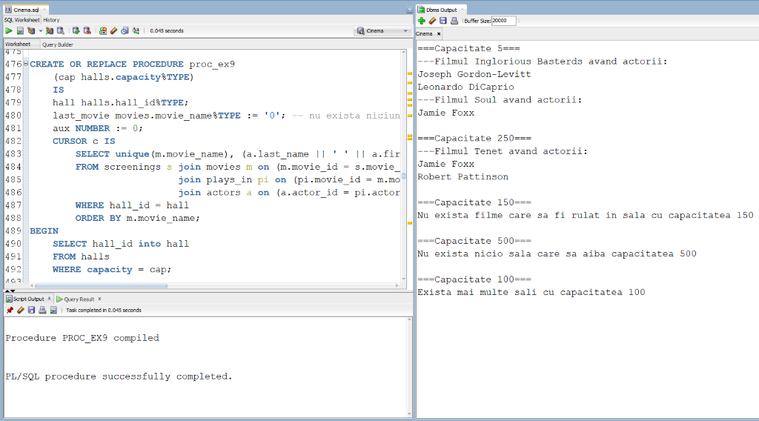

10. Să se definească un declanșator care să nu permită nimănui să lucreze în ziua de Crăciun cu comenzile UPDATE, INSERT, DELETE pe tabela filmelor. (Declanșatorul se va testa cu ziua în care ne aflăm, în loc de 25/12.)

|  |
| --- |
| **CREATE** **OR** **REPLACE** **TRIGGER** trig_ex10   **BEFORE** **INSERT** **OR** **UPDATE** **OR** **DELETE** **ON** movies  **BEGIN**   **IF** (TO_CHAR(**SYSDATE**,'DD/MM') = '25/12') **THEN**   RAISE_APPLICATION_ERROR(-20001,'Ia o pauza! E Craciunul.');   **END** **IF**;  **END**;  /    --TESTARE:    **INSERT** **INTO** MOVIES  **VALUES** (15, 'Soul', 'Docter', **TO_DATE**('2020/12/25', 'yyyy/mm/dd'), 'Drama', 10);    **DELETE** **FROM** MOVIES  **WHERE** movie_id = 11;    **UPDATE** MOVIES  **SET** movie_name = 'Film'  **WHERE** movie_id = 11; |

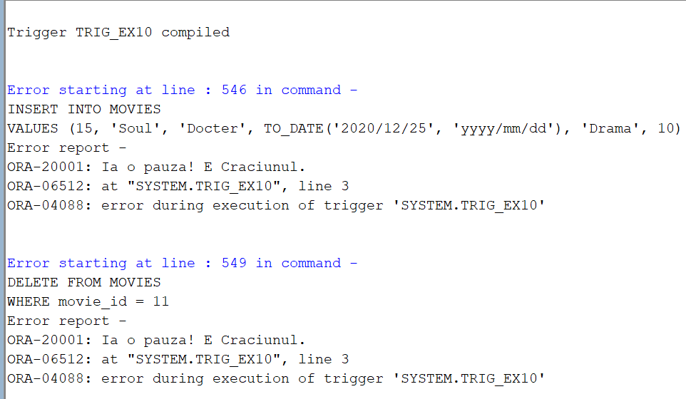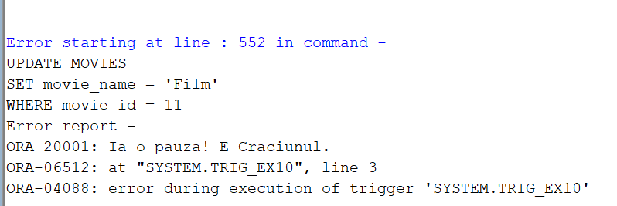

11. Să se definească un declanșator care să nu permită(să afișeze o eroare) inserarea în tabela biletelor a unor valori corespunzătoare unui client care nu are vârsta necesară pentru a putea vedea o anumită ecranizare a unui film.

--functie auxiliara pentru declansator

|  |
| --- |
| CREATE **OR** REPLACE **FUNCTION** are_voie_ex11   (screening tickets.screening_id%TYPE, id_client clients.client_id%TYPE)   **RETURN** BOOLEAN   **IS**   CURSOR crs **IS**   **SELECT** m.age_restriction   **FROM** screenings s **join** movies m **on** (m.movie_id = s.movie_id)   **WHERE** s.screening_id = screening;   CURSOR crs2 **IS**   **SELECT** TRUNC(MONTHS_BETWEEN(sysdate, birth_date) / 12)   **FROM** clients   **WHERE** client_id = id_client;   age number;   age_r movies.age_restriction%TYPE;  BEGIN   OPEN crs;   FETCH crs **INTO** age_r;   CLOSE crs;   OPEN crs2;   FETCH crs2 **INTO** age;   CLOSE crs2;   **IF** (age_r <= age) **THEN**   **RETURN** TRUE;   **ELSE**   **RETURN** FALSE;   **END** **IF**;  **END** are_voie_ex11;  /  CREATE **OR** REPLACE TRIGGER trig_ex11   BEFORE INSERT **ON** tickets   **FOR** **EACH** ROW  BEGIN   **IF** (are_voie_ex11(:**NEW**.screening_id, :**NEW**.client_id) = FALSE) **THEN**   RAISE_APPLICATION_ERROR(-20001,'ATENTIE! Clientul nu are varsta necesara pentru a vedea acest film!');   **END** **IF**;  **END**;  /    --TESTARE:    INSERT **INTO** TICKETS  VALUES (28, 2, 4, 2); -- nu are voie    INSERT **INTO** TICKETS  VALUES (28, 2, 1, 2); -- are voie |

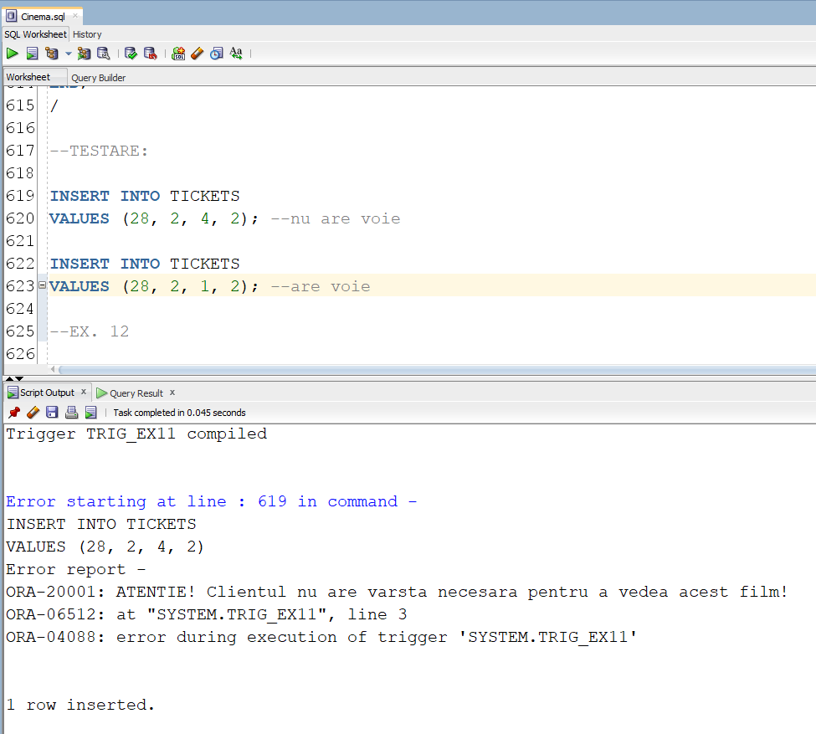

12. Să se definească un declanșator care să introducă date într-un tabel de tip audit după ce utilizatorul a folosit o comandă LDD.

|  |
| --- |
| **CREATE** **TABLE** audit_ex12 (   user_name VARCHAR2(30),   database_name VARCHAR2(50),   **event** VARCHAR2(20),   object_name VARCHAR2(30),   date_triggered DATE  );    **CREATE** **OR** **REPLACE** **TRIGGER** trig_ex12   **AFTER** **CREATE** **OR** **DROP** **OR** **ALTER** **ON** **SCHEMA**  **BEGIN**   **INSERT** **INTO** audit_ex12   **VALUES** (SYS.LOGIN_USER,   SYS.DATABASE_NAME,   SYS.SYSEVENT,   SYS.DICTIONARY_OBJ_NAME,   **SYSDATE**);  **END**;  /    --TESTARE:    **CREATE** **INDEX** ind_ex12  **ON** movies(movie_name);    **DROP** **INDEX** ind_ex12;    **SELECT** * **FROM** audit_ex12; |

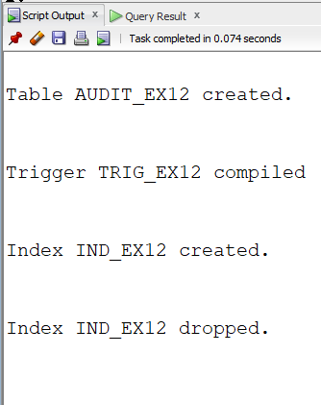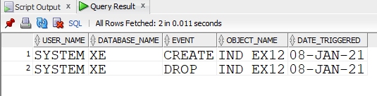

13.

|  |
| --- |
| **CREATE** **OR** REPLACE PACKAGE package_ex13 **AS**   **FUNCTION** **pack_fct_ex6**(director movies.director_name%**TYPE** **DEFAULT** 'Nolan')   **RETURN** **NUMBER**;   **PROCEDURE** **pack_proc_ex7**(tip ticket_types.type_name%**TYPE** **DEFAULT** 'Adult');   **FUNCTION** **pack_fct_ex8**(gen movies.genre%**TYPE** **DEFAULT** 'Comedy')   **RETURN** **NUMBER**;   **PROCEDURE** **pack_proc_ex9**(cap halls.capacity%**TYPE**);   **FUNCTION** **pack_are_voie_ex11**(screening tickets.screening_id%**TYPE**, id_client clients.client_id%**TYPE**)   **RETURN** **BOOLEAN**;  **END** package_ex13;  /    **CREATE** **OR** REPLACE PACKAGE BODY package_ex13 **AS**   **FUNCTION** **pack_fct_ex6**   (director movies.director_name%**TYPE** **DEFAULT** 'Nolan')   **RETURN** **NUMBER**   **IS**   **TYPE** **type_actors** **IS** **TABLE** **OF** **varchar**(255);   **TYPE** type_roles **IS** TABLE **OF** varchar(255);   **TYPE** type_movies **IS** TABLE **OF** varchar(255);   t_actors type_actors;   t_roles type_roles;   t_movies type_movies;   **BEGIN**   **SELECT** (last_name|| ' ' || first_name) actor, (pi.character_name) personaj, (m.movie_name) BULK COLLECT **INTO** t_actors, t_roles, t_movies   **FROM** actors a **JOIN** plays_in pi **on** (pi.actor_id = a.actor_id)   **JOIN** movies m **on** (pi.movie_id = m.movie_id)   **WHERE** m.director_name = director   **ORDER** **BY** m.movie_name;     DBMS_OUTPUT.PUT_LINE('---In filmele lui ' || director || ' au jucat:');     **FOR** I **in** t_actors.first..t_actors.last **LOOP**   DBMS_OUTPUT.PUT_LINE('Actorul ' || t_actors(i) || ' a jucat rolul ' || t_roles(i) || ' in filmul ' || t_movies(i) || '.');   **END** **LOOP**;   DBMS_OUTPUT.NEW_LINE;   RETURN t_actors.count;   **END** pack_fct_ex6;       **PROCEDURE** **pack_proc_ex7**   (tip ticket_types.type_name%**TYPE** **DEFAULT** 'Adult')   **IS**   **CURSOR** **crs** **IS**   **SELECT** **unique**(last_name), **first_name**, **birth_date**   **FROM** **clients** **c** **join** **tickets** **t** **on** (t.client_id = c.client_id)   **join** **ticket_types** **tt** **on** (tt.type_id = t.type_id)   **WHERE** **tt**.**type_name** = **tip**;   **TYPE** ticket_typess **IS** TABLE **OF** ticket_types.type_name%**TYPE**;   all_types ticket_typess;   varsta NUMBER;   este_tip BOOLEAN := **FALSE**;   **BEGIN**   **SELECT** type_name bulk collect **into** all_types   **FROM** ticket_types;     **FOR** i **IN** all_types.first..all_types.last **LOOP**   **IF** (all_types(i) = tip) **THEN**   este_tip := **TRUE**;   **END** **IF**;   **END** **LOOP**;   **IF** (este_tip = **TRUE**) **THEN**   DBMS_OUTPUT.PUT_LINE('---Bilete de tipul ' || tip || ' au fost cumparate de urmatorii clienti: ');   **ELSE**   DBMS_OUTPUT.PUT_LINE ('Nu exista bilete de tipul ' || tip || '.');   **END** **IF**;   **FOR** i **in** crs **LOOP**   varsta := TRUNC(MONTHS_BETWEEN(sysdate, i.birth_date) / 12);   **IF** (varsta >= 20) **THEN**   DBMS_OUTPUT.PUT_LINE('Clientul ' || i.last_name || ' ' || i.first_name || ' cu varsta de ' || TRUNC(MONTHS_BETWEEN(sysdate, i.birth_date) / 12) || ' de ani.');   **ELSE**   DBMS_OUTPUT.PUT_LINE('Clientul ' || i.last_name || ' ' || i.first_name || ' cu varsta de ' || TRUNC(MONTHS_BETWEEN(sysdate, i.birth_date) / 12) || ' ani.');   **END** **IF**;   **END** **LOOP**;   DBMS_OUTPUT.NEW_LINE;   **END** pack_proc_ex7;       **FUNCTION** **pack_fct_ex8**   (gen movies.genre%**TYPE** **DEFAULT** 'Comedy')   **RETURN** **NUMBER**   **IS**   **aux** **NUMBER** := 0;   screening screenings.screening_id%**TYPE**;   show_time screenings.showtime%**TYPE**;   movie movies.movie_name%**TYPE**;   sold_tickets NUMBER;   cap halls.capacity%**TYPE**;   **BEGIN**   **SELECT** s.screening_id, m.movie_name, s.showtime, count(t.ticket_id) , h.capacity **INTO** screening, movie, show_time,sold_tickets, cap   **FROM** screenings s **join** halls h **on** (h.hall_id = s.hall_id)   **join** tickets t **on** (t.screening_id = s.screening_id)   **join** movies m **on** (m.movie_id = s.movie_id)   **WHERE** genre = gen   **GROUP** **BY** s.screening_id, m.movie_name, s.showtime ,h.capacity   HAVING COUNT(t.ticket_id) >= h.capacity * (9/10);   DBMS_OUTPUT.PUT_LINE('Filmul ' || movie || ' a rulat la ' || TO_CHAR(show_time, 'dd/mm/yyyy HH24:MI') || ' cu capacitatea ' || sold_tickets || '/' || cap || '.');   DBMS_OUTPUT.NEW_LINE;   RETURN screening;   EXCEPTION   WHEN NO_DATA_FOUND **THEN**   DBMS_OUTPUT.PUT_LINE('Nu exista filme care au rulat la capacitate de peste 90% avand genul ' || gen);   DBMS_OUTPUT.NEW_LINE;   return -1;   WHEN TOO_MANY_ROWS **THEN**   DBMS_OUTPUT.PUT_LINE('Exista mai multe filme care au rulat la capacitate de peste 90% avand genul ' || gen);   DBMS_OUTPUT.NEW_LINE;   return -2;   WHEN OTHERS **THEN**   DBMS_OUTPUT.PUT_LINE('Alta eroare!');   return -3;   **END** pack_fct_ex8;     **PROCEDURE** **pack_proc_ex9**   (cap halls.capacity%**TYPE**)   **IS**   **hall** **halls**.**hall_id**%**TYPE**;   last_movie movies.movie_name%**TYPE** := '0'; -- nu exista niciun film **in** baza de date cu numele '0'   aux NUMBER := 0;   CURSOR c **IS**   **SELECT** unique(m.movie_name), (a.last_name || ' ' || a.first_name) nume   **FROM** screenings s **join** movies m **on** (m.movie_id = s.movie_id)   **join** plays_in pi **on** (pi.movie_id = m.movie_id)   **join** actors a **on** (a.actor_id = pi.actor_id)   **WHERE** hall_id = hall   **ORDER** **BY** m.movie_name;   **BEGIN**   **SELECT** hall_id **into** hall   **FROM** halls   **WHERE** capacity = cap;     **FOR** i **in** c **LOOP**   **IF** (i.movie_name != last_movie) **THEN**   DBMS_OUTPUT.PUT_LINE ('---Filmul ' || i.movie_name || ' avand actorii: ');   **END** **IF**;   DBMS_OUTPUT.PUT_LINE (i.nume);   last_movie := i.movie_name;   aux := aux + 1;   **END** **LOOP**;   **IF** (aux = 0) **THEN**   DBMS_OUTPUT.PUT_LINE('Nu exista filme care sa fi rulat in sala cu capacitatea ' || cap);   **END** **IF**;   EXCEPTION   WHEN TOO_MANY_ROWS **THEN**   DBMS_OUTPUT.PUT_LINE('Exista mai multe sali cu capacitatea ' || cap);   WHEN NO_DATA_FOUND **THEN**   DBMS_OUTPUT.PUT_LINE('Nu exista nicio sala care sa aiba capacitatea ' || cap);   WHEN OTHERS **THEN**   DBMS_OUTPUT.PUT_LINE('Alta eroare');   **END** pack_proc_ex9;       **FUNCTION** **pack_are_voie_ex11**   (screening tickets.screening_id%**TYPE**, id_client clients.client_id%**TYPE**)   **RETURN** **BOOLEAN**   **IS**   **CURSOR** **crs** **IS**   **SELECT** **m**.**age_restriction**   **FROM** **screenings** **s** **join** **movies** **m** **on** (m.movie_id = s.movie_id)   **WHERE** **s**.**screening_id** = **screening**;   CURSOR crs2 **IS**   **SELECT** TRUNC(MONTHS_BETWEEN(sysdate, birth_date) / 12)   **FROM** clients   **WHERE** client_id = id_client;   age number;   age_r movies.age_restriction%**TYPE**;   **BEGIN**   OPEN crs;   FETCH crs **INTO** age_r;   CLOSE crs;   OPEN crs2;   FETCH crs2 **INTO** age;   CLOSE crs2;   **IF** (age_r <= age) **THEN**   RETURN **TRUE**;   **ELSE**   RETURN **FALSE**;   **END** **IF**;   **END** pack_are_voie_ex11;  **END** package_ex13;  /    --APELARE:    **BEGIN**   DBMS_OUTPUT.PUT_LINE('===6===');   DBMS_OUTPUT.NEW_LINE;   DBMS_OUTPUT.PUT_LINE('Total: ' || package_ex13.pack_fct_ex6() || ' actori');   DBMS_OUTPUT.NEW_LINE;   DBMS_OUTPUT.PUT_LINE('Total: ' || package_ex13.pack_fct_ex6('Tarantino') || ' actori');   DBMS_OUTPUT.NEW_LINE;   DBMS_OUTPUT.PUT_LINE('Total: ' || package_ex13.pack_fct_ex6('Fincher') || ' actori');   DBMS_OUTPUT.NEW_LINE;     DBMS_OUTPUT.PUT_LINE('===7===');   DBMS_OUTPUT.NEW_LINE;   package_ex13.pack_proc_ex7();   package_ex13.pack_proc_ex7('Student');   package_ex13.pack_proc_ex7('Retired');   package_ex13.pack_proc_ex7('Dummy');     DBMS_OUTPUT.PUT_LINE('===8===');   DBMS_OUTPUT.NEW_LINE;   DBMS_OUTPUT.PUT_LINE(package_ex13.pack_fct_ex8('Drama'));   DBMS_OUTPUT.NEW_LINE;   DBMS_OUTPUT.PUT_LINE(package_ex13.pack_fct_ex8('Comedy'));   DBMS_OUTPUT.NEW_LINE;   DBMS_OUTPUT.PUT_LINE(package_ex13.pack_fct_ex8('Action')); -- mai mult de 1 film   DBMS_OUTPUT.NEW_LINE;   DBMS_OUTPUT.PUT_LINE(package_ex13.pack_fct_ex8('Documentary')); -- niciun film   DBMS_OUTPUT.NEW_LINE;     DBMS_OUTPUT.PUT_LINE('===9===');   DBMS_OUTPUT.NEW_LINE;   package_ex13.pack_proc_ex9(5); -- mai multe filme   DBMS_OUTPUT.NEW_LINE;   package_ex13.pack_proc_ex9(250); -- un singur film   DBMS_OUTPUT.NEW_LINE;   package_ex13.pack_proc_ex9(150); -- niciun film   DBMS_OUTPUT.NEW_LINE;   package_ex13.pack_proc_ex9(500); -- nu exista capacitatea   DBMS_OUTPUT.NEW_LINE;   package_ex13.pack_proc_ex9(100); -- mai multe sali cu capacitatea respectiva   DBMS_OUTPUT.NEW_LINE;     DBMS_OUTPUT.PUT_LINE('===11===');   DBMS_OUTPUT.NEW_LINE;   **IF** (package_ex13.pack_are_voie_ex11(2, 4) = **TRUE**) **THEN** --client cu varsta 12 vrea sa mearga la film cu restrictie de 15   DBMS_OUTPUT.PUT_LINE('Allowed');   **ELSE**   DBMS_OUTPUT.PUT_LINE('Not allowed');   **END** **IF**;   **IF** (package_ex13.pack_are_voie_ex11(2, 1) = **TRUE**) **THEN** --client cu varsta 20 vrea sa mearga la film cu restrictie de 15   DBMS_OUTPUT.PUT_LINE('Allowed');   **ELSE**   DBMS_OUTPUT.PUT_LINE('Not allowed');   **END** **IF**;  **END**;  / |

