Tudorache Alexandru-Theodor

Grupa 242

**Proiect SGBD**

1. Baza de date este a unui cinema cu o singură locație (nu un lanț de cinematografe precum Cinema City), dar cu săli multiple. Cu ajutorul acestei baze de date clienții își pot cumpăra bilete la anumite ecranizări ale filmelor pe care vor să le vizioneze, biletele având diferite tipuri pentru a putea determina prețul acestora. De asemenea, în baza de date se află și actorii care joacă în filmele care sunt ecranizate pentru a putea fi afișați alături de filmul/filmele în care joacă.

2.

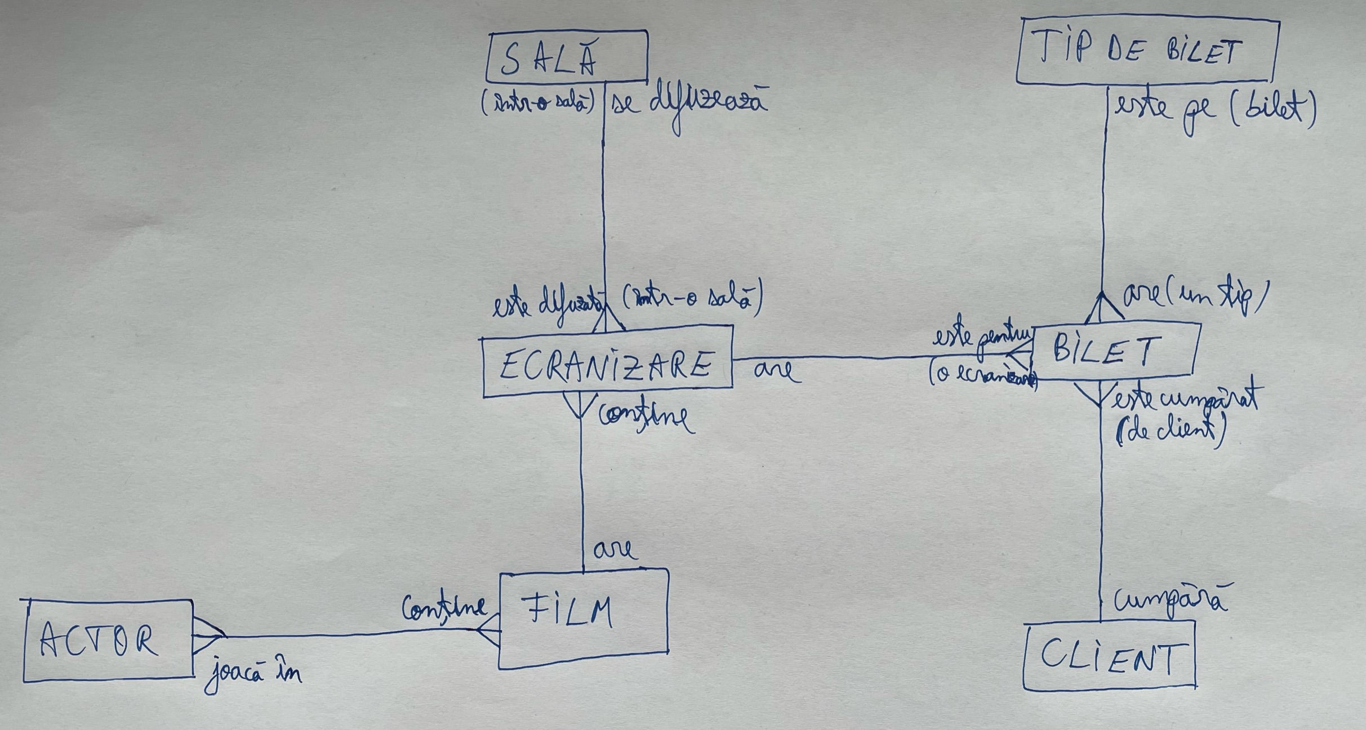

3.

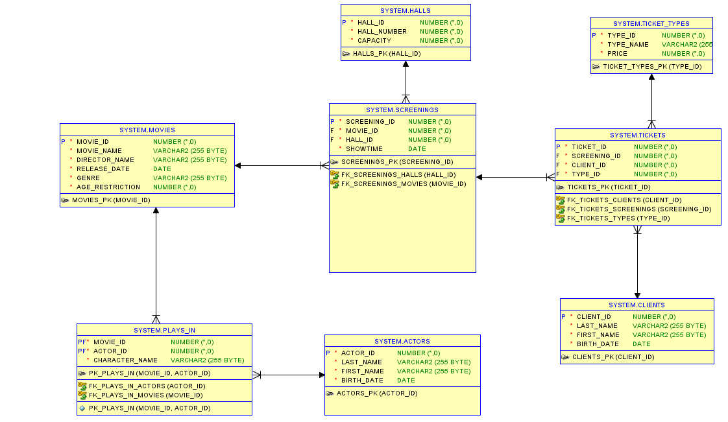

4.

CREATE TABLE ACTORS (

actor_id INT PRIMARY KEY,

last_name varchar(255) NOT NULL,

first_name varchar(255) NOT NULL,

birth_date DATE NOT NULL

);

CREATE TABLE MOVIES (

movie_id INT PRIMARY KEY,

movie_name varchar(255) NOT NULL,

director_name varchar(255) NOT NULL,

release_date DATE NOT NULL,

genre varchar(255) NOT NULL,

age_restriction int NOT NULL

);

CREATE TABLE PLAYS_IN (

movie_id INT NOT NULL,

actor_id INT NOT NULL,

character_name varchar(255) NOT NULL,

CONSTRAINT FK_PLAYS_IN_MOVIES FOREIGN KEY (movie_id) REFERENCES MOVIES(movie_id),

CONSTRAINT FK_PLAYS_IN_ACTORS FOREIGN KEY (actor_id) REFERENCES ACTORS(actor_id),

CONSTRAINT PK_PLAYS_IN PRIMARY KEY (movie_id, actor_id)

);

CREATE TABLE CLIENTS (

client_id INT PRIMARY KEY,

last_name varchar(255) NOT NULL,

first_name varchar(255) NOT NULL,

birth_date DATE NOT NULL

);

CREATE TABLE HALLS (

hall_id INT PRIMARY KEY,

hall_number INT NOT NULL,

capacity INT NOT NULL

);

CREATE TABLE SCREENINGS (

screening_id INT PRIMARY KEY,

movie_id INT NOT NULL,

hall_id INT NOT NULL,

showtime DATE NOT NULL,

CONSTRAINT FK_SCREENINGS_MOVIES FOREIGN KEY (movie_id) REFERENCES MOVIES(movie_id),

CONSTRAINT FK_SCREENINGS_HALLS FOREIGN KEY (hall_id) REFERENCES HALLS(hall_id)

);

CREATE TABLE TICKETS (

ticket_id INT PRIMARY KEY,

screening_id INT NOT NULL,

client_id INT NOT NULL,

type_id INT NOT NULL,

CONSTRAINT FK_TICKETS_SCREENINGS FOREIGN KEY (screening_id) REFERENCES SCREENINGS(screening_id),

CONSTRAINT FK_TICKETS_CLIENTS FOREIGN KEY (client_id) REFERENCES CLIENTS(client_id),

CONSTRAINT FK_TICKETS_TYPES FOREIGN KEY (type_id) REFERENCES TICKET_TYPES(type_id)

);

CREATE TABLE TICKET_TYPES (

type_id INT PRIMARY KEY,

type_name VARCHAR(255) NOT NULL,

price INT NOT NULL

);

5.

-----ACTORS INSERTS-----

INSERT INTO ACTORS

VALUES (1, 'Leonardo', 'DiCaprio', TO_DATE('1974/11/11', 'yyyy/mm/dd'));

INSERT INTO ACTORS

VALUES (2, 'Jamie', 'Foxx', TO_DATE('1967/12/13', 'yyyy/mm/dd'));

INSERT INTO ACTORS

VALUES (3, 'Gary', 'Oldman', TO_DATE('1958/03/21', 'yyyy/mm/dd'));

INSERT INTO ACTORS

VALUES (4, 'Robert', 'Pattinson', TO_DATE('1986/05/13', 'yyyy/mm/dd'));

INSERT INTO ACTORS

VALUES (5, 'Matthew', 'McConaughey', TO_DATE('1969/11/04', 'yyyy/mm/dd'));

INSERT INTO ACTORS

VALUES (6, 'Joseph', 'Gordon-Levitt', TO_DATE('1981/02/17', 'yyyy/mm/dd'));

-----MOVIES INSERTS-----

INSERT INTO MOVIES

VALUES (1, 'Soul', 'Docter', TO_DATE('2020/12/25', 'yyyy/mm/dd'), 'Drama', 10);

INSERT INTO MOVIES

VALUES (2, 'Mank', 'Fincher', TO_DATE('2020/11/13', 'yyyy/mm/dd'), 'Drama', 13);

INSERT INTO MOVIES

VALUES (3, 'Borat 2', 'Woliner', TO_DATE('2020/10/23', 'yyyy/mm/dd'), 'Comedy', 15);

INSERT INTO MOVIES

VALUES (4, 'Tenet', 'Nolan', TO_DATE('2020/09/18', 'yyyy/mm/dd'), 'Action', 13);

INSERT INTO MOVIES

VALUES (5, 'Interstellar', 'Nolan', TO_DATE('2014/11/07', 'yyyy/mm/dd'), 'Sci-Fi', 13);

INSERT INTO MOVIES

VALUES (6, 'Dunkirk', 'Nolan', TO_DATE('2017/07/13', 'yyyy/mm/dd'), 'Action', 15);

INSERT INTO MOVIES

VALUES (7, 'Inglorious Basterds', 'Tarantino', TO_DATE('2020/09/04', 'yyyy/mm/dd'), 'Action', 13);

INSERT INTO MOVIES

VALUES (8, '30 Years and 15 Minutes', 'Mandachi', TO_DATE('2020/08/08', 'yyyy/mm/dd'), 'Action', 15);

INSERT INTO MOVIES

VALUES (9, 'The Social Dilemma', 'Orlowski', TO_DATE('2020/09/09', 'yyyy/mm/dd'), 'Documentary', 10);

INSERT INTO MOVIES

VALUES (10, 'Inception', 'Nolan', TO_DATE('2020/07/30', 'yyyy/mm/dd'), 'Action', 13);

-----PLAYS IN INSERTS-----

INSERT INTO PLAYS_IN

VALUES (1, 2, 'Joe');

INSERT INTO PLAYS_IN

VALUES (4, 4, 'Neil');

INSERT INTO PLAYS_IN

VALUES (4, 2, 'Protagonist');

INSERT INTO PLAYS_IN

VALUES (5, 5, 'Cooper');

INSERT INTO PLAYS_IN

VALUES (10, 1, 'Cobb');

INSERT INTO PLAYS_IN

VALUES (10, 6, 'Arthur');

INSERT INTO PLAYS_IN

VALUES (10, 5, 'Eames');

INSERT INTO PLAYS_IN

VALUES (7, 1, 'Aldo Raine');

INSERT INTO PLAYS_IN

VALUES (7, 6, 'Hans Landa');

INSERT INTO PLAYS_IN

VALUES (2, 5, 'Kane');

INSERT INTO PLAYS_IN

VALUES (2, 3, 'Mank');

INSERT INTO PLAYS_IN

VALUES (2, 4, 'Joe');

-----CLIENTS INSERTS-----

INSERT INTO CLIENTS

VALUES (1, 'Tudorache', 'Theodor', TO_DATE('2000/05/20', 'yyyy/mm/dd'));

INSERT INTO CLIENTS

VALUES (2, 'Bugheciu', 'Eduard', TO_DATE('2000/02/27', 'yyyy/mm/dd'));

INSERT INTO CLIENTS

VALUES (3, 'Constantin', 'Sorin', TO_DATE('1987/07/17', 'yyyy/mm/dd'));

INSERT INTO CLIENTS

VALUES (4, 'Craciun', 'Andrei', TO_DATE('2008/09/07', 'yyyy/mm/dd'));

INSERT INTO CLIENTS

VALUES (5, 'Curtamet', 'Ixan', TO_DATE('2006/08/02', 'yyyy/mm/dd'));

INSERT INTO CLIENTS

VALUES (6, 'Raduna', 'Daniel', TO_DATE('2005/10/08', 'yyyy/mm/dd'));

-----HALLS INSERTS-----

INSERT INTO HALLS

VALUES (1, 1, 100);

INSERT INTO HALLS

VALUES (2, 2, 50);

INSERT INTO HALLS

VALUES (3, 3, 250);

INSERT INTO HALLS

VALUES (4, 4, 100);

INSERT INTO HALLS

VALUES (5, 5, 150);

INSERT INTO HALLS

VALUES (6, 6, 5);

-----SCREENINGS INSERTS-----

INSERT INTO SCREENINGS

VALUES (1, 1, 6, TO_DATE('2020-12-25 13:00', 'YYYY-MM-DD HH24:MI'));

INSERT INTO SCREENINGS

VALUES (2, 3, 6, TO_DATE('2020-12-25 17:00', 'YYYY-MM-DD HH24:MI'));

INSERT INTO SCREENINGS

VALUES (3, 1, 1, TO_DATE('2020-12-30 21:00', 'YYYY-MM-DD HH24:MI'));

INSERT INTO SCREENINGS

VALUES (4, 2, 2, TO_DATE('2021-01-02 20:00', 'YYYY-MM-DD HH24:MI'));

INSERT INTO SCREENINGS

VALUES (5, 4, 3, TO_DATE('2020-01-03 17:00', 'YYYY-MM-DD HH24:MI'));

INSERT INTO SCREENINGS

VALUES (6, 4, 3, TO_DATE('2021-01-03 17:00', 'YYYY-MM-DD HH24:MI'));

INSERT INTO SCREENINGS

VALUES (7, 5, 4, TO_DATE('2021-01-03 13:00', 'YYYY-MM-DD HH24:MI'));

INSERT INTO SCREENINGS

VALUES (8, 6, 5, TO_DATE('2021-01-05 11:00', 'YYYY-MM-DD HH24:MI'));

INSERT INTO SCREENINGS

VALUES (9, 7, 6, TO_DATE('2021-01-05 20:00', 'YYYY-MM-DD HH24:MI'));

INSERT INTO SCREENINGS

VALUES (10, 8, 6, TO_DATE('2021-01-01 21:00', 'YYYY-MM-DD HH24:MI'));

INSERT INTO SCREENINGS

VALUES (11, 9, 5, TO_DATE('2020-12-29 17:00', 'YYYY-MM-DD HH24:MI'));

INSERT INTO SCREENINGS

VALUES (12, 10, 4, TO_DATE('2020-12-31 10:00', 'YYYY-MM-DD HH24:MI'));

-----TICKETS INSERTS-----

INSERT INTO TICKETS

VALUES (1, 1, 1, 1);

INSERT INTO TICKETS

VALUES (2, 1, 2, 2);

INSERT INTO TICKETS

VALUES (3, 1, 3, 2);

INSERT INTO TICKETS

VALUES (4, 1, 4, 1);

INSERT INTO TICKETS

VALUES (5, 1, 5, 3);

INSERT INTO TICKETS

VALUES (6, 2, 1, 2);

INSERT INTO TICKETS

VALUES (7, 2, 2, 3);

INSERT INTO TICKETS

VALUES (8, 2, 3, 2);

INSERT INTO TICKETS

VALUES (9, 2, 4, 1);

INSERT INTO TICKETS

VALUES (10, 2, 5, 3);

INSERT INTO TICKETS

VALUES (11, 3, 1, 1);

INSERT INTO TICKETS

VALUES (12, 4, 2, 2);

INSERT INTO TICKETS

VALUES (13, 5, 3, 3);

INSERT INTO TICKETS

VALUES (14, 10, 1, 1);

INSERT INTO TICKETS

VALUES (15, 10, 2, 2);

INSERT INTO TICKETS

VALUES (16, 10, 3, 2);

INSERT INTO TICKETS

VALUES (17, 10, 4, 1);

INSERT INTO TICKETS

VALUES (18, 10, 5, 3);

INSERT INTO TICKETS

VALUES (19, 9, 1, 2);

INSERT INTO TICKETS

VALUES (20, 9, 2, 3);

INSERT INTO TICKETS

VALUES (21, 9, 3, 2);

INSERT INTO TICKETS

VALUES (22, 9, 4, 1);

INSERT INTO TICKETS

VALUES (23, 9, 5, 3);

-----TICKET TYPES INSERTS-----

INSERT INTO TICKET_TYPES

VALUES (1, 'Adult', 21);

INSERT INTO TICKET_TYPES

VALUES (2, 'Student', 14);

INSERT INTO TICKET_TYPES

VALUES (3, 'Retired', 16);

6. Să se definească o funcție care să afișeze numele actorilor, dar și personajul lor, care au jucat în filmele regizate de un regizor cu nume dat că parametru(Parametrul default va fi 'Nolan'). Acest subprogram trebuie să returneze numărul acestor actori.

CREATE OR REPLACE FUNCTION fct_ex6

(director movies.director_name%TYPE DEFAULT 'Nolan')

RETURN NUMBER

IS

TYPE type_actors IS TABLE OF varchar(255);

TYPE type_roles IS TABLE OF varchar(255);

TYPE type_movies IS TABLE OF varchar(255);

t_actors type_actors;

t_roles type_roles;

t_movies type_movies;

BEGIN

SELECT (last_name|| ' ' || first_name) actor, (pi.character_name) personaj, (m.movie_name) BULK COLLECT INTO t_actors, t_roles, t_movies

FROM actors a JOIN plays_in pi on (pi.actor_id = a.actor_id)

JOIN movies m on (pi.movie_id = m.movie_id)

WHERE m.director_name = director

ORDER BY m.movie_name;

DBMS_OUTPUT.PUT_LINE('---In filmele lui ' || director || ' au jucat:');

FOR I in t_actors.first..t_actors.last LOOP

DBMS_OUTPUT.PUT_LINE('Actorul ' || t_actors(i) || ' a jucat rolul ' || t_roles(i) || ' in filmul ' || t_movies(i) || '.');

END LOOP;

DBMS_OUTPUT.NEW_LINE;

RETURN t_actors.count;

END fct_ex6;

/

APELARE:

BEGIN

DBMS_OUTPUT.PUT_LINE('Total: ' || fct_ex6() || ' actori');

DBMS_OUTPUT.NEW_LINE;

DBMS_OUTPUT.PUT_LINE('Total: ' || fct_ex6('Tarantino') || ' actori');

DBMS_OUTPUT.NEW_LINE;

DBMS_OUTPUT.PUT_LINE('Total: ' || fct_ex6('Fincher') || ' actori');

END;

/

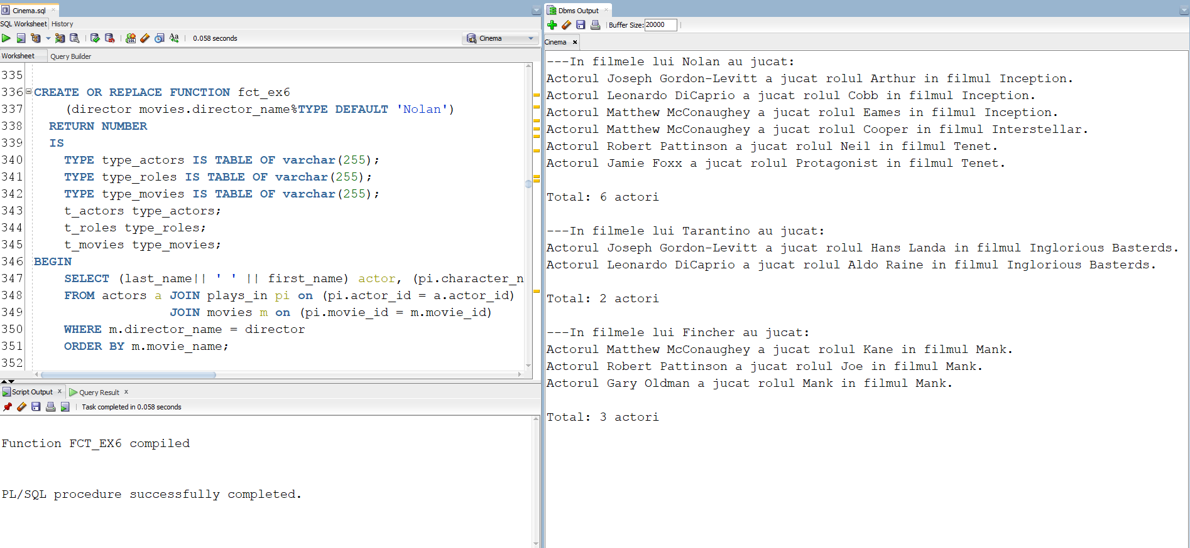

7. Să se definească o procedură care să afișeze(o singură dată) numele și vârstă tuturor clienților care au cumpărat bilete de tipul dat ca parametru(Parametrul default va fi 'Adult').

CREATE OR REPLACE PROCEDURE proc_ex7

(tip ticket_types.type_name%TYPE DEFAULT 'Adult')

IS

CURSOR crs IS

SELECT unique(last_name), first_name, birth_date

FROM clients c join tickets t on (t.client_id = c.client_id)

join ticket_types tt on (tt.type_id = t.type_id)

WHERE tt.type_name = tip;

TYPE ticket_typess IS TABLE OF ticket_types.type_name%TYPE;

all_types ticket_typess;

varsta NUMBER;

este_tip BOOLEAN := FALSE;

BEGIN

SELECT type_name bulk collect into all_types

FROM ticket_types;

FOR i IN all_types.first..all_types.last LOOP

IF (all_types(i) = tip) THEN

este_tip := TRUE;

END IF;

END LOOP;

IF (este_tip = TRUE) THEN

DBMS_OUTPUT.PUT_LINE('---Bilete de tipul ' || tip || ' au fost cumparate de urmatorii clienti: ');

ELSE

DBMS_OUTPUT.PUT_LINE ('Nu exista bilete de tipul ' || tip || '.');

END IF;

FOR i in crs LOOP

varsta := TRUNC(MONTHS_BETWEEN(sysdate, i.birth_date) / 12);

IF (varsta >= 20) THEN

DBMS_OUTPUT.PUT_LINE('Clientul ' || i.last_name || ' ' || i.first_name || ' cu varsta de ' || TRUNC(MONTHS_BETWEEN(sysdate, i.birth_date) / 12) || ' de ani.');

ELSE

DBMS_OUTPUT.PUT_LINE('Clientul ' || i.last_name || ' ' || i.first_name || ' cu varsta de ' || TRUNC(MONTHS_BETWEEN(sysdate, i.birth_date) / 12) || ' ani.');

END IF;

END LOOP;

DBMS_OUTPUT.NEW_LINE;

END proc_ex7;

/

APELARE:

BEGIN

proc_ex7();

proc_ex7('Student');

proc_ex7('Retired');

proc_ex7('Dummy'); -- nu se va afisa nimic

END;

/

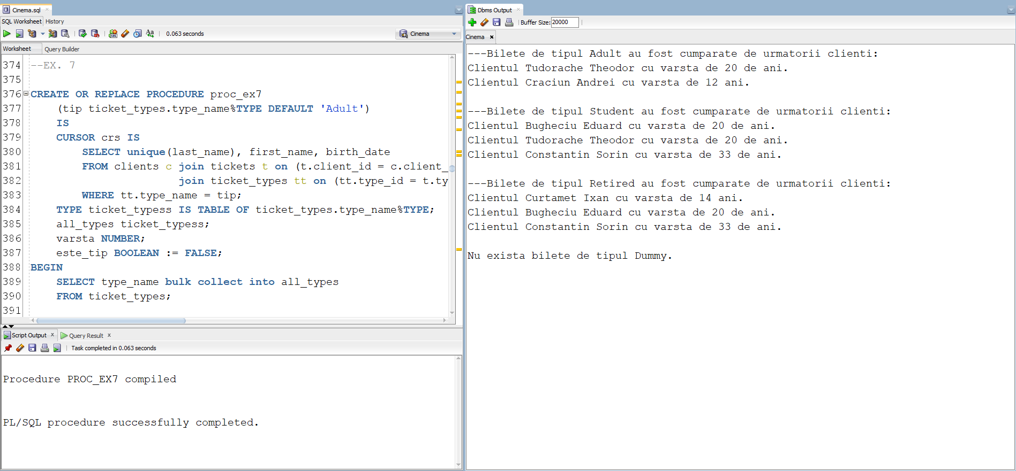

8. Să se definească o funcție care să afișeze următoarele detalii: (numele filmului; dată și ora la care a fost ecranizat) despre filmul care a rulat la o capacitate de peste 90% din sala în care au fost ecranizate, având genul dat ca parametru. Subprogramul trebuie să returneze id-ul ecranizării respective.

CREATE OR REPLACE FUNCTION fct_ex8

(gen movies.genre%TYPE DEFAULT 'Comedy')

RETURN NUMBER

IS

aux NUMBER := 0;

screening screenings.screening_id%TYPE;

show_time screenings.showtime%TYPE;

movie movies.movie_name%TYPE;

sold_tickets NUMBER;

cap halls.capacity%TYPE;

BEGIN

SELECT s.screening_id, m.movie_name, s.showtime, count(t.ticket_id) , h.capacity INTO screening, movie, show_time,sold_tickets, cap

FROM screenings s join halls h on (h.hall_id = s.hall_id)

join tickets t on (t.screening_id = s.screening_id)

join movies m on (m.movie_id = s.movie_id)

WHERE genre = gen

GROUP BY s.screening_id, m.movie_name, s.showtime ,h.capacity

HAVING COUNT(t.ticket_id) >= h.capacity * (9/10);

DBMS_OUTPUT.PUT_LINE('Filmul ' || movie || ' a rulat la ' || TO_CHAR(show_time, 'dd/mm/yyyy HH24:MI') || ' cu capacitatea ' || sold_tickets || '/' || cap || '.');

DBMS_OUTPUT.NEW_LINE;

RETURN screening;

EXCEPTION

WHEN NO_DATA_FOUND THEN

DBMS_OUTPUT.PUT_LINE('Nu exista filme care au rulat la capacitate de peste 90% avand genul ' || gen || '.');

DBMS_OUTPUT.NEW_LINE;

return -1;

WHEN TOO_MANY_ROWS THEN

DBMS_OUTPUT.PUT_LINE('Exista mai multe filme care au rulat la capacitate de peste 90% avand genul ' || gen || '.');

DBMS_OUTPUT.NEW_LINE;

return -2;

WHEN OTHERS THEN

DBMS_OUTPUT.PUT_LINE('Alta eroare!');

return -3;

END fct_ex8;

/

APELARE:

BEGIN

DBMS_OUTPUT.PUT_LINE('Id-ul ecranizarii: ' || fct_ex8('Drama'));

DBMS_OUTPUT.NEW_LINE;

DBMS_OUTPUT.PUT_LINE('Id-ul ecranizarii: ' || fct_ex8('Comedy'));

DBMS_OUTPUT.NEW_LINE;

DBMS_OUTPUT.PUT_LINE('Eroare: ' || fct_ex8('Action')); -- mai mult de 1 film

DBMS_OUTPUT.NEW_LINE;

DBMS_OUTPUT.PUT_LINE('Eroare: ' || fct_ex8('Documentary')); -- niciun film

DBMS_OUTPUT.NEW_LINE;

END;

/

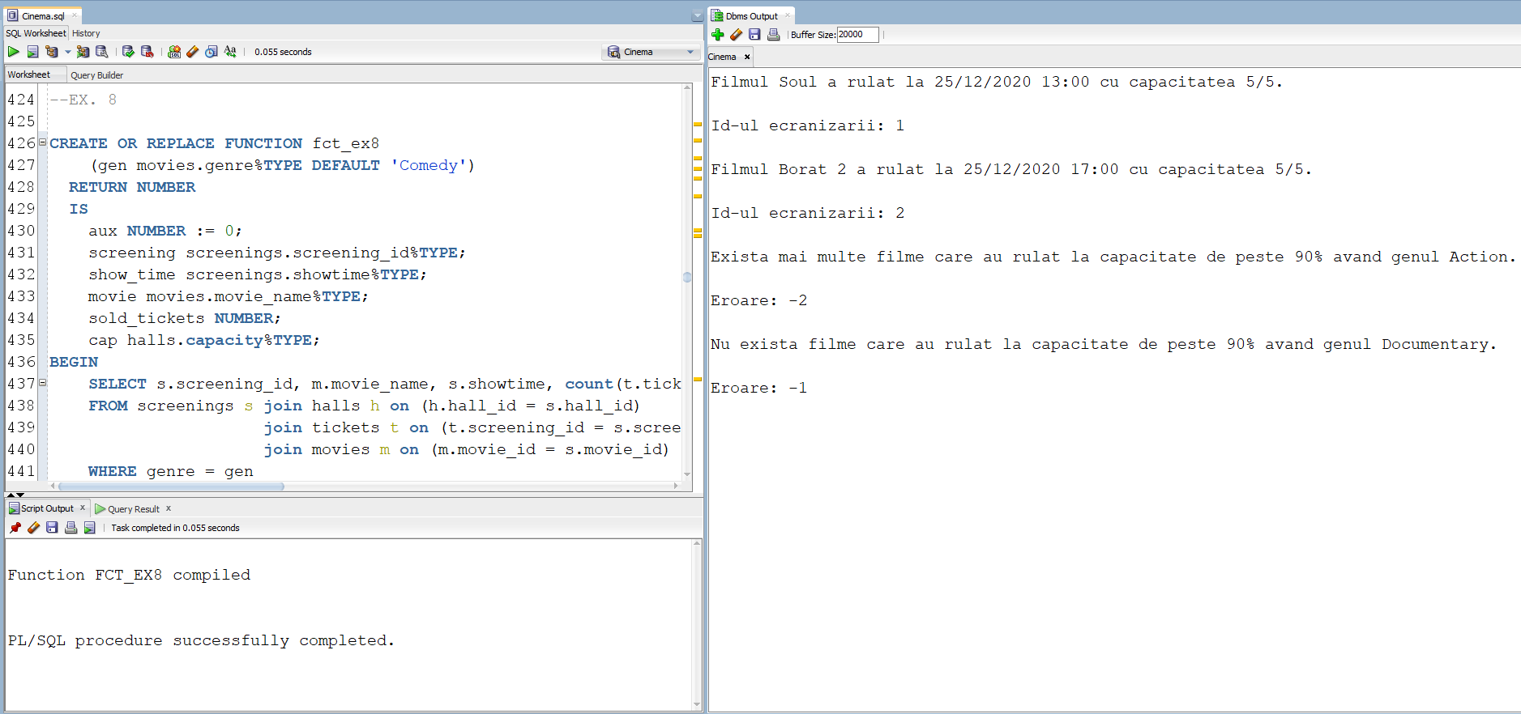

9. Să se definească o procedură care să afișeze numele filmelor(o singură dată) și numele actorilor care au jucat în ele, care au rulat în sala cu capacitate dată ca parametru.

CREATE OR REPLACE PROCEDURE proc_ex9

(cap halls.capacity%TYPE)

IS

hall halls.hall_id%TYPE;

last_movie movies.movie_name%TYPE := '0'; -- nu exista niciun film in baza de date cu numele '0'

aux NUMBER := 0;

CURSOR c IS

SELECT unique(m.movie_name), (a.last_name || ' ' || a.first_name) nume

FROM screenings s join movies m on (m.movie_id = s.movie_id)

join plays_in pi on (pi.movie_id = m.movie_id)

join actors a on (a.actor_id = pi.actor_id)

WHERE hall_id = hall

ORDER BY m.movie_name;

BEGIN

SELECT hall_id into hall

FROM halls

WHERE capacity = cap;

FOR i in c LOOP

IF (i.movie_name != last_movie) THEN

DBMS_OUTPUT.PUT_LINE ('---Filmul ' || i.movie_name || ' avand actorii: ');

END IF;

DBMS_OUTPUT.PUT_LINE (i.nume);

last_movie := i.movie_name;

aux := aux + 1;

END LOOP;

IF (aux = 0) THEN

DBMS_OUTPUT.PUT_LINE('Nu exista filme care sa fi rulat in sala cu capacitatea ' || cap);

END IF;

EXCEPTION

WHEN TOO_MANY_ROWS THEN

DBMS_OUTPUT.PUT_LINE('Exista mai multe sali cu capacitatea ' || cap);

WHEN NO_DATA_FOUND THEN

DBMS_OUTPUT.PUT_LINE('Nu exista nicio sala care sa aiba capacitatea ' || cap);

WHEN OTHERS THEN

DBMS_OUTPUT.PUT_LINE('Alta eroare');

END proc_ex9;

/

APELARE:

BEGIN

DBMS_OUTPUT.PUT_LINE('===Capacitate 5===');

proc_ex9(5); -- mai multe filme

DBMS_OUTPUT.NEW_LINE;

DBMS_OUTPUT.PUT_LINE('===Capacitate 250===');

proc_ex9(250); -- un singur film

DBMS_OUTPUT.NEW_LINE;

DBMS_OUTPUT.PUT_LINE('===Capacitate 150===');

proc_ex9(150); -- niciun film

DBMS_OUTPUT.NEW_LINE;

DBMS_OUTPUT.PUT_LINE('===Capacitate 500===');

proc_ex9(500); -- nu exista capacitatea

DBMS_OUTPUT.NEW_LINE;

DBMS_OUTPUT.PUT_LINE('===Capacitate 100===');

proc_ex9(100); -- mai multe sali cu capacitatea respectiva

END;

/

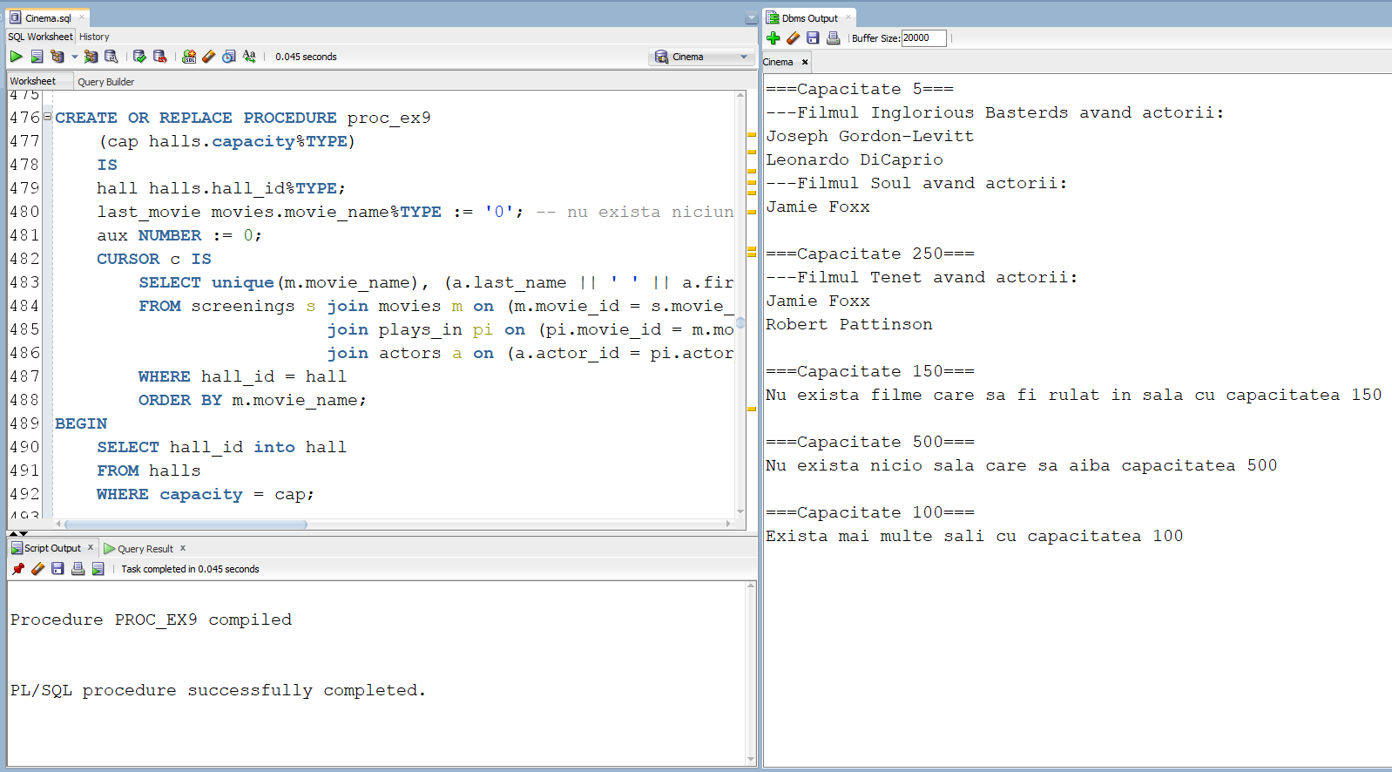

10. Să se definească un declanșator care să nu permită nimănui să lucreze în ziua de Crăciun cu comenzile UPDATE, INSERT, DELETE pe tabela filmelor. (Declanșatorul se va testa cu ziua în care ne aflăm, în loc de 25/12.)

CREATE OR REPLACE TRIGGER trig_ex10

BEFORE INSERT OR UPDATE OR DELETE ON movies

BEGIN

IF (TO_CHAR(SYSDATE,'DD/MM') = '25/12') THEN

RAISE_APPLICATION_ERROR(-20001,'Ia o pauza! E Craciunul.');

END IF;

END;

/

TESTARE:

INSERT INTO MOVIES

VALUES (15, 'Soul', 'Docter', TO_DATE('2020/12/25', 'yyyy/mm/dd'), 'Drama', 10);

DELETE FROM MOVIES

WHERE movie_id = 11;

UPDATE MOVIES

SET movie_name = 'Film'

WHERE movie_id = 11;

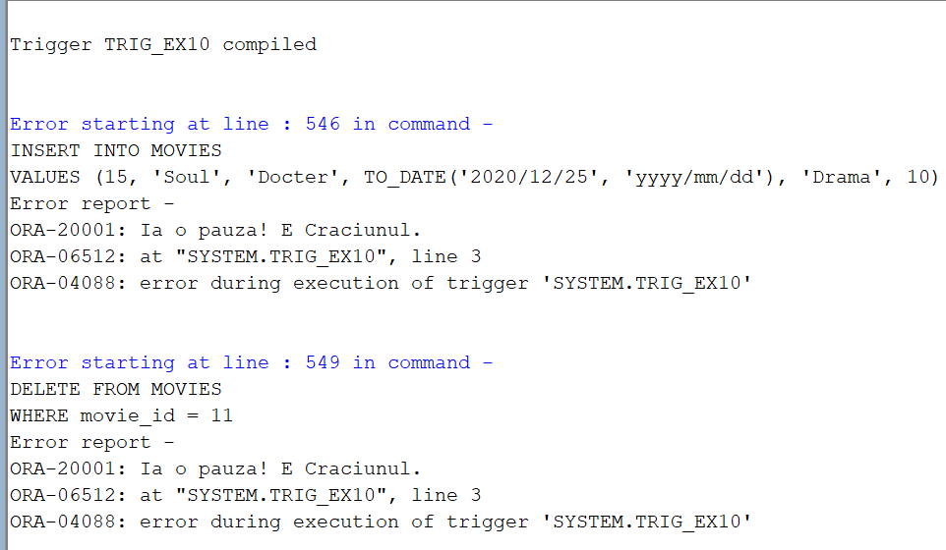

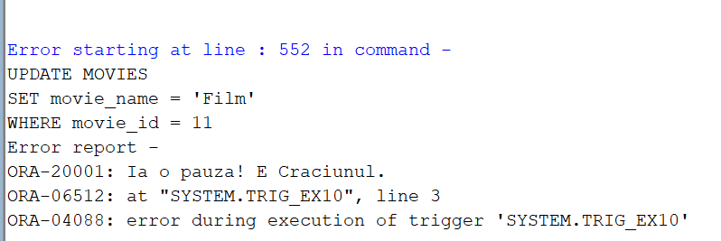

11. Să se definească un declanșator care să nu permită(să afișeze o eroare) inserarea în tabela biletelor a unor valori corespunzătoare unui client care nu are vârsta necesară pentru a putea vedea o anumită ecranizare a unui film.

--functie auxiliara pentru declansator

CREATE OR REPLACE FUNCTION are_voie_ex11

(screening tickets.screening_id%TYPE, id_client clients.client_id%TYPE)

RETURN BOOLEAN

IS

CURSOR crs IS

SELECT m.age_restriction

FROM screenings s join movies m on (m.movie_id = s.movie_id)

WHERE s.screening_id = screening;

CURSOR crs2 IS

SELECT TRUNC(MONTHS_BETWEEN(sysdate, birth_date) / 12)

FROM clients

WHERE client_id = id_client;

age number;

age_r movies.age_restriction%TYPE;

BEGIN

OPEN crs;

FETCH crs INTO age_r;

CLOSE crs;

OPEN crs2;

FETCH crs2 INTO age;

CLOSE crs2;

IF (age_r <= age) THEN

RETURN TRUE;

ELSE

RETURN FALSE;

END IF;

END are_voie_ex11;

/

CREATE OR REPLACE TRIGGER trig_ex11

BEFORE INSERT ON tickets

FOR EACH ROW

BEGIN

IF (are_voie_ex11(:NEW.screening_id, :NEW.client_id) = FALSE) THEN

RAISE_APPLICATION_ERROR(-20001,'ATENTIE! Clientul nu are varsta necesara pentru a vedea acest film!');

END IF;

END;

/

--TESTARE:

INSERT INTO TICKETS

VALUES (28, 2, 4, 2); -- nu are voie

INSERT INTO TICKETS

VALUES (28, 2, 1, 2); -- are voie

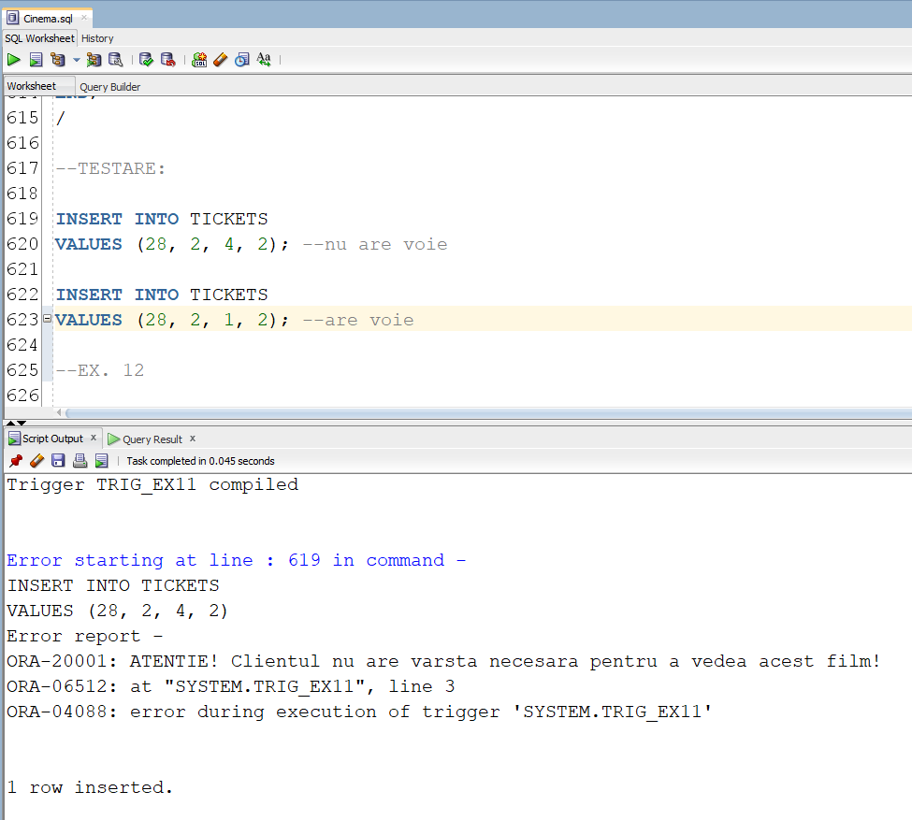

12. Să se definească un declanșator care să introducă date într-un tabel de tip audit după ce utilizatorul a folosit o comandă LDD.

CREATE TABLE audit_ex12 (

user_name VARCHAR2(30),

database_name VARCHAR2(50),

event VARCHAR2(20),

object_name VARCHAR2(30),

date_triggered DATE

);

CREATE OR REPLACE TRIGGER trig_ex12

AFTER CREATE OR DROP OR ALTER ON SCHEMA

BEGIN

INSERT INTO audit_ex12

VALUES (SYS.LOGIN_USER,

SYS.DATABASE_NAME,

SYS.SYSEVENT,

SYS.DICTIONARY_OBJ_NAME,

SYSDATE);

END;

/

TESTARE:

CREATE INDEX ind_ex12

ON movies(movie_name);

DROP INDEX ind_ex12;

SELECT * FROM audit_ex12;

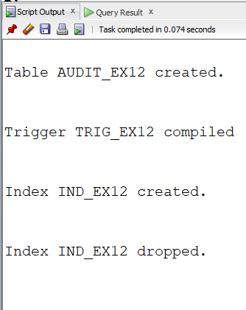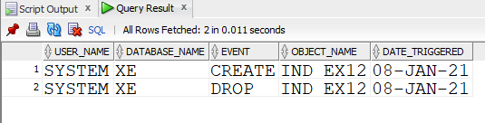

13.

CREATE OR REPLACE PACKAGE package_ex13 AS

FUNCTION pack_fct_ex6(director movies.director_name%TYPE DEFAULT 'Nolan')

RETURN NUMBER;

PROCEDURE pack_proc_ex7(tip ticket_types.type_name%TYPE DEFAULT 'Adult');

FUNCTION pack_fct_ex8(gen movies.genre%TYPE DEFAULT 'Comedy')

RETURN NUMBER;

PROCEDURE pack_proc_ex9(cap halls.capacity%TYPE);

FUNCTION pack_are_voie_ex11(screening tickets.screening_id%TYPE, id_client clients.client_id%TYPE)

RETURN BOOLEAN;

END package_ex13;

/

CREATE OR REPLACE PACKAGE BODY package_ex13 AS

FUNCTION pack_fct_ex6

(director movies.director_name%TYPE DEFAULT 'Nolan')

RETURN NUMBER

IS

TYPE type_actors IS TABLE OF varchar(255);

TYPE type_roles IS TABLE OF varchar(255);

TYPE type_movies IS TABLE OF varchar(255);

t_actors type_actors;

t_roles type_roles;

t_movies type_movies;

BEGIN

SELECT (last_name|| ' ' || first_name) actor, (pi.character_name) personaj, (m.movie_name) BULK COLLECT INTO t_actors, t_roles, t_movies

FROM actors a JOIN plays_in pi on (pi.actor_id = a.actor_id)

JOIN movies m on (pi.movie_id = m.movie_id)

WHERE m.director_name = director

ORDER BY m.movie_name;

DBMS_OUTPUT.PUT_LINE('---In filmele lui ' || director || ' au jucat:');

FOR I in t_actors.first..t_actors.last LOOP

DBMS_OUTPUT.PUT_LINE('Actorul ' || t_actors(i) || ' a jucat rolul ' || t_roles(i) || ' in filmul ' || t_movies(i) || '.');

END LOOP;

DBMS_OUTPUT.NEW_LINE;

RETURN t_actors.count;

END pack_fct_ex6;

PROCEDURE pack_proc_ex7

(tip ticket_types.type_name%TYPE DEFAULT 'Adult')

IS

CURSOR crs IS

SELECT unique(last_name), first_name, birth_date

FROM clients c join tickets t on (t.client_id = c.client_id)

join ticket_types tt on (tt.type_id = t.type_id)

WHERE tt.type_name = tip;

TYPE ticket_typess IS TABLE OF ticket_types.type_name%TYPE;

all_types ticket_typess;

varsta NUMBER;

este_tip BOOLEAN := FALSE;

BEGIN

SELECT type_name bulk collect into all_types

FROM ticket_types;

FOR i IN all_types.first..all_types.last LOOP

IF (all_types(i) = tip) THEN

este_tip := TRUE;

END IF;

END LOOP;

IF (este_tip = TRUE) THEN

DBMS_OUTPUT.PUT_LINE('---Bilete de tipul ' || tip || ' au fost cumparate de urmatorii clienti: ');

ELSE

DBMS_OUTPUT.PUT_LINE ('Nu exista bilete de tipul ' || tip || '.');

END IF;

FOR i in crs LOOP

varsta := TRUNC(MONTHS_BETWEEN(sysdate, i.birth_date) / 12);

IF (varsta >= 20) THEN

DBMS_OUTPUT.PUT_LINE('Clientul ' || i.last_name || ' ' || i.first_name || ' cu varsta de ' || TRUNC(MONTHS_BETWEEN(sysdate, i.birth_date) / 12) || ' de ani.');

ELSE

DBMS_OUTPUT.PUT_LINE('Clientul ' || i.last_name || ' ' || i.first_name || ' cu varsta de ' || TRUNC(MONTHS_BETWEEN(sysdate, i.birth_date) / 12) || ' ani.');

END IF;

END LOOP;

DBMS_OUTPUT.NEW_LINE;

END pack_proc_ex7;

FUNCTION pack_fct_ex8

(gen movies.genre%TYPE DEFAULT 'Comedy')

RETURN NUMBER

IS

aux NUMBER := 0;

screening screenings.screening_id%TYPE;

show_time screenings.showtime%TYPE;

movie movies.movie_name%TYPE;

sold_tickets NUMBER;

cap halls.capacity%TYPE;

BEGIN

SELECT s.screening_id, m.movie_name, s.showtime, count(t.ticket_id) , h.capacity INTO screening, movie, show_time,sold_tickets, cap

FROM screenings s join halls h on (h.hall_id = s.hall_id)

join tickets t on (t.screening_id = s.screening_id)

join movies m on (m.movie_id = s.movie_id)

WHERE genre = gen

GROUP BY s.screening_id, m.movie_name, s.showtime ,h.capacity

HAVING COUNT(t.ticket_id) >= h.capacity * (9/10);

DBMS_OUTPUT.PUT_LINE('Filmul ' || movie || ' a rulat la ' || TO_CHAR(show_time, 'dd/mm/yyyy HH24:MI') || ' cu capacitatea ' || sold_tickets || '/' || cap || '.');

DBMS_OUTPUT.NEW_LINE;

RETURN screening;

EXCEPTION

WHEN NO_DATA_FOUND THEN

DBMS_OUTPUT.PUT_LINE('Nu exista filme care au rulat la capacitate de peste 90% avand genul ' || gen);

DBMS_OUTPUT.NEW_LINE;

return -1;

WHEN TOO_MANY_ROWS THEN

DBMS_OUTPUT.PUT_LINE('Exista mai multe filme care au rulat la capacitate de peste 90% avand genul ' || gen);

DBMS_OUTPUT.NEW_LINE;

return -2;

WHEN OTHERS THEN

DBMS_OUTPUT.PUT_LINE('Alta eroare!');

return -3;

END pack_fct_ex8;

PROCEDURE pack_proc_ex9

(cap halls.capacity%TYPE)

IS

hall halls.hall_id%TYPE;

last_movie movies.movie_name%TYPE := '0'; -- nu exista niciun film in baza de date cu numele '0'

aux NUMBER := 0;

CURSOR c IS

SELECT unique(m.movie_name), (a.last_name || ' ' || a.first_name) nume

FROM screenings s join movies m on (m.movie_id = s.movie_id)

join plays_in pi on (pi.movie_id = m.movie_id)

join actors a on (a.actor_id = pi.actor_id)

WHERE hall_id = hall

ORDER BY m.movie_name;

BEGIN

SELECT hall_id into hall

FROM halls

WHERE capacity = cap;

FOR i in c LOOP

IF (i.movie_name != last_movie) THEN

DBMS_OUTPUT.PUT_LINE ('---Filmul ' || i.movie_name || ' avand actorii: ');

END IF;

DBMS_OUTPUT.PUT_LINE (i.nume);

last_movie := i.movie_name;

aux := aux + 1;

END LOOP;

IF (aux = 0) THEN

DBMS_OUTPUT.PUT_LINE('Nu exista filme care sa fi rulat in sala cu capacitatea ' || cap);

END IF;

EXCEPTION

WHEN TOO_MANY_ROWS THEN

DBMS_OUTPUT.PUT_LINE('Exista mai multe sali cu capacitatea ' || cap);

WHEN NO_DATA_FOUND THEN

DBMS_OUTPUT.PUT_LINE('Nu exista nicio sala care sa aiba capacitatea ' || cap);

WHEN OTHERS THEN

DBMS_OUTPUT.PUT_LINE('Alta eroare');

END pack_proc_ex9;

FUNCTION pack_are_voie_ex11

(screening tickets.screening_id%TYPE, id_client clients.client_id%TYPE)

RETURN BOOLEAN

IS

CURSOR crs IS

SELECT m.age_restriction

FROM screenings s join movies m on (m.movie_id = s.movie_id)

WHERE s.screening_id = screening;

CURSOR crs2 IS

SELECT TRUNC(MONTHS_BETWEEN(sysdate, birth_date) / 12)

FROM clients

WHERE client_id = id_client;

age number;

age_r movies.age_restriction%TYPE;

BEGIN

OPEN crs;

FETCH crs INTO age_r;

CLOSE crs;

OPEN crs2;

FETCH crs2 INTO age;

CLOSE crs2;

IF (age_r <= age) THEN

RETURN TRUE;

ELSE

RETURN FALSE;

END IF;

END pack_are_voie_ex11;

END package_ex13;

/

APELARE:

BEGIN

DBMS_OUTPUT.PUT_LINE('===6===');

DBMS_OUTPUT.NEW_LINE;

DBMS_OUTPUT.PUT_LINE('Total: ' || package_ex13.pack_fct_ex6() || ' actori');

DBMS_OUTPUT.NEW_LINE;

DBMS_OUTPUT.PUT_LINE('Total: ' || package_ex13.pack_fct_ex6('Tarantino') || ' actori');

DBMS_OUTPUT.NEW_LINE;

DBMS_OUTPUT.PUT_LINE('Total: ' || package_ex13.pack_fct_ex6('Fincher') || ' actori');

DBMS_OUTPUT.NEW_LINE;

DBMS_OUTPUT.PUT_LINE('===7===');

DBMS_OUTPUT.NEW_LINE;

package_ex13.pack_proc_ex7();

package_ex13.pack_proc_ex7('Student');

package_ex13.pack_proc_ex7('Retired');

package_ex13.pack_proc_ex7('Dummy');

DBMS_OUTPUT.PUT_LINE('===8===');

DBMS_OUTPUT.NEW_LINE;

DBMS_OUTPUT.PUT_LINE(package_ex13.pack_fct_ex8('Drama'));

DBMS_OUTPUT.NEW_LINE;

DBMS_OUTPUT.PUT_LINE(package_ex13.pack_fct_ex8('Comedy'));

DBMS_OUTPUT.NEW_LINE;

DBMS_OUTPUT.PUT_LINE(package_ex13.pack_fct_ex8('Action')); -- mai mult de 1 film

DBMS_OUTPUT.NEW_LINE;

DBMS_OUTPUT.PUT_LINE(package_ex13.pack_fct_ex8('Documentary')); -- niciun film

DBMS_OUTPUT.NEW_LINE;

DBMS_OUTPUT.PUT_LINE('===9===');

DBMS_OUTPUT.NEW_LINE;

package_ex13.pack_proc_ex9(5); -- mai multe filme

DBMS_OUTPUT.NEW_LINE;

package_ex13.pack_proc_ex9(250); -- un singur film

DBMS_OUTPUT.NEW_LINE;

package_ex13.pack_proc_ex9(150); -- niciun film

DBMS_OUTPUT.NEW_LINE;

package_ex13.pack_proc_ex9(500); -- nu exista capacitatea

DBMS_OUTPUT.NEW_LINE;

package_ex13.pack_proc_ex9(100); -- mai multe sali cu capacitatea respectiva

DBMS_OUTPUT.NEW_LINE;

DBMS_OUTPUT.PUT_LINE('===11===');

DBMS_OUTPUT.NEW_LINE;

IF (package_ex13.pack_are_voie_ex11(2, 4) = TRUE) THEN --client cu varsta 12 vrea sa mearga la film cu restrictie de 15

DBMS_OUTPUT.PUT_LINE('Allowed');

ELSE

DBMS_OUTPUT.PUT_LINE('Not allowed');

END IF;

IF (package_ex13.pack_are_voie_ex11(2, 1) = TRUE) THEN --client cu varsta 20 vrea sa mearga la film cu restrictie de 15

DBMS_OUTPUT.PUT_LINE('Allowed');

ELSE

DBMS_OUTPUT.PUT_LINE('Not allowed');

END IF;

END;

/

