**Summary**

There is variance in recorded PM2.5 values across stations. Numerous spikes are observed indicating periods of significantly increased PM2.5 concentration. At GC-5, a spike was observed in which the 24-hour time weighted average of recorded PM2.5 was above the EPA primary 24-hour PM2.5 standard of 35 ug/m3. At all other stations the 24-hour time weighted PM2.5 was within the EPA standard.

**Methods**

Available PM2.5 data from installed stations was downloaded from April 1st to September 29 using the PurpleAir API. Data was aggregated to *1-day* for analysis.

Data analysis was performed in Python and R.

**Results and Discussion**

There is apparent variance in recorded PM2.5 values across stations. Spikes in the daily average are observed across all stations. GC-5 shows a spike in which the 24-hour time weighted average (TWA) of recorded PM2.5 was above the EPA primary 24-hour PM2.5 standard of 35 ug/m3. This spike occurred on 4/26/24. Given that the day before and after show significantly lower PM2.5 and similar spikes are not observed at other stations, this could be an outlier related to an isolated event, or potential sensor error. While below the EPA daily standard, we see higher PM2.5 levels in June-July, potentially corresponding to the South Fork Fire. Mean daily PM2.5 ranged from 1.2 – 6.7 ug/m3 (Figure 1, Table 1).

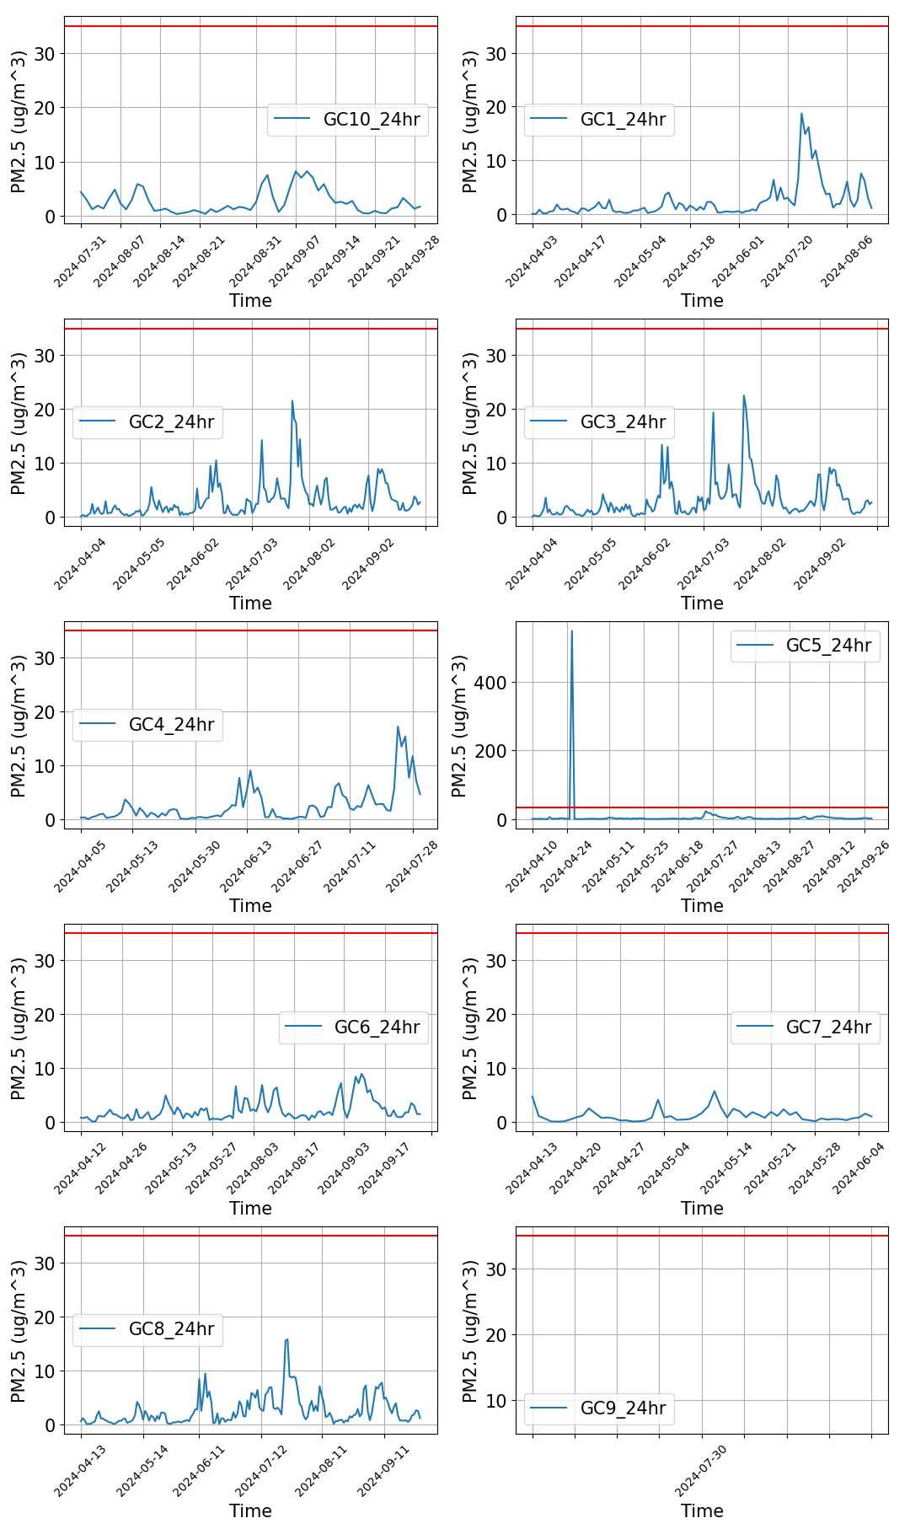

Figure - PM2.5 concentration (ug/m3) 1-day average from April to September. Note observed spikes in recorded PM2.5. Note: Red-line indicates EPA 24-hr PM 2.5 standard of 35 ug/m3.

Table - Descriptive statistics

