**Summary**

There is variance in recorded PM2.5 values across stations. Numerous spikes are observed indicating periods of significantly increased PM2.5 concentration. The highest readings are seen at the Crow Agency and Wyola stations. At all stations, sustained periods are observed in which the 24-hour time weighted average of recorded PM2.5 was above the EPA primary 24-hour PM2.5 standard of 35 ug/m3. Variance tests indicate that there are no statistically significant differences in average recorded PM2.5 levels between stations.

**Methods**

Available PM2.5 data from installed stations was downloaded from June 22nd to August 22st using the PurpleAir API. Data was aggregated to *1-day* for analysis.

Available Meteorological data from installed MET stations was downloaded from June 22nd to August 22st using the Montana Mesonet API. Data was aggregated to *1-day* for analysis.

Data analysis was performed in Python and R.

**Results and Discussion**

There is apparent variance in recorded PM2.5 values across stations. Spikes in the daily average are observed across all stations, with sustained periods in which the 24-hour time weighted average (TWA) of recorded PM2.5 was above the EPA primary 24-hour PM2.5 standard of 35 ug/m3. The largest spike was seen in Wyola on July 14th in which the daily average was 154 ug/m3, significantly higher than the EPA standard. On average, 8.25 cumulative days of elevated PM 2.5 were recorded across sites (Figure 1, Table 1, 2). These observations indicate sustained periods of elevated PM levels in the Hardin, Crow Agency, Wyola, and Pryor communities that may pose risks to public health.

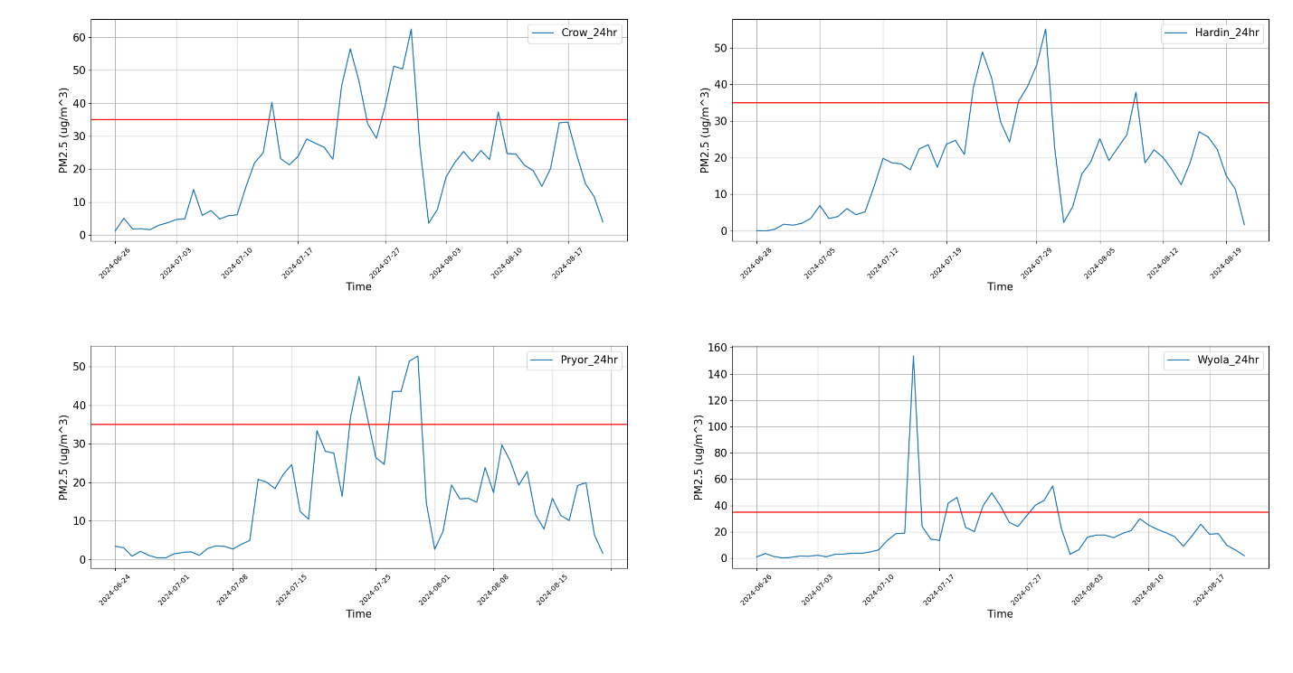

Figure 1 - PM2.5 concentration (ug/m3) 1-day average from June to August. Note observed spikes in recorded PM2.5. Note: Red-line indicates EPA 24-hr PM 2.5 standard of 35 ug/m3.

Table 1 - Descriptive statistics of PM2.5 concentration (ug/m3) 1-day average from June to August. Note the high max values above the EPA standard of 35 ug/m3.

The largest spikes can be seen in boxplots as outliers in the data from the Crow, Hardin, and Wyola stations. Wyola shows a spike in the 1-day average that is significantly greater compared to the other stations (Figure 2).

Figure 2 - Distributions of pm2.5 (ug/m3) 1-day readings across stations.

Normality tests indicate that data distributions from Crow and Hardin are normal, while Pryor and Wyola are more right-skewed (Figure 3, 4). A Kruskal-Wallace variance test indicates that mean variances between stations are not statistically significant (Table 2).

Figure 3 - Histograms of pm2.5 1-day averages from stations overlaid on top of each-other.

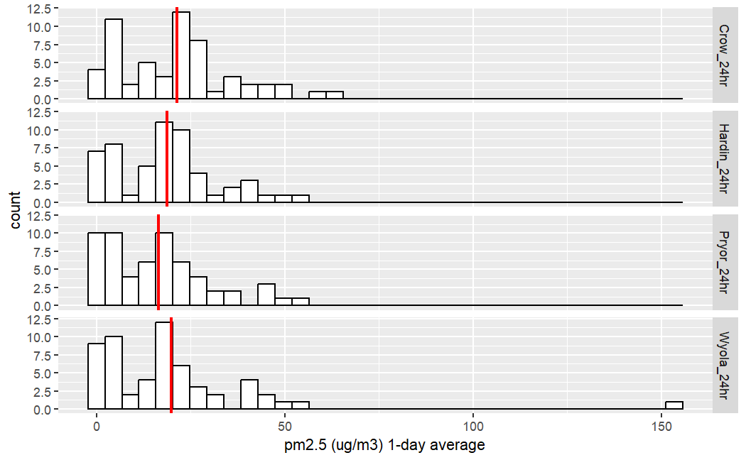

Figure 4 - Histograms of pm2.5 1-day averages from stations. Note large spikes recorded in Crow and Wyola..

Table 2 - Kruskal-Wallace variance test results. Results indicate no statistically significant difference in mean-rank recorded 1-day average pm2.5 between.

|  |  |
| --- | --- |
| Kruskal-Wallace Result |  |
| H-statistic | 5.31 |
| p-value | 0.15 |

Figure 5 - Daily precipitation, air temp, and wind speed (Wyola)

Figure 6 - Average windspeed and direction (Wyola)

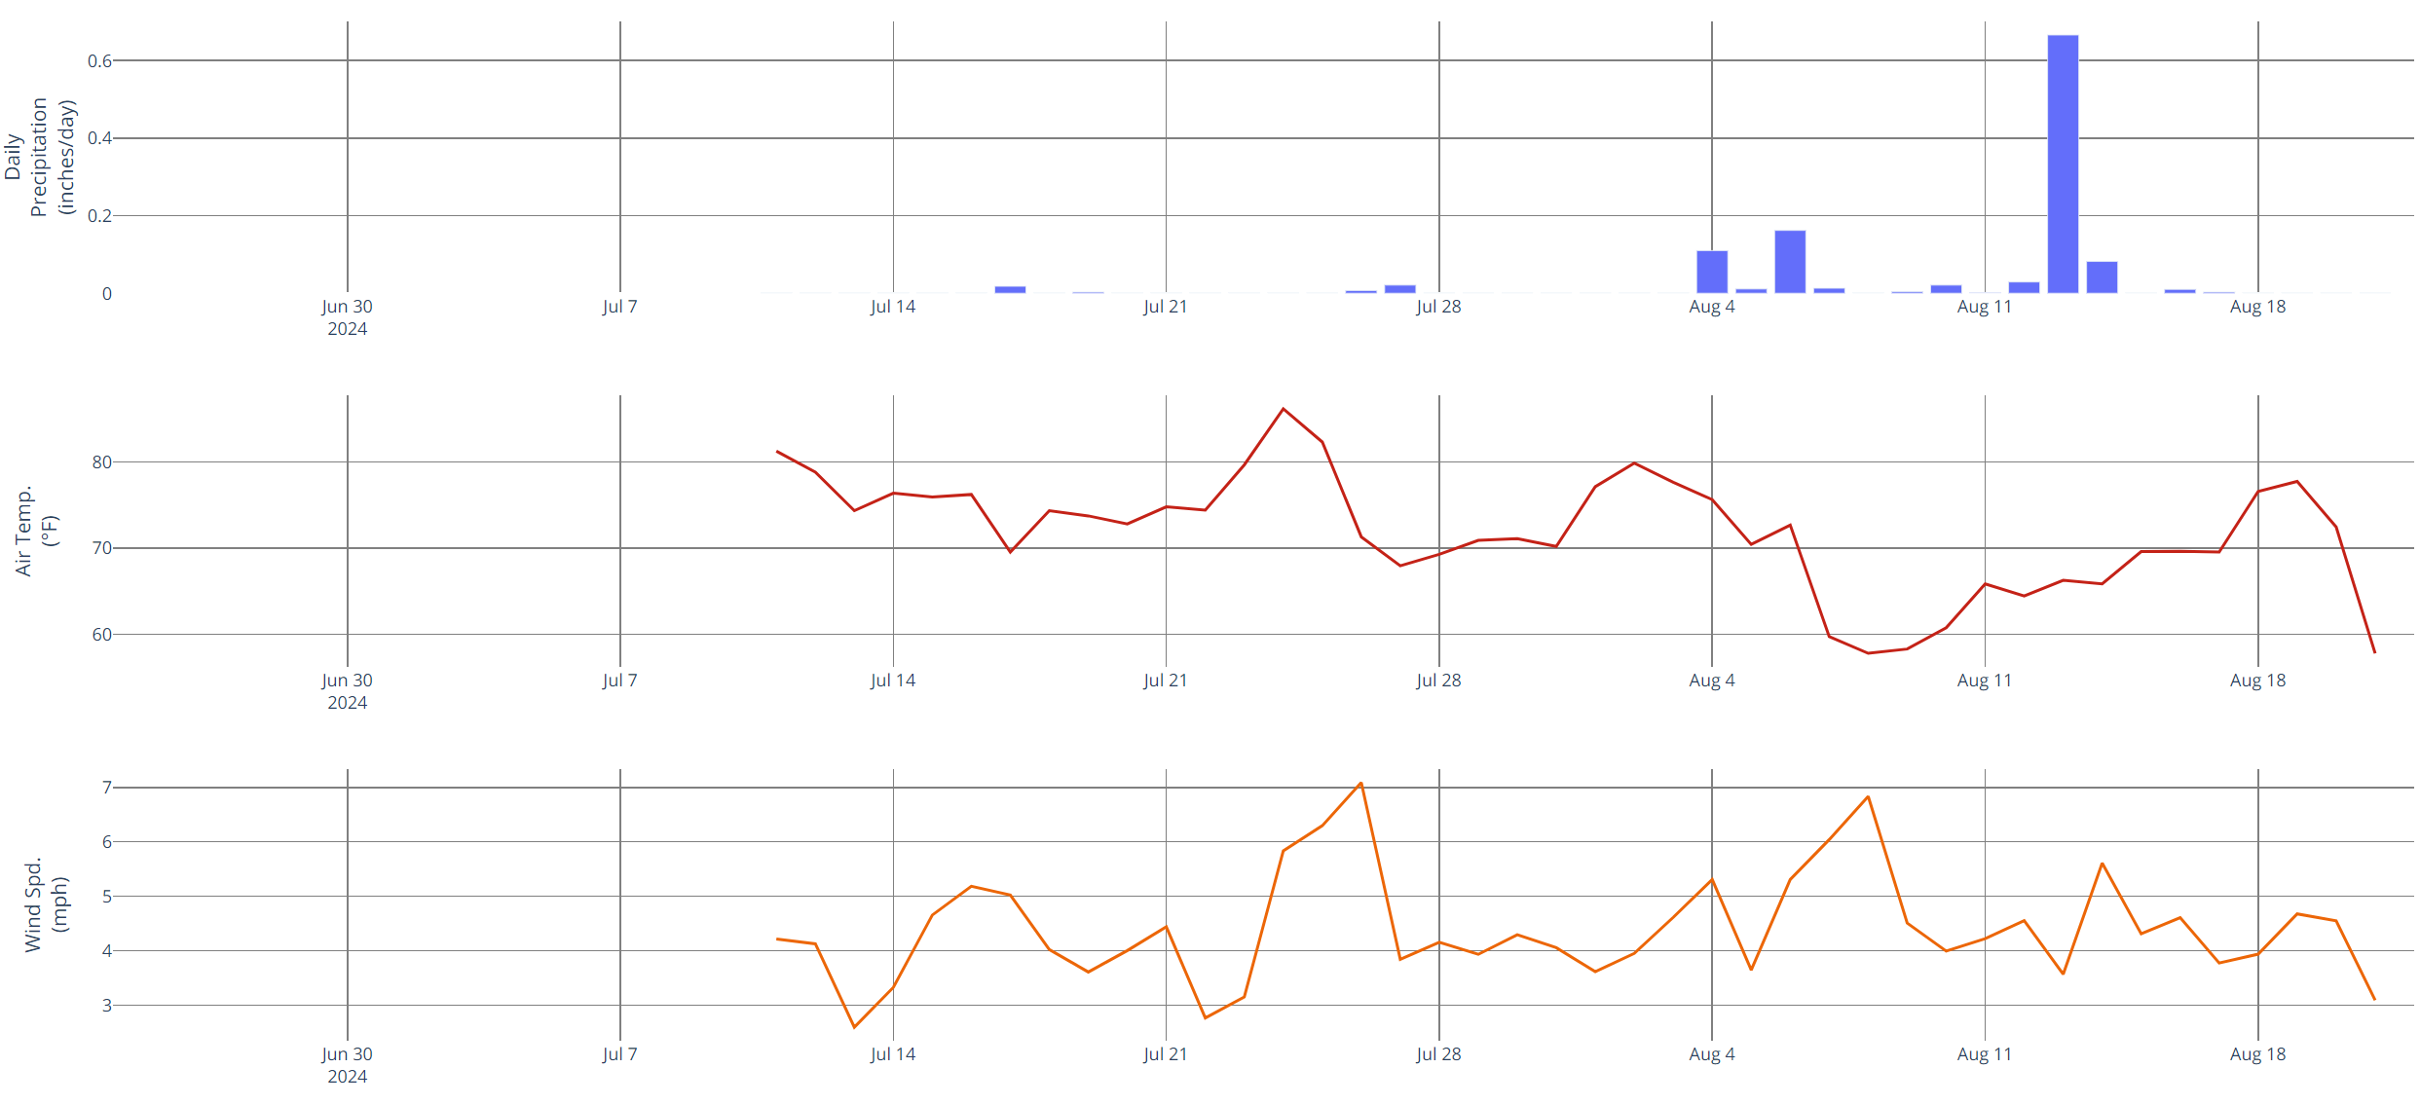

Figure 7 - Daily precipitation, air temp, and wind speed (Pryor)

Figure 8 - Average windspeed and direction (Wyola)