Module ICT3715

INFORMATION AND COMMUNICATION TECHNOLOGY PROJECT

|  |  |  |  |  |  |  |  |  |  |
| --- | --- | --- | --- | --- | --- | --- | --- | --- | --- |
| STUDENT NUMBER (Student completes) | | | | | | | | | |
| 5 | 1 | 1 | 5 |  | 2 | 1 | 7 |  | 7 |

|  |  |  |  |  |  |  |  |  |  |  |  |  |
| --- | --- | --- | --- | --- | --- | --- | --- | --- | --- | --- | --- | --- |
| IDENTITY NUMBER (Student completes) | | | | | | | | | | | | |
| 7 | 9 | 0 | 9 | 2 | 3 | 5 | 5 | 3 | 5 | 0 | 8 | 0 |

No handwritten assignments will be accepted.

**INSTRUCTIONS:**

Complete this Front Page (page 1)

Complete the Plagiarism Pledge (page 2). Your assignment will not be assessed without this.

After you have completed the front page with your information, the plagiarism pledge, and Assignment 2 with Section A and B, save the document as a PDF document.

Keep a copy of the original should there be problem with the upload.

PLAGIARISM PLEDGE BY THE STUDENT

1. I have read Unisa’s plagiarism policy.
2. I understand Unisa’s plagiarism policy.
3. I agree to abide by Unisa’s plagiarism policy.
4. I have read the direct copying, plagiarism, and “patch-writing” document.
5. I understand what direct copying, plagiarism, and “patch-writing” is.
6. I undertake to avoid copying directly, plagiarism and patch writing.
7. All academic work, written or otherwise, that I submit is expected to be the result of my own skill and labour.
8. I understand that, if I am guilty of the infringement of breach of copyright/plagiarism or unethical practice, I will be subject to the applicable disciplinary code as determined by Unisa.
9. The marker has the right to refuse to assess the assignment and the system if plagiarism is detected.

Student name and Surname: Tshililo Theophelus Makhado

Student number: 51152177

Student signature: TTM Date:10/02/2023

**Assignment 2 [848057]**

|  |  |
| --- | --- |
| **Due date Monday 4 July 2022, 11:00 PM** |  |

**Notes:**

This is a compulsory assignment. The assignment contributes to 30% of your year mark.

**System | Online examination file submission system**

Due to the pandemic, the University of South Africa (UNISA) has decided to **conduct all examinations in an online environment.**

The **purpose of this project** is then to look at the digital environment and **design and develop a simulation of such a system, using the real-life scenario and environment.**

You thus must design and develop an online examination file submission system, that can be presented to the University to be used as an alternative to the current system.

**Note**: You are not allowed to develop any other system or use any other data that was not prescribed or provided to you.

The outcome of this assignment will form part of the design, development, and implementation

of the database and the system. Your implementation effort will be greatly reduced if you take care with the preparation phases of the system.

**Instructions:**

* Make sure that you did complete the instructions on page 1 of this document
* Complete the header and footer with your own information
* Add your practical system content to the document
* Remove everything that is in brackets []
* Keep the answers that you had for the Assignment 1 also in this document
* Make sure that your Table of Content is updated
* Save the document as PDF, e.g., 12345678_ICT3715_02.pdf, (replace 1234568 with your student number)
* When you are done submit via myModules 2022 on the Module Site under Assignment 2

Table of Contents

1 Assignment 2 7

1.1 Section A = Database [20] 7

1.1.1 Create the database for your system and importing the data from your .csv file (20) 7

1.2 Section B = Backup and Recovery for the Database and Programming code [10] 7

1.2.1 Database (5) 8

1.2.2 Programming code & Portfolio (assignments) (20) 8

2 Assignment 1 9

2.1 Section A [4] 9

2.1.1 Programming Languages (2) 9

2.1.2 Database (2) 9

2.2 Section B [10] 9

2.2.1 Cleaning the data 9

2.3 Section C [10] 9

2.3.1 Activity Diagram (7) 9

2.3.2 ERD Diagram (3) 10

2.4 Section Backup and Recovery for the Database and Programming code [6] 10

2.4.1 Backup and Recovery Software for the Database (3) 10

2.4.2 Backup and Recovery process for the Programming code and your Portfolio (assignments) (3) 10

# Assignment 2

## Section A = Database [20]

### Create the database for your system and importing the data from your .csv file (20)

**Process**

* I started by opening the Data.csv file which was given to us
* I had to break down an analysis each table and columns needed per table
* I also analysed the data type and range for each of the columns and paid attention which are PK and FK
* I had to copy the columns needed per table on a separate worksheet which I then saved as separate csv file which represents each table
* Then using PHPMyAdmin I could easily create the database, tables and columns using the simple interface. The interface also allows to specify PK, FK and datatypes.
* Then I had to import the csv files to PHPMyAdmin to make sure the data was properly inserted.
* After this process then I extract an “SQL” file

**Problems**

The problems encountered where many I will break it down table by table and provide extra info

“studentmodule table”

* There was a lot of duplicate data of which I dealt with by deleting them in the csv file
* Making the 2 columns primary was simple as the interface provided that option
* Making the “ModuleCode” columns foreign key was hard, but I ran an SQL query to deal with that.
* ALTER TABLE `studentmodule` ADD PRIMARY KEY(`StudentNumber`, `ModuleCode`);

“studentinfo table”

* The only issue in this table was to create an email column and collect data from the studentnumber and add text. That issue was sort using the SQL query below
* UPDATE studentinfo SET email = StudentNumber + "@mylife.unisa.ac.za"

“staffinfo table”

* There was a lot of duplicate data of which I dealt with by deleting them in the csv file

“moduleleader table”

* There was a lot of duplicate data of which I dealt with by deleting them in the csv file
* Making the 2 columns primary was simple as the interface provided that option

“moduleinfo table”

* There was a lot of duplicate data of which I dealt with by deleting them in the csv file

“examsetup table”

* There was a lot of duplicate data of which I dealt with by deleting them in the csv file
* I also paid attention to the DATE datatype from the csv file

“examoutput table”

* There was a lot of duplicate data of which I dealt with by deleting them in the csv file
* I also paid attention to the DATE datatype from the csv file

Extra

* Just paying attention to certain datatypes such as date and time; I had to set them from the csv file so when it is imported it uses the right datatype.

**Screenshots**

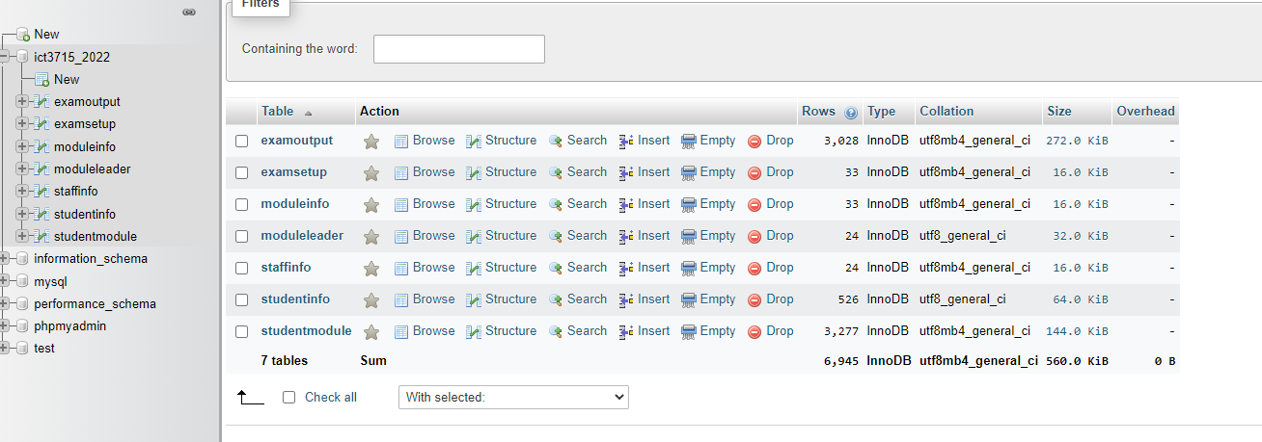

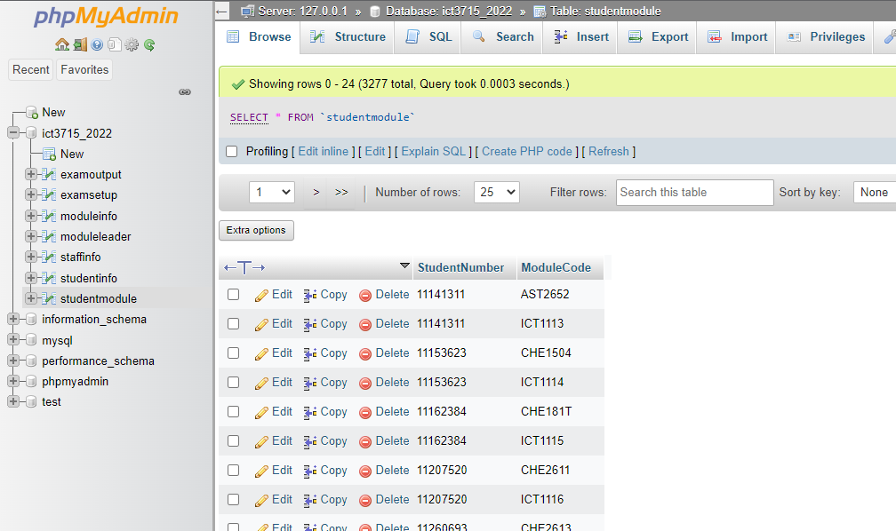

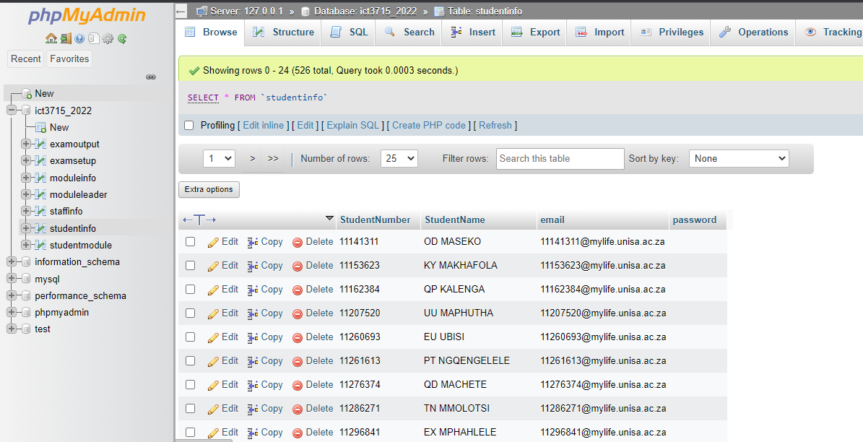

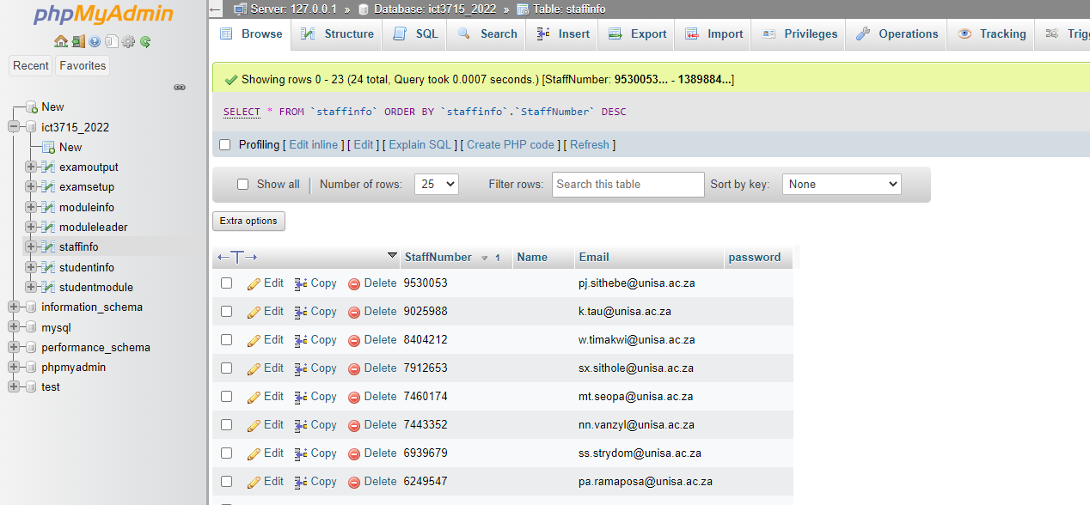

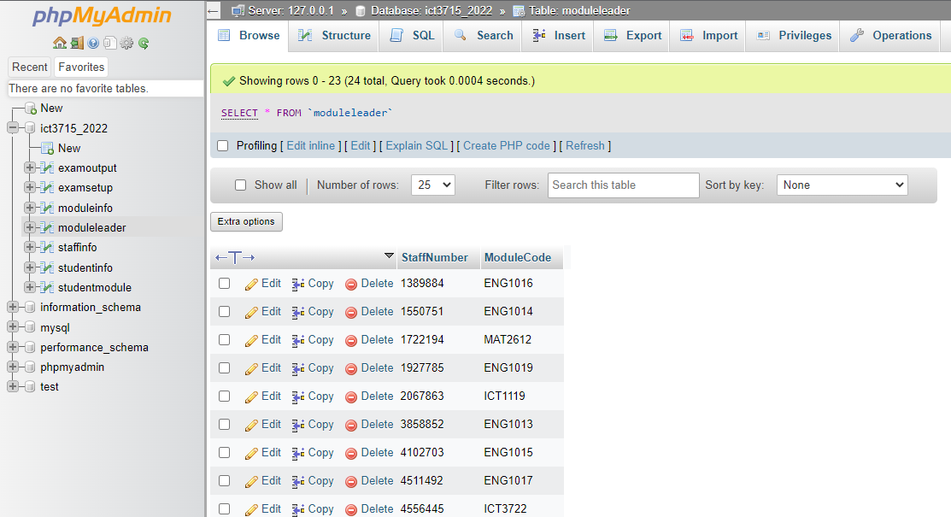

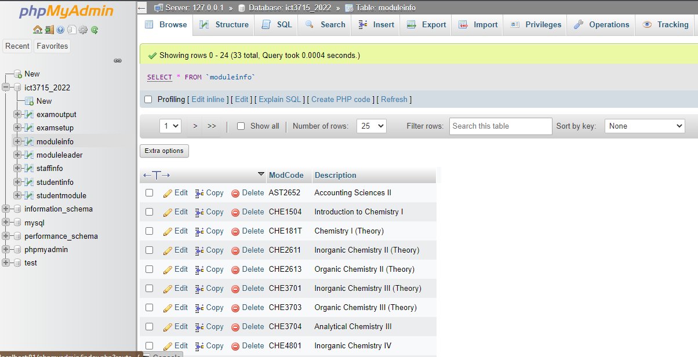

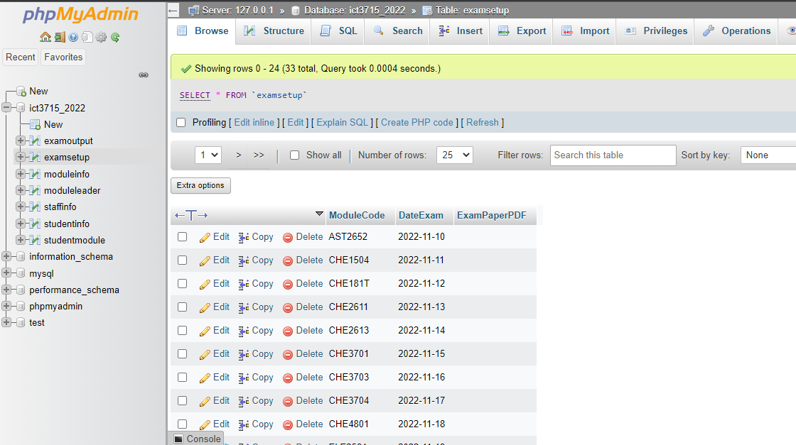

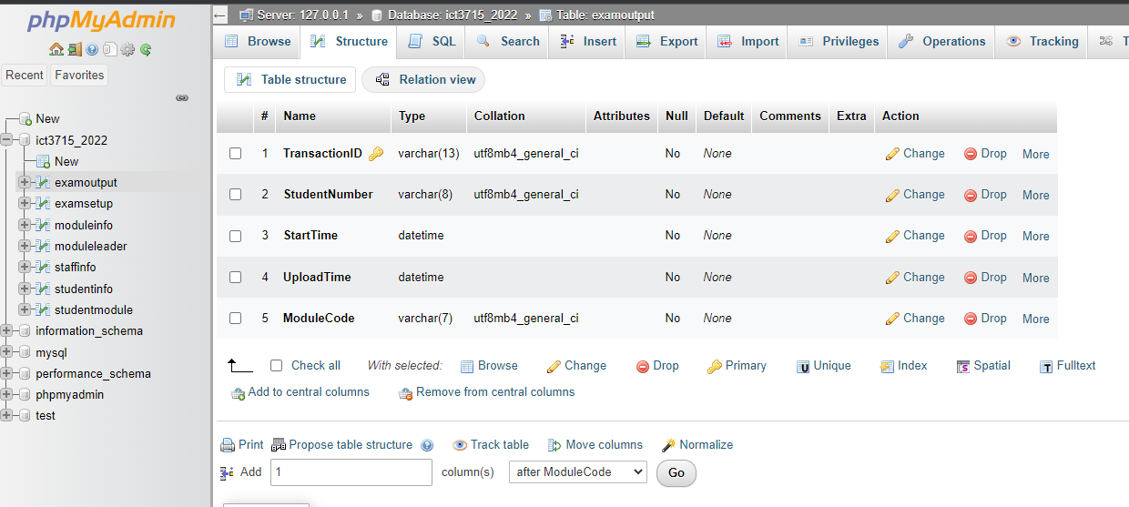

## Section B = Backup and Recovery for the Database and Programming code [10]

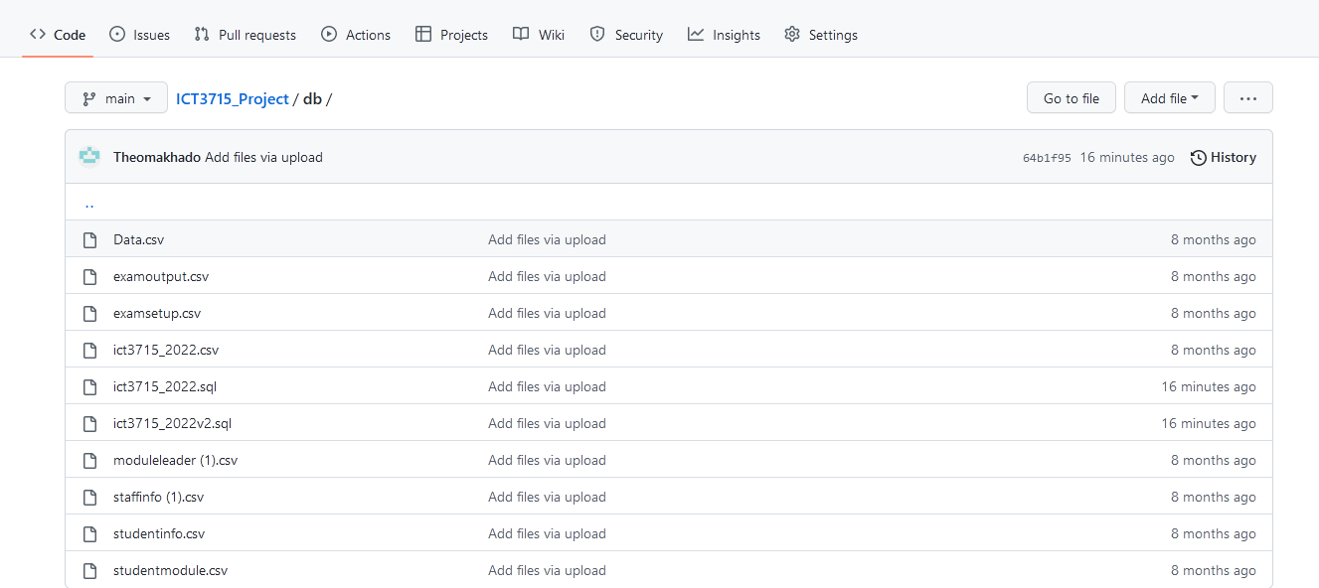

### Database (5)

1. I start by opening my xampp software and running PHPMyAdmin using the localhost
2. Then extract the sql and csv file from the database and it adds it to the downloads folder
3. Then this get uploaded on a weekly basis to my GitHub accounts as well as to Google Drive for extra backup
4. GitHub being a source control software I can commit changes and go back to previous changes. Basically, it allows me to track changes made to the database file
5. 000webhost will also be used to upload the database from the local server to a cloud-based server.
6. This is done weekly to keep track of changes and make sure I have no database crashes.

### Programming code & Portfolio (assignments) (20)

--

-- Database: `ict3715_2022`

--

-- --------------------------------------------------------

--

-- Table structure for table `examoutput`

--

CREATE TABLE `examoutput` (

`TransactionID` varchar(13) NOT NULL,

`StudentNumber` varchar(8) NOT NULL,

`StartTime` datetime NOT NULL,

`UploadTime` datetime NOT NULL,

`ModuleCode` varchar(7) NOT NULL

) ENGINE=InnoDB DEFAULT CHARSET=utf8mb4;

--

-- Table structure for table `examsetup`

--

CREATE TABLE `examsetup` (

`ModuleCode` varchar(7) NOT NULL,

`DateExam` date NOT NULL,

`ExamPaperPDF` varchar(150) NOT NULL

) ENGINE=InnoDB DEFAULT CHARSET=utf8mb4;

--

-- Table structure for table `moduleinfo`

--

CREATE TABLE `moduleinfo` (

`ModCode` varchar(7) NOT NULL,

`Description` varchar(100) NOT NULL

) ENGINE=InnoDB DEFAULT CHARSET=utf8mb4;

--

-- Table structure for table `moduleleader`

--

CREATE TABLE `moduleleader` (

`StaffNumber` varchar(7) NOT NULL,

`ModuleCode` varchar(7) NOT NULL

) ENGINE=InnoDB DEFAULT CHARSET=utf8;

--

-- Table structure for table `staffinfo`

--

CREATE TABLE `staffinfo` (

`StaffNumber` varchar(7) NOT NULL,

`Name` varchar(150) NOT NULL,

`Email` varchar(200) NOT NULL,

`password` text NOT NULL

) ENGINE=InnoDB DEFAULT CHARSET=utf8mb4;

CREATE TABLE `studentinfo` (

`StudentNumber` varchar(8) NOT NULL,

`StudentName` varchar(100) DEFAULT NULL,

`email` varchar(150) DEFAULT NULL,

`password` varchar(200) DEFAULT NULL

) ENGINE=InnoDB DEFAULT CHARSET=utf8;

--

**CREATE** **TABLE** `studentmodule` **(**

`StudentNumber` varchar**(**8**)** **NOT** **NULL,**

`ModuleCode` varchar**(**7**)** **NOT** **NULL**

**)** ENGINE**=**InnoDB **DEFAULT** CHARSET**=**utf8mb4**;**

--

--

-- Indexes for dumped tables

--

--

-- Indexes for table `examoutput`

--

ALTER TABLE `examoutput`

ADD PRIMARY KEY (`TransactionID`);

--

-- Indexes for table `examsetup`

--

ALTER TABLE `examsetup`

ADD PRIMARY KEY (`ModuleCode`);

--

-- Indexes for table `moduleinfo`

--

ALTER TABLE `moduleinfo`

ADD PRIMARY KEY (`ModCode`);

--

-- Indexes for table `moduleleader`

--

ALTER TABLE `moduleleader`

ADD PRIMARY KEY (`StaffNumber`,`ModuleCode`),

ADD UNIQUE KEY `ModuleCode` (`ModuleCode`);

--

-- Indexes for table `staffinfo`

--

ALTER TABLE `staffinfo`

ADD PRIMARY KEY (`StaffNumber`);

--

-- Indexes for table `studentinfo`

--

ALTER TABLE `studentinfo`

ADD PRIMARY KEY (`StudentNumber`);

--

-- Indexes for table `studentmodule`

--

ALTER TABLE `studentmodule`

ADD PRIMARY KEY (`StudentNumber`,`ModuleCode`);

COMMIT;





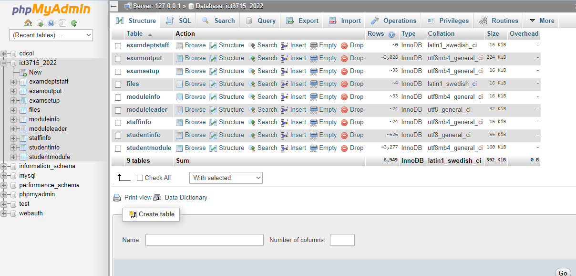

# Assignment 1

## Section A [4]

### Programming Languages (2)

PHP, JavaScript, jQuery, Bootstrap, Fusion Charts

### Database (2)

MySQL, PHPMyAdmin, MariaDB

## Section B [10]

### Cleaning the data

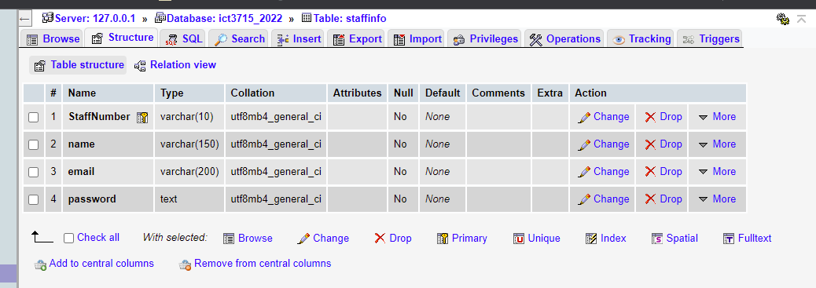

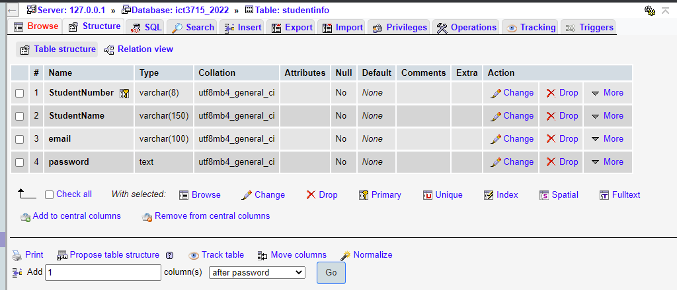

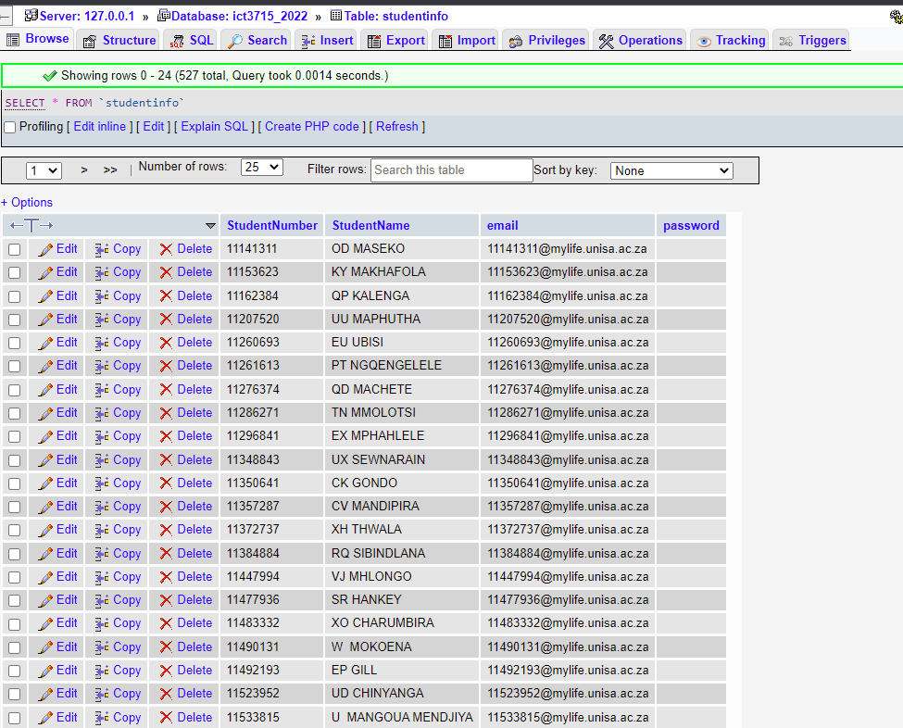

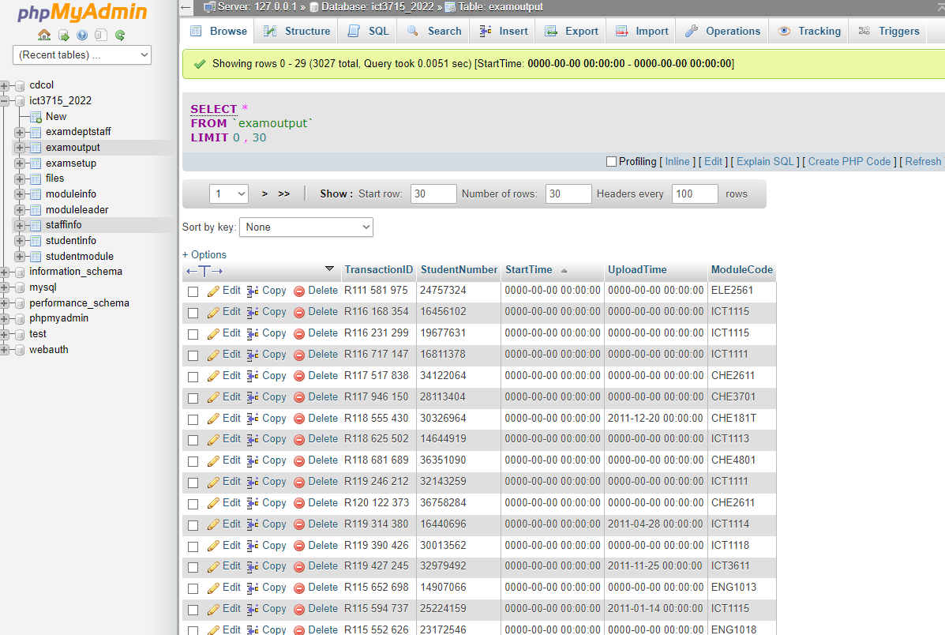

## Section C [10]

### Activity Diagram (7)

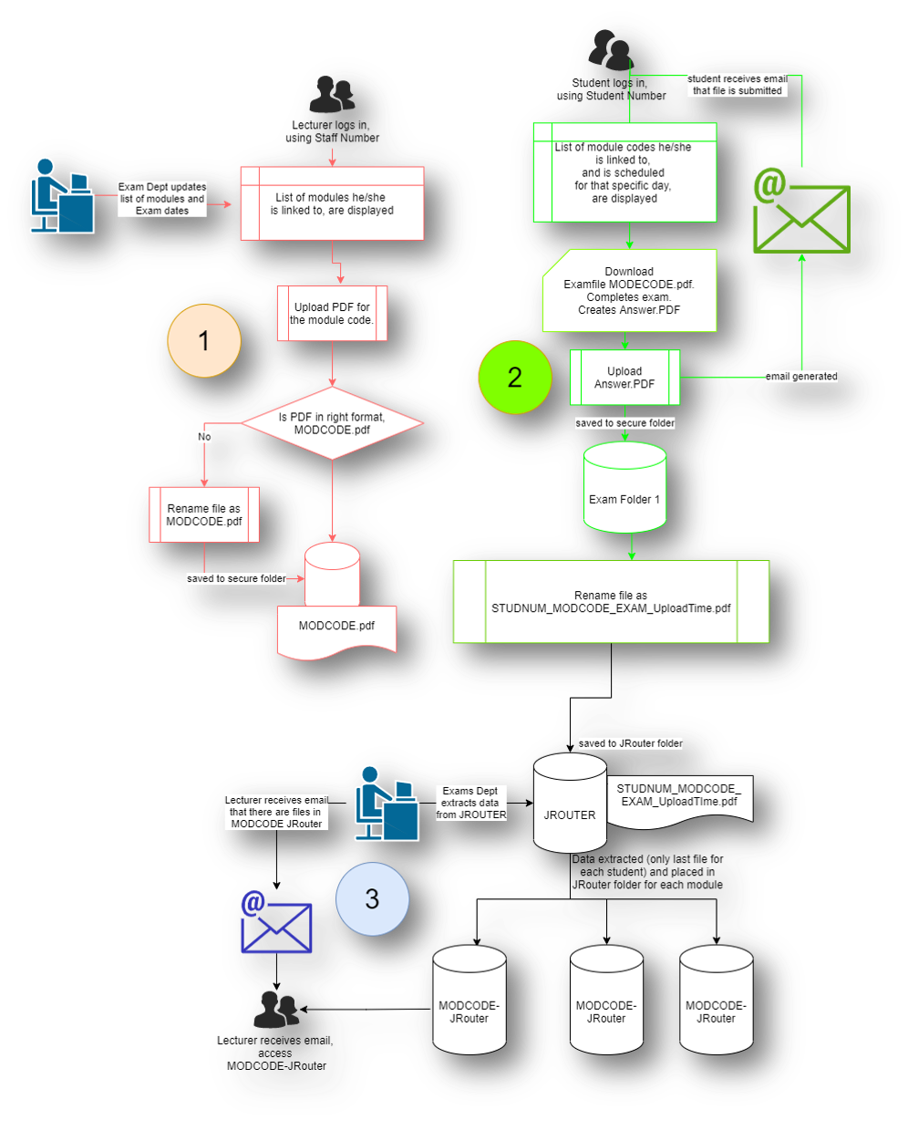

### ERD Diagram (3)

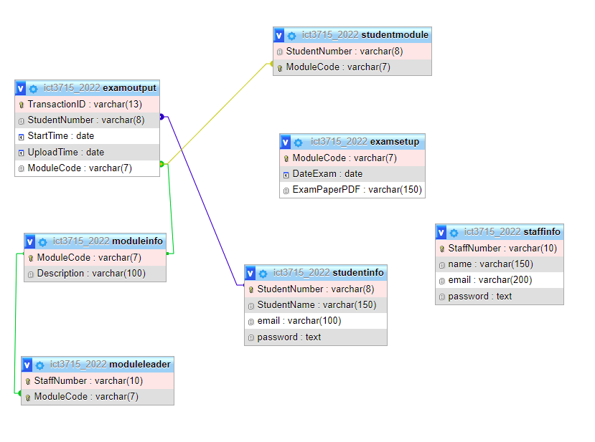

## Section Backup and Recovery for the Database and Programming code [6]

### Backup and Recovery Software for the Database (3)

GitHub, 000Webhost, mySQLWorkBench, dbForge

GitHub – is a provider of Internet hosting for software development and version control using Git. It offers the distributed version control and source code management functionality of Git, plus its own features.

000Webhost - Free web hosting tends to be so limited in capabilities and features that users must pay to get what they need. However, 000webhost is a free website hosting solution that provides an array of valuable features, including a website builder, WordPress support, and no ads.

mySQLWorkBench - MySQL Workbench is a visual database design tool that integrates SQL development, administration, database design, creation, and maintenance into a single integrated development environment for the MySQL database system.

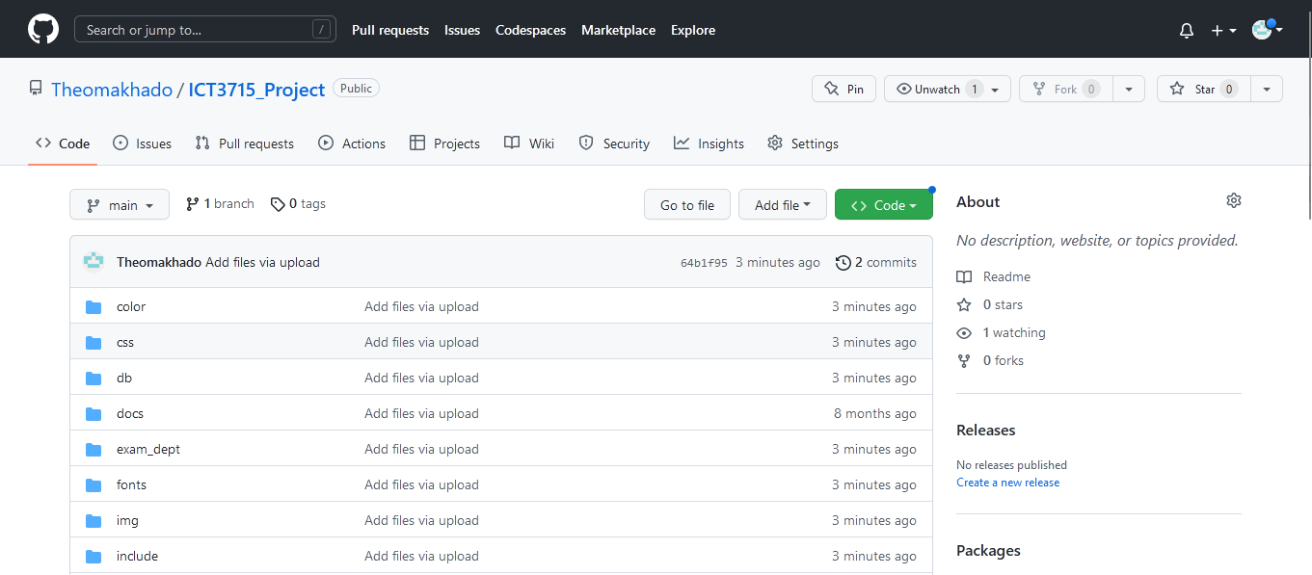

### Backup and Recovery process for the Programming code and your Portfolio (assignments) (3)

Google Drive, OneDrive, 000Webhost

Google Drive - is a file storage and synchronization service developed by Google. Google Drive allows users to store files in the cloud, synchronize files across devices, and share files.

Microsoft OneDrive is a file hosting service operated by Microsoft. It enables registered users to share and synchronize their files. OneDrive also works as the storage backend of the web version of Microsoft Office.

