# Task 2.1

## Normal Report

### Daily Report

View Modules

* This will display the information within the moduleinfo and examsetup table
* The columns selected are ModuleCode(examsetup), ModDesc, DateExam
* The table is then ordered by ModuleCode(examsetup)

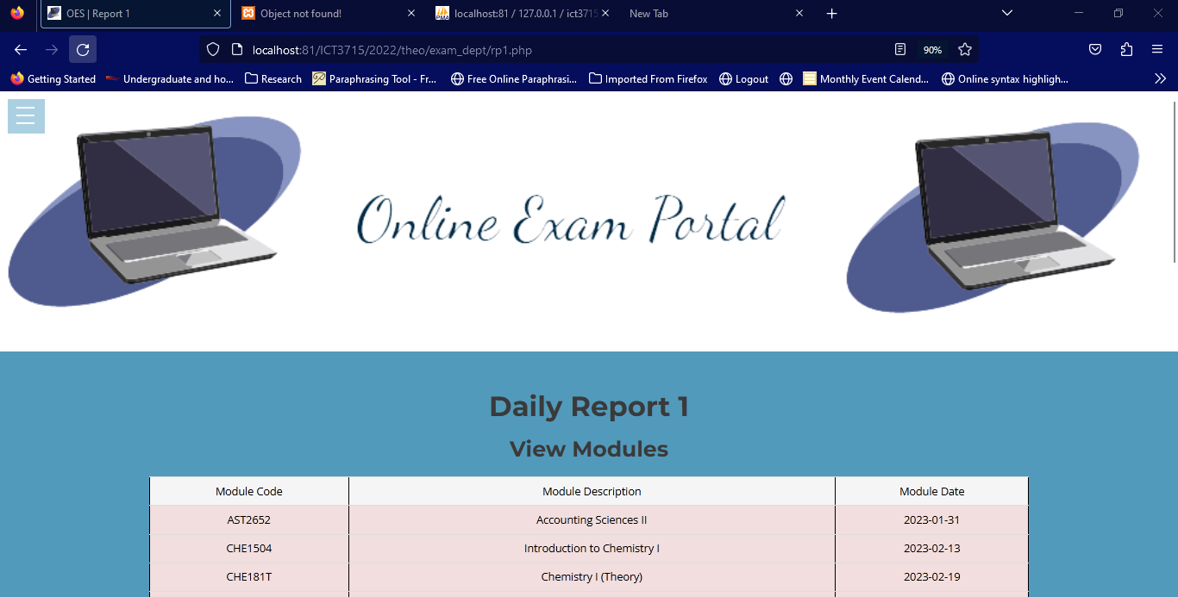

### Weekly Report

Count number of registered student per module

* This will display the information within the moduleinfo and studentmodule table
* The columns selected are ModuleCode(studentmodule), ModDesc, NoOfStudents
* The GROUP BY and HAVING clause is used
* COUNT function is also used

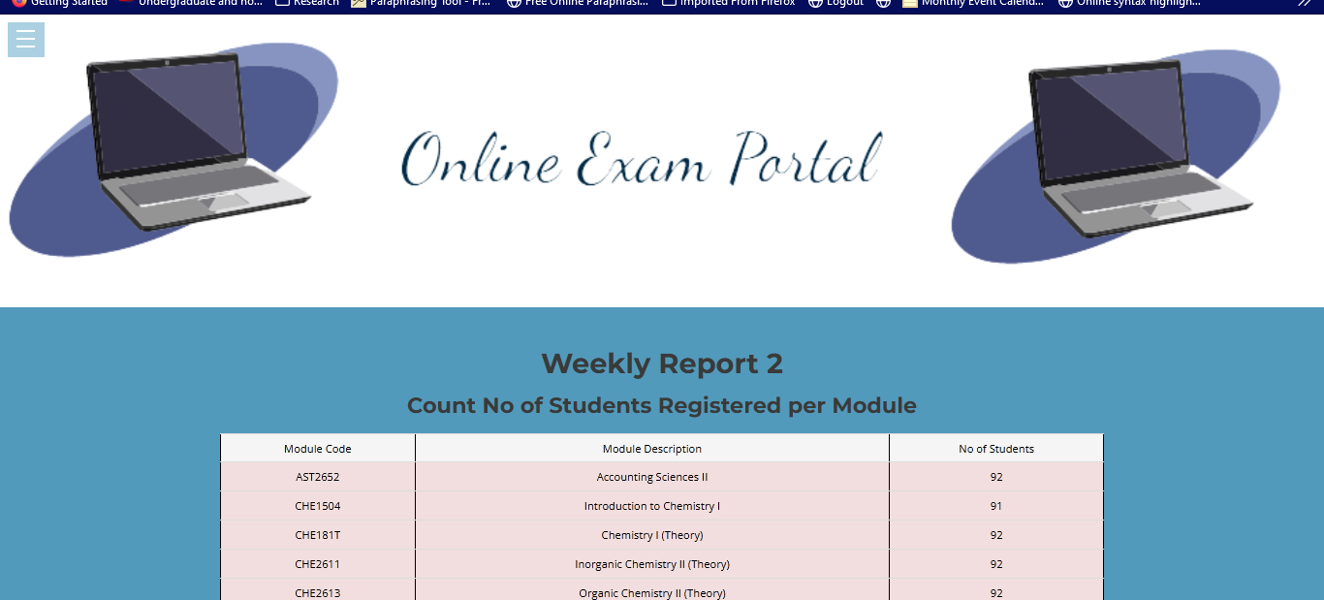

### Extra Report

Count number of students

* Total number of students

Count number of modules

* Total number of modules

Count number of lecturer

* Total number of lecturers

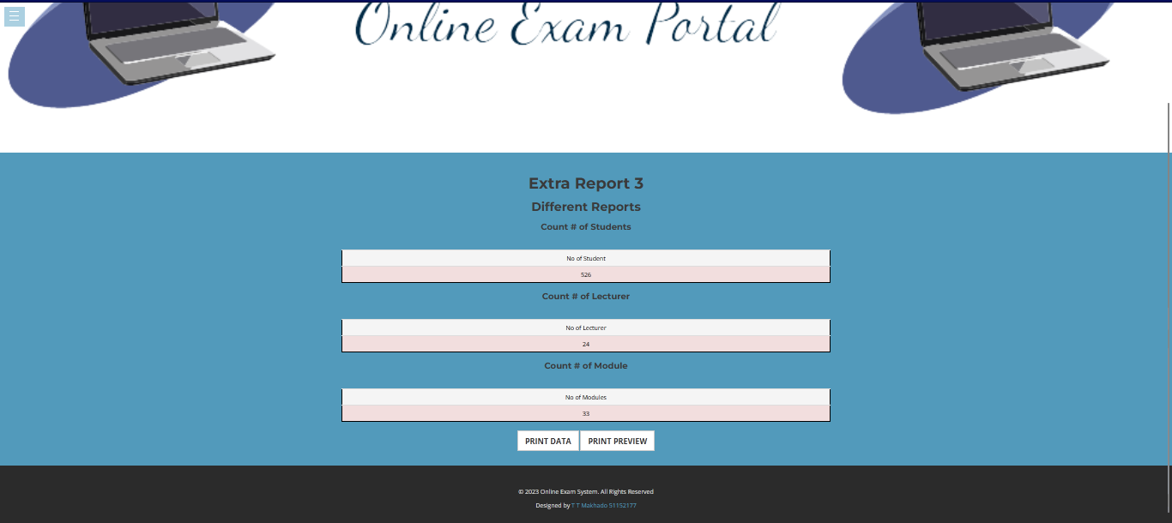

Modules and Lecturer Information

* Displays the module information and links it up with the lecturer information and exam date
* These are the tables used (moduleleader, moduleinfo, staffinfo, examsetup)
* The table is then ordered by ModuleCode(moduleleader)

## MIS Report

### MIS Report 1

3D Bar graph of modules with most registered student

### MIS Report 2

Bar graph with top module submissions

### MIS Report 3

Pie chart of top 5 modules average

