Hand gesture recognition & object detection
See the evolution of an old project

Petitjean Théo
University of burgundy, Vibot
Le creusot, France
theop31@hotmail.fr

Abstract—This report will focus on the work and the evolution of this work, for the VP project. It will focus on the evolution of my mind set during this project. Since I was a true newbie in this field, I tried different way and approach in order to learn and understand the most stuff than possible. It will focus more on color detection and some other feature in order to get our hand features and try to play on the recognition of its gesture.

Introduction
The main idea of this project come from an old project realized when I was in the IUT. The main goal of this project was, to make a robotics hand move in order to play, with a user, to the very known game ‘rock paper scissors. After my IUT, the project was at the point that, the hand gets designed and created, and also the code for making it move was working. At that point we started to guess to make it fully automatic, and wanted to implement a way to allows the hand to detect the position of the user hand. In order to do this, we were all ready at that time guessing about some way to detect the hand but unfortunately, we run out of time and stop the project here. So now 2 years after, I decide to try our previous expectation.
In order to achieve that I had first to start from the very beginning. Instead of detecting a hand, I first tried to detect simple object and features. That helped me a lot in order to understand and learn the different steps to follow in order to detect more or less properly a hand (which is in a sense a difficult and complex object). Then once those basics was more or less controlled and learned I start to see about the hand. So, I’ll try in this report to quote and go through each point I’ve learn and each problem I’ve more or less encountered.

Basics object detection

Features and flann matching
For this first part I focused myself on the most basics part of the detection of object. I tried by using OPEN-CV libraries to compute and see the features of different images. In order to do this, I refer to the different tutorial available online on the official web site of open cv. So, in this first time I tried to detect the features with different method. I tried to used SIFT, FAST, and SURF. I’ll quickly describe those method but for more information please check online courses of open cv [1]
- Sift (scale-invariant feature Transform): SIFT algorithm uses Difference of Gaussians which is an approximation of LoG. Difference of Gaussian is obtained as the difference of Gaussian blurring of an image with two different , let it be and .
- FAST (features from accelerated segment test): FAST (Features from Accelerated Segment Test) algorithm was proposed by Edward Rosten and Tom Drummond in their paper “Machine learning for high-speed corner detection” in 2006 (Later revised it in 2010).
- SURF (speeded up robust features): SURF goes a little further and approximates LoG with Box Filter. One big advantage of this approximation is that, convolution with box filter can be easily calculated with the help of integral images. And it can be done in parallel for different scales. Also the SURF rely on determinant of Hessian matrix for both scale and location.
The features drawing will look like the following figure: in the same order than the picture it is like this, sift/fast/surf
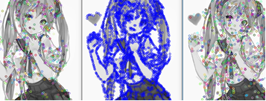
Figure 1: Drawn features
Once we have all those features, we can match the find feature in another images. In order to search and make of feature match on another image we will uses the inbuild function called FLANN [1]. This function will allow us to detect and make matches the features when they appear in a new image. SO, you load an image of the object you want to find back in a scene, get it’s features with on of the feature finder describe just before, then make it match thanks to the FLANN function. It will give you something like this:
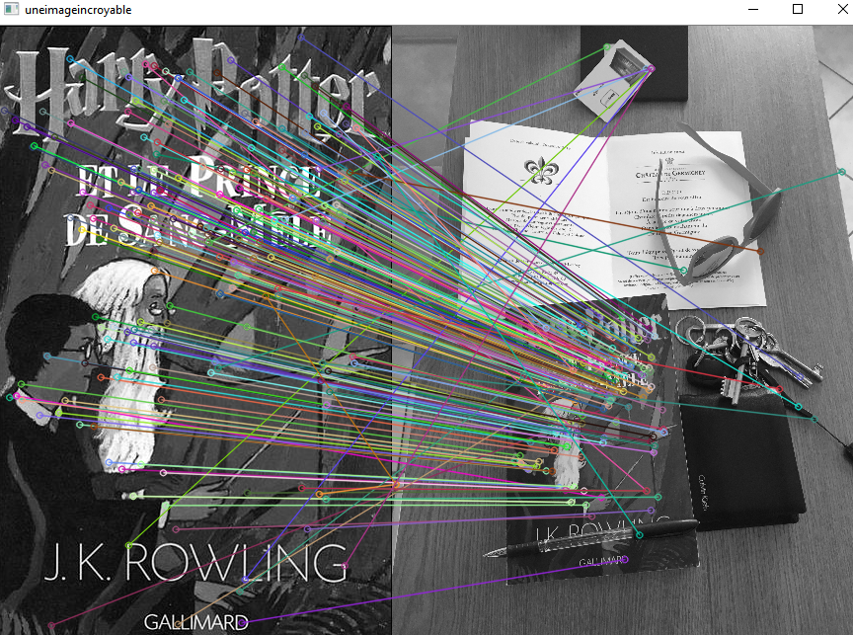
Figure 2: Point matching between 2 images

Features matching and Homography
In the same basic idea than just before, we first select an image on which we will apply a features detection. In our example I took an image of the book cover of Harry Potter. Once I’ve applied the FLANN matching and I’ve found the corresponding point in my camera frame, I’ll drawn a bounding box around the book cover and sow where the object is. This allow me to detect and track very easily one well defined object in a dynamic scene.
In order to make it more robust to deformation and the difference of distance between the point of my reference’s images and the frame, I’ll compute the holography in order to allow the deformation and see in a better way the object even when it’s bend, or tilted. In order to compute this part of the algorithm I refer a lot in the course of MSCV1 [2] but also some nice online example (they are to many to quote them all but to quote only him I refer to the work of source[3] which helped me a lot in order to understand and start programming in python)
We will have the following result:
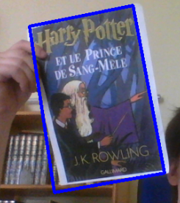
Figure 3 : Bounding box and homography result

Simple object detection based on it’s colour
Then once I’ve saw the previous basic method, I started to guess how to detect a hand. It appears to be a complex job and a lot of new method are using some deep learning and machine learning techniques. In my case I wanted to focus on more ‘classical’ methods so I tried to do it by using the colour range of the skin. In order to understand a discovers this method I tried to do it on strong colour such as blue.
So, I tried to change the colour range of my images by going in HSV range. Thanks to the HSV range I will be able to easily set some upper and lower colour in order to generate a mask that will remove all the other colour.
Once our image is changed in the HSV range, we have to generate the different value in order to create our threshold and to generate our mask. In order to do that I could set it in brut force by directly entering the value inside our code but I wanted my code to be a bit more automatic. There is some really nice feature online and they are many ways to do it, so I decide to change those value by using the open cv feature trackbar. This function will allow us to generate a trackbar for each and every channel upper and lower.
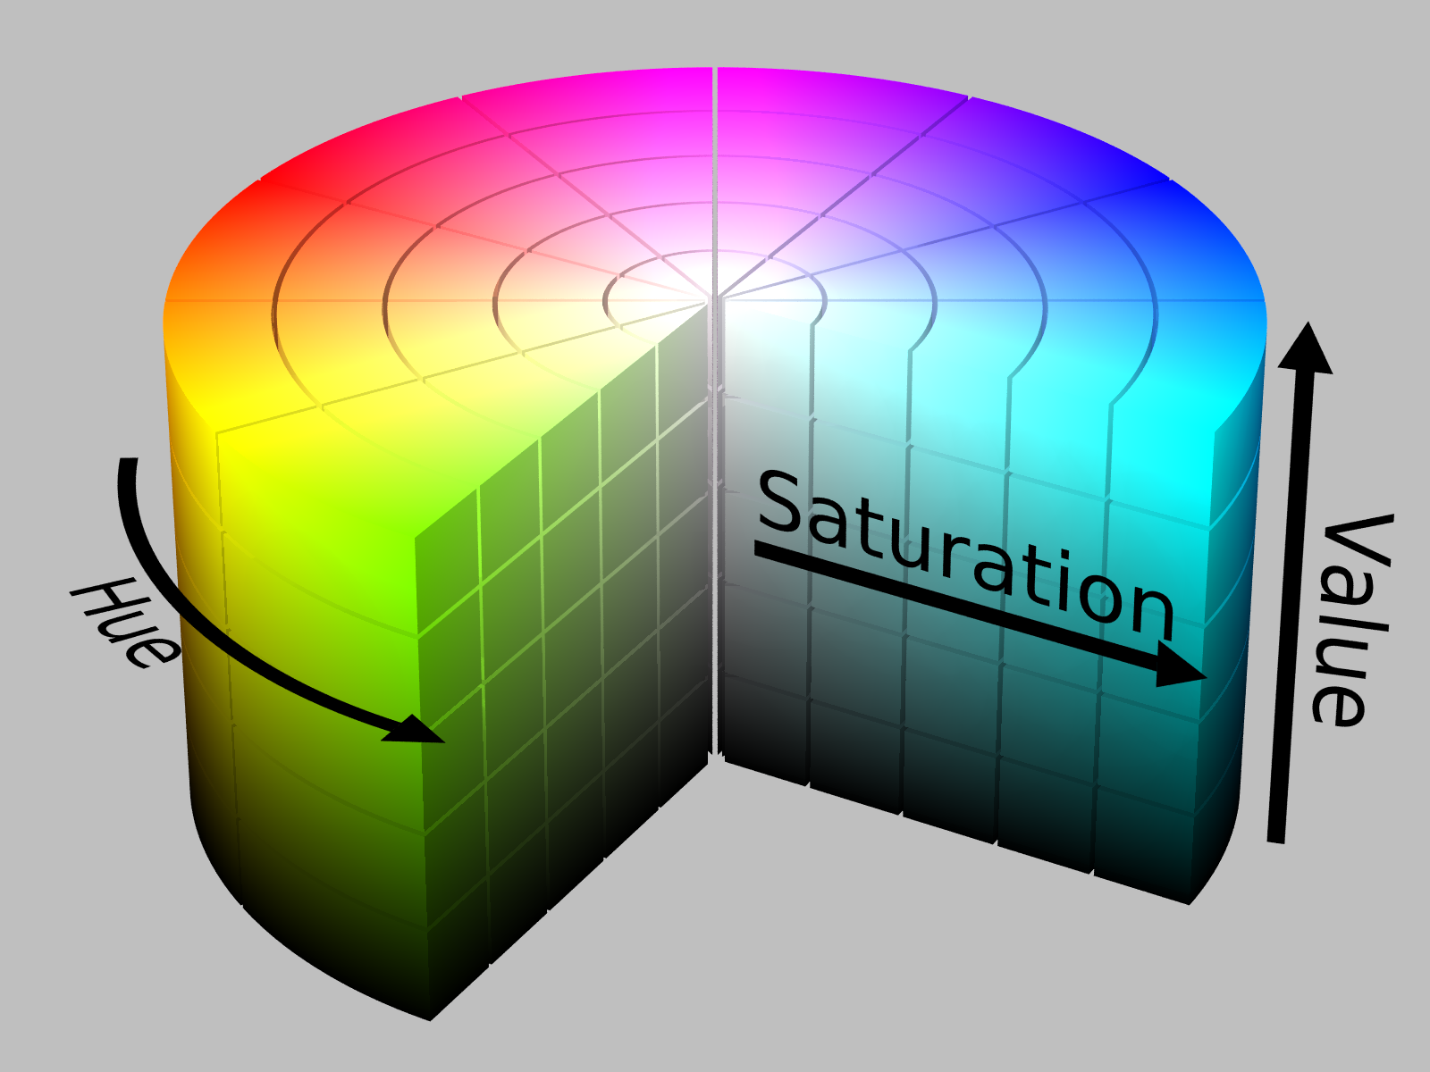
Figure 4: HSV description
As we can see on the previous figure the HSV colour range is composed of 3 channel, HUE, Saturation, And value. So, I created 2 trackbar for each channel, on for the lower value and the other for the upper value. It will allow us to play with it and to directly see if our mask is well defined and if the range value (given by the trackbar) are good enough for or application.
In the following example I set my trackbar in order to detect the blue colour of my chair. Once the mask is done, I can easily draw the contour of the object (since only its colour is kept, so it will draw a nice contour around the object detected. To this I added an algorithm that I found online which allow you to draw a circle and to put a dot at the centre of the detected object. It gives the following result:
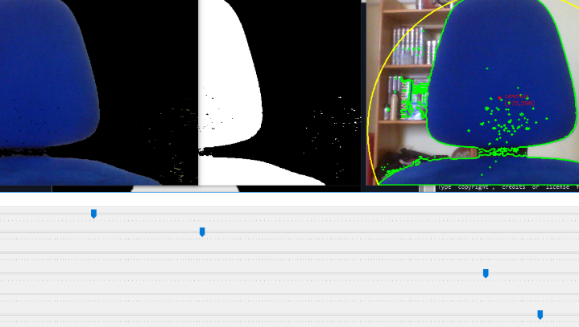
Figure 5: Colour detection
It exist also some other method to detect the object. I tried some of it but I quicly focued on the hand detection and I let thoses other method for may be some future work, they don’t appear to be so adapted for our example. Just to quote them I tried also mean shift and cam shift, and I also tried some stuff about the optical flow with Lucas Kanade method. I wanted to track signle point of the space but it apear to be unadapted at all.

Hand gesture
Now we will go a bit further in the hart part of this project. Detecting than recognize a hand gesture. In order to do that there was a lot of option. Here we will focus on the skin colour option. But I’ll quote here all the option I’ve been through when I was searching some solution. Such as I presented at the begin of this report, I first guessed about doing features matching in order to detect the 3-hand position of a shi fu mi game (rock paper and scissors). But I quickly let this method because it seems (to me to be not that appropriate.), I also guessed about doing shape matching with the convex hull, but we will discuss about that a bit later on.
In order to detect our hand, we will do some pre-processing steps. Before detecting by using skin colour I tried to use some other method, so I’ll describe them in a first time then I’ll focus on a common part of all those techniques which is the convex hull.

Binary try
First, I tried a very simple approach by only using some simple image processing method. So, in this first example, I try to do it with the following steps:
- Apply a blur on the image before binarize it in order to smooth a bit more the contours and the edge (open cv gaussian blur)
- Then binarize the images by setting proper threshold value (depend a lot on the light of the scene)
- Then once the image is binarize we apply a median blur in order to remove the most of the artefact of it.
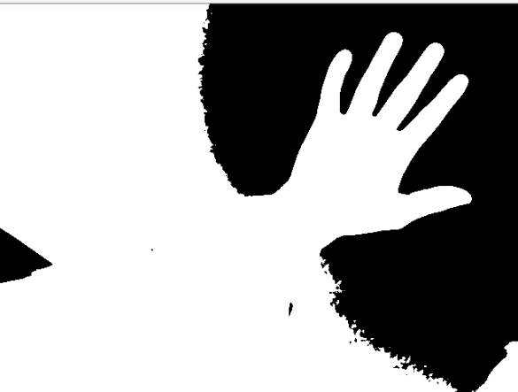
Figure 6 : first method result
We will discuss about the result in the part 4

Colour skin detection
In this part I tried to use back the knowledge I had won in the first part and my try in color detection. So, such as explain in the first part I tried to used my track bar to filter the color of the skin.
So exactly as before, I play with the track bare in order to sed the upper and lower range for the skin. This will allow me to create in an easy way a mask in order to keep only the hand.
Once this is done, we will be able to start working on the hand. We will describe just after the steps executed to detect the gesture and the different try; I’ve made about it.
Here is the result I get for a hand:

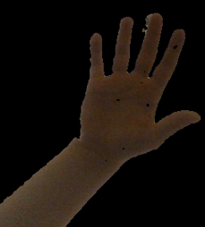
Figure 7: color filtering of the hand

Draw contour
Even is this prat being quite easy since I’m using the already build library of open cv it remains a really important since each following step are linked to this one. If this part encounters a problem all the rest of my program will be destroyed (I use here the inbuild function from open cv drawn and find contours). We can see on the following picture the contours are drawn in green on my result frame. We will have the following result:
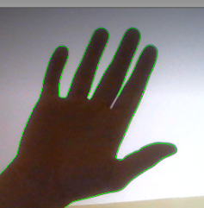
Figure 8 : hand with drawn contour

Convex hull and convex defect
Once we draw the contour, we will be able to compute the convex hull of this contour. In mathematics, the convex hull or convex envelope or convex closure of a set X of points in the Euclidean plane or in a Euclidean space (or, more generally, in an affine space over the reals) is the smallest convex set that contains X. For instance, when X is a bounded subset of the plane, the convex hull may be visualized as the shape enclosed by a rubber band stretched around X.
Formally, the convex hull may be defined either as the intersection of all convex sets containing X, or as the set of all convex combinations of points in X. With the latter definition, convex hulls may be extended from Euclidean spaces to arbitrary real vector spaces; they may also be generalized further, to oriented matroids.
As you can see the hull is a polygon spanned by the hand contour. In order to display this, we use the open cv function convexhull (for this part see more about it in the sources [4] and [5]).

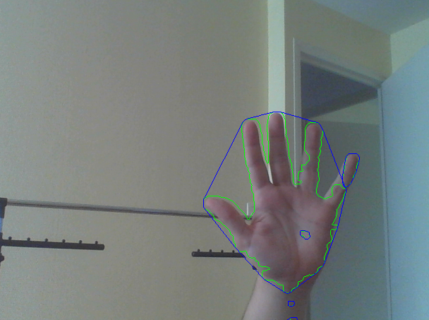
Figure 9: convex hull
Then once we have the shape of the convex hull we will display the convex defect (we still use the inbuild function of open cv).
With this feature we will be able to count those defects and in function of the number of it we will be able to detect the gesture provided by the user.
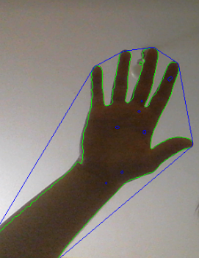

Figure 10: nice drawn of convex hull
Once we have a nice draw hull shape, we can compute the defect is will look like that:
The following image come from on of the paper I’ve read about this subject please find in the source [6] the reference to this paper.
Here we can nicely see the different part of the convex defect created with the hull.
By counting this point, we are able to detect what position the hand actually take.
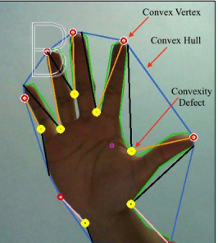
Figure 11: parameter of convex

conclusion and discusion
To conclude this report, we will talk about the different try and result that I’ve got during this project. It’s important to precise that at the very end my program work more or less. The part where I use convex defect was one of the main problems that I’ve encountered.
First of all, the detection of the hand remains really sensitive to the luminosity of the scene and isn’t that robust to the noise of the scene. The rare try where it worked was with very specific illumination and with a more or less homogeneous background. As we can see on the follow figure there is a lot of noise and some problem in order to deal with the noise and the rest. This problem could be probably fixed by using more parameter in convex hull and trying to filter the contour detected such like for example detecting the biggest shape drawn with the contours function.
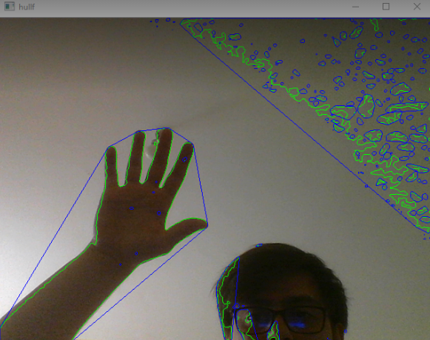
Figure 12 : noisy image destroy the counting of convex
I saw then that the fact that a lot of convex was created, was actually breaking my if loop that manage to draw on the last image a text box in which the position detected is displayed. For future work I should have to focus on the reducing of the noise and make my detection of hand more robust to ilimination change.
While I was doing this I’ve also checked more option in order to do this gesture detection but I didn’t get enougt time in order to implement it. I guessed about doing a shape matcher by using the global shape of the hull created for each position and make it match with some previous database. (a picture of each position on which I draw the hull with the same logic than on the camera. I also tried an other approch in order to detect the hand by using the HAar method but I didn’t get further enough in order to talk about It in this report.
As last world I’ll say that I miss some more time in order to totally finish this project and I’ll try to do it after word.

Acknowledgment
The project allow me to discover a lot of method about object detection, and background subtraction. I learned about the colour range a lot and how to deal with the draw contour and hull convex.
I’ve also discovered some nice principle in the hand gesture detection which was actually a really funny and interesting project.

References
Please find attached the references, if I forgot some, I’m deeply sorry about it I tried to remember all of them. Next project I’ll quote each and every reference that I used in my project. It’s important to quote that there is on some of the reference some hyperlink to the page that I’ve used.
- SIFT, FAST,SURF,FLANN tutorial from open cv online libraries (see link with hypertext)
- D. Fofi, course of VP .
- Sergio Canu, Different tutorial about python and open cv
- OpenCv website, convex hull documentation
- Wikipedia for the general culture about convex
- Pongsathorn Khetkun, Sirikan Chucherd, SIGN LANGUAGE TRANSLATION SYSTEM FOR SPEECH DISABILITY USING IMAGE PROCESSING

