Format original data from Kolpelke et al. 2016 with R

By Jens-Peter Kopelke, Tommi Nyman, Kevin Cazelles, Dominique Gravel, Steve Vissault and Tomas Roslin

November 18, 2016

For conciseness, the data are offered as a single spreadsheet with its variables defined in section B (above). To provide the tools for the correct import of this complex data set in R, for reshaping the spreadsheet format as a series of relational objects, and for exploring the resulting data structure, we here provide R code for the benefit of the data user. The approach is based on splitting the data set into different files for which primary keys (i.e. unique identifiers) are assigned, thus allowing the user to easily retrieve pieces of information from each files. Below, we offer examples of how to handle the data, how to obtain a quick map and how to use the data for network analyses.

# R and add-on packages

For this purpose, we use R (version >= 3.2; R Core Team 2016) and the following set of add-on packages:

Add-on packages used.

|  |  |
| --- | --- |
| packages | version |
| bipartite | 2.07 |
| dismo | 1.1-1 |
| igraph | 1.0.1 |
| magrittr | 1.5 |
| rgdal | 1.1.10 |
| raster | 2.5.8 |
| reshape2 | 1.4.2 |
| sp | 1.2.3 |

To run the following lines of code properly, the above packages must first be installed. For instance, to function used to reshape the data set requires function from the *magrittr* package to be installed and loaded. The code below install this specific package if not available, the user can do the same for all the packages listed above.

if(!require(magrittr)) install.packages("magrittr")  
library(magrittr)

# Reshaping the original dataset

The original dataset can be reshaped as follows:

Cleaning the existing ./csv/ and ./rdata/ folders if any,

unlink("./csv", recursive = TRUE)  
unlink("./rdata", recursive = TRUE)

Importing the R script which contains the reshaping function:

source("./lib/format4R.r")

Applying the reshaping function to the original dataset:

get_formatData("./data/Salix_webs.csv")

Two new folders have now been created (./csv/ and ./rdata/) in your working directory, within which six files have been added with the following contents:

|  |  |  |
| --- | --- | --- |
| File | row | description |
| df_site | 2029 | Location and of the sites |
| df_salix | 52 | Information on willow nodes |
| df_galler | 96 | Information on sawfly nodes |
| df_parasit | 126 | Information on parasitoids nodes |
| df_interact | 4749 | Interactions details among each node (willows, gallers, sawflies) |
| df_salix_galler | 2029 | Supplementary information on the interaction among willows and gallers |

# Exploring the new data structure

## Sampling sites

The next few lines will import and display the structure of the file describing the sampling units (i.e. file ./rdata/df_site.rds).

df_site <- readRDS("./rdata/df_site.rds")  
str(df_site, strict.width="cut")

## 'data.frame': 2029 obs. of 9 variables:  
## $ REARING_NUMBER: Factor w/ 2029 levels "198203W1-R3Ovimin",..: 320 321 ..  
## $ YEAR_OF_COLL : num 1987 1987 1987 1987 1987 ...  
## $ LEG : Date, format: "1987-07-20" "1987-07-20" ...  
## $ COUNTRY : chr "Austria" "Austria" "Austria" "Austria" ...  
## $ REGION : chr "Tirol" "Tirol" "Tirol" "Tirol" ...  
## $ SITE : chr "Gern-Alm" "Gern-Alm" "Zillertal, Hintertux/ Wei"..  
## $ NDECDEG : num 47.5 47.5 47.1 47.4 47.5 ...  
## $ EDECDEG : num 11.6 11.6 11.7 11.8 11.6 ...  
## $ ELEVATION : num 1253 1253 1769 1875 1253 ...

In this file, each row refers to a willow species sampled at a specific time (YEAR_OF COLL) in a given location (SITE). The field REARING NUMBER is the primary key of this table, and thus points to a unique record.

## Nodes

The command lines below will import and display the structure of the tables (available in ./rdata) associated with the different levels of the network.

### Willow species (df_salix.rds)

df_salix <- readRDS("./rdata/df_salix.rds")  
str(df_salix, strict.width="cut")

## 'data.frame': 52 obs. of 3 variables:  
## $ RSAL : Factor w/ 52 levels "Sal1","Sal10",..: 1 12 23 34 45 49 50 51..  
## $ SPECIES: chr "elaeagnos" "appendiculata" "myrsinifolia" "foetida" ...  
## $ AUTHOR : chr "Scop. 1772" "Villars 1789" "Salisbury 1796" "Schleich."..

This file contains information on the Salix species, with RSAL as its unique identifier (primary key).

### Galler species (df_galler.rds)

df_galler <- readRDS("./rdata/df_galler.rds")  
str(df_galler, strict.width="cut")

## 'data.frame': 96 obs. of 7 variables:  
## $ RGALLER : Factor w/ 96 levels "Eangus","Eappen",..: 63..  
## $ GENUS : chr "Pontania" "Pontania" "Pontania" "Pont"..  
## $ SPECIES : chr "elaeagnocola" "bridgmanii" "varia" "o"..  
## $ GENUS_SPECIES : chr "Pontania elaeagnocola" "Pontania brid"..  
## $ AUTHOR : chr "Kopelke 1994" "(Cameron 1883)" "Kopel"..  
## $ CODE_GALLTYPE : chr "RK1" "RK3" "RK4" "RK3" ...  
## $ CODE_GALLTYPE SIMPLIFIED: chr "Leaf blade sausage gall" "Leaf blade "..

This file contains information on galler species, with RGALLER as its unique identifier.

### Parasitoid species (df_parasit.rds)

df_parasit <- readRDS("./rdata/df_parasit.rds")  
str(df_parasit, strict.width="cut")

## 'data.frame': 126 obs. of 11 variables:  
## $ RPAR : Factor w/ 126 levels "Aacumi","Aalvea",..:..  
## $ ORDER : chr "Hymenoptera" "Hymenoptera" "Hymenop"..  
## $ SUPERFAMILY : chr "Chalcidoidea" "Chalcidoidea" "Chalc"..  
## $ FAMILY : chr "Eulophidae" "Eulophidae" "Eulophida"..  
## $ GENUS : chr "Anaprostocetus" "Aprostocetus" "Apr"..  
## $ GOODNESS OF ID : chr "species" "species" "species" "genus"..  
## $ P/I : chr "P" "P" "P" "P" ...  
## $ ENDO/ECTO : chr "Endo" "Endo" "Endo" "Endo" ...  
## $ KOINO/IDIO : chr "Koino" "Koino" "Koino" "Koino" ...  
## $ 1INSTAR/LINSTAR/COCOON/EGG: chr "1INSTAR" "1INSTAR" "1INSTAR" "1INST"..  
## $ FULL_NAME : chr "Anaprostocetus acuminatus (Ratzebur"..

This file contains information on parasitoid species, with RPAR as its unique identifier.

## Links

df_interact <- readRDS("./rdata/df_interact.rds")  
str(df_interact, strict.width="cut")

## 'data.frame': 4749 obs. of 6 variables:  
## $ REARING_NUMBER: Factor w/ 2029 levels "198203W1-R3Ovimin",..: 320 320 ..  
## $ RSAL : Factor w/ 52 levels "Sal1","Sal10",..: 1 1 1 1 1 12 12..  
## $ RGALLER : Factor w/ 96 levels "Eangus","Eappen",..: 63 63 63 63 ..  
## $ RPAR : chr "Pdolic" "Chalci" "Svesic" "Ccruxx" ...  
## $ N_GALLS : num 22 22 22 22 22 32 32 66 66 66 ...  
## $ NB_GALLS_PAR : num 9 3 2 5 1 7 8 2 27 1 ...

This file provides information of the interaction among gallers, willows and parasitoids. Here, RSAL, RGALLER and RPAR are foreign keys allowing us to retrieve information from files df_salix, df_galler and df_parasit, respectively.

df_salix_galler <- readRDS("./rdata/df_salix_galler.rds")  
str(df_salix_galler, strict.width="cut")

## 'data.frame': 2029 obs. of 10 variables:  
## $ RSAL : Factor w/ 52 levels "Sal1","Sal10",..: 1 12 23 ..  
## $ RGALLER : Factor w/ 96 levels "Eangus","Eappen",..: 63 60..  
## $ REARING_NUMBER : chr "198714E1-J1Oelaea" "198714L1-V1Obridg" ""..  
## $ LEG : chr "20.07.87" "20.07.87" "22.07.87" "20.07.8"..  
## $ N_GALLS : num 22 32 66 66 91 92 54 125 129 14 ...  
## $ N_CLEAN GALLS : num 0 7 0 14 0 8 8 0 12 5 ...  
## $ N_REAL GALLS : num 22 25 66 52 91 84 46 125 117 9 ...  
## $ PARASITISED_GALLS : num 20 15 30 34 78 27 24 8 1 1 ...  
## $ UNPARASITISED_GALLS : num 2 10 36 18 13 57 22 117 116 8 ...  
## $ TOTAL_PARASITISM RATE: num 0.909 0.6 0.455 0.654 0.857 ...

This file provides supplementary information on interactions among *Salix* species and sawflies species.

# Manipulation of files containing nodes and links files

## Binding files together

df_site <- readRDS("./rdata/df_site.rds")  
 df_interact <- readRDS("./rdata/df_interact.rds")  
 site_interact <- merge(df_site, df_interact, by="REARING_NUMBER")  
 head(site_interact)

## REARING_NUMBER YEAR_OF_COLL LEG COUNTRY REGION  
## 1 198203W1-R3Ovimin 1982 1982-06-15 Germany Hessen  
## 2 198203W1-R3Ovimin 1982 1982-06-15 Germany Hessen  
## 3 198203W1-R3Ovimin 1982 1982-06-15 Germany Hessen  
## 4 198203W1-R3Ovimin 1982 1982-06-15 Germany Hessen  
## 5 198204A-V1Ovimin 1982 1982-06-15 Germany Hessen  
## 6 198204A-V1Ovimin 1982 1982-06-15 Germany Hessen  
## SITE NDECDEG EDECDEG ELEVATION RSAL RGALLER RPAR  
## 1 Kühkopf, Mordhecke I 49.81667 8.416667 87 Sal10 Ovimin Eacicu  
## 2 Kühkopf, Mordhecke I 49.81667 8.416667 87 Sal10 Ovimin Etorym  
## 3 Kühkopf, Mordhecke I 49.81667 8.416667 87 Sal10 Ovimin Ilappo  
## 4 Kühkopf, Mordhecke I 49.81667 8.416667 87 Sal10 Ovimin Ccruxx  
## 5 Griesheim bei Darmstadt 49.85000 8.516667 92 Sal10 Ovimin Eacicu  
## 6 Griesheim bei Darmstadt 49.85000 8.516667 92 Sal10 Ovimin Etorym  
## N_GALLS NB_GALLS_PAR  
## 1 48 5  
## 2 48 8  
## 3 48 1  
## 4 48 5  
## 5 51 6  
## 6 51 1

To include taxonomic information on, for instance, sawflies, we have to merge df_galler with site_interact using the shared key RGALLER.

df_galler <- readRDS("./rdata/df_galler.rds")  
 site_interact_wth_taxo <- merge(site_interact, df_galler, by="RGALLER")  
 head(site_interact_wth_taxo)

## RGALLER REARING_NUMBER YEAR_OF_COLL LEG COUNTRY REGION  
## 1 Eangus 199436XEangus 1994 1994-10-19 Germany Hessen  
## 2 Eappen 1998SZ18Eappen 1998 1998-08-22 Austria Salzburg  
## 3 Eappen 1998SZ14Eappen 1998 1998-08-22 Austria Salzburg  
## 4 Eappen 1998SZ11Eappen 1998 1998-08-22 Austria Salzburg  
## 5 Eappen 1998SZ14Eappen 1998 1998-08-22 Austria Salzburg  
## 6 Eappen 1998SZ11Eappen 1998 1998-08-22 Austria Salzburg  
## SITE NDECDEG EDECDEG ELEVATION RSAL RPAR N_GALLS  
## 1 Kühkopf, Mordhecke III 49.85000 8.383333 85 Sal31 none 1  
## 2 Obertauern III 47.23333 13.566667 1656 Sal2 Chalci 10  
## 3 Tauernpaß, Tweng 47.18333 13.583333 1266 Sal2 Enobbe 92  
## 4 Obertauern III 47.23333 13.566667 1656 Sal2 Pdolic 160  
## 5 Tauernpaß, Tweng 47.18333 13.583333 1266 Sal2 Chalci 92  
## 6 Obertauern III 47.23333 13.566667 1656 Sal2 Chalci 160  
## NB_GALLS_PAR GENUS SPECIES  
## 1 0 Euura angusta  
## 2 5 Euura E. sp. / S. appendiculata  
## 3 1 Euura E. sp. / S. appendiculata  
## 4 1 Euura E. sp. / S. appendiculata  
## 5 50 Euura E. sp. / S. appendiculata  
## 6 15 Euura E. sp. / S. appendiculata  
## GENUS_SPECIES AUTHOR CODE_GALLTYPE  
## 1 Euura angusta (Hartig 1837) Sproß  
## 2 Euura E. sp. / S. appendiculata nicht vorh Knospe  
## 3 Euura E. sp. / S. appendiculata nicht vorh Knospe  
## 4 Euura E. sp. / S. appendiculata nicht vorh Knospe  
## 5 Euura E. sp. / S. appendiculata nicht vorh Knospe  
## 6 Euura E. sp. / S. appendiculata nicht vorh Knospe  
## CODE_GALLTYPE SIMPLIFIED  
## 1 Shoot gall  
## 2 Bud gall  
## 3 Bud gall  
## 4 Bud gall  
## 5 Bud gall  
## 6 Bud gall

## B. Turning into matrices

The package reshape2 allows us to turn long data formats into simple matrices.

if(!require(reshape2)){install.packages(reshape2);library(reshape2)}

## Loading required package: reshape2

### Community matrix

To build a community matrix detailing which species of willows are present in a specific year at a specific site, we write

commat_willows <- dcast(SITE+YEAR_OF_COLL~RSAL,data=site_interact,fun.aggregate=length,  
 value.var="RSAL")  
head(commat_willows[,1:7])

## SITE YEAR_OF_COLL Sal1 Sal10 Sal11 Sal12 Sal13  
## 1 Ahrenshoop, Darß 2009 0 0 0 0 0  
## 2 Albulapaß nr. Paßhöhe 1999 0 0 0 0 0  
## 3 Albulapaß nr. Paßhöhe 2000 0 0 0 0 0  
## 4 Aldino 2009 0 5 0 0 0  
## 5 Alta 2001 0 0 0 0 0  
## 6 Alta, Baeskades 1988 0 0 0 0 0

To achieve a similar tabulation of sawflies present at a specific site in a specific year, we use

commat_gallers <- dcast(SITE+YEAR_OF_COLL~RGALLER,data=site_interact,fun.aggregate=length,  
 value.var="RGALLER")  
head(commat_gallers[,1:7])

## SITE YEAR_OF_COLL Eangus Eappen Eatraa Eaurit Eboreo  
## 1 Ahrenshoop, Darß 2009 0 0 0 0 0  
## 2 Albulapaß nr. Paßhöhe 1999 0 0 0 0 0  
## 3 Albulapaß nr. Paßhöhe 2000 0 0 0 0 0  
## 4 Aldino 2009 0 0 0 0 0  
## 5 Alta 2001 0 0 0 0 0  
## 6 Alta, Baeskades 1988 0 0 0 0 0

To generate an interaction matrix among willows and sawflies, we use

df_interact <- readRDS("./rdata/df_interact.rds")  
sal_vs_gall <- dcast(RSAL~RGALLER,data=df_interact,fun.aggregate=sum,  
 value.var="N_GALLS")  
head(sal_vs_gall[,1:7])

## RSAL Eangus Eappen Eatraa Eaurit Eboreo Eciner  
## 1 Sal1 0 0 0 0 0 0  
## 2 Sal10 0 0 0 0 0 0  
## 3 Sal11 0 0 695 0 0 0  
## 4 Sal12 0 0 872 0 0 0  
## 5 Sal13 0 0 0 0 0 0  
## 6 Sal14 0 0 0 0 0 0

To generate an interaction matrix among sawflies and parasitoids, we write

df_interact <- readRDS("./rdata/df_interact.rds")  
gall_vs_par <- dcast(RGALLER~RPAR,data=df_interact,fun.aggregate=sum,  
 value.var="NB_GALLS_PAR")  
head(gall_vs_par[,1:7])

## RGALLER Aacumi Aalvea Acubic Adelog Agalli Aminim  
## 1 Eangus 0 0 0 0 0 0  
## 2 Eappen 1 0 0 0 0 0  
## 3 Eatraa 10 0 0 0 0 0  
## 4 Eaurit 28 0 0 0 0 0  
## 5 Eboreo 0 0 0 0 0 0  
## 6 Eciner 22 0 0 0 0 0

## Mapping sites

Here we show how to derive the map of the sampling, as shown in Fig. 1A (above).

We first load the packages needed and import the data set:

library(rgdal)

## Loading required package: sp

## rgdal: version: 1.2-6, (SVN revision 651)  
## Geospatial Data Abstraction Library extensions to R successfully loaded  
## Loaded GDAL runtime: GDAL 1.11.5, released 2016/07/01  
## Path to GDAL shared files: /usr/local/Cellar/gdal/1.11.5_1/share/gdal  
## Loaded PROJ.4 runtime: Rel. 4.9.3, 15 August 2016, [PJ_VERSION: 493]  
## Path to PROJ.4 shared files: (autodetected)  
## Linking to sp version: 1.2-4

library(raster)

##   
## Attaching package: 'raster'

## The following object is masked from 'package:magrittr':  
##   
## extract

library(dismo)

We then convert the sites into a spatial object (as described in the sp package):

df_site <- readRDS("rdata/df_site.rds")[,c(  
 "SITE", "NDECDEG", "EDECDEG")] %>% unique  
#  
sp_site <- SpatialPointsDataFrame(  
 df_site[,c("EDECDEG", "NDECDEG")],  
 df_site[c("SITE")],  
 proj4string = CRS("+proj=longlat +datum=WGS84 +no_defs  
 +ellps=WGS84 +towgs84=0,0,0")  
 )

We adopt a background map available on-line and add our points on top of it:

## background map  
bg_map <- gmap('Europe', type="satellite",  
 zoom=3, exp=1.1, scale=2, add=T)

## Loading required namespace: XML

## map  
par(mar=c(1,1,1,1))  
plot(c(-258698, 4351808), c(4350881, 11745460), asp=1, ann=F, axes=F, type="n")  
plot(bg_map, add=TRUE)  
plot(spTransform(sp_site, CRS("+init=epsg:3857")), add=TRUE,  
 col="grey25", bg="grey75", cex=1, pch=21)

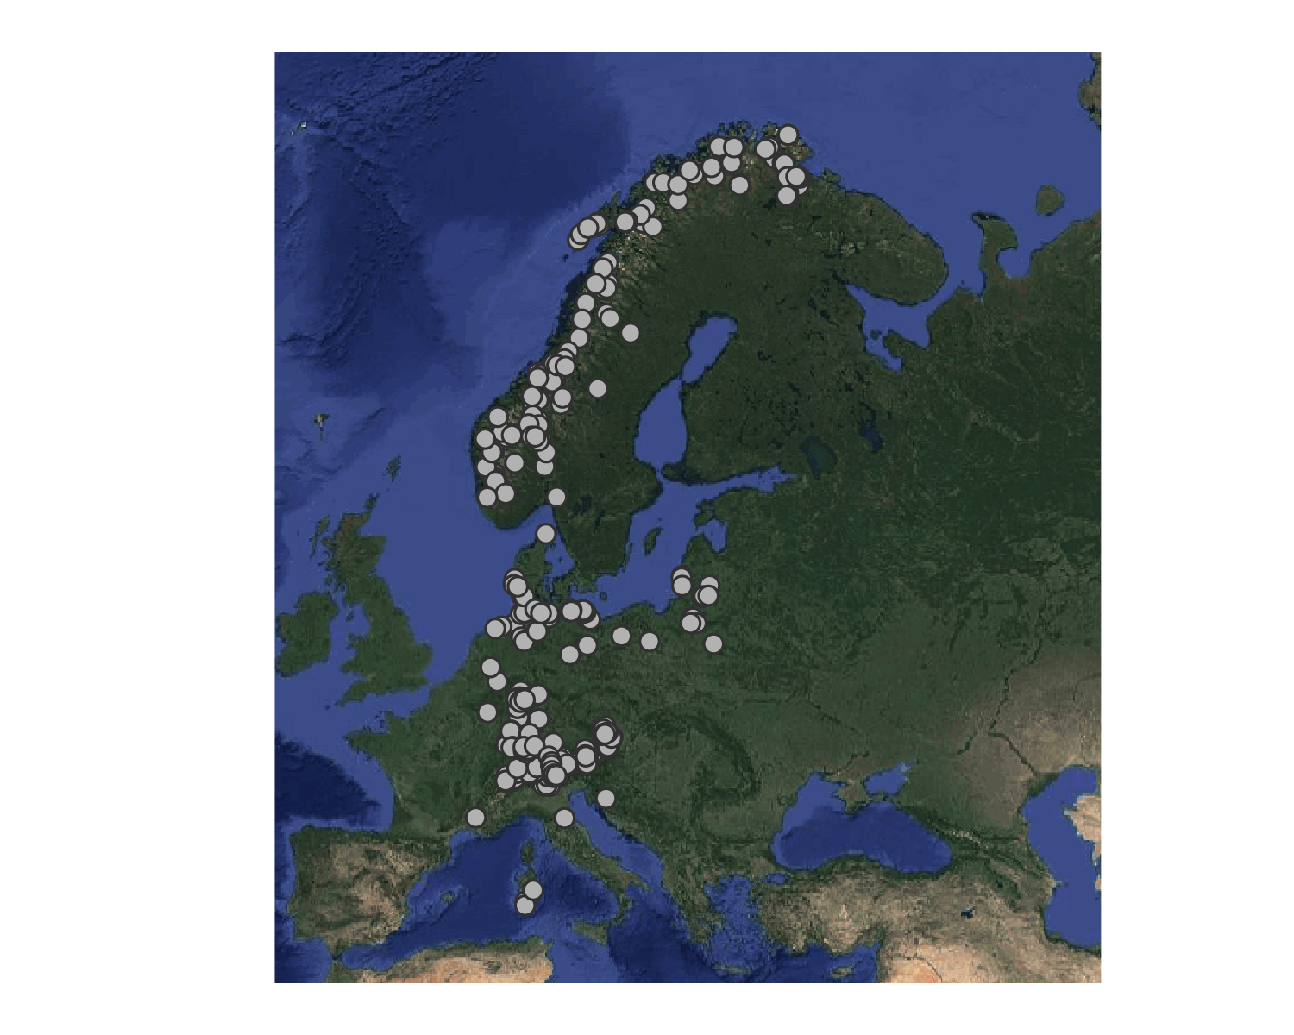

## Number of times the sites are visited

We are now able to easily retrieve the number of times a site is visited. Below we do do and display the barplot associated.

tmp <- readRDS("rdata/df_site.rds")  
par(las=1, cex.axis=.8, mgp=c(2, .4, 0), tcl=-0.2)  
cool <- tmp %>% `[`(,c("EDECDEG", "NDECDEG", "YEAR_OF_COLL")) %>%  
 unique %>% `[`(,c("EDECDEG", "NDECDEG")) %>%  
 apply(1,paste, collapse="/") %>% table %>% table %>%  
 graphics::barplot(border=NA, col="grey25")  
mtext(1, text= "Number of times visited", line=1.25)  
mtext(3, at=-1, text= "Number of sites", line=.8, adj=0)

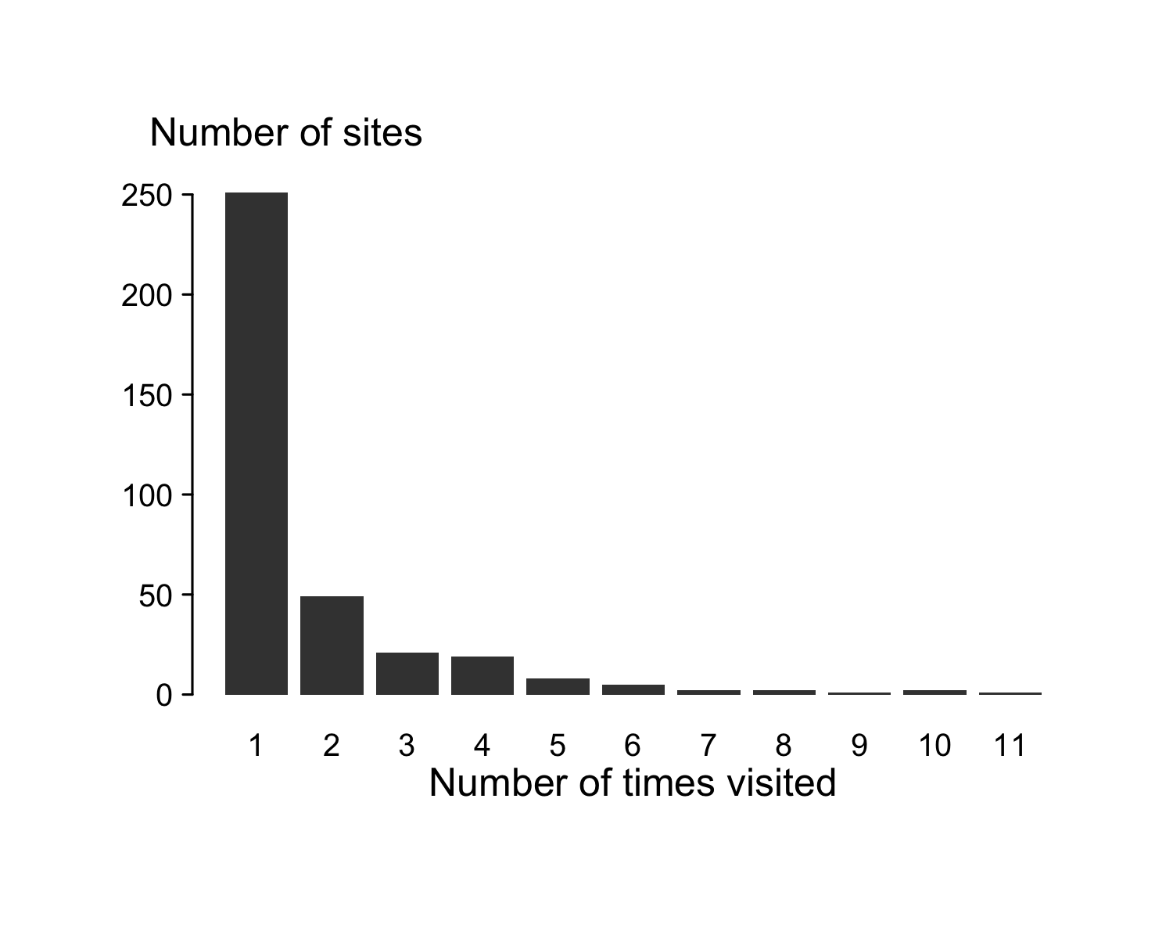

## Extracting environmental data from WorldClim

Converting sites into R spatial object (sp package) offers the possibility to gather environmental data from WorldClim (<http://www.worldclim.org/>) using the raster package. For instance, to retrieve the bioclimatic variables at each site:

We first download the bioclimatic rasters and then extract the values at each site location (using the sp_site spatial object previously created).

climate <- getData('worldclim', var='bio', res=2.5)  
clim_site <- extract(climate,sp_site,df=TRUE)

As result, we obtain a dataframe wherein each column corresponds to a bioclimatic variables (<http://worldclim.org/bioclim>) and each row is a specific site:

clim_site <- data.frame(SITE=sp_site@data$SITE,clim_site[,-1])  
str(clim_site)

## Interaction networks

We next show how to prepare the data to be used in R packages dedicated to network analyses. For this, we first load additional packages:

library(igraph)

##   
## Attaching package: 'igraph'

## The following object is masked from 'package:raster':  
##   
## union

## The following object is masked from 'package:magrittr':  
##   
## %>%

## The following objects are masked from 'package:stats':  
##   
## decompose, spectrum

## The following object is masked from 'package:base':  
##   
## union

library(bipartite)

## Loading required package: vegan

## Loading required package: permute

##   
## Attaching package: 'permute'

## The following object is masked from 'package:igraph':  
##   
## permute

## Loading required package: lattice

## This is vegan 2.4-3

##   
## Attaching package: 'vegan'

## The following object is masked from 'package:igraph':  
##   
## diversity

## Loading required package: sna

## Loading required package: statnet.common

## Loading required package: network

## network: Classes for Relational Data  
## Version 1.13.0 created on 2015-08-31.  
## copyright (c) 2005, Carter T. Butts, University of California-Irvine  
## Mark S. Handcock, University of California -- Los Angeles  
## David R. Hunter, Penn State University  
## Martina Morris, University of Washington  
## Skye Bender-deMoll, University of Washington  
## For citation information, type citation("network").  
## Type help("network-package") to get started.

##   
## Attaching package: 'network'

## The following objects are masked from 'package:igraph':  
##   
## %c%, %s%, add.edges, add.vertices, delete.edges,  
## delete.vertices, get.edge.attribute, get.edges,  
## get.vertex.attribute, is.bipartite, is.directed,  
## list.edge.attributes, list.vertex.attributes,  
## set.edge.attribute, set.vertex.attribute

## sna: Tools for Social Network Analysis  
## Version 2.4 created on 2016-07-23.  
## copyright (c) 2005, Carter T. Butts, University of California-Irvine  
## For citation information, type citation("sna").  
## Type help(package="sna") to get started.

##   
## Attaching package: 'sna'

## The following objects are masked from 'package:igraph':  
##   
## betweenness, bonpow, closeness, components, degree,  
## dyad.census, evcent, hierarchy, is.connected, neighborhood,  
## triad.census

## This is bipartite 2.08  
## For latest changes see versionlog in ?"bipartite-package".  
## For citation see: citation("bipartite").  
## Have a nice time plotting and analysing two-mode networks.

##   
## Attaching package: 'bipartite'

## The following object is masked from 'package:vegan':  
##   
## nullmodel

## The following object is masked from 'package:igraph':  
##   
## strength

df_interact <- readRDS("rdata/df_interact.Rds")

### Using the 'bipartite' package

The lines below creates a contingency table suited for the 'bipartite' package.

bip_salgal <- df_interact[,c("RSAL","RGALLER")] %>% table  
bip_galpar <- df_interact[,c("RGALLER","RPAR")] %>% table

As an example of the information to be extracted, we compute the C-score using the same package:

C.score(bip_galpar)

## [1] 0.7891025

### Using 'igraph'

We here create the metaweb, *i.e* the network including all the interactions described in the dataset. First, we create two networks, one for associations between plants and herbivores, and one for associations between herbivores and their parasitoids, respectively:

mweb_salgal <- df_interact[,c("RSAL","RGALLER")] %>% unique  
igr_salgal <- data.frame(  
 from = mweb_salgal$RSAL,  
 to = mweb_salgal$RGAL  
 ) %>% graph_from_data_frame(directed=TRUE)  
#  
id <- df_interact$RPAR!="none"  
mweb_galpar <- df_interact[id,c("RPAR","RGALLER")] %>% unique  
igr_salpar <- data.frame(  
 from = mweb_galpar$RGAL,  
 to = mweb_galpar$RPAR  
 ) %>% graph_from_data_frame(directed=TRUE)

Then we combine the two networks:

metweb <- igraph::union(igr_salgal, igr_salpar)

As an example of the information contained by these matrices, we compute the degree for (*i.e.* number of species associated with) each *Salix* species.

igraph::degree(metweb)[1:20]

## Sal1 Sal2 Sal3 Sal4 Sal5 Sal6 Sal7 Sal8 Sal9 Sal10 Sal11 Sal12   
## 3 4 4 4 3 3 4 3 7 6 4 4   
## Sal13 Sal14 Sal15 Sal16 Sal17 Sal18 Sal19 Sal20   
## 2 8 3 6 5 8 4 4

# References

1. R Core Team (2016). R: A language and environment for statistical computing. R Foundation for Statistical Computing, Vienna, Austria. URL <https://www.R-project.org/>.