ECE411 Lab2 Report

RUI ZENG 1003979091

**4 Experiment**

**4.1** Continuous Control Design Using Linearized Model

**1)**

choose f1 = 7 f2 = 1

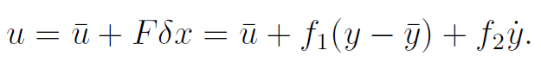

Response of y:

**2)**

choose f1 = 3.2 f2 = 0.14 α=10

文本

Both output feedback control and state feedback control can lead y to reach equilibrium but the rate of reaching equilibrium are different. Also the parameter chosen for f1,f2 is different in output feedback control.

**4.2** Digital Control Design for the Nonlinear System

**1)**

Add zero-order hold with T = 0.05

choose f1 = 7 f2 = 1

黑色的钟表

**2)**

f1 = 3.2 f2 = 0.14 α=10 T = 0.05

**卡通人物

**

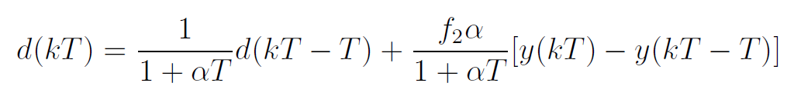

**3)** f1 = 3.2 f2 = 0.14 α=10 T = 0.05

CT controller

文本

Convert to DT controller

**形状

**

The discretized controller makes y to stabilize around 10s with vibration.

The output feedback controller makes y to stabilize around 10s with vibration, the output is similar to the output of discretized controller.

The state feedback controller makes y to stabilize faster at 2s with less vibration.

**4)**

Here we are using the discretized controller and increasing $δx(0)$

$$x\left(0\right)=\overline{x}+δx\left(0\right) \overline{x}=[\begin{matrix}0.5 \\ 0\end{matrix}]$$

The largest $δx(0)$ that system still reach equilibrium

$$δx\left(0\right)=[\begin{matrix}1.4 \\ 1.1\end{matrix}]$$

The smallest $δx(0)$ that system begin to not reach equilibrium

$$δx\left(0\right)=[\begin{matrix}1.5 \\ 1.2\end{matrix}]$$

Graph of y when $$δx\left(0\right)=[\begin{matrix}1.5 \\ 1.2\end{matrix}]$$

That the equilibrium is no longer reached

**5)**

Here we are using the discretized controller and increasing sampling time T

$$δx\left(0\right)=[\begin{matrix}0.8 \\ 0.5\end{matrix}]$$

|  |  |  |  |  |  |
| --- | --- | --- | --- | --- | --- |
| T = 0.05 | T = 0.1 | T = 0.11 | T = 0.12 | T=0.13 | T=0.15 |
| work | work | work | work | Not work | Not work |

we found that

T = 0.12s y still can reach equilibrium

T = 0.13s y no longer reach equilibrium

Now investigate with larger sampling time, will the range of initial value become smaller.

|  |  |
| --- | --- |
| T /s | Largest $δx\left(0\right)$ that y still reach equilibrium |
| 0.05 | [1.4 1.1] |
| 0.12 | [0.8 0.5] |

From the table above with larger T allowable range of initial deviation become smaller.