**Assignment No. 1**

**Subject: Artificial Intelligence**

**Class: TY core/ TY NS**

Q.1 Compare Goal based agent and Utility agent.

Q.2 For each of the following agents, develop a PEAS description of the task environment:

i. Soccer Playing Robot

ii. Internet Shopping Agent

Q.3 Simple reflex agent works well in fully observable environment”. Justify, also list down different properties of the environments?

Q.4 Draw and explain learning agent. Discuss the significance of performance measure in learning agent.

Q.5 Simple reflex agent works well in fully observable environment”. Justify, also list down different properties of the environments?

Q.6 Draw and explain learning agent. Discuss the significance of performance measure in learning agent.

Q.7 Find an optimal solution using A* algorithm, also state number of nodes in open list at the time of algorithm convergence.

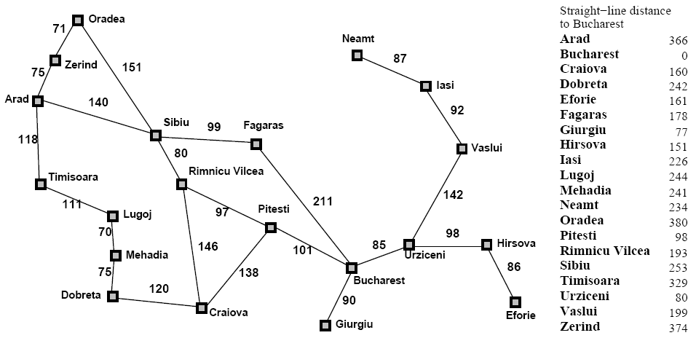

Initial State: Arad Goal State: Bucharest