API Tournament Builder

Planning

Original proposal

The original Proposal for this project was to be a full stack web application for Aberwistwyth University squash team. It was to build a tournament tracker to track the progress of a tournament know as old buys which they have every year, in this tournament old graduates of the uni return to play with the current university students.

This was going to take players name to create a player in the tournament and produce a group table with all the relevant fixtures. They wanted built in scale-ability to the back-end so that the front end could be manipulated in the future to create different tournament structures such as a knockout or double elimination knockout, they also wanted to be able to put people against the players they used to play against while they where at university in these cases. Therefore the back-end had to be able to differentiate between a group match, to track the players wins/losses in the group for example, and had to take in a graduation year.

The Frameworks used

The back-end uses a Spring framework as it it one of the best for making Rest Api’s in java. Using a Controller level listening for the request being made, a Service level handling the logic, the interface repository layer talking to the database and the entity level handling the model.

As I required a relational database I went with MySql, its a simple relational database which is easy to use.

For my original front end plan, before it was removed from the scope, was to use an angular framework using Type-script, HTML and SCSS.

Version control was done using git and GitHub

Alternative frameworks considered

For the back-end the scala play framework was considered as an alternative because of its increased speed handling requests however for the rest api being built slow responses was never going t be an issue.

A NodeJs Framework could also have been used but was rejected as it is an unconventional choice for the backend.

for the front end I could have used Twirl play framework but decided against this as it is more suited to used with a play backend framework.

The Postgress and Mongo database’s were also considered but as Mongo is non relational it would not have fit the requirements and postgress

The Design

The design stage started with me working with the squash society president in designing what the web-page specifically needed, what it was going to be required to do and what it was going to look like. The results of these meetings was some basic wire-frames the colour theming.

The agreed upon frameworks for the front end and the database are shown below.

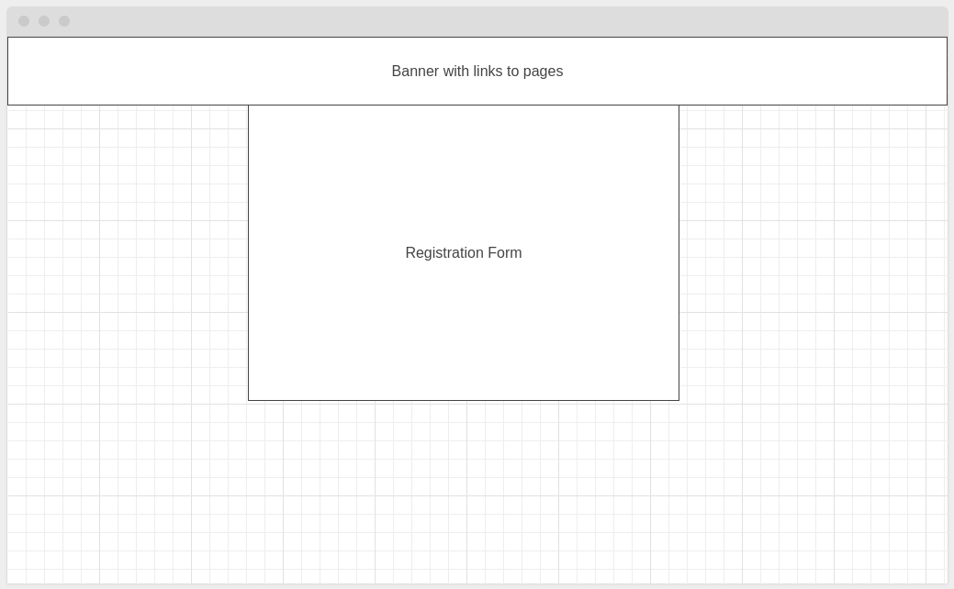
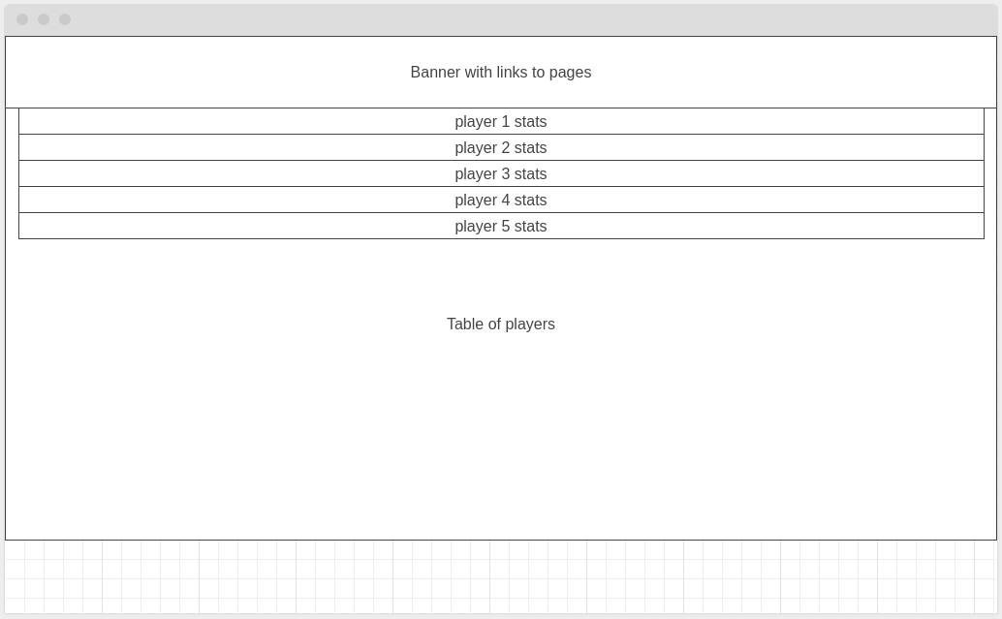
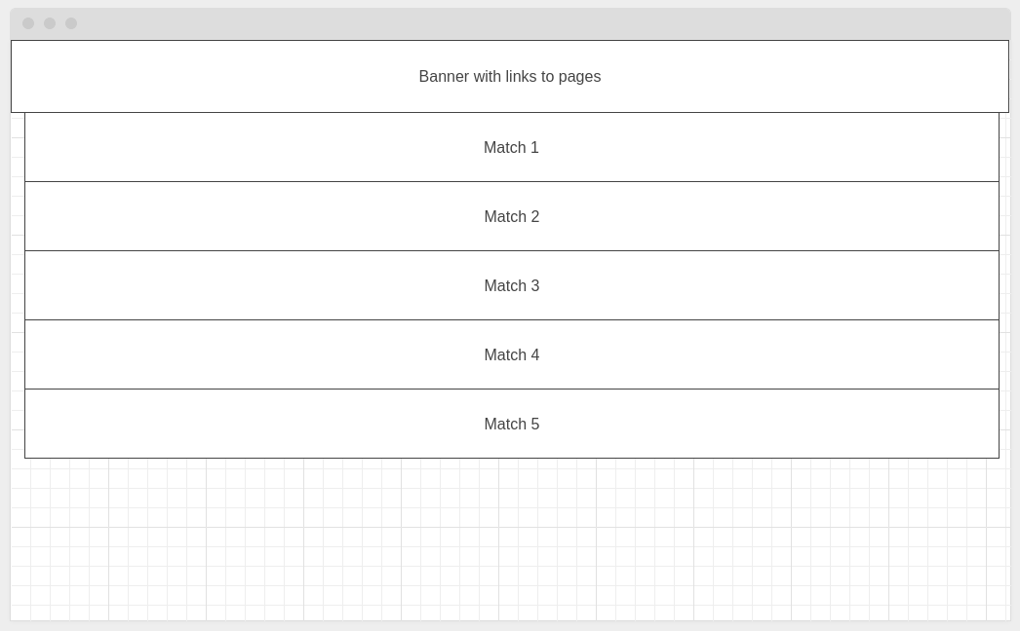
Development

The Early Project
So development began with a basic layout of the Front-End, get all the pages created and all the fields set out with placeholder data. The homepage/registration page, the page showing all players, the page showing the standings once the tournament has been started, the page to show all fixtures and results. No major problems occurring during this phase of development.

Then the back-end development began, Used spring initiliser in intellij. Then began by building out the entities then conecting to the MySql database which caused a few problems. There was no user set up in mysql so I had to use “sudo mysql” to get in and input a user into the MySql database to be able to use it. Following this minor setback I went about building my first API. A get all Api for the players.

I went about it this way as it is the easiest one to build and this would test to make sure everything was set up right. It was not, there was a and error on startup cause by either multiple versions of the servlet or an outdated version of the servlet being used. I couldn't figure out what the problem was for quite some time. And in this time the scope of the project changed.

The new scope

As the project went on and other spots clubs at the university heard about the builder they all wanted a similar thing. This however was not going to be possible in a full stack as they all required different things. So an agreement with the university was made to make the API’s for all the teams to use with that same basic setup and they design their own front ends as a 3rd party with access to The API’s.

So now at a stage where I required nothing but a back-end, it was this part which was causing all the trouble. With no help online and none of my trusted debugger sources not being able to figure it out either (it got to the point where I was asking anyone who knew java at all) I decided to just initilise a new project. Doing this and then copying over all my old code had fixed the issue and I could now get back to work with the building. I quickly had the basic crud functionality Api’s built and was well on the way.

As an Api only service I now also required documentation for each Api, including a the call for the Api, the endpoint, the requirements in the request, and the error messages produced. Which was an important requirement so that the customer can understand what the Api will do for them and how they can make it do it.

Testing

the tools
For the testing I used J-unit and Mokito.

The Testing
Testing of the Api’s was fairly easy. Not much much testing required. Smoke testing and unit testing. All of which were completed with 95% line coverage and 98% method coverage.
