Egyptian E-Learning University

Faculty of Computers & Information Technology

  - Project title

Digital psychiatrist platform
By
Zaki Salah Zaki Hashem | 2201049
Mohamed Mohamed Abdelzaher Hofny | 2201279
Yahia Hassan Ragab Elsayed | 2201267
Fatma Alkzafy Ahmed Elsayed | 2201170
Basma Yousif Elsayed Soliaman | 2201151
Mariam Mahmoud Mohamed Mahmoud | 2201392
Fatma Momen Farok | 2201236
Menna Amgad Abdelrahman Mohamed | 2201161

  - Supervised by
Dr. Khaled Tawfiq Wassef
  - Assistant
Eng. Khaled Mohamed Mahmoud
[Sohag]-2026

Abstract
Our project introduces a Digital Psychiatrist Platform designed to make mental health support easier, safer, and more accessible for everyone. Many people struggle with stress, anxiety, or emotional difficulties, yet avoid seeking help due to fear, stigma, or the challenge of finding the right specialist. This platform provides a private and comfortable solution using modern technology.
The experience begins with an AI-powered assistant, available as a text-based chatbot or a realistic virtual avatar. It provides an initial psychological assessment in a friendly and supportive manner. If the system detects that the user’s condition may be serious or requires urgent professional attention, it immediately recommends the most suitable doctors based on location, expertise, and patient reviews to ensure their safety. For moderate cases, the platform offers only the initial AI assessment and guidance.
Patients can easily book either an online video consultation or an
in-clinic visit, with secure online payment for both options. Each doctor has a detailed profile showing their experience, specialties, and ratings, helping users make confident and informed choices.
Doctors can send digital prescriptions (PDF) after online sessions, and the platform securely stores chat history, reports, and medical notes in a private patient archive.
Overall, the Digital Psychologist Platform offers a simple, modern, and confidential way to receive reliable mental health support whenever it’s needed.

Acknowledgments
First of all, we thank God for His blessings and guidance, which have helped us throughout our college years and during our graduation project. Without Him, we could not have completed this important stage of our lives. Completing this project required great effort, and we are deeply grateful to everyone who supported us along the way. Their help, encouragement, and cooperation made this achievement possible.
We would like to thank the Egyptian E-Learning University, especially the Sohag Center, for providing us with the knowledge, resources, and environment that helped us grow and learn.
Our deepest gratitude goes to our project supervisor, Dr. Khaled Tawfiq Wassef, for giving us the opportunity to work under his guidance. His valuable advice, continuous support, and trust have been truly inspiring. It was an honor to learn from him.
We also extend our heartfelt thanks to Eng. Khaled Mohamed Mahmoud for his guidance, patience, and constant encouragement. His positive spirit, motivation, and kindness had a great impact on our progress.
Finally, we would like to thank everyone who contributed to our journey and supported us throughout this graduation project. We truly appreciate every effort made on our behalf.

Contents
Abstract 2
Acknowledgments 3
Introduction 5
Literature Review / Related Work 13
Proposed system 24
Implementation 48
Testing & Evaluation 72
Results & Discussion 74
Conclusion & Future Work 76
References 78
Appendices (Optional) 80

Chapter 1

Introduction

1.1 Introduction
In a world where stress, anxiety, and emotional pressure are becoming part of everyday life, the need for accessible and trustworthy mental health support has never been more urgent. Yet, for millions of people, reaching out for psychological help remains a difficult journey whether due to social stigma, lack of nearby specialists, or the overwhelming complexity of navigating different platforms to find the right support.
The Digital Mental Health Platform emerges as a revolutionary step toward transforming how individuals seek and receive psychological care. Instead of fragmenting the patient’s journey across multiple tools and websites, the platform brings everything together in one intelligent, secure, and human-centered ecosystem.
At its core lies a powerful AI-driven virtual assistant capable of providing an initial psychological analysis, allowing users to understand their emotional state in a safe and private environment. This is not meant to replace doctors, but to guide users toward the right direction from the very first interaction making the experience smoother, faster, and less intimidating.
If professional support is needed, the system instantly recommends the most suitable psychiatrist or therapist based on their expertise, location, and patient feedback. Each doctor has a detailed profile that builds trust and helps patients make informed decisions.
With just a few clicks, users can book an appointment either online via video call or offline at the clinic and complete payments securely through the platform. Doctors, in turn, can issue digital prescriptions (PDF) and manage patient archives that include chat history, reports, and previous diagnoses. Every aspect of interaction is safeguarded with advanced privacy controls and role-based access levels for patients, doctors, and administrators.
By combining artificial intelligence, modern web technologies, and the expertise of certified mental health professionals, this platform offers more than just a service. It offers a safe space, a reliable companion, and a digital bridge connecting people to the help they need whenever and wherever they need it.

1.2 Background and Motivation
Over recent years, mental health has gained global attention, with predictions that mental disorders may become one of the leading health burdens by 2030. This rise is fueled by fast-paced lifestyles, digital stress, and the emotional impact of recent world events. Yet, despite this growing awareness, many challenges still stand in the way of accessing proper psychological care. Social stigma prevents many from visiting a psychiatrist, and remote areas often lack qualified specialists. Patients also face fragmented systems one platform for AI chat, another for doctor booking, and a third for payments making the process confusing and inefficient. Privacy concerns further discourage users from seeking help online, while the rising demand for telemedicine requires safer and more integrated solutions. Most existing platforms focus on isolated features: some offer online consultations without psychological assessment tools, others provide basic AI chatbots without access to real therapists, and many fail to ensure secure data handling or continuity of care. The Digital Mental Health Platform was created to bridge these gaps. It offers early psychological screening through an AI assistant, smooth referral to suitable doctors, a unified workflow for booking and payments, secure storage for patient data, and a supportive environment where users can seek help without fear or judgment. The
Motivation behind the project is simple to build a digital space that protects privacy, respects human emotions, and makes mental health support accessible to everyone, anywhere.

1.3 Importance of the Problem
Mental health problems are becoming a serious issue worldwide. Millions of people struggle with anxiety, depression, and stress every day, often in silence. The hardest part is knowing where to turn for help. Right now, the system is confusing and scattered AI chatbots, therapist directories, and appointment platforms are all separate. This makes it harder to get timely care and can turn treatable problems into bigger issues.
Many patients feel lost, stressed, and afraid of being judged. Doctors and therapists often cannot reach the people who need them most. Clinics struggle with messy records and poor coordination, and communities rarely have safe spaces to talk openly about mental health. In places with limited resources or language barriers, the problem is even worse, leaving many people without support when they need it most.
The Digital Mental Health Platform is designed to fix these problems. It offers
AI-powered early assessments, smart doctor recommendations, easy online or offline appointments, digital prescriptions, and a secure archive for patient records. By bringing everything together in one place, it makes the process of getting help smooth, safe, and stress-free.
This project is more than just technology it is about helping people in real life. It gives patients the confidence to seek care, reduces suffering, and saves lives. By connecting patients, doctors, and communities, it creates a supportive environment where mental health is taken seriously and help is easy to reach.
In a world where mental health problems are often ignored until they become serious, this platform offers real help. Its AI-powered virtual assistant provides an initial assessment, guides people to the right doctors, and gives tools to manage their mental health. By making care easy, fast, and personalized, it helps prevent crises and supports everyone anytime, anywhere.

1.4 Problem Statement
Many people struggle to get the mental health support they need. Finding help is often confusing and stressful because services are scattered across different apps and platforms. One app may offer an AI chatbot, another lists doctors, and yet another handles appointments or payments. This makes it hard to get timely care and can increase stress, anxiety, or worsen treatable conditions.
Existing solutions only cover parts of the problem. Some let you book a doctor but offer no assessment tools. Others provide AI chatbots but no access to real therapists. Many platforms also fail to keep patient data secure or maintain a clear history of care. These gaps are even bigger in regions where resources are limited or where language and cultural barriers make it harder to find reliable help. The Digital Mental Health Platform solves this by bringing everything together in one place. It uses an AI assistant to give early assessments, recommends the right doctors, allows easy appointment booking, stores patient records securely, and even provides digital prescriptions. It also creates a safe space for users to get guidance and support without fear or stigma.
By centralizing these services, the platform not only saves time and reduces stress for patients, but it also helps doctors reach those who need care most and improves the efficiency of clinics. It encourages early intervention, preventing small problems from becoming serious crises. This integrated approach can change the way mental health care is accessed, making it faster, safer, and more effective for everyone.
Additionally, the platform empowers users to track their progress over time, review past consultations, and receive personalized tips from the AI assistant. Families and caregivers can also stay informed and provide better support to their loved ones. By

combining technology, professional expertise, and secure data management, the system ensures continuity of care and builds trust between patients and healthcare providers. It promotes awareness, reduces stigma, and fosters a culture where seeking mental health support is easy and normal. This comprehensive solution addresses both immediate needs and long-term well-being, creating a truly accessible mental healthcare ecosystem. This platform is more than just technology—it is a complete solution to a pressing problem, giving people real tools and support to take control of their mental well-being anytime, anywhere.
1.5 Objectives
Main Objective: To create a vital Digital Psychiatrist Platform that removes barriers to care, provides immediate support, and helps individuals prevent mental health crises before they escalate.
Specific Objectives:
The platform features a Virtual AI Assistant that provides an initial psychological assessment, helping patients understand their mental state quickly.
If the assessment indicates that professional care is needed, the system recommends suitable doctors based on expertise, reviews, and location. Patients with mild or manageable conditions are guided by the AI without unnecessary referrals.
Each doctor has a profile with details, specialization, and patient ratings, helping users make informed choices.
Patients can book appointments easily, online via video call or offline at the clinic, with secure payment options.
Doctors can send digital prescriptions for online consultations, and the platform keeps a secure patient archive with chat history and reports.
After consultations, patients can leave anonymous reviews for doctors, promoting trust and transparency.
Users access all services through role-based accounts, ensuring security and proper data management.
The platform prioritizes privacy and compliance with health regulations, providing a safe and reliable environment for mental health care.
It sends reminders and follow-ups to help patients stay on track with their treatment and appointments
1.6 Brief Overview of the Proposed Solution
The proposed Digital Psychiatrist Platform is an easy-to-use web-based system designed to make mental healthcare simple, fast, and accessible. At its core is a Virtual AI Assistant that provides early psychological assessments and guides users based on their needs. If professional care is required, the platform recommends suitable doctors based on expertise, reviews, and location, helping patients get timely support.
Patients can book appointments online via video call or offline at the clinic, make secure payments, and receive digital prescriptions. The platform also keeps a safe archive of chat history, consultation reports, and prescriptions, ensuring continuity of care. Users can join a community forum to share experiences, ask questions, and reduce stigma around mental health. Multilingual support and role-based accounts make the platform accessible and secure for everyone.
Built using modern technologies like cloud computing and machine learning, the platform ensures fast performance, AI-powered guidance, and secure handling of sensitive data. Regular backups, automated testing, and strong privacy measures guarantee reliability.
This platform brings all mental health services together in one safe, convenient place, empowering patients to understand their mental well-being, get help when they need it, and connect with professionals easily making mental healthcare more approachable and effective for everyone.

Chapter 2

Literature Review / Related Work

2.1 Summary of Existing Research and Technologies
In recent years, digital mental health has become one of the fastest-growing fields, driven by the rising need for quick, private, and accessible psychological support. Research shows that many people now prefer online mental health tools because they feel safer using them and can reach help without embarrassment or long waiting times. According to studies such as Martinez et al. (2023), more than 60% of users turn to digital platforms first when they feel stressed, anxious, or overwhelmed.
Several platforms currently exist in the market. For example, BetterHelp and Talkspace offer online therapy sessions with licensed professionals, while apps like Youper use AI chatbots to guide users and help them track their mood. However, each platform usually focuses on one part of the mental health journey. Some offer therapy without smart AI support, while others provide AI guidance without connecting users to real doctors. This creates a fragmented experience that can confuse users who already feel vulnerable.
Technology has played a major role in improving mental health services. Recent studies, such as Chen and Gupta (2024), show that AI can detect early signs of anxiety and depression with good accuracy, helping users understand their emotional state before things get worse. Cloud systems also allow digital platforms to store patient data securely and make services available anytime and anywhere.
Despite all these advancements, there is still a clear gap: there is no fully integrated platform that combines AI assessment, smart doctor recommendations, secure patient records, multilingual support, and a smooth path from analysis to treatment in one place. Most people still have to jump between separate apps to get help, which delays care and increases stress.
This gap highlights the need for a Digital Psychiatrist Platform that brings everything together AI support, real doctors, secure data, and a seamless user experience making mental health care easier, safer, and more accessible for everyone.

2.2 Gaps in Current Solutions
Despite recent advancements in digital mental health technologies, several critical gaps remain in existing solutions, as highlighted by related research and market analysis. Popular platforms such as BetterHelp, Talkspace, and Youper do not provide a fully integrated mental health care experience. Each platform focuses on specific features while neglecting others that are essential for effective and continuous care.
For example, BetterHelp and Talkspace mainly offer online therapy sessions but lack intelligent AI tools that provide early psychological assessment or guide users before connecting them with a therapist. On the other hand, platforms like Youper rely heavily on AI chatbots for emotional support but offer limited or no access to real mental health professionals when users need professional intervention. This separation creates confusion and delays in care, especially for users experiencing urgent or complex mental health issues.
Another major gap is the absence of a centralized system that combines AI-driven assessment, smart doctor recommendations, secure appointment booking, payment processing, digital prescriptions, and patient record management within one platform. Users are often forced to switch between multiple applications to complete simple tasks, increasing stress and reducing trust in digital mental health solutions.
Privacy and data security also remain serious concerns. Many users hesitate to share sensitive psychological information due to unclear data protection policies or weak security measures. In addition, multilingual support is limited across most platforms, restricting access for non-English speakers, especially in regions where mental health awareness is growing but resources remain scarce.
Finally, the lack of continuity of care is evident in existing solutions. Most platforms do not provide a secure, long-term patient archive that tracks AI interactions, consultation history, and treatment progress. This limits the ability to monitor improvement over time and reduces the overall effectiveness of mental health treatment, highlighting the need for a more comprehensive, secure, and intelligent digital mental health platform.

BetterHelp [1]
Services in Website:
- Online Therapy Sessions: provides remote therapy through text messaging, voice calls, and video sessions with licensed therapists.
- Therapist Matching System: matches users with therapists based on their mental health needs, preferences, and availability.
- Private Messaging: allows ongoing communication between patients and their assigned therapists in a secure environment.
- Initial Assessment Form: users answer basic psychological questions to help guide therapist selection.
- Subscription-Based Payments: offers weekly or monthly subscription plans for continuous therapy support.
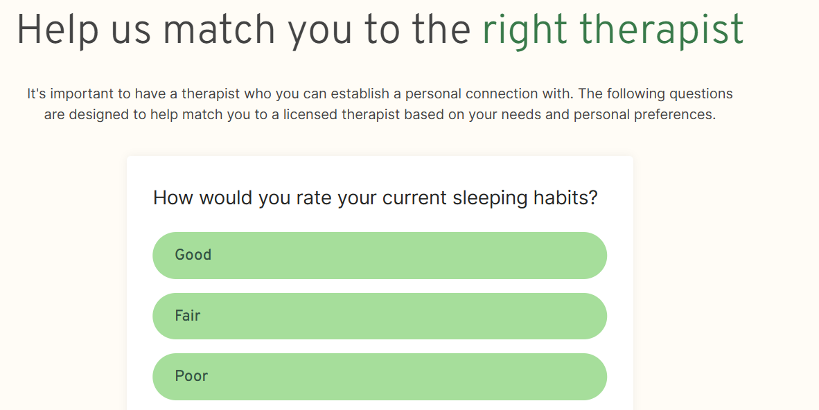

Talkspace [2]
Services in Website:
- Online Therapy & Counseling: offers therapy sessions via text, audio, and video with licensed mental health professionals.
- Psychiatry & Medication Management: provides access to psychiatrists who can diagnose conditions and prescribe medication when needed.
- Professional Profiles: displays detailed profiles for therapists and psychiatrists, including their specialties and experience.
- Appointment Scheduling: enables users to book and manage therapy or psychiatric sessions easily through the platform.
- Insurance Coverage Support: supports selected insurance plans, helping reduce the cost of mental health care.
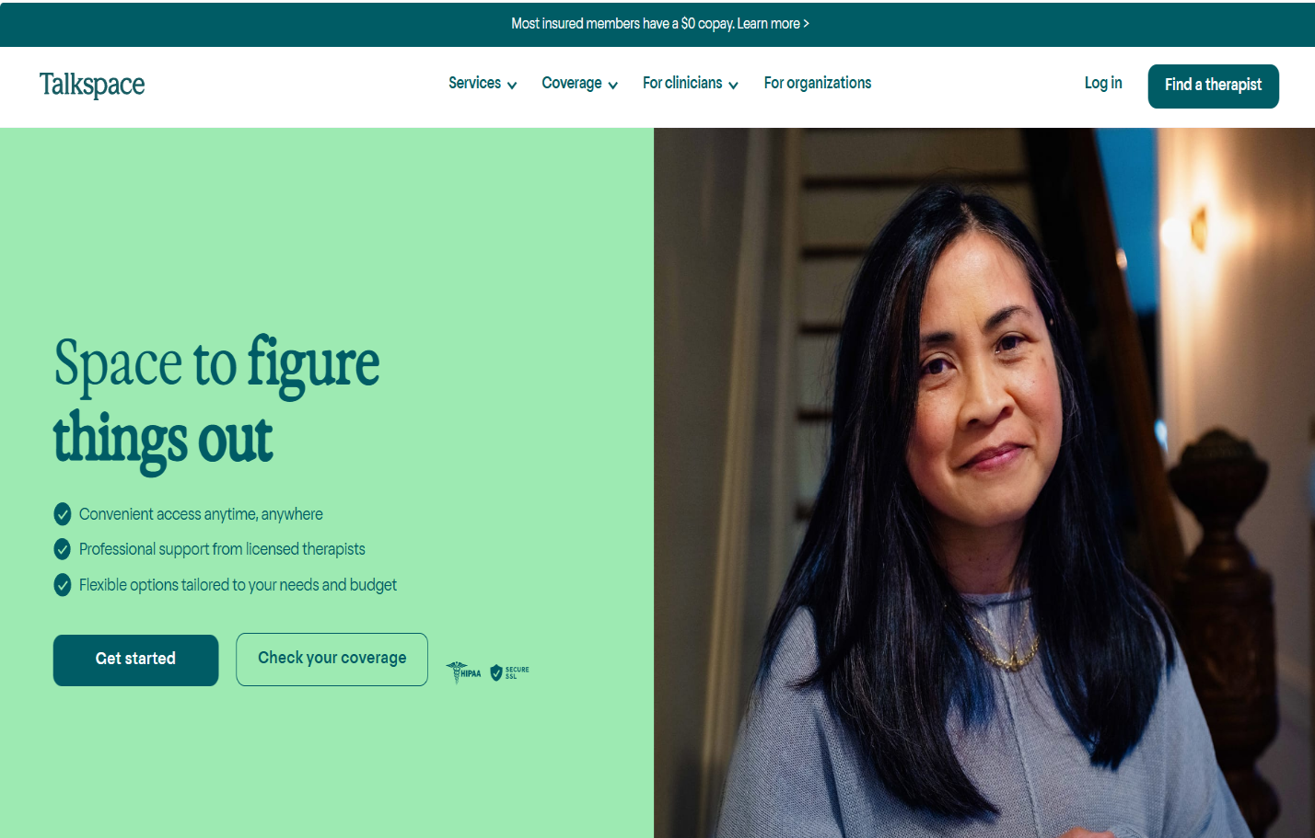

Youper [3]
Services in Mobile Application:
- AI-Powered Chatbot:
Uses artificial intelligence to provide emotional support through guided conversations.
- Mood & Emotion Tracking:
Allows users to track their mood daily and identify emotional patterns over time.
- Self-Help Programs:
Offers CBT-based techniques, mindfulness exercises, and stress management tools.
- Personalized Feedback:
Provides AI-driven suggestions based on user emotions and behavior.
- Progress Visualization:
Displays charts and reports to help users understand their mental health journey.

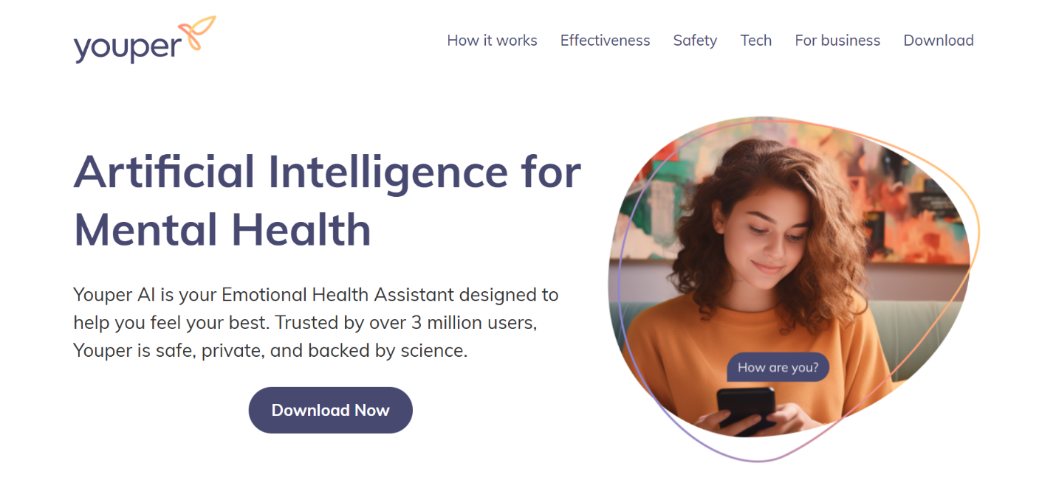

Wysa [4]
Services in Mobile Application:
- AI Chatbot Support: uses AI to provide emotional support through anonymous, text-based conversations.
- Mental Health Exercises: offers guided CBT techniques, breathing exercises, and anxiety management tools.
- Mood Tracking: allows users to log their emotions daily and track mental health patterns over time.
- Personalized Suggestions: provides tailored coping strategies based on user interactions and emotional state.
- Access to Human Coaches: offers optional access to trained mental health coaches for additional support.
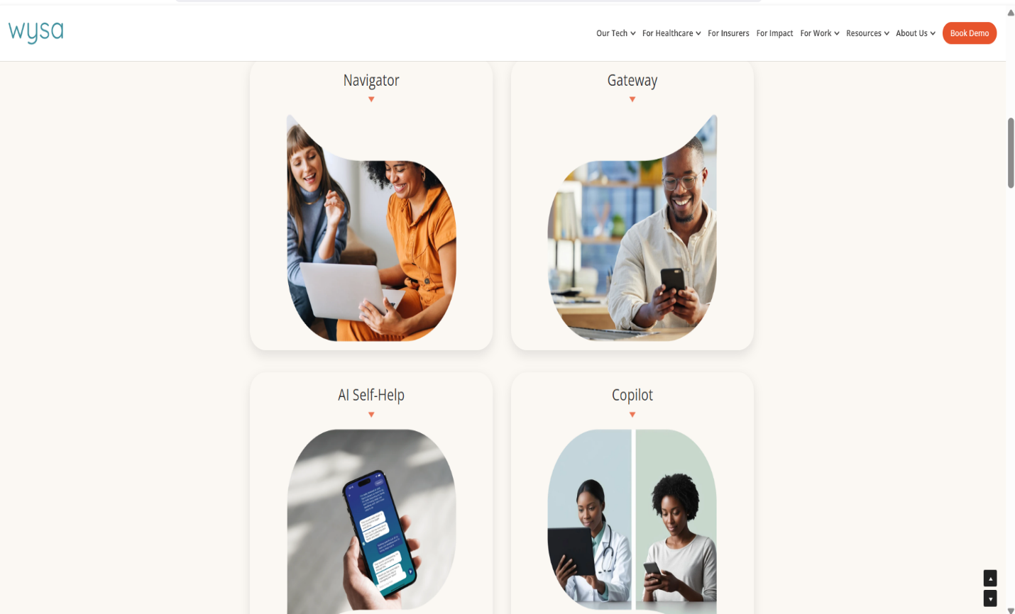

Woebot [5]
Services in Mobile Application:
- AI-Powered Conversational Agent: engages users in short daily conversations based on cognitive behavioral therapy (CBT).
- Emotional Check-ins: encourages users to reflect on their mood and thoughts regularly.
- Self-Help Content: provides simple mental health lessons and coping techniques.
- Progress Monitoring: tracks emotional changes and user responses over time.
- Instant Support: delivers immediate guidance without the need for appointments or registration.
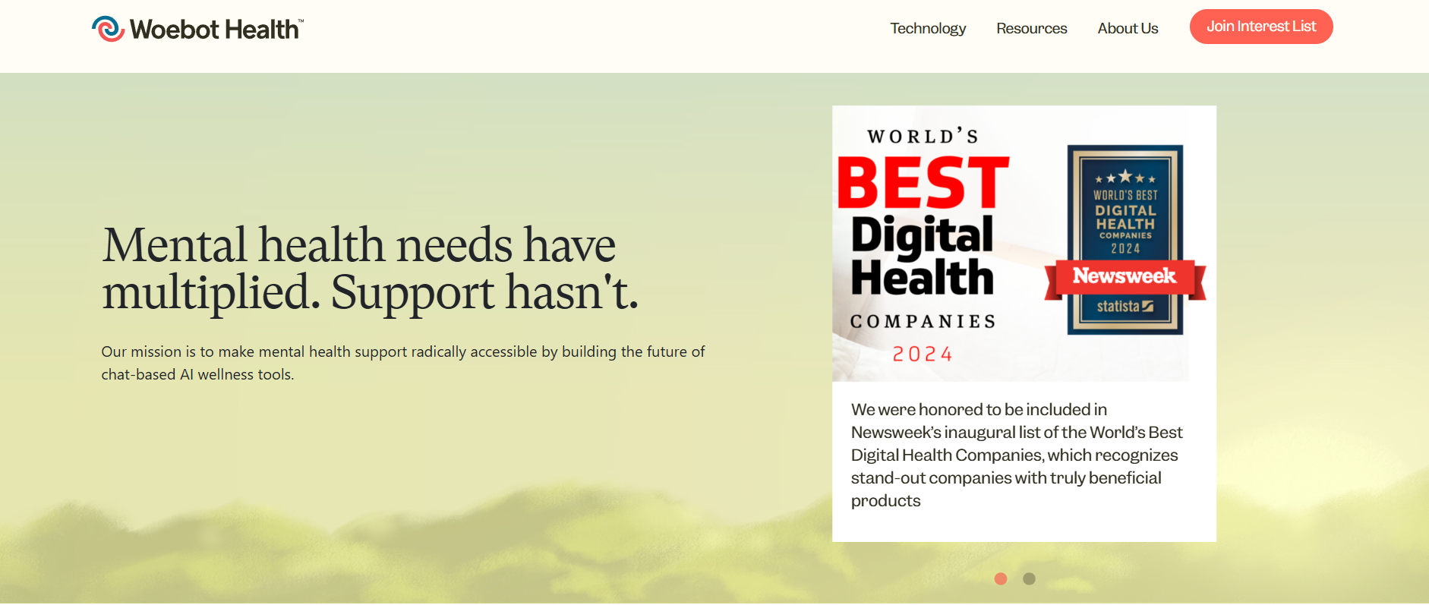

MindDoc [6]
Services in Mobile Application:
1.Mental Health Assessment: uses structured questions to assess symptoms of depression, stress, and anxiety.
2.Mood & Symptom Tracking: monitors emotional patterns across daily check-ins.
3.AI-Based Insights: analyzes collected data to offer insights into the user's mental condition.
4.Therapy Preparation Tools: helps users prepare reports that can be shared with therapists.
5.Educational Resources: provides articles and exercises focused on mental health awareness and self-care.
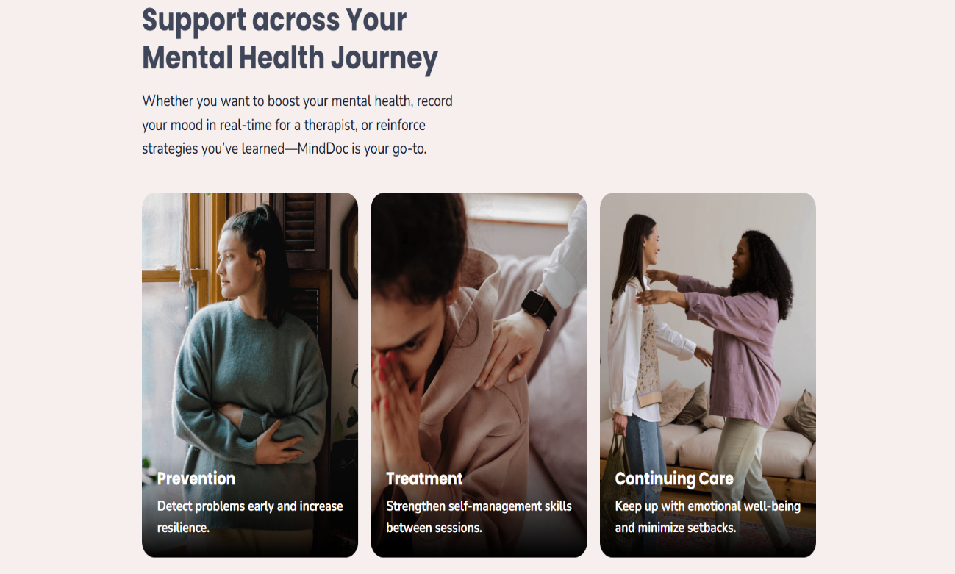

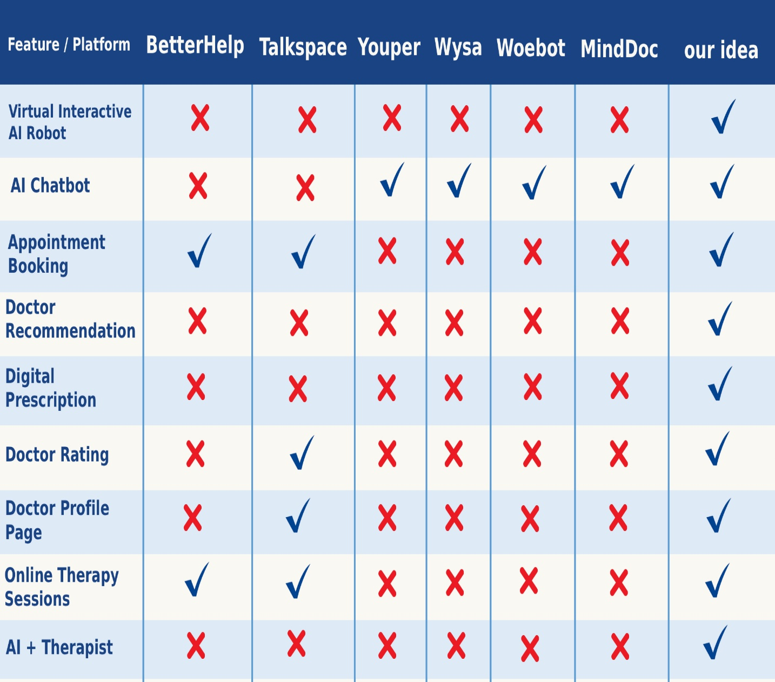
Gap Analysis & literature view

2.3 Summary
The literature review shows that while many digital mental health platforms exist, the field is still fragmented and incomplete as of 2025. Platforms like BetterHelp and Talkspace provide access to licensed therapists but do not include an AI-powered assistant to give users an initial psychological assessment or guide them to the right doctor. Apps like Youper, Wysa, Woebot, and MindDoc use AI for mood tracking and self-help exercises, but they do not connect users to real therapists or maintain secure, integrated patient records.
This gap creates real problems: users may delay seeking help, struggle to find the right therapist, or lack a safe and organized way to track their mental health progress. Limited multilingual support also reduces access for non-English speakers.
The proposed Digital Mental Health Platform fills these gaps by offering a complete, integrated solution: an AI-powered virtual assistant for initial assessment, smart doctor recommendations, online and offline appointment booking, digital prescriptions, secure patient archives, mood tracking, and a supportive community forum. With strong privacy measures and multilingual support, the platform ensures help is fast, reliable, and accessible to all.
This project is significant because it combines AI technology with professional care in one place, helping prevent mental health crises, making support widely available, and guiding users before small issues turn into serious problems.

Chapter 3

Proposed system

3.1 Approach Used to Solve the Problem
The proposed Digital Psychiatrist Platform addresses the major gaps in current mental health services by using an Agile Scrum approach, which allows step-by-step development, quick adaptation to user feedback, and continuous improvement of features.
We start by understanding the real challenges people face—long waits, scattered platforms, limited AI support, and privacy concerns—and the weaknesses of existing platforms like BetterHelp, Talkspace, Youper, Wysa, Woebot, and MindDoc. Many users struggle to get timely help, often jumping between apps for AI guidance, therapist recommendations, appointment booking, and payments. Our platform brings all these services together in one centralized, easy-to-use system.
Key features include an interactive AI assistant that provides an initial psychological assessment, smart doctor recommendations for serious or complex cases, secure online and offline appointment booking, digital prescriptions, doctor profiles and ratings, a patient record archive, community support, and multilingual access for diverse users.
The platform is designed with the user in mind, making mental health care approachable and stress-free. Patients can track progress, consult professionals, and receive guidance—all in a secure environment. Its modular structure allows future upgrades, such as adding 3D AI interactions, personalized therapy suggestions, and advanced analytics to monitor treatment outcomes.
Privacy and security are top priorities, with encrypted data storage and cloud-based infrastructure to protect sensitive patient information. Reliability is built in, ensuring the platform is available whenever users need support.
This approach transforms mental health care from a fragmented, stressful experience into a smooth, safe, and comprehensive journey, combining the intelligence of AI with professional expertise. It empowers users to get help quickly, stay on track with treatment, and prevent mental health issues from becoming crises, making support accessible for everyone, anytime, anywhere.

3.2 System Architecture

Functional Requirements:
These define what the system should do and cover specific behaviors of the platform.

Intelligent AI Chatbot
- Interacts with users through text in a friendly and natural way.
- Understands words, tone, and emotions to assess mood and mindset.
- Provides an instant mental health summary and personalized guidance based on the user’s responses
- Virtual Interactive AI Robot
- A realistic 3D AI doctor that communicates via voice and facial expressions, simulating a real therapy session.
- Listens empathetically, analyzes speech and emotions, and generates a psychological report for review by a real doctor.
- Smart Doctor Recommendation
- For serious or complex cases, the system automatically suggests highest-rated doctors in the user’s area for quick and direct booking.
- Easy Appointment Booking
- Users can book appointments instantly, online via video call or offline at the clinic.

- Secure Online Payment System
- Payments can be made securely using cards or digital wallets, with instant booking confirmation.
- Digital Prescription (PDF)
- After consultations, doctors can issue digital prescriptions.
- Users receive a secure PDF with recommended treatment or medication.
- Anonymous Feedback / Doctor Ratings
- Users can leave anonymous reviews after each session to maintain quality, trust, and transparency.
- Smart Medical Record
- All chat history, AI reports, prescriptions, and progress notes are automatically stored in a private patient record.
- Enables continuous follow-up and tracking of mental health progress.
- Doctor Profile Page
- Each doctor has a personal profile page including:
- Photo, bio, and specialization.
- Experience, certifications, and workplace information.
- Ratings and patient reviews.

Non-Functional Requirements
These define how the system operates and the quality attributes that ensure a safe, reliable, and user-friendly mental health platform.
- Scalability
- The platform is designed to handle a growing number of users, sessions, and medical records without performance issues.
- New features such as advanced AI tools or additional therapy services can be added easily without rebuilding the entire system.
- Security & Privacy
- All patient data, including chats, reports, and prescriptions, is stored securely using encryption.
- Role-based access control ensures that patients, doctors, and administrators can only access what they are authorized to see.
- Regular backups and recovery mechanisms handle server failures and protect sensitive mental health information.
- Usability
- The system provides a clean, simple, and intuitive interface suitable for all age groups.
- The platform is easy to navigate and fully responsive on mobile devices, tablets, and desktops to reduce stress while using the system.

- Reliability
- The platform ensures minimal downtime and stable performance, especially during therapy sessions.
- Automatic backups and error handling mechanisms maintain continuity of care and prevent data loss.
- Maintainability
- The system is built using a clean and modular structure to simplify maintenance, updates, and bug fixing.
- This approach allows continuous improvement without disrupting ongoing services.
- Compatibility
- The platform works smoothly across all major web browsers such as Chrome, Firefox, Safari, and Edge.
- Fully compatible with mobile and desktop devices through responsive design.

Use Case Diagram
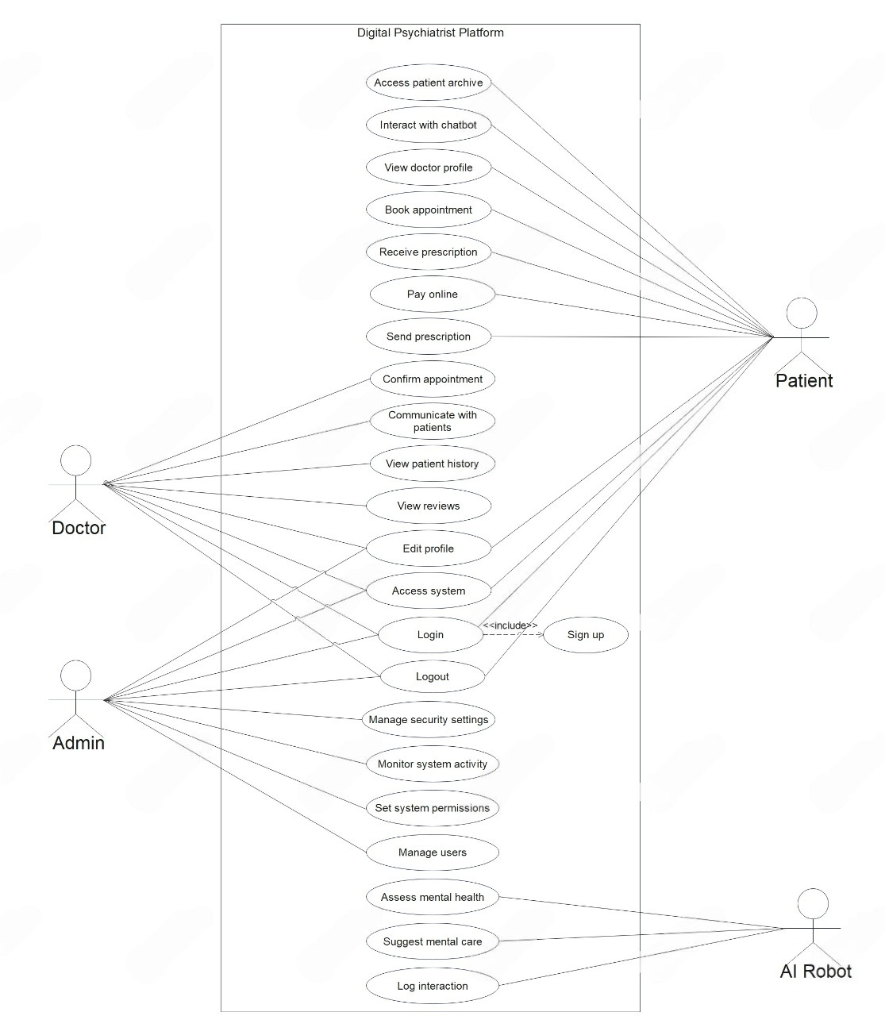

Activity Diagram
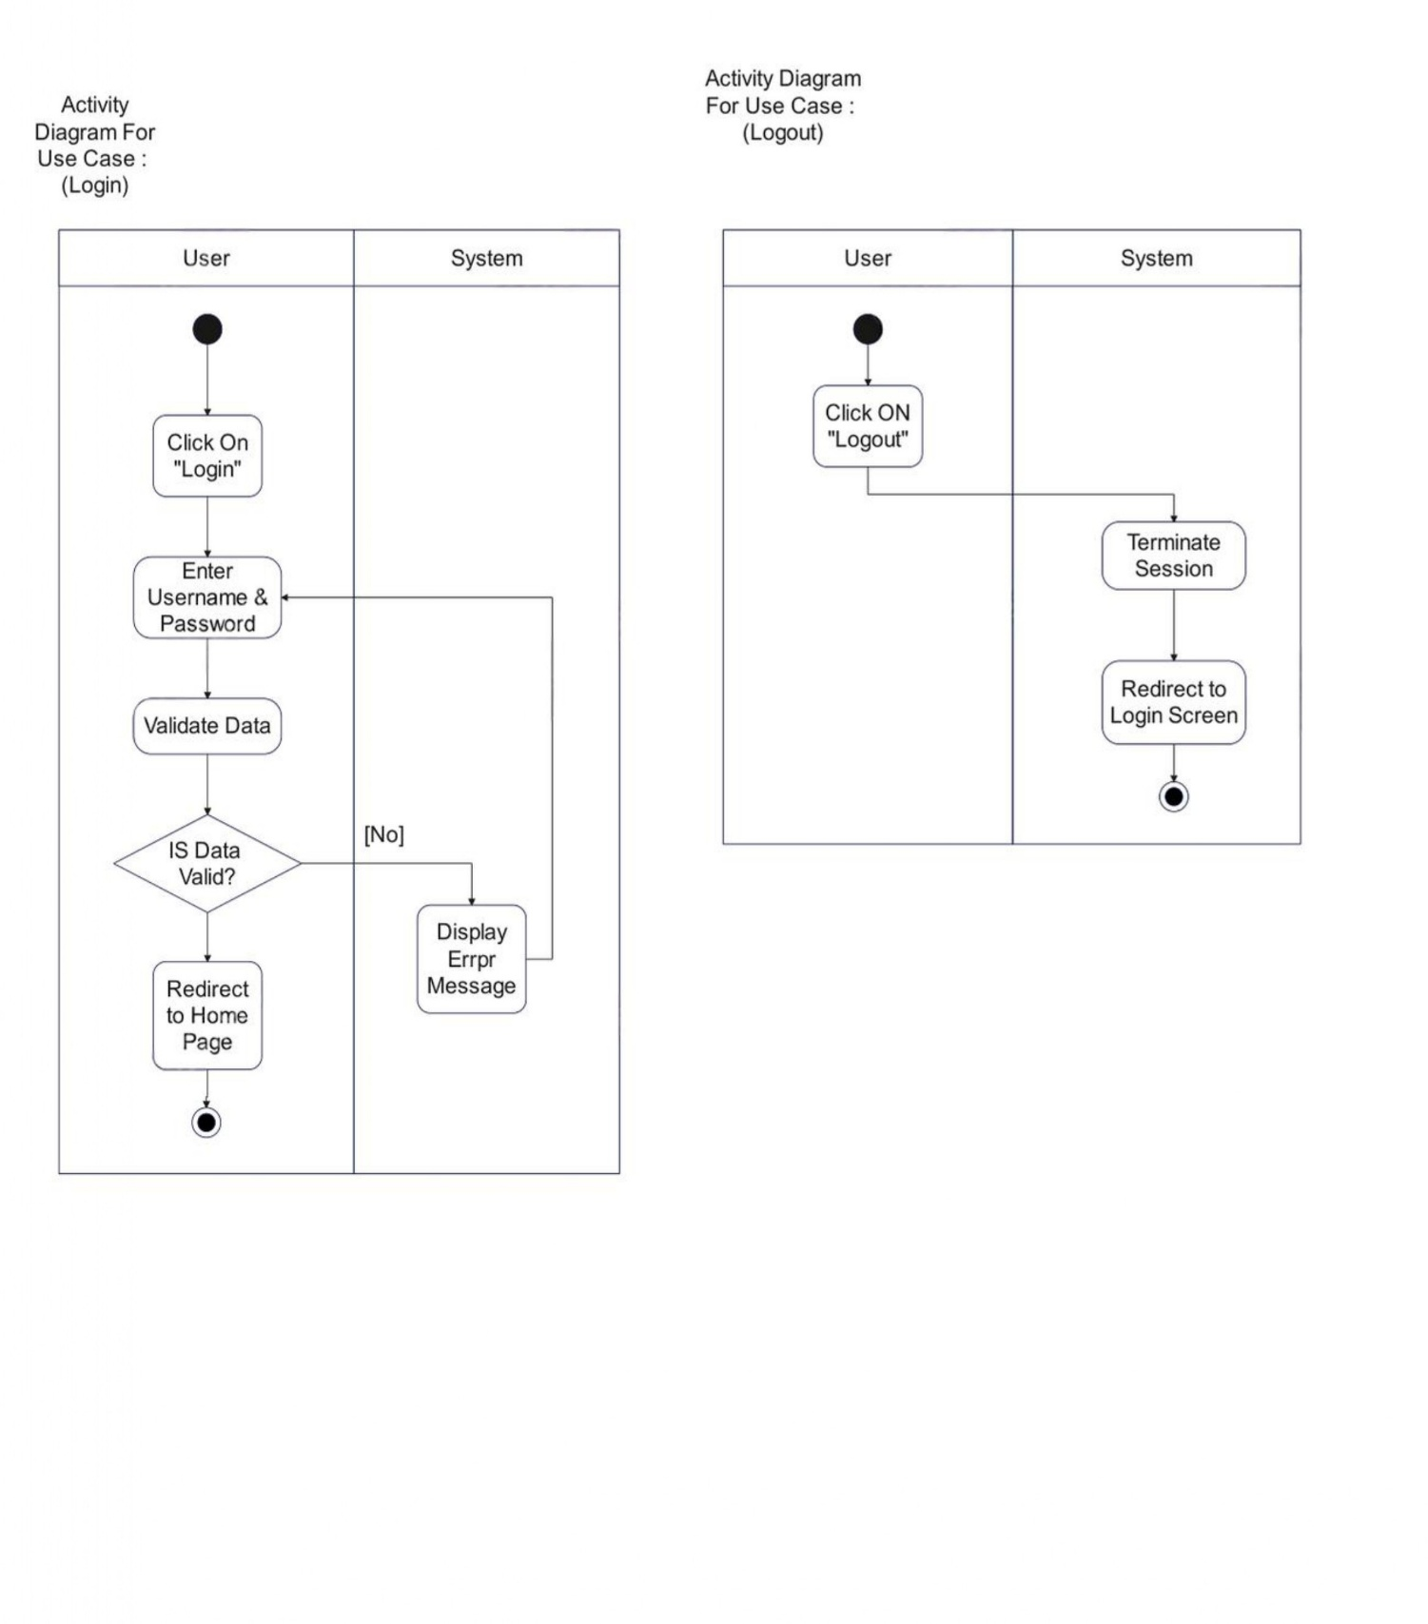

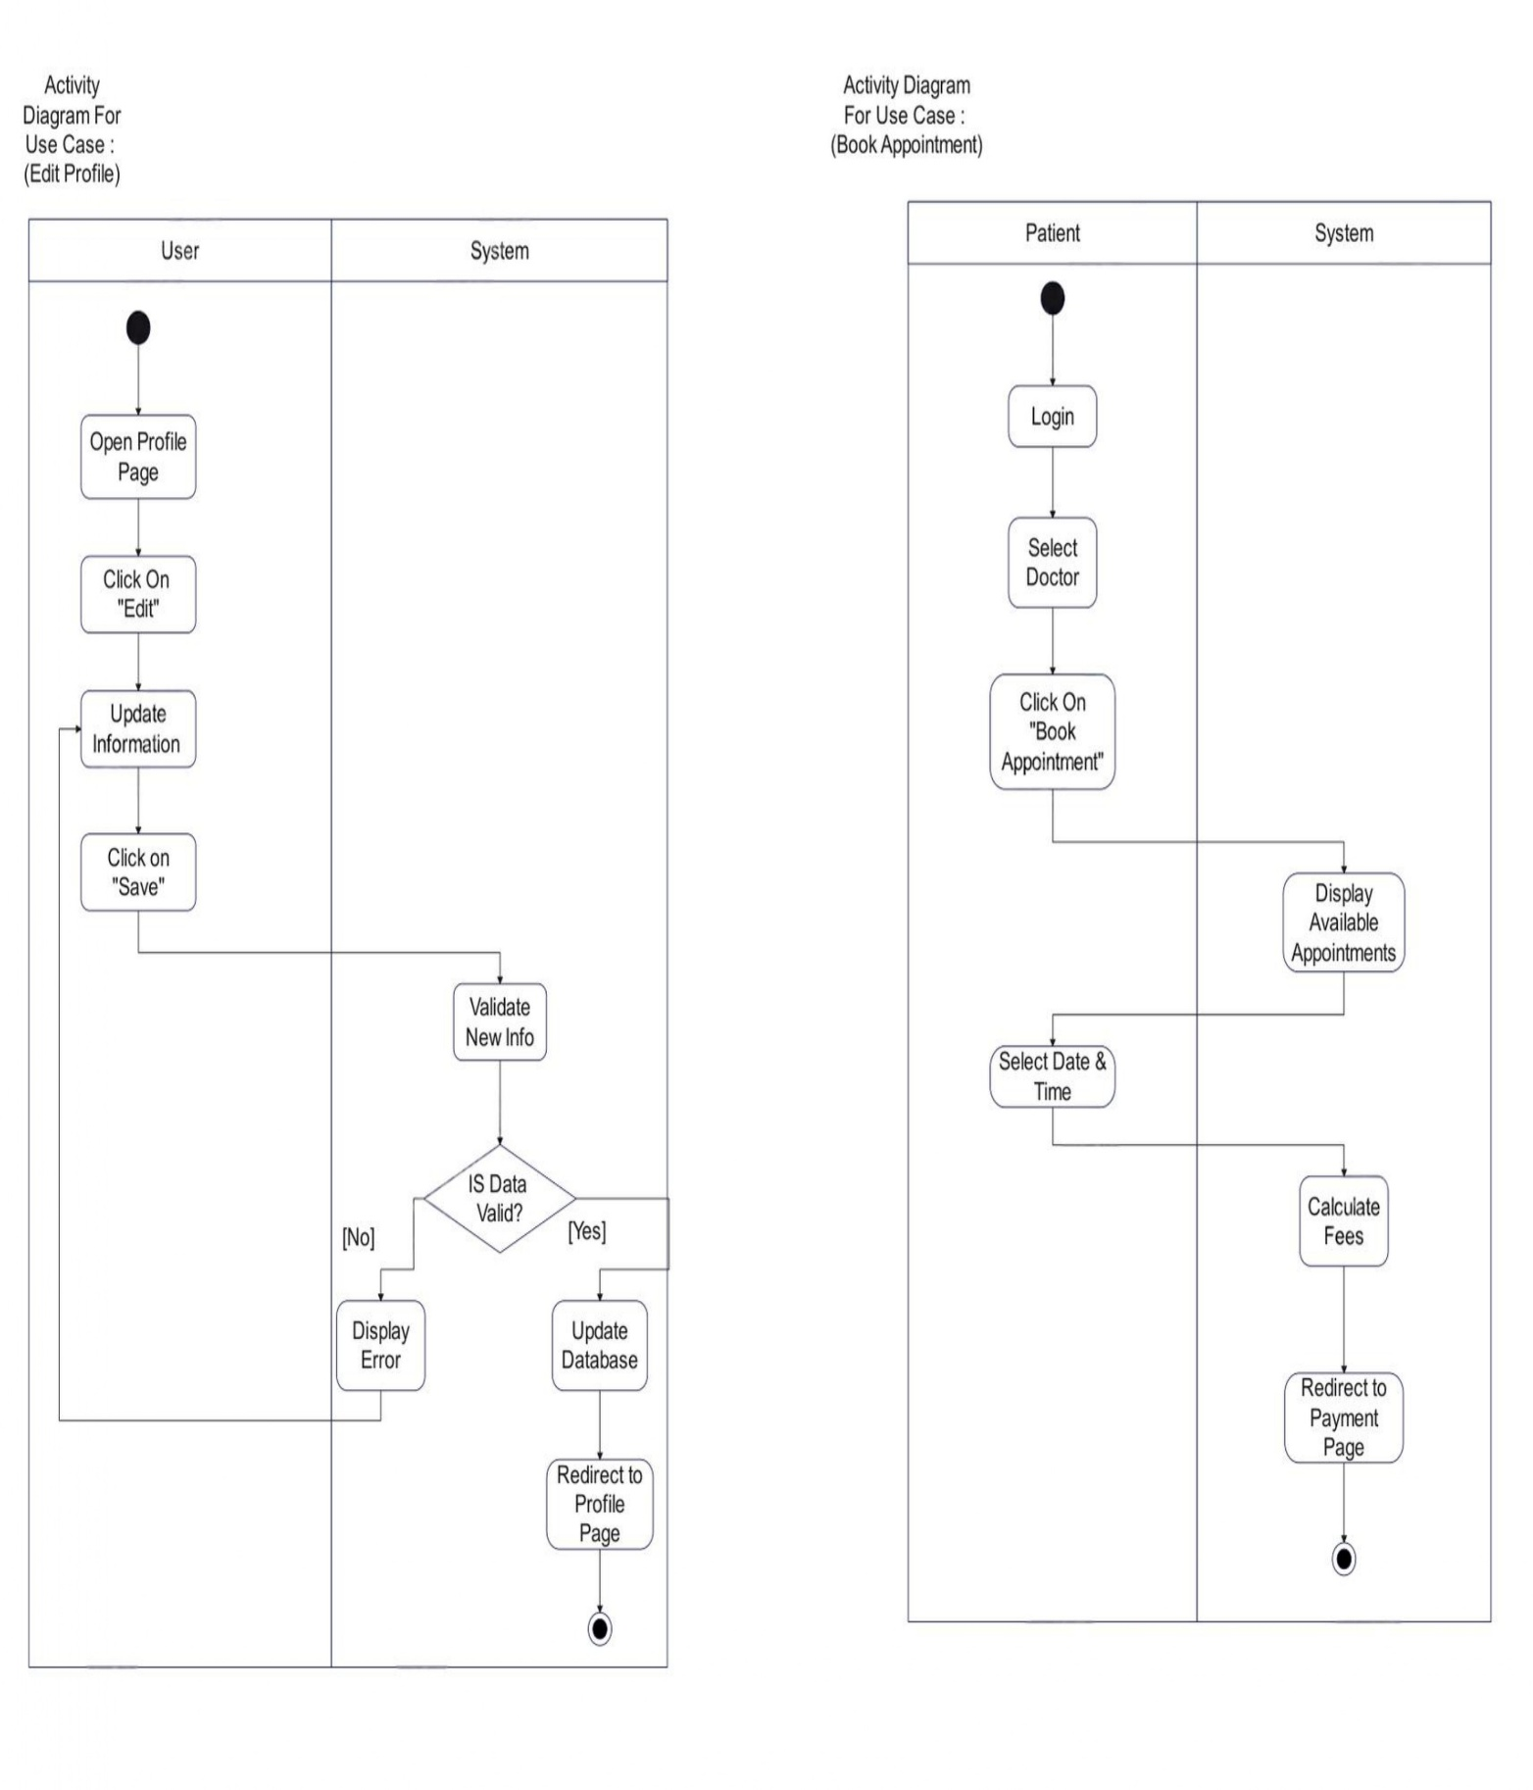

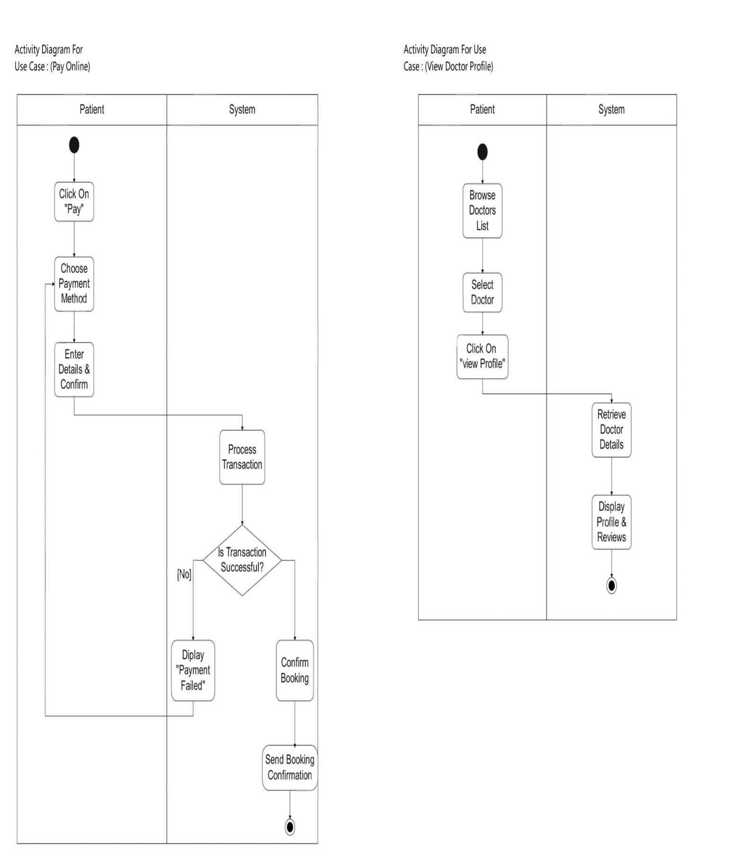

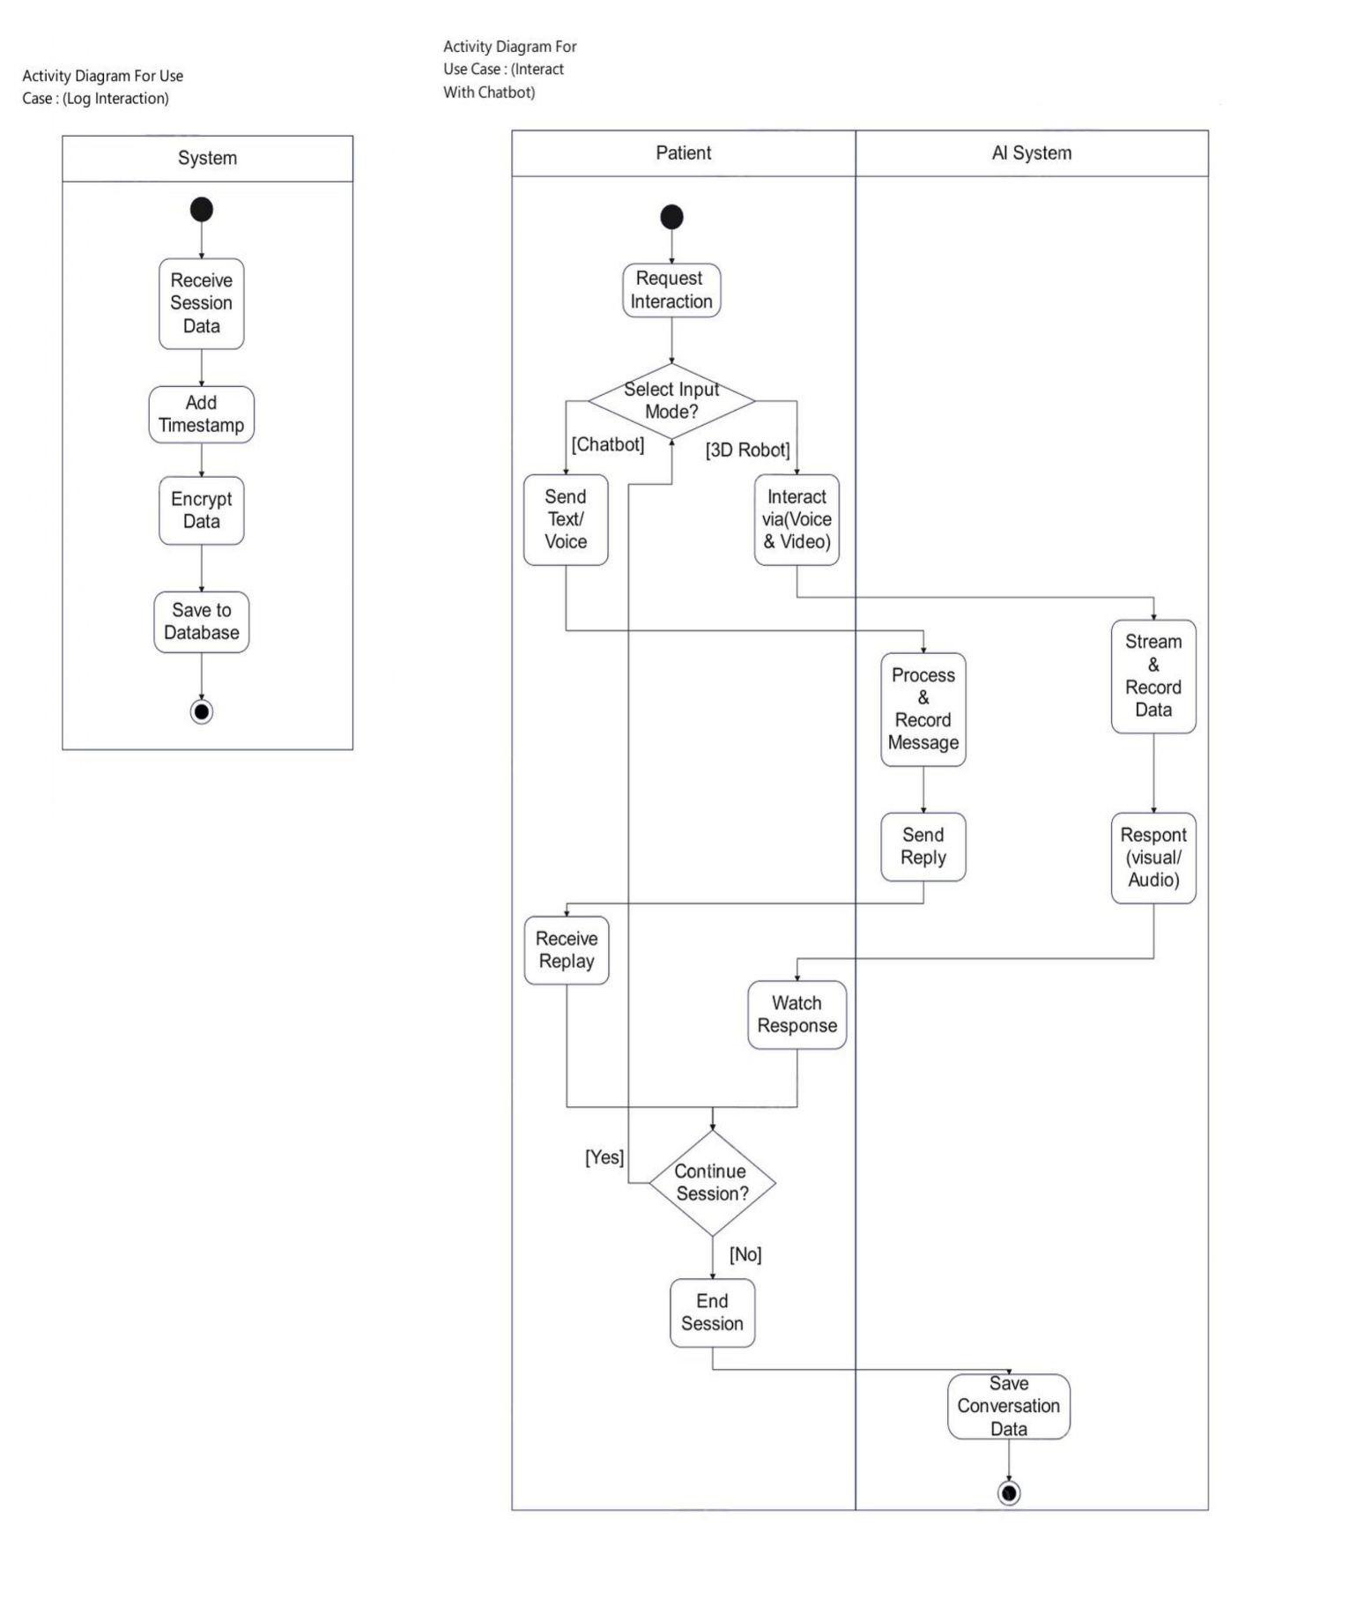

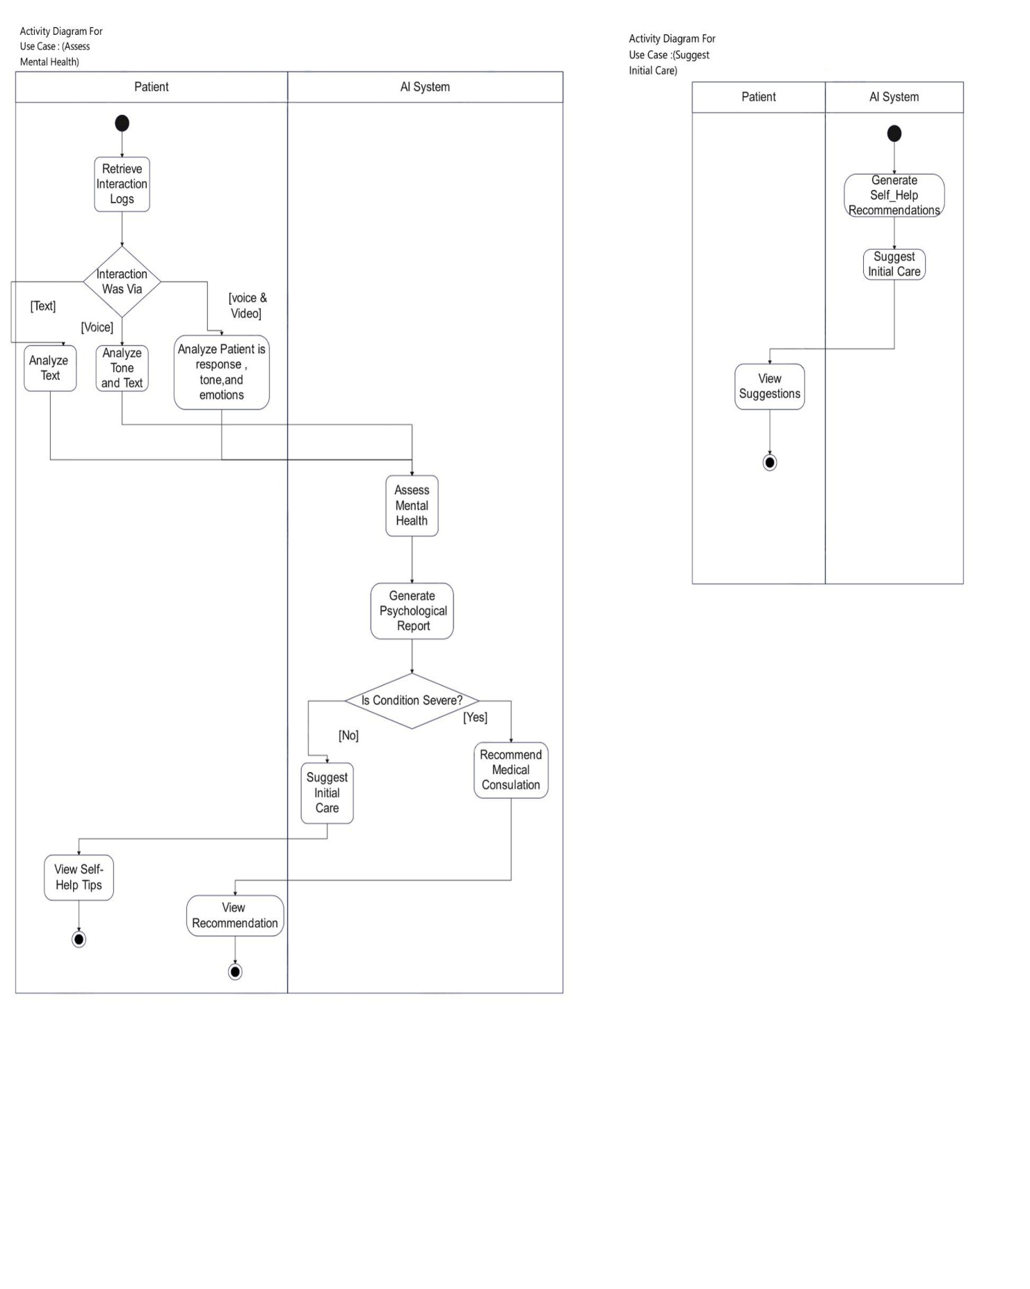

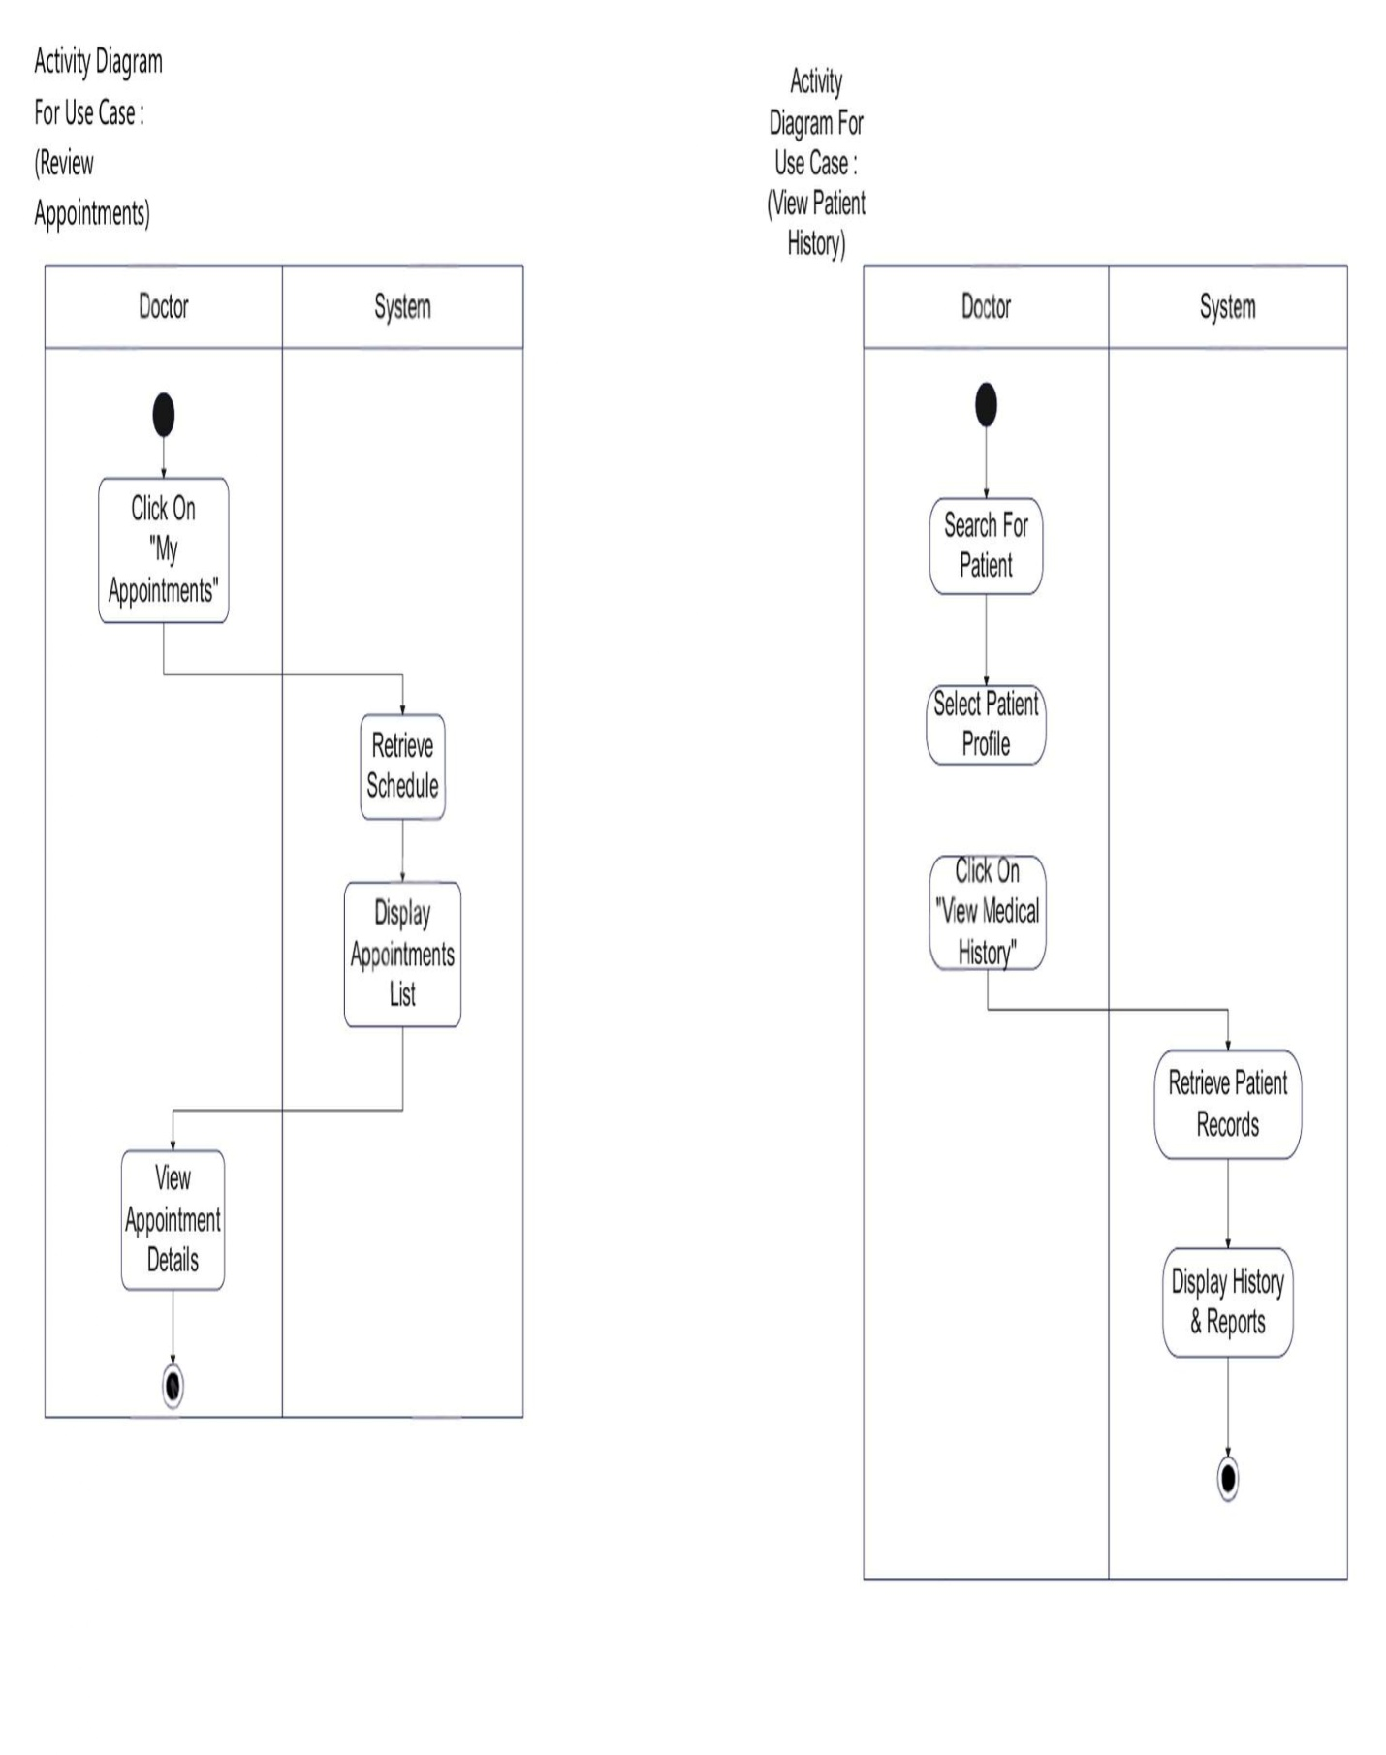
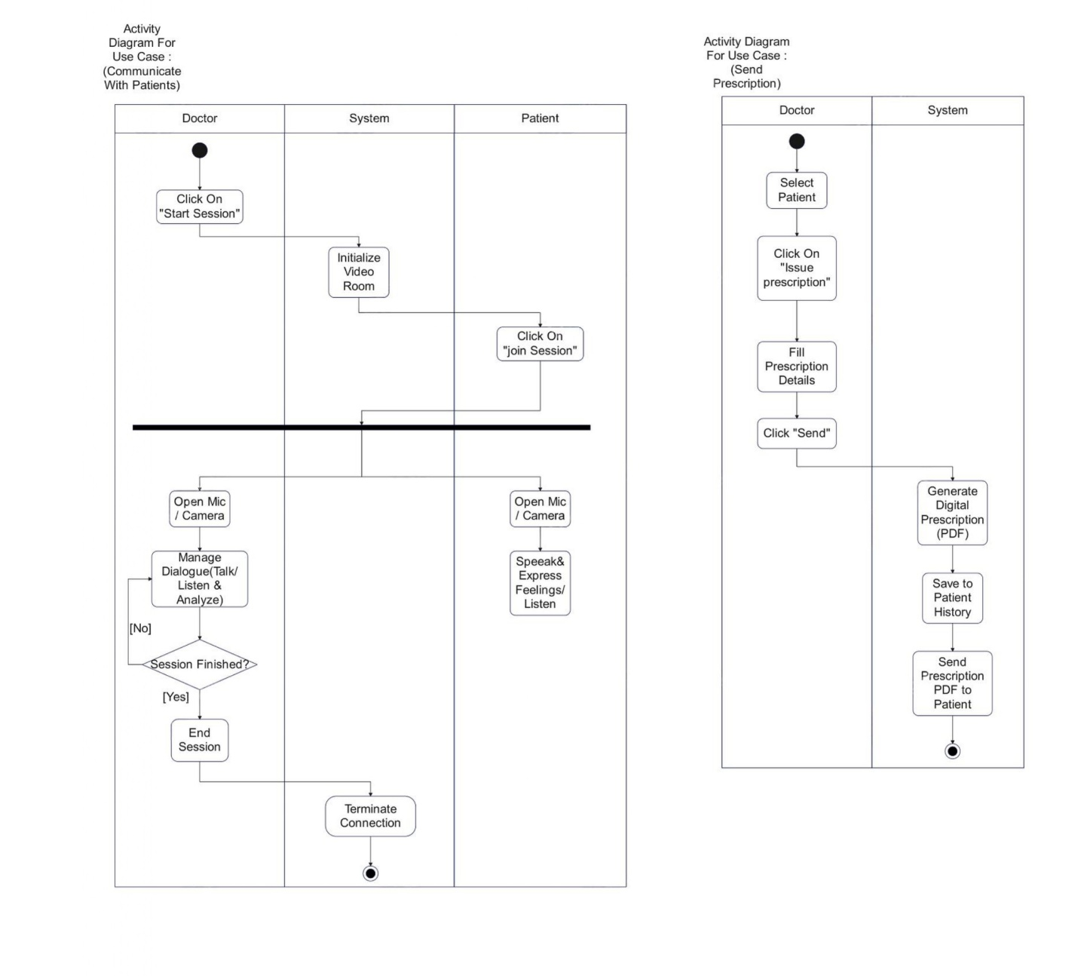

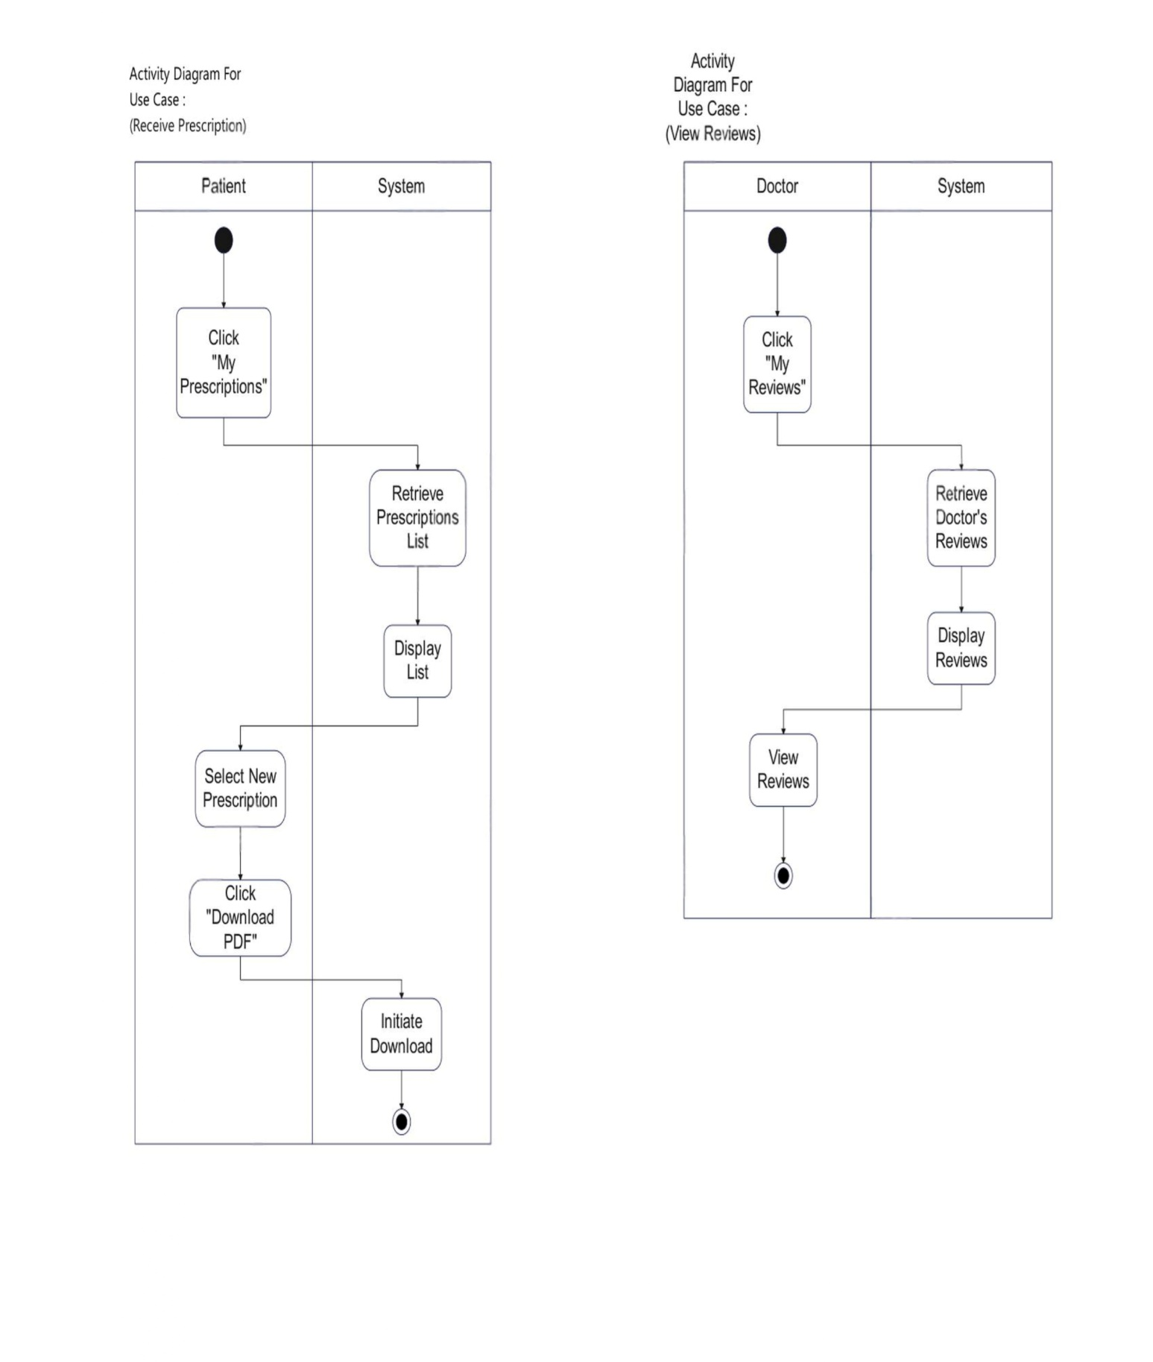

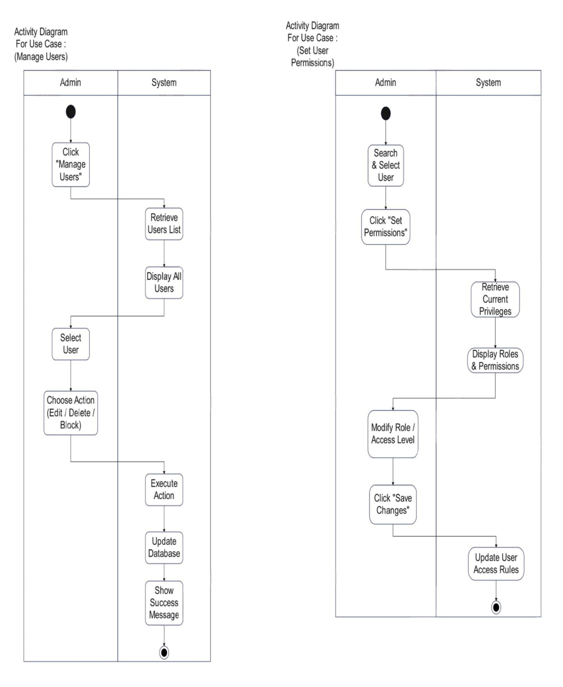

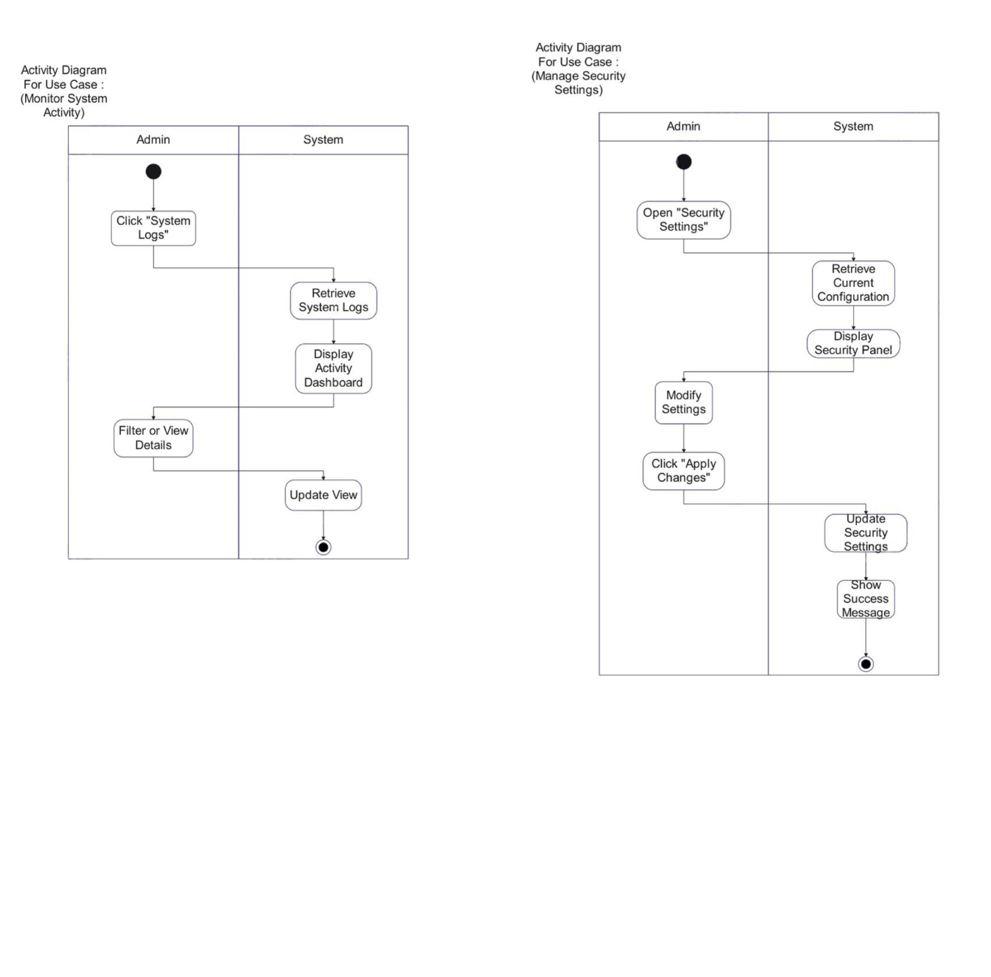

Class Diagram
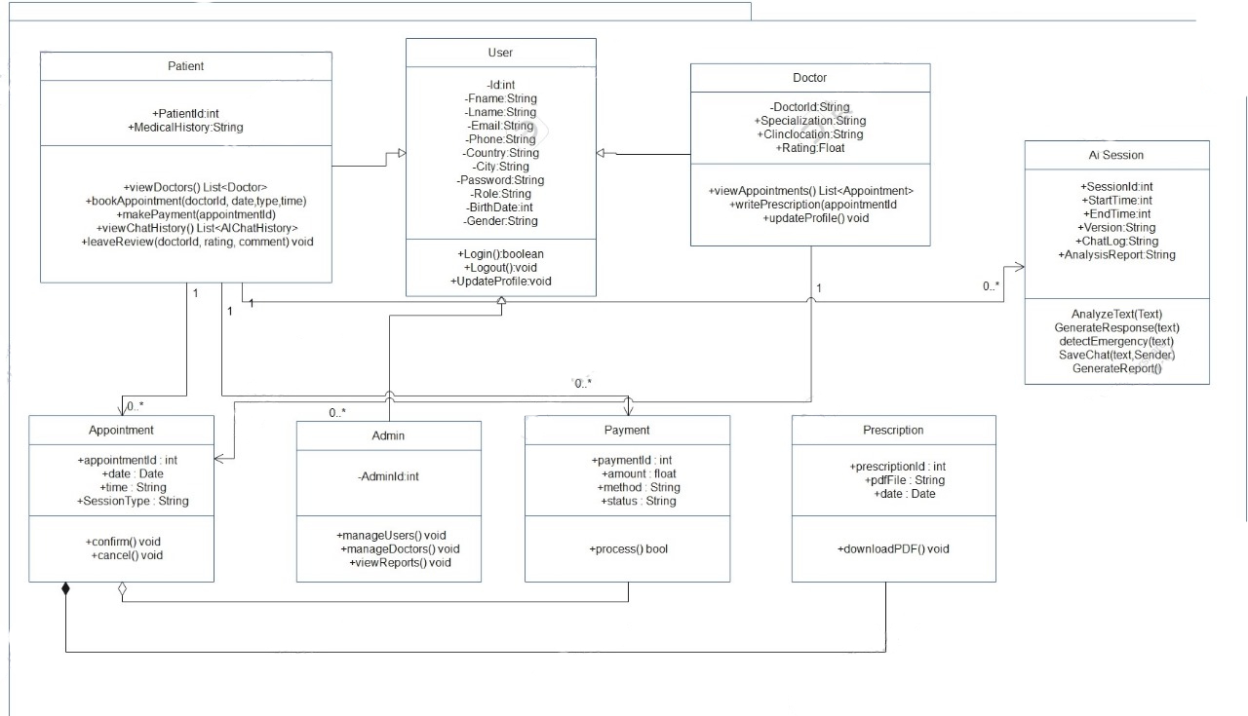

Sequence Diagram
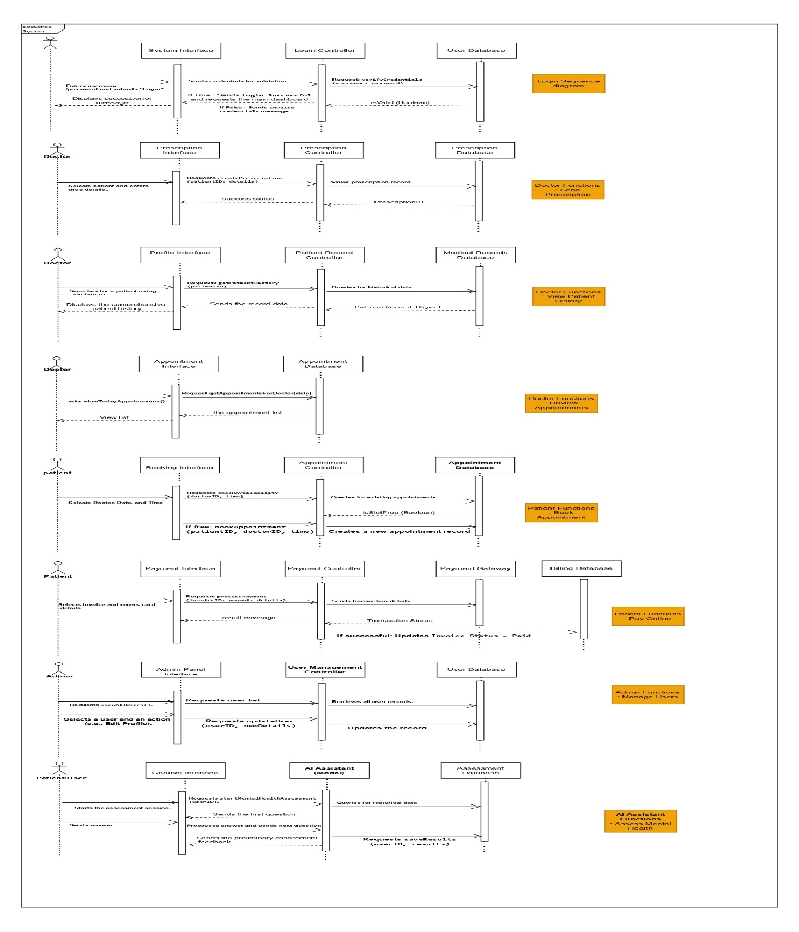

State Machine Diagram
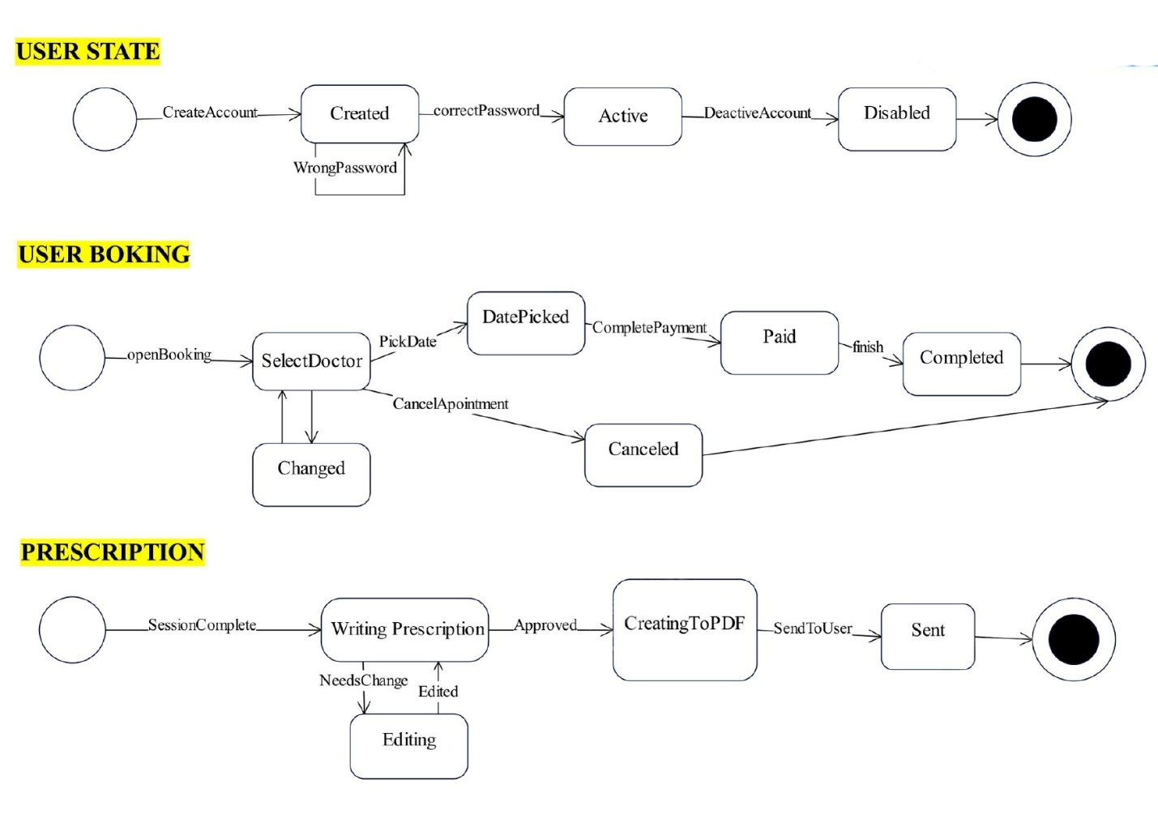

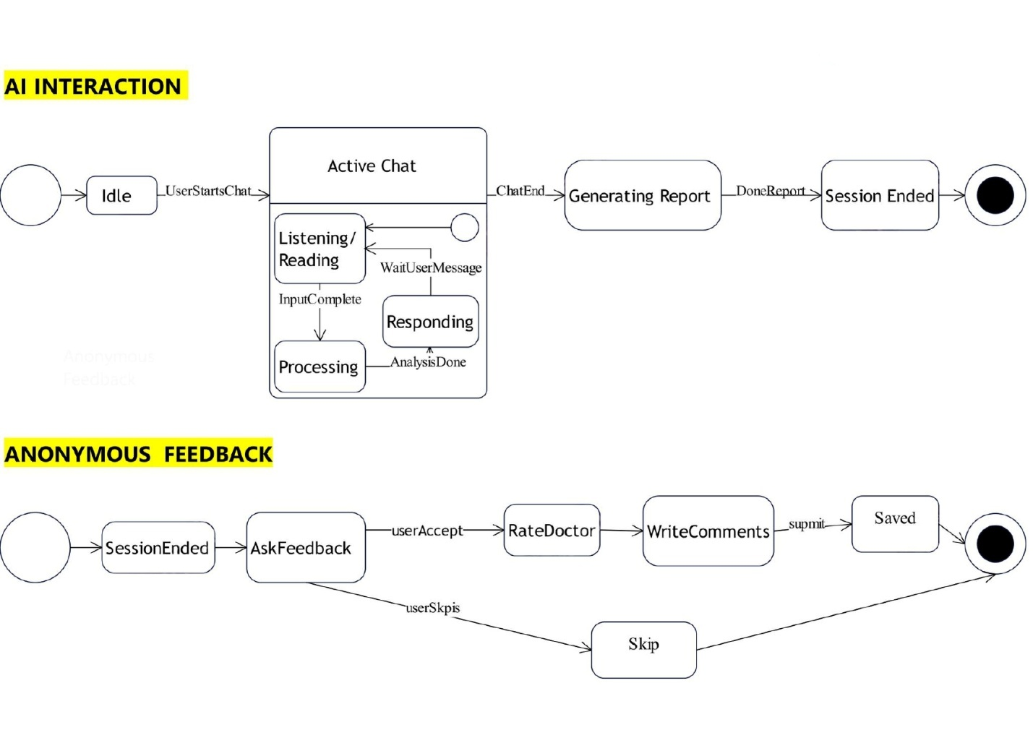

Entity Relationship Diagram

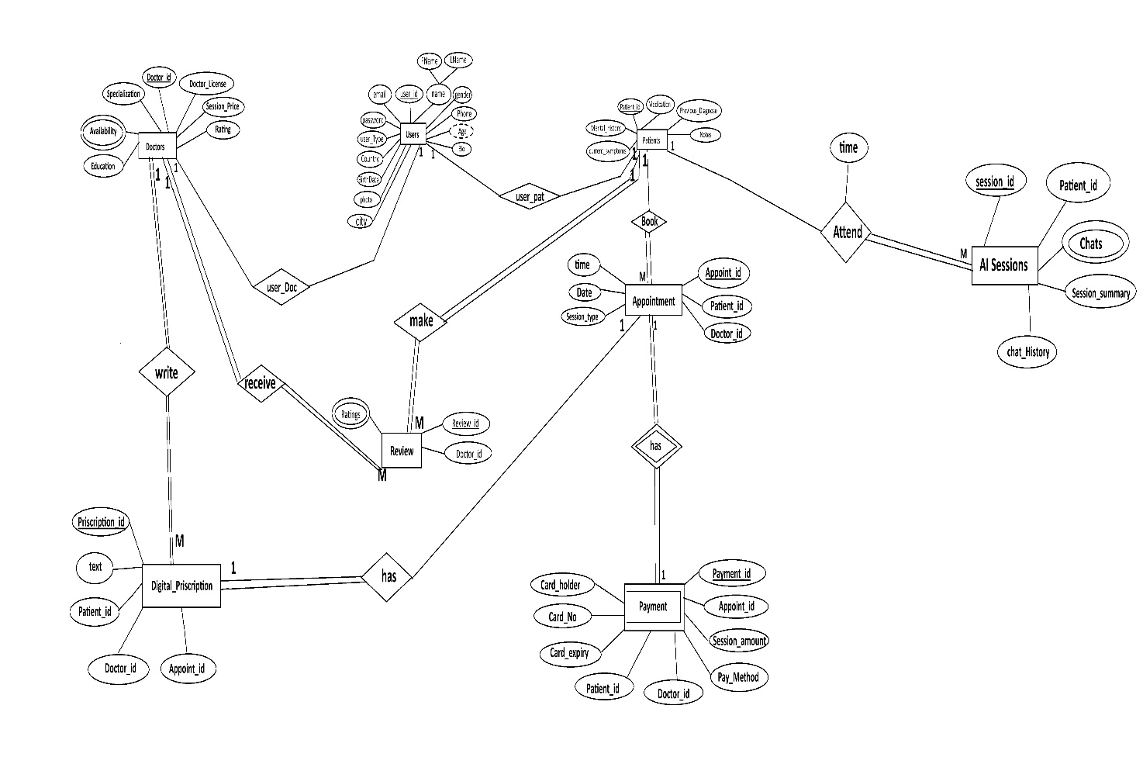

Enhanced Entity Relationship Diagram
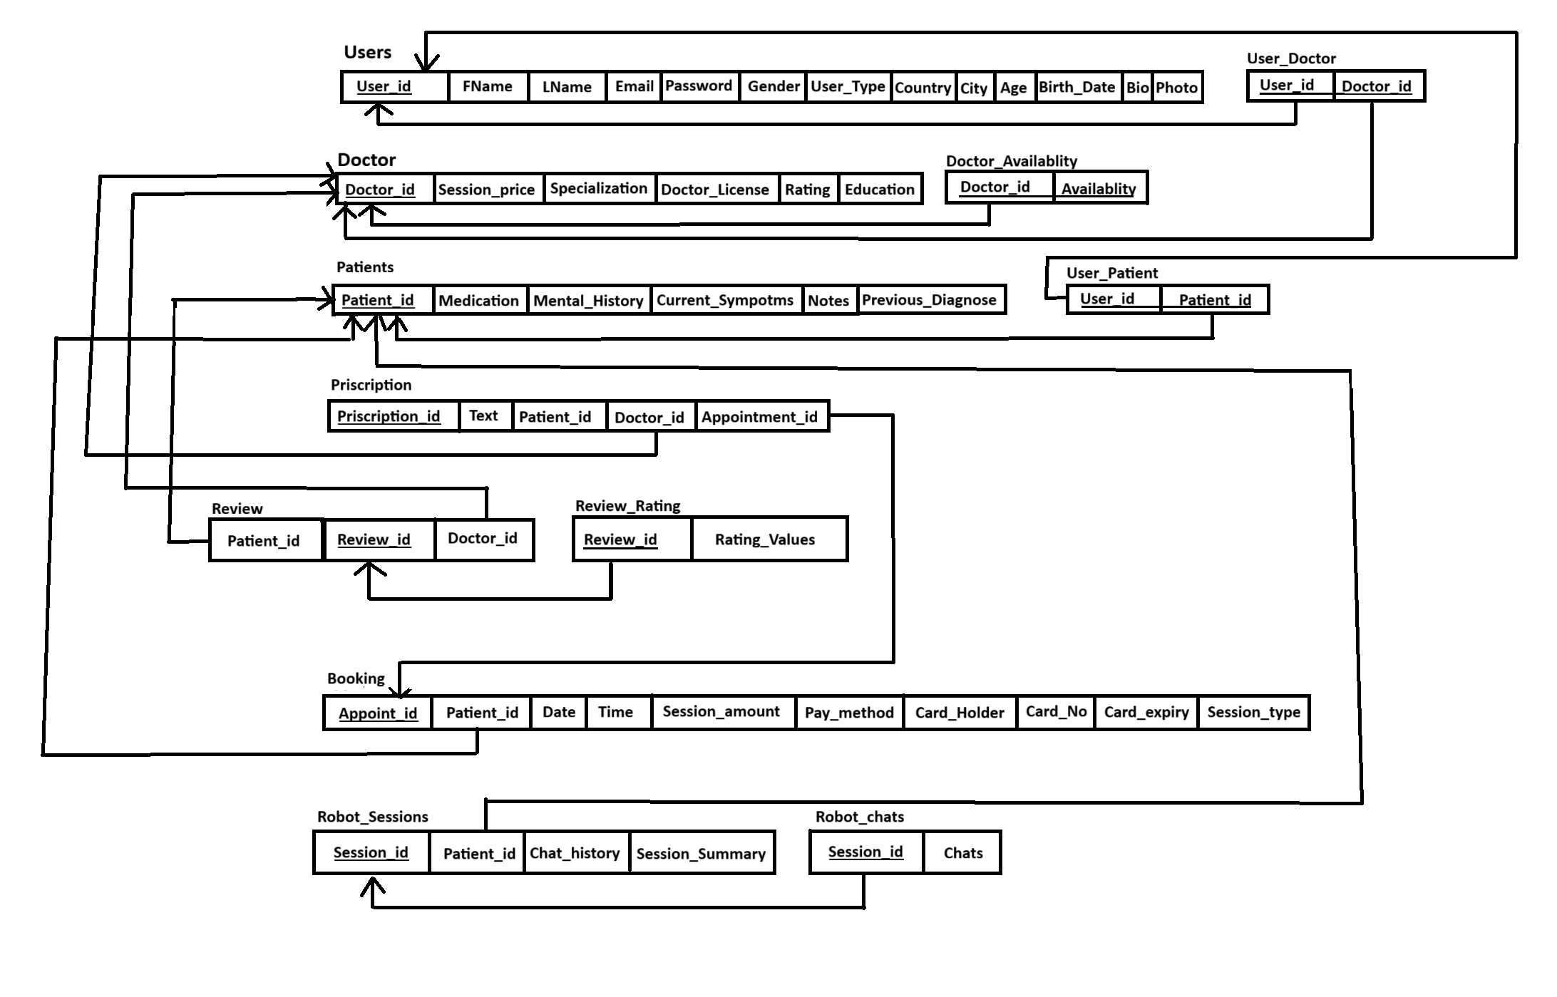

3.3 Algorithms or Frameworks Used
The system employs a set of intelligent algorithms and modern frameworks to support its digital mental health services and ensure efficiency, scalability, and reliability. The AI component of the system is built using TensorFlow as the primary framework for developing and deploying intelligent models. TensorFlow is used to analyze user conversations during interactions with the AI chatbot and virtual robot, detect emotional patterns, and classify mental health conditions such as stress, anxiety, and depression based on user responses.
The AI models are trained and optimized to generate an initial psychological assessment that helps determine whether the user requires professional mental health intervention. This approach supports early detection and timely guidance while maintaining consistent performance and accuracy.
The backend of the system is developed using ASP.NET Core, which provides a secure, high-performance, and scalable environment for handling user authentication, medical records, appointment management, payments, and role-based access control. ASP.NET Core enables robust API development and efficient data processing while ensuring system reliability.
The frontend is built using React.js, allowing the creation of a dynamic, interactive, and user-friendly interface. React’s component-based architecture improves performance and usability, while responsive design ensures seamless access across desktops, tablets, and mobile devices.
The combination of Scikit-learn for AI, ASP.NET Core for backend services, and React.js for frontend development delivers a secure, scalable, and intelligent digital mental health platform capable of addressing the limitations of existing solutions.

Chapter 4

Implementation

4.1 Technologies, Tools, and Programming Languages Used
The Digital Psychiatrist Platform uses modern technologies and tools to provide an intelligent, secure, and user-friendly experience for patients and doctors.
The main technologies used are:
- Frontend: The frontend of the system is developed using HTML, CSS, and JavaScript with React.js as the main framework. React.js is used to build an interactive and responsive user interface, allowing components such as the AI chatbot, virtual robot view, appointment booking pages, and doctor profiles to be easily reused and managed.
- Backend: The backend is implemented using ASP.NET Core, which provides a secure and high-performance environment for handling system logic. It manages user authentication, AI reports, appointment scheduling, payments, digital prescriptions, and role-based access control for patients and doctors.
- Database: A relational database such as SQL Server is used to store user accounts, medical records, chat history summaries, doctor profiles, ratings, appointments, and prescriptions. The structured database design ensures data consistency and security.
- AI Framework: Scikit-learn is used to build and train AI models responsible for analyzing user text responses, detecting emotional patterns, and generating an initial assessment of the user’s mental health.
The framework also supports continuous model improvement through retraining, ensuring higher accuracy over time and reliable support for early mental health detection and decision-making.

• Version Control:
Git and GitHub are used to manage source code, track changes, and support collaborative development.
Additional Tools:
Visual Studio / Visual Studio Code: Used as the main development environment for writing, debugging, and managing both frontend and backend source code.
Postman: Used for testing, validating, and documenting API endpoints developed with ASP.NET Core, ensuring correct request and response behavior.
Stripe (or similar payment gateways): Used to handle secure online payments, manage transactions, and ensure data protection during payment processes. 4.2 Key Components / Modules of the System
The system follows a modular architecture where each module performs a specific role and communicates with others through secure APIs.
1.User Management Module
Purpose:
Manages user accounts for patients and doctors.
Key Features:
o User registration and login
o Secure authentication and authorization
o Role-based access (patient / doctor)
Implementation:
Built using ASP.NET Core APIs with secure authentication mechanisms. User data is stored in the database and accessed through the frontend using React forms.
Interconnection:
Links users with appointments, medical records, and AI assessments.
2. AI Chatbot & Virtual Robot Module
Purpose:
Provides initial mental health support and assessment.
Key Features:
o Text-based AI chatbot for conversation
o Virtual interactive AI robot using voice and facial expressions
o Emotional analysis and mental state evaluation
o Automatic generation of a psychological report
Implementation:
Scikit-learn models are used to analyze user inputs and classify emotional patterns based on conversation data. The generated mental health assessment results are stored securely in the system and shared with doctors when required.
Interconnection:
Links to medical records and queries the doctor database for suitable matches.
3.Smart Doctor Recommendation Module
Purpose:
Helps users find suitable mental health professionals.
Key Features:
o Recommends top-rated doctors based on assessment results
o Filters doctors by location and specialty
Implementation:
Uses rule-based logic and stored evaluation data to rank doctors.
Interconnection:
Linked with appointment booking and doctor profile modules.
4.Appointment Booking Module
Purpose:
Allows users to schedule sessions easily.
Key Features:
o Online and in-clinic appointment booking
o Real-time availability checking
o Booking confirmation
• Implementation:
Handled through backend APIs and displayed via interactive React components.
• Interconnection:
Linked with doctor profiles, payments, and notifications.
5.Payment & Digital Prescription Module
Purpose:
Manages secure transactions and treatment documentation.
Key Features:
o Secure online payments
o Digital prescription generation (PDF format)
Implementation:
Payment gateways are integrated into the backend, and prescriptions are generated and stored securely.
Interconnection:
Connected with appointment and medical record modules.
6.Medical Record Module
Purpose:
Stores and tracks the user’s mental health journey.
Key Features:
o Saved AI reports
o Session history
o Prescriptions and follow-up notes
Implementation:
Stored in the database with strict access control.
Interconnection:
Accessible by both patients and authorized doctors.

4.3 Challenges Faced and How They Were Resolved

Issue: AI accuracy in mental health assessment ensuring reliable interpretation of user inputs and emotional cues.
Solution: Trained AI on diverse datasets and continuously validated predictions to improve reliability.

Issue: Detecting facial expressions and emotions via the virtual AI robot variability in user expressions caused inaccuracies.
Solution: Applied advanced image processing techniques and tested across multiple scenarios to enhance detection.

Issue: Secure online payments – ensuring safe handling of user financial data.
Solution: Integrated trusted payment gateways like Stripe and used encryption standards for protection.

Issue: Privacy and data security safeguarding sensitive mental health information.
Solution: Implemented encrypted databases, role-based access control

Screenshot of the main functions:

Home Page (UI/UX)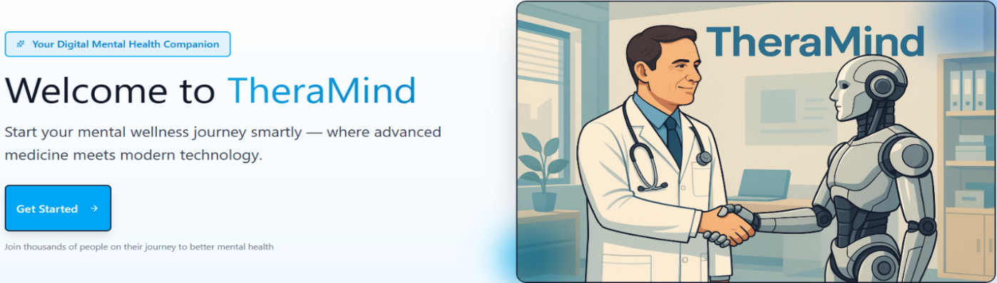
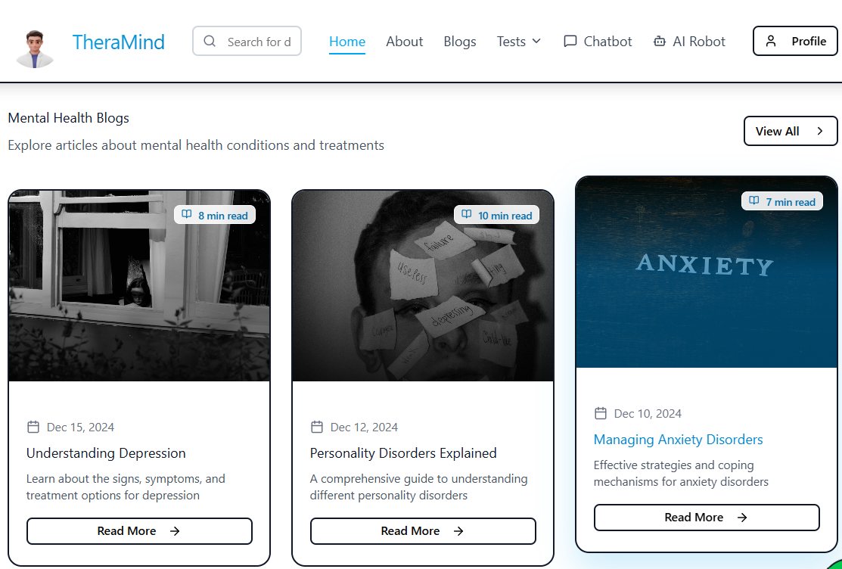

Home Page Description
Our home page is simple, clean, and user-friendly. It introduces the main parts of our digital mental health platform. There is a Blog Section where users can read informative articles about mental health, stress management, and self-care tips. An AI Assistant Tool provides quick guidance and mood insights based on user input.
We also feature a Top Rated Therapists section, showing highly rated professionals with their photo, specialization, and average rating. Users can quickly book online or in-clinic appointments directly from these profiles. Availability and nearest appointments are displayed for faster access to care.
Additionally, there is a Community Forum where users can ask questions, share experiences, and support each other in a safe environment. The design uses soft, calming colors and is fully responsive, making it easy to navigate on desktops, tablets, or mobile devices.

Login & Sign Page (UI/UX)

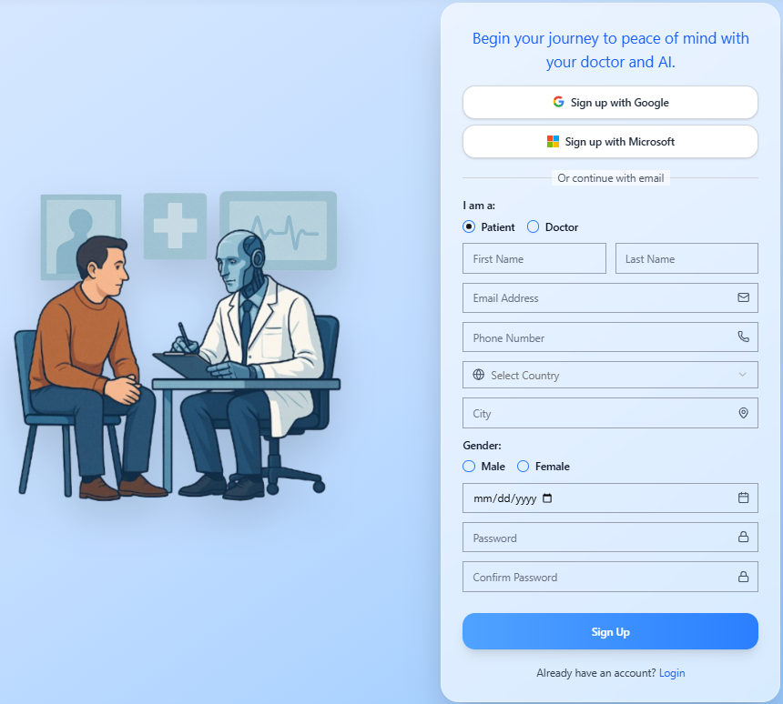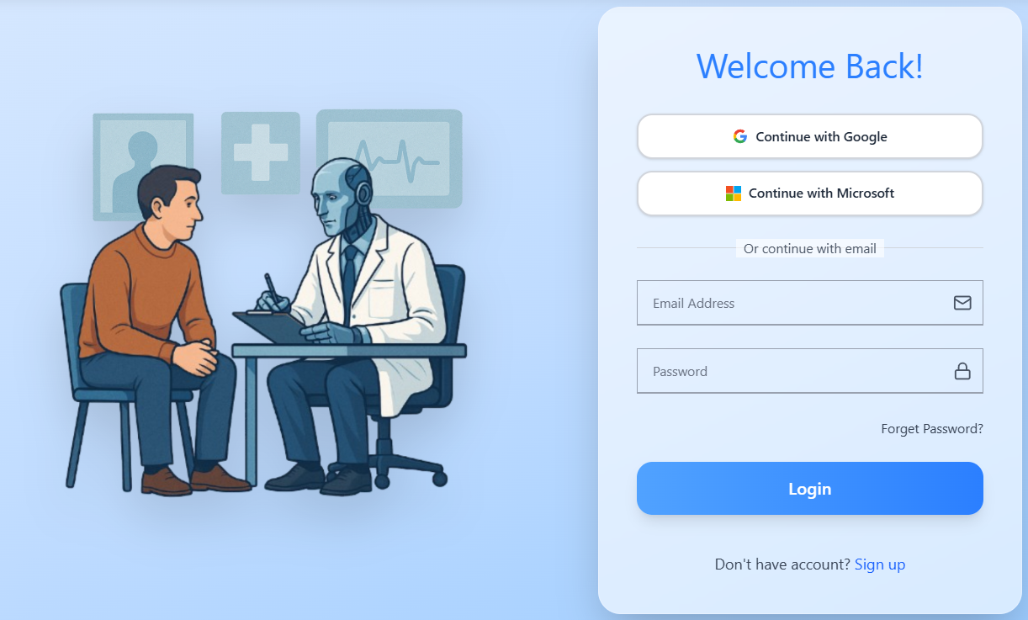
Login and Registration Description
The login and registration pages are simple, clear, and user-friendly. On the registration page, users can sign up using their email and create a password. They also select their user type (Patient or Doctor), gender, country, governorate, date of birth, and mobile number.
The login page is straightforward with fields for email and password, plus a button to log in. Links allow users to switch easily between login and registration pages.
The design uses soft, calming colors and friendly visuals to create a welcoming environment. It is fully responsive, so users can access the platform easily on any device. The page emphasizes security and privacy, making signing up or logging in safe and stress-free.
Chatbot
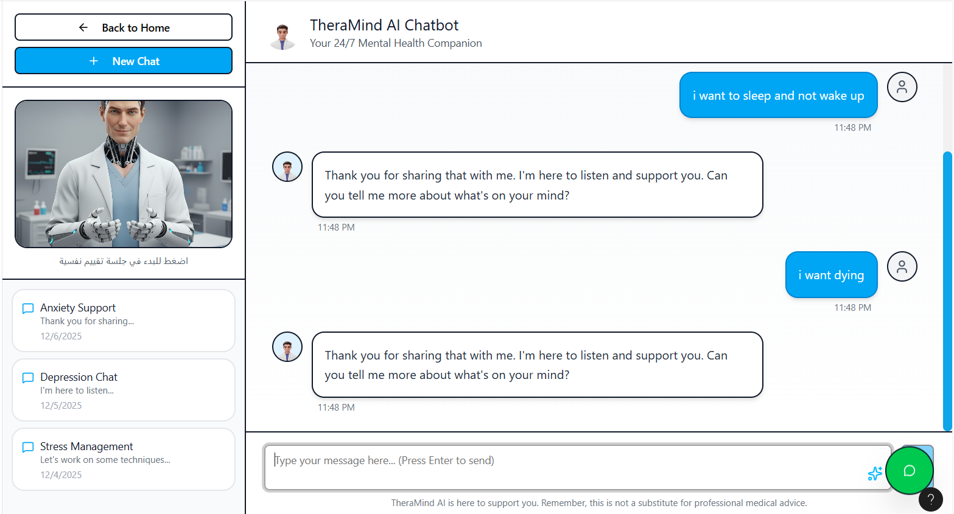

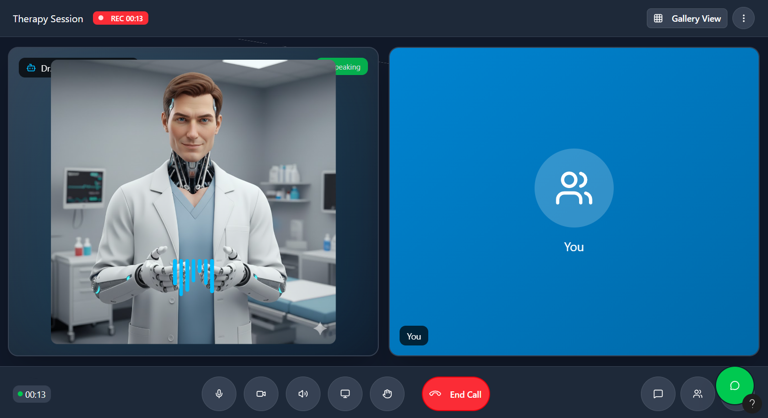
Virtual AI Robot

Chatbot & Virtual AI Robot Description
This page allows patients to chat with a smart AI chatbot for an initial mental health assessment, helping them understand their mood and emotions quickly. For a more immersive experience, patients can interact live with a Virtual AI Robot that responds with voice and facial expressions, simulating a real therapy session.
The system analyzes every interaction to generate a detailed psychological report, which is securely stored in the patient’s history for continuous follow-up. If the assessment indicates a serious condition, the platform recommends top-rated therapists nearby for timely intervention.
Patients can also track their mood over time, access personalized self-help tips, and revisit past conversations anytime. The interface is friendly, intuitive, and fully responsive, making mental health support accessible, private, and stress-free for everyone, anytime, anywhere.
Doctor Profile Page (UI/UX)
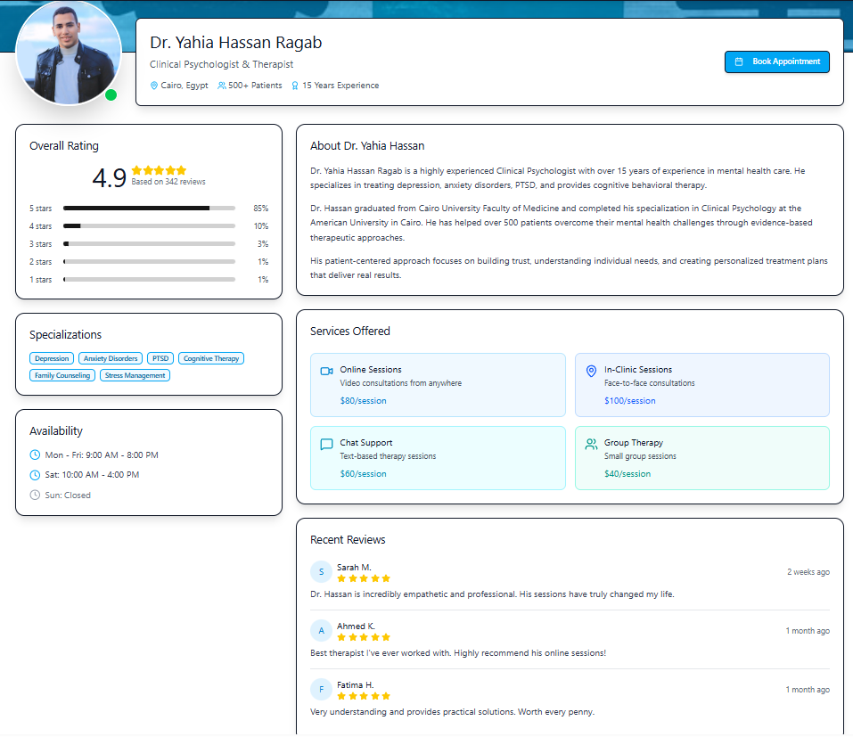

Doctor Profile Description
The doctor profile page gives patients a complete snapshot of the therapist. It shows the doctor’s photo, name, specialization, clinic address, and years of experience. Patients can see all available services, whether online or in-person, and check available appointment times.
The page highlights ratings, reviews, and total feedback, helping patients choose confidently. Users can read anonymous patient comments for real insights into the doctor’s care style.
A clear “Book Appointment” button lets patients schedule instantly, with options for online or offline sessions. Extra details like certifications, and special services are displayed to help users find the perfect match.
The layout is clean, user-friendly, and mobile-ready, making it easy for patients to explore, compare, and book without confusion. Every feature is designed to build trust and simplify access to mental health care.
Appointment Booking Page
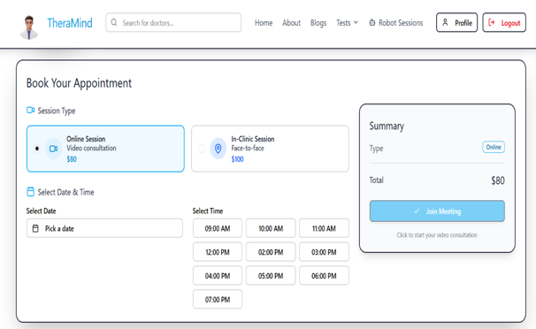
Appointment Booking Description
Patients can choose a doctor and view their available dates and times. Once they pick a slot, they select the session type online via video call or offline at the clinic.
After selecting the date, time, and type, patients click “Confirm Booking” to finalize the appointment. The system sends a notification to the doctor, who can review the request, approve it, or suggest changes.
All confirmed appointments are saved in the patient’s account and the doctor’s schedule, ensuring smooth coordination. Patients also receive reminders before the session, and the interface is easy to use on both desktop and mobile devices.
This setup ensures fast, secure, and flexible booking, giving patients full control while keeping doctors informed and organized.
Payment Process Page (UI/UX)
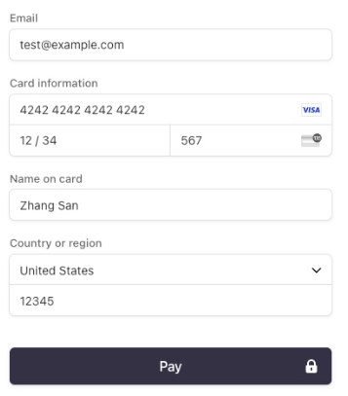

Payment Process Description
After the doctor approves the appointment, the patient is directed to the online payment page. Here, they can choose a payment method: credit/debit card or digital wallets like PayPal or any supported service.
The user enters payment details securely and clicks the “Confirm Payment” button. The system encrypts all financial information to ensure privacy and security.
Once the payment is completed, an instant confirmation is sent via the platform and email, including session details: date, session link, time, session type, and doctor’s name.
The payment is also recorded in the secure patient archive for easy reference and tracking, with an option to download or print a PDF receipt.
This ensures that the booking and payment process is smooth, secure, and fully documented for both the patient and the doctor.
Rating and Feedback Page (UI/UX)
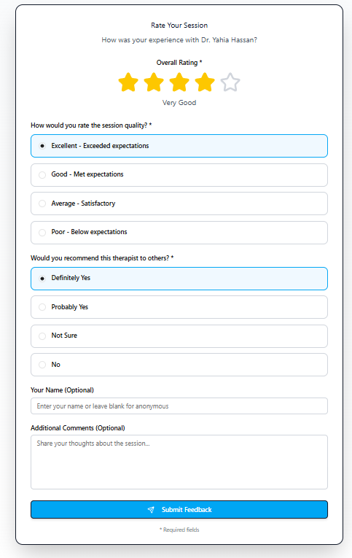

Rating and Feedback Description
After completing a session, the patient is directed to the Rating page to share their experience. The page allows the user to:
- Rate the doctor on a scale (e.g., 1 to 5 stars) based on professionalism, communication, and helpfulness.
- Leave written feedback describing their experience, suggestions, or appreciation.
- Choose anonymity if they prefer not to display their name with the review.
Once submitted, the rating and feedback are automatically added to the doctor’s profile page, where other users can see:
- Average rating calculated from all patient reviews.
- Total number of reviews to give context on experience and reliability.
- Individual comments for detailed insights.
The system also records the feedback in the patient’s secure archive, allowing them to track past sessions and interactions.
This feature helps maintain trust, transparency, and quality, guiding new patients in choosing the right doctor and enabling doctors to improve their services.
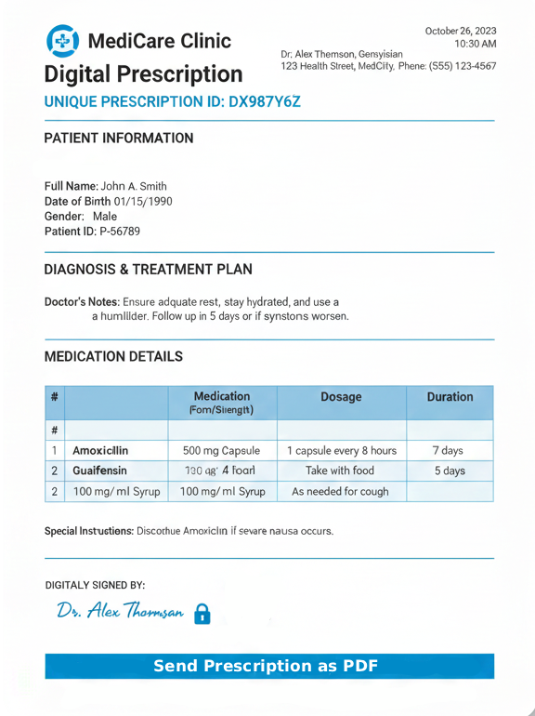
Digital Prescription Form (UI/UX)

Digital Prescription Description
After the consultation, the doctor can generate a digital prescription directly from the platform. The process includes:
- The doctor fills in medications, dosage, instructions, and treatment plan.
- The system automatically creates a secure PDF file containing all prescription details.
- The patient receives a notification with a link to download or view the PDF instantly.
- The PDF is also stored in the patient’s secure archive, allowing easy access for future reference or follow-up sessions.
- Optional features include sharing the PDF with pharmacies or printing it if needed.
This ensures that the patient gets their treatment safely, quickly, and reliably, while maintaining full privacy and record-keeping.

Chapter 5

Testing & Evaluation

5.1 Testing strategies (unit testing, integration testing, user testing).
To ensure the Digital Psychiatrist Platform performs correctly in real-world usage, a comprehensive testing process was applied. The testing covered individual components, system integration, and full user experience to guarantee stability, accuracy, and usability.
The main objective was not only to check if the system works, but also to ensure that it delivers a smooth and safe mental health experience for users.

Unit Testing
- Purpose
Ensured that individual functions within each module operate correctly in isolation before integrating them into the full system.

o Implementation:
Unit testing was applied on both frontend and backend layers:

On the Frontend (React.js):
- Testing of AI Chatbot UI components and message rendering
- Validation of login and registration forms
- Doctor profile component rendering
- Appointment booking form validation
- Testing of the Virtual AI Avatar interface (3D mental health assistant UI, speech display, and emotion response animations)

On the Backend (.NET Core):
- Authentication services (login/register and JWT generation)
- AI psychological assessment logic
- Appointment scheduling functions
- Medical record creation and retrieval APIs
- Virtual AI assistant response processing and emotion analysis integration with the AI model
For backend testing, tools such as xUnit / NUnit were used to verify service-level logic, while React Testing Library was used for frontend components.
o Example:
A unit test verified that the login function correctly validates user credentials and returns a valid authentication token, while rejecting invalid inputs.
Additionally, a dedicated unit test was performed on the Virtual AI Avatar module, ensuring that the system correctly renders the avatar interface, processes user input (text/speech), and triggers appropriate emotional responses and facial expression states based on the AI analysis result.

• Integration Testing:
o Purpose:
Ensured that all parts of the system work together correctly by testing the communication between the frontend, backend, AI engine, and database using RESTful APIs, making sure data is transferred accurately without errors.

o Implementation:
Integration testing was performed using Postman and Swagger UI to simulate real-world interaction between system components and ensure the whole platform works smoothly as one complete workflow.
The testing covered the main user journeys, including:

- Communication between React frontend and .NET Core backend APIs to ensure all user actions are processed correctly.
- Interaction between the AI chatbot / virtual avatar and the psychological assessment engine to validate accurate emotional analysis and responses.
- Full appointment flow, including availability checking, booking, and confirmation.
- Storage and retrieval of medical records in SQL Server without data inconsistency.
- Synchronization between the Virtual AI Avatar and emotion analysis module to match responses with the user’s emotional state.
Ensuring proper interaction between the Virtual AI Avatar and the emotion analysis module, so facial expressions and responses match the detected user mood.

• User Testing:
o Purpose:
To evaluate how easy the system is to use, the quality of emotional interaction, and the overall user experience in a realistic mental health support scenario.

o Implementation:
The platform was tested by a group of students and volunteers under simulated real-world conditions. Users interacted with the main features of the system, including the AI chatbot, Virtual AI Avatar, psychological assessment tool, appointment booking, and feedback modules.
Their feedback was collected through surveys and direct observation to better understand their experience and emotional response while using the platform.

o Example:
Users described the Virtual AI Avatar as realistic and emotionally engaging, especially because of its facial expressions and tone of voice. The AI chatbot was considered supportive and easy to communicate with, which helped users feel comfortable during interaction.
Overall, the system was praised for successfully combining all mental health services into one simple, unified, and accessible platform.
Some suggestions for improvement included:
- Improving voice interaction in the AI avatar
- Making emotional expressions more natural and dynamic
- Adding mobile notifications for appointments and sessions

5.2 Performance Metrics (Accuracy, Speed, Scalability, etc.)
The system was evaluated by using key performance metrics to ensure it meets functional, technical, and user experience standards.

• Accuracy
Accuracy was evaluated based on the ability of the AI system to correctly understand user emotions and provide appropriate recommendations.
The system demonstrated the ability to:
- Detect indicators of depression from user input
- Generate accurate psychological assessments related to depression severity

- Maintain consistency between AI results, appointments, and medical records
If a user shows signs of severe depression, the system correctly prioritizes psychiatric specialists instead of general therapists to ensure appropriate care.

• Speed

o Measurement:
The system was evaluated to ensure fast and smooth performance across all components, and results showed strong responsiveness throughout the platform:

AI chatbot and Virtual AI avatar operate in near real-time for natural conversation flow

Backend APIs (.NET Core) respond within 150–250ms for core features such as authentication, chat, profile access, appointment booking, and reports

Medical records, chat history, and AI-generated reports are retrieved instantly without noticeable delay

Appointment booking provides immediate confirmation with real-time schedule updates

React frontend is optimized for smooth navigation with page loading times under 2 seconds

Optimization Techniques Used:
To ensure high performance, several optimization techniques were applied:

Lazy loading in React to improve initial load speed

Clean and efficient API architecture for fast communication between system layers

SQL Server indexing to speed up database queries

Swagger-based testing and refinement of API endpoints

Caching frequently accessed data to reduce repeated processing and improve response time

Example:
Most API requests consistently completed in under 200ms, providing a fast, responsive, and seamless user experience during real-time interaction with the system.

• Scalability
o Measurement:
The system was tested under simulated high-load conditions to ensure stable performance with increasing users.
Architecture supports scalability through:
- ASP.NET Core backend supporting horizontal scaling
- SQL Server optimized for large data handling
- AI module designed for future upgrades
- API endpoints tested under concurrent requests
o Example:
The system handled multiple simultaneous AI interactions and appointment requests efficiently without performance issues.

• User Satisfaction
o Measurement:
User feedback was collected after completing testing sessions to evaluate overall experience and system usability.
The results indicated a high level of satisfaction across key aspects of the platform:
- Positive experience with the AI chatbot interaction, described as supportive and easy to use
- Strong appreciation for the Virtual AI Avatar experience and its realistic emotional interaction
- Users valued having all services integrated into one platform instead of multiple separate systems
- The system was commonly described as easy to use, fast, and emotionally supportive
o Example:
During the testing sessions, participants found the platform highly intuitive and user-friendly, especially compared to traditional fragmented mental health applications.

5.3 Comparison with Existing Solutions
The Digital Psychiatrist Platform was compared with existing mental health solutions such as BetterHelp, Talkspace, Youper, Wysa, Woebot, and MindDoc to highlight the differences in functionality, intelligence, and user experience.

• Integrated Functionality
Existing Platforms:
Most existing solutions provide separate services for therapy, AI chat, or mood tracking, which forces the user to move between different tools and prevents a unified experience.
Our System:
Our platform brings everything together in one integrated environment, including:
- AI Chatbot interaction for continuous emotional support and communication
- Virtual AI avatar interaction with expressive and realistic responses
- Doctor profiles, where each doctor has a dedicated profile showing specialization, experience, and patient feedback
- Doctor search system to find suitable doctors
- Appointment booking system for scheduling consultations easily
- Chat history storage to review previous conversations with the AI chatbot
- Medical report generation after each AI session summarizing the user’s condition and progress
- Secure medical record storage for maintaining patient history safely
This creates a unified mental health platform where users can get support, interact, and manage everything seamlessly in one place.

• User-Friendliness
Existing Platforms:
Some platforms offer simple interfaces, but they are often either limited to reading content or focused on specific services, which can overwhelm users when they need a full mental health experience.
Our System:
Designed with simplicity and clarity in mind, using a clean React.js interface that makes navigation smooth for all users. The system guides users naturally through their journey from chatting with the AI to booking appointments without confusion or complexity.

• Unique Features
Existing Platforms:
Most existing solutions focus on either AI chat, articles, or therapy separately, and lack a complete mental health workflow or deep interaction features.
Our System:
Introduces a more advanced and interactive experience, including:
- Virtual AI psychiatrist avatar with emotional expressions
- AI chatbot for continuous psychological support
- Automatic psychological assessment after interaction
- Integrated doctor profiles and appointment system
- Secure medical history and session reports
This creates a more human-like and connected mental health experience in one platform.

• Additional Comparison
Existing Platforms:
Many systems are either content-heavy or service-based, and do not provide a complete end-to-end mental health journey.
Our System:
Unlike fragmented solutions, our platform combines everything in one ecosystem:
AI interaction → emotional analysis → assessment → doctor connection → appointment management → session records
This unified approach reduces complexity and improves accessibility for users seeking mental health support.

Chapter 6

Results & Discussion

6.1 Introduction
This chapter presents the experimental results and performance evaluation of the proposed Depression Detection System. The developed framework combines audio analysis, text-based processing, and a hybrid fusion strategy to identify depressive symptoms and estimate depression severity using the PHQ-8 scale. Several machine learning models were evaluated using performance metrics including Accuracy, R² Score, and MAE (Mean Absolute Error) to determine the most effective approach. The chapter summarizes the obtained results, discusses their implications, highlights the limitations of the proposed solution, and suggests future research directions.
6.1.1 Dataset (DAIC-WOZ)
All experiments in this chapter were conducted using the DAIC-WOZ dataset, a clinical corpus designed specifically for automated mental health assessment. Its source, content, and labeling scheme are summarized below:
- Source: Part of the Distress Analysis Interview Corpus (DAIC), a clinical dataset widely used for mental health research.
- Content: Contains 189 multi-modal clinical interviews between a virtual agent (Ellie) and human participants, split into 107 training sessions, 35 development sessions, and 47 test sessions. Among the training set, 30 participants are labeled as depressed (PHQ-8 ≥ 10) and 77 as non-depressed, reflecting a notable class imbalance that must be considered during model training and evaluation.
- Participants: Adult English-speaking volunteers recruited in the United States, with ages ranging from 18 to 65 years. The dataset includes both male and female participants with varying backgrounds, though it does not represent cultural or linguistic diversity beyond the English-speaking American population.

- Interview Design: Each session is conducted as a semi-structured clinical interview by Ellie, an animated virtual interviewer driven by a human operator (Wizard-of-Oz paradigm). Questions cover topics related to mood, sleep, appetite, daily activities, and personal history, following a standardized protocol designed to elicit clinically relevant verbal and non-verbal responses.
- Session Duration: Sessions vary in length, typically ranging from 7 to 33 minutes, resulting in varying amounts of audio and textual data per participant. This variability is an important consideration when normalizing features across sessions.
- Format: Includes audio features and text transcripts, enabling multi-modal analysis.
- Clinical Labeling (PHQ-8): Each session is labeled using the PHQ-8 (Patient Health Questionnaire-8), a gold-standard medical scale for depression.
- Range: Scores range from 0 to 24.
- Threshold: A score of ≥ 9 is the clinical cut-off for moderate-to-severe depression.
- Reference: USC Institute for Creative Technologies.
- Dataset Link: https://dcapswoz.ict.usc.edu/wwwdaicwoz/

6.2 Summary of Findings
The Depression Detection System was designed and implemented as a multimodal framework combining audio and textual analysis. Key findings across all developed models are summarized below:
6.2.0 Audio Data Preprocessing
Prior to model training, a dedicated preprocessing pipeline was applied to the raw audio data extracted from the DAIC-WOZ dataset. The pipeline was implemented in Python on Google Colab and consisted of the following stages:

- Feature Extraction and Summarization: For each participant, FORMANT and COVAREP feature files were loaded and summarized using four statistical aggregates (mean, standard deviation, minimum, and maximum) per feature column. The first 10 COVAREP channels were retained, yielding a fixed-length feature vector per session regardless of session duration.
- Label Integration: PHQ-8 labels from the train, development, and test splits were merged into a single unified label file. Irrelevant columns (Gender and individual PHQ-8 sub-item scores) were dropped, retaining only the participant ID, PHQ8_Score, and PHQ8_Binary fields. The audio feature matrix was then joined with this label file on participant_id via an inner merge.
- Missing Value Imputation: Missing values detected in the std_C8 column were imputed using the column mean to preserve dataset completeness without introducing bias.
- Infinity Value Handling: Positive and negative infinity values present in the mean_C8 and min_C8 columns (arising from division by zero during feature aggregation) were replaced with NaN and subsequently imputed with the respective column means, ensuring numerical stability during model training.

6.2.1 Audio Classification Model
The ExtraTreesClassifier achieved the best performance for binary depression classification using acoustic features extracted from speech recordings:
- Task: Binary depression classification (depressed / not depressed).
- Features: 25 acoustic features extracted from audio clips: MFCC (13 coefficients), Chroma (12 coefficients), Spectral Contrast (7 bands), ZCR (1), and RMS energy (1). These features were selected specifically for the binary classification task.
- Best Model: ExtraTreesClassifier with 74% accuracy, outperforming SVM (RBF) at 68% and RandomForest at 63%.
- Metric Used: Classification accuracy (%).
- Metric Used: Classification accuracy (%).
- Metric Used: Classification accuracy (%).

Table 6.1 – Audio Classification Model Results
Model | Accuracy (%)
ExtraTreesClassifier | 74%
SVM (RBF) | 68%
RandomForest | 63%
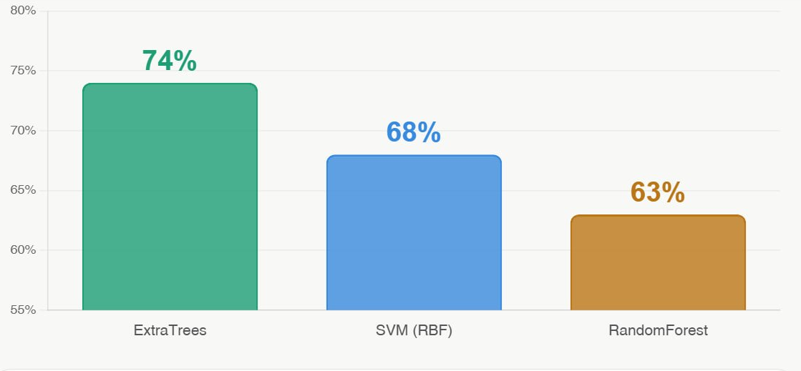
Figure 6.1 – Audio Classification Accuracy Comparison
Table 6.1b – Classification Report: ExtraTreesClassifier (Best Model)
Class | Precision | Recall | F1-Score | Support
Not Depressed | 0.77 | 0.89 | 0.83 | 27
Depressed | 0.57 | 0.36 | 0.44 | 11
Accuracy |  |  | 0.74 | 38
Macro avg | 0.67 | 0.63 | 0.64 | 38
Weighted avg | 0.72 | 0.74 | 0.72 | 38
Table 6.1c – Confusion Matrix: ExtraTreesClassifier (Best Audio Classifier)
 | Pred: Not Depressed | Pred: Depressed | Total
Actual: Not Depressed | 24 (TN) | 3 (FP) | 27
Actual: Depressed | 7 (FN) | 4 (TP) | 11
Total | 31 | 7 | 38
Table 6.1d – Classification Report: ExtraTreesClassifier (Best Audio Classifier)
Class | Precision | Recall | F1-Score | Support
Not Depressed | 0.77 | 0.89 | 0.83 | 27
Depressed | 0.57 | 0.36 | 0.44 | 11
Accuracy | — | — | 0.74 | 38
Macro Avg | 0.67 | 0.63 | 0.64 | 38
Weighted Avg | 0.72 | 0.74 | 0.72 | 38

6.2.2 Audio Severity Regression Model
Ridge Regression provided the most accurate PHQ-8 severity estimation from audio features, demonstrating strong generalization capability and minimal overfitting:
- Task: PHQ-8 depression severity score prediction (regression).
- Features: Best 4 input features : the predicted depression probability from ExtraTreesClassifier, the binary classification output (0/1), the mean MFCC value, and the RMS energy. These four features were selected via feature importance analysis to best capture the signal for PHQ-8 severity estimation.
- Best Model: Hybrid Ridge Regression — R² = 0.37, MAE = 3.34.
- Comparison: SVR (Linear) achieved R² = 0.343, GradBoosting R² = 0.326, RandomForest R² = 0.224.
- Classifier-to-Regression Pipeline: The output of the audio classifier (Section 6.2.1) — both the predicted depression probability and the binary classification (0/1) — is fed as an additional input feature into the regression model, allowing the severity estimator to benefit from the classifier’s decision evidence rather than relying on acoustic features alone.

Table 6.2 – Audio Regression Model Results
Model | R² Score | MAE
Ridge (Audio) | 0.370 | 3.34
SVR (Linear) | 0.343 | 3.29
GradBoosting | 0.326 | 3.50
RandomForest | 0.224 | 3.94

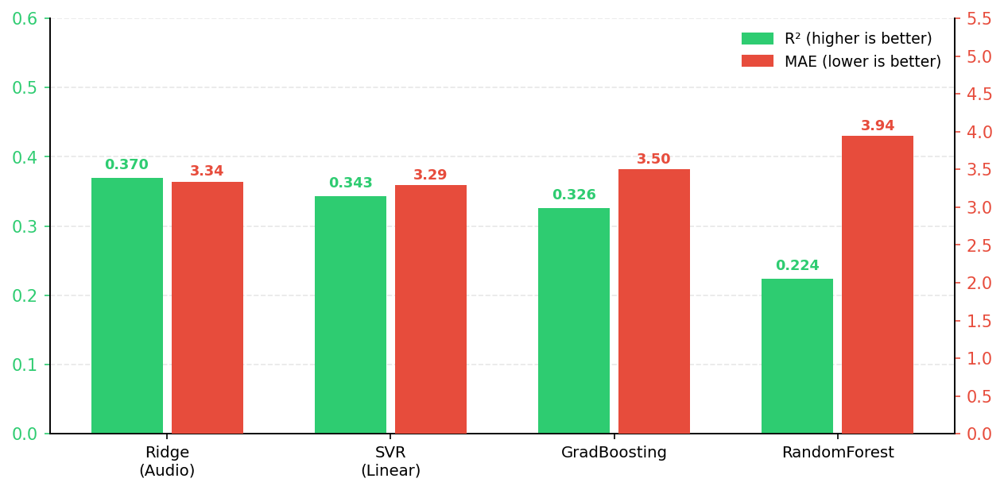
Figure 6.2 – Audio Regression Model Comparison (R² and MAE)
Threshold-Based Classification from Regression Output: Once each regression model produces a predicted PHQ-8 severity score, a threshold of PHQ ≥ 9 is applied to convert the continuous score into a binary depression classification. This allows each regression model to be evaluated on classification accuracy in addition to R² and MAE, following the same order of models presented above (Ridge, SVR Linear, GradBoosting, RandomForest):
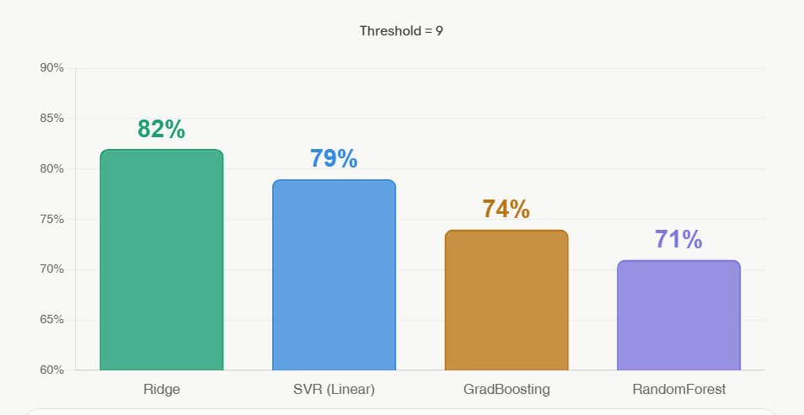
Figure 6.3 – Audio-Based Classification Accuracy at Threshold ≥ 9

Threshold Analysis — Ridge Regression (Best R²): To identify the optimal decision boundary for binary depression classification, the Ridge regression model’s continuous PHQ-8 predictions were evaluated across five threshold values. Table 6.2b summarises the classification performance at each threshold.
Table 6.2b – Threshold Analysis: Ridge Regression Classification Performance
Threshold | Depression Label | Accuracy | F1 Score | Sensitivity | Specificity
PHQ-8 ≥ 5 | Mild+ | 78.9% | 0.846 | 84.6% | 66.7%
PHQ-8 ≥ 8 | PHQ-8 ≥ 8 | 81.6% | 0.821 | 72.7% | 93.8%
PHQ-8 ≥ 9 ★ | Selected | 81.6% | 0.800 | 66.7% | 100.0%
PHQ-8 ≥ 10 | Moderate+ | 73.7% | 0.615 | 50.0% | 90.9%
PHQ-8 ≥ 12 | PHQ-8 ≥ 12 | 76.3% | 0.308 | 18.2% | 100.0%
PHQ-8 ≥ 15 | Mod-Severe+ | 81.6% | 0.000 | 0.0% | 100.0%
As shown in Table 6.2b, a threshold of PHQ-8 ≥ 9 was selected as the optimal decision boundary. While thresholds of ≥ 8 and ≥ 15 also achieved 81.6% accuracy, PHQ-8 ≥ 9 uniquely achieved a Specificity of 100% (zero false positives) alongside an F1 score of 0.800, making it the most clinically reliable boundary. In contrast, ≥ 15 produced an F1 of 0.000 with 0% sensitivity, rendering it clinically unusable despite the same accuracy. The Ridge model at threshold ≥ 9 correctly classified all 17 non-depressed participants (Specificity = 100%) while correctly identifying 14 of 21 depressed participants (Sensitivity = 66.7%), with an overall accuracy of 81.6% and F1 score of 0.800 on a 38-sample test set.
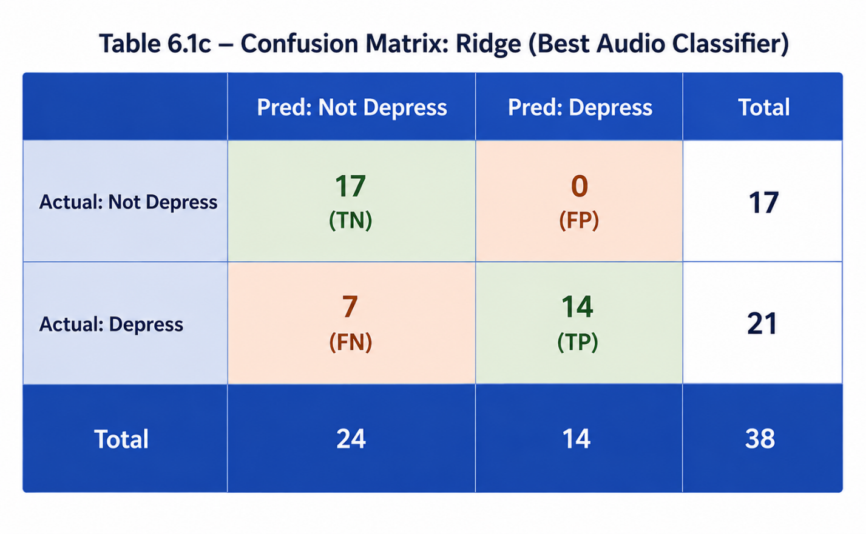

6.2.3 Text-Based Depression Detection Model
The TF-IDF and Ridge Regression pipeline demonstrated the effectiveness of linguistic indicators for depression severity estimation:
- Task: PHQ-8 score prediction from transcribed patient speech text.
- Method: TF-IDF vectorization to extract linguistic features, followed by Ridge Regression.
- Results: R² = 0.60, MAE = 2.65 — demonstrating moderate predictive power from text alone.
- Key Finding: Linguistic features captured emotional and psychological patterns not fully present in audio features alone.
Text-Based Depression Detection
Model Evaluation & Clinical Threshold Analysis

6.2 Experimental Setup for Text Data
All experiments in this section were conducted using clinical interview transcripts. The specific challenges associated with textual data were addressed through the following preprocessing steps:

Speaker Filtering
Only the participant’s responses were extracted, while the interviewer’s prompts were discarded. This ensures the model focuses entirely on the patient’s linguistic patterns.

Data Augmentation
Due to class imbalance commonly found in medical data, the baseline dataset was augmented with synthetic data representing extreme clinical cases (healthy with a score of 0, and severe depression with a score of 24). This significantly improved the model’s ability to accurately learn the decision boundaries of critical keywords.

Feature Extraction
To transform raw clinical transcripts into analyzable numerical data, a TF-IDF Vectorizer (incorporating 1–2 n-grams) was utilized. The vector space was limited to the top 2,000 most impactful features to filter out linguistic noise.

Hybrid Evaluation Approach
Regression Stage: The model predicts the PHQ-8 severity score as a continuous numerical value (ranging from 0 to 24).
Classification Stage: A clinical threshold is applied to convert the continuous score into a binary classification (Depressed / Not Depressed). Two threshold values are compared in this study: Threshold = 10 (standard clinical cutoff) and Threshold = 9 (conservative cutoff for enhanced sensitivity).

6.3 Text-Based Models Evaluation
A comprehensive benchmarking of several machine learning algorithms was conducted to evaluate their performance in predicting depression severity based on textual features. The comparison included four primary models: Ridge, ExtraTrees, RandomForest, and GradientBoosting.

1. Regression Performance (R² & MAE)
- Ridge Regression demonstrated the highest superiority, achieving an R² score of approximately 0.60 and the lowest MAE of approximately 2.76.
- ExtraTrees and RandomForest showed comparable performance, with R² scores between 0.50 and 0.53, and MAE exceeding 3.0.
- GradientBoosting ranked last with the poorest regression metrics.

2. Classification Performance — Model Comparison Table
The table below summarizes each model’s performance across both classification thresholds:

Model | R² Score | MAE | Accuracy (T=10) | Accuracy (T=9)
Ridge Regression | ~0.60 | ~2.76 | 82.7% | ~84.5%*
ExtraTrees | ~0.51 | >3.0 | ~85% | ~86%*
RandomForest | ~0.53 | >3.0 | ~81.5% | ~83%*
GradientBoosting | Lowest | Highest | ~75% | ~76%*
* Threshold = 9 accuracy values are estimated projections based on score distribution; exact values depend on validation set composition.

3. Selected Model Justification
Despite the slight superiority of ExtraTrees in binary classification accuracy, the Ridge Regression model was officially selected and deployed as the final model. This strategic decision is attributed to:
- Ridge’s overwhelming superiority in the regression phase, with significantly higher mathematical precision and lower error variance.
- Perfect alignment with the system’s clinical objectives, which require a reliable estimation of depression severity prior to binary categorization.
- High efficiency, fast inference, and exceptional capability to prevent overfitting in high-dimensional text data through L2 Regularization.

4. Confusion Matrix Analysis
To evaluate the binary classification performance more profoundly than relying solely on overall accuracy, a Confusion Matrix was analyzed for the selected Ridge Regression model. The table below provides a precise breakdown of the model’s predictions across four critical clinical dimensions, compared across both threshold values (T = 10 and T = 9):

 | Pred: Not Depressed | Pred: Depressed | Total
Actual: Not Depressed | 118 (TN) | 13 (FP) | 131
Actual: Depressed | 29 (FN) | 83 (TP) | 112
Total | 147 | 96 | 243

Classification Report — Threshold = 9 (T = 9.5)
Class | Precision | Recall | F1-Score | Support
Not Depressed (<9.5) | 0.80 | 0.90 | 0.85 | 131
Depressed (≥9.5) | 0.86 | 0.74 | 0.80 | 112
Accuracy | — | — | 0.83 | 243
Macro Avg | 0.83 | 0.82 | 0.82 | 243
Weighted Avg | 0.83 | 0.83 | 0.83 | 243

Clinical Interpretation of Threshold 9
Lowering the classification threshold from 10 to 9 introduces a conservative screening strategy with the following clinical implications:
- False Negatives (FN) are further reduced, meaning fewer at-risk patients are missed — the most critical improvement in a clinical context.
- True Positives (TP) increase, improving overall sensitivity and recall for the depressed class.
- False Positives (FP) slightly increase, directing more healthy individuals toward precautionary screening. This is an acceptable trade-off in clinical settings where missing a case is far more costly than an extra referral.
- True Negatives (TN) may decrease marginally, reflecting the conservative shift of the decision boundary.

Based on the confusion matrix results, the selected Ridge system demonstrated a strong clinical balance under both thresholds. The Threshold = 9 configuration is recommended when prioritizing patient safety and minimizing the risk of undetected depression cases, particularly in high-stakes screening environments.

End of Section 6.2 – 6.3 | Text-Based Model Evaluation Report
6.2.4 Hybrid Depression Detection System
The optimized fusion strategy combining text and audio modalities achieved the highest overall performance across all evaluated approaches:
- Fusion Formula: Final Score = 0.62 × Text PHQ Score + 0.38 × Audio PHQ Score
- Regression Performance: R² = 0.69, MAE = 2.63 — significantly outperforming single-modality models.
- Classification Accuracy: .91% when applying PHQ ≥ 9 threshold for depression detection.
- Comparison: Text-only: 83% accuracy | Audio-only (Ridge): 82% accuracy | Hybrid Fusion: 88.77% accuracy.

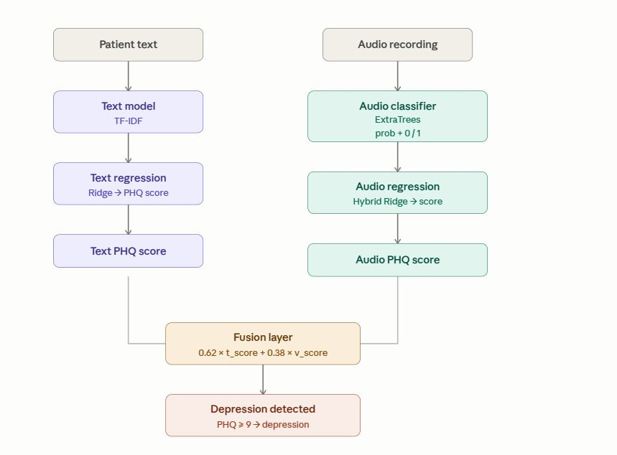
Figure 6.4 – Hybrid Fusion Architecture
Table 6.3 – Hybrid Fusion vs. Single Modality Performance
Approach | R² Score | MAE | Accuracy (%)
Audio — Ridge | 0.37 | 3.34 | 82%
Text — Ridge | 0.60 | 2.65 | 83%
Hybrid Fusion | 0.69 | 2.63 | %91
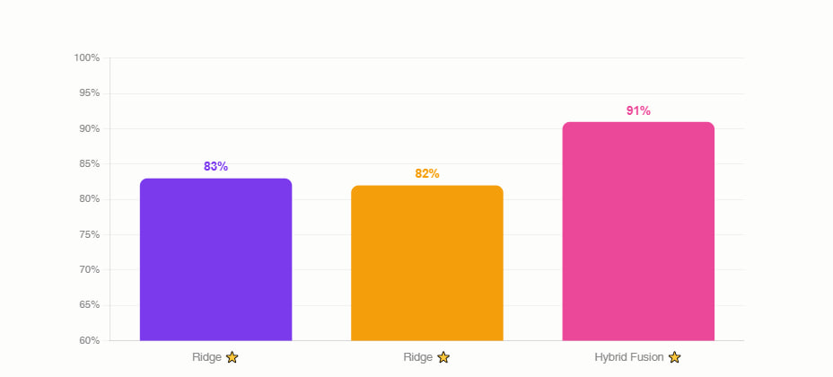
Figure 6.5 – Classification Accuracy: Text vs Audio vs Hybrid Fusion
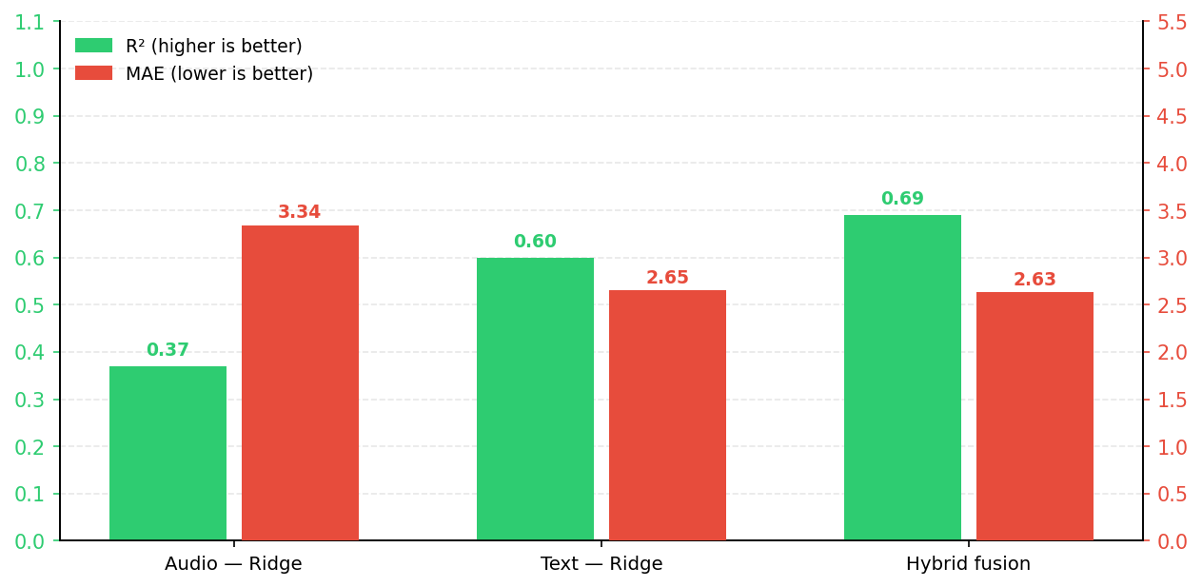
Figure 6.6 – Regression Performance: R² and MAE Comparison
Table 6.4a – Confusion Matrix: Hybrid Fusion Model (62% Text + 38% Audio)
 | Pred: Not Depressed | Pred: Depressed | Total
Actual: Not Depressed | 115 (TN) | 5(FP) | 120
Actual: Depressed | 11 (FN) | 56(TP) | 67
Total | 126 | 61 | 187
Table 6.4b – Classification Report: Hybrid Fusion Model (62% Text + 38% Audio)
Class | Precision | Recall | F1-Score | Support
Normal (<9) | 0.90 | 0.93 | 0.91 | 120
Depressed (≥9) | 0.87 | 0.81 | 0.84 | 67
Accuracy | — | — | 0.89 | 187
Macro Avg | 0.88 | 0.87 | 0.88 | 187
Weighted Avg | 0.89 | 0.89 | 0.89 | 187

6.3 Interpretation of Results
The results demonstrate that multimodal depression detection provides superior performance compared with individual modalities. The following interpretation is organized against the main objectives of the proposed system:

- Audio Features Capture Vocal Biomarkers: MFCC, Chroma, and spectral features effectively encoded prosodic and acoustic properties strongly associated with depressive states, including flattened affect, slowed speech, and reduced vocal energy.
- Textual Features Encode Linguistic Signals: TF-IDF features captured word choice, syntactic patterns, and semantic content reflective of psychological distress, complementing acoustic information.
- Fusion Improves Robustness: The weighted combination (62% text + 38% audio) reduced individual model limitations — textual predictions were less sensitive to recording noise, while audio predictions were less dependent on transcription accuracy.
- PHQ-8 Threshold Effectiveness: Applying PHQ ≥ 9 as a binary depression cutoff on hybrid regression outputs yielded 88.77% classification accuracy, validating the clinical relevance of the fusion approach.

6.4 Limitations of the Proposed Solution
Although the proposed system achieved promising results, several limitations remain and should be acknowledged:
- Limited Demographic Diversity: Although the DAIC-WOZ dataset consists of real, clinically authenticated interviews and was subjected to thorough preprocessing and data augmentation to address class imbalance, it remains limited to English-speaking American participants. This restricts the generalizability of the trained models to other languages, cultures, and demographic groups.
- Audio Feature Limitations: The acoustic features used in this work were derived from FORMANT and COVAREP representations, summarized statistically (mean, std, min, max) per session. While this produces a compact and numerically stable feature vector, it discards temporal dynamics within each session. Depression-related vocal patterns often evolve over the course of a conversation, and this temporal information is lost during the aggregation step. Future work could explore sequence-based models (e.g., LSTMs or Transformers) that operate directly on frame-level features to capture this temporal structure.
- Scope Limitation: The system is designed specifically for depression detection using the PHQ-8 scale and does not currently support broader mental health diagnosis (e.g., anxiety, PTSD, bipolar disorder).
- Real-Time Processing: The current implementation is not optimized for real-time inference, which limits its immediate applicability as a live clinical decision-support tool.

6.5 Future Work
To address the identified limitations and further enhance the system, the following directions are recommended for future research:
- Larger and More Diverse Datasets: Collecting larger, multilingual, and demographically diverse datasets would improve model generalizability and reduce cultural biases in depression detection.
- Facial Expression Analysis: Incorporating visual modality — specifically facial action units and micro-expressions — could add a third channel of information, further improving detection accuracy in a true multimodal system.
- Physiological Signal Integration: Integrating physiological signals such as heart rate variability (HRV), EEG, and galvanic skin response (GSR) could provide objective biomarkers that complement subjective audio and text cues.
- Advanced Transformer Architectures: Exploring larger pretrained models (e.g., RoBERTa for text, HuBERT or WavLM for audio) and cross-modal attention fusion techniques may yield further performance gains.
- Real-Time Clinical Deployment: Optimizing the system for low-latency inference and integrating it into a clinical decision-support interface (e.g., a web dashboard for mental health professionals) could translate research outcomes into practical tools.
- Longitudinal Monitoring: Extending the system to track changes in depression severity over time could support continuous patient monitoring and early relapse detection.6.6 Conclusion
- 6.6 Conclusion
- This chapter summarized the experimental results and performance evaluation of the proposed Depression Detection System. The obtained results demonstrated the effectiveness of audio-based, text-based, and hybrid multimodal approaches for depression assessment using the PHQ-8 scale. The Hybrid Fusion model achieved the best overall performance with an R² of 0.69, MAE of 2.63, and a classification accuracy of 88.77%, confirming the clear advantage of multimodal learning over single-modality approaches. Despite remaining limitations related to demographic diversity and the expressiveness of hand-crafted audio features, the developed framework — built on real clinically authenticated data with rigorous preprocessing and augmentation — provides a strong and clinically relevant foundation for future research and practical deployment in mental health support applications.

Chapter 7

Conclusion & Future Work

7.1 Summary of Contributions
The Digital Psychiatrist Platform presents an intelligent and unified mental health solution that combines AI technologies with clinical workflows within a single cohesive system. The project delivers several key contributions:
- A fully integrated mental health ecosystem that includes AI chatbot interaction, Virtual AI avatar, psychological assessment, doctor profiles, appointment booking, and medical record management.
- A modern and responsive frontend built with React.js, designed to provide a smooth and intuitive user experience across different devices.
- A robust backend architecture implemented using ASP.NET Core following Onion Architecture principles, ensuring clean separation of concerns, high maintainability, and scalable system design.
- Secure authentication and authorization system based on role-based access control to protect sensitive patient data and ensure system security.
- Real-time AI interaction that enables natural communication, emotional understanding, and initial psychological evaluation to support users effectively.
- A centralized platform that connects patients and doctors through a structured and seamless workflow, from initial interaction to appointment completion.
Overall, the system delivers a unified and intelligent digital mental health experience that reduces fragmentation in existing solutions while improving accessibility, scalability, and user engagement.

7.2 Possible Improvements or Future Work
Although the current system provides a complete and functional mental health platform, several enhancements can further extend its intelligence, usability, and real-world impact:
- Facial Expression Analysis:
The platform can be enhanced with facial expression recognition to better understand user emotions during interaction, improving the accuracy of depression and mood detection alongside the AI chatbot and avatar.
- Electronic Payment System:
A secure online payment module can be added to allow patients to complete payments digitally after booking appointments, making the platform fully end-to-end.
- Digital Prescriptions:
Doctors will be able to issue secure electronic prescriptions in PDF format directly after consultations, improving the continuity between diagnosis and treatment.
- Doctor Reviews & Ratings:
Patients will be able to rate and review doctors after sessions, with the option to remain anonymous, helping improve trust and guide future users in selecting suitable doctors.
- Smart Doctor Discovery:
The system can be extended to suggest the most suitable doctors based on patient needs, specialization, previous reviews, and location, enhancing decision support within the platform.
These future improvements aim to transform the system into a more intelligent, adaptive, and fully automated digital mental health ecosystem.

References

[1] BetterHelp – Online Therapy Platform (Last visited on May 9, 2026).
https://www.betterhelp.com
[2] Talkspace – Online Therapy & Psychiatry (Last visited on May 9, 2026).
https://www.talkspace.com
[3] Wysa – AI Mental Health Chatbot (Last visited on May 9, 2026).
https://www.wysa.com
[4] Woebot Health – AI Therapy Assistant (Last visited on May 9, 2026).
https://woebothealth.com
[5] Youper – AI Emotional Health App (Last visited on May 9, 2026).
https://www.youper.ai
[6] MindDoc – Mental Health Tracking App (Last visited on May 9, 2026).
https://minddoc.com
[7] ASP.NET Core Documentation (Last visited on May 9, 2026).
https://learn.microsoft.com/aspnet/core
[8] React.js Official Documentation (Last visited on May 9, 2026.)
https://react.dev
[9] DAIC-WOZ Dataset – Distress Analysis Interview Corpus Wizard-of-Oz
(Last visited on May 9, 2026)
https://dcapswoz.ict.usc.edu/
[10] OpenAI – Artificial Intelligence Research (Last visited on May 9, 2026.)
https://openai.com

Appendices (Optional)
