*Исламов Радмир ПИН-23*

Отчет по лабораторной работе №8

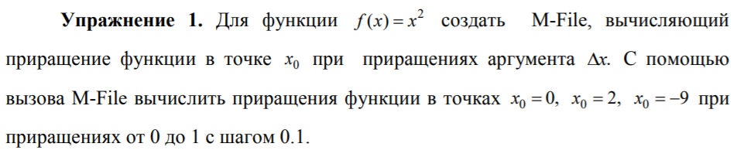

function [df]=increment(f, x0, ot, do, step)

f=x0^2;

dx=ot:step:do;

df=(x0+dx).^2-f;

end

clc, clear

syms x

f=x^2;

increment(f, 0, 0, 1, 0.1)

increment(f, 2, 0, 1, 0.1)

increment(f, -9, 0, 1, 0.1)

ans =0 0.0100 0.0400 0.0900 0.1600 0.2500 0.3600 0.4900 0.6400 0.8100 1.0000

ans =0 0.4100 0.8400 1.2900 1.7600 2.2500 2.7600 3.2900 3.8400 4.4100 5.0000

ans =0 -1.7900 -3.5600 -5.3100 -7.0400 -8.7500 -10.4400 -12.1100 -13.7600 -15.3900

-17.0000

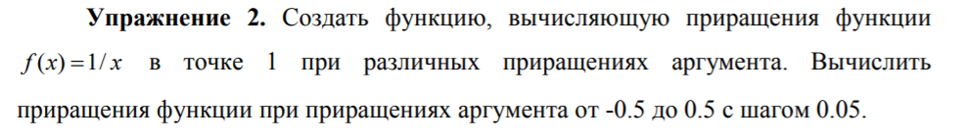

function [df]=increment2(f, x0, ot, do, step)

f=1/x0;

dx=ot:step:do;

df=1./(x0+dx)-f;

end

clc, clear

syms x

f=1/x;

increment2(f, 1, -0.5, 0.5, 0.05)

ans =

Columns 1 through 10

1.0000 0.8182 0.6667 0.5385 0.4286 0.3333 0.2500 0.1765 0.1111 0.0526

Columns 11 through 20

0 -0.0476 -0.0909 -0.1304 -0.1667 -0.2000 -0.2308 -0.2593 -0.2857 -0.3103

Column 21

-0.3333

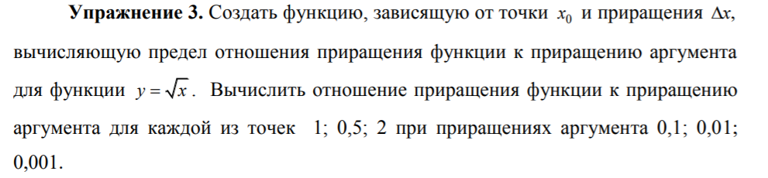

function diff = diff1(x,dx)

dy=(x+dx).^0.5-sqrt(x);

diff=dy./dx;

clc, clear

syms x

dx=[0.1 0.01 0.001];

diff1(1, dx)

diff1(0.5,dx)

diff1(2, dx)

ans = 0.4881 0.4988 0.4999

ans = 0.6749 0.7036 0.7068

ans = 0.3492 0.3531 0.3535

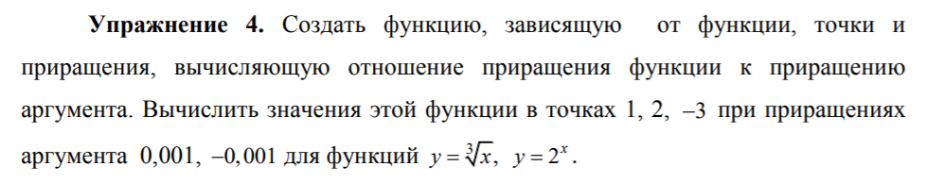

function diff = diff2(fname,x0,dx)

dy=feval(fname,x0+dx)-feval(fname,x0);

dy1=feval(fname,x0-dx)-feval(fname,x0);

diff=[dy./(dx) dy1./(-dx)];

clc, clear

dx=0.001;

diff2(@(x) x^(1/3),1,dx)

diff2(@(x) x^(1/3),2,dx)

diff2(@(x) x^(1/3),-3,dx)

diff2(@(x) 2^x,1,dx)

diff2(@(x) 2^x,2,dx)

diff2(@(x) 2^x,-3,dx)

ans = 0.3332 0.3334

ans = 0.2100 0.2100

ans = -0.0801 - 0.1388i -0.0801 - 0.1388i

ans = 1.3868 1.3858

ans = 2.7735 2.7716

ans = 0.0867 0.0866

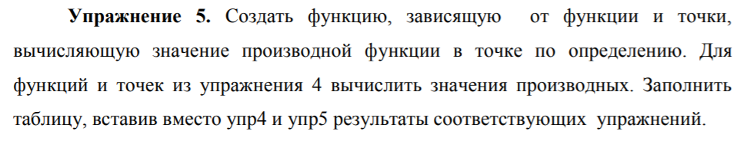

function y=diff3(fname,x0)

% функция, зависящую от функции и точки

%вычисляющая по определению значение производной

syms dx x

dy=feval(fname,x+dx)-feval(fname,x);

y=limit(dy/dx,dx,0);

y=subs(y,x,x0);

end

clc, clear

diff3(@(x) x^(1/3),1)

diff3(@(x) x^(1/3),2)

diff3(@(x) x^(1/3),-3)

diff3(@(x) 2^x,1)

diff3(@(x) 2^x,2)

diff3(@(x) 2^x,-3)

ans = 0.3333

ans = 0.2100

ans = -0.0801 - 0.1388i

ans = 1.3863

ans = 2.7726

ans = 0.0866

|  |  |  |
| --- | --- | --- |
|  | $$y=\sqrt[3]{x}$$ | $$y=2^{x}$$ |
| x0=1 | **0.3332** | **1.3868** |
| 0.3333 | 1.3863 |
| x0=2 | **0.2100** | **2.7735** |
| 0.2100 | 2.7726 |
| x0=-3 | **-0.0801 - 0.1388i** | **0.0867** |
| -0.0801 - 0.1388i | 0.0866 |

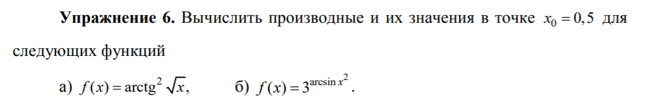

clc, clear

syms x x1

y=diff('(atan(sqrt(x)))^2',x,1)

subs(y,x,0.5)

y1=diff('3^(asin(x^2))',x,1)

subs(y1,x,0.5)

y =atan(x^(1/2))/(x^(1/2)*(x + 1))

ans = 0.5803

y1 =(2*3^asin(x^2)*x*log(3))/(1 - x^4)^(1/2)

ans = 1.4977

