Отчёт по работе  
import math  
import multiprocessing  
  
  
def is_prime(n):  
 if n <= 1:  
 return False  
 for i in range(2, int(math.sqrt(n)) + 1):  
 if n % i == 0:  
 return False  
 return True  
  
  
def prime_factors(n):  
 factors = []  
 for i in range(2, n + 1):  
 if is_prime(i):  
 while n % i == 0:  
 factors.append(i)  
 n //= i  
 return factors  
  
  
def main():  
 pool = multiprocessing.Pool()  
 results = pool.map(prime_factors, range(1, 101))  
 for i in range(len(results)):  
 str_out = ""  
 for elem in results[i]:  
 str_out = str_out + " " + str(elem)  
 print(str(i) + " = " + str_out)  
  
  
if __name__ == '__main__':  
 main()

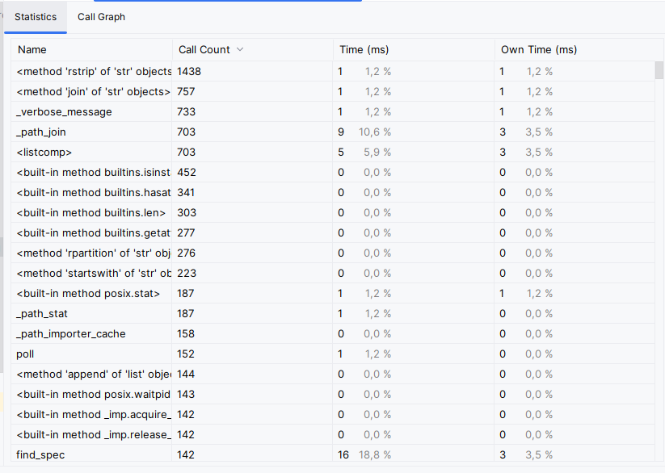

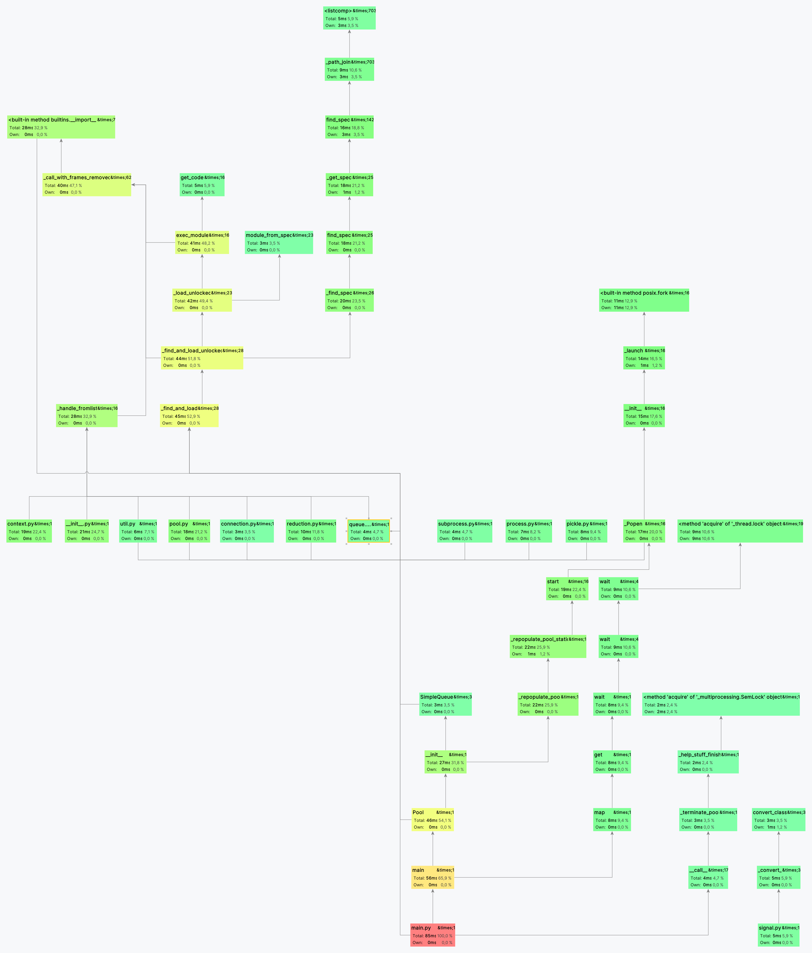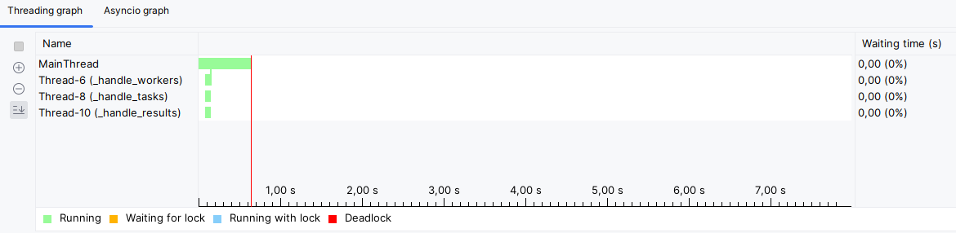

С параметорм 2000

