1. Download packaging tool from  
   <https://www.microsoft.com/en-us/p/msix-packaging-tool/9n5lw3jbcxkf?activetab=pivot:overviewtab>
2. Launch the packaging tool and click on Modification package:  
   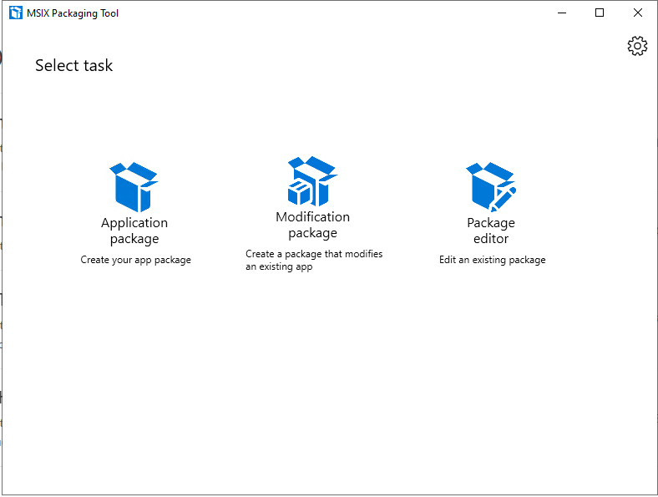
3. Select “create package on this computer” and click next:  
   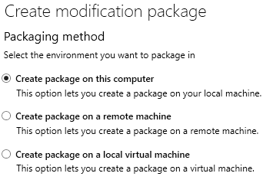
4. On this tab, click on next:  
   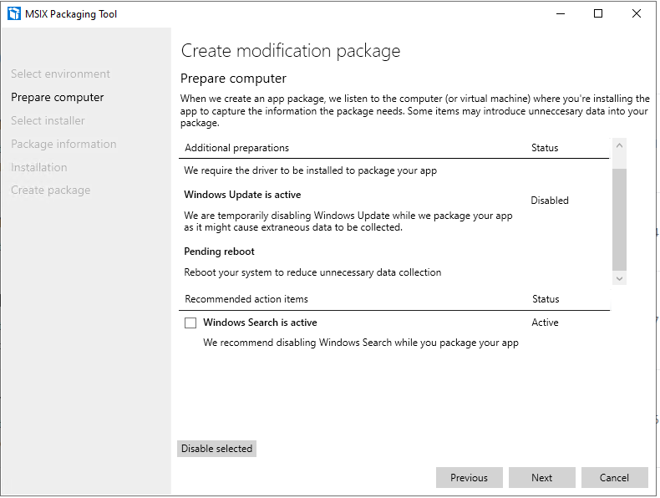
5. – Choose the installer you want to package by clicking on the “Browse” button or entering the path  
   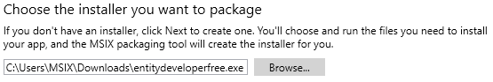  
   - Tick the “Manually enter the main package information” field and insert your package and company name and choose a signature type:  
    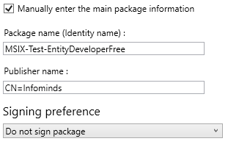  
   - Sign the package according to your signature method
6. Enter your Package Information, choose your install location and click on “next”  
   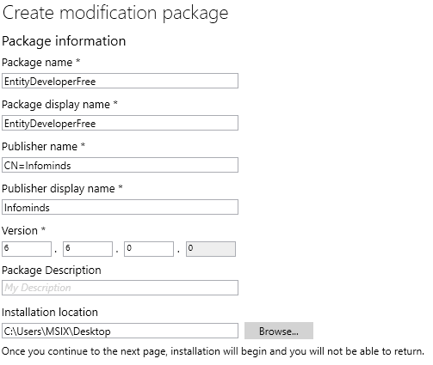
7. - Now the installer for your application should pop up; install the application normally  
   Note: if the default installer needs a restart, click on the Restart button on the MSIX Tool window  
   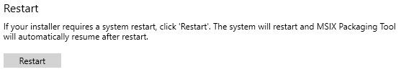  
   - click on “next”  
   - if prompted with the following window, click on “yes, move on”  
   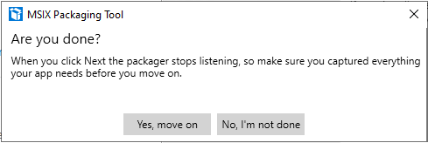
8. On the following Window, choose a saving location for your .msix package   
   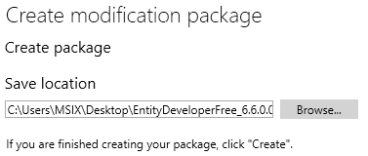  
   - if your package needs specific properties, click on the “package editor” button and set them via the .Manifest file that´s accessible via the “open file” button: 